# CS566: Speech Processing

# Project: Speech based control panel for desktop

# Roll No. Name

184101002 Abhishek Kumar

184101009 Ayush Jaiswal

184101010 Bal Krishna D

# **Architecture of the system**

1. **Block Diagram:**

Data

Vector Quantizer

Front End Processing

ADC

Training

Testing

Apply batch command according to the recognized word

Select the max probability among all models

Scoring of word models

(Forward Procedure)

Store HMM

Creation of HMM and Updating

1. **Words in the vocabulary:**

There are 7 words in the vocabulary on which the HMM model is trained. Words are as follows:

* Browser
* VLC
* Music
* Home
* Settings
* Close
* All

1. **Commands:**
2. When user speaks “browser”, application opens the chrome browser.

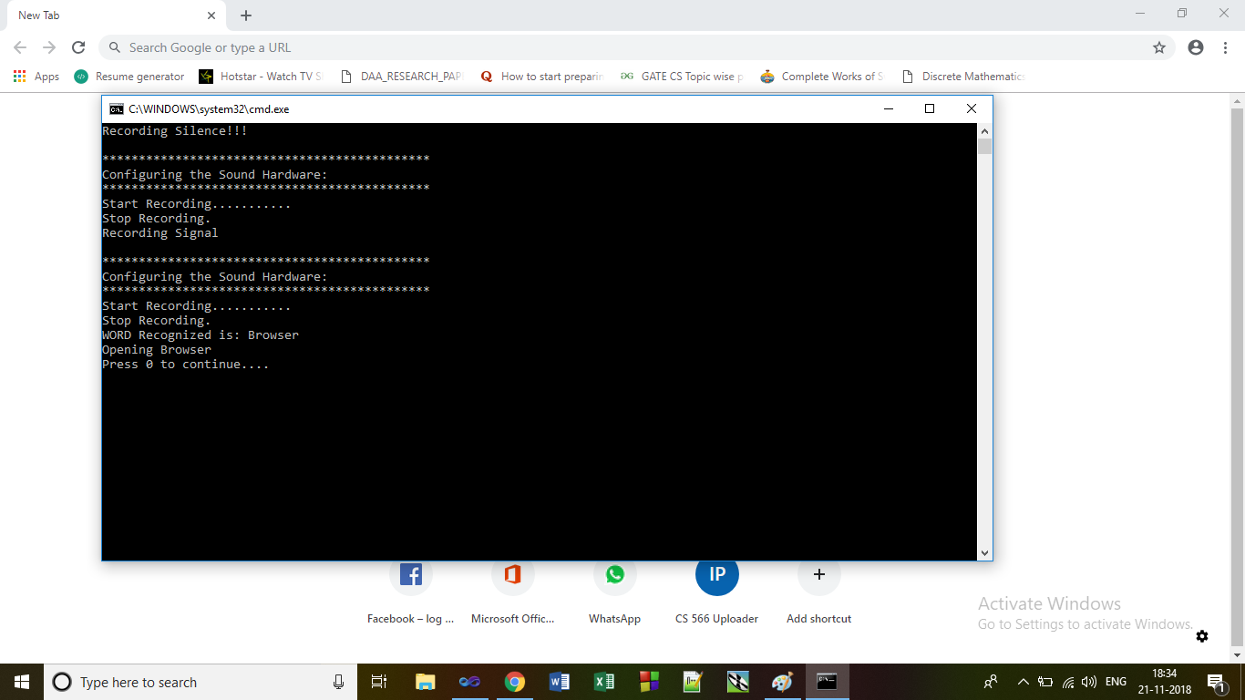

1. When user speaks “VLC”, application opens the VLC media player.
2. When user speaks “music”, application opens the windows media player.

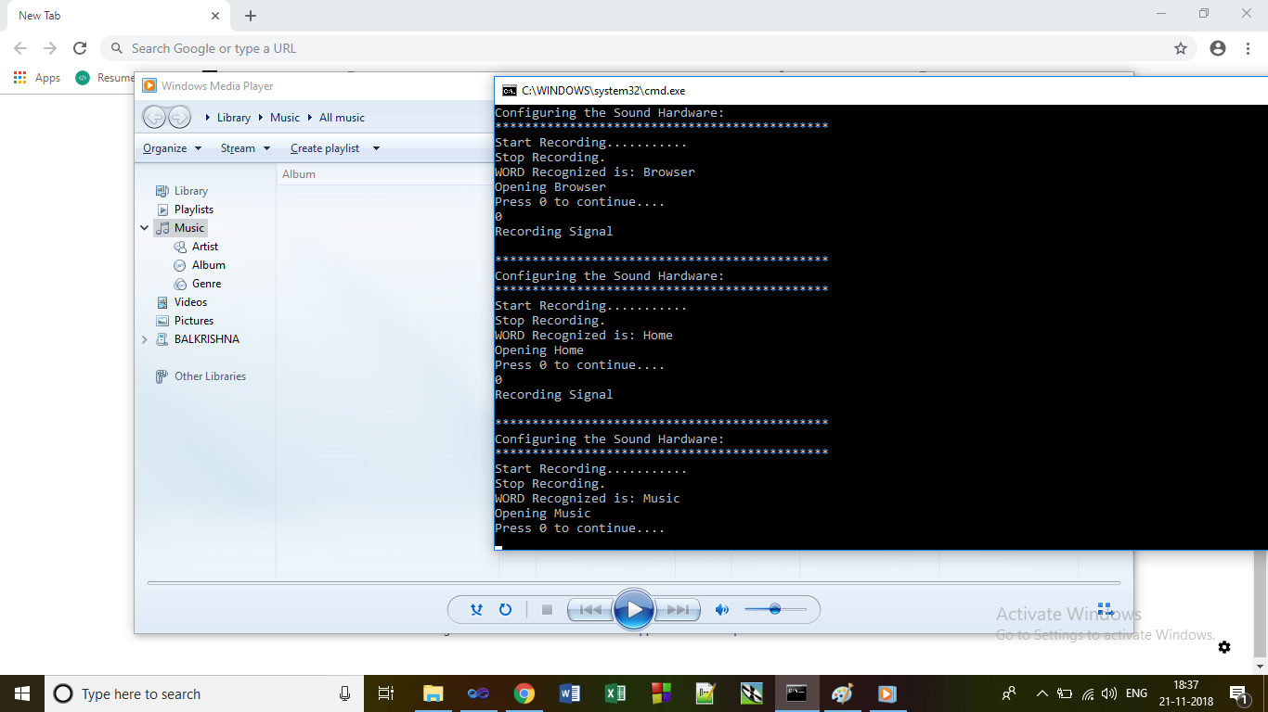

1. When user speaks “home”, application opens file explorer.

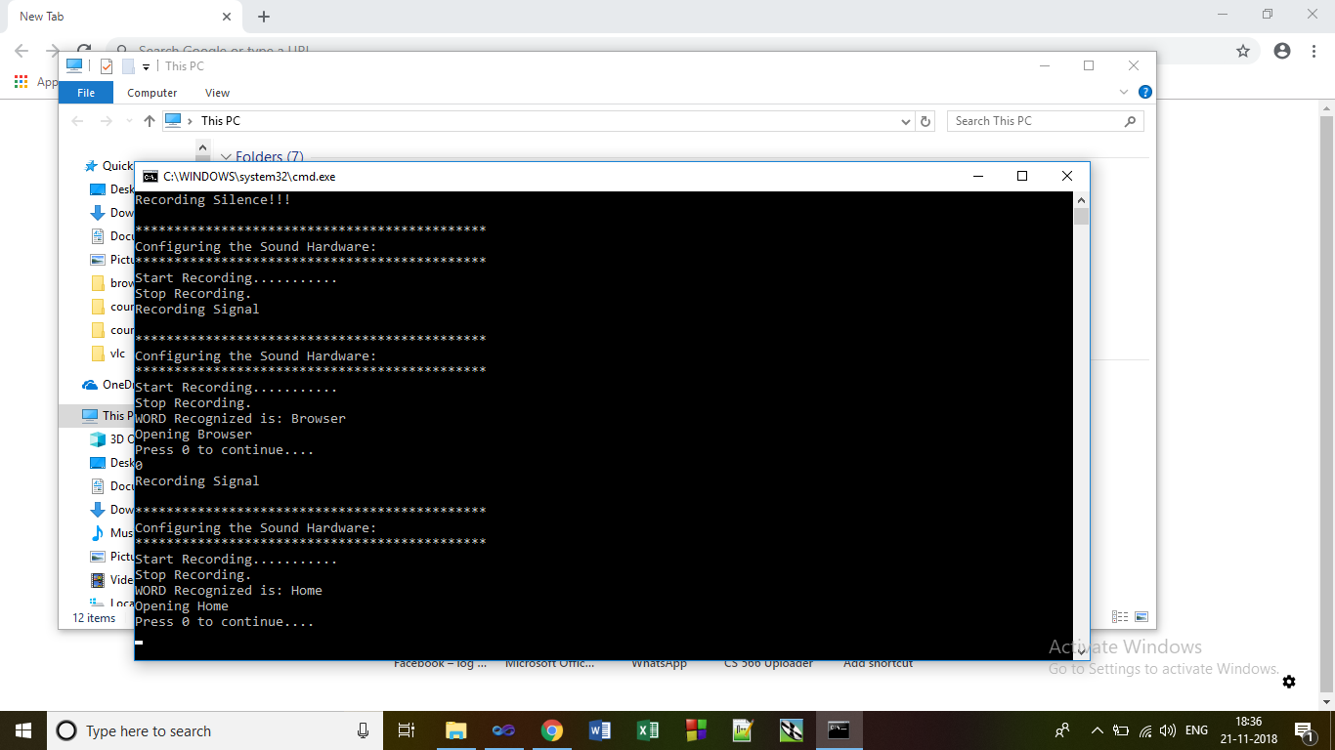

1. When user speaks “settings”, application opens the control panel.
2. When user speaks “close”, it again asks which application to close. When user speaks the name of the application e.g. Browser it closes that application.

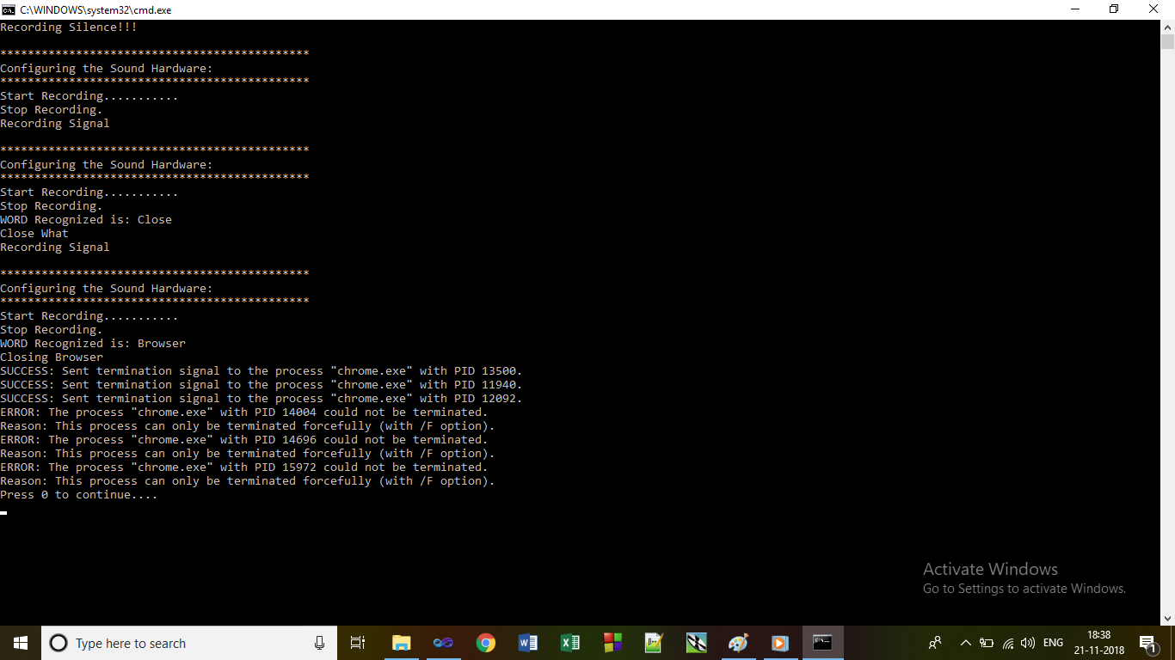

1. After “close” command if you speaks “all” then it closes all running applications.
2. **Steps to run the project:**
3. Open the project in the visual studios named Group4_Speech_Based_Control_Panel_For_Desktop.
4. 184101010_HMM_Cep_Generation contains the WordData which has the database of our 7 words.
5. It creates the cepstral coefficients for all the iterations of the word database and stores it in the Cepstral_coefficients_file and also creates the HMM_Universe simultaneously.
6. CodebookGeneration is used to generate the codebook using the HMM_Universe generated in the previous step.
7. After getting the codebook, 184101010_training_HMM_model is used to train the model using the cepstral coefficients. The Average Model is computed and stored in the Average_Model folder.
8. Using this Average_Model and codebook generated earlier we test the model from the 184101010_Testing_HMM_Model project folder.
9. Retraining the model of a word with another users voice needs the recording of the new users voice sample in a separate folder. This folder is used to re-generate the new model.