**A**

**SYNOPSIS**

**Report On**

**E-Commerce Website Using MERN Stack**

**Group. No. – GB-11**

**Submitted By-:**

**Ayush Jha – 2100290140045**

**Ayush Sharma – 2100290140047**

**Aman Raghava – 2100290140020**

**Session: 2022-2023 (4th Semester)**

**Under The Supervision of -:**

**Dr. Vipin Kumar (Associate Professor)**

**KIET Group of Institutions, Delhi-NCR, Ghaziabad**



### Department Of Computer Applications

**KIET GROUP OF INSTITUTIONS, DELHI-NCR, GHAZIABAD-201206**

(march- 2023)

**ABSTRACT**

The Business to Consumer (B2C) aspect of electronic commerce (e-commerce) is the most visible business use of the Word Wide Web. The primary goal of an e-commerce site is to sell goods or services online. The drivers for electronic commerce (e-commerce) are both technological (under the tremendous pressure of innovation) and business oriented. E-Commerce is now seen as a reality for many businesses and a normal part of a business plan. The immediate benefits, in terms of cost savings, efficiencies and enhanced profitability are clear at every stage in the supply chain.

Adopting e-business is no longer a competitive advantage, but a normal business process, without which an enterprise is unlikely to survive in the new age. Year 2000 saw many Dot-com companies built up and many companies going into E-commerce however now it is a different story, more and more companies are failing, and investors are becoming cautious to invest money into Internet ventures. There is more cash needed then was expected. Some of them had to get on the bandwagon as everybody else were and didn’t want to be left behind, and now that the bubble has burst they are facing the consequences.

In order to make a website that can acquire the needs of both customers and retailers,

MERN (MongoDB, Express.js framework, ReactJS library, NodeJS platform) is one of the powerful stacks that can help us to develop an e-commerce web application.

This is a project with the objective to develop a basic website where a consumer is provided with a shopping cart application and also to know about the technologies used to develop such an application.

**Keywords-:** B2C (Business to Consumer), e-Commerce, Innovation, MERN, Web Application

**TABLE OF CONTENTS**

1. Introduction 3
2. Literature Review 4
3. Project Objective 5
4. Methodology 6
   * 1. Modules Description 7
     2. Software and Hardware Requirement 7
     3. Technology Used 8
5. Project Outcome 9
6. Proposed Time Duration (Using Gantt Chart) 10
7. References 11

**INTRODUCTION**

The "Online E-commerce System" has been developed to override the

problems prevailing in the practicing manual system. This software is

supported to eliminate and in some cases reduce the hardships faced by

this existing system. Moreover this system is designed for the particular

need of the company to carry out operations in a smooth and effective

manner.

The "Online E-commerce System" has been developed to override the

problems prevailing in the practicing manual system. This software is

supported to eliminate and in some cases reduce the hardships faced by

this existing system. Moreover this system is designed for the particular

need of the company to carry out operations in a smooth and effective

manner.

The "Online E-commerce System" has been developed to override the

problems prevailing in the practicing manual system. This software is

supported to eliminate and in some cases reduce the hardships faced by

this existing system. Moreover this system is designed for the particular

need of the company to carry out operations in a smooth and effective

manner

The "Online E-commerce System" has been developed to override the

problems prevailing in the practicing manual system. This software is

supported to eliminate and in some cases reduce the hardships faced by

this existing system. Moreover this system is designed for the particular

need of the company to carry out operations in a smooth and effective

manner

The "Online E-commerce System" has been developed to override the

problems prevailing in the practicing manual system. This software is

supported to eliminate and in some cases reduce the hardships faced by

this existing system. Moreover this system is designed for the particular

need of the company to carry out operations in a smooth and effective

manner.

The "Online E-commerce System" has been developed to override the

problems prevailing in the practicing manual system. This software is

supported to eliminate and in some cases reduce the hardships faced by

this existing system. Moreover this system is designed for the particular

need of the company to carry out operations in a smooth and effective

manner.

The "Online E-commerce System" has been developed to override the

problems prevailing in the practicing manual system. This software is

supported to eliminate and in some cases reduce the hardships faced by

this existing system. Moreover this system is designed for the particular

need of the company to carry out operations in a smooth and effective

manner.

The "Online E-commerce System" has been developed to override the

problems prevailing in the practicing manual system. This software is

supported to eliminate and in some cases reduce the hardships faced by

this existing system. Moreover this system is designed for the particular

need of the company to carry out operations in a smooth and effective

manner.

The "Online E-commerce System" has been developed to override the

problems prevailing in the practicing manual system. This software is

supported to eliminate and in some cases reduce the hardships faced by

this existing system. Moreover this system is designed for the particular

need of the company to carry out operations in a smooth and effective

manner.

The "Online E-commerce System" has been developed to override the

problems prevailing in the practicing manual system. This software is

supported to eliminate and in some cases reduce the hardships faced by

this existing system.

The "Online E-commerce System" has been developed to override the

problems prevailing in the practicing manual system. This software is

supported to eliminate and in some cases reduce the hardships faced by

this existing system.

The "Online E-commerce System" has been developed to override the

problems prevailing in the practicing manual system. This software is

supported to eliminate and in some cases reduce the hardships faced by

this existing system.

The "Online E-commerce System" has been developed to override the

problems prevailing in the practicing manual system.

E-commerce and online shopping in India is getting a noticeable growth as more usage of internet facilities, high educational standards, changing life style and economic growth of the country reasons in the demand of ecommerce techniques and tools. Versatile shopping experience and rapid development of transaction facilities is further boosting opportunities for the remaining market segments. The biggest advantage of e-commerce is the ability to provide secure shopping transactions via the internet and coupled with almost instant verification and validation of credit card transactions. One of the most important issues to be addressed in electronic commerce is the area of services.

Purchasing and selling products and services over the internet without the need of going physically to the market was a time taking process. Online shopping is just like retail store shopping that we do by going to the market, but it is done through the internet. Online shopping has made shopping painless and added more fun. Online stores offer product descriptions, pictures, comparisons, prices, and much more. A few examples of these are Amazon.com, ebay.com, and framt.com and the benefits of online shopping is that by having direct access to consumer, the online stores can offer products that cater to the needs of the consumer, and cookies can be used for tracking the customer selection over the internet or what is of their interest when they visit the site again. Online shopping makes use of digital technology for managing the flow of information, products, and payment between consumers, site owners, and suppliers. Online shopping can be either B2B (business to business) or B2C (business to consumer).

E-commerce is fast gaining ground as an accepted and used business paradigm. More and more business houses are implementing web sites providing functionality for performing commercial transactions over the web. It is reasonable to say that the process of shopping on the web is becoming commonplace.

**LITERATURE REVIEW**

Electronic Commerce (e-commerce) applications support the interaction between different parties participating in a commerce transaction via the network, as well as the management of the data involved in the process.

The increasing importance of e-commerce is apparent in the study conducted by researchers at the GVU (Graphics, Visualization, and Usability) centre at the Georgia Institute of Technology. In their summary of the findings from the eighth survey, the researchers report that “e-commerce is taking off both in terms of the number of users shopping as well as the total amount people are spending via Internet based transactions”.

Over three quarters of the 10,000 respondents report having purchased items online. The most cited reason for using the web for personal shopping was convenience (65%), followed by availability of vendor information (60%), no pressure form sales person (55%) and saving time (53%).

Although the issue of security remains the primary reason why more people do not purchase items online, the GVA survey also indicates that faith in the security of ecommerce is increasing. As more people gain confidence in current encryption technologies, more and more users can be expected to frequently purchase items online

A good e-commerce site should present the following factors to the customers for better usability:

1. Knowing when an item was saved or not saved in the shopping cart.
2. Returning to different parts of the site after adding an item to the shopping cart.
3. Easy scanning and selecting items in a list.
4. Effective categorical organization of products.
5. Simple navigation from home page to information and order links for specific products.
6. Obvious shopping links or buttons.
7. Minimal and effective security notifications or messages.
8. Consistent layout of product information.

**PROJECT OBJECTIVE**

The project objective is to deliver the online shopping application. The objective of this project is to develop a general purpose e-commerce store where books from any field can be bought from the comfort of home through the Internet.

An online store is a virtual store on the Internet where customers can browse the catalogue and select products of interest. The selected items may be collected in a shopping cart. At checkout time, the items in the shopping cart will be presented as an order. At that time, more information will be needed to complete the transaction. Usually, the customer will be asked to fill or select a billing address, a shipping address, a shipping option, and payment information such as credit card number. An e- mail notification is sent to the customer as soon as the order is placed.

This project is an attempt to provide the advantages of online shopping to customers of a real shop. It helps buying the products from anywhere through internet by using a web site. Thus the customer will get the service of online shopping and home delivery from this shop.

Since the application is available online through its website so it is easily accessible and always available.

Sellers can increase and widen their reach to way beyond their cities – they can get customers from literally anywhere in the world, provided they are willing to ship.

• Even small businesses can increase their sales and grow by selling online

• They can enjoy massive savings in infrastructure, as they need not rent or purchase space in pricey locations or spend on interiors, displays.

• As online stores can be operated with minimal staff, there are huge savings in salaries; sellers can also save on overheads like electricity and other utility bills.

• Online storefronts are open 24/7 to serve customers – no more worrying about missing out because of holidays, strikes, or even lockdowns.

• They can respond quickly to market demands

• Sellers can deal in a wide range of products

**METHODOLOGY**

Methodology is a body of methods, rules, and postulates employed by a discipline or a particular procedure or set of procedures.

Sharing your methodology gives legitimacy to your research. An unreliable or erroneous methodology produces unreliable or erroneous results. The reader of your research expects you to have followed accepted practices so that the conclusions you reach are valid. The methodology you report needs to be repeatable, meaning anyone who uses the methods you write about should reach the same conclusions you reached.

The project provides users to login into the website by entering their name, email, and other details and password links. The account verification link will be sent to that email address, after clicking the link the account will get activated and the user can log in to their account and sees the products and order the items. The selected items are stored in the shopping cart where he /she sees all the products that he/ she selects to order.

For ordering the product the user’s address is then given and user selects the payment method to pay the price of that product. If the user selects by debit card/credit card then the customer must enter their card details for doing the online payment functionality with the help of payment gateway.

A shopping cart is one of the important facilities provided in online shopping, this lets customers browse different goods and services, and once they select an item to purchase they can place the item in the shopping cart, and continue browsing till the final selection. Customers can even remove the items from the shopping cart that were selected earlier before they place the final order. It reminds us of the shopping basket that we carry in a departmental store.

1. **MODULE DESCRIPTION**

In this project, we give many modules that’s make the website user friendly and easy to use the project following are key modules -:

**1.** **Create Account or Sign Up Module:** In this module, the user enters his /her name, email id, and password and other details necessary for account creation such as address, contact number and pin code and then clicks the continue button then the customer gets an account verification link in his email account and after confirmation the user can login with their credentials.

**2.** **Login Module:** In this module, after the creation of the account the user login with the help of Email id and password, if a customer forgot the password then he/she can reset the password with the forgot the password button provided in the login module.

**3.** **Home Page:** After successful login the home page is opened and on the home page user can see different products, search the products and if he wants to buy a product he/she can adds the product to the cart.

**4.** **Add to Cart:** After selecting and adding the products which the user needs to buy. He or she can open add to Cart page where the customer see all products which he/she wants to buy. In this page, users can also remove the products

**5.** **Buy Module:** On the Buy Page user can buy the product and select the payment method such as cash or card or UPI, if the user chooses by card method then the customer needs to enter his or her card details

1. **HARDWARE REQUIREMENT AND SOFTWARE REQUIREMENT**

Following are some of the hardware and software requirements which are necessary for the project to run -:

* Windows XP, Windows 7 (32/64 bit) or higher
* Minimum 4 GB RAM and higher
* 10 GB available space on the hard disk
* At least one Internet Browser e.g. Chrome, Firefox, Microsoft Edge etc.
* Node.js to be installed
* Active internet connection minimum speed 512kbps and above.
* At least one installed code Editor to test and debug your code e.g.
* Visual studio code

1. **TECHNOLOGY USED**

**JavaScript**

JavaScript is a scripting, object-oriented, cross-platform programming language. Objects of host environment can be connected to JavaScript and arrange ways to operate them.

Standard libraries for objects are contained by JavaScript, for such as Array, Date, Math, and the essence component of programming languages for instance managers, control framework and statements.

JavaScript is developed by implementing objects for controlling the browser and DOM. For instance, an application is granted by client-side extensions to influence components on an HTML page and answer to user behavior like mouse hovers, form input and page changeover.

**NodeJS**

Node.js is an open source, a system application and furthermore is an environment for servers. Nodejs is an independent development platform built on Chrome's JavaScript Runtime that we can build network applications quickly and easily. Google V8 JavaScript engine is used by Node.js to execute code. Moreover, a huge proportion of essential modules are written in JavaScript.

An event-driven, non-blocking I / O mechanisms (Input / Output) are implemented by

Node.js. It optimizes application throughout and is extremely high extensible. Node.js use asynchronous in it functions. Therefore, Node.js processes and executes all tasks in the background (background processing).

**MongoDB**

MongoDB is an open source database; it is also the leading NoSQL (*) database currently used by millions of people. It is written in one of the most popular programming languages today. In addition, MongoDB is cross-platform data that operates on the concepts of Collections and Documents, providing high performance with high availability and ease of expansion.

(*) NoSQL is a source database format that does not use Transact-SQL to access information, this database was developed on JavaScript Framework on JSON data type. With its introduction, it has overcome the disadvantages of RDBMS relational data model to improve operating speed, functionality, model scalability, cache

Furthermore, MongoDB is a cross-platform database, performing on Collection and Document approach, it produces sharp production, huge availability, and effortless scalability.

**PROJECT OUTCOME (OUTPUT)**

The main theme is to build an e-commerce web application with all three i.e., Front end, back end, and database. This web application is a fully fledged working web application right from the login authentication, admin authorization, add items to cart, using payment gateway. It can be used by anyone to buy the products from anywhere with the help of internet. The web application is easy for them to access and without any effort categories can be created and products can be added by them. It will be very attractive for the customer to see the products by sitting at home or office.

Following are some of the key features which are fulfilled with the help of this web application -:

1. Global Market

2. Always Open

3. Budget Saving

4. Inventory Management

5. Most Accurate customer reach

6. Anyone can use it from anywhere

**PROPOSED TIME DURATION (Using Gantt chart)**

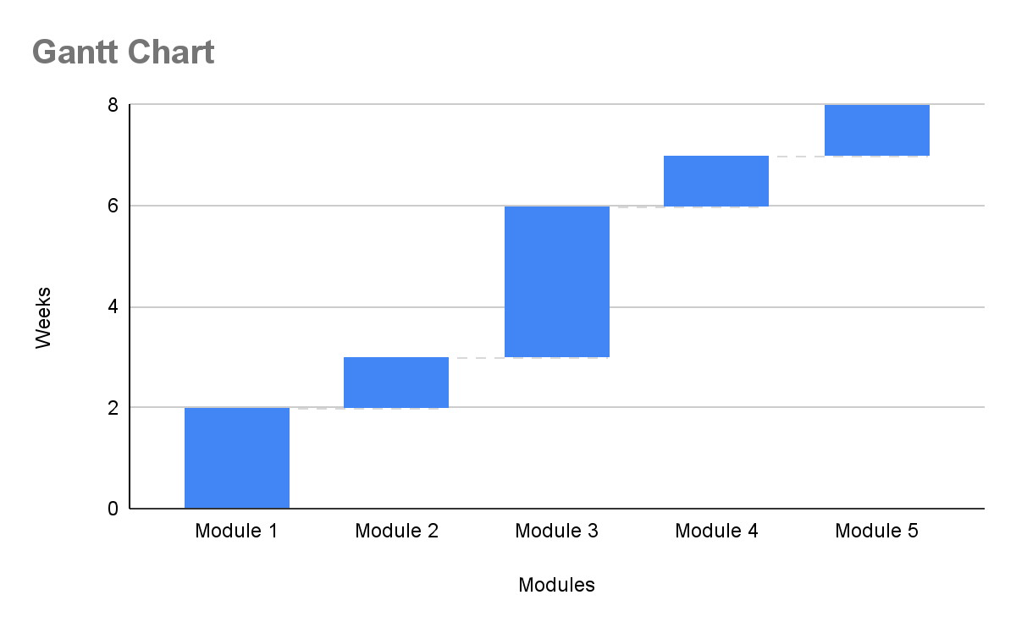

**REFERENCES**

* NodeJS Introduction [Internet]. Tutorialspoint.com. Available from: <https://www.tutorialspoint.com/nodejs/nodejs_introduction.html>
* JavaScript [Internet]. Mozilla.org. Available from: <https://developer.mozilla.org/en-US/docs/Web/JavaScript>
* E-commerce Application using MERN stack by Quang Nhat Mai
* MongoDB [Internet]. Mongodb.com. Available from: <https://docs.mongodb.com/manual/introduction/>
* <https://reactjsexample.com/e-commerce-website-using-the-mern-stack/>
* <https://github.com/topics/mern-ecommerce>
* <https://www.google.co.in/>
* <https://reactjs.org/>
* <https://www.w3schools.com/css/>
* <https://developer.mozilla.org/en-US/docs/Web/CSS>
* <https://www.youtube.com/watch?v=1rc2zYqexLI>
* <https://www.youtube.com/watch?v=HseGVOM85W4>