AICTE | IBM SkillsBuild
Data Analytics with AI Internship 2026 · BharatCares
PROJECT REPORT
KrishiNetra: AI-Powered Crop Recommendation using Data Analytics
Submitted by
Ayush Jha
B.Tech CSE (Cyber Security), Batch 2025–2029
Noida Institute of Engineering and Technology (NIET), Greater Noida
Enrollment No.: 0251CYS120
October 2026

Abstract
This report presents KrishiNetra ("eye of agriculture"), an AI crop advisor built on soil and weather data.
Selecting a crop that suits the soil and weather of a field is a central decision in agriculture. This project applies data analytics and machine learning to the Crop Recommendation dataset, which links seven measurable conditions (soil nitrogen, phosphorus, potassium, pH, temperature, humidity and rainfall) to the crop best suited to them. After cleaning and exploring the data, four engineered features were added and five classification models were compared using 5-fold cross-validation. A tuned Random Forest performed best, reaching 99.17% accuracy and a macro-F1 of 0.990 on a held-out test set (3 errors in 363 samples). Feature-importance analysis shows that humidity, rainfall and soil potassium and phosphorus are the main drivers of the recommendation. The approach can be embedded in low-cost IoT soil-sensing systems to give farmers data-driven crop advice.

1. Introduction

1.1 Background
Agriculture depends on matching crops to local conditions. Soil nutrient levels, acidity, temperature, humidity and rainfall all influence whether a crop will thrive. Farmers often rely on experience and tradition, which can be unreliable when climate patterns and soil health change. Data analytics and AI can learn these relationships from historical data and turn sensor readings into clear recommendations.

1.2 Problem statement
Given measurements of soil nutrients (N, P, K), soil pH and local climate (temperature, humidity, rainfall), predict the most suitable crop to cultivate.

1.3 Objectives
- Clean and validate a crop-suitability dataset.
- Explore how growing conditions differ between crops.
- Build and compare several machine-learning classifiers.
- Identify the factors that most influence the recommendation.
- Provide a reusable function that returns the top-3 recommended crops for a new field.

2. Dataset
The project uses the Crop Recommendation Dataset published on Kaggle (https://www.kaggle.com/datasets/atharvaingle/crop-recommendation-dataset). The notebook reads Crop_recommendation.csv if it is available locally and otherwise downloads a public GitHub mirror of the same data. The run documented in this report used the mirror, which contains 1815 records and 20 crops; the original Kaggle file has 2,200 records and 22 crops, so figures can differ slightly when it is used.
Column | Description | Unit
N | Nitrogen content in soil | ratio / kg per ha
P | Phosphorus content in soil | ratio / kg per ha
K | Potassium content in soil | ratio / kg per ha
temperature | Average temperature | °C
humidity | Relative humidity | %
ph | Soil pH | 0–14
rainfall | Rainfall | mm
label | Target: recommended crop | category

3. Tools and Technologies
- Python 3 and Jupyter Notebook for development.
- pandas and NumPy for data handling.
- Matplotlib and Seaborn for visualisation.
- scikit-learn for modelling, cross-validation, tuning and evaluation; joblib for saving the model.

4. Methodology

4.1 Data cleaning
Column types, missing values and duplicates were checked. Labels were standardised to lower case, and physical range checks confirmed that pH lies between 0 and 14 and humidity between 0 and 100. No missing values or duplicate rows were found, so all 1815 records were retained.

4.2 Exploratory data analysis
Crop frequency, feature distributions, correlations and per-crop condition profiles were examined (Section 5).

4.3 Feature engineering
Four features were derived from the originals: NPK_total (N+P+K), N_to_K and P_to_K (nutrient ratios, with +1 in the denominator to avoid division by zero) and moisture_index (humidity × rainfall / 100), which combines the two water-related variables.

4.4 Modelling and evaluation
The data was split 80/20 with stratification. Logistic Regression and KNN (with standard scaling), Decision Tree, Random Forest and Gradient Boosting were compared using 5-fold stratified cross-validation on the training set. The best family, Random Forest, was tuned with GridSearchCV over the number of trees, maximum depth and minimum samples per split, then evaluated once on the untouched test set using accuracy, macro-F1, a classification report and a confusion matrix.

5. Exploratory Data Analysis
The number of samples per crop is nearly balanced, with most crops having about 100 samples and a few having 60–96, so accuracy is a fair metric and macro-F1 is reported alongside it.
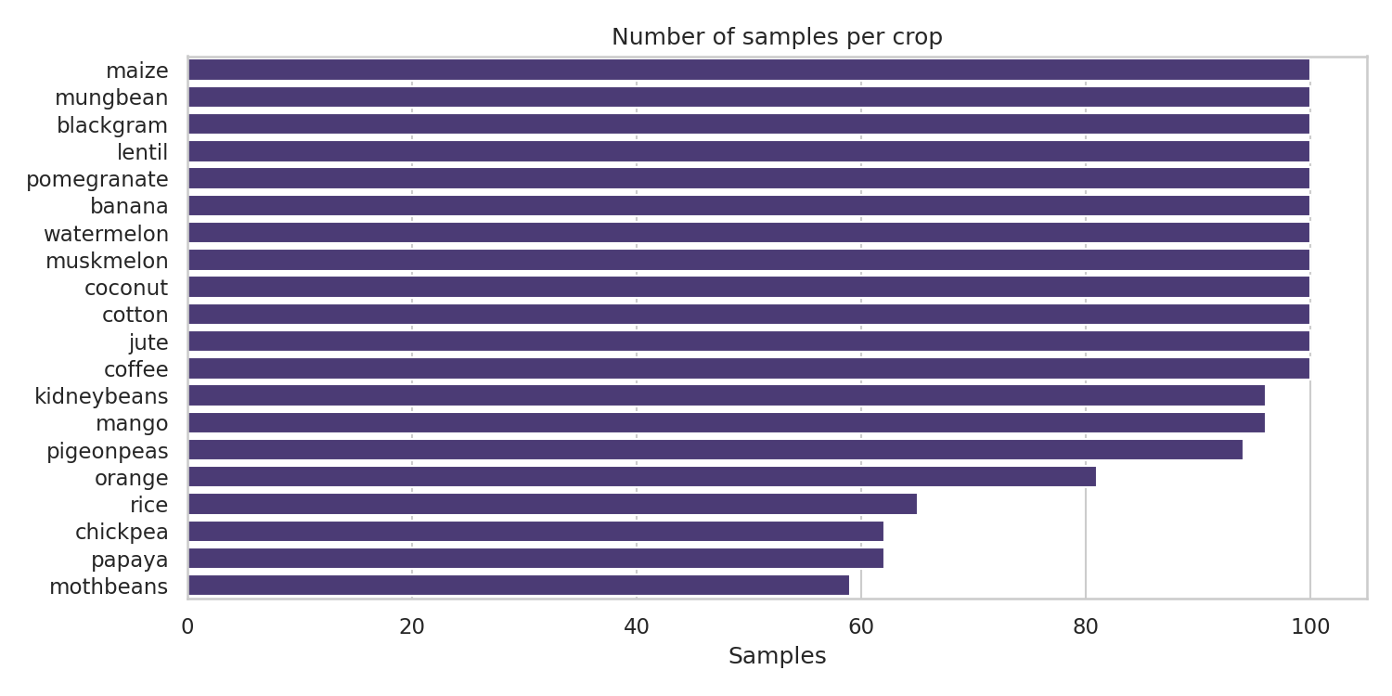
Figure 1: Number of samples per crop
Feature histograms show that each variable covers a wide range, which is useful because different crops occupy different parts of those ranges.
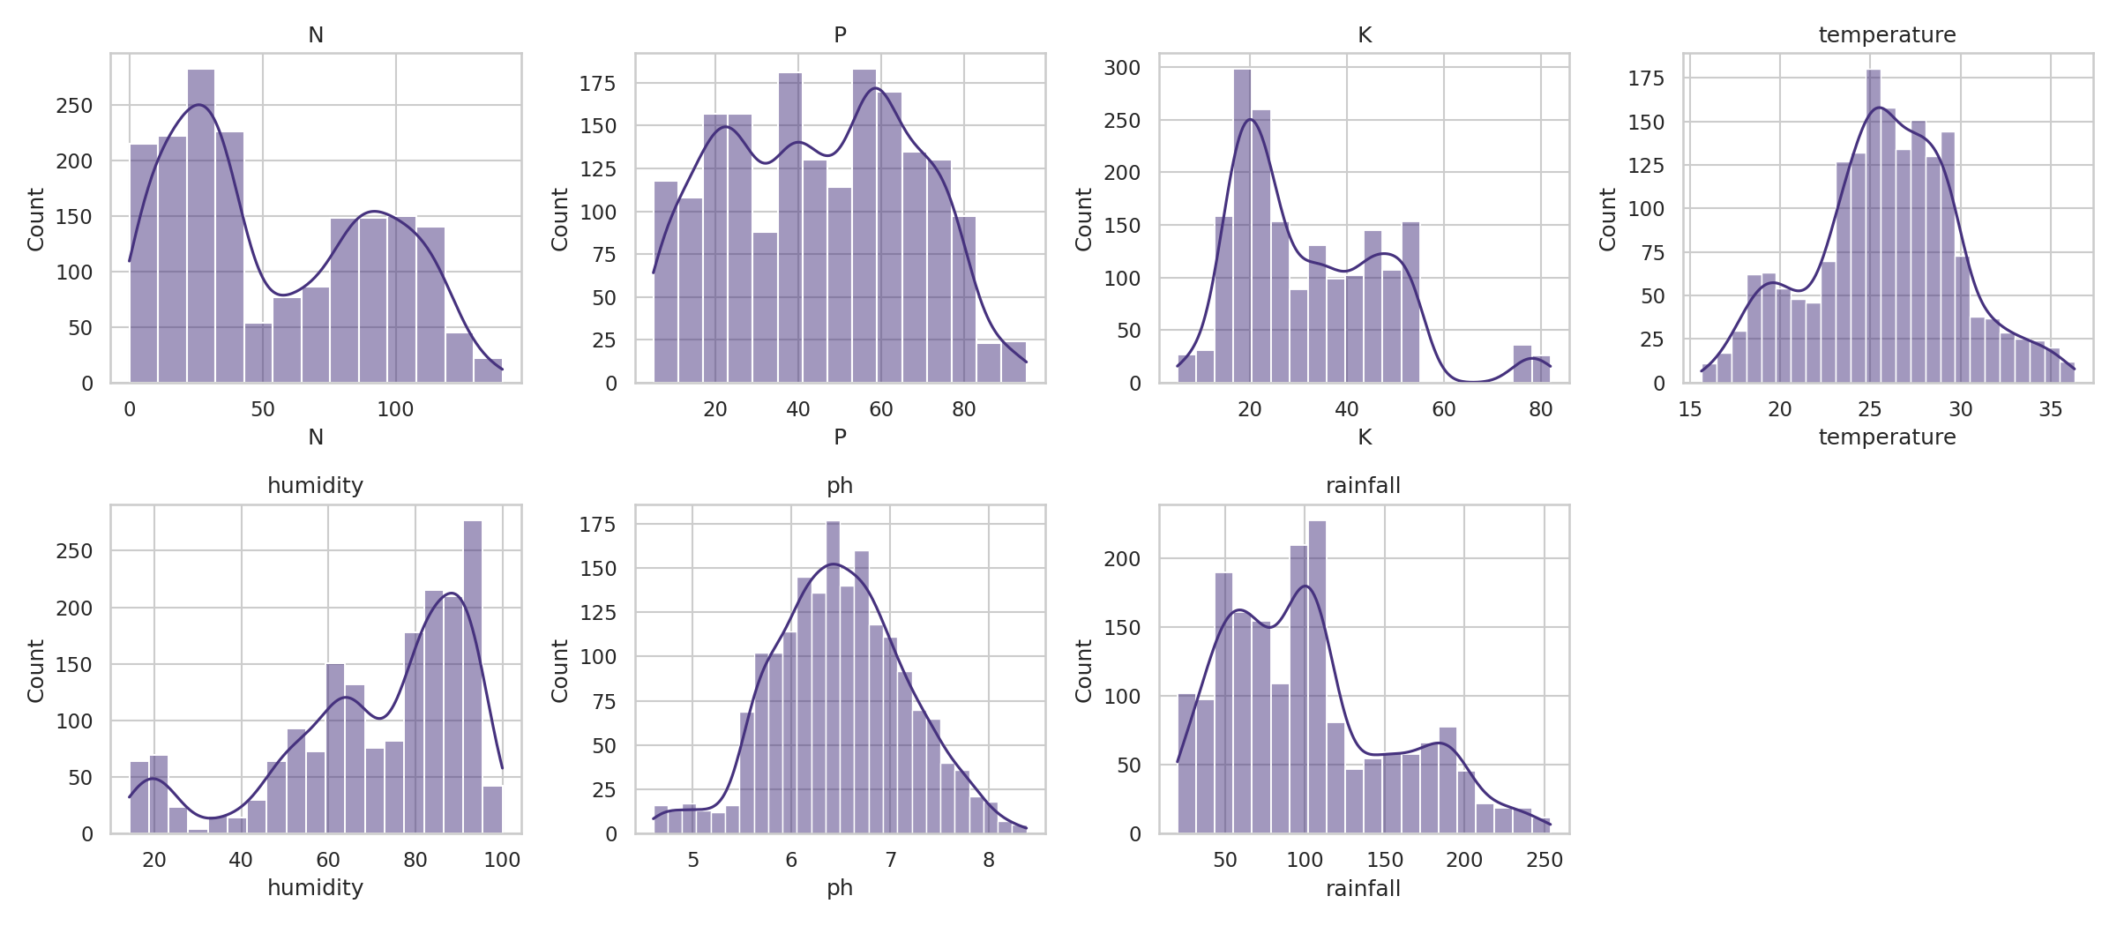
Figure 2: Distribution of the seven input features
Correlations between features are mostly weak. The strongest are humidity versus phosphorus (about -0.47) and nitrogen versus potassium (about 0.33), so the inputs carry largely independent information.
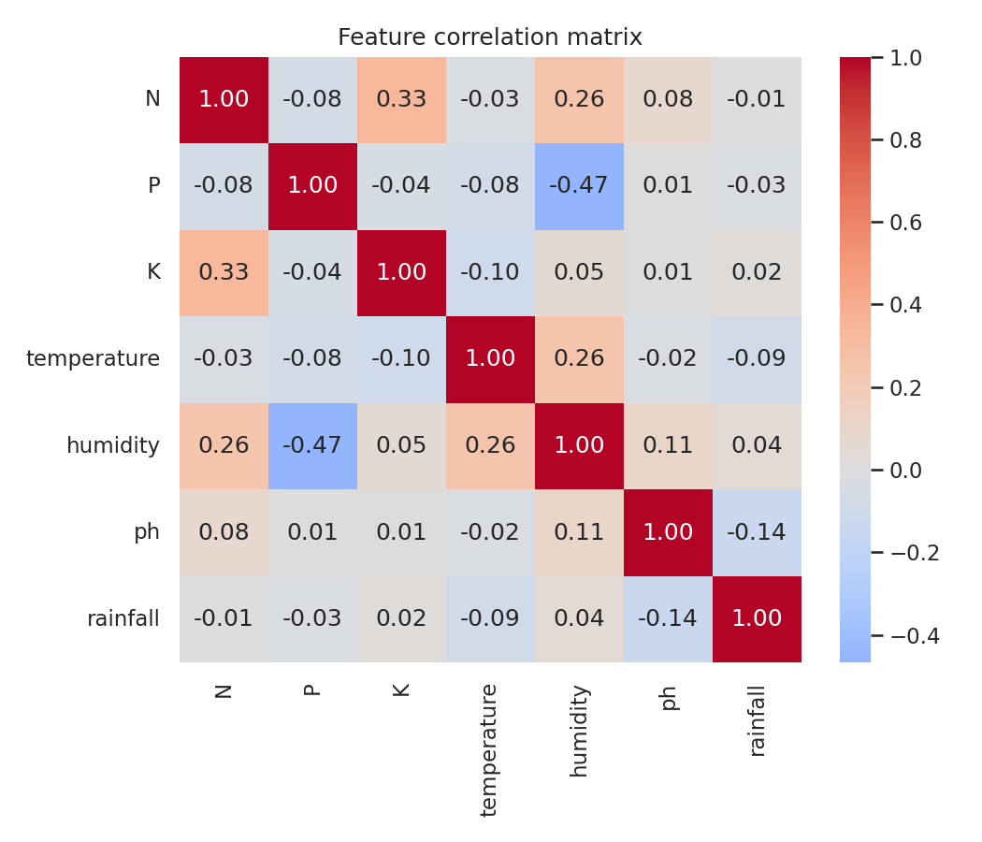
Figure 3: Feature correlation matrix
Box plots show clear separation between crops. For example, rice, jute and coconut grow in high-rainfall conditions, while chickpea, lentil and mothbeans are associated with much lower rainfall.
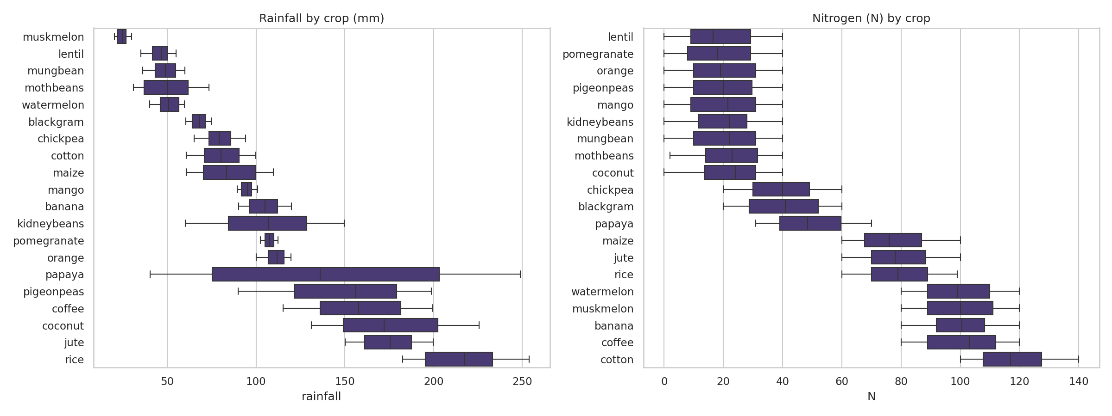
Figure 4: Rainfall and nitrogen by crop
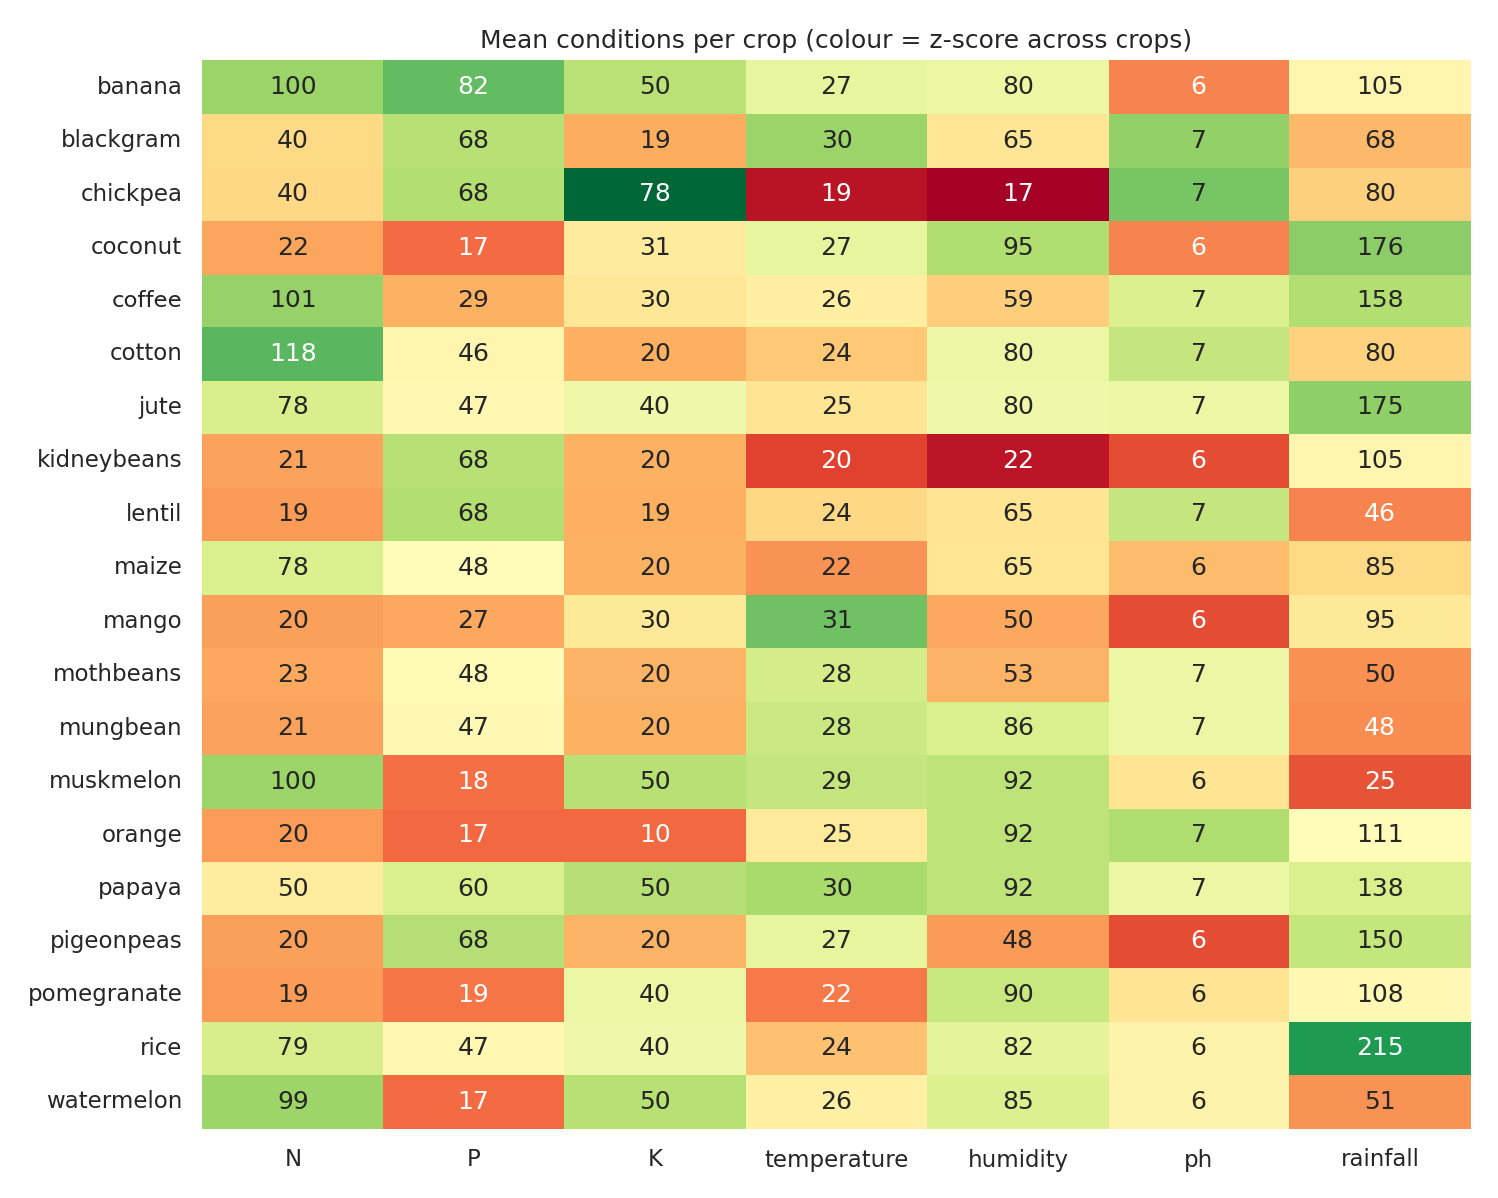
Figure 5: Mean growing conditions per crop

6. Model Results

6.1 Model comparison
Model | CV accuracy (mean) | CV std
Random Forest | 98.97% | 0.0081
Decision Tree | 97.38% | 0.0051
Gradient Boosting | 97.31% | 0.0080
Logistic Regression | 97.04% | 0.0060
KNN | 96.42% | 0.0035

All five models exceed 96% cross-validated accuracy, showing that the conditions are highly informative. Random Forest is the strongest and the most stable-performing choice, so it was selected for tuning.
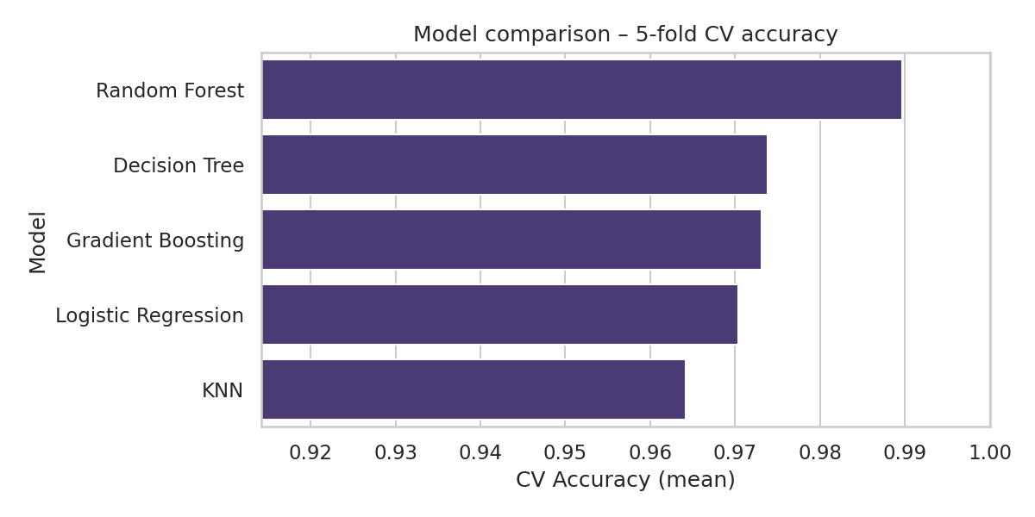
Figure 6: Cross-validation accuracy of the compared models

6.2 Tuned model and test performance
The best parameters found were n_estimators = 200, max_depth = None (unlimited) and min_samples_split = 4. On the held-out test set the model achieved an accuracy of 99.17% and a macro-F1 of 0.990, with 3 misclassified samples out of 363.
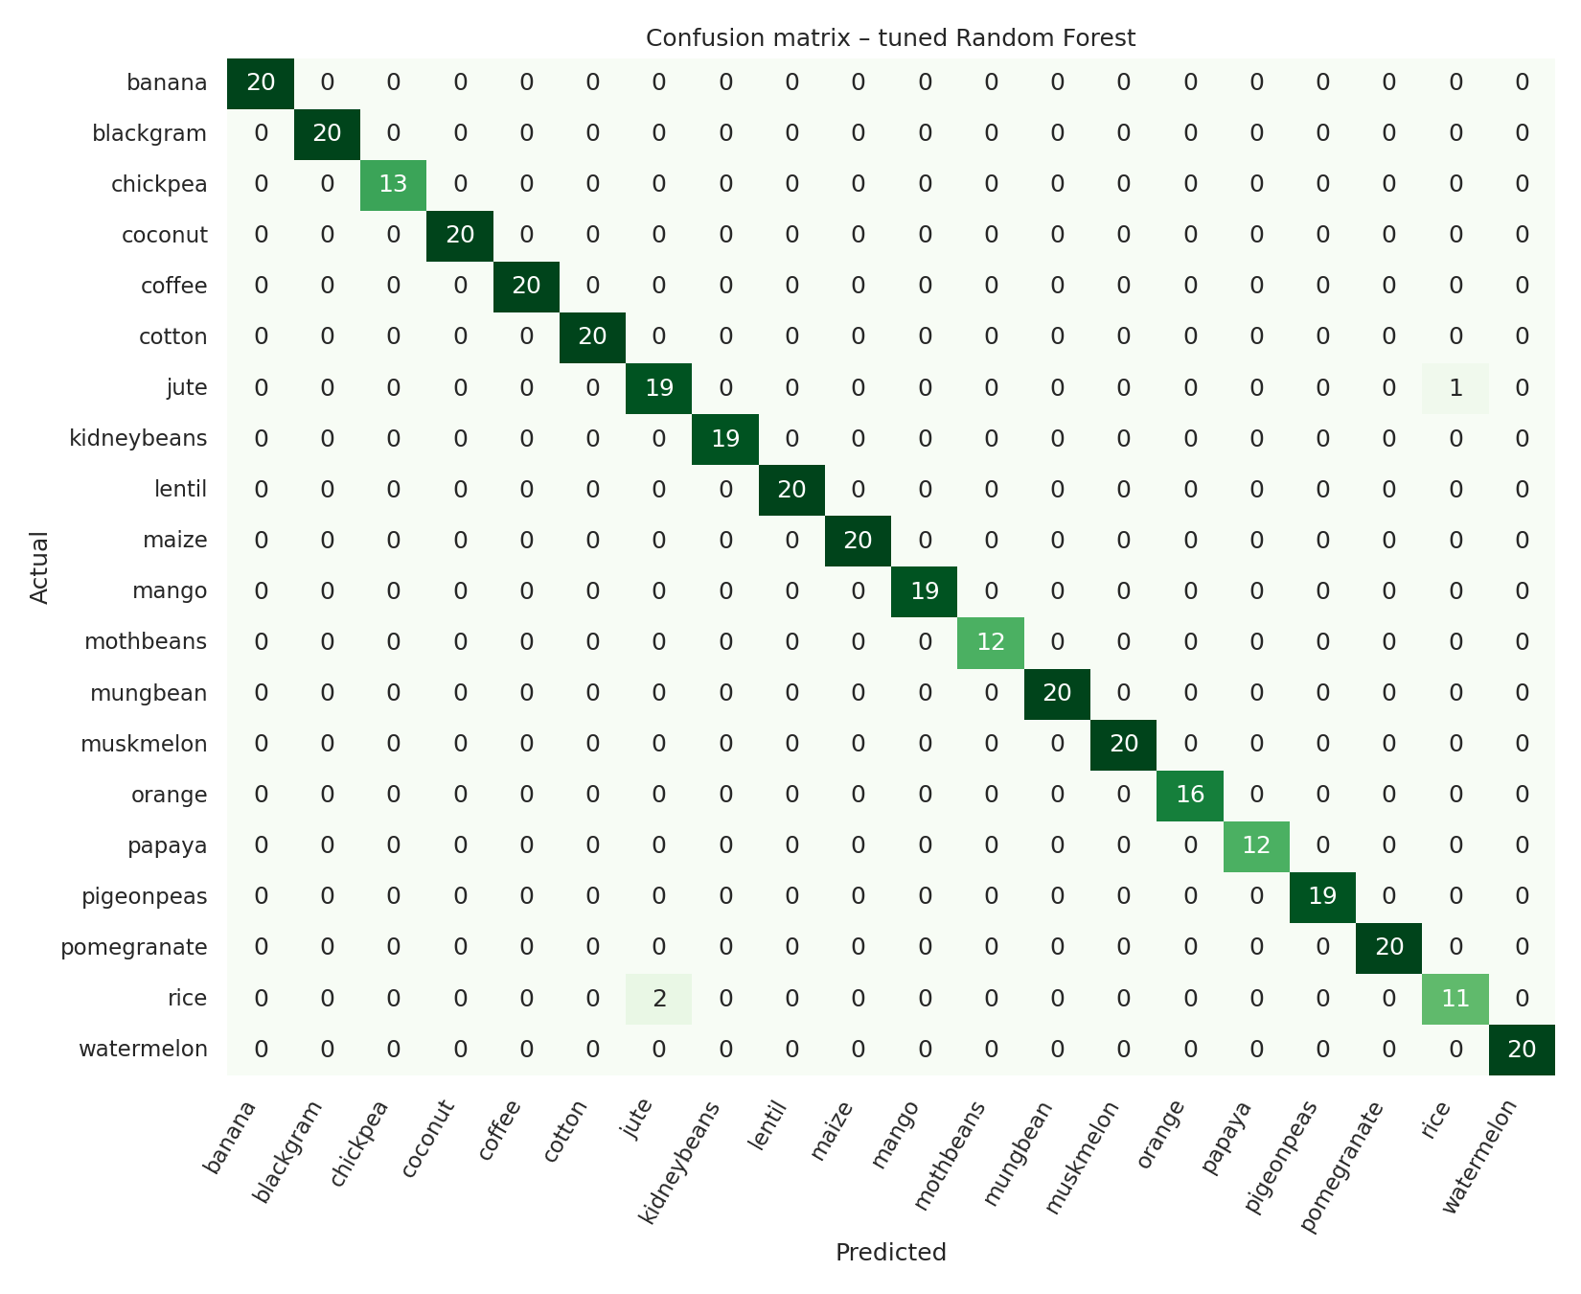
Figure 7: Confusion matrix on the test set
All errors occurred between rice and jute (two rice samples predicted as jute and one jute sample predicted as rice). Both crops are grown in warm, humid, high-rainfall conditions, which explains the overlap.

6.3 Feature importance
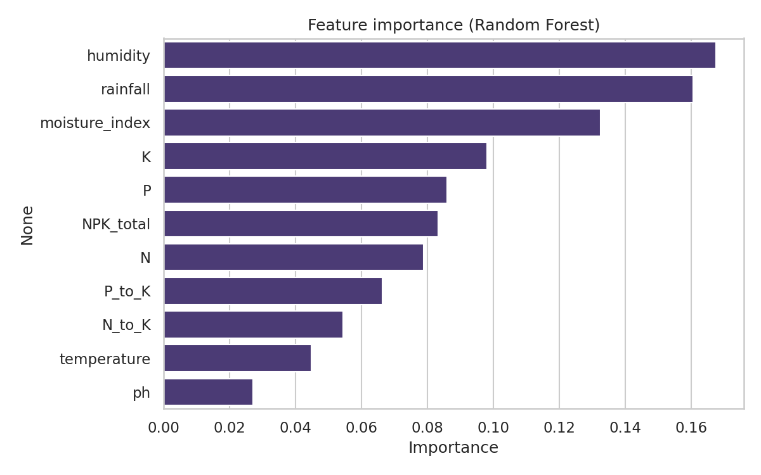
Figure 8: Random Forest feature importance
The most influential features were humidity (0.168), rainfall (0.161), the engineered moisture_index (0.132), potassium (0.098) and phosphorus (0.086). The engineered moisture index ranks among the top three, which supports the value of the feature-engineering step.

6.4 Crop recommendation function
The notebook includes recommend_crop(N, P, K, temperature, humidity, ph, rainfall), which returns the three most probable crops with their probabilities. Returning several options is more useful to a farmer than a single answer, because agronomically similar crops can be hard to separate.

7. Conclusion
This project shows that soil nutrient and weather data can identify a suitable crop with very high accuracy. A tuned Random Forest reached 99.17% test accuracy, and the analysis highlights humidity, rainfall and potassium and phosphorus levels as the key drivers. These are quantities that a low-cost IoT soil and weather sensor can measure, so the approach is practical for precision-agriculture applications.

8. Limitations and Future Work
- The dataset is clean and curated; real field data contains sensor noise, missing readings and seasonal variation, so accuracy will likely be lower in the field.
- The run used a public mirror with 20 crops; results on the full Kaggle file may differ slightly.
- Market price, yield and soil type are not modelled.
- Future work: integrate live IoT sensor readings, add yield and price data, validate on local field data, and deploy the model as a web or mobile app for farmers.

9. References
- Ingle, A. Crop Recommendation Dataset. Kaggle. https://www.kaggle.com/datasets/atharvaingle/crop-recommendation-dataset
- Pedregosa, F. et al. Scikit-learn: Machine Learning in Python. Journal of Machine Learning Research, 12, 2011.
- Breiman, L. Random Forests. Machine Learning, 45(1), 2001.
- pandas, Matplotlib and Seaborn documentation.

