**Introduction**

Project Management System is a system where students will be able to submit their project proposal, report, slides and demo and respective supervisor and the college will be able to review and verify them.

It automates the back-and-forth supervisor visit for review. College will also be able to keep track of students' progress and give feedback.

**Problem Statement**

Colleges are facing difficulty in keeping track of student project progress. Junior students do not have proper reference for projects.

**Objectives**

The objectives of this project are:

* To automate project review and supervision.
* To give Junior students a platform where they can take reference for their projects.

**Scope and Limitations**

Project management system will have a CMS for both students and supervisors, which provides all the information efficiently and in a managed way.

* The system will be accessible to the all people associated with college.
* The system will allow for faster communication between students and their supervisors.

**Limitations**

* Authenticity of project cannot be determined.
* The system will not be available offline.

**Methodology**

This project follows waterfall approach. Since the requirements are predefined, and each part are processed, reviewed, and completed one at a time project time is short, waterfall model is suitable for this project.

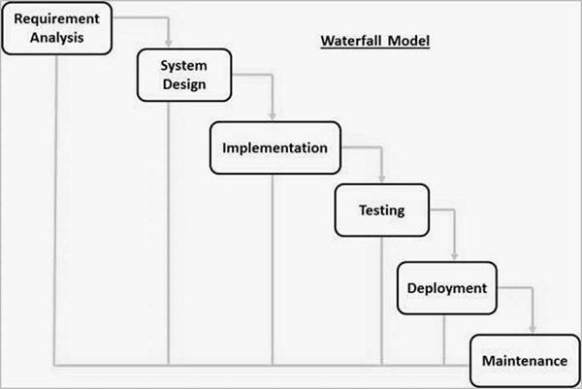

**Expected Outcome:**

College and Teachers will be able to supervise and keep track of student’s projects. Student will be able to submit their reports and get feedback from assigned supervisor. Other students will also be able to take reference from those submitted reports.