Problem 1

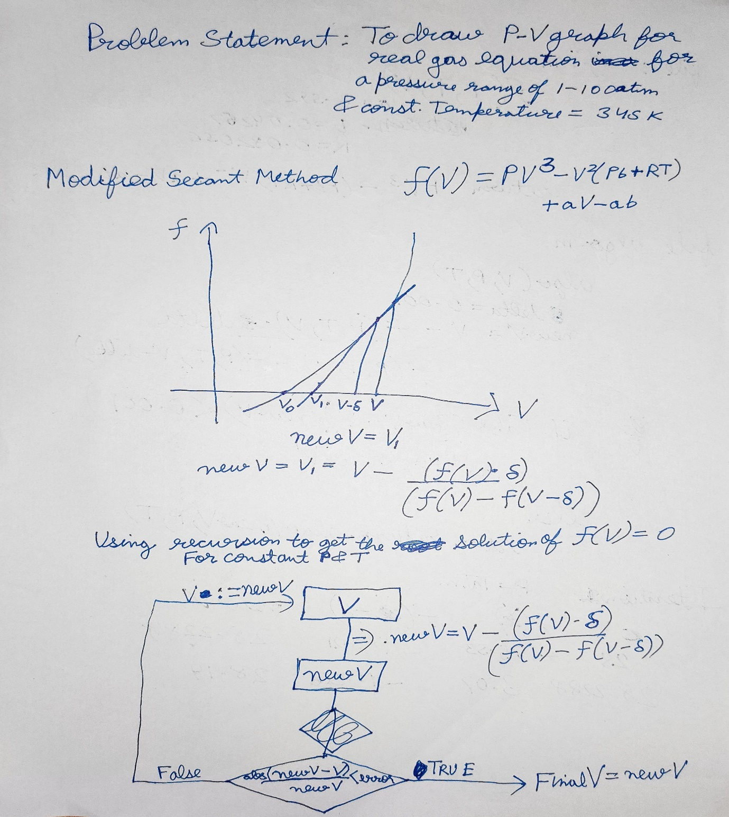

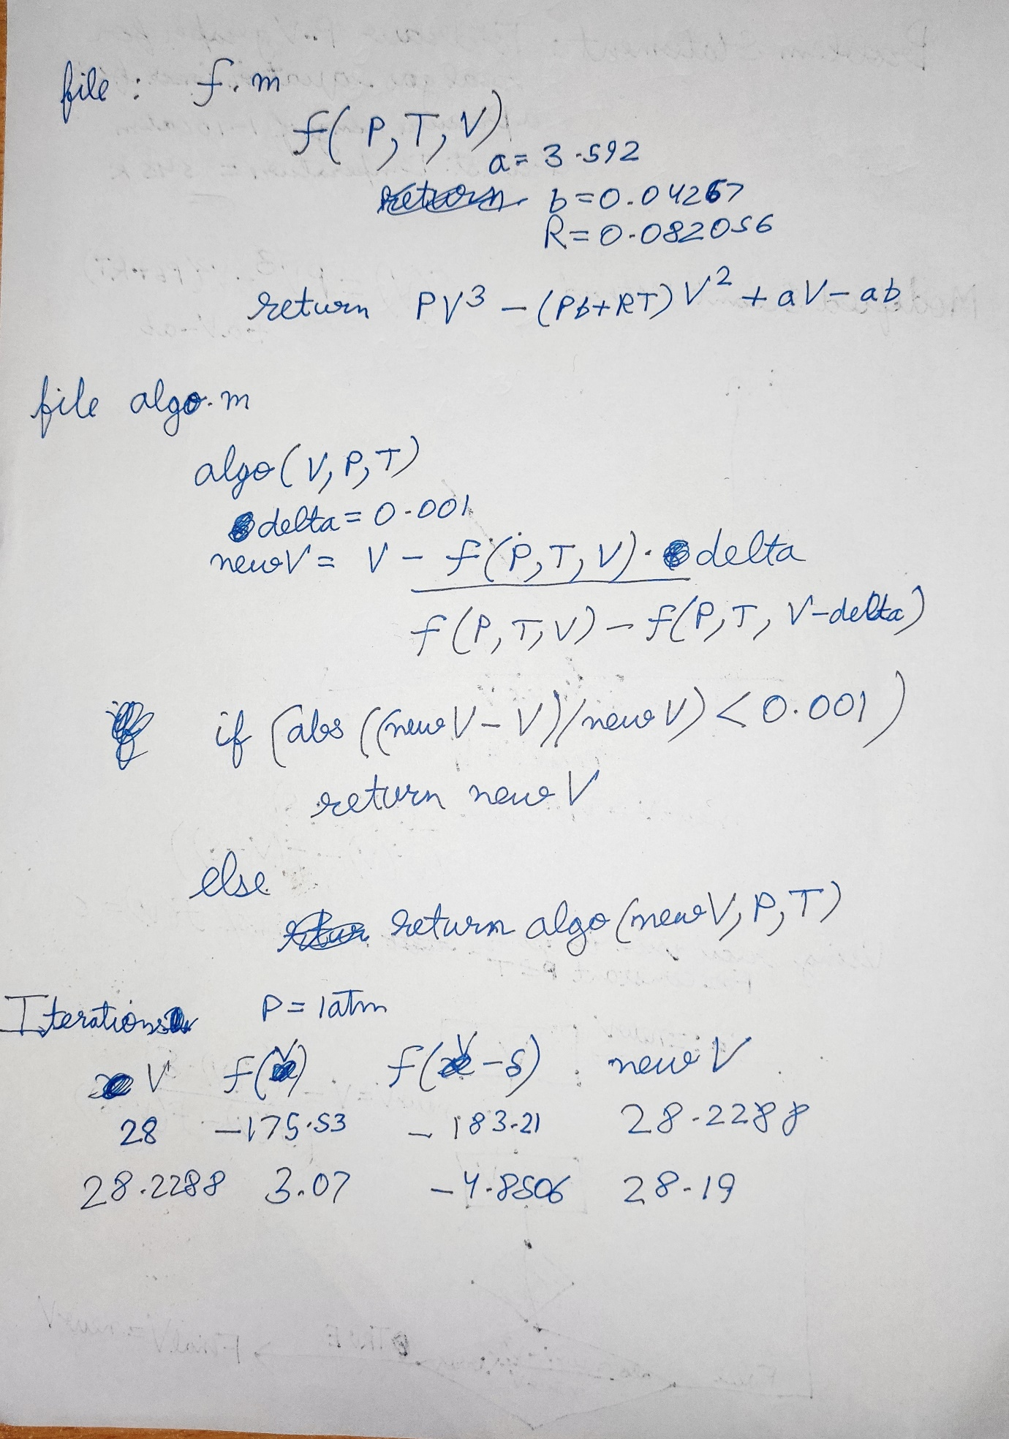

# MATLAB CODE

<f.m>

function val = f(P,T,V)

a = 3.592;

b = 0.04267;

R = 0.082056;

val = P*V^3 - (P*b+R*T)*V^2 +a*V -a*b;

return

end

<algo.m>

function result = algo(V,P,T)

delta = 0.01;

newV = V - (f(P,T,V)*delta)/(f(P,T,V)-f(P,T,V-delta));

if abs((newV- V)/newV) <= 0.00001

result = newV;

return

else

result = algo(newV,P,T);

return

end

<main.m>

P = 1:1:100;

V = P;

T=345;

v1 = input("guess number");

for i =P

V(i)= algo(v1,P(i),T);

end

V

plot(P,V)

