Q. To determine the inverse of a matrix A using LU decomposition method followed by forward and back substitution.

A =[

9 -4 1 0 0 0 0 0 0 0 0 0 0 0 0

-4 6 -4 1 0 0 0 0 0 0 0 0 0 0 0

1 -4 6 -4 1 0 0 0 0 0 0 0 0 0 0

0 1 -4 6 -4 1 0 0 0 0 0 0 0 0 0

0 0 1 -4 6 -4 1 0 0 0 0 0 0 0 0

0 0 0 1 -4 6 -4 1 0 0 0 0 0 0 0

0 0 0 0 1 -4 6 -4 1 0 0 0 0 0 0

0 0 0 0 0 1 -4 6 -4 1 0 0 0 0 0

0 0 0 0 0 0 1 -4 6 -4 1 0 0 0 0

0 0 0 0 0 0 0 1 -4 6 -4 1 0 0 0

0 0 0 0 0 0 0 0 1 -4 6 -4 1 0 0

0 0 0 0 0 0 0 0 0 1 -4 6 -4 1 0

0 0 0 0 0 0 0 0 0 0 1 -4 6 -4 1

0 0 0 0 0 0 0 0 0 0 0 1 -4 5 -2

0 0 0 0 0 0 0 0 0 0 0 0 1 -2 1

]

Work Flow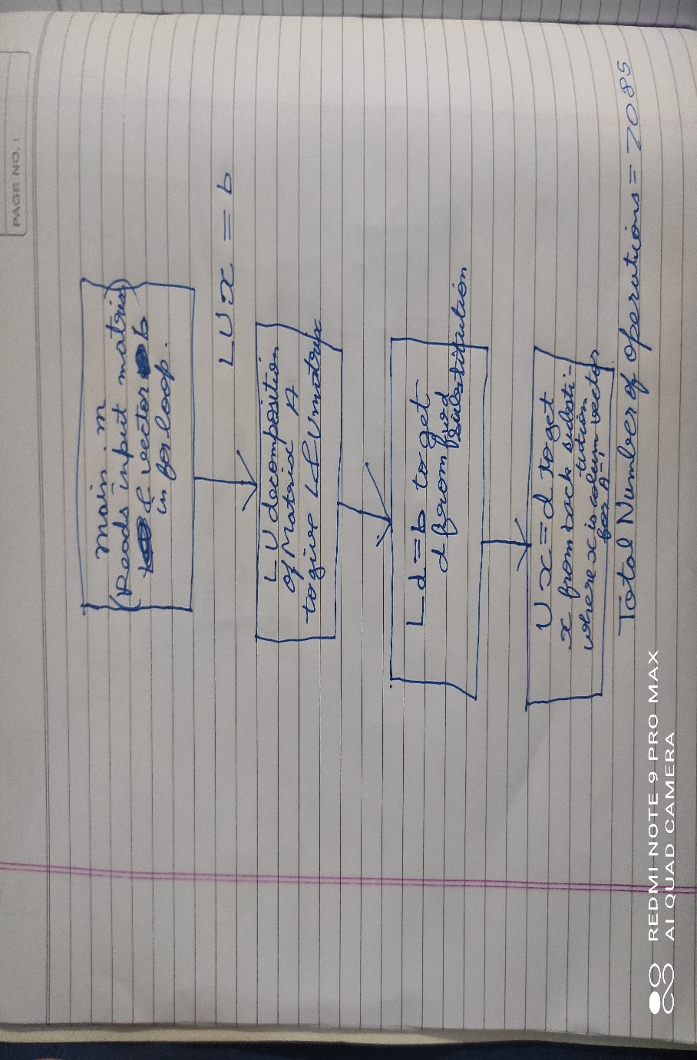



MATLAB code

Main.m file

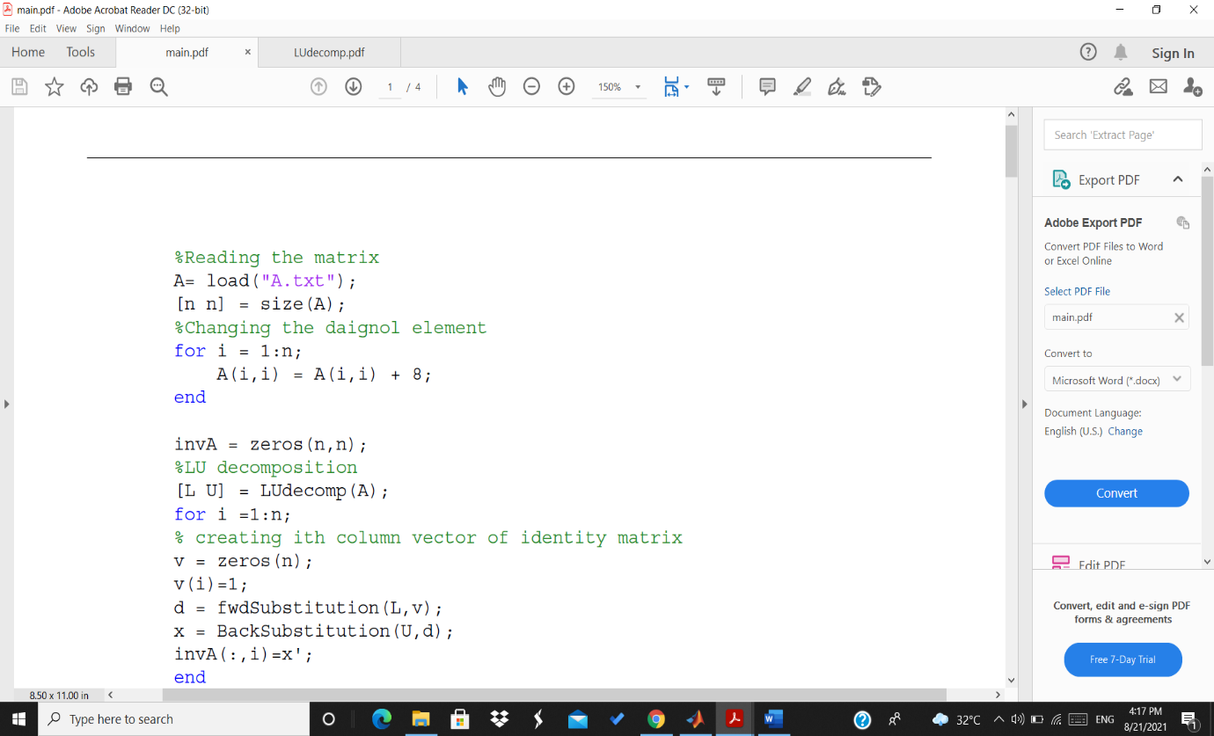

LUdecomp.m file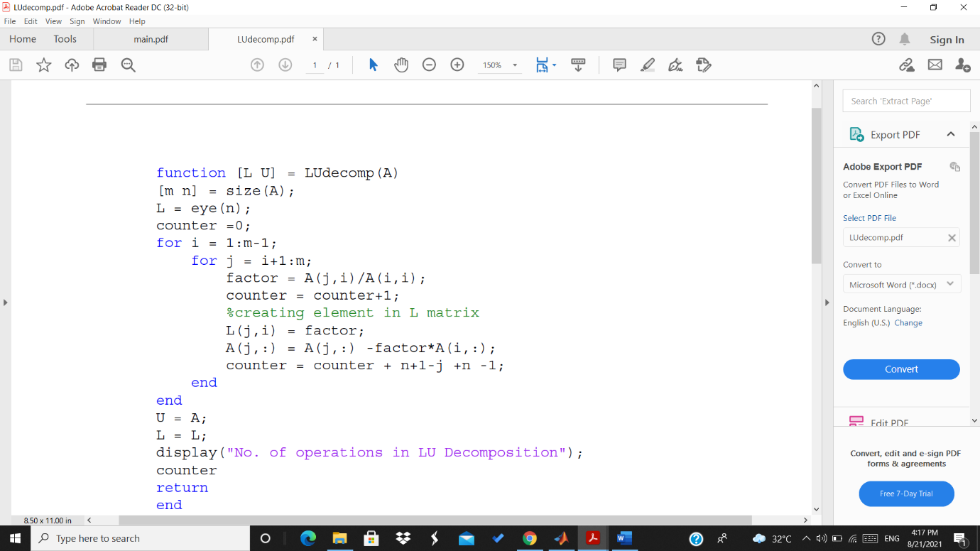

fwdSubstitution.m file

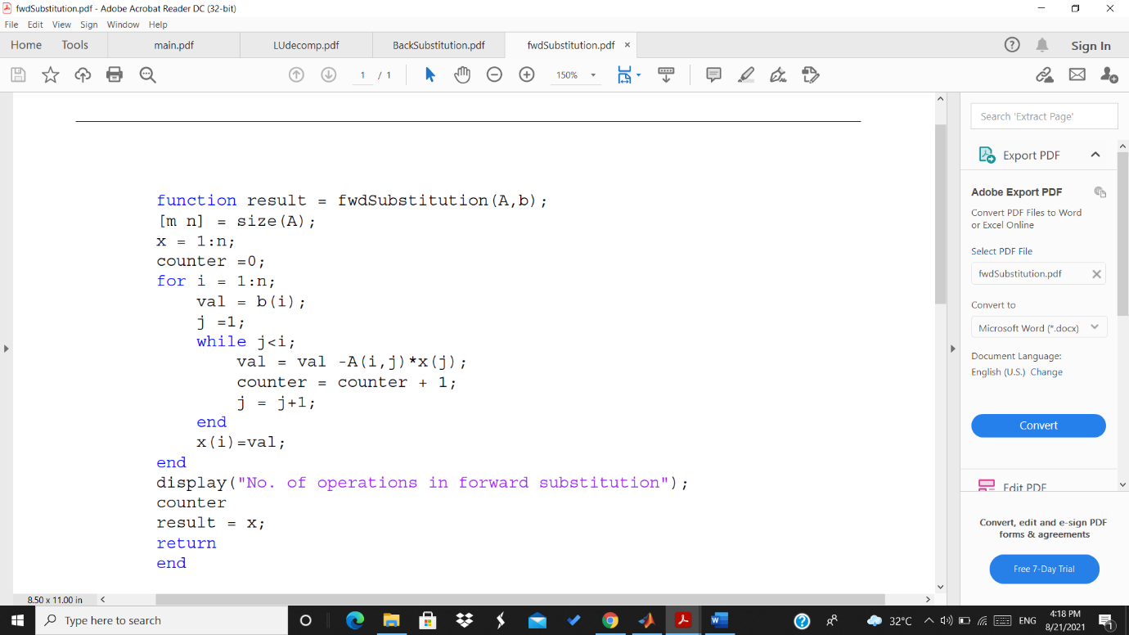

BackSubstitution.m file

