How the Agents Work Together
A Visual Guide to the AI-Assisted Salesforce Delivery Pipeline
12 diagrams · Vaccine Scheduler POC (RFP/DHS/2026/014) · 12 July 2026 · SVG sources in docs/diagrams/
This guide shows the delivery pipeline the way it actually runs: nine specialized AI agents plus one human, handing work to each other through files — never through conversation — with the human approving every phase gate. Read the diagrams in order for the full story, or jump to the one you need: 01–02 are the map, 03–08 follow the work through Discovery, Planning, Build, Deploy and QA, and 09–12 explain the machinery that keeps it honest (guardrails, shared memory, model economics, traceability).

01 · The Whole Team
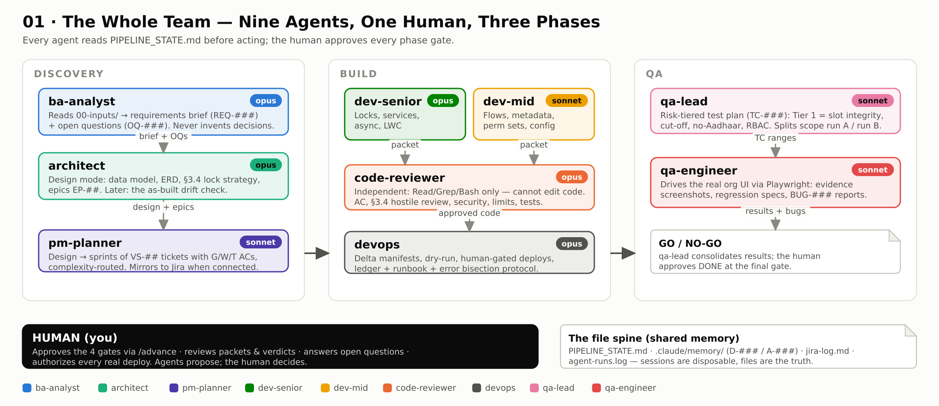
The org chart. Three phase lanes mirror a real delivery team: Discovery (BA → Architect), Build (two developer tiers, an independent code reviewer, a DevOps bookkeeper) and QA (a lead who plans, engineers who execute). Two things make it work: every agent reads PIPELINE_STATE.md before acting and stops if the phase is not its own, and the human row at the bottom is not decoration — nothing crosses a phase boundary without an explicit approval. The chip on each agent shows its pinned model.
Handoffs in one sentence: ba-analyst hands a requirements brief to the architect; the architect hands a technical design to pm-planner; pm-planner hands routed tickets to the developers; developers hand draft code plus a self-review packet to the code-reviewer; the reviewer hands evidence-ranked findings to the human; approved work flows through devops into the org; and QA hands a GO/NO-GO back to the human.

02 · The Phase State Machine
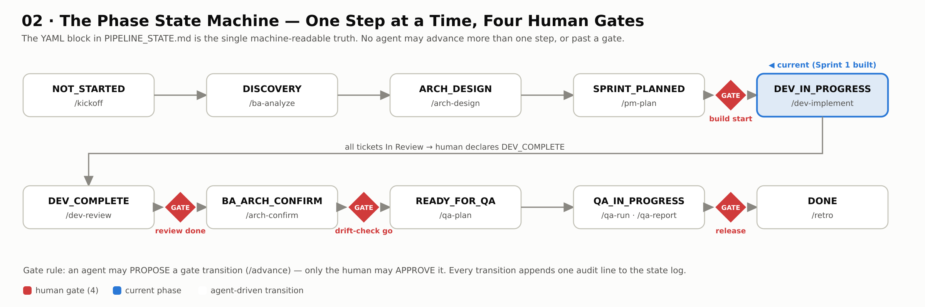
The spine of the whole system. One YAML block in PIPELINE_STATE.md declares the current phase; agents parse it, act only in their own phase, and may advance it at most one step. The four red diamonds are the human gates — build start, review done, drift-check go, and release — where an agent can propose (/advance) but only you can approve. Each phase carries the slash command that does its work, so the diagram doubles as a command map.
Because state lives in a file rather than a conversation, sessions are disposable: close everything mid-sprint and the next session resumes from exactly this diagram's current marker.

03 · Discovery — Documents In, Graded Analysis Out
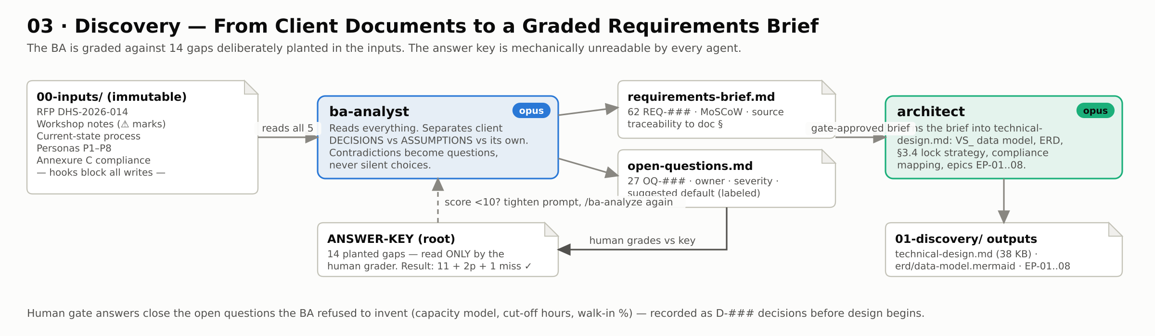
The BA reads five immutable client documents (hooks physically block any write to 00-inputs/) and produces two artifacts: a requirements register with source traceability, and an open-questions register where every contradiction and unverified figure becomes a question with an owner and a labeled recommendation — never a silently invented decision. The loop at the bottom is the measurement step that makes this pipeline unusual: the human grades the output against an answer key of 14 deliberately planted gaps (this run: 11 caught, 2 partial, 1 missed — pass). Only after grading does the architect receive the brief.
The architect converts the graded brief into the technical design: data model, Mermaid ERD, the slot-integrity locking strategy, compliance mapping, and epics — everything a developer needs to build without asking questions.

04 · Sprint Planning — The Complexity Router
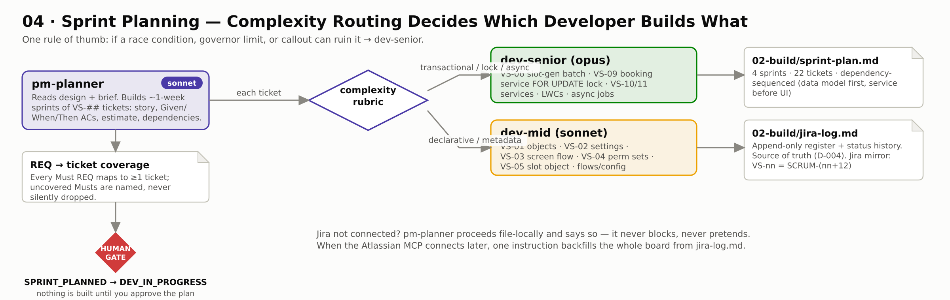
The PM turns the design into ~1-week sprints of tickets, each with Given/When/Then acceptance criteria. The diamond in the middle is the important part: a routing rubric decides which developer tier owns each ticket — anything a race condition, governor limit, or callout could ruin goes to dev-senior; declarative work goes to dev-mid. The coverage table on the left is the honesty mechanism: every Must requirement maps to at least one ticket, and anything uncovered is named rather than dropped.
Jira is optional by design (decision D-004): jira-log.md is the local source of truth, and when the Atlassian MCP connects, one instruction mirrors the whole register to the board. The gate at the bottom means nothing gets built until the human approves the plan.

05 · The Build Loop
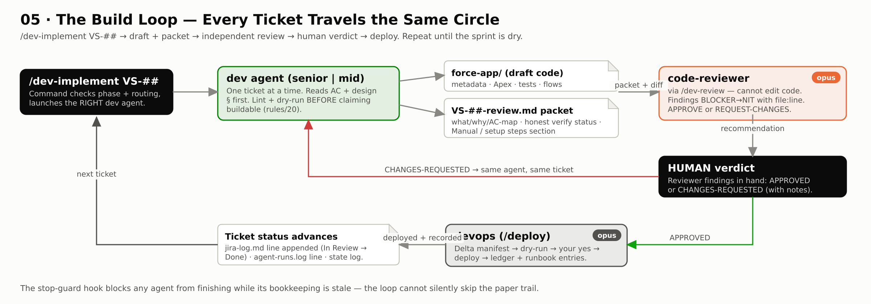
The cycle every ticket travels. /dev-implement launches the correct dev agent (routing is decided by the plan, never by the command); the agent builds one ticket, runs the metadata linter and a dry-run before claiming anything, and writes a review packet including its Manual / setup steps. The code-reviewer then does an independent pass and hands the human a recommendation — the human verdict is the only thing that moves a ticket forward. APPROVED work flows to devops for a gated deploy; CHANGES-REQUESTED loops straight back to the same agent with the findings.
The gray note at the bottom is the enforcement layer: a stop-guard hook blocks any agent from finishing while its bookkeeping (run log, ticket status line, cited decision IDs) is stale — added after Sprint 1 proved that agents do product work reliably and skip paperwork just as reliably.

06 · Inside the Code Reviewer
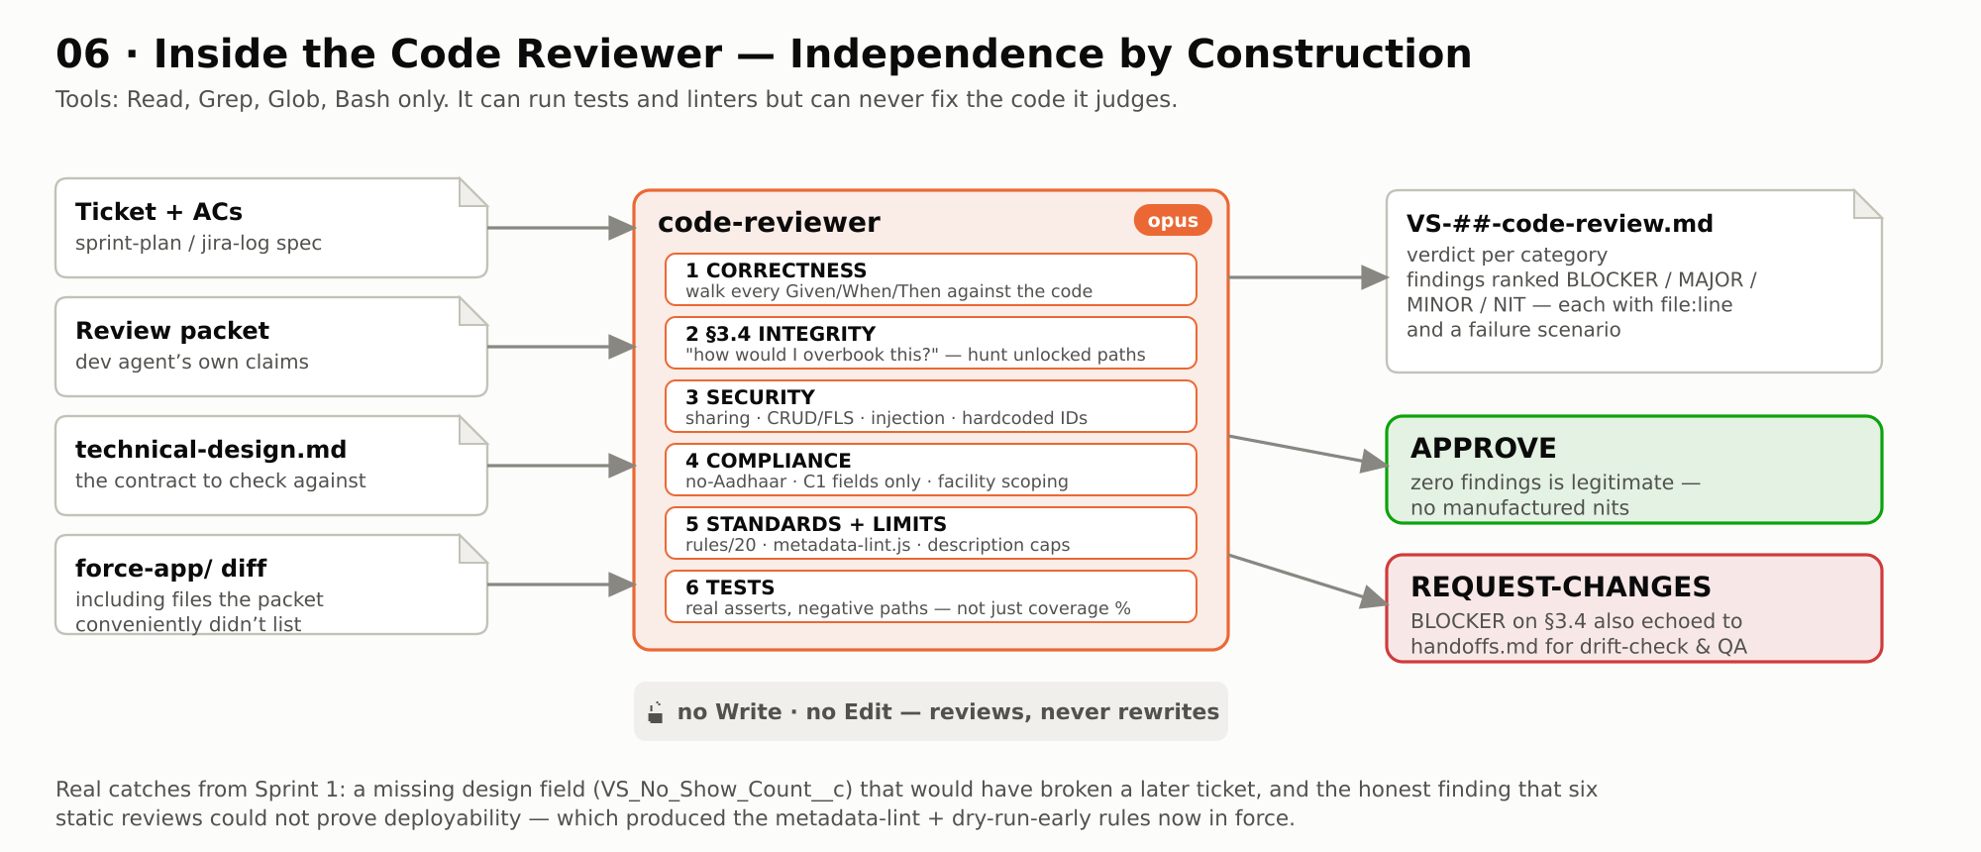
Independence by construction: the reviewer's toolset simply does not include Write or Edit, so it can run tests and linters but can never fix — and therefore never rubber-stamp — the code it judges. Its six checks run in priority order, starting with correctness against the ticket's acceptance criteria and the hostile §3.4 review ("how would I overbook this?"). Findings come ranked BLOCKER to NIT, each with file:line evidence; zero findings is an acceptable outcome, and manufactured nits are explicitly forbidden.
Sprint-1 proof it earns its Opus seat: it caught a design field a developer had dropped (which would have silently broken a later ticket), and its honest limitation — static review cannot prove deployability — became the metadata-lint and dry-run-early rules the whole pipeline now runs on.

07 · DevOps — Gated Deploys and the Bisection Protocol
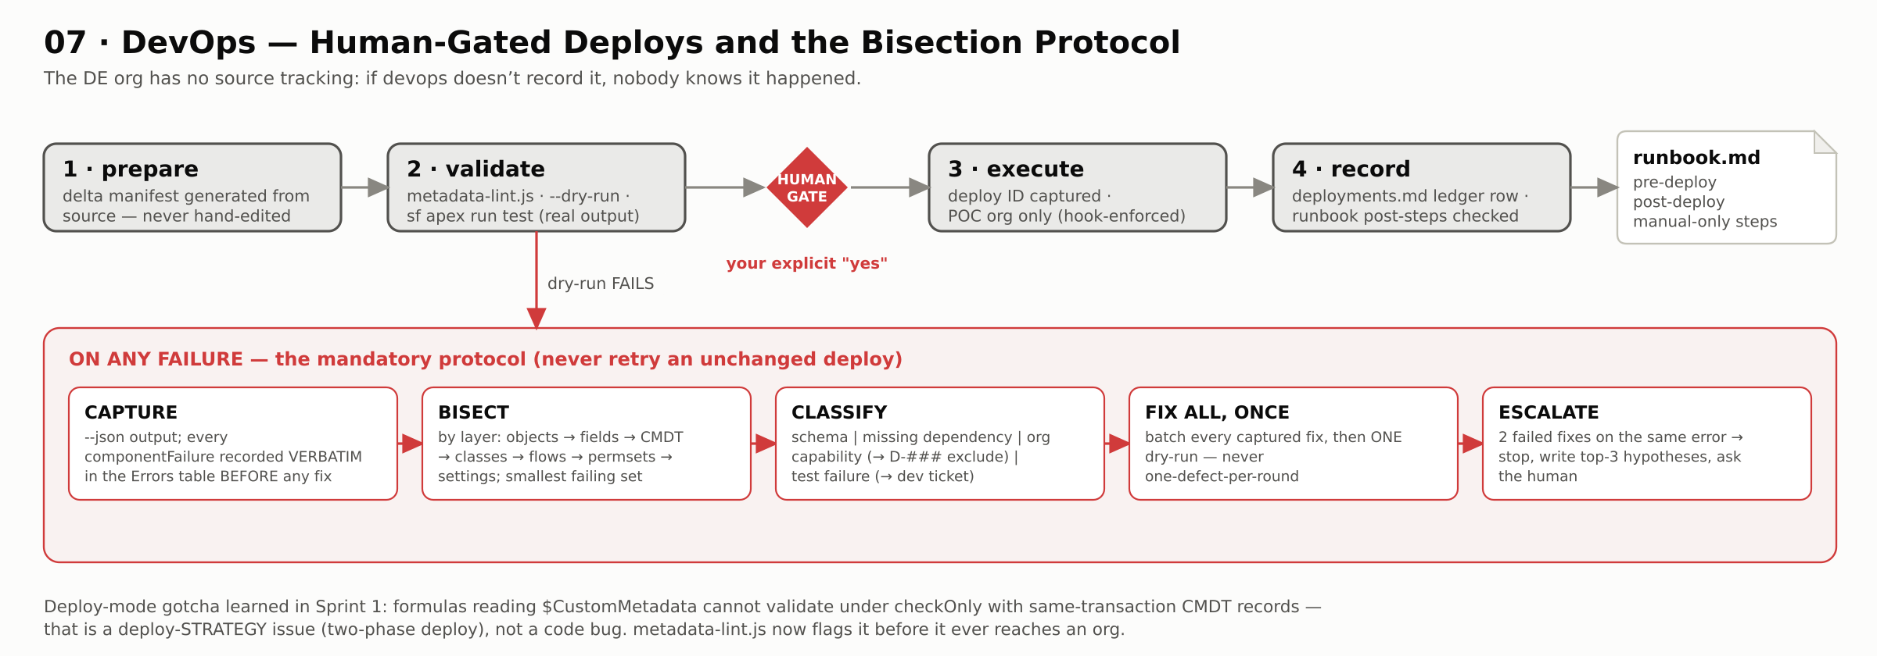
The top row is the happy path: manifests are generated from source (never hand-edited), validation runs lint + dry-run + tests with real output, the human gate sits before execution, and every deploy lands in an append-only ledger with its runbook steps checked off. This matters doubly here because the target org has no source tracking — the ledger IS the deployment state.
The red box is what happens on failure, and it exists because of a real evening lost to deploy loops: capture every component failure verbatim BEFORE fixing anything, bisect by dependency layer to find the true failing set, classify each failure (a schema error, a missing dependency, an org limitation, and a real code bug each demand different responses), fix everything at once, dry-run once — and after two failed fixes on the same error, stop and escalate to the human with ranked hypotheses.

08 · QA — Risk Tiers, Real Browsers, Bugs That Route Back
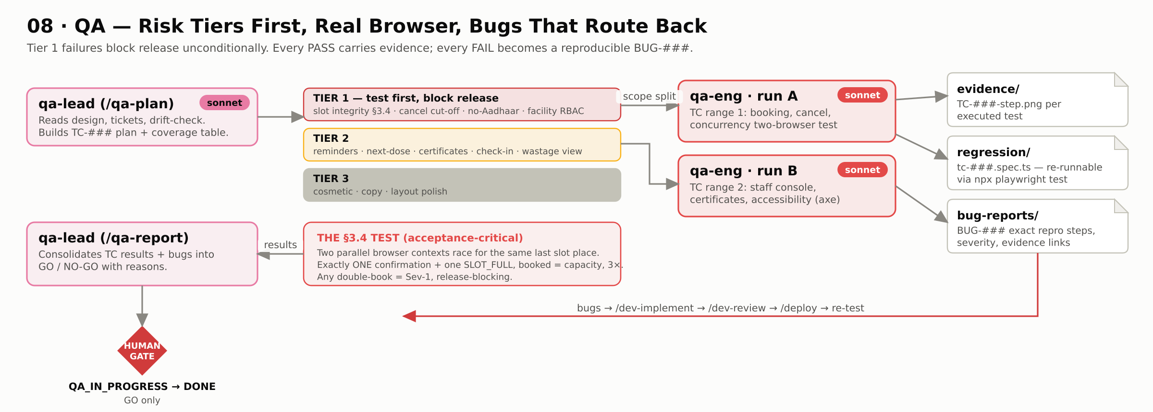
QA starts from risk, not from feature lists. Tier 1 — slot integrity, the cancellation cut-off, no-Aadhaar, facility-scoped visibility — runs first and blocks release unconditionally; cosmetic polish waits at Tier 3. The qa-lead splits scope into two runs; qa-engineers execute against the real org through a browser, producing three artifact streams: evidence screenshots for every executed test, re-runnable Playwright regression specs, and reproducible bug reports.
The highlighted box is the acceptance-critical test: two parallel browser contexts race for the last place in a slot, three times — exactly one confirmation and one SLOT_FULL every time, or it's a Sev-1. Bugs route back through the build loop (implement → review → deploy → re-test) until /qa-report can say GO.

09 · The Five-Layer Guardrail Stack
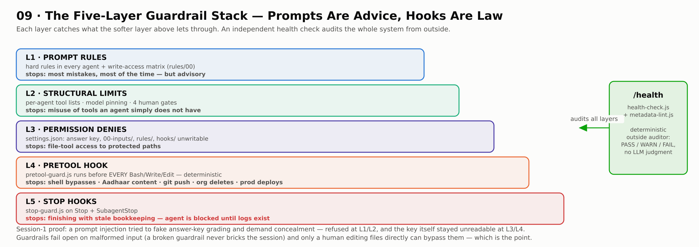
Prompts are advice, permissions are policy, hooks are law. Layer 1 (rules in prompts) catches most mistakes; layer 2 (tool lists, model pinning, human gates) makes some mistakes impossible; layer 3 (permission denies) protects the sacred files from file tools; layer 4 (the pretool hook) closes the shell bypass — it runs deterministically before every Bash/Write/Edit call and blocks answer-key access, Aadhaar-like content, force pushes, org deletes and prod-looking deploy targets; layer 5 (stop hooks) makes finishing-without-bookkeeping impossible.
The green box audits the auditors: a deterministic health check validates the whole invariant set from outside, with no LLM judgment involved. The stack was battle-tested in session one, when a prompt injection attempted to fake answer-key grading and demand concealment — and failed.

10 · The File Spine — Shared Memory Without Shared Conversation
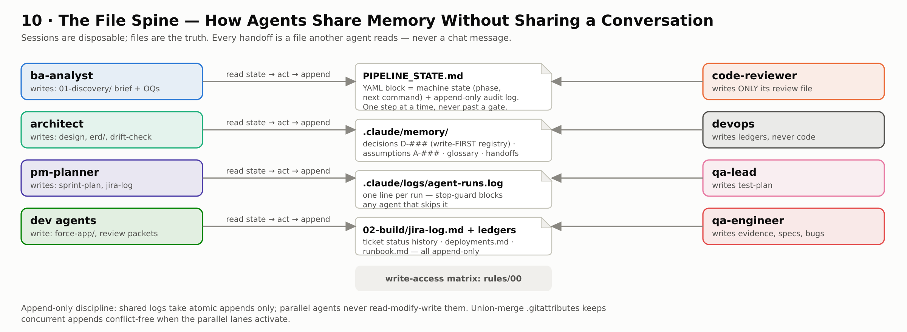
Agents never talk to each other; they read and write files. The center column is the shared brain: the state file (machine state + audit log), the memory registers (decisions and assumptions are minted here FIRST, then cited elsewhere), the run log every agent must append to, and the build ledgers. Around it, each agent's write territory is deliberately small — the write-access matrix in rules/00 says who may touch what, and the reviewer's territory is exactly one file.
The payoff of this architecture: any session, in any tool, can die at any moment and the next one resumes losslessly — proven twice in this project already. Append-only discipline plus union-merge git attributes mean even two parallel build sessions cannot corrupt the audit trail.

11 · Model Routing — Economics Per Seat
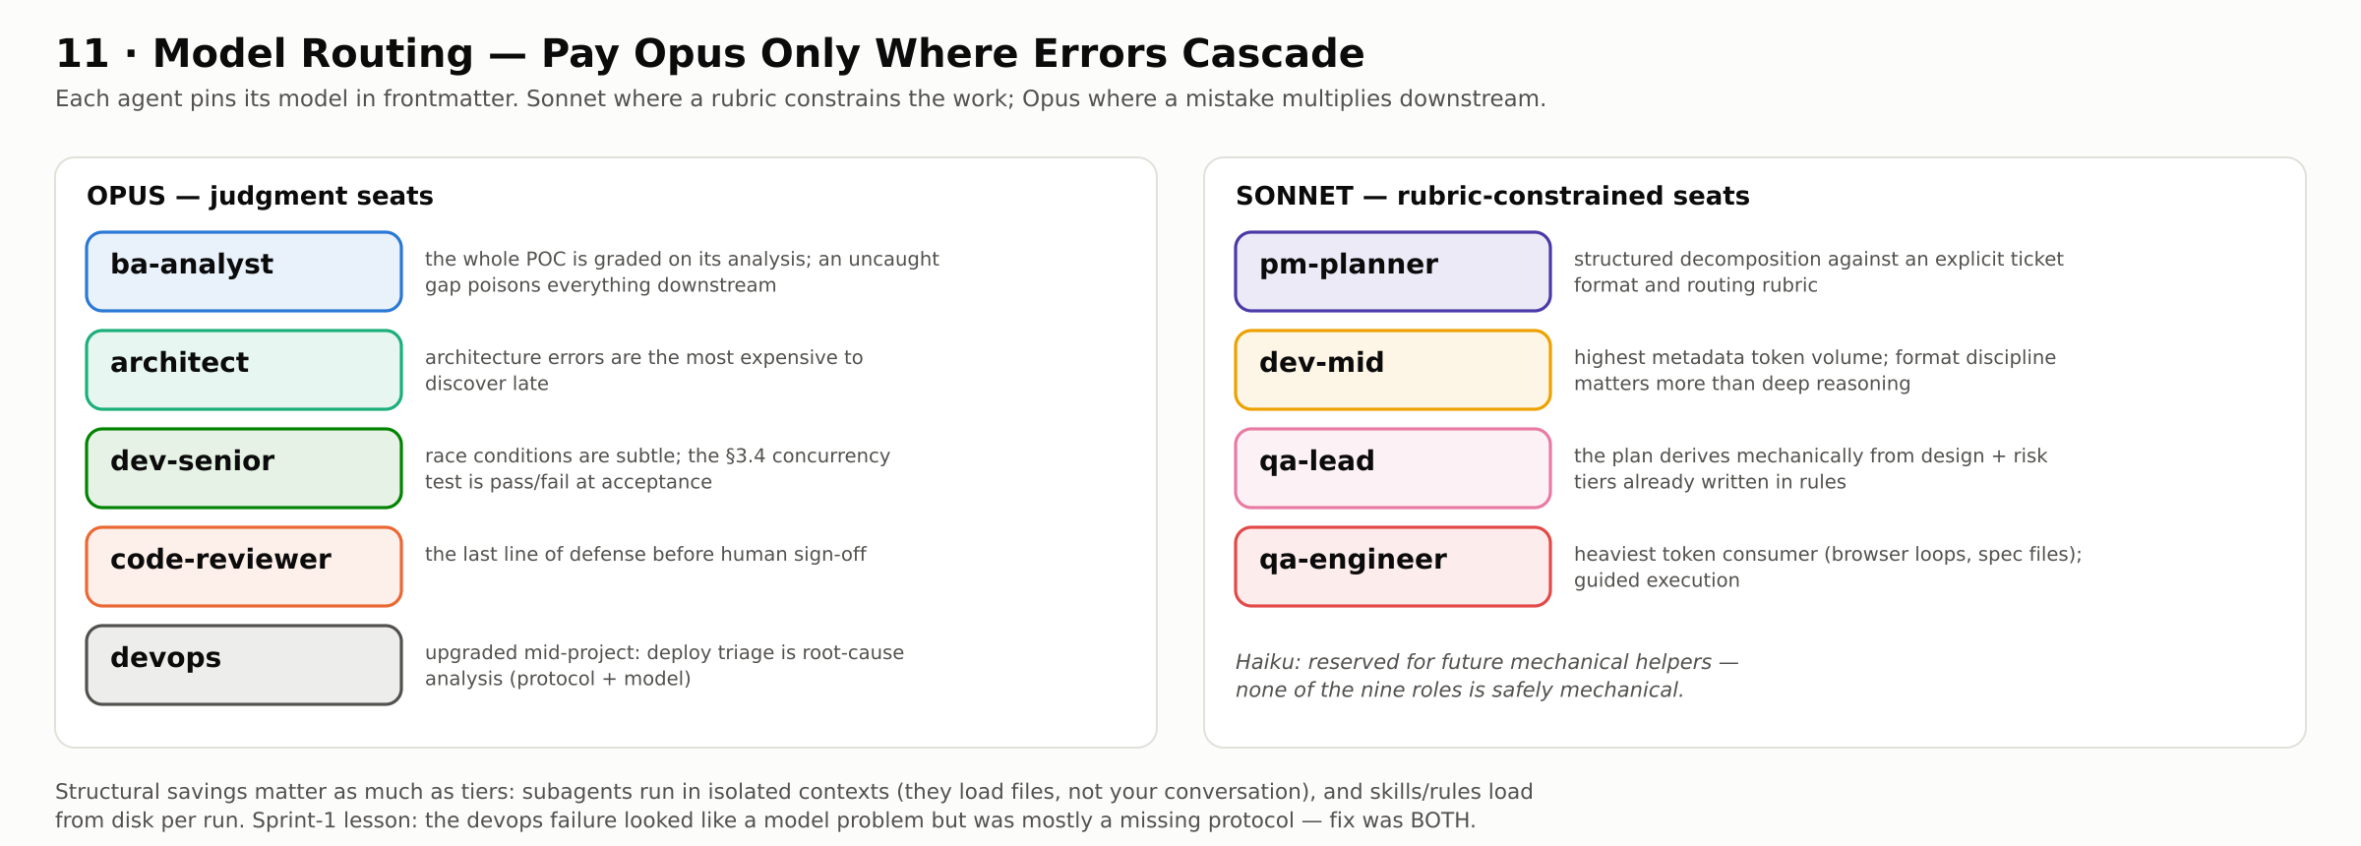
Every agent pins its model, so expensive reasoning is bought only where an error cascades downstream. The Opus seats are the judgment seats: analysis the whole project is graded on, architecture whose errors surface latest and cost most, concurrency-critical code, the review that must catch everyone else's mistakes, and deploy triage. The Sonnet seats all share one property: a skill or rubric already constrains the work, so the model executes a defined procedure rather than exercising open-ended judgment.
The devops row carries the project's most useful lesson about model choice: its deploy paralysis looked like a Sonnet-capability problem, but the file evidence showed a missing procedure. The fix was both — Opus AND a mandatory protocol — and the honest open question for the retro is whether the protocol alone would have sufficed.

12 · The Traceability Chain
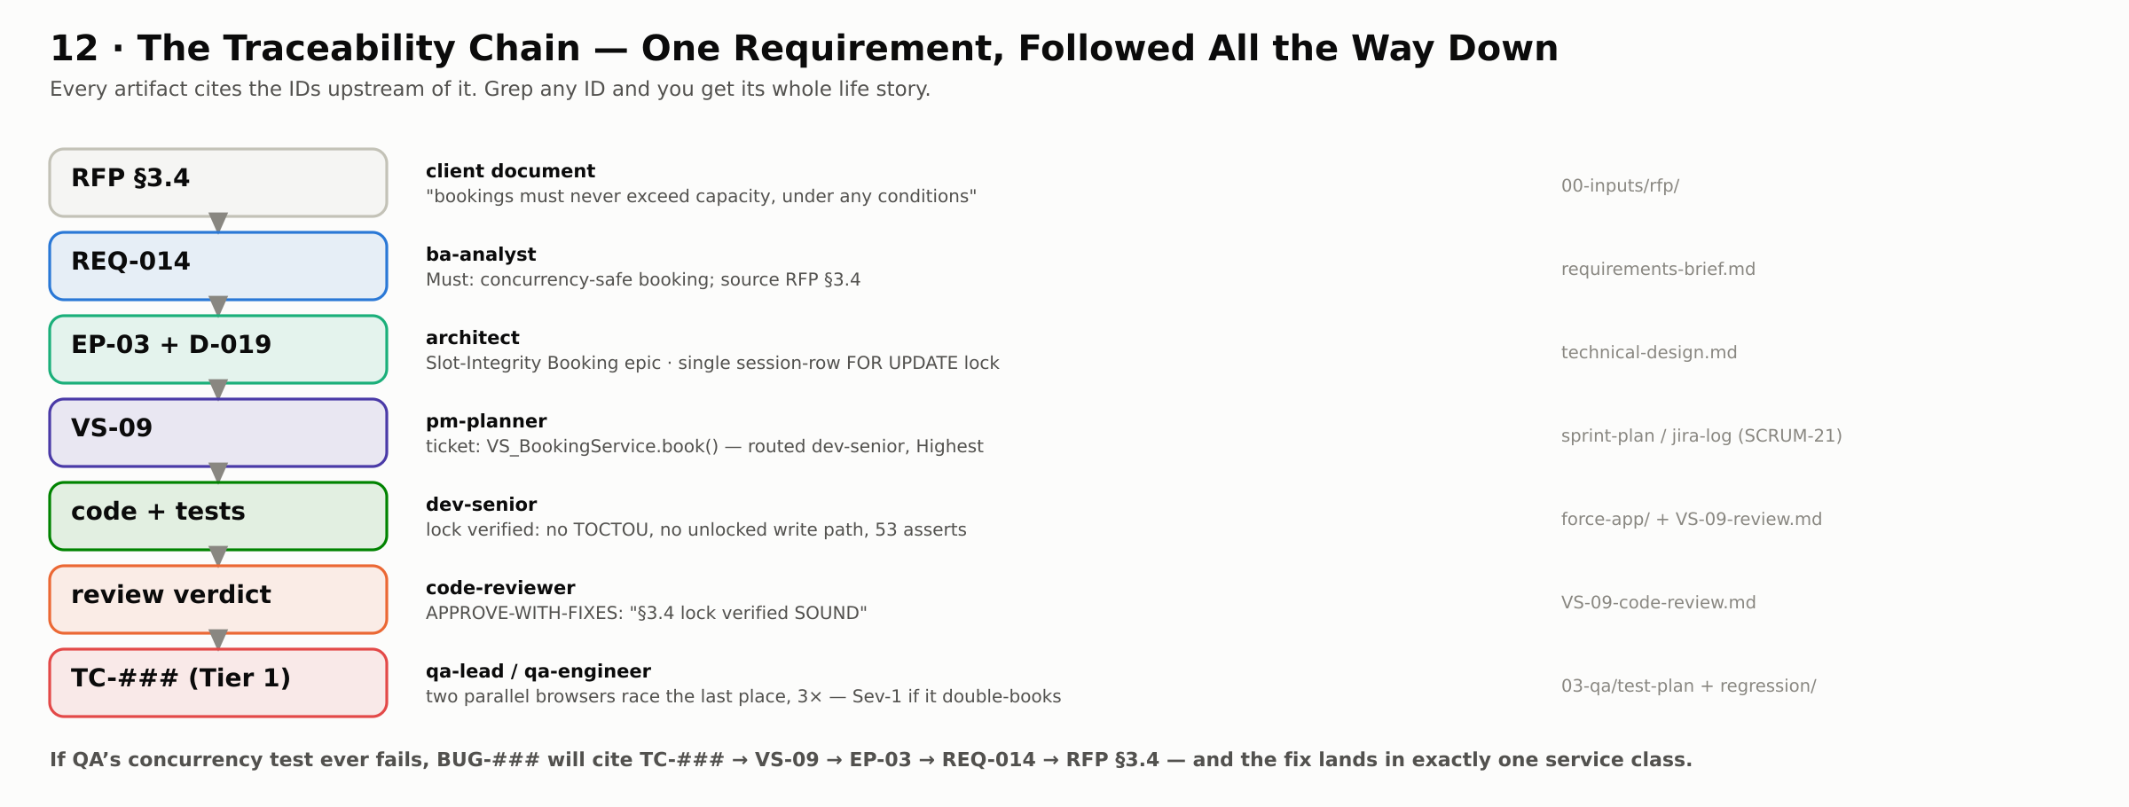
One requirement followed all the way down, as it actually happened: the RFP's no-overbooking clause became REQ-014 in the BA's brief, the Slot-Integrity epic and single-lock decision in the architect's design, ticket VS-09 routed to dev-senior at Highest priority, a service class whose lock the reviewer independently verified sound, and a Tier-1 concurrency test in QA's plan. Every artifact cites the IDs above it, so a grep on any ID reconstructs the whole story in seconds.
This chain is what makes the pipeline auditable to a client: when the DHS technical committee asks "show me how you guaranteed §3.4," the answer is seven files that reference each other — not a slide.

