**STOCK ANALYSIS DASHBOARD**

Data Manipulation Assignment by Ayush Kadbe

**Task 1: First Create a New Sub Sheet & Fetch all the Data from the Sheet called "Data Set" where Data from the PE Ratio is not Blank & PE Ratio < 100 using Query Function and sort the data by Descending of Market Cap Amount.**

Formula Used: =QUERY('Data Set'!A:J, "Select * Where D < 100 and D is not null Order by B Desc", 1)

A new sheet named **“Status”** is created. This formula is applied on A1 on which it fetches all data from the **"Data Set"** sheet where the PE Ratio is not blank and is less than 100. It sorts the data by descending order of Market Cap Amount.

**Status Sheet: Fetching Data**

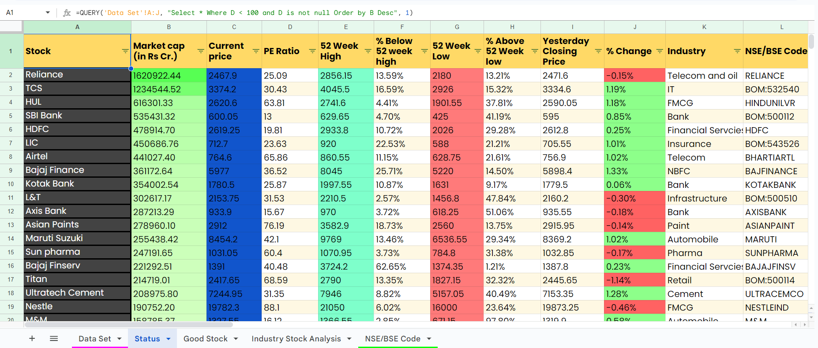

**Task 2: Now Create 2 Columns of Industry & NSE/BSE Code & Fetch Data from the Second Sheet with VLOOKUP. Make sure the VLOOKUP Formula is used with "ARRAYFORMULA" meaning formula will be written only once but will be applicable throughout the column. Also make sure the Formula of VLOOKUP will be applied only until when data is there in the column, handle this with IF CONDITIONS in that same formula.**

Formula Used: =ArrayFormula(IF(A2:A<>"",VLOOKUP(A2:A, 'NSE/BSE Code'!A4:C, 2,0),""))

A new column named **“Industry”** is created in **“Status”** sheet. This formula is performs a VLOOKUP to fetches Industry data from 2nd column in the **"NSE/BSE Code"** sheet. It is applied using an ARRAYFORMULA to ensure it's applied throughout the column.

**Status Sheet: Fetching Industry Column Data**

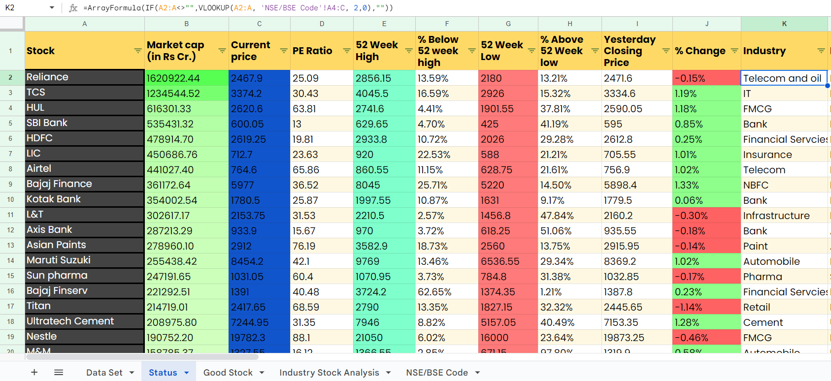

Formula Used: =ArrayFormula(IF (A2:A<>"", VLOOKUP(A2:A, 'NSE/BSE Code'!A4:C,3,0),""))

A new column named **“NSE/BSE Code”** is created in **“Status”** sheet. This formula performs VLOOKUP to fetches NSE/BSE Code data from 3rd column in the **"NSE/BSE Code"** sheet. It is applied using an ARRAYFORMULA to ensure it's applied throughout the column.

**Status Sheet: Fetching NSE/BSE Code Column Data**

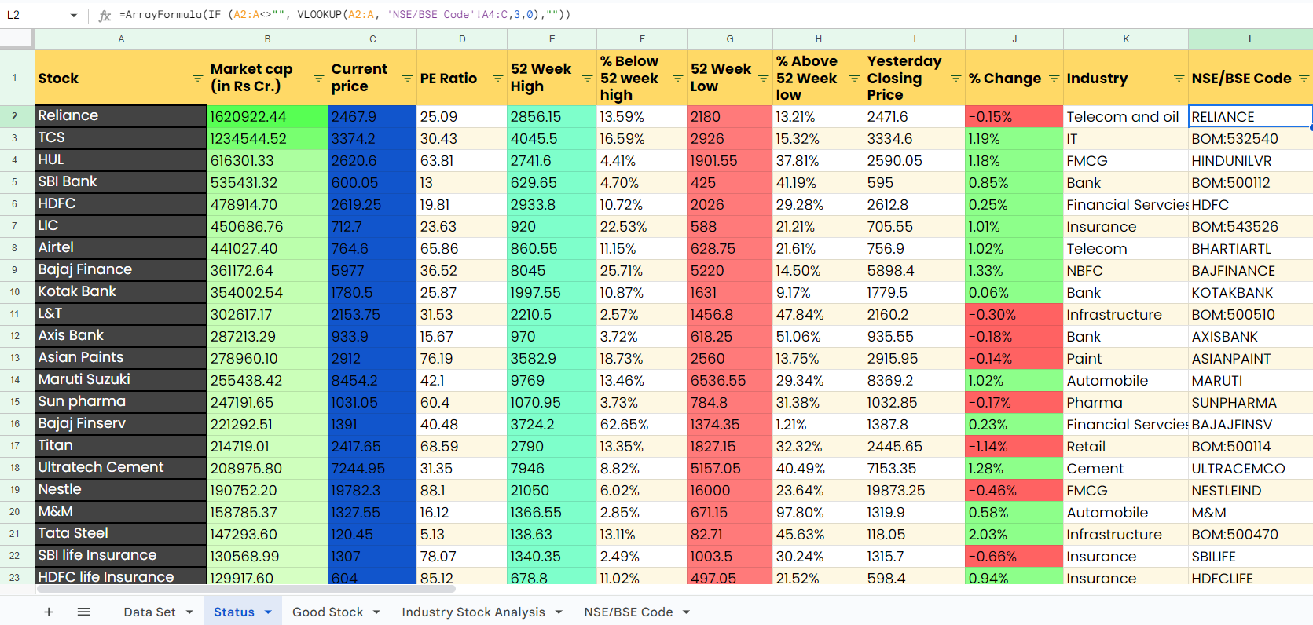

**Task 3: Now Create 2 More Columns at the End with the Heading "Bear Mode 1" & "Bear Mode 2"**

**Bear Mode 1 Condition: Use IF Condition to print "Yes" if % Change from 52 Week High > 30 else "No"**

**Bear Mode Condition 2: Use IF Condition to print "Yes" if % Change from 52 Week Low < 30 else "No"**

**Stock Status: Now Create a Column named "Stock Status" & then apply multiple IF Conditions to check if PE Ratio <65, Bear Mode 1 & 2 = "No" then Print "Good Stock" in the column else "".**

Formula Used: =ARRAYFORMULA(If (F2:F<>"", IF(F2:F*100 > 30, "Yes", "No"),"")

A new column named **“Bear Mode 1”** is created in **“Status”** sheet. This formula checks if the % Change from 52 Week High is greater than 30 and prints "Yes" if true, otherwise "No". It is applied using an ARRAYFORMULA to ensure it's applied throughout the column.

**Status Sheet: Bear Mode 1**

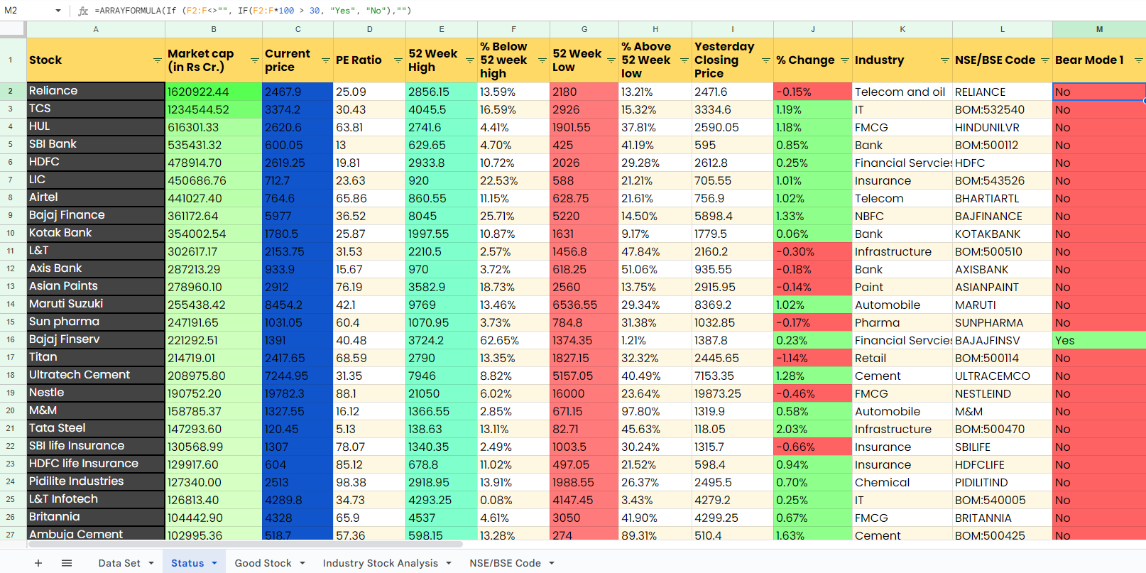

Formula Used: =ARRAYFORMULA(If (H2:H<>"",IF(H2:H*100 < 30, "Yes", "No"),""))

A new column named **“Bear Mode 2”** is created in **“Status”** sheet. This formula checks if the % Change from 52 Week Low is less than 30 and prints "Yes" if true, otherwise "No". It is applied using an ARRAYFORMULA to ensure it's applied throughout the column.

**Status Sheet: Bear Mode 2**

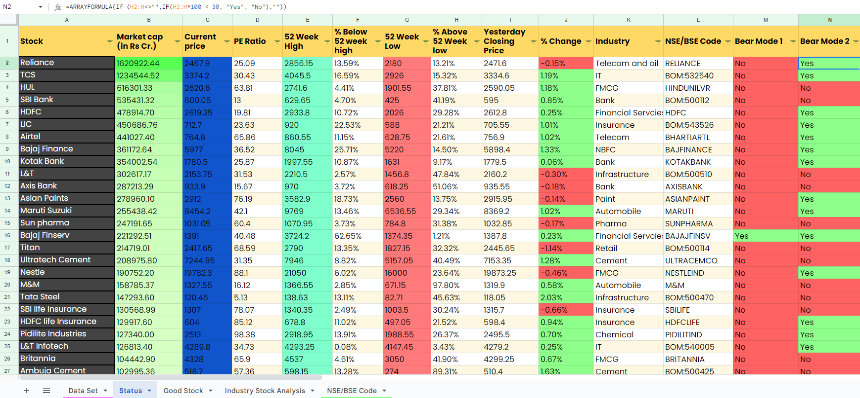

Formula Used: =ArrayFormula(IF(D2:D <65,IF(M2:M=”No”,If(N2:N=”No”,”Good Stock”,””),””),””))

A new column named **“Stock Status”** is created in **“Status”** sheet. This formula uses multiple if condition to check if PE <65, Bear Mode 1 & Bear Mode 2 is “No”, then print “Good Stock” if all conditions are met, otherwise leaves the cell blank.

**Status Sheet: Stock Status**

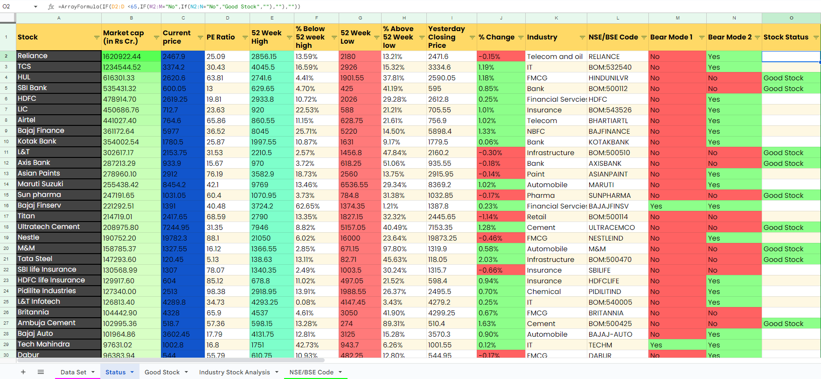

**Task 4: Now create a new sheet & fetch all Data where Stock Status = 'Good Stock' which will be your Final Organized Data Source, so Create Proper Formatting to this Sheet like the Data Source Sheet & also add Appropriate Conditional Formatting Color Scales.**

Formula Used: =QUERY(Status!A1:O, "SELECT A,B,C,D,E,F,G,H,I,J,K,L WHERE O='Good Stock' AND K<>'' ", 1)

A new sheet named **“Good Stock”** is created. This formula fetches all data from the **"Status"** sheet where the Stock Status = ‘Good Stock’.

**Good Stock Sheet**

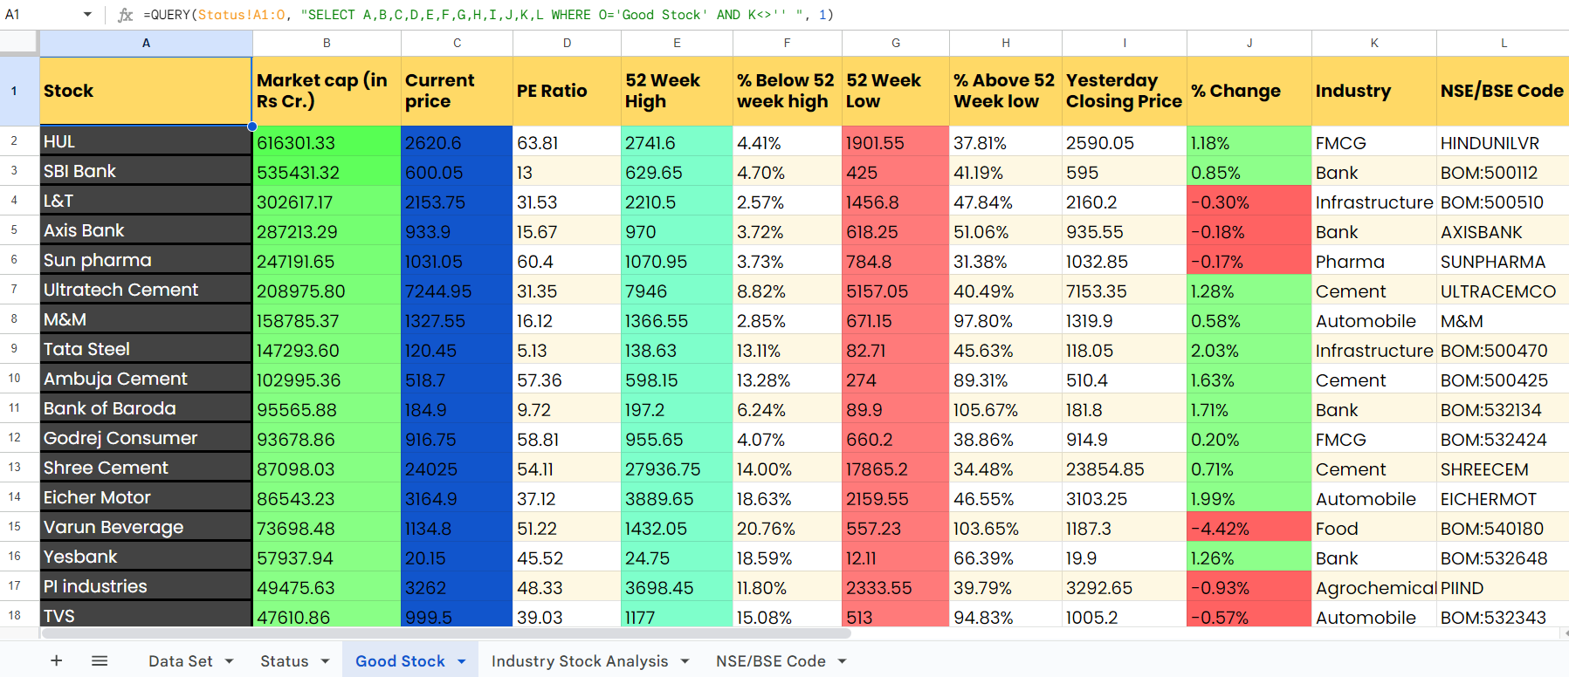

**Task 5: Create a Pivot Table Report as Follows:**

**Industry wise Total Count of Companies**

**Industry wise Average Market Cap**

**Industry wise sum of Market Cap**

**(The Report should have proper formatting with proper heading, slicers & Color formatting with color scale or Conditional Formatting so that it looks like a professional report & not just a simple pivot table)**

Steps:

1. Go to Insert > Pivot Table in **“Industry Stock Analysis”** sheet.
2. Select the range of data from **“Good Stock”** sheet.
3. Add heading as “Industry Stock Analysis” and row named “Statistics”.
4. Add "Stock" & “Market Cap” to Rows.
5. Go to Insert > Pivot Table in **“Industry Stock Analysis”** sheet.
6. Select the range of data from **“Good Stock”** sheet.
7. Add "Industry" to Rows.
8. Add "Stock" to Values three times. Change the aggregation method to Count.
9. Add "Market cap (in Rs Cr.)" to Values two times. Change the aggregation method to Average, and Sum for each instance.
10. Add slicers for Industry, Total Stock & Total Market cap (in Rs Cr.).
11. Format the pivot table as desired with proper headings and formatting options.
12. Apply conditional formatting or color scales to highlight key metrics.

This pivot table provides insights into Industry-wise Total Count of Companies, Average Market Cap, and Sum of Market Cap.

**Industry Stock Analysis Sheet**

