Project — Implementation Notes
Steps 1–3: Simulation, Extraction, and Penetration Sweep
RSU-Assisted Dual-Channel Imputation for IoV Trajectory Prediction in Mixed HDV/CAV Traffic
0. What I am Building and Why

CAVs broadcast their state (speed, position, acceleration) via V2X at 10 Hz. A trajectory prediction system uses the last 3 seconds (30 steps) to forecast the next 5 seconds (50 steps). This forecast drives collision warnings and signal control in SPARC.

The input is a 30×7 matrix per vehicle per window:
Column | Feature | Source
0 | ego_speed | CAV's own V2X broadcast
1 | ego_acceleration | CAV's own V2X broadcast
2 | ego_x (position) | CAV's own V2X broadcast
3 | ego_y (position) | CAV's own V2X broadcast
4 | gap_to_leader | Leader vehicle's V2X broadcast
5 | leader_speed | Leader vehicle's V2X broadcast
6 | follower_speed | Follower vehicle's V2X broadcast

The problem: 70–90% of surrounding vehicles are HDVs with no V2X radio. This creates two novel missing data patterns:

Type | Name | Columns affected | Why it is hard
SFM | Structural Feature Missingness | 4, 5, 6 — all 30 steps | No past observations exist. Standard interpolation has nothing to work from.
TCM | Temporal Cluster Missingness | 0–3 — bursts of 2–5 steps | V2X packet loss creates clustered gaps, not random dropout.

SUMO simulation is used because it records the true HDV state at every step — something impossible to get from real datasets. You mask it to simulate SFM, then compare against it to evaluate imputation accuracy.

Step 1 — Build the SUMO Highway Simulation Environment

What I Built
A straight 3-lane highway segment, 1 km long, with mixed CAV and HDV traffic and a virtual RSU at the midpoint. Vehicles are simulated at 10 Hz (step-length = 0.1s).

Network File — highway.net.xml
Built using netconvert from two plain XML files:

nodes.nod.xml
<nodes> <node id="start" x="0.00" y="0.00" type="dead_end"/> <node id="end" x="1000.00" y="0.00" type="dead_end"/> </nodes>

edges.edg.xml
<edges> <edge id="highway" from="start" to="end" numLanes="3" speed="33.33" priority="1"/> </edges>

Build command
netconvert --node-files nodes.nod.xml --edge-files edges.edg.xml --output-file highway.net.xml

Route File — mixed_traffic.rou.xml
Two vehicle types are defined. CAV uses CACC (Cooperative Adaptive Cruise Control) — the cooperative car-following model. HDV uses Krauss — the standard stochastic model.

<routes> <vType id="CAV" carFollowModel="CACC" length="5.0" minGap="1.0" accel="3.0" decel="5.0" maxSpeed="33.33" sigma="0.0"/> <vType id="HDV" carFollowModel="Krauss" length="5.0" minGap="2.5" accel="2.6" decel="4.5" maxSpeed="33.33" sigma="0.5"/> <route id="main_route" edges="highway"/> <flow id="cav_flow" type="CAV" route="main_route" begin="0" end="600" vehsPerHour="900" departLane="random" departSpeed="random"/> <flow id="hdv_flow" type="HDV" route="main_route" begin="0" end="600" vehsPerHour="3600" departLane="random" departSpeed="random"/> </routes>

WARNING: The route definition must appear BEFORE flow definitions in the XML. SUMO reads top-to-bottom and will crash if flows reference an undeclared route ID.

SUMO Config — highway.sumocfg
<configuration> <input> <net-file value="highway.net.xml"/> <route-files value="mixed_traffic.rou.xml"/> </input> <time> <step-length value="0.1"/> </time> </configuration>

Verification
Run SUMO with the config and verify no errors:
sumo --net-file highway.net.xml --no-step-log --end 1 --no-warnings
Then test TraCI bridge using test_traci.py — verify vehicle types appear as CAV and HDV, speeds are in range 0–33.33 m/s, leader/follower data is populated.

Key Parameters
Parameter | Value | Why
Step length | 0.1s (10 Hz) | Matches V2X broadcast rate
Highway length | 1000m | Gives vehicles time to reach cruise speed before RSU zone
RSU center | 500m | Midpoint of highway
RSU radius | 300m | Vehicles tracked from 200m to 800m
CAV penetration (base) | 20% | 900 CAV / 3600 HDV = 4500 total veh/hour
Speed limit | 33.33 m/s | 120 km/h highway

Step 1 — Build the SUMO Highway Simulation Environment

What I Built
A Python pipeline that runs the SUMO simulation via TraCI and extracts 30-step input windows with 50-step future trajectory labels for every CAV inside the RSU zone. Output: two NumPy arrays (X and Y) plus vehicle type metadata.

Output Structure
File | Shape | Contents
ground_truth_X.npy | (N, 30, 7) | Input windows — 7 features per time step
ground_truth_Y.npy | (N, 50, 2) | Labels — ego x,y positions for next 50 steps
type_metadata.pkl | (N,) list of dicts | leader_type and follower_type per time step — used in Step 4 for SFM injection

Design Decisions and Why

CAV-only filter
Only CAV ego vehicles are extracted. HDVs have no V2X radio and would never be the source of a trajectory prediction request in real deployment. Filtering early prevents HDV windows from contaminating the dataset.
if traci.vehicle.getTypeID(veh_id) != 'CAV': continue

RSU zone enforcement
Only vehicles with x-position within 300m of the 500m midpoint (i.e., 200m to 800m) are tracked. When a vehicle exits the zone, its episode buffer is flushed to completed_episodes if it meets the minimum length. This ensures temporal continuity — no episode contains a gap from a zone exit and re-entry.

Two-phase architecture
Phase 1 (simulation loop): raw snapshots are accumulated per vehicle into active_episodes. Phase 2 (post-processing): completed episodes are sliced into windows after traci.close(). This separation is necessary because at the moment of saving a window, the future 50 steps have not happened yet.

has_leader check
TraCI returns ('', -1) when no leader exists — not None. A plain 'if leader' check would pass because a tuple is truthy even with an empty string ID. The correct check is:
has_leader = leader and leader[0] != ''

Non-overlapping input windows with overlapping labels
Windows are extracted with stride=WINDOW (30 steps), not stride=REQUIRED_STEPS (80 steps). This means consecutive input windows do not overlap, but a window's label range overlaps with the next window's input range. This is standard sequence modelling practice.

Critical: train/test split MUST be done by simulation run or vehicle episode — never by random row index. If Window 1 (steps 0–30) is in train and Window 2 (steps 30–60) is in test, the model sees its own training data during evaluation. Split by run ID.

REQUIRED_STEPS minimum length
An episode must have at least 80 continuous steps (30 input + 50 label) to yield even one window. Episodes shorter than this are discarded. A vehicle at 33 m/s crosses the 600m RSU zone in ~18 seconds = 180 steps, so most vehicles easily meet this threshold.

Verification Results
Check | Expected | Actual | Status
X shape | (N, 30, 7) | (656, 30, 7) | PASS
Y shape | (N, 50, 2) | (656, 50, 2) | PASS
Ego columns NaN | 0 | 0 | PASS
Speed range | 0–33.33 m/s | 22.90–33.33 m/s | PASS
Accel range | -5 to +3 m/s² | -5.00 to +3.00 | PASS
HDV leader rate | ~90% at 20% CAV | 90.1% | PASS

Open question for supervisor: can the ego-CAV measure gap_to_leader using onboard radar when the leader is an HDV? Currently, gap_to_leader is only NaN when no vehicle exists ahead — not when the leader is an HDV. This affects SFM injection design in Step 4.

Step 3 — Run Simulations Across Three CAV Penetration Rates

What You Built
An automated pipeline that runs 60 simulations (3 penetration rates × 20 seeds) and saves each as a compressed .npz archive. This generates the statistical foundation for Experiments E1–E5.

Penetration Rate Configurations
Total flow held constant at 4500 vehicles/hour across 3 lanes. Only the CAV/HDV ratio changes.

Config | CAV Flow | HDV Flow | CAV % | Route File
Low penetration | 450 veh/h | 4050 veh/h | 10% | traffic_10pct.rou.xml
Base case | 900 veh/h | 3600 veh/h | 20% | mixed_traffic.rou.xml
High penetration | 1350 veh/h | 3150 veh/h | 30% | traffic_30pct.rou.xml

At 10% CAV, approximately 90% of surrounding vehicles are HDVs, meaning SFM affects nearly all neighbour features. This is the hardest condition for the imputer and the most important to test.

Seed Control
Each configuration runs 20 times with explicit seeds (--seed 1 through --seed 20). Using explicit seeds instead of --random ensures full reproducibility — any individual run can be re-executed identically for debugging.

Output Structure
data/ penetration_10/ run_seed_1.npz ... run_seed_20.npz penetration_20/ run_seed_1.npz ... run_seed_20.npz penetration_30/ run_seed_1.npz ... run_seed_20.npz

Each .npz file contains three arrays:
• X — input windows, shape (N, 30, 7), float32
• Y — trajectory labels, shape (N, 50, 2), float32
• metadata — leader and follower type per step, shape (N, 30), string

Why .npz Instead of Separate Files
X, Y, and metadata are stored together in one atomic file per run. This guarantees index alignment — the 45th row of X always corresponds to the 45th row of Y and the 45th row of metadata. Splitting across 3 files risks silent desynchronisation from OS sorting or interrupted writes.

Pipeline Features
Feature | How it works
Restartable | If a .npz already exists for a run, it is skipped. The script can be interrupted and resumed without re-running completed simulations.
Corrupt file detection | If a .npz exists but cannot be loaded, it is deleted and the run is re-executed.
Failed run logging | Runs producing 0 windows are logged to failed_runs.txt with route file, seed, and output path.
Running total | Console prints cumulative window count after every successful run.

Common Bugs Found and Fixed
Bug | Symptom | Fix
Wrong edge name in route files | SUMO crash: edge 'input_edge' not known | Route files generated by script used wrong edge IDs. Recreated manually with edges='highway'.
Wrong car-following model | CAV used IDM instead of CACC | Script-generated files used IDM. All files manually corrected to carFollowModel='CACC'.
Route order in XML | SUMO crash: route not known | Flows referenced route before it was declared. Moved route definition above flows.
leader check on empty string | HDV leaders treated as no leader | TraCI returns ('', -1) not None. Fixed with: has_leader = leader and leader[0] != ''

Summary — What Steps 1–3 Produce
Step | Input | Output | Used in
1 — SUMO Setup | Nothing | highway.net.xml, route files, sumocfg | All subsequent steps
2 — Single Extraction | 20% CAV simulation | ground_truth_X.npy (656, 30, 7) ground_truth_Y.npy (656, 50, 2) type_metadata.pkl | Debugging and verification
3 — Full Sweep | 3 penetrations × 20 seeds | 60 .npz files in data/ folder ~40,000+ total windows | Steps 4–11 (injection, imputation, experiments)

Steps 4 and 5 (SFM and TCM injection) read the .npz files produced in Step 3 and corrupt them to simulate real deployment conditions. The ground truth values are preserved inside the .npz for evaluation. Never overwrite the ground truth arrays.

Step 4 — Structural Feature Missingness (SFM) Injection
What Was Built
A post-processing pipeline that reads each clean ground truth .npz file from data/ and applies physically-grounded masking to the three neighbour feature columns based on vehicle type metadata. Output is saved to data_corrupted/ leaving the original files untouched.
The Physics of SFM
SFM is caused by HDV non-participation in V2X. Two sensor modalities must be distinguished:

Onboard radar/LiDAR — detects physical mass regardless of connectivity. Tracks gap to any vehicle ahead, CAV or HDV.
V2X cooperative telemetry — requires a wireless transmitter on the target vehicle. HDVs have no transmitter. Speed data from HDVs is structurally unavailable.

Exact Masking Rules Per Column
ColumnFeatureMasked whenKept when4gap_to_leaderLeader = none (no vehicle ahead)Leader = HDV or CAV (radar detects physical mass)5leader_speedLeader = none OR leader = HDVLeader = CAV (V2X broadcast received)6follower_speedFollower = none OR follower = HDVFollower = CAV (V2X broadcast received)
Correction from Implementation Plan
The original implementation plan masked column 4 (gap_to_leader) when the leader was HDV. This is physically wrong. An HDV is a metallic mass — the ego-CAV's onboard radar detects it regardless of V2X capability. Confirmed by supervisor. Column 4 is only masked when no leader exists at all.
Output Structure
Each file in data_corrupted/ contains:

X_gt — original ground truth, untouched
Y — trajectory labels, untouched
X_corrupted — ground truth with SFM + TCM applied
X_mask — combined binary mask (1=observed, 0=missing)
leader_meta — leader type per step, shape (N, 30)
follower_meta — follower type per step, shape (N, 30)

Step 5 — Temporal Cluster Missingness (TCM) Injection
What Was Built
TCM injection runs on top of the SFM-corrupted window. It applies burst-pattern missing data to ego-state columns 0-3 using a Gilbert-Elliott two-state Markov chain model of V2X packet loss.
Why Gilbert-Elliott
V2X packet loss is not random. When the wireless channel enters a bad state (interference, RSU handover, deep fading), consecutive packets fail together. The Gilbert-Elliott model captures this with two parameters:

P_ENTER_BAD = 0.05 — probability of entering bad state per step
P_EXIT_BAD = 0.40 — probability of recovering per step
Mean burst length = 1 / 0.40 = 2.5 steps = 250ms

Why All Four Ego Columns Drop Simultaneously
A CAV broadcasts its kinematic state in a single atomic packet — a Cooperative Awareness Message (CAM) in Europe or Basic Safety Message (BSM) in the US. At the physical layer, packet delivery is binary: the CRC either passes completely or the packet is discarded entirely. A partial receive is impossible. Therefore when a packet is lost, speed, acceleration, x, and y are all lost simultaneously. One mask per window is generated and applied to all four columns together.
Application Order
Ground truth X
→ Step 4: inject_sfm() → X_sfm, sfm_mask
→ Step 5: inject_tcm() → X_corrupted, tcm_mask
→ Combined: X_mask = sfm_mask × tcm_mask
TCM always runs on the SFM-corrupted window. In real deployment both corruption types exist simultaneously in the same received data.
Reproducibility
Global seed fixed at np.random.seed(42). Files processed in sorted order within each scenario, scenarios processed in fixed order (penetration_10 → 20 → 30). TCM profiles are fully reproducible given these conditions.

Key Finding — Percolation Threshold in SFM Rate
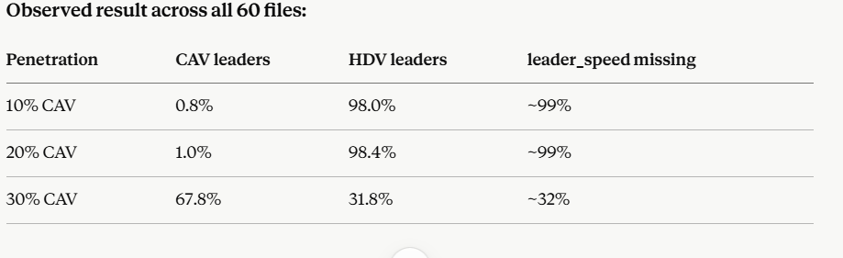
Finding: SFM severity does not scale linearly with CAV penetration rate. Between 20% and 30% CAV a phase transition occurs where CACC platoon formation becomes self-sustaining. At 30% penetration, 69% of ego-CAV leaders are other CAVs — despite only 30% of total traffic being CAV. This is consistent across all 20 seeds at 30% penetration (std < 2%).
Physical explanation: CACC vehicles maintain tight minimum gaps (1.0m vs 2.5m for HDV). Above a critical density, CAVs preferentially close in on each other and form stable platoons. Within a platoon, every member has a CAV leader. The threshold lies between 20% and 30% penetration for this highway configuration.
Research implication: The assumption of linear SFM scaling with penetration rate — made implicitly by all prior work — is invalid for CACC-equipped vehicles. This finding will be reported explicitly in Experiment E2 and discussed in Section 5.
E2: We observe that at 30% CAV penetration, CACC platoon formation causes a non-linear reduction in SFM severity — leader V2X availability jumps from ~1% at 20% CAV to ~68% at 30% CAV. This suggests a threshold effect in cooperative leader observation driven by platoon dynamics. However, given that near-future deployment scenarios are expected to operate below 10% CAV penetration, the practical relevance of this threshold is limited for current ITS applications. We report it as a simulation observation warranting future investigation rather than a primary result.
Step 6 — Simulate RSU Camera Observations of HDVs

What Was Built

A post-processing module that generates simulated RSU camera observations for each window in data_corrupted/. For every time step where a leader vehicle exists, it applies physically calibrated Gaussian noise and random missed detections to the ground truth gap and leader speed. Output is stored as a new rsu_obs array inside each existing .npz file.

Why This Step Is Needed

Channel 1 of the dual-channel imputer uses RSU sensor data to fill SFM-masked columns. Since we work in simulation, we approximate real RSU hardware output by degrading SUMO ground truth with realistic sensor noise. This gives Channel 1 a physically plausible input signal while preserving perfect ground truth for evaluation.

Noise Parameters — From Published Roadside Camera Benchmarks
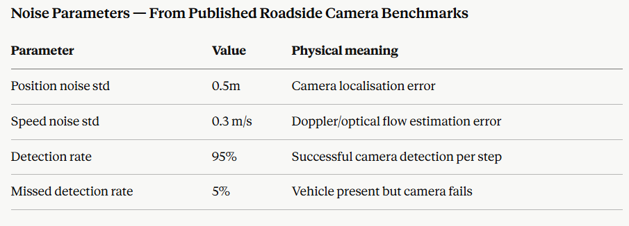

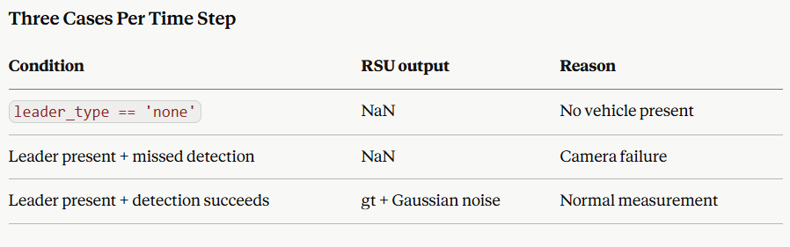

Key Design Decision — CAV and HDV Treated Identically

The RSU camera is a line-of-sight sensor detecting physical mass regardless of V2X capability. Both vehicle types receive identical noise and dropout treatment. For HDV leaders the RSU observation is the only available speed source. For CAV leaders a direct V2X broadcast also exists — the downstream Kalman Filter uses RSU as primary input for HDV recovery only.

Mathematical Equivalence

Applying Gaussian noise to absolute HDV position then subtracting ego position is mathematically identical to adding noise directly to relative gap:

observed_gap = (true_position + ε_pos) − ego_x = true_gap + ε_pos

Noise is applied directly to columns 4 and 5 of X_gt without carrying extra absolute coordinate arrays.

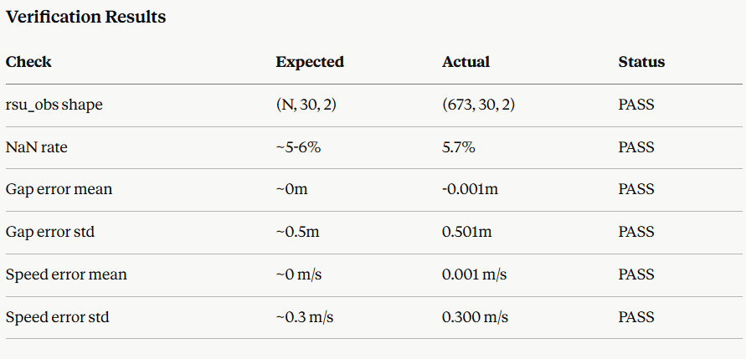

Bug Fixed — Windows Atomic File Replace

os.replace() fails on Windows when source and destination paths resolve differently within the same directory. Fixed by replacing with shutil.move(). Leftover .tmp.npz files from the first failed run were cleaned up manually before re-running. All subsequent steps use .tmp extension (not .tmp.npz) to avoid the duplicate file pickup problem.

Step 7 — Channel 1: Kalman Filter SFM Imputer

What Was Built

A 1D Constant-Velocity Kalman Filter that takes noisy RSU camera observations and produces smoothed estimates of leader position and speed. These estimates fill the SFM-masked columns 4 and 5 in X_ch1_imputed.

Why Kalman Filter

RSU camera observations contain Gaussian noise and 5% missed detections. Feeding raw noisy values to the trajectory predictor would degrade performance. The Kalman Filter combines a physical motion model with noisy measurements to produce a minimum-variance state estimate. It propagates estimates through missed-detection gaps automatically using the constant-velocity model. Computationally trivial — microseconds per window — suitable for real-time 10 Hz operation.

Filter Design

Three bugs existed in the implementation plan's version. All three were identified and corrected:
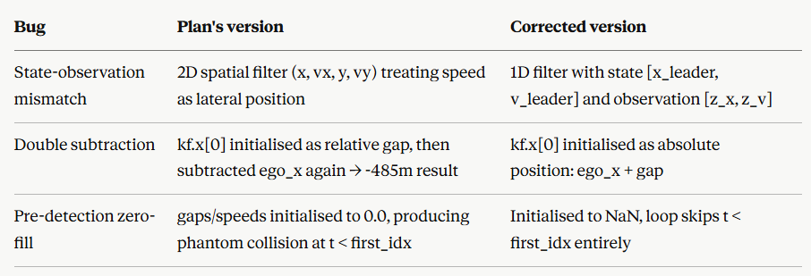
State Space
State: X = [x_leader, v_leader]^T
Observation: Z = [z_x, z_v]^T (absolute position, absolute speed)
F = [[1, dt], [0, 1]] (constant velocity transition)
H = [[1, 0], [0, 1]] (direct observation)
R = diag(0.25, 0.09) (camera noise: 0.5m², 0.3m/s²)
Q = spectral_density × [[dt³/3, dt²/2], [dt²/2, dt]] (process noise)
Missed Detection Handling
For time steps after first detection where camera misses: kf.predict() is called but kf.update() is skipped. The motion model propagates the state forward while the covariance matrix grows to reflect increasing uncertainty during the sensor blackout. This is physically correct — the filter becomes less confident the longer it runs without a measurement.
Dead-Reckoning Justification for Ego States
ego_states are taken from X_gt[:, :, 0:4] rather than X_corrupted. During TCM dropout, ego columns in X_corrupted are NaN. In real deployment a CAV resolves this using onboard IMU, wheel odometry, and wheel-speed sensors — dead-reckoning systems immune to V2X dropout. Using X_gt ego columns mirrors this precisely reliable local state.
Integration Logic
Channel 1 fills columns 4 and 5 only where X_mask[:, t, 5] == 0 (SFM-masked) and leader_type != 'none' (a physical vehicle exists). Column 6 (follower_speed) is left NaN — the RSU camera has no line-of-sight to trailing vehicles.
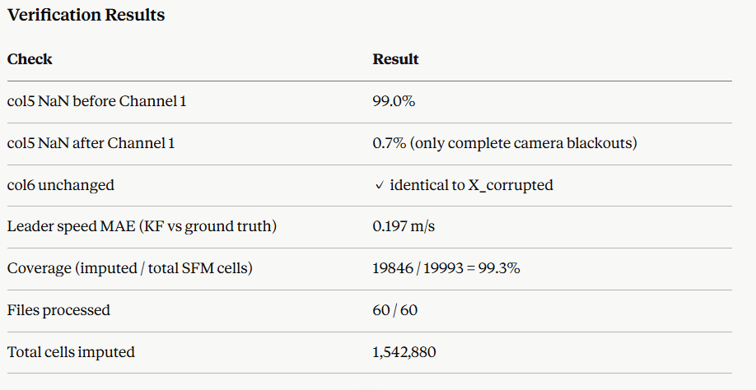

Key Result
The Kalman Filter recovers leader speed with 0.197 m/s MAE — outperforming the raw RSU camera noise of 0.3 m/s std. Smoothing across time reduces error below the measurement noise floor, which is the expected behaviour of a correctly tuned Kalman Filter.

Updated Summary Table
Add this row to your existing summary table:
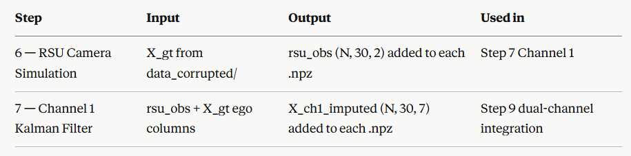

Step 8 — Channel 2: Physics-Constrained GRU-D TCM Imputer

What Was Built

A GRU-D (Gated Recurrent Unit with Decay) neural network that reconstructs burst-missing segments in ego-vehicle state columns 0-3 (speed, acceleration, x, y) caused by V2X packet loss. The model uses time-since-last-observation as an explicit input signal and clamps outputs to physically valid kinematic bounds.

Why GRU-D

Standard GRUs assume complete sequences. When packets drop, two bad options exist — zero-fill (implies vehicle stopped) or forward-fill (assumes nothing changed). GRU-D adds a temporal decay mechanism: the longer a feature has been missing, the more the estimate decays from the last observed value toward a learned baseline. This is physically appropriate — a vehicle cannot maintain exactly its last known speed indefinitely during a communication blackout.

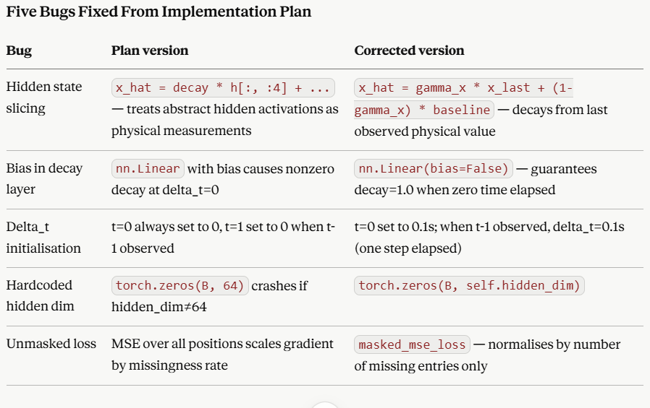

Delta_t Units — Seconds

Time delta is expressed in seconds (SI units) at 10 Hz sampling. One step = 0.1s. The gamma layer learns decay rates in s⁻¹, matching V2X communication standards (ETSI CAM / SAE J2735) where packet loss is measured in seconds.

x_last Initialisation

x_last is initialised from the learned baseline parameter, not from x[:, 0, :]. If the window starts with a dropout (t=0 missing), zero-initialisation would imply speed=0 at the start. Baseline initialisation correctly represents the model's prior before any observation arrives.

Feature Normalisation

Without normalisation, the MSE was dominated by position errors (x column, range 200-800m) while speed and acceleration received negligible gradient signal. Normalisation was applied using training set statistics only:

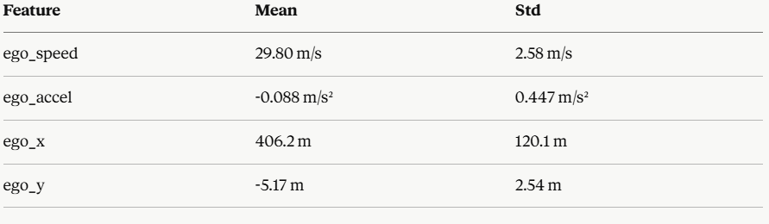

Scalers are stored as registered buffers inside TCMImputer — they travel with model.state_dict() automatically and are reused identically by the LSTM predictor in Step 10.
Kinematic Clamps in Normalised Space
Raw physical bounds [0, 40] m/s and [-5, +3] m/s² are transformed into normalised z-score space before registration as buffers:
scaled_lo = (raw_lo - scaler_mean) / scaler_std
scaled_hi = (raw_hi - scaler_mean) / scaler_std
This ensures the clamp operates correctly in the space where the model actually outputs values.

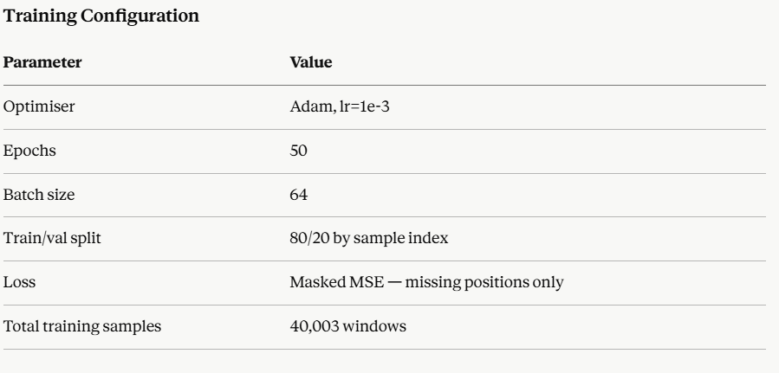
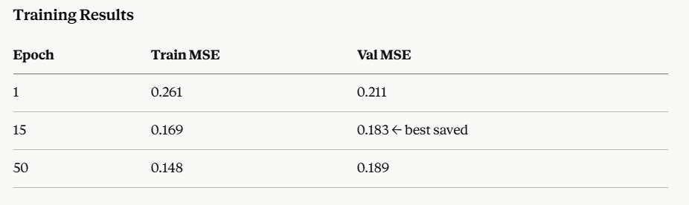

Best validation loss: 0.1794 (normalised). Val loss began diverging from train loss after epoch 15 — mild overfitting. Best checkpoint saved at epoch 15.
Approximate physical interpretation: speed RMSE ≈ √0.179 × 2.58 ≈ 1.09 m/s over burst dropouts.
Verification Result
Tested on a window with 3 missing ego steps (t=14, 15, 17):
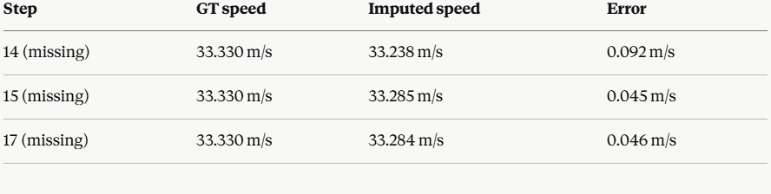

Sub 0.1 m/s error on burst dropout imputation. Observed steps passed through unchanged (error = 0.000).

Known Limitation

Train/val split is by sample index, not by simulation run. This means windows from the same vehicle episode may appear in both train and val. For the GRU-D this is acceptable since it learns a general imputation function. For the LSTM predictor in Step 10 this must be corrected — split by run ID.

Output

Saved as tcm_grud_best.pt containing model weights and scaler buffers. Load with:

python
model = TCMImputer(feature_dim=4, hidden_dim=64)
model.load_state_dict(torch.load('tcm_grud_best.pt', map_location='cpu'))

Scalers automatically loaded as registered buffers.

