PROJECT REPORT
INT375
(DATA SCIENCE TOOLBOX: PYTHON PROGRAMMING)
COMPUTER SCIENCE AND ENGINEERING
Title: Air Quality Analysis
Submitted by: Ayush katewa
Submitted to: Baljinder Kaur
LOVELY PROFESSIONAL UNIVERSITY

DECLARATION
I, Aayush, a student of Bachelor of Technology under CSE discipline at Lovely Professional University, Punjab, hereby declare that all the information furnished in this project report is based on my own work and is genuine.
Your name: Ayush katewa
Registration Number: 12319174

CERTIFICATE
This is to certify that Aayush bearing Registration no. 12319174 has completed INT375 project titled, “Air Quality Analysis” under my guidance and supervision. To the best of my knowledge, the present work is the result of his/her original development, effort and study.
Baljinder Kaur
Professor
School of Computer Science Engineering
Lovely Professional University
Phagwara, Punjab.
Date: 13th April, 2025

Acknowledgment
I would like to express my heartfelt gratitude to Prof. Baljinder Kaur for her guidance, support, and motivation throughout the duration of this project. Her expertise in data science and dedication to teaching provided the ideal environment to complete this analysis. I am also thankful to my peers for their discussions and feedback that helped enhance the overall outcome of this work.
Additionally, I appreciate the open-source community and data contributors whose efforts made this project possible.

Introduction
Air quality is an important environmental indicator affecting public health and climate. This project, titled "Air Quality Analysis," involves an exploratory data analysis (EDA) of environmental datasets containing measurements of air pollution across various locations. The goal is to identify trends, patterns, and insights that can inform policy-making and awareness.
The analysis utilizes Python-based libraries like Pandas, Matplotlib, and Seaborn for data processing and visualization, and highlights spatial and temporal variations in pollution data.

Dataset Description
The dataset used in this project is titled "Air_Quality.csv" and includes records of air quality measurements collected from multiple locations.
Dataset Characteristics:
• Total Rows: 18000+(approx)
• Columns: Includes Start_Date, Geo Place Name, Measure, Data Value, Geo Type Name, and Time Period.
• Data Types: Both numerical and categorical.
• Time Frame: Varies by location and sensor.
• Target Field: Data Value
Source: Environmental monitoring systems, open government repositories.

Exploratory Data Analysis (EDA)
Full EDA and visualization-based analysis coming next...

Exploratory Data Analysis (EDA)
Exploratory Data Analysis (EDA) was conducted on the air quality dataset to extract insights regarding pollution levels across different locations, time frames, and measurement types.
Objectives of EDA:
• Understand structure and distribution of air quality readings
• Identify missing or invalid values and clean data
• Analyze variation across time and geographical regions
• Explore pollution patterns across types of measurements (e.g., PM2.5, NO2)
• Visualize data using effective plots and dashboards

Techniques Used:
• Descriptive Statistics: Count, mean, std dev to summarize numerical data.
• Missing Value Handling: Dropped rows with nulls in critical columns.
• Univariate Analysis: Histogram, count plots to analyze individual features.
• Multivariate Analysis: Line plots, bar charts, box plots, scatter plots.
• Correlation Analysis: Heatmaps to find relationships.
• Dashboards: Multiple graphs combined for holistic insights.

Key Findings:
• Histogram of Data Value:
Shows the frequency distribution of air quality readings. Most values are concentrated in the lower range, indicating that extreme pollution events are less frequent but exist.
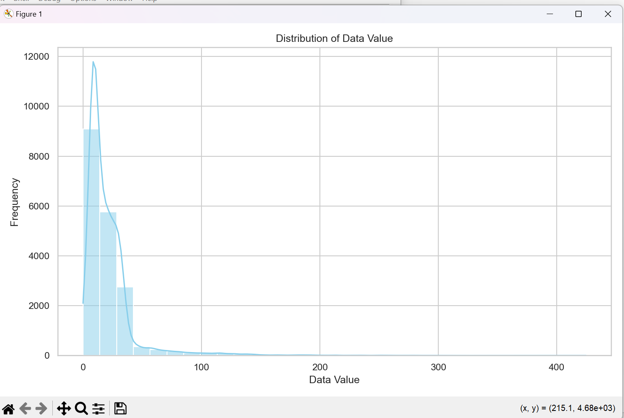
• Line Plot of Average Data Value Over Time:
Displays temporal trends of air pollution levels. Seasonal and monthly variations are observed, suggesting higher pollution in specific periods.
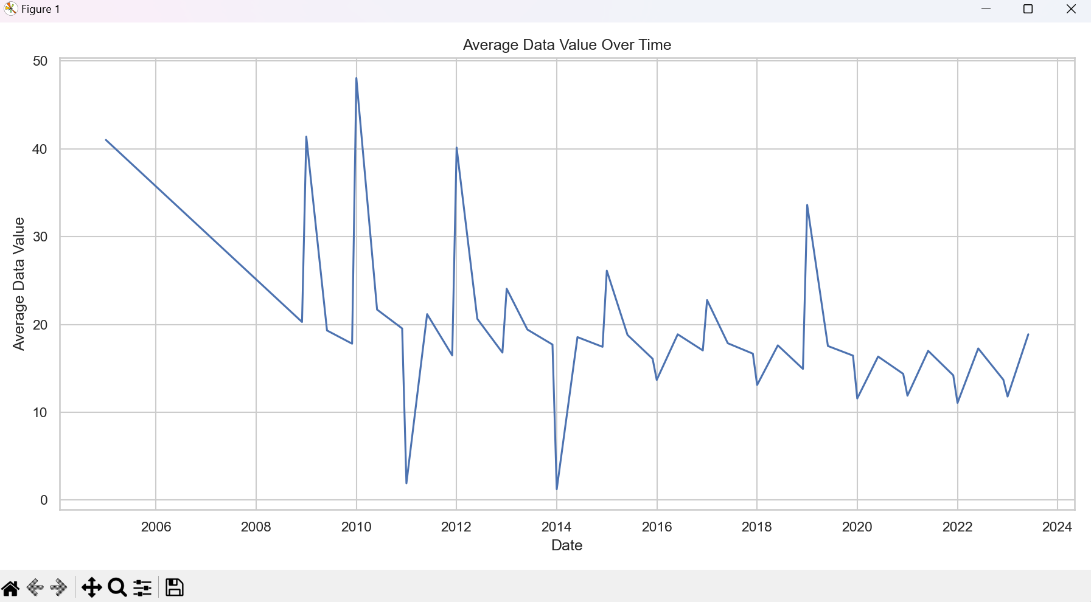
• Bar Chart – Top 10 Locations:
Lists the cities or locations with the highest mean pollution levels. These are hotspots that require urgent environmental policy attention.
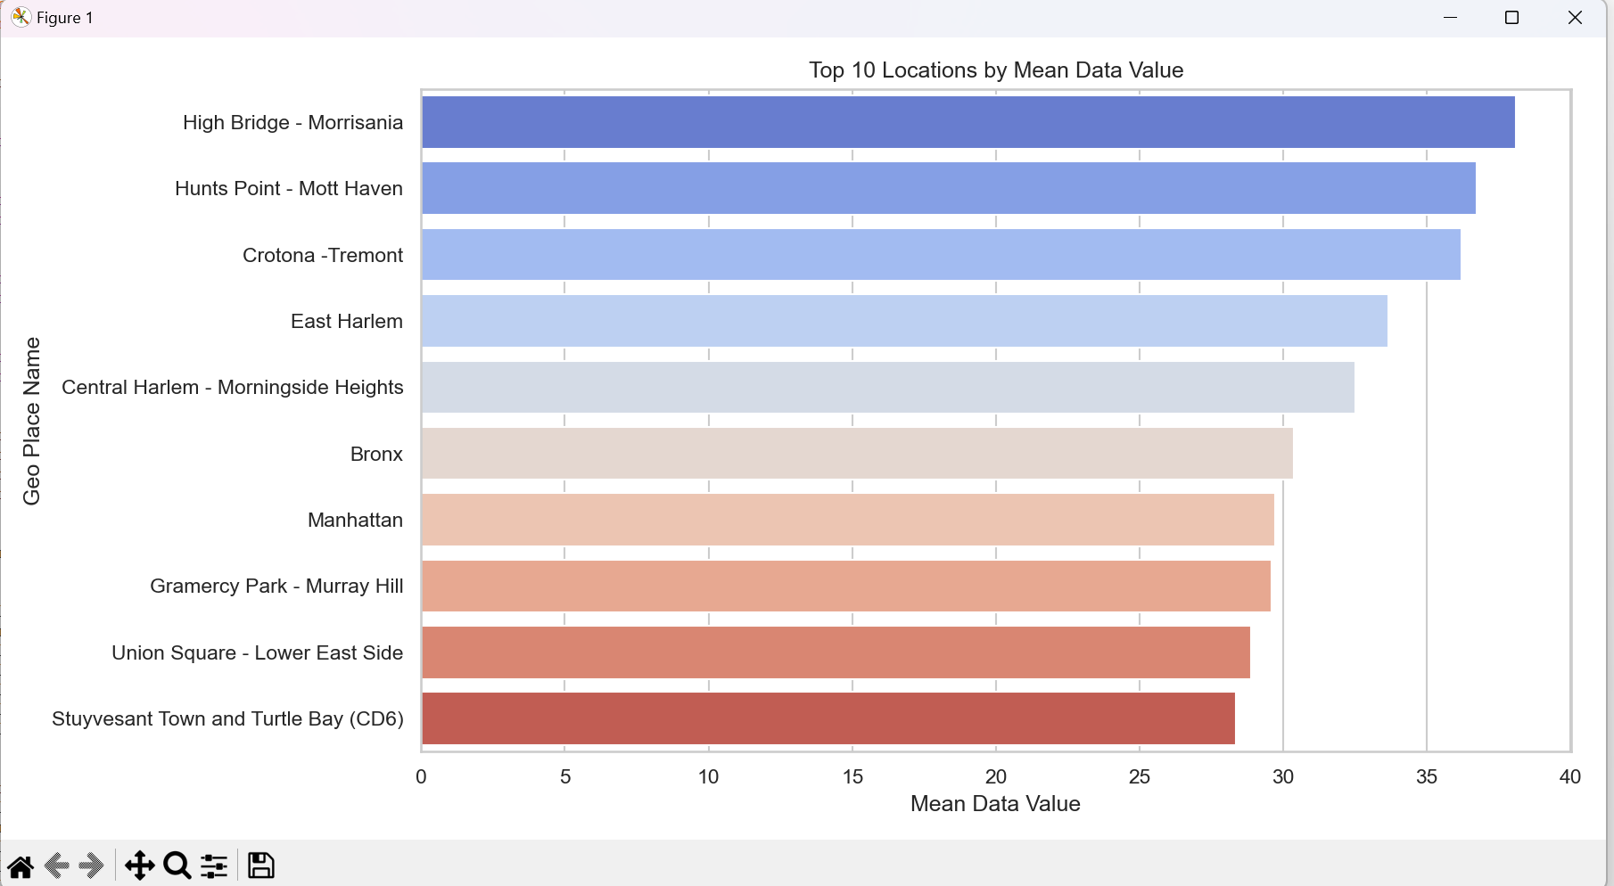
• Box Plot by Measure:
Highlights the spread of pollution readings by type (e.g., Ozone, PM2.5). Some measures show high variability and outliers.
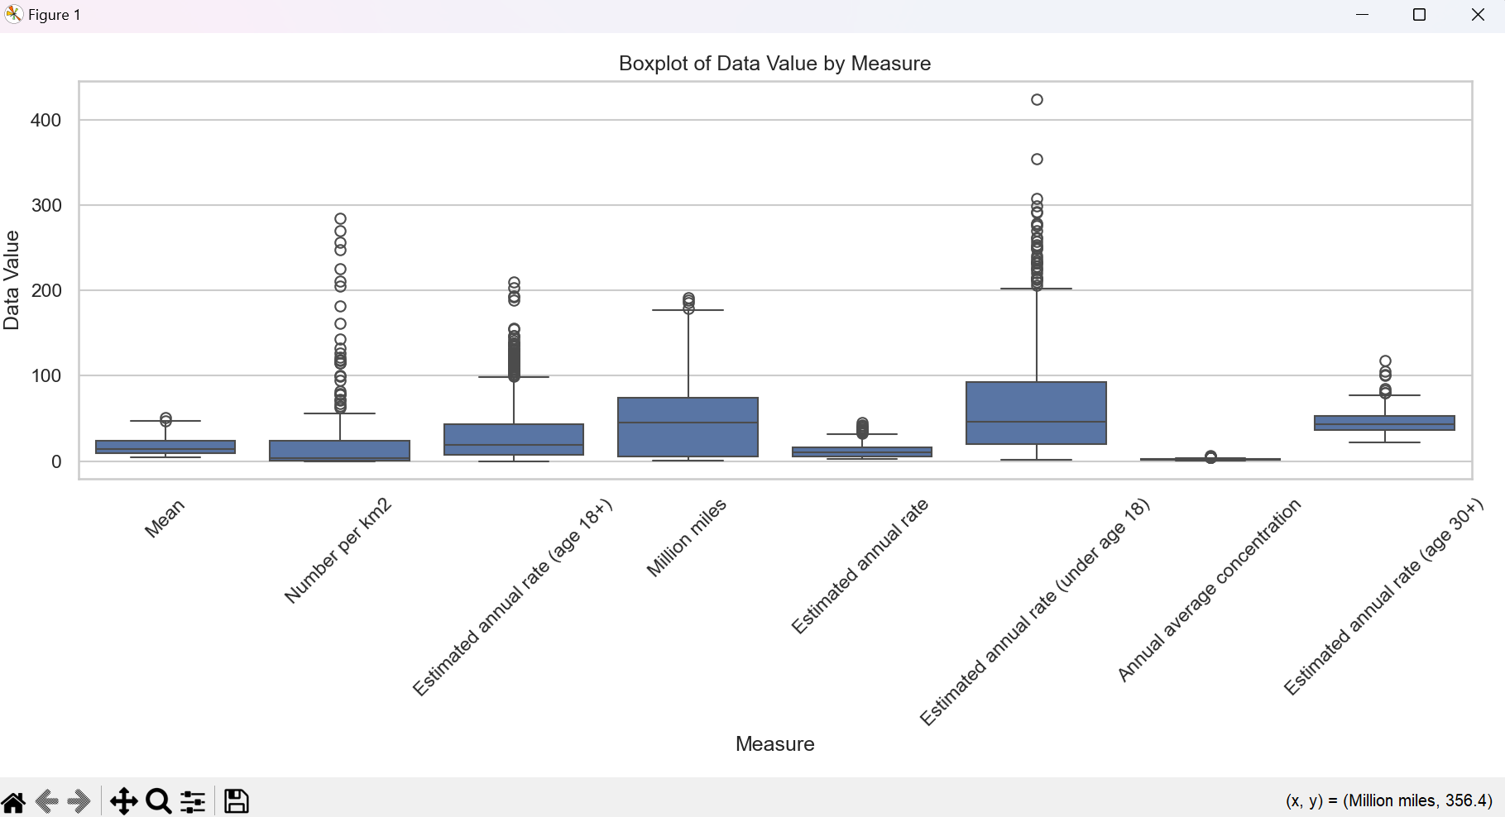
• Count Plot by Geo Type:
Indicates how many records belong to each geographical type like Boroughs, Counties, or Cities.
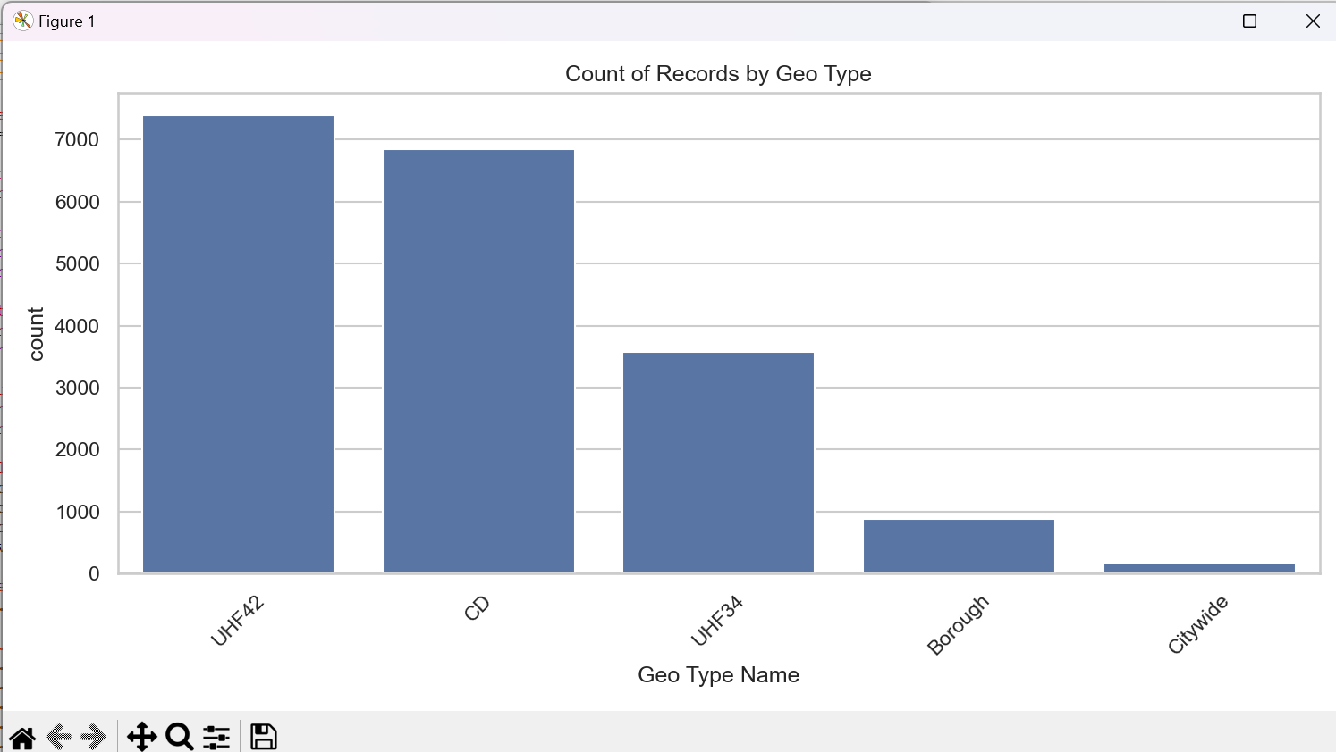
• Correlation Heatmap:
Shows relationships between numerical columns. Strong correlations can hint at overlapping pollution metrics.
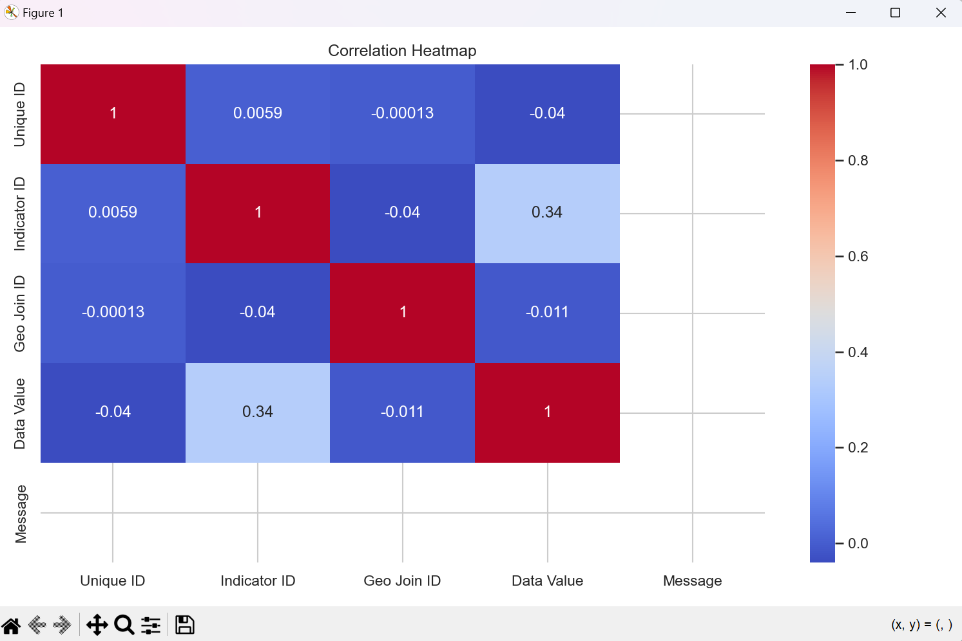
• Scatter Plot (Time Period vs Data Value):
Helps observe any irregularities or patterns over time, based on categorical time periods.
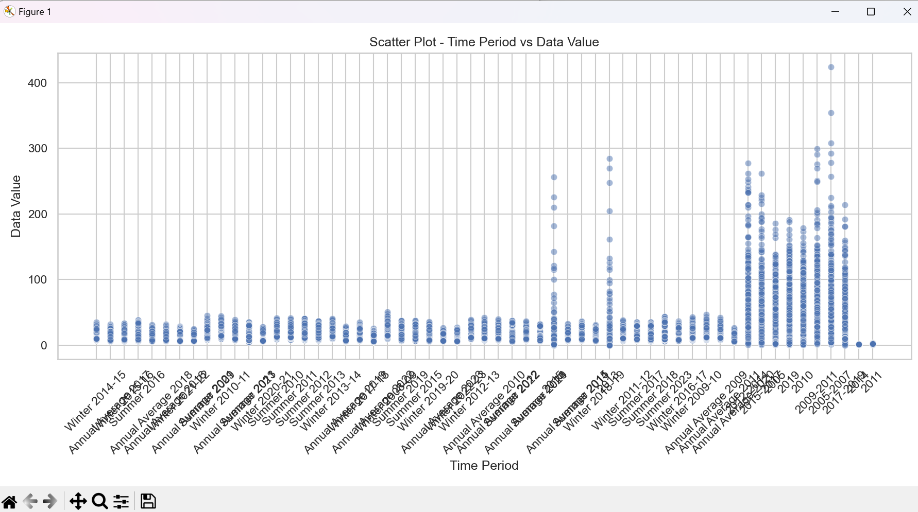
• Pie Chart – Top 5 Measures:
Breaks down the most frequently measured pollutants.
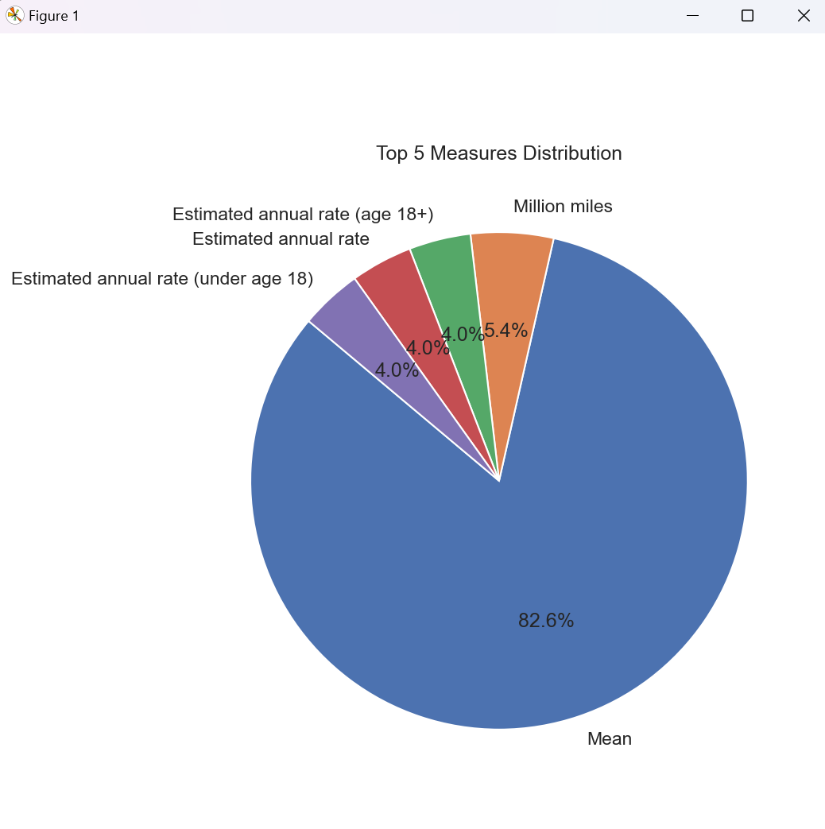

Dashboards:
Two dashboards were created:
• Dashboard 1: Combines Histogram, Line Plot, Bar Chart, and Box Plot – offering a broad overview of data distribution and trends.
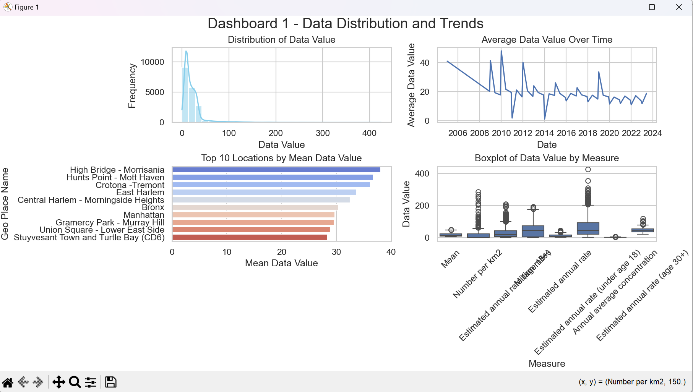
• Dashboard 2: Combines Count Plot, Heatmap, Scatter Plot, and Pie Chart – providing geo-level and measure-based insights.
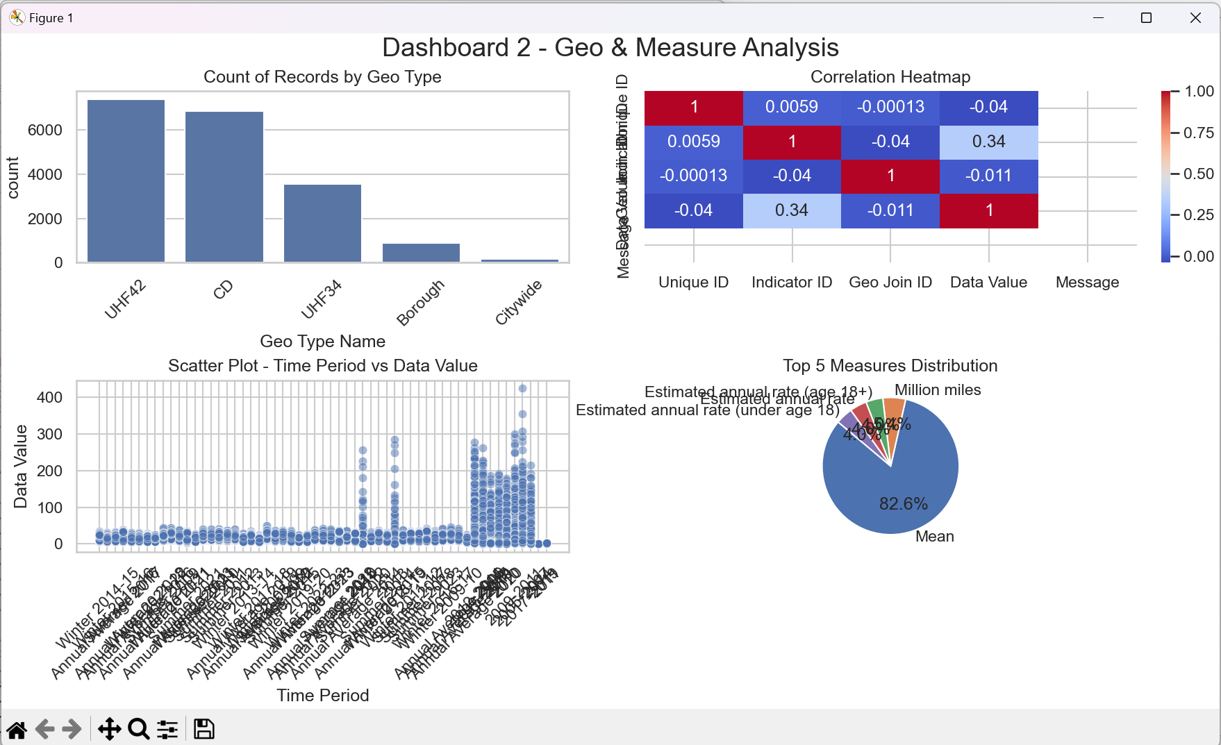

Conclusion:
The EDA performed on the air quality dataset uncovered important trends in pollution levels across different regions and time periods. The findings suggest that pollution is often localized, seasonal, and varies based on pollutant type. Visualization techniques enabled the detection of pollution hotspots, irregular time periods, and outliers that might otherwise go unnoticed. This project demonstrates the power of data analysis in driving environmental awareness and action.

Recommendations:
1. Targeted Action in High Pollution Zones:
Regions with consistently high mean data values should be prioritized for pollution control.
2. Seasonal Monitoring:
Increased monitoring in peak pollution seasons (e.g., winter) can guide preventive measures.
3. Measure-Specific Interventions:
Each pollutant type shows different behavior; tailored mitigation is required.
4. Public Awareness:
Locations with recurring pollution patterns should receive targeted environmental education and awareness drives.
5. Real-Time Dashboards:
Government agencies can implement real-time dashboards for quick decision-making.

Source Code:
The full source code for this project is implemented in Python using libraries such as Pandas, Matplotlib, and Seaborn. It includes data cleaning, processing, visualization, and dashboard generation. Please refer to the attached `.py` script titled 'Aayush.py' for detailed implementation.
Dataset link: https://catalog.data.gov/dataset/air-quality
Linkdin: https://www.linkedin.com/posts/ayush-katewa-b60642294_airquality-datascience-pythonproject-activity-7316684727237677056-15a1?utm_source=share&utm_medium=member_desktop&rcm=ACoAAEdJH_gBcR42zPfUY7p8wQvGYaZ_OP1tAvE

