

Executive Summary

December 16

Authored by: AYUSH



Executive Summary

Content:

Analysis of device insurance attach % across Jumbo & Company stores (Aug–Dec 2025)

Objectives:

Identify monthly trends in insurance adoption

Benchmark branch & store performance

Categorize stores (High/Medium/Low)

Predict January 2026 attach %

Provide actionable recommendations

Key Findings:

Monthly attach % increased from 12.86% (Aug) → 21.72% (Dec)

Pune & Delhi_NCR are top branches; Telangana & Gujarat lag

Top stores: Delhi(Hauz Khas) 62.2%, Pune(Hadapsar) 58.6%

Predicted Jan attach % ~20% average

Month-wise Trend
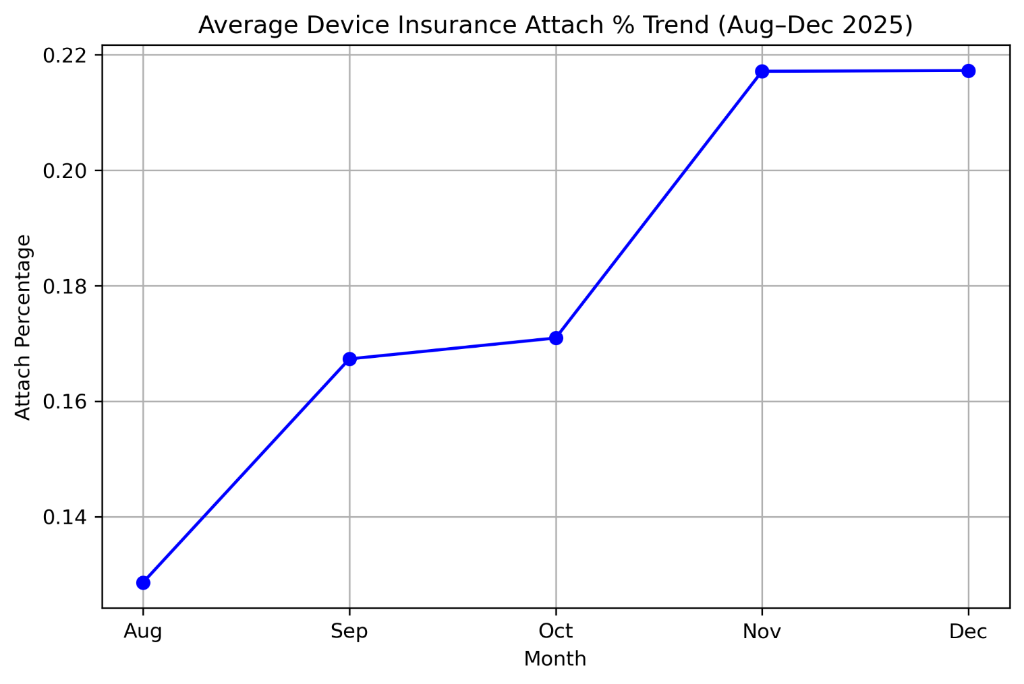
Content (Bullets):
- Steady growth: Aug 12.86% → Dec 21.72%
- High growth during festive months (Nov–Dec)
- Strategy: replicate festive promotions across stores

Branch-wise Performance
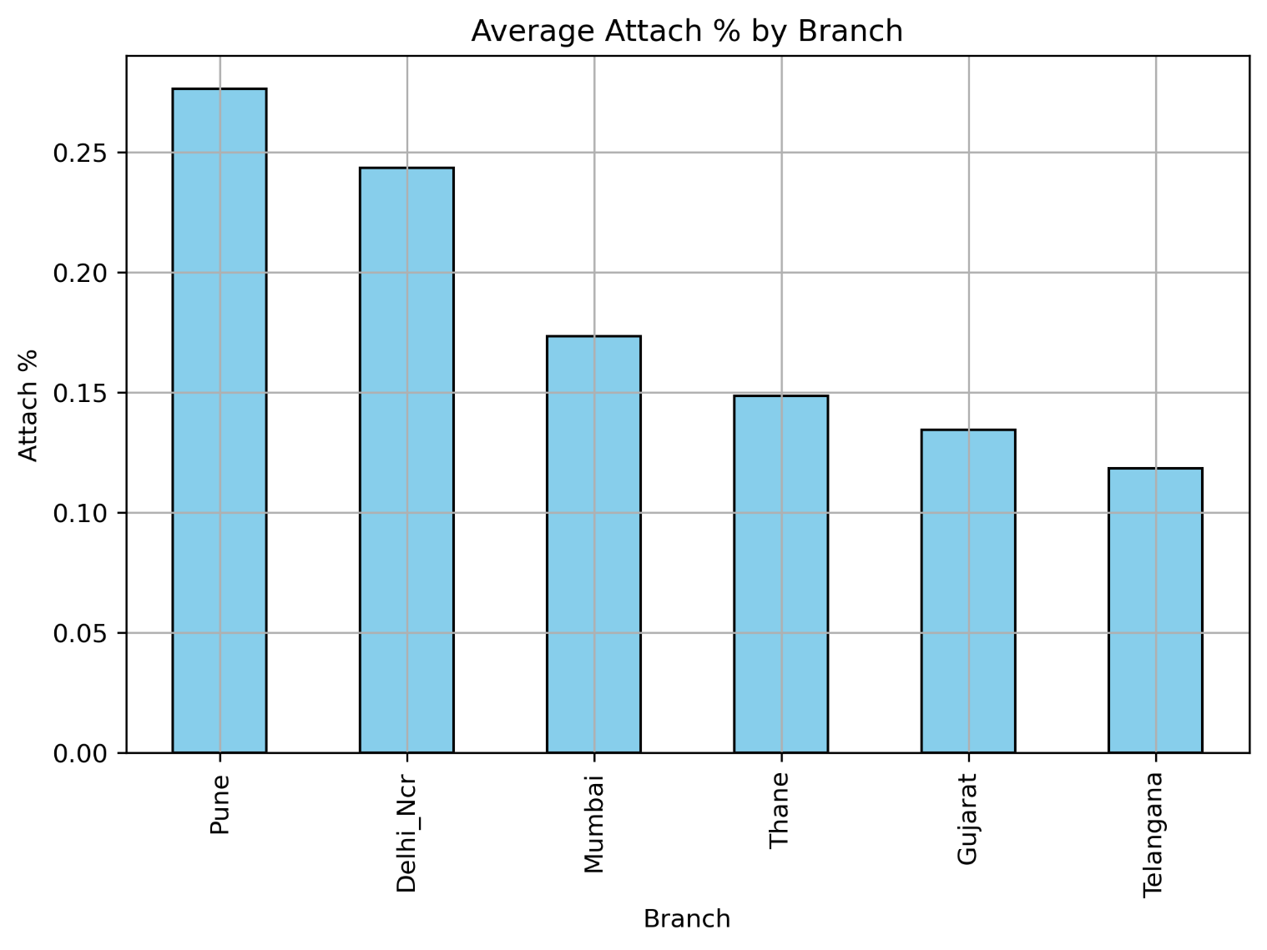
Content (Bullets):
- Top branches: Pune 27.65%, Delhi_NCR 24.37%
- Low branches: Telangana 11.83%, Gujarat 13.46%
- Strategy: replicate top branch practices, focus on low-performing branches

Store Categorization
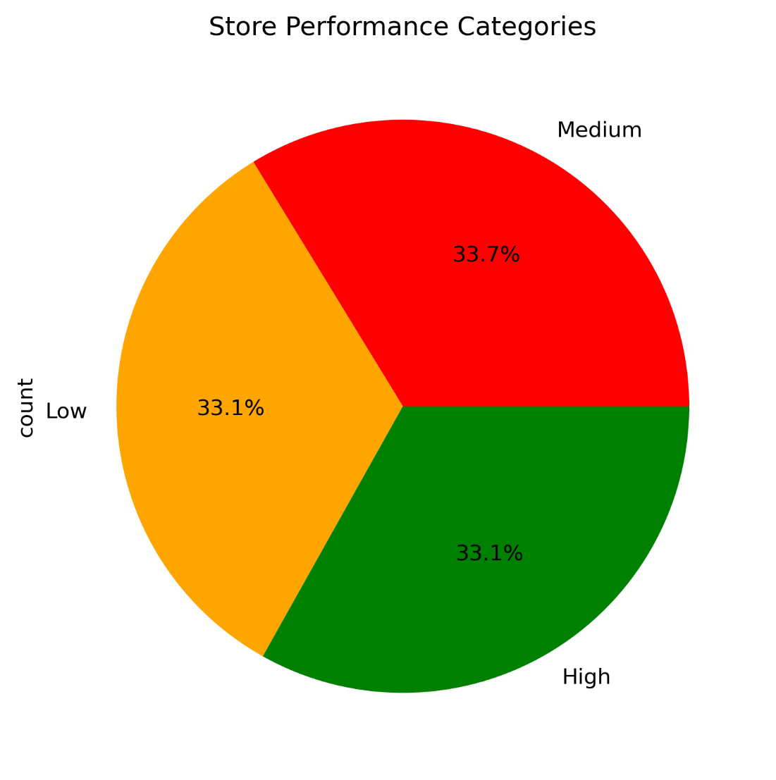
• Stores categorized into High / Medium / Low performers
• High performers: replicate best practices
• Medium: provide coaching & guidance
• Low: immediate intervention required
Top 5 Stores
TOP STORES | Branch | Attach %
Delhi(Hauz Khas) | Delhi_NCR | 62.2%
Pune(Hadapsar) | Pune | 58.6%
Pune(Kondhawa) | Pune | 41.4%
Delhi(Budh Vihar) | Delhi_NCR | 39.0%
Delhi(Daryaganj) | Delhi_NCR | 38.6%

Predicted January 2026
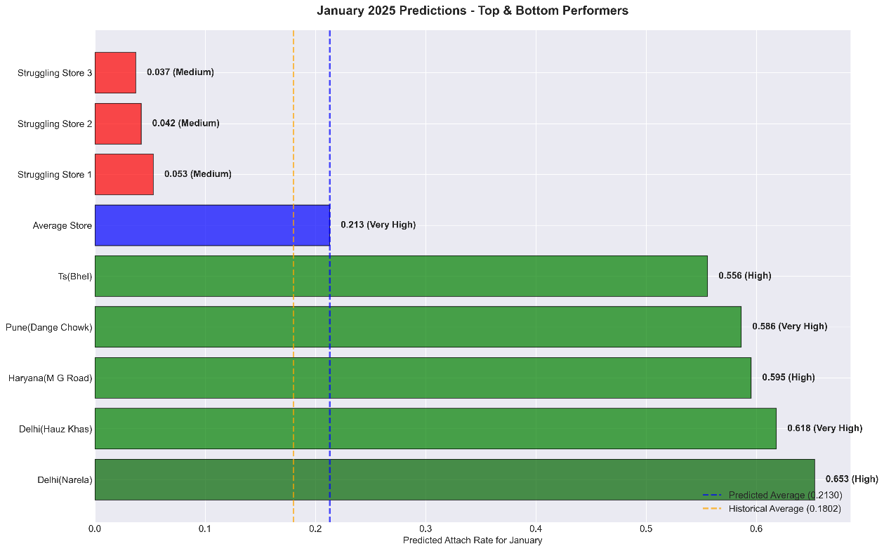

- Average predicted attach %: 20.18%
- Min: 0%, Max: 61.33%
- High-performing stores maintain leadership
- Low-performing stores need attention
metric | Value
Count | 163
mean | 20.18%
Std mean | 11.67%
min | 0.0%
25% | 12.33%
median | 18.33%
75% | 61.33%

Recommendations
1)Replicate Best Practices: Document strategies from top-performing stores and apply across medium/low-performing stores.
2) Targeted Training & Awareness: Workshops for low-performing store staff; increase customer awareness of insurance benefits.
3) Incentives & Promotions: Promotions during festive months to maximize attach %. Reward staff achieving targets.
4) Monitoring & Follow-up: Track January attach % to validate predictions and adjust strategies.

Conclusion

1) This analysis provides a comprehensive view of attach % performance across stores and branches.
2) Implementing recommendations will help:
- Improve overall attach %,
- Reduce gaps between stores,
- Increase customer adoption of insurance products,
- Achieve higher revenue from device protection plans.

