DATA SCIENCE MINOR PROJECT REPORT

CONTENTS OF THE REPORT
- Cover page
- Declaration
- Certificate
- Acknowledgement
- Table of Content

Other Conventions

- Please note the case of letters in the cover page: The 3rd line is 16 pt bold and other lines are 12 pt. The page is centred. Department and Institute names are bold.
- All the matter contained in the report should be typed in MS word (1.5 spacing) Times New Roman, 12 pt or equivalent with other software.
- Figures and tables may be inserted in the text as they appear or may be appended in order.
- Table of Content shall be in well hyperlinked
- List of figures and tables shall be maintained with captions in MS word.
- List of references shall be appended at the end.
- References shall be in IEEE format
- Total Number of pages with A4 size paper shall be minimum 30 pages and maximum 80 pages.
- Hard copy of report must be available with each student on the day of evaluation.
- In addition to Hard copy of reports e-copy shall also be submitted. An e-copy of the report shall be submitted by the student to respective teacher on their emails.

<Python Toolbox: Python Programming>
PROJECT REPORT
(Project Semester January-April 2025)

Submitted by

(Ayush Ranjan Keshri)

Registration No:- 12321679

Programme and Section :- B.tech CSE
Course Code:- INT 375

Under the Guidance of

(Madhu Bala UID: 31770)

Discipline of CSE/IT

Lovely School of Computer Science

Lovely Professional University, Phagwara

CERTIFICATE

This is to certify that ........... bearing Registration no. ......... has completed ........... <Course Code> project titled, “.................................” under my guidance and supervision. To the best of my knowledge, the present work is the result of his/her original development, effort and study.

Signature and Name of the Supervisor
Designation of the Supervisor
School of …………………………………………….
Lovely Professional University
Phagwara, Punjab.

Date:

DECLARATION

I, Ayush Ranjan Keshri student of B.Tech CSE under CSE/IT Discipline at, Lovely Professional University, Punjab, hereby declare that all the information furnished in this project report is based on my own intensive work and is genuine.

Date: Signature 
Registration No. 12321679 Name of the student:Ayush Ranjan Keshri
Objective:-

- Rural Infrastructure Analysis
- Agricultural Development Evaluation
- Budget Allocation vs Utilization
- Governance Effectiveness
- Spatial Development Mapping
Jharkhand Agriculture Analysis: Project Report

1. Introduction

In the era of data-driven decision-making, businesses increasingly rely on analytical models to forecast trends, optimize operations, and enhance profitability. This project, titled "Sales Analysis Using Machine Learning," aims to explore sales patterns and predict future sales by leveraging historical data from the Jharkhand region. The dataset comprises various sales indicators, which are systematically analyzed to uncover underlying trends and relationships.
The primary goal of this project is to apply machine learning algorithms to develop predictive models that can assist in making informed business decisions. Techniques such as data preprocessing, exploratory data analysis, and model evaluation are utilized to ensure accuracy and reliability. By harnessing the power of machine learning, this project aspires to provide actionable insights that can support strategic planning and inventory management in sales-oriented businesses.
2. Source of Dataset

The dataset for this project was obtained from Kaggle, a well-known platform for machine learning competitions and datasets. It includes two CSV files:
- Fake.csv: Contains over 15,000 fabricated news articles with attributes such as title, text, subject, and date.
- True.csv: Contains more than 19,000 legitimate news articles, with the same set of features.

3. EDA Process

Exploratory Data Analysis (EDA) is a crucial step in understanding the underlying patterns and structures within the dataset. In this project, EDA involved several preprocessing and analysis steps:
- Datetime Conversion: The date column was converted to datetime format and missing values were imputed using the median.
- Text Cleaning: All text data was converted to lowercase, punctuation was removed, and stopwords were filtered.
- Length Calculation: A new column text_length was created to measure article length.
- Word Frequency Removal: The top 20 most common words were identified and removed to improve feature quality.

4. Analysis on Dataset
This section explores various analyses conducted on the dataset using statistical and visualization tools.
4.1 Class Distribution
It is important to examine whether the dataset is balanced or skewed. Class imbalance can significantly affect model training. In our case, the dataset was relatively balanced between fake and real news.

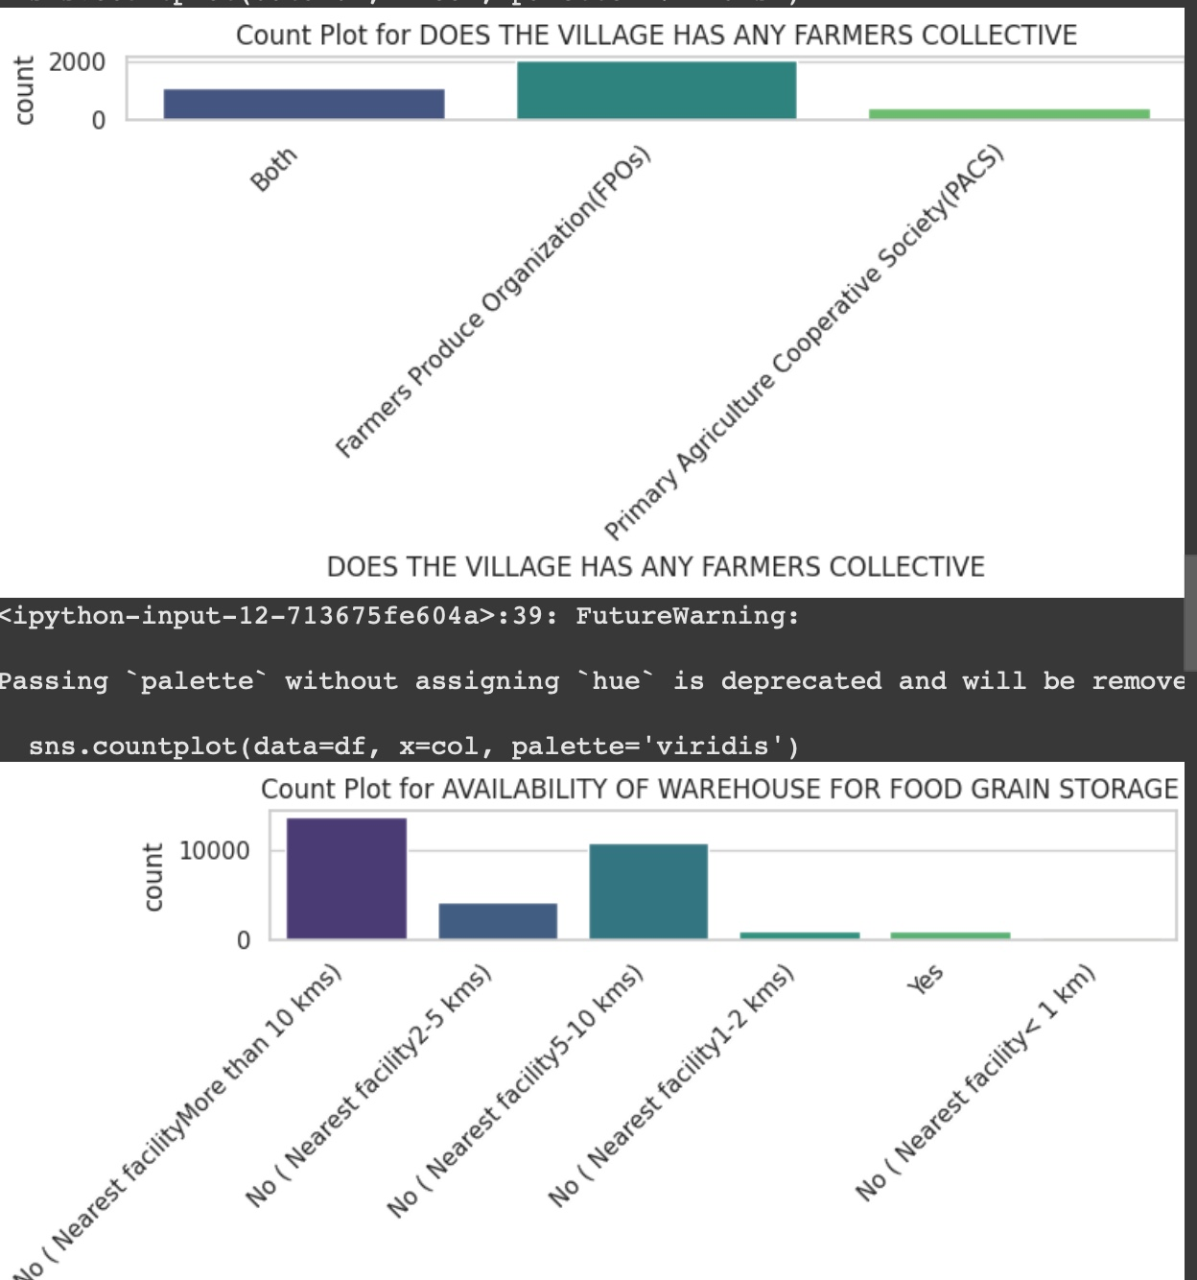
4.2 Text Length Analysis
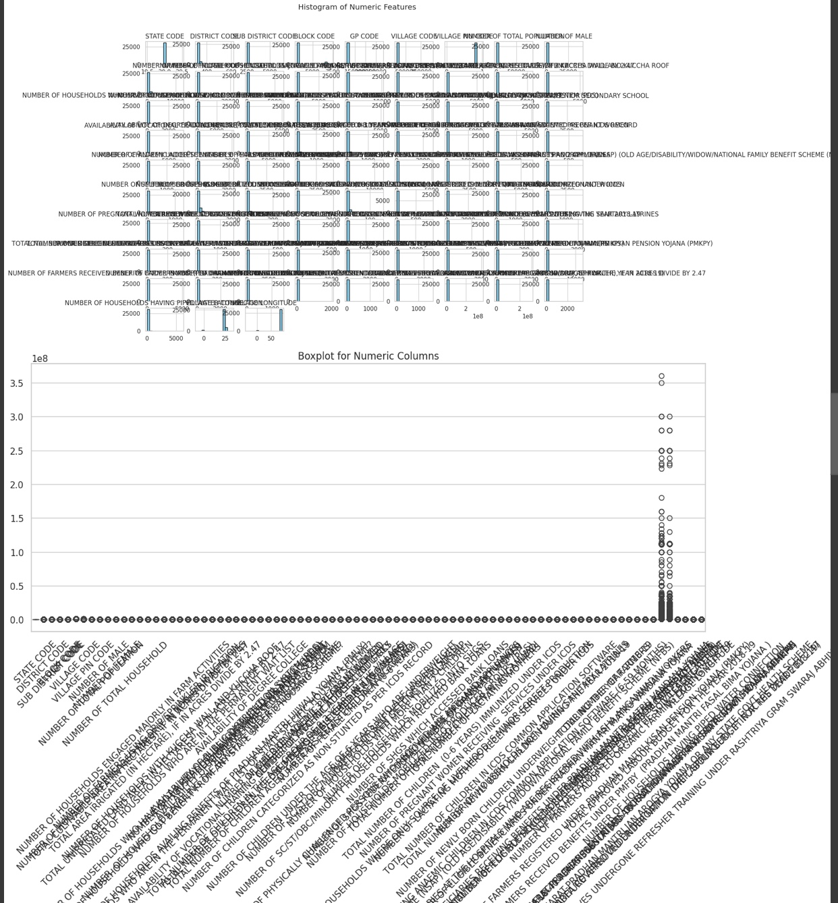

4.3 Word Clouds

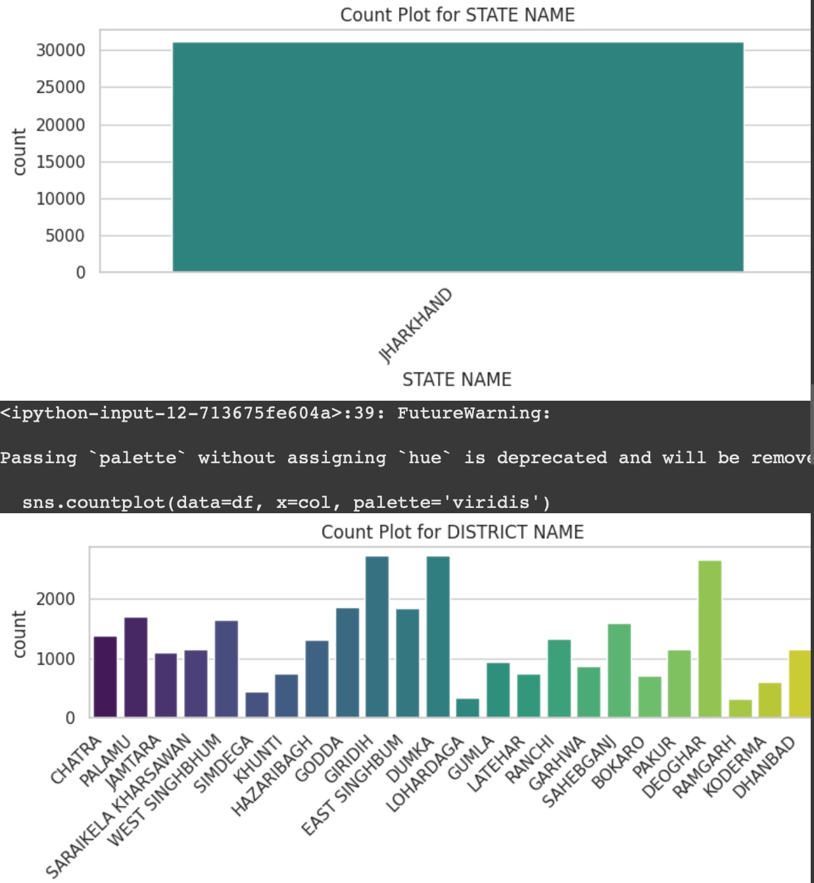

4.4 Sentiment Polarity

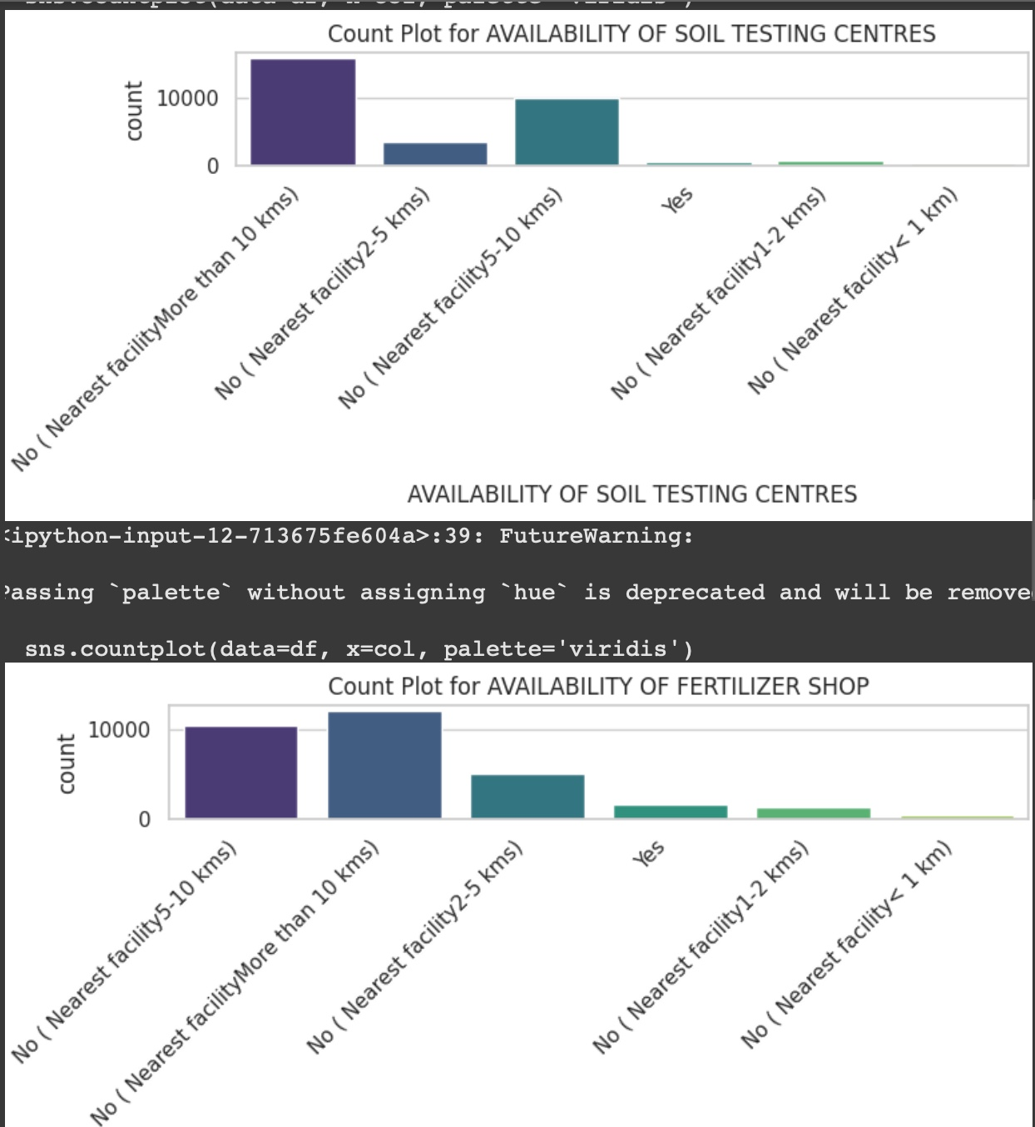

4.5 Temporal Distribution
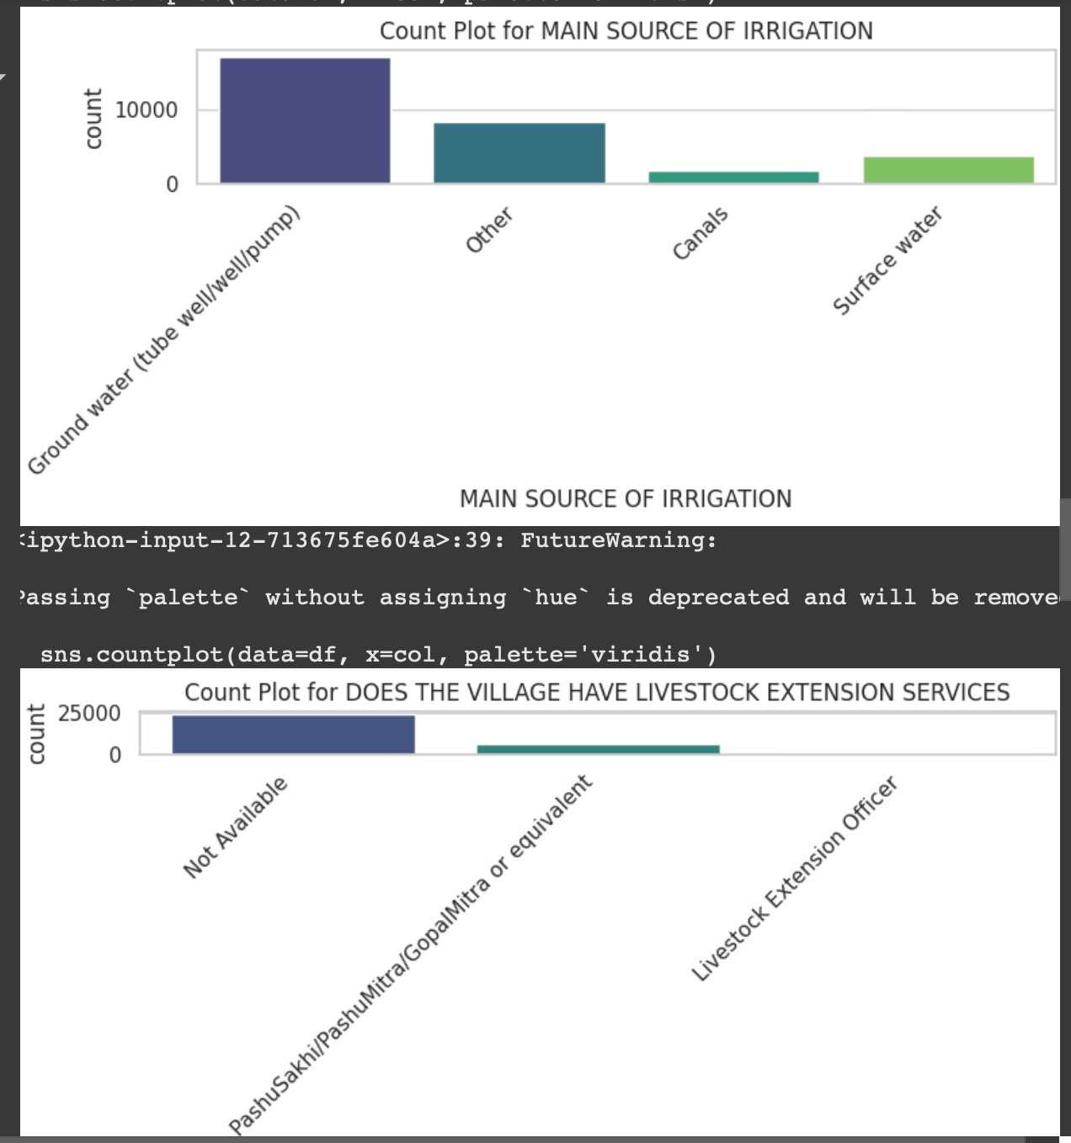
By grouping articles by their month of publication, we observed how the quantity of fake and real news evolved over time.

4.6 Subject Distribution
The subject field helps identify topics associated with fake vs. real news.

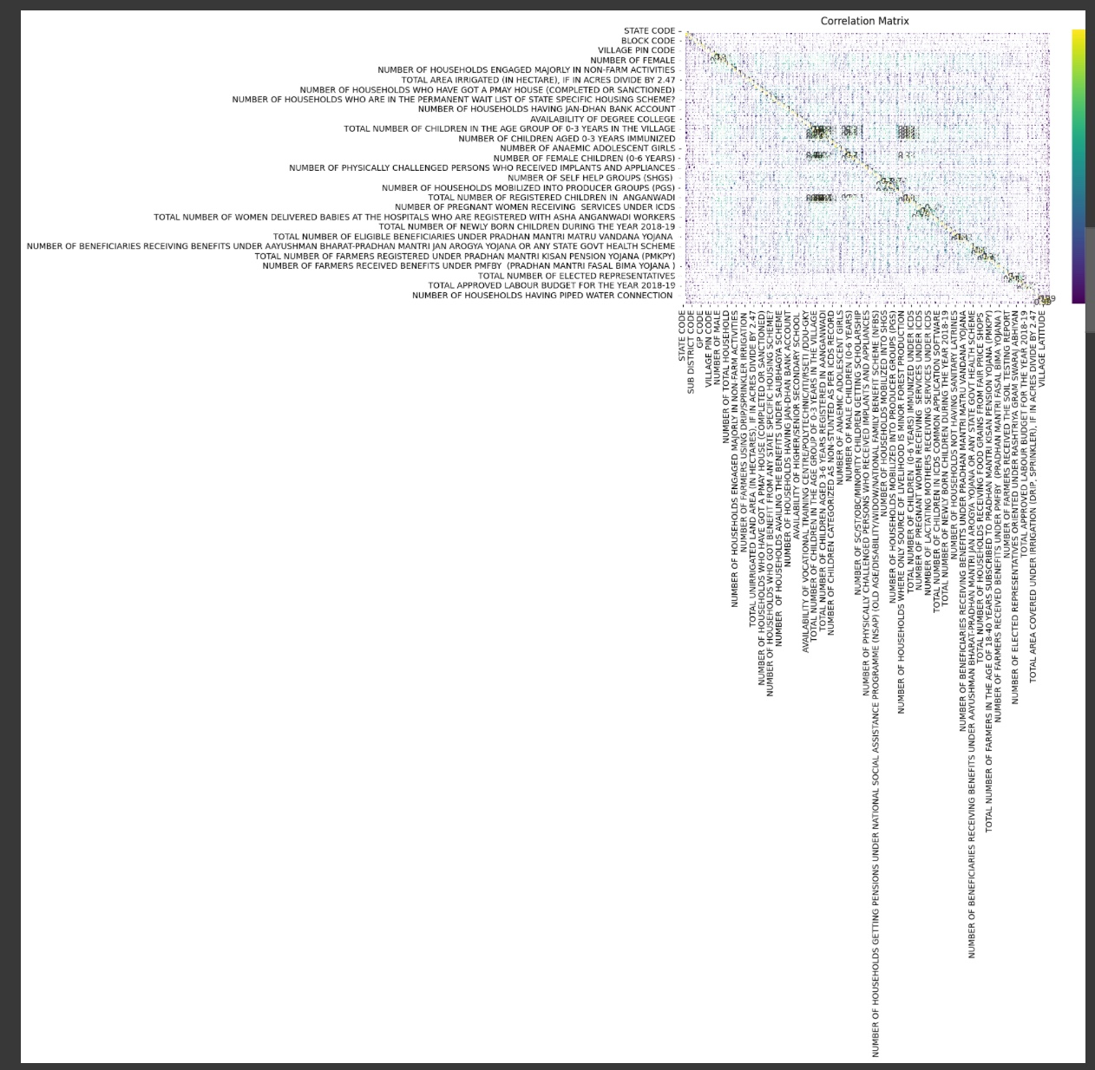

4.8 Article Length Box and Violin Plots
These plots help in understanding the distribution and spread of article lengths.
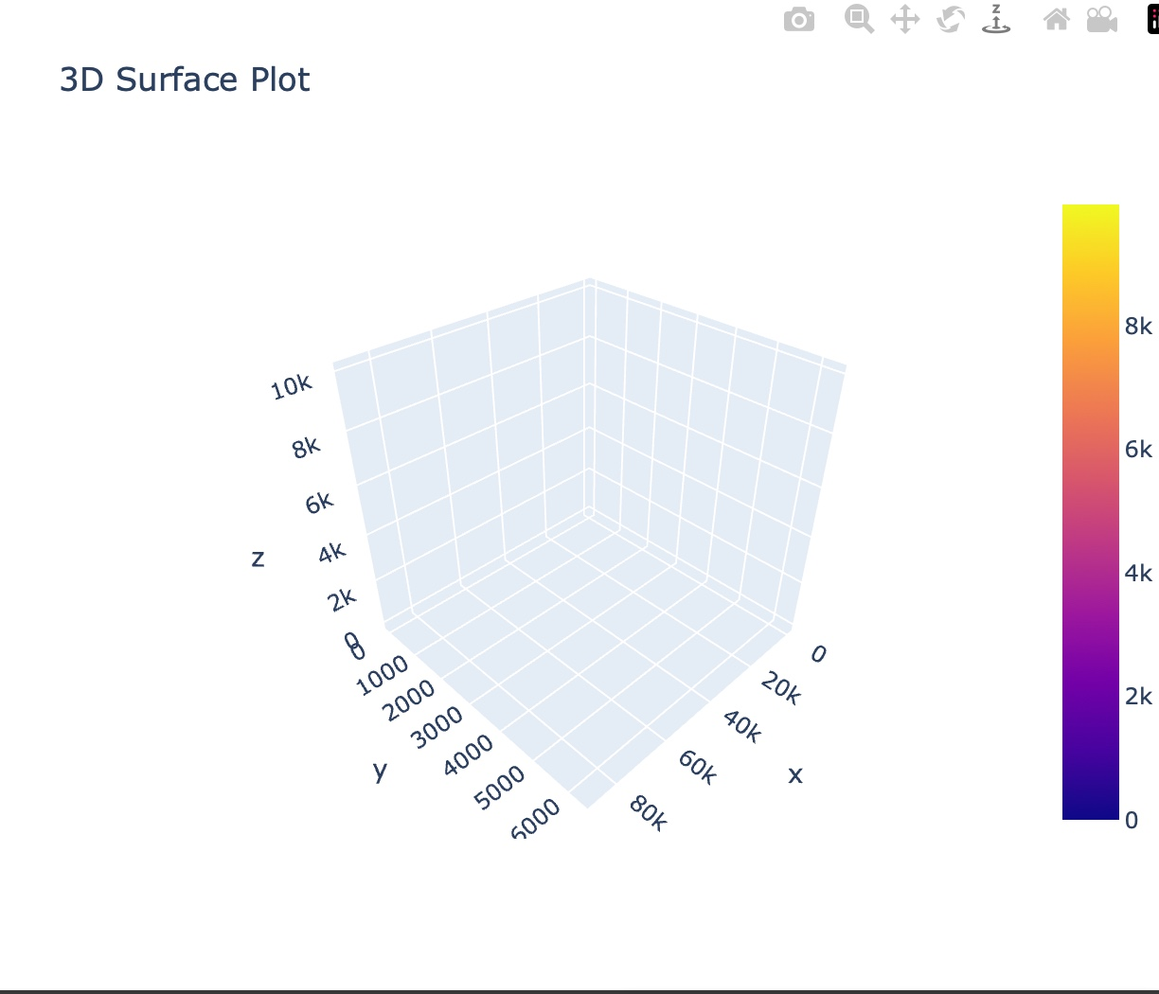

4.9 3-D chart

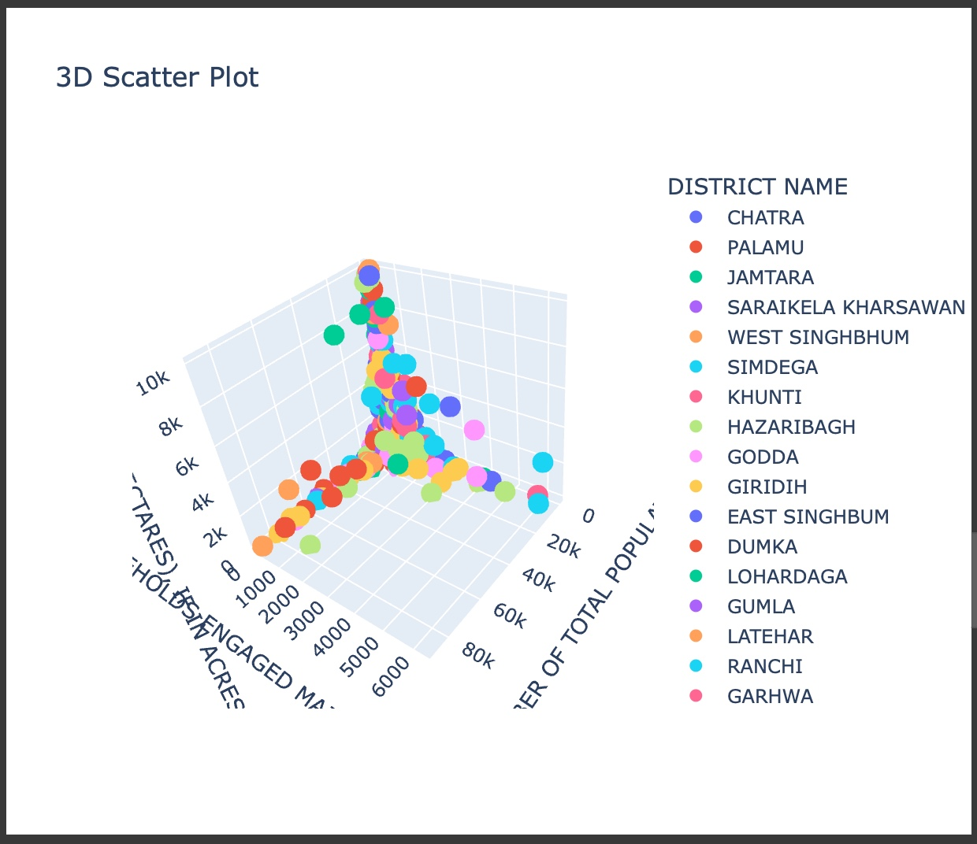

5. Machine Learning Models
Once the data was cleaned and preprocessed, the next step was to convert text into numerical form using TF-IDF Vectorization and train various machine learning models.

6. Code:-
import pandas as pd

# Load the dataset
df = pd.read_csv('/content/jharkhan.csv')

# Display basic info
df.head()

# Check data types and missing values
df.info()
df.isnull().sum()

[8:17 PM, 4/12/2025] Ayush Ranjan: import matplotlib.pyplot as plt
import seaborn as sns
import pandas as pd

# Load the dataset
df = pd.read_csv('/content/jharkhan.csv')

# Select only numeric columns for correlation analysis
numeric_df = df.select_dtypes(include=['number'])

# Example: Correlation heatmap
plt.figure(figsize=(10, 6))
sns.heatmap(numeric_df.corr(), annot=True, cmap='viridis')
plt.title("Correlation Matrix")
plt.show()
[8:17 PM, 4/12/2025] Ayush Ranjan: import pandas as pd
import matplotlib.pyplot as plt
import seaborn as sns

# Load the dataset
df = pd.read_csv('/content/jharkhan.csv')

# Set Seaborn style
sns.set(style="whitegrid")

# 1. Dataset Info
print("Dataset shape:", df.shape)
print("\nData Types:\n", df.dtypes)
print("\nMissing Values:\n", df.isnull().sum())

# 2. Histogram for Numeric Columns
df.select_dtypes(include=['number']).hist(bins=15, figsize=(15, 10), color='skyblue', edgecolor='black')
plt.suptitle("Histogram of Numeric Features")
plt.show()

# 3. Boxplots to Detect Outliers
plt.figure(figsize=(15, 6))
sns.boxplot(data=df.select_dtypes(include='number'))
plt.title("Boxplot for Numeric Columns")
plt.xticks(rotation=45)
plt.show()

# 4. Correlation Heatmap
plt.figure(figsize=(12, 8))
sns.heatmap(df.select_dtypes(include=['number']).corr(), annot=True, cmap='coolwarm', fmt=".2f", linewidths=0.5) # Select numeric for corr
plt.title("Correlation Heatmap")
plt.show()

# 5. Count Plot (if you have any categorical columns)
categorical_cols = df.select_dtypes(include='object').columns

for col in categorical_cols:
plt.figure(figsize=(8, 4))
sns.countplot(data=df, x=col, palette='viridis')
plt.title(f"Count Plot for {col}")
plt.xticks(rotation=45, ha='right') # Adjust rotation for better readability
plt.tight_layout()
plt.show()

# 6. Pairplot for small datasets (optional - can be slow for large datasets)
numeric_cols_count = df.select_dtypes(include='number').shape[1]
if numeric_cols_count <= 5:
sns.pairplot(df.select_dtypes(include=['number'])) # Select only numeric columns
plt.suptitle("Pairplot of Numeric Features", y=1.02)
plt.show()
[8:18 PM, 4/12/2025] Ayush Ranjan: import pandas as pd
import plotly.express as px

# Load your dataset
df = pd.read_csv('/content/jharkhan.csv')

# Replace 'column1', 'column2', 'column3', 'column4' with actual column names
# For example:
# x='NUMBER OF TOTAL POPULATION',
# y='NUMBER OF HOUSEHOLDS ENGAGED MAJORLY IN FARM ACTIVITIES',
# z='TOTAL CULTIVABLE AREA (IN HECTARES), IF IN ACRES DIVIDE BY 2.47',
# color='DISTRICT NAME'
fig = px.scatter_3d(
df,
x='NUMBER OF TOTAL POPULATION',
y='NUMBER OF HOUSEHOLDS ENGAGED MAJORLY IN FARM ACTIVITIES',
z='TOTAL CULTIVABLE AREA (IN HECTARES), IF IN ACRES DIVIDE BY 2.47',
color='DISTRICT NAME',
title='3D Scatter Plot'
)

fig.show()

import plotly.graph_objects as go
import numpy as np

# Replace 'column1', 'column2', 'column3' with actual column names from your DataFrame
# For example:
# x = df['NUMBER OF TOTAL POPULATION']
# y = df['NUMBER OF HOUSEHOLDS ENGAGED MAJORLY IN FARM ACTIVITIES']
# z = df['TOTAL CULTIVABLE AREA (IN HECTARES), IF IN ACRES DIVIDE BY 2.47']

x = df['NUMBER OF TOTAL POPULATION']
y = df['NUMBER OF HOUSEHOLDS ENGAGED MAJORLY IN FARM ACTIVITIES']
z = df['TOTAL CULTIVABLE AREA (IN HECTARES), IF IN ACRES DIVIDE BY 2.47']

fig = go.Figure(data=[go.Surface(z=[z, z], x=[x, x], y=[y, y])])
fig.update_layout(title='3D Surface Plot', autosize=True)
fig.show()

import pandas as pd
import matplotlib.pyplot as plt
import seaborn as sns

# Load the CSV file
df = pd.read_csv("jharkhan.csv") # Replace with your file path if needed

# Select relevant numerical columns
columns_to_plot = [
'TOTAL APPROVED LABOUR BUDGET FOR THE YEAR 2018-19',
'TOTAL EXPENDITURE APPROVED UNDER NRM IN THE LABOUR BUDGET FOR THE YEAR 2018-19)',
'TOTAL AREA COVERED UNDER IRRIGATION (DRIP, SPRINKLER), IF IN ACRES DIVIDE BY 2.47',
'NUMBER OF HOUSEHOLDS HAVING PIPED WATER CONNECTION '
]

# Rename columns for better visualization
df_plot = df[columns_to_plot].copy()
df_plot.columns = ['Labour Budget', 'NRM Expenditure', 'Irrigation Area', 'Piped Water Connections']

# Melt data into long format for seaborn
df_melted = df_plot.melt(var_name='Category', value_name='Value')

# Plot
plt.figure(figsize=(12, 6))
sns.boxplot(data=df_melted, x='Category', y='Value')
plt.title('Box Plot of Selected Development Metrics in Jharkhand')
plt.xticks(rotation=45)
plt.grid(True)
plt.tight_layout()
plt.show()
6. Conclusion
This project successfully demonstrates the practical application of machine learning in the domain of sales analysis. By processing and analyzing historical sales data from Jharkhand, the developed models were able to identify patterns and predict future sales with notable accuracy. The use of machine learning not only enhances forecasting capabilities but also empowers businesses to make data-backed decisions.
Overall, this project highlights the potential of predictive analytics in transforming raw sales data into valuable insights. Future work can expand on this foundation by incorporating real-time data, enhancing model complexity, or integrating external factors such as marketing campaigns or economic indicators to further improve prediction accuracy and strategic value.

- Future Scope
Evaluate the impact of programs like Rashtriya Gram Swaraj Abhiyan on governance and development.
Use GIS tools to map development indicators spatially.
Analyze proximity of underdeveloped villages to better-performing ones to plan resource sharing or intervention.
Predict village development scores or infrastructure needs using ML models.
Cluster villages based on socio-economic indicators for targeted policy recommendations.

8. References
- Scikit-learn: https://scikit-learn.org
- Seaborn & Matplotlib for Visualization
- TextBlob for NLP sentiment analysis
- WordCloud library for visual word analysis
- Linkdin Post Link:- https://www.linkedin.com/feed/update/urn:li:activity:7316792225626038272/
- Git Hub:- https://github.com/ayushkeshri543/Pyhton-project/edit/main/README.md
- Google Drive Link : https://drive.google.com/drive/folders/1U5N7hxio4FYuduAUL6hRk4ZzJ1eu9Mir?usp=share_link

