Invention Disclosure Form

Please provide the following information:

- INVENTOR(S) INFORMATION:-

- INVENTOR(1) INFORMATION

Name |  | Address
Mobile
Email

- INVENTOR(2) INFORMATION

Name | Astha | Address | Dayananda Ashram, Muni Ki Reti, Rishikesh
Mobile | 8126817259
Email | asthasengar2088@gmail.com

- INVENTOR(3) INFORMATION

Name | Ayush Koli | Address | Bhattnagari Ranipokhari Dehradun
Mobile | 9389083196
Email | ayushkoli976105@gmail.com

- INVENTOR(4) INFORMATION

Name | Palak | Address | Ram Nagar Danda Thano,  Dehradun
Mobile | 7505782984
Email | palakmanwal9@gmail.com

- Applicant (S) INFORMATION:-
Applicant(1) INFORMATION

Name |  | Address
Mobile
Email

- List the countries in which you wish to seek patent protection:

IN India

- INVENTION INFORMATION

- Title of the invention: (not more than 15 words…).

Online Learning Management System (LMS)

- Invention Domain/technical field? Specify, if more than one domains are involved.

Education Technology, Cyber Security, Web Applications, Identity and Access Management (IAM)

- Please describe invention crux in layman terms (not more than 500 words). Do not assume any technical terms. One or more examples can be included.
The educational platform functions as a secure system which protects against unauthorized access and eliminates proxy attendance. The system implements four various security bridge which establishes secure connections between Students, Instructors, Admin and Parents.
- Login Security: The system implements an email-based One-Time Password (OTP) authentication method which have a time limit of 5 minutes before the password becomes invalid.
- Classroom Integrity: The "Live Session Code" is generated by the lecturers themselves in their respective classes. This very code is entered by students to mark their presence and ensure that they are present during the whole session.
- Parental Oversight: Parents receive secure read-only access through "Parent Access" which enables them to view their child's records(Like Attendance,Result). The system requires parents to complete separate OTP verification for access which protects student data while allowing transparency.
- Please describe background of the invention. (what are the current problems which invention solves). The problems could have other solutions elsewhere. But please focus on how the current invention is solving those problems?
Educational institutions including schools, universities and training centers utilize online learning systems to manage their class scheduling time, attendance monitoring, assignment distribution/submission and communication between students and faculty. The current systems face major Operational problems because their existing mechanisms restrict their capacity to function properly and protect their systems from malicious attacks. Most online learning platforms today are primarily gripped by the security challenges originating from vulnerabilities present in user authentication systems.The majority of systems allow users to create accounts through two elements which are their password and their fundamental identification data. The system allows unauthorized users to create fake accounts which enable them to access the system unlawfully, crashing of the website and use the system in an inappropriate manner. The password-based security system suffers from frequent breaches which establish privacy violations and diminish user trust. The system presents another significant challenge because it requires students to provide proof of their attendance. The traditional online attendance systems enable proxy attendance because they rely on either manual marking or basic click methods. Students can mark attendance for their fellow students while teachers do not possess reliable methods to confirm student attendance in classrooms. Biometric systems require substantial costs to operate while they also raise privacy concerns and create implementation difficulties for online use.
Today educational platforms face their most serious problem because most parents do not engage in their children's educational activities. The current educational systems used by multiple institutions do not enable parents to access their children's academic records and attendance information through secure verification methods. Parents use indirect communication methods because they lack secure access to their children's academic details which makes it difficult for them to understand their child's progress and to take action when needed. The educational institutions face difficulties in managing their scheduled activities. The process of creating timetables through manual methods takes too much time and sometimes result in improper management because it results in mistakes that create class schedule collisions and teacher availability problems. The existing solutions present difficulties because they need extra equipment or they operate in an overly complicated way. The current learning platforms depend on third-party plugins which serve as their main element because these plugins deliver core functions such as user authentication and attendance and scheduling capabilities.The system becomes more complicated because new security threats emerge while users face problems because their requirements remain unfulfilled. The present invention solves these issues by providing a secure and integrated online learning system. The system uses a one-time code verification process to authenticate user identity during login which blocks fake users from accessing the system. The system uses session-based one-time codes to secure attendance because this method ensures that only students who attend classes will receive attendance marks and it prevents students from using proxies to attend classes. The invention enables parents to access a special system which lets them securely access their child's attendance records and academic performance information while preventing them from changing any details. The system uses automated timetable generation which helps to minimize both scheduling conflicts and the work required for administrative tasks. The invention creates a unified system which provides all required features because it allows users to work without needing external tools while protecting security and making the system easier to use and helps in building trust in digital education platforms.
- What is the novelty of the invention? Please describe in layman terms. If the current invention is an incremental innovation over an existing invention, please focus only on the incremental part. In effect, we are trying to identify the most essential novel elements of this invention. One or more examples can be included.
The main innovation or nobility of this system is its asynchronous verification loop, which uses multiple verification factors. The system implements four distinct roles for students, instructor, admin and parents through its central verification system.
- The Incremental Innovation: Installation of an electronic automated registration system by the instructor would enhance efficiency in attendance records.
- Parental Linkage: The system establishes a "Parent Access" link to the "Student Role" through secure cryptographic methods which enable users to access particular data after they complete SMTP-OTP verification.
- Please describe the invention in very detailed manner (not more than 10 pages, unless invention demands). Include diagrams to assist in the description. Provide details of each cited figure.
The present invention is a Online Learning Management System (LMS) architected through its client-server design to create a protected academic environment which requires authentication and assigns different user roles. The system operates with multi-tier logic to manage user data and educational content distribution and attendance monitoring functions.
- System Logic and High-Level Data Flow (DFD Level 0 & 1)
The system operates as a central system which establishes connections to four primary user groups. The user groups of the system include Students, Instructors, Administrators, and Parents. The Data Flow Diagrams (DFD) demonstrate the basic design of the system.
- Authentication Flow: The User begins the process by submitting a "Login Request" which the system processes through "Manage Authentication" system. The system authenticates users by using "User Data" storage to verify their credentials and produce an "Authentication Response".

- Instructional Workflow: Instructors create course materials together with student grades and attendance records which they send to students and parents through secure "Notifications" and "Announcements" systems.
- Administrative Oversight :The Admin entity controls "Manage Enrollment" together with "Submission Requests" to make sure proper role assignment happens for each user between Student, Instructor, and Parent roles.
- Parental Monitoring: The system allows parents to track their children's academic progress through their "Performance requests" which they use to request "Marks/Attendance" information. The parents use a special communication channel named "Doubts/Feedback" to interact with the educational process.
- Specialized Functional Modules ( Detailed DFD Level 1)
To assure modularity and security, the system is Broken down into definite functional units:
- Manage Authentication: Utilized to execute first login, validation, and authentication of User Data.
- Manage Enrollment: Analyzes the student "Registration Data" to link users with some particular courses of their academic interest.
- Manage Assignments & Submissions: It is a system that manages the life cycle of academic tasks, from the time the professor submits the task to the point where it is graded and assessed.
- Manage Quizzes & Performance: The feedback process is also supported by a system that goes on a "Doubt" and "Quiz" loop that allows a Student to interact with an Instructor, and achievement data is sent to Parents.
- Manage Attendance: The security system protects attendance data which instructors create and students and their parents need to verify their identity due to the presence in order to stop unauthorized people from using proxy systems.
- Database Schema and Entity Relationships (Figure 2: ER Diagram)
Underlying data architectures confirm strictly to the relational schema for maintaining integrity of data and role isolation.
- User Hierarchy: The system uses an "ISA" relationship to inherit attributes from a core User entity which contains user_id, name, email, and password into specialized roles: Student, Admin, and Instructor.
- Temporal OTP & Attendance Integration: The Attendance entity connects to both the Student table through the Student ID and the Course table through the Course ID. The system keeps attendance records that are specific to each session and different users and multiple courses.
- Academic Record Linking: The system establishes connections from Assignments to Submissions which then connect back to Attendance and Course records. The system uses this method to compare a student's submission with their official attendance record for the purpose of verifying academic integrity.
- Security Implementation Details
The system appears to be using a framework based on a Temporal-OTP Synchronization in the frame of critical activities.
- Role-Based Access Control (RBAC): Validation of role attribute of User entity is carried out initially during each system operation (Enrollment, Assignment, Attendance) to avoid unauthorized intrusion.
- Time-Bound Attendance: The instructor controls the entire process of creating attendance records. The "Manage Attendance" process demonstrates that data storage uses distinct timestamps to stop proxy attendance tracking.
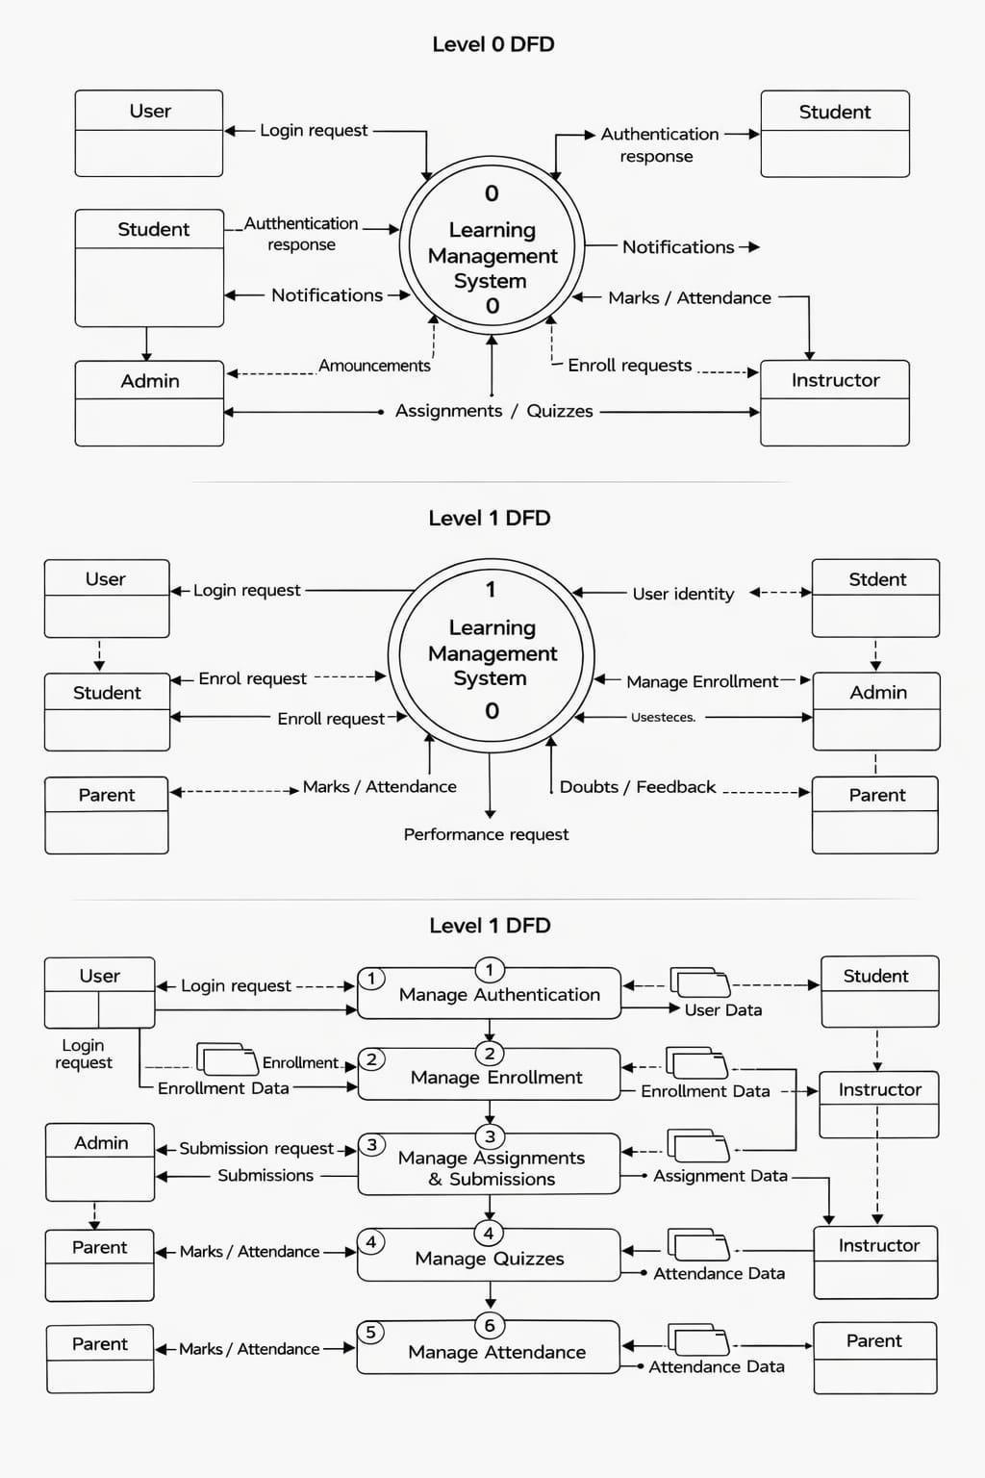
DFD Diagram (Level 0 & 1)
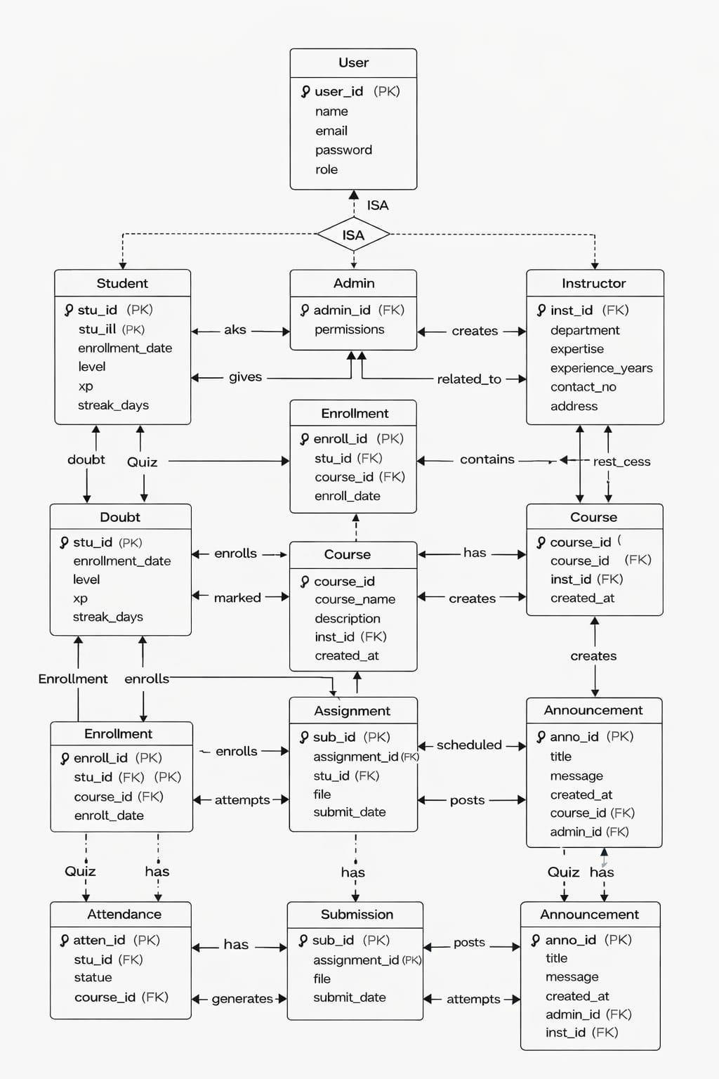
ER Diagram

- What are the advantages of the current invention over the existing technologies?

- Proxy Attendance: No proxies allowed. Every student's physical presence must be felt to mark their attendance in a class.
- Role Isolation: It ensures that parents can view progress without being interference in the academic data.
- Attack Resilience: The Flask-Limiter guards against brute-forcing threats, while the OTP expiration averts replay attacks.

- Please provide a set of keywords that could assist in finding the right classification of patents to analyze the patentability of the invention?

The list consists of six items which include Temporal OTP, Online LMS, Proxy-Prevention, SMTP-Verification, Role-Based Access Control (RBAC), Parental Monitoring Interface, Multi-Stakeholder Transparency, Parent-Student Data Linking, Educational Cybersecurity and Read-Only Access Control.

- Please provide a list of claims (that you think should be included in the patent specification and that are essential for the invention).
- The educational platform uses three main components which include a central server and NoSQL database and an encrypted SMTP communication relay.
- The system provides a secure login method which uses a time-sensitive 6-digit One-Time Password sent through email to authenticate users within a five-minute period.
- The attendance verification method requires an "Instructor" to create temporary tokens which "Students" must validate during an active session.
- The security framework enables parents to access student academic records in "Read-Only" mode which requires separate One-Time Password authentication for security purposes.
- The system prevents unauthorized access to administrative routes through two security measures which include role-based session decorators and rate-limiting middleware.

Please provide any known references in published literature or patents relating to the problem or subject.

LITERATURE REVIEW AND RELATED WORKS

1. Theoretical Frameworks & Long-term Trends
- On Historical Evolution and Mapping:
[2]: "Learning Management System (LMS) Research During 1991–2021: How Technology Affects Education."
  - Relevance: The research establishes a 30-year bibliometric basis which serves as the foundation for our study. The research identifies fundamental e-learning clusters while showing that software-program mismatch continues to be the main obstacle after three decades of development.
- On User Acceptance (TAM Theory):
[3]: "Learning Management System (LMS) among university students: Does it work?"
  - Relevance: The human element of attitude towards software systems exists as the most essential component of the system. Our research uses this to justify why a "user-friendly" interface is prioritized in my proposed design.
2. Systems Architecture & Integration
- On Unified Content Management (LCMS):
[8]: "CMS, LMS and LCMS for eLearning."
  - Relevance: This paper was set up to back up the backend logic on the system of content management (CMS) and management of learners (LMS) integration.
- On Web-Based Development Modules:
[8]: "Design and development of a web-based learning management system."
  - Relevance: Appropriating the structural framework of a modular system, We categorized that system into a student module, a teacher module, and an administration module for the architectural design of our own system.

3. Evaluation Metrics & Success Factors
- On Quality Comparison:
[4]: "Learning Management Systems for Higher Education: A Brief Comparison."
  - Relevance: Their SQTL metric which measures interoperability, security, and accessibility serves as our evaluation tool to assess the system quality of our proposed solution against present-day industry standards.
- On Success Determinants:
[9]: "Evaluating E-learning systems success."
  - Relevance: The research identifies "Student Satisfaction" as the main success factor for its quantitative study. Our system addresses this by incorporating the "Anytime, Anywhere" flexibility recommended in the findings.

4. Impact on Stakeholders (Teachers & Students)
- On Faculty Change Management:
[7]: "Learning Management Systems (LMS): Case study on an implementation."
  - Relevance: The "Ambassador" role functions as a key element for managing organizational change. The "Instructor Module" of our system receives its information through this research which aims to decrease teacher workload while enhancing system understanding.
- On Engagement & Autonomy:
[6]: "LMS Use with Online Instruction."
  - Relevance: Our system requires validation through the testing process which uses asynchronous tools for student learning to confirm their ability to learn independently and maintain their study motivation.

5. Future Trends: AI & Sustainability
- On Artificial Intelligence Integration:
[1]: "The impact of AI and LMS integration on the future of higher education."
  - Relevance: This is the most recent "Prior Art." The document proves that our system needs future-proofing because it describes adaptive learning and predictive analytics yet the document also warns us about ethical risks which require our protection.

- DISCLOSURE INFORMATION

- Has any disclosure to others been made, whether public or confidential, e.g., discussions with collaborators, suppliers, abstracts, journal publications, conference proceedings, seminars, (under)graduate project reports, grant applications, scientific conferences, poster sessions, industry meetings, offers to sell, etc.? If so to whom, when and where?

The invention has been disclosed only as part of an academic final-year project submitted to Swami Rama Himalayan University in February,2026. The organization has not shared any information with the public or to commercial entities or for industrial purposes. The organization shared information only to evaluate academic performance.

- Is there, within the next six months, a meeting of a learned society or deadline for publication of a scientific journal to which you plan to make disclosure? If so, when and where?

Current research has not produced proof of any upcoming publication plans for journals or conferences or public exhibitions which will take place within the next six months. The organization will announce information to the public only after completing the patent application process.

- Please indicate, whether you have been associated with the any research on the specific issue of the invention or the development, during the course of your past employment, with a detailed description of what your achievements are in your past employment in the same area.

Our work experience does not include any professional role which involves developing Learning Management Systems or authentication security systems. The invention originated from academic research which produced innovative technological developments. The Dual-Layer OTP Framework and Instructor-Synchronized Attendance Logic both exist because we developed them through our research work on educational cybersecurity which we conducted outside of my professional duties.

- APPLICATIONS AND COMMERCIALIZATION

- Please describe where or how your apparatus, product or process may be used.

The Online Learning Management System (LMS) has developed into an educational framework which various industries can use for their educational needs. The system functions in any environment that needs registered users to prove their identity through active authentication methods.
1. K-12 and Higher Education Institutions
- The system works as an academic management system which enables educational institutions to protect their operational activities through its primary functions of assignment tracking and grading assessment and timetable management.
- The Parent-Student Linkage system enables schools to involve parents in their educational activities while securing students' main account information through their controlled access permissions. This model works effectively for schools which adopt "Parent-Teacher-Student" transparency systems.
- The Instructor-Controlled OTP system allows universities to monitor student attendance at large lectures since it verifies student presence through their actual physical attendance and their virtual attendance. The system blocks all attendance proxying methods which create serious difficulties for universities to handle.
2. Corporate Training and Professional Certification
- The system enables organizations to verify that employees have completed their required training through its functionality which stops unauthorized individuals from accessing safety and legal training programs. The Temporal OTP login method verifies the identity of the trainee.
- The Assessment Module together with rate-limiting and secure access control features enables platforms to function as internal corporate certification systems which require strict data integrity protection.
3. Hybrid and Remote Learning Environments
- Remote Proctoring: The system verifies student identities during remote tests through SMTP-verified OTPs which permit only registered students to access the question bank.
- Asynchronous Learning: Whereas the Doubt Box and AI-powered Course Recommendations not only facilitate self-paced learning, but also give maximum safety with regard to the user's data-access.
4. Government and Vocational Training Programs
- The government operates a platform that enables its vocational training programs which receive governmental funding to track both student attendance and assessment performance. Government funds through the Attendance Module secure their spending because the system only verifies active participants who pass its identity test.
- 5. Competitive Exam Coaching Centers
- Private coaching centers employ the Assessment Module to establish rank-based leaderboards which generate competitive environments while parents access student performance information through the Parent Module without requiring staff to generate progress updates.

- FURTHER WORK

Do you expect to continue work toward improving the apparatus, product or process? Please elaborate.

Our objective for the Learning Management System work requires me to turn this secure web application into an educational system that operates entirely through automated AI technologies. The planned improvements focus on three core pillars: Advanced Identity Verification, Automated Intelligence, and Platform Mobility.

1. Implementation of Biometric-OTP Hybridization
The upcoming development phase will introduce Biometric Authentication through FIDO2 and WebAuthn after current system operations with SMTP-based temporal one-time passwords. The system enables users to authenticate their identity through fingerprint and facial recognition methods which work on approved devices. The system eliminates the need for users to wait for email delivery because it employs "What you are" biometric authentication as a security measure which works together with the existing "What you have" one-time password protection.
2. Geolocation-Locked Attendance Verification
Future research efforts will implement IP-Geofencing and GPS Verification to achieve "Zero-Proxy" attendance. The system will be upgraded so that the Attendance Module only accepts the session OTP if the student’s mobile/system coordinates are within a predefined radius (e.g., 50 meters) of the instructor’s location or the physical classroom. The system prevents students from marking attendance from distant locations which they can access through the session code.

3. AI-Driven Predictive Analytics and Personalization
Our intention to improve the Assessment Module requires we will implement Machine Learning algorithms. The next version will introduce these functionalities:
- Predictive Performance Modeling: The system will use historical data to predict academic failure risk when a student's attendance and quiz patterns reach critical thresholds which the system will communicate to their parents and instructors.
- Automated Content Personalization: The AI system creates "Remedial Learning Paths" for students who attain scores below a specific threshold in particular modules.
4. Cross-Platform Mobile Application Development
The system will be moved to a native mobile environment which supports both Android and iOS to boost accessibility. The system will use Push Notifications to replace email-based alerts which will deliver students and parents immediate updates about announcements and timetable changes and attendance alerts.

5. Integration with Virtual Classroom Infrastructure
We plan to create API connections for external video conferencing platforms which include Zoom and Microsoft Teams. The system will achieve automatic attendance data synchronization because students who join live virtual sessions trigger the process which establishes a direct connection between video lectures and the LMS database.

- FILING INFORMATION

Please fill the filing instructions as follows:-

Type of filing: Provisional ( yes ) Complete ( )

Applicant status: Natural person (yes ) Small Entity ( ) Startup (yes ) Others ( )

We the undersigned inventor(s), through our activities at Swami Rama Himalayan University, hereby, declare that any information pertaining to the above furnished inventions, ideas, trademarks, copyrights, designs, etc are results of our true works. I acknowledge that IPRSRG is accepting this information for review purposes only. We also understand that any comments, suggestions, reports, etc which we receive review based upon this analysis is neither meant nor understood to be a conclusive legal opinion. Further, We agree that IPRSRG, cannot be held responsible for acceptance or rejection or any other office actions of our inventions, creations, copyrights, trademarks, designs by appropriate authorities. Hereby disclose this “Invention” to the IPRSRG on the date signed below.

Signature of the Inventor(s)
By : Astha Singh By: Ayush Koli
Name : Astha Singh Name: Ayush Koli
Date: 09-02-2026 Date: 09-02-2026

By : Palak By:
Name : Palak Name:
Date: 09-02-2026 Date:

Please submit the completed Invention Disclosure Form and Signature Page signed by all inventors and a soft copy (in person) to

REFERENCES
[1] Alotaibi, N. S. (2024). The impact of AI and LMS integration on the future of higher education: Opportunities, challenges, and strategies for transformation. Sustainability, 16(23), 10357. https://doi.org/10.3390/su162310357
[2] Prahani, B. K., et al. (2022). Learning Management System (LMS) Research During 1991–2021: How Technology Affects Education. International Journal of Emerging Technologies in Learning (iJET), 17(17), 28–49. https://doi.org/10.3991/ijet.v17i17.30763
[3] Adzharuddin, N. A., & Ling, L. H. (2013). Learning Management System (LMS) among university students: Does it work? International Journal of e-Education, e-Business, e-Management and e-Learning, 3(3), 248–252. https://doi.org/10.7763/IJEEEE.2013.V3.233
[4] Sánchez, J., et al. (2023). Learning Management Systems for Higher Education: A Brief Comparison. Journal of Software Quality Evaluation. Search via Google Scholar
[5] Ninoriya, S., et al. (2011). CMS, LMS and LCMS for eLearning. IJCSI International Journal of Computer Science Issues, 8(2). https://www.ijcsi.org/papers/IJCSI-8-2-617-621.pdf
[6] Bradley, V. M. (2021). Learning Management System (LMS) Use with Online Instruction. International Journal of Technology in Education (IJTE), 4(1), 68-92. https://doi.org/10.46328/ijte.36
[7] Andersson, T. (2019). Learning Management Systems (LMS): Case study on an implementation of an LMS and its perceived effects on teachers. DiVA Academic Archive. http://urn.kb.se/resolve?urn=urn:nbn:se:uu:diva-384462
[8] Arisha, A., et al. (2021). Design and development of a web-based learning management system. Turkish Journal of Computer and Mathematics Education, 12(10), 1250–1257. https://turcomat.org/index.php/turkbilmat/article/view/4351
[9] Al-Fraihat, D., et al. (2020). Evaluating E-learning systems success: An empirical study. International Journal of Educational Technology in Higher Education, 17(18). https://doi.org/10.1186/s41239-020-00191-y

