Phase 8: Data Management & Deployment

In this phase, we ensure that Migrant Health CRM data can be safely managed, exported, imported, and that the solution is deployable from one Salesforce environment to another using Salesforce CLI (sf) since Change Sets are not available in Developer Edition.

# Part A — Data Management

## Step 1: Prepare Sample Data

1. Go to the Patients tab and click New.  
2. Create 3–5 sample patients (fill Name, Patient_ID__c, DOB, Phone, Email, Gender).  
3. Go to the Appointments tab → create appointments linked to these patients.  
4. Go to the Migrant Records tab → create 1–2 records linked to patients.

## 

## Step 2: Export Data (Backup)

Option A — Data Export Service:

1. Setup → Quick Find → Data Export → Export Now.  
2. Select objects: Patient__c, Appointment__c, Migrant_Record_Number__c.  
3. Check 'Include images, documents…' if required.  
4. Click Start Export → Salesforce emails a zip with CSVs.

## Step 3: Import / Load Data (Bulk Upload Simulation)

1. Open Data Loader → Insert.  
2. Choose Object: Patient__c.  
3. Select CSV with new patients (columns: Name, Patient_ID__c, DOB__c, Phone__c, Email__c, Gender__c).  
4. Map fields → Next → Finish.  
5. Confirm new Patients appear in Salesforce.

# 

# Part B — Deployment (Using Salesforce CLI)

## Step 1: Authorize Orgs

1. Open VS Code Terminal.  
2. Authorize source (Dev Org):  
 sf org login web --alias DevOrg  
3. Authorize target (Target Org):  
 sf org login web --alias TargetOrg  
4. Confirm both orgs are connected:  
 sf org list

## 

## Step 2: Retrieve Metadata from Dev Org

Use the following command to retrieve metadata from the source org:  
  
sf project retrieve start --target-org DevOrg --metadata "CustomObject:Patient__c" --metadata "CustomObject:Appointment__c" --metadata "CustomObject:Migrant_Record_Number__c" --metadata "ApexClass" --metadata "ApexTrigger" --metadata "LightningComponentBundle" --metadata "FlexiPage"

## 

## Step 3: Deploy Metadata to Target Org

Deploy the retrieved metadata to the target org using:  
  
sf project deploy start --target-org TargetOrg --source-dir force-app  
  
This command pushes all components from the force-app directory into the Target Org.

## 

## Step 4: Open and Verify in Target Org

1. Open the target org:  
 sf org open --target-org TargetOrg  
2. In App Launcher, open Migrant CRM App.  
3. Verify that:  
 - Patient, Appointment, Migrant Record objects exist.  
 - Tabs and record pages load.  
 - patientSearch LWC appears.  
 - Dashboard/Reports migrated.

# 

# Part C — Deployment Checklist

Before marking deployment complete, ensure:  
• All objects, fields, picklist values migrated.  
• Apex classes/triggers compile successfully.  
• Lightning Web Components deployed.  
• Tabs, record pages, dashboards migrated.  
• Profiles/permissions updated.  
• Tests (MigrantTests) run successfully.

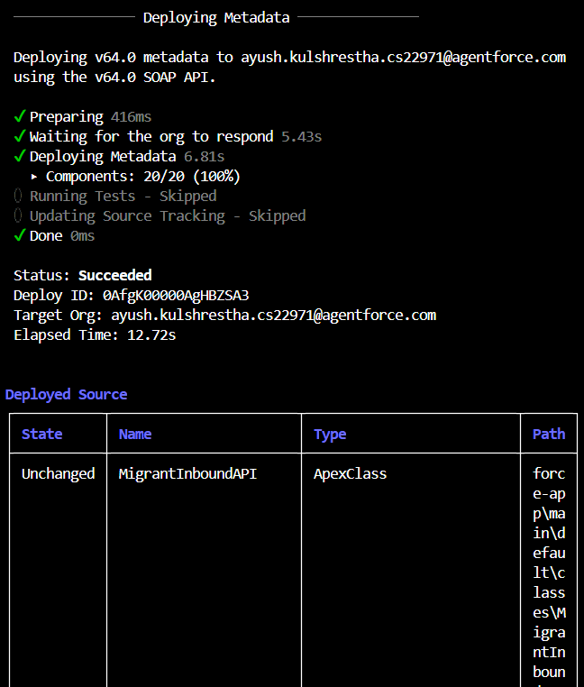

# Part D — Post-Deployment Verification

After deployment, log in to the Target Org and validate:  
• Patient, Appointment, Migrant Record records accessible.  
• LWC (patientSearch) functional.  
• Reports and dashboards show data.  
• No errors in Apex triggers or flows.

