# Phase 9: Reporting, Dashboards & Security Review

In this phase, we configure reporting and dashboards to provide actionable insights into patient and healthcare data, and perform a security review to ensure compliance, data protection, and adherence to Salesforce best practices.

## Part A — Reporting

The following reports were created to provide visibility into core Migrant Health CRM data:

### 1. Active Patients Report

• Navigate to Reports → New Report → Select Patients object.  
• Add fields: Name, Patient_ID__c, DOB__c, Age__c, Gender__c.  
• Filter: Active__c = TRUE.  
• Format: Tabular.  
• Save as Active Patients Report.

### 

### 2. Appointments by Doctor

• Navigate to Reports → New Report → Select Appointments object.  
• Add fields: Appointment_Date__c, Patient__c, Doctor__c, Status__c.  
• Group rows by Doctor__c.  
• Add summary: Row Count.  
• Format: Summary.  
• Save as Appointments by Doctor.

### 

### 3. Migrant Records per Patient

• Navigate to Reports → New Report → Select Migrant Records object.  
• Add fields: Record_Date__c, Notes__c, Patient__c.  
• Group rows by Patient__c.  
• Add summary: Row Count.  
• Format: Summary.  
• Save as Migrant Records per Patient.

## 

## Part B — Dashboards

A Migrant Executive Dashboard was created to visually represent key healthcare metrics.

Steps:  
1. Navigate to Dashboards → New Dashboard → Name: Migrant Executive Dashboard.  
2. Add components:

* Patients Table
* Appointment Table
* Migrant Records Table

3. Arrange components in a 2x2 grid.  
4. Save, Done, and Refresh the dashboard.

## 

## Part C — Security Review

The security review ensures that data visibility and protection are aligned with organizational policies.

### 1. Sharing Settings

• Setup → Sharing Settings.  
• Patient__c = Private (only owners/assigned users can view).  
• Appointment__c, Migrant_Record_Number__c = Controlled by Parent.

### 





### 2. Field-Level Security

• Sensitive fields (DOB__c, Phone__c, Email__c) set as Read-only or Hidden for non-admins.  
• Hide unused fields to minimize exposure.

### 

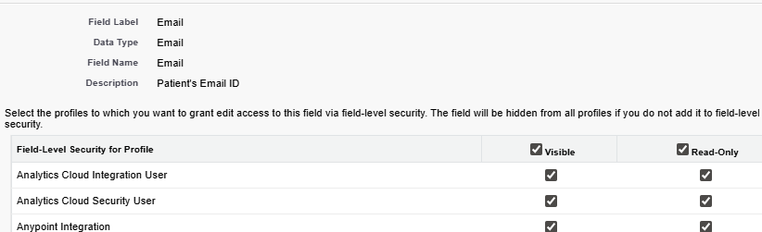

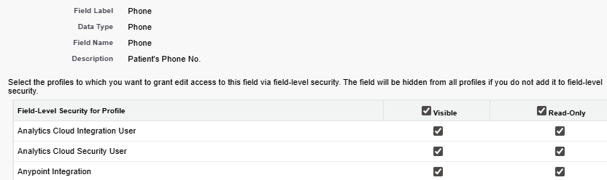

### 3. Health Check

• Setup → Health Check.  
• Review password policies, session timeouts, and other security metrics.  
• Fix high-risk and medium-risk warnings to align with Salesforce baseline.

## 