Python-Based Machine Learning
Model Development and Evaluation Plan
Week 3 Deliverable
A structured plan for problem definition, data preprocessing, model selection and training, evaluation, and deployment of a machine-learning system

Executive Overview
This document lays out a complete, step-by-step plan for developing and evaluating a machine learning model in Python. It covers all conceptual phases of a real-world ML project — problem definition, data preprocessing, model selection and training, evaluation and validation, and deployment/maintenance — together with workflow diagrams, an evaluation-metric discussion, and a time-boxed execution schedule. No code is executed as part of this exercise; the plan is designed so that it could be handed to an engineer and implemented directly.

Estimated Time Allocation (30–35 hours)
Phase | Hours | Key Outputs
Problem definition & scoping | 2–3 | Problem statement, success metrics, constraints
Data collection & exploration (EDA) | 5–6 | Data profile, distribution plots, quality report
Data preprocessing & feature engineering | 6–7 | Clean dataset, engineered features, train/val/test splits
Model selection & training | 7–8 | Trained candidate models, training logs
Hyperparameter tuning & cross-validation | 5–6 | Best hyperparameters, CV score summary
Evaluation & error analysis | 3–4 | Metric report, confusion matrix, ROC curve
Deployment planning & documentation | 2–3 | Deployment plan, monitoring plan, final report

1. Problem Definition

1.1 Hypothetical Problem Statement
Business context: A regional bank wants to reduce losses from customers who default on personal loans. The bank's collections team currently relies on manual, rule-based flags (e.g., “two missed payments”) that catch defaults too late to intervene effectively.
Machine learning problem: Build a supervised binary classification model that predicts, at the time a loan application is reviewed, the probability that an applicant will default within the first 12 months of the loan term. The model output is a probability score (0–1) that the credit team can rank-order and threshold to prioritize manual review, adjust interest rates, or decline high-risk applications.

1.2 Justification and Relevance
- Business impact: even a modest improvement in early identification of high-risk applicants directly reduces charge-offs and improves portfolio quality.
- Data availability: banks retain structured, tabular historical loan data (applicant demographics, credit bureau scores, payment history), which is well suited to classical machine learning rather than deep learning.
- Actionability: a probability score integrates cleanly into existing underwriting workflows via a decision threshold, unlike a black-box “approve/deny” flag.
- Well-understood problem class: credit-risk default prediction is a mature ML use case with established evaluation practices (ROC AUC, KS statistic, precision/recall trade-offs), making it a strong vehicle for demonstrating the full ML lifecycle.

1.3 Success Criteria
- Primary metric: ROC AUC ≥ 0.80 on a held-out test set (industry-typical benchmark for retail credit scoring).
- Operational constraint: at a decision threshold that flags the riskiest 20% of applicants, recall on true defaulters should exceed 60%, so the collections team can prioritize effectively without reviewing the entire portfolio.
- Fairness constraint: false-positive rates should not differ by more than 5 percentage points across protected demographic groups (to be checked in the evaluation phase).
- Interpretability constraint: the model must support feature-importance or SHAP-based explanations, since credit decisions are subject to regulatory adverse-action-notice requirements.

2. End-to-End Machine Learning Workflow
The diagram below summarizes the full plan as a flowchart. Each numbered stage corresponds to a section of this document. The dashed feedback loop reflects that evaluation, and later production monitoring, can send the process back to feature engineering or model selection.
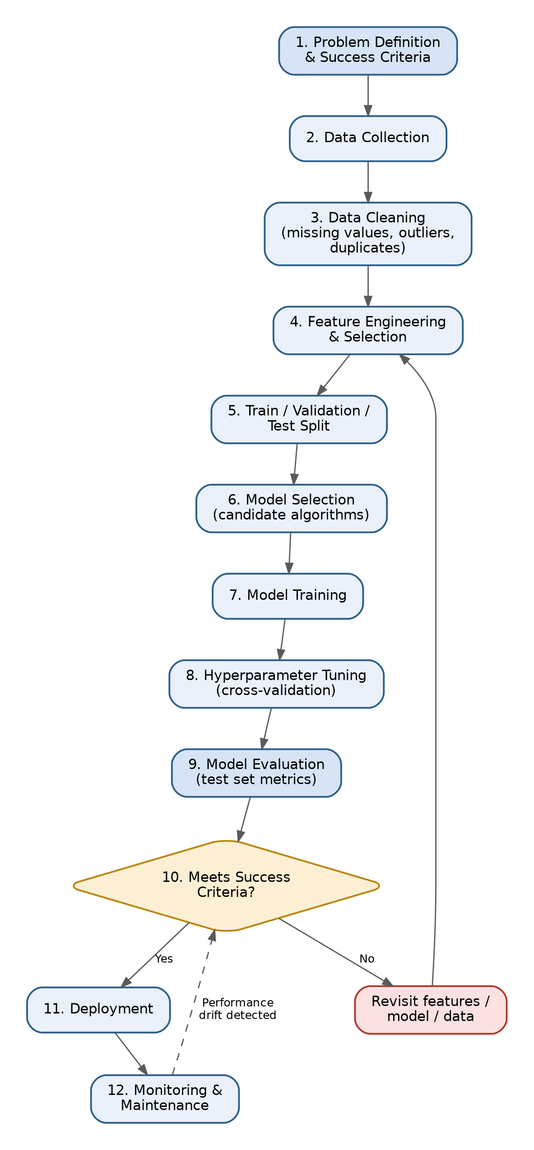
Figure 1. End-to-end machine learning development and deployment workflow.

3. Data Preprocessing

3.1 Data Cleaning
- Missing values: profile missingness per column (missingno / pandas .isna().sum()). Use median imputation for skewed numeric fields (e.g., income), mode imputation for low-cardinality categoricals, and add a binary “was_missing” indicator flag where missingness itself may be predictive (e.g., missing employment history).
- Duplicates: drop exact duplicate applicant records; investigate near-duplicates (same applicant ID, different timestamps) and keep only the most recent record per applicant.
- Outliers: cap or winsorize extreme numeric values (e.g., income, loan amount) at the 1st/99th percentile rather than deleting rows, to avoid discarding legitimate high-value applicants.
- Data-type and consistency checks: standardize categorical text (casing, whitespace), enforce valid ranges (e.g., age between 18 and 100), and reconcile inconsistent category labels (e.g., “Self-employed” vs “self employed”).
- Class imbalance check: defaults are typically a minority class (often 5–15% of loans); quantify the imbalance early since it drives both preprocessing choices (resampling) and metric choices (Section 5).

3.2 Normalization and Scaling
- Apply StandardScaler (zero mean, unit variance) for models sensitive to feature scale (logistic regression, SVM, k-NN, neural networks).
- Tree-based models (decision trees, random forest, gradient boosting) are scale-invariant, so scaling is optional for those but is still applied consistently to keep the pipeline uniform across candidate models.
- Fit the scaler only on the training fold and apply the fitted transform to validation/test folds, to prevent data leakage.

3.3 Feature Engineering
- Derived ratios: debt-to-income ratio, loan-to-income ratio, credit-utilization ratio — typically more predictive than raw dollar amounts.
- Temporal features: months since account opened, months since last delinquency, number of credit inquiries in the last 6 months.
- Categorical encoding: one-hot encoding for low-cardinality nominal fields (e.g., loan purpose); target/frequency encoding for higher-cardinality fields (e.g., employer industry) to avoid an explosion of sparse columns.
- Binning: convert continuous credit-bureau scores into risk bands where domain knowledge suggests non-linear effects, as an input to simpler interpretable models.

3.4 Feature Selection
- Filter methods: remove near-zero-variance features and features with correlation > 0.95 to another feature (multicollinearity check via a correlation matrix / VIF).
- Embedded methods: use L1 (Lasso) regularization coefficients or tree-based feature importances to rank and prune low-value features.
- Wrapper validation: confirm the reduced feature set does not degrade cross-validated performance versus the full feature set before finalizing.

3.5 Potential Challenges and Solutions
Challenge | Solution
Severe class imbalance (defaults are rare) | Use class-weighted loss functions, SMOTE/undersampling on the training fold only, and threshold-independent metrics (ROC AUC, PR AUC) rather than raw accuracy
Data leakage from features unavailable at prediction time (e.g., post-origination payment behavior) | Freeze the feature set to information known strictly at application time; time-based validation split to catch leakage
Inconsistent or missing values from merged data sources | Standardize schemas before merging; explicit missingness indicators; document imputation assumptions
High-cardinality categorical variables | Target/frequency encoding with cross-validation-safe encoding (fit on training folds only)
Concept drift between historical training data and current applicant population | Track feature distributions over time; retrain on a rolling window; monitor post-deployment (Section 7)

4. Model Selection and Training

4.1 Candidate Models
Model | Strengths | Weaknesses
Logistic Regression | Highly interpretable, fast to train, strong baseline, coefficients map directly to adverse-action reasons | Assumes linear decision boundary in log-odds space; may underfit complex interactions
Decision Tree | Captures non-linear interactions, easy to visualize | Prone to overfitting; unstable to small data changes
Random Forest (bagging ensemble) | Reduces variance vs. a single tree, handles non-linearity and interactions well, robust to outliers | Less interpretable than a single tree or linear model; larger memory/inference footprint
Gradient Boosting (e.g., XGBoost / LightGBM) | Typically strongest raw predictive performance on tabular data; handles missing values natively; supports monotonic constraints for regulatory fairness | More hyperparameters to tune; higher risk of overfitting without careful regularization

4.2 Chosen Model and Justification
Primary model: Gradient Boosting (XGBoost) is proposed as the primary candidate because tabular, structured credit data of this kind is the setting where gradient-boosted trees consistently outperform both linear models and deep learning in practice, while remaining fast enough to retrain regularly. Its native support for missing values and monotonic constraints (e.g., forcing risk to increase monotonically with debt-to-income ratio) also helps satisfy the interpretability and fairness constraints from Section 1.3.
Retained baseline: Logistic Regression is kept as an interpretable benchmark and as a fallback if regulatory reviewers require full coefficient-level transparency rather than SHAP-based explanations. Random Forest is retained as a secondary ensemble to sanity-check that gradient boosting's gains are not simply due to overfitting.

4.3 Training Process
- Split data 70% train / 15% validation / 15% test, using a time-based split (train on older loans, test on more recent loans) to mimic real deployment and detect temporal drift.
- Establish a naive baseline (majority-class predictor) and a logistic-regression baseline to contextualize all later performance gains.
- Train each candidate model on the training set with default hyperparameters to get an initial performance read.
- Apply k-fold (k=5) stratified cross-validation on the training set for model comparison and hyperparameter tuning (Section 4.4), keeping the test set untouched until final evaluation.
- Log every experiment (model type, feature set version, hyperparameters, CV score, training time) to ensure reproducibility — conceptually, this is where a tool such as MLflow would be used in an implementation phase.
- Select the final model configuration based on cross-validated performance, then retrain it once on the full training + validation data before final test-set evaluation.

4.4 Hyperparameter Tuning Strategy
- Search method: use randomized search or Bayesian optimization (e.g., Optuna) rather than exhaustive grid search, since the hyperparameter space for gradient boosting is large and randomized/Bayesian search finds strong configurations far more efficiently.
- Key hyperparameters for XGBoost: max_depth, learning_rate, n_estimators, subsample, colsample_bytree, min_child_weight, and scale_pos_weight (to address class imbalance).
- Regularization: tune L1 (reg_alpha) and L2 (reg_lambda) penalties, and use early stopping on the validation fold to prevent overfitting rather than fixing n_estimators in advance.
- Nested cross-validation: use an outer loop for unbiased performance estimation and an inner loop for hyperparameter selection, so the reported cross-validated score is not optimistically biased by the same folds used to tune parameters.

5. Evaluation Metrics and Validation Strategy

5.1 Why Accuracy Alone Is Insufficient
Because defaults are a minority class (Section 3.1), a model that always predicts “no default” could score above 90% accuracy while being useless. The plan therefore prioritizes threshold-independent and imbalance-aware metrics.

5.2 Core Metrics
Metric | What it Measures | Why it Matters Here
Precision | Of applicants flagged high-risk, what fraction actually default | Controls the cost of unnecessarily declining or delaying good applicants
Recall (Sensitivity) | Of applicants who actually default, what fraction the model flags | Directly tied to loss prevention — missed defaulters are the costliest errors
F1-score | Harmonic mean of precision and recall | Single number to compare models when both false positives and false negatives carry real cost
ROC AUC | Model's ability to rank a random defaulter above a random non-defaulter, across all thresholds | Threshold-independent; chosen as the primary success metric since the operating threshold may be tuned later by the business
PR AUC | Area under the precision-recall curve | More informative than ROC AUC specifically under severe class imbalance
KS Statistic | Max separation between cumulative default and non-default distributions | Standard credit-industry metric for score separability
Calibration (Brier score / reliability curve) | How well predicted probabilities match observed default rates | Needed because the score feeds risk-based pricing, not just a binary decision

5.3 Cross-Validation for Robust Estimates
Stratified k-fold cross-validation (k=5) is used throughout model selection and tuning so that each fold preserves the overall default rate, preventing folds with too few positive examples to evaluate meaningfully. For this time-sensitive problem, a rolling-window / forward-chaining time-series split is used as a secondary validation check, since applicants are not independent and identically distributed over time — a standard random shuffle-split can leak future information into training and overstate performance.
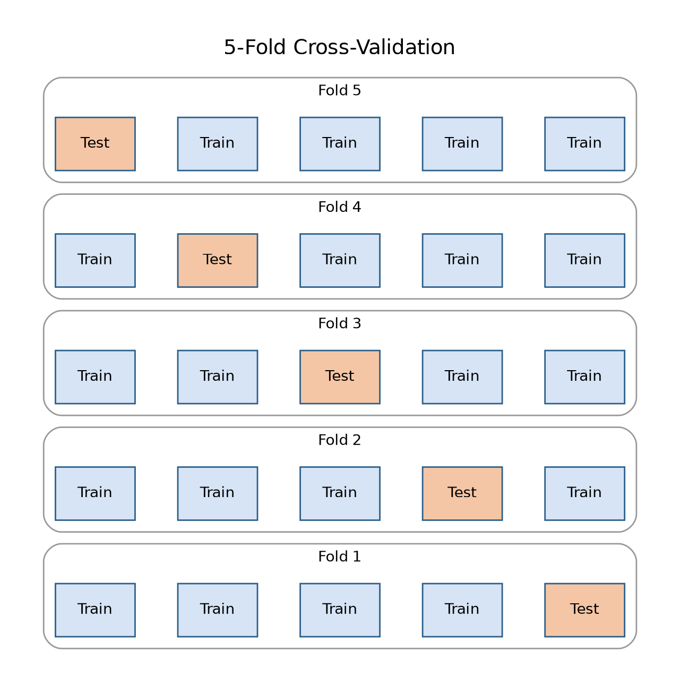
Figure 2. Five-fold stratified cross-validation: each fold rotates which slice is held out as the test partition while the remaining four train the model.

5.4 Confusion Matrix and Threshold Selection
The final model's confusion matrix on the test set will be reported at multiple candidate thresholds, not just the default 0.5 cutoff, since the business can move the threshold to trade recall for precision depending on collections-team capacity. A threshold will be recommended by plotting precision and recall against threshold value and selecting the point that satisfies the recall ≥ 60% operational constraint from Section 1.3 at the lowest achievable false-positive rate.

5.5 Illustrative Candidate-Model Comparison
The chart below illustrates the kind of comparison the evaluation phase should produce once real experiments are run — the specific values are illustrative placeholders, not measured results, and would be replaced with actual cross-validated scores during implementation.
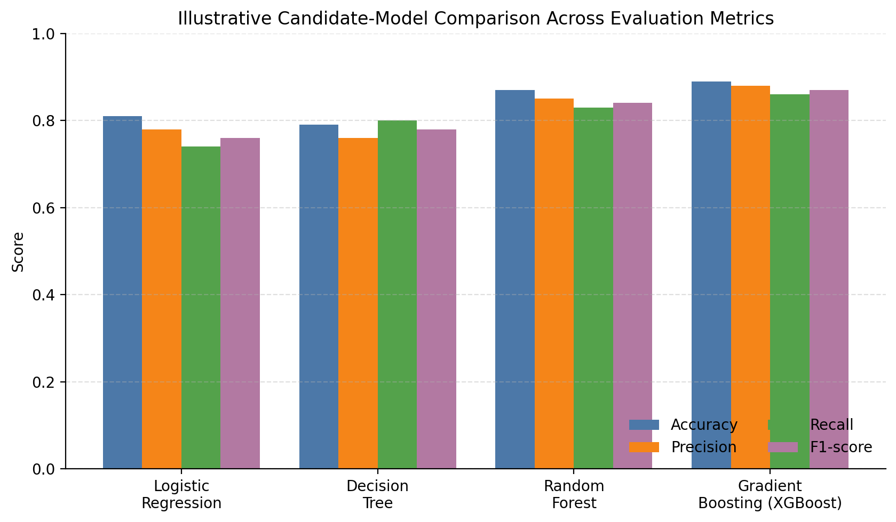
Figure 3. Illustrative comparison of candidate models across four metrics (placeholder values for planning purposes).

6. Error Analysis and Fairness Review
- Segment errors by applicant subgroup (age band, geography, loan purpose) to check for systematically weaker performance on any segment.
- Review a sample of false negatives (missed defaulters) and false positives (wrongly flagged good applicants) manually to look for patterns the model may be missing or overreacting to.
- Run a fairness audit comparing false-positive and false-negative rates across protected classes against the constraint set in Section 1.3, using disparate-impact and equalized-odds style checks.
- Use SHAP values to confirm the top drivers of individual predictions are sensible and defensible from a regulatory standpoint (e.g., debt-to-income ratio, not zip code, driving the score).

7. Model Deployment and Maintenance (Optional Extension)

7.1 Deployment Architecture
- Package the final model (preprocessing pipeline + trained model) as a single serialized artifact (e.g., a scikit-learn Pipeline saved with joblib, or an XGBoost Booster with a paired feature-transform step) to guarantee training/serving consistency.
- Expose the model behind a lightweight internal REST API (e.g., FastAPI) that the loan-origination system calls synchronously at application time.
- Version every deployed model artifact and log the model version alongside each prediction for traceability and rollback.

7.2 Monitoring
- Track prediction-score distribution drift over time (e.g., population stability index) versus the training-time distribution.
- Track realized default rates against predicted risk bands on a rolling basis (once outcomes are observed, 12 months later) to catch calibration decay.
- Alert if input feature distributions shift meaningfully (data drift), which often precedes performance decay.

7.3 Maintenance and Retraining
- Establish a scheduled retraining cadence (e.g., quarterly) using the most recent rolling window of labeled outcomes.
- Define an automatic retraining trigger if monitored ROC AUC on recent labeled outcomes drops below an agreed floor (e.g., 0.75).
- Maintain a champion/challenger process: new candidate models are evaluated in shadow mode against the current production model before promotion.
- Keep a documented model card recording training data window, feature set version, evaluation metrics, and known limitations, updated at every retraining cycle.

8. Summary
This plan walks through the full lifecycle of a Python-based machine learning system for credit-default prediction: a clearly justified problem definition with measurable success criteria; a rigorous preprocessing and feature-engineering plan that anticipates class imbalance and leakage risks; a comparative model-selection process centered on gradient boosting with interpretable baselines; a validation strategy built on stratified and time-aware cross-validation; a metrics framework suited to an imbalanced, cost-asymmetric business problem; and a deployment and monitoring plan that keeps the model accountable after launch. Together, these sections provide a blueprint thorough enough to guide a full-scale implementation.

