

ayushkumarpanigrahi@gmail.com

***Full Stack Developer | AI Enthusiast | Esports Leader***

**Anurag University**

*B.Tech in Computer Science & Engineering (Data Science Specialization)*

***Aug 2022 – May 2026 | Hyderabad, Telangana***

**Sri Chaitanya Junior College**

*Intermediate in MPC (Mathematics, Physics, Chemistry)*

**Aug 2020 – May 2022 | Hyderabad, Telangana**

**Nava Bharat Public School**

*High School / Secondary Education (C.B.S.E Affiliated)*

**Aug 2007 – May 2020 | Palwancha, Telangana**

SKILLS

Full Stack Development (Java, Spring Boot, Python, Next.js, Node.js)

Machine Learning & AI

Cloud Computing

Data Analysis & Visualization

Web & Mobile App Development

Esports Leadership & Management

EDUCATION

ayushkumarpanigrahi.info

+91 7815929654

Hyderabad, India

CONTACT

WORK EXPERIENCE

PROFILE

**Full Stack Developer**

Learn-X | May 2024 – Present

* Developed AI-powered coding solutions and interactive learning platforms.
* Built dynamic web applications using Next.js, Node.js, and MongoDB.
* Integrated AI-driven features to enhance student learning experiences.

**Front-End Developer**

CoffeeCodes | Oct 2023 – Present

* Designed and implemented intuitive UI components using React.js and Tailwind CSS.
* Worked on web solutions for NGOs and Esports organizations.

**Co-Founder**

Learn-X | May 2024 – Present

* Spearheaded the creation of an AI-driven learning platform for students.
* Led a team to develop coding assistants and interactive learning modules.
* Managed strategic partnerships and platform development.

Ayush Kumar

Passionate about technology, software development, and gaming, I bring hands-on experience in full-stack development, machine learning, cloud computing, and esports leadership. With expertise in Java, Python, Next.js, Spring Boot, and AI/ML, I thrive in developing innovative solutions and leading projects that blend technology and creativity.

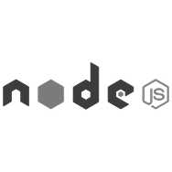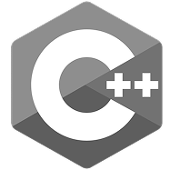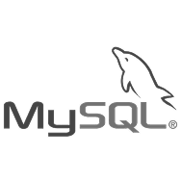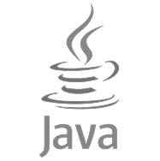

Development Tools & Frameworks:

**Co-Founder**

Makluan Esports | 2024 – Present

* Established an elite BGMI esports organization.
* Managed team recruitment, sponsorships, and tournaments.

Certifications

Adobe Illustrator

Adobe After Effects

Cap Cut

Premier Pro

Adobe Photoshop

Jet Brains IDE

Visual Studio Code

Eclipse

Infosys Springboard

AWS Certified, CSS Certificate, Java (Basic), JavaScript (Basic), Python (Basic), SQL (Basic), Infosys Spring Board, AI & ML, AWS Fundamentals, CSS, Data Science, Data Structures, HTML5, Java Programming for Beginners, JavaScript Essentials, Programming in C, Python 3

HackerRank

AWS Certified, CSS Certificate, Java (Basic), JavaScript (Basic), Python (Basic), SQL (Basic)

CISCO

CCNA - Enterprise Networking, Security & Automation, CCNA - Switching, Routing & Wireless Essentials, Cyber Threat Management, JavaScript Essentials 1, Junior Cybersecurity Analyst Career Path

Softwares

Coding

Music

Editing

Gaming

Sports

LINGUAGES

EXPERIENCE CONTINUED

INTERESTS

**Chief Editor**

Noobsverse Pvt. Ltd. | Aug 2022 – Present

* Led content creation, video editing (VFX/EFX), and brand identity development.
* Managed a team for esports-related digital content and social media strategies.

English

fluent

Telugu

Near native / fluent

Hindi

Native speaker