KATHMANDU UNIVERSITY

DHULIKHEL KAVRE

**COEG-304:** Instrumentation and Control

Lab Sheet No. 1

**SUBMITTED BY SUBMITTED TO:**

Name: Ayush Kumar Shah Bibek Mahaseth Sir

Roll no: 44 Date of Submission:

Group: CE 3rd year 1st sem …./…./2018

Level: UNG

**KATHMANDU UNIVERSITY**

**School of Engineering**

**Department of Electrical and Electronics Engineering**

**Instrumentation and Control Lab I**

**Introduction to MATLAB**

* 1. **Matrix operation**

**Example-1**

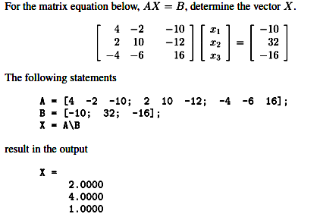

Ans:

>>B=[-10;32;-16];

>> A=[4 -2 -10; 2 10 -12; -4 -6 16];

>> X=A\B

X =

2.0000

4.0000

1.0000

**1.2 Inverse of a matrix**

**Example-2**

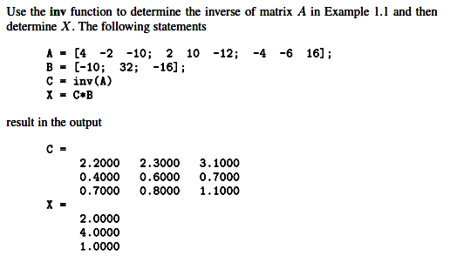

Ans:

>> Y=inv(A)

Y =

2.2000 2.3000 3.1000

0.4000 0.6000 0.7000

0.7000 0.8000 1.1000

>> X=Y*B

X =

2

4

1

**1.3 Roots of polynomial**

**Example-3**

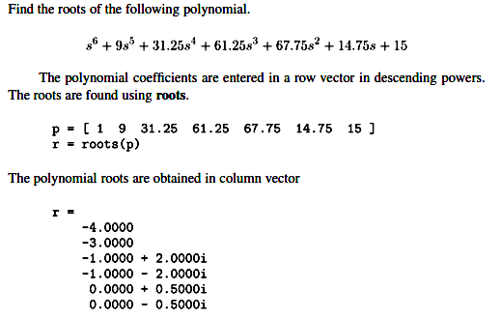

Ans:

P=[1 9 31.25 61.25 67.75 14.75 15]

P =

1.0000 9.0000 31.2500 61.2500 67.7500 14.7500 15.0000

>> r=roots(P)

r =

-4.0000 + 0.0000i

-3.0000 + 0.0000i

-1.0000 + 2.0000i

-1.0000 - 2.0000i

-0.0000 + 0.5000i

-0.0000 - 0.5000i

**Example-4**



Ans:

>> Q=[-1 -2 -3+j*4 -3-j*4]

Q =

-1.0000 + 0.0000i -2.0000 + 0.0000i -3.0000 + 4.0000i -3.0000 - 4.0000i

>> p=poly(Q)

p =

1 9 45 87 50

**1.4 X-Y Plot**

**Example-5**

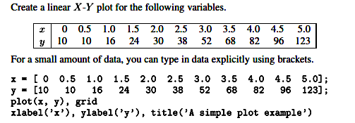

Ans:

>> X=[0:0.5:5]

X =

0 0.5000 1.0000 1.5000 2.0000 2.5000 3.0000 3.5000 4.0000 4.5000 5.0000

>> Y=[10 10 16 24 30 38 52 68 82 96 123]

Y =

10 10 16 24 30 38 52 68 82 96 123

>> plot(X,Y), grid, xlabel('X'), ylabel('Y'), title('X vs Y')

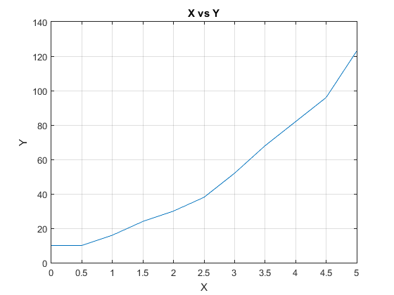

**Example-6**

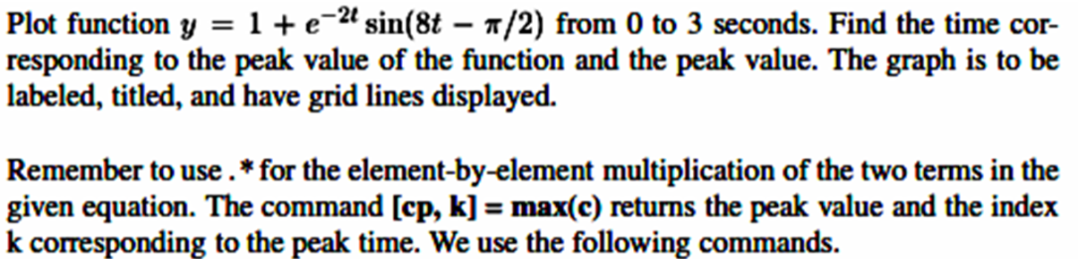

Ans:

>> t=0:0.005:3;

>> c=1+exp(-2*t).*sin(8*t-pi/2);

>> [cp,k]=max(c)

cp =

1.4702

k =

73

>> tp=t(k)

tp =

0.3600

>> plot(t,c), xlabel('t-sec'),ylabel('c'),grid;

title('Damped sime curve');

text(0.6,1.4,['cp=', num2str(cptext(0.6,1.3,['tp=', num2str(tp)]);

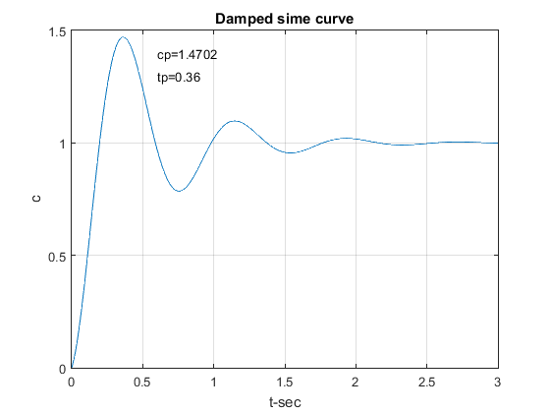

**1.5 Three-Dimensional Plots**

**Example-7**

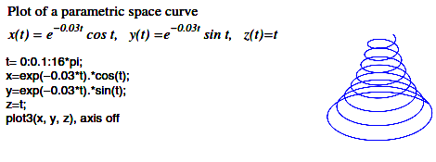

Ans:

t=0:01:16*pi;

x=exp(-0.03*t).*cos(t);

y=exp(-0.03*t).*sin(t);

z=t;

plot3(x,y,z),axis off

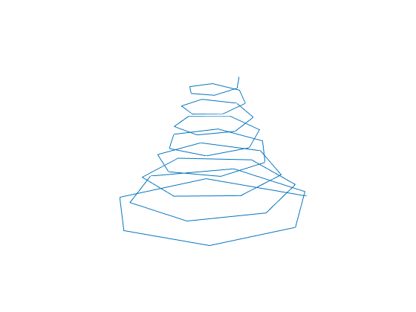

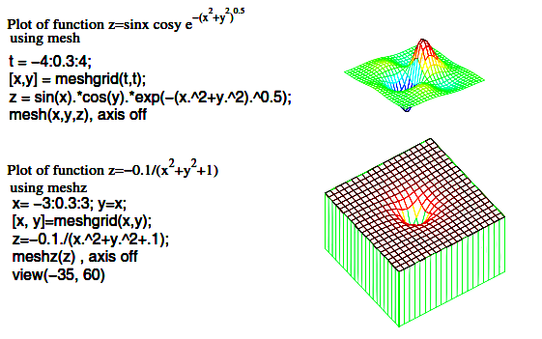

Ans:

t=-4:0.3:4;

[x,y]=meshgrid(t,t);

z=sin(x).*cos(y).*exp(-(x.^2+y.^2).^0.5);

mesh(x,y,z), axis off 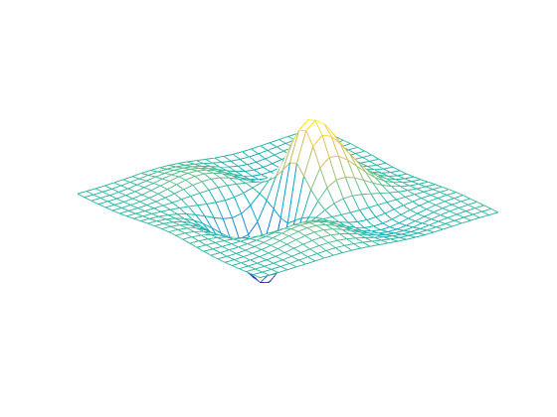

Ans:

x=-3:0.3:3;

y=x;

[x,y]=meshgrid(x,y);

z=-0.1./(x.^2+y.^2+.1);

meshz(z), axis off, view(-35,60)

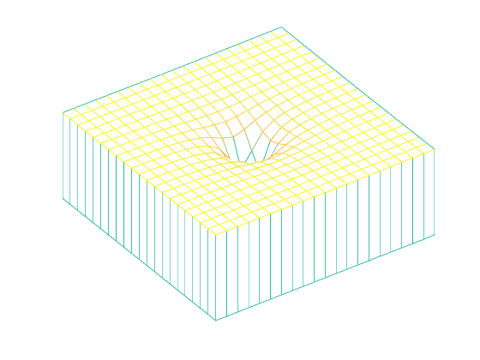

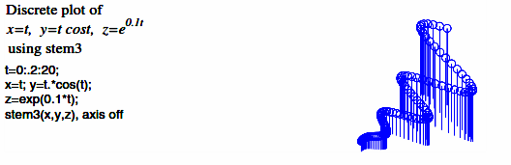

Ans:

t=0:0.2:20;

x=t;

y=t.*cos(t);

z=exp(0.1*t);

stem3(x,y,z), axis off

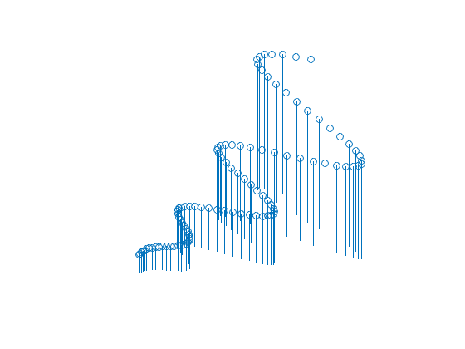

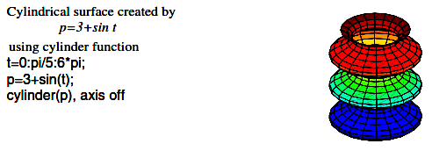

Ans:

t=0:pi/5:6*pi;

p=3+sin(t);

cylinder(p), axis off

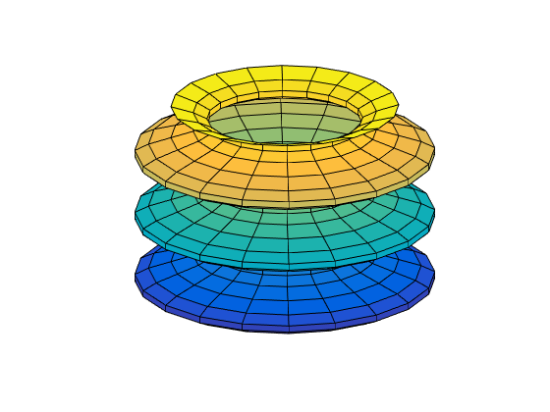

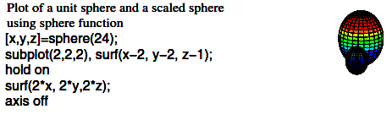

Ans:

[x,y,z]=sphere(24);

subplot(2,2,2),surf(x-2,y-2,z-1);

hold on

surf(2*x,2*y,2*z);

axis off

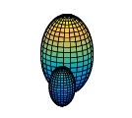

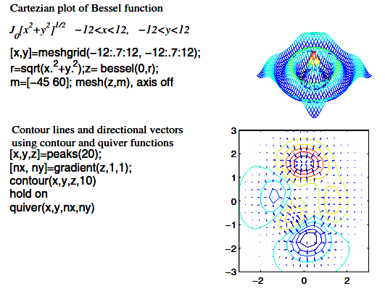

Ans:

[x,y]=meshgrid(-12:.7:12,-12:.7:12);

r=sqrt(x.^2+y.^2);

z=bessel(0,r);

z=besselj(0,r);

m=[-45 60];

mesh(z,m), axis off

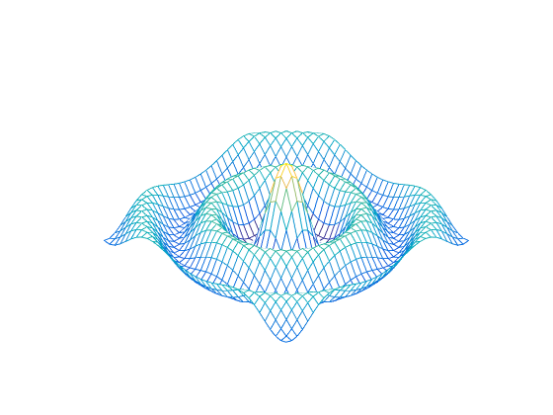

Ans:

[x,y,z]=peaks(20);

[nx,ny]=gradient(z,1,1);

contour(x,y,z,10)

hold on

quiver(x,y,nx,ny)

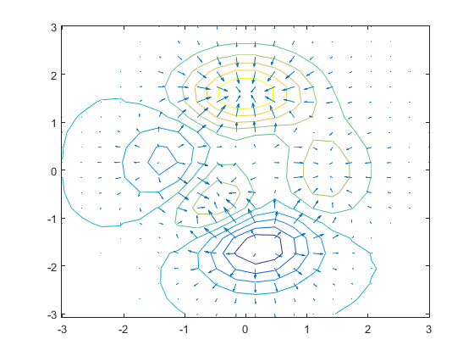

**1.6 Transfer Function**

**Example-8**

**Write a matlab code to obtain the following transfer function.**

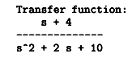

Ans:

>> num=[1 4]; den=[1 2 10];

sys=tf(num,den)

sys =

s + 4

--------------

s^2 + 2 s + 10

Continuous-time transfer function.

**Example-9**

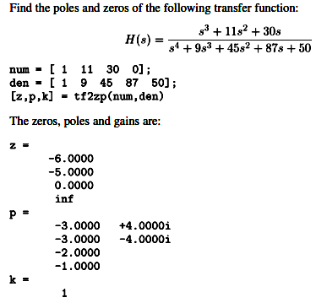

Ans:

>> num=[1 11 30 0];

den=[1 9 45 87 50];

[z,p,k]=tf2zp(num,den) %transfer function to zero and pole, k-gain. here k =1

z =

0

-6.0000

-5.0000

p =

-3.0000 + 4.0000i

-3.0000 - 4.0000i

-2.0000 + 0.0000i

-1.0000 + 0.0000i

k =

1

**Example-10**

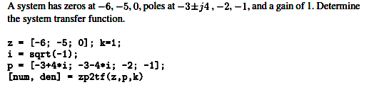

Ans:

>> z=[-6; -5; 0];

k=1;

i=sqrt(-1);

p=[-3+4*i;-3-4*i;-2;-1];

[num,den]=zp2tf(z,p,k)

num =

0 1 11 30 0

den =

1 9 45 87 50

**Example-11**

**Find the Laplace transform.**



Ans:

>> syms t s;

laplace(t*exp(-4*t),t,s)

ans =

1/(s + 4)^2

**Example-12**

**Find the inverse Laplace transform.**



Ans:

>> syms s t;

ilaplace(s*(s+6)/((s+3)*(s^2+6*s+18)))

ans =

2*cos(3*t)*exp(-3*t) - exp(-3*t)