KATHMANDU UNIVERSITY

DHULIKHEL, KAVRE

**Subject: COMP-407: Digital Signal Processing**

**Lab no: 1: Introduction to MATLAB**

**Submitted By:**

Name: Ayush Kumar Shah

Roll no: 44

Group: CE 4th year 1st sem

Level: UNG

**Submitted To:**

Satyendra Nath Lohani Sir

**Introduction to Matlab**

1. **To study important commands of MATLAB software**

**clc, close, xlabel, ylabel, zlabel, title, figure, subplot, linspace, stem, bar, plot.**

**Code**

clc %the screen is cleared

f1=figure; %a figure window is opened

surf(peaks); %a 3d surface plot is created

xlabel('X-axis')

ylabel('Y-axis')

zlabel('Height')

title('Peaks')

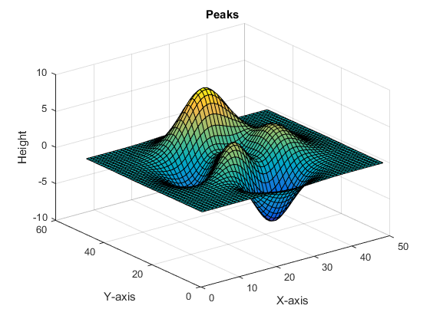

x=linspace(1,19,10); %returns a row vector of 10 evenly spaced points between x1=1 and x2=19.

%Default no of points=100

y=x*2;

close(f1); %the figure window f1 is closed

f2 = figure; %figure window f2 is created

figure(f2); %figure window f2 is selected

subplot(3,1,1); % divides the current figure into an 3 -by- 1 grid and creates axes in the position specified by p=1

stem(x,y); %plots the data sequence, Y, at values specified by X. The X and Y inputs must be vectors or matrices of the same size.

xlabel('X')

ylabel('Y')

title('Stem diagram')

subplot(3,1,2);

bar(x,y); %draws the bars at the locations specified by x.

xlabel('X')

ylabel('Y')

title('Bar diagram')

subplot(3,1,3);

plot(x,y); %creates a 2-D line plot of the data in Y versus the corresponding values in X.

xlabel('X')

ylabel('Y')

title('Plot diagram')

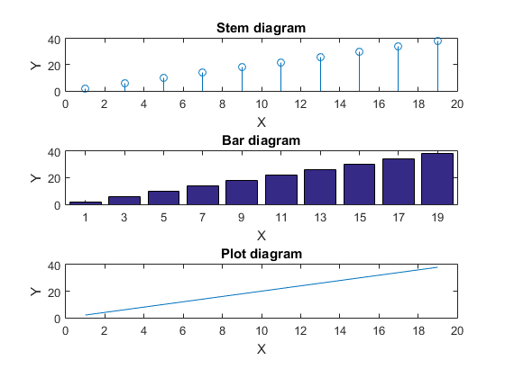

1. **Familiarization with MATLAB environment.**
2. **Create a matrix, A of size 3*4.**

>> A=[1 2 3 4

5 6 7 8

9 10 11 12]

A =

1 2 3 4

5 6 7 8

9 10 11 12

1. **Create another matrix, B of size 4*3.**

>> B=[1 2 3

4 5 6

7 8 9

10 11 12]

B =

1 2 3

4 5 6

7 8 9

10 11 12

1. **Add Matrix A and B. Subtract A from B.**

>> C=A+B

Error using -+

Matrix dimensions must agree.

>> D=A-B

Error using -

Matrix dimensions must agree.

1. **Multiply A and B. Multiply B And 4 [Errors Feason ?]**

>> E=A*B

E =

70 80 90

158 184 210

246 288 330

F=B*A

F =

38 44 50 56

83 98 113 128

128 152 176 200

173 206 239 272

1. **Transpose matrix A and B. Multiply the transposed matrices.**

>> AT=A'

AT =

1 5 9

2 6 10

3 7 11

4 8 12

>> BT=B'

BT =

1 4 7 10

2 5 8 11

3 6 9 12

>> G=AT*BT

G =

38 83 128 173

44 98 152 206

50 113 176 239

56 128 200 272

**Conclusion:**

Thus, we familiarized with the above MATLAB commands and viewed the results of these commands in MATLAB.