KATHMANDU UNIVERSITY

DHULIKHEL, KAVRE

**Subject: COMP-407: Digital Signal Processing**

**Lab no: 2**

**Submitted To:**

Satyendra Nath Lohani Sir

**Submitted By:**

Name: Ayush Kumar Shah

Roll no: 44

Group: CE 4th year 1st sem

Level: UNG

1. **Generate a continuous time sinusoidal wave of amplitude 5.**

x = linspace(-5*pi,5*pi); %range of x

y1 = 5*sin(x);

plot(x,y1);

title('Sine wave of amplitude 5');

xlabel('x');

ylabel('y(x)');

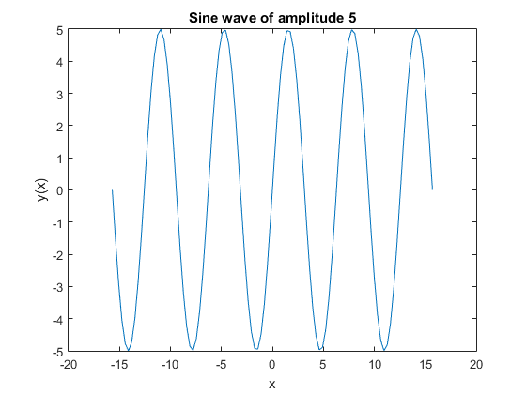

1. **Generate a unit impulse function.**

**Theory:**

The unit impulse sequence is “a sequence of discrete samples having unit magnitude at origin and zero magnitude at all other sample instants”.

https://cramster-image.s3.amazonaws.com/definitions/DC-585v1.png

**Code:**

t = [-10:10]; %range of t

impulse = t==0; %impulse function

figure;

stem(t,impulse);

title('Unit impulse function')

xlabel('t');

ylabel('x(t)');

**Output:**

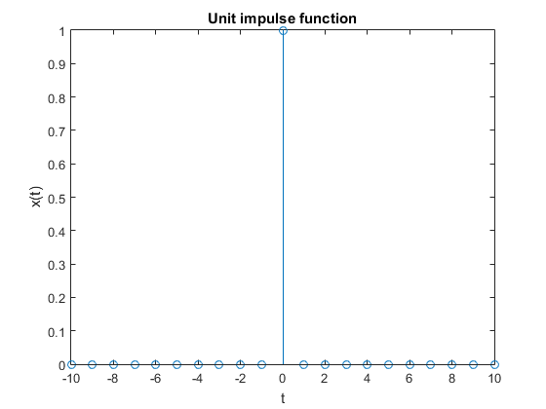

1. **Generate a unit step function.**

**Theory**

The unit step function, is defined as

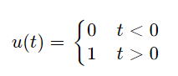

​

i.e., u is a function of time t, and u has value zero when time is negative; and value one when time is positive or zero.

**Code:**

unitstep = t>=0; %unit step function

figure;

stem(t,unitstep);

title('Unit step function')

xlabel('t');

ylabel('x(t)');

**Output:**

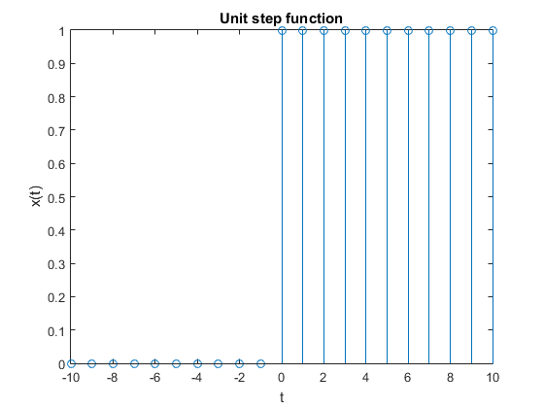

1. **Generate a unit ramp function.**

**Theory**

A signal whose magnitude increases same as time. It can be obtained by integrating unit step. Its graph is shaped like a ramp. Its value is 0 for negative inputs, output equals input for non-negative inputs.

​

r(t) = {t for t⩾0

1. for t<0

**Code:**

ramp = t.*unitstep; %ramp function

figure;

stem(t,ramp);

title('Unit ramp function')

xlabel('t');

ylabel('x(t)');

**Output:**

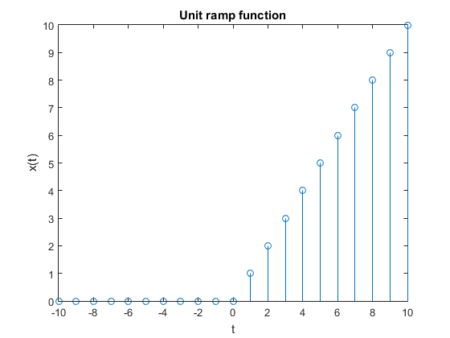

1. **Generate a continuous time sinc function**

**Theory**

The sinc function sinc(x), also called the "sampling function," is a function that arises frequently in signal processing and the theory of Fourier transforms. The full name of the function is "sine cardinal," but it is commonly referred to by its abbreviation, "sinc” and is defined by

​  sinc(x)={1   for x=0; (sinx)/x   otherwise, 

**Code:**

y2 = sinc(x); %sinc function

figure;

plot(x,y2);

title('Continuous time sinc function')

xlabel('t');

ylabel('x(t)');

**Output:**

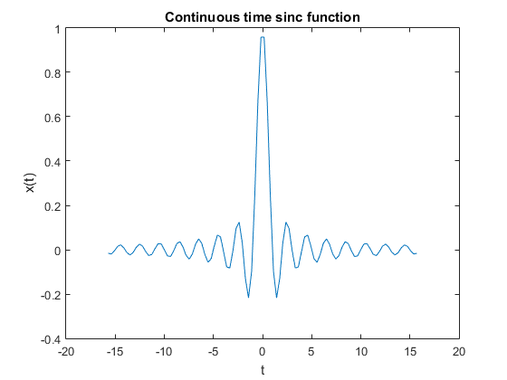

1. **Generate a continuous time exponential (growing, decaying, DC signal)**

**Theory:**

A continuous time exponential signal is a mathematical signal of the following form:

x(t)=eat

If a>0; it is growing signal

If a<0; it is decaying signal

If a=0; it is DC signal

**Code:**

figure;

y=exp(0.5*t); %growing continuous exponential function

subplot(3,1,1);

plot(t,y);

title('Continuous time exponential function (growing)')

xlabel('t');

ylabel('x(t)');

y=exp(-0.5*t); %decaying continuous exponential function

subplot(3,1,2);

plot(t,y);

title('Continuous time exponential function (decaying)')

xlabel('t');

ylabel('x(t)');

y =exp(0*t); %DC signal

subplot(3,1,3);

plot(t,y);

title('Continuous time Dc signal')

xlabel('t');

ylabel('x(t)');

**Output:**

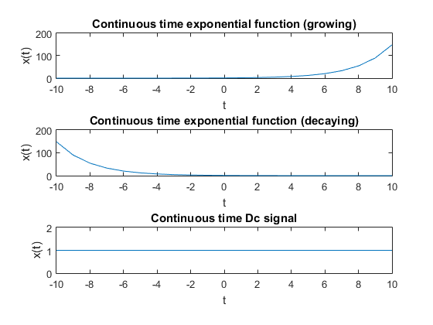

**Conclusion:**

Thus, we studied about different types of signal and represented them in MATAB and viewed the graphs.