KATHMANDU UNIVERSITY

DHULIKHEL, KAVRE

**Subject: COMP-407: Digital Signal Processing**

**Lab no: 3**

**Submitted By:**

Name: Ayush Kumar Shah

Roll no: 44

Group: CE 4th year 1st sem

Level: UNG

**Submitted To:**

Satyendra Nath Lohani Sir

**Sampling:**

In signal processing, sampling is the reduction of a continuous-time signal to a discrete-time signal. A common example is the conversion of a sound wave (a continuous signal) to a sequence of samples (a discrete-time signal).

A sample is a value or set of values at a point in time and/or space.

The typical method of obtaining a discrete-time representation of a continuous-time signal is through periodic sampling, wherein a sequence of samples, x[n], is obtained from a continuous-time signal xc(t) according to the relation

x[n] = xc(nT) -oo < n < oo.

T is the sampling period, and its reciprocal, fs, = 1/ T. is the sampling frequency

The sampling frequency or sampling rate, fs, is the average number of samples obtained in one second (samples per second), thus fs = 1/T.

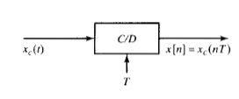

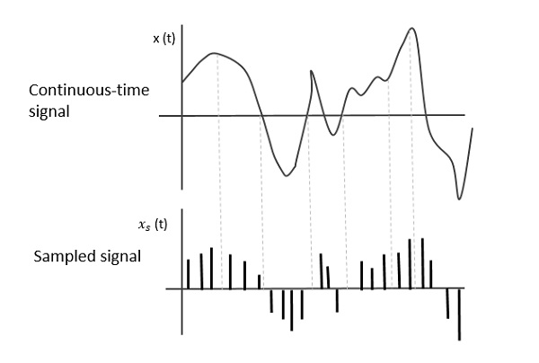

**Fig: Sampling of continuous signal**

**Nyquist Sampling Theorem:**

Let xc(t) be bandlimited signal with Xc(JΩ)=0 for |Ω|≥ΩN, then xc(t) is uniquely determined by its samples x[n] = xc(nT) if Ωs≥2ΩN ;n=0,±1,±2,±3,..

Here, Ωs is sampling frequency in radiansper seconds

ΩN is the maximum component frequency of the signal to be sampled

Xc(JΩ) is the Fourier transform of xc(t)

Nyquist rate is twice the maximum component frequency of the function being sampled.

**Aliasing**

If the inequality Ωs≥2ΩN does not hold, the copies of Xc(JΩ) overlap, so that when they are added together, Xc(JΩ) is no longer recoverable by lowpass filtering. In this case, the reconstructed output xr(t) is related to the original continuous-time input through a distortion referred to as aliasing distortion, or simply, aliasing.

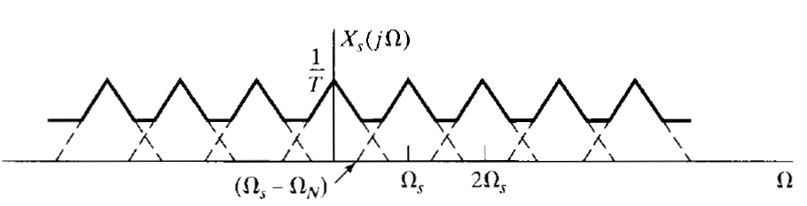

**Fig: Aliasing**

**Question 1**: Generate the signal x = 5sin(2 pi f t) with 5 cycles, where f = 2 kHz signal and sample the signal with frequency 5 KHz, 10 Khz, 20 KHz. (Title and label each figure)

**Code:**

f=2e3; %Frequency of sinusoid

cycles=5; %generate five cycles of sinusoid

t=0:1/500e3:cycles*1/f; %time index

x = 5*sin(2*pi*f*t);

subplot(4,1,1);

plot(t,x);

title('Continuous sinusoidal signal (fm=2 kHz)');

xlabel('Time(s)');

ylabel('Amplitude');

fs1=5e3; %5kHz sampling rate

t1=0:1/fs1:cycles*1/f; %time index

x1 = 5*sin(2*pi*f*t1);

fs2=10e3; %10kHz sampling rate

t2=0:1/fs2:cycles*1/f; %time index

x2=5*sin(2*pi*f*t2);

fs3=20e3; %20kHz sampling rate

t3=0:1/fs3:cycles*1/f; %time index

x3=5*sin(2*pi*f*t3);

subplot(4,1,2);

plot(t,x);

hold on;

stem(t1,x1);

title('Sampling Continuous sinusoidal signal at fs1=5 kHz');

xlabel('Time(s)');

ylabel('Amplitude');

subplot(4,1,3);

plot(t,x);

hold on;

stem(t2,x2);

title('Sampling Continuous sinusoidal signal at fs2=10 kHz');

xlabel('Time(s)');

ylabel('Amplitude');

subplot(4,1,4);

plot(t,x);

hold on;

stem(t3,x3);

title('Sampling Continuous sinusoidal signal at fs3=20 kHz');

xlabel('Time(s)');

ylabel('Amplitude');

**Output:**

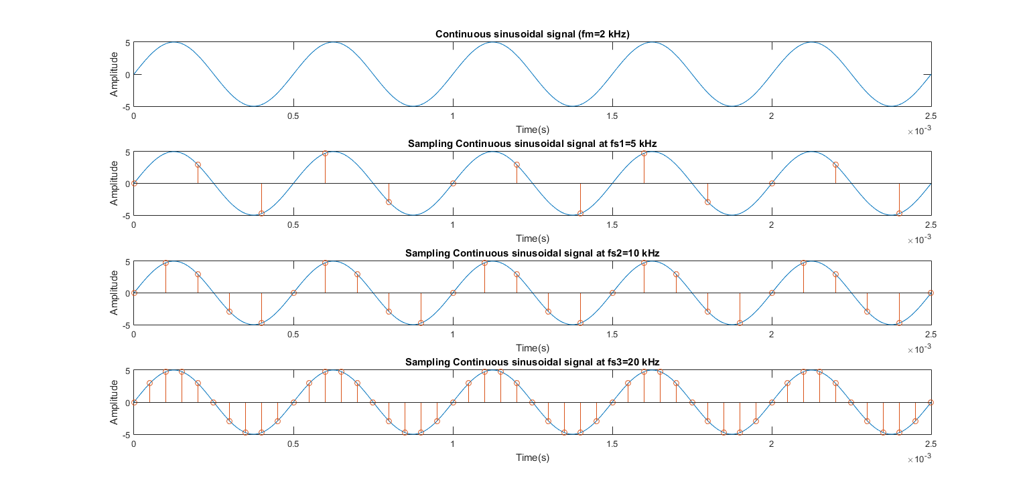

**Question 2**: Generate the signal x = 5cos(2 pi f t) with 3 cycles, where f = 2 kHz signal and sample the signal with frequency 5 KHz, 10 Khz, 20 KHz. (Title and label each figure)

**Code:**

%ques 2

f=2e3; %Frequency of sinusoid

cycles=3; %generate five cycles of sinusoid

t=0:1/500e3:cycles*1/f; %time index

x = 5*cos(2*pi*f*t);

figure;

subplot(4,1,1);

plot(t,x);

title('Continuous sinusoidal signal (fm=2 kHz)');

xlabel('Time(s)');

ylabel('Amplitude');

fs1=5e3; %5kHz sampling rate

t1=0:1/fs1:cycles*1/f; %time index

x1 = 5*cos(2*pi*f*t1);

fs2=10e3; %10kHz sampling rate

t2=0:1/fs2:cycles*1/f; %time index

x2=5*cos(2*pi*f*t2);

fs3=20e3; %20kHz sampling rate

t3=0:1/fs3:cycles*1/f; %time index

x3=5*cos(2*pi*f*t3);

subplot(4,1,2);

plot(t,x);

hold on;

stem(t1,x1);

title('Sampling Continuous sinusoidal signal at fs1=5 kHz');

xlabel('Time(s)');

ylabel('Amplitude');

subplot(4,1,3);

plot(t,x);

hold on;

stem(t2,x2);

title('Sampling Continuous sinusoidal signal at fs2=10 kHz');

xlabel('Time(s)');

ylabel('Amplitude');

subplot(4,1,4);

plot(t,x);

hold on;

stem(t3,x3);

title('Sampling Continuous sinusoidal signal at fs3=20 kHz');

xlabel('Time(s)');

ylabel('Amplitude');

**Output:**

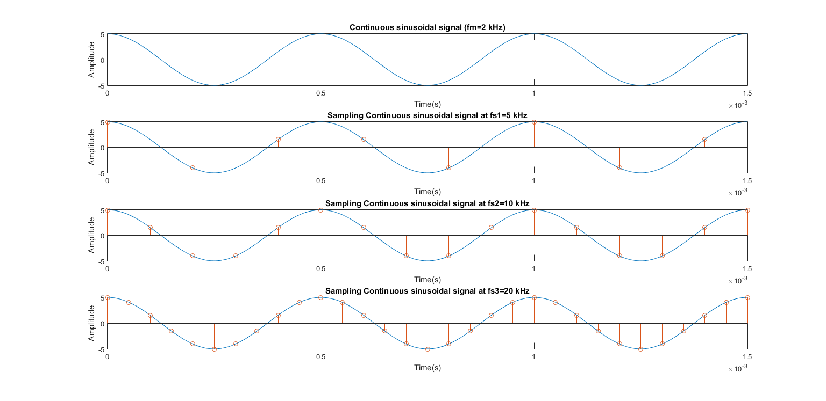

**Conclusion:**

Thus, we performed sampling on continuous sinusoidal waves at different sampling frequencies and viewed the results in MATLAB