KATHMANDU UNIVERSITY

DHULIKHEL, KAVRE

**Subject: COMP-407: Digital Signal Processing**

**Lab no: 4**

**Submitted By:**

Name: Ayush Kumar Shah

Roll no: 44

Group: CE 4th year 1st sem

Level: UNG

**Submitted To:**

Satyendra Nath Lohani Sir

**Discuss Fourier Series and perform following operation.**

**Theory:**

A Fourier series is an expansion of a periodic function f(x) in terms of an infinite sum of sines and cosines. Fourier series make use of the orthogonality relationships of the sine and cosine functions. The computation and study of Fourier series is known as harmonic analysis and is extremely useful to break up an arbitrary periodic function into a set of harmonics.

1. **Classical Fourier Series representation**

**Synthesis equation:**

$$x\left(t\right)=\sum_{k=-∞}^{∞}{a_{k}e^{jkω_{0}t}}$$

**Analysis equation:**

$$a_{k}=\frac{1}{T}\int_{0}^{T}{{x(t)e}^{-jkω_{0}}dt}$$

1. **Generalized equation:**

**Synthesis equation:**

$$x\left(t\right)=a_{0}+\sum_{n=1}^{∞}{a_{n}cos⁡(n}ω_{0}t)+b_{n} sin⁡({nω}_{0}t)$$

P=T

**Analysis equation:**

$$a_{0}=\frac{1}{T}\int_{T}{x\left(t\right)dt}$$

$$a_{n}=\frac{2}{T}\int_{T}{x\left(t\right)\cos\left(nω_{0}t\right)dt}$$

$$b_{n}=\frac{2}{T}\int_{T}{x\left(t\right)\sin\left(nω_{0}t\right)dt}$$

**Synthesis equation:**

$$f(x)=a_{0}+\sum_{n=1}^{N}{a_{n}cos⁡(\frac{nπx}{L}})+b_{n} sin⁡(\frac{nπx}{L})$$

P=2L

**Analysis equation:**

$$a_{0}=\frac{1}{P}\int_{P}{f(x)dt}$$

$$a_{n}=\frac{2}{P}\int_{P}{f(x)\cos\left(\frac{nπx}{L}\right)dx}$$

$$b_{n}=\frac{2}{P}\int_{P}{f(x)\sin\left(\frac{nπx}{L}\right)dx}$$

1. **Fourier series expansion of odd signal for different N.(N= 3, 9, 100).**

We take an odd signal given by

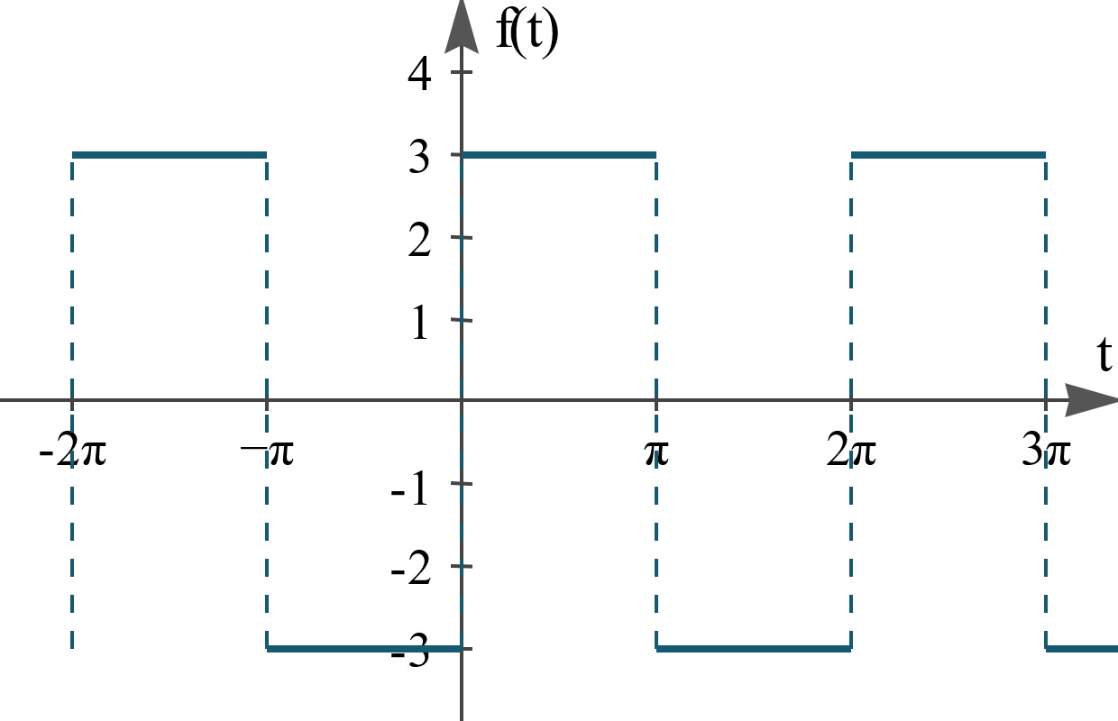

**Code:**

%odd signal

x = linspace(-2*pi,2*pi); % time grid

N1=3;

N2=9;

N3=100;

n1 = [1:2:N1];

n2 = [1:2:N2];

n3 = [1:2:N3];

a0=0;

c=1;

% plot

figure;

subplot(3,1,1);

fx =a0+ sum(4*c/pi*diag(1./n1)*sin(n1(:)*x(:)')); % summation

plot(x,fx);

xlabel('x');

ylabel('f(x)');

title('Fourier series expansion of odd signal for N=3');

subplot(3,1,2);

fx =a0+ sum(4*c/pi*diag(1./n2)*sin(n2(:)*x(:)')); % summation

plot(x,fx);

xlabel('x');

ylabel('f(x)');

title('Fourier series expansion of odd signal for N=9');

subplot(3,1,3);

fx =a0+ sum(4*c/pi*diag(1./n3)*sin(n3(:)*x(:)')); % summation

plot(x,fx);

xlabel('x');

ylabel('f(x)');

title('Fourier series expansion of odd signal for N=100');

**Output:**

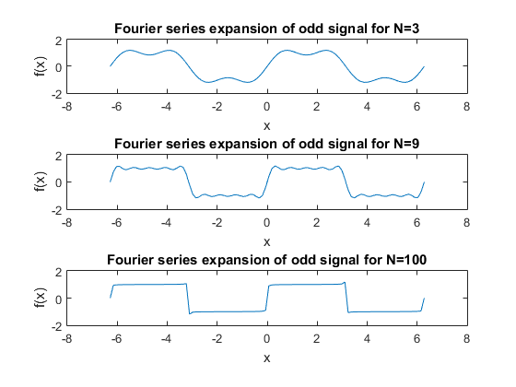

1. **Fourier series expansion of even signal for different N. (N=3,9,100).**

We take an even signal given by

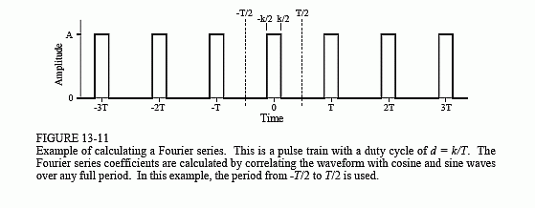

**Code:**

%even signal

t = linspace(-1,1); % time grid

a0=1/2;

T=1;

% plot

figure;

subplot(3,1,1);

xt =a0+ sum(2/pi*diag((1./n1).*((-1).^((ceil(n1./2))+1)))*cos(2*pi*(1/T)*n1(:)*t(:)')); % summation

plot(t,xt);

xlabel('t');

ylabel('x(t)');

title('Fourier series expansion of even signal for N=3, T=1');

subplot(3,1,2);

xt =a0+ sum(2/pi*diag((1./n2).*((-1).^((ceil(n2./2))+1)))*cos(2*pi*(1/T)*n2(:)*t(:)')); % summation

plot(t,xt);

xlabel('t');

ylabel('x(t)');

title('Fourier series expansion of even signal for N=9, T=1');

subplot(3,1,3);

xt =a0+ sum(2/pi*diag((1./n3).*((-1).^((ceil(n3./2))+1)))*cos(2*pi*(1/T)*n3(:)*t(:)')); % summation

plot(t,xt);

xlabel('t');

ylabel('x(t)');

title('Fourier series expansion of even signal for N=100, T=1');

**Output:**

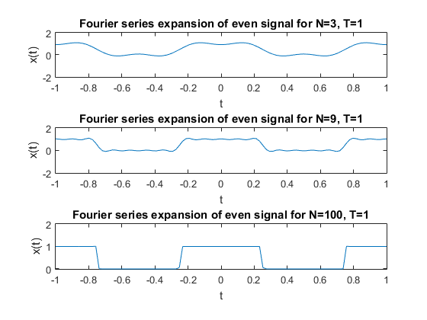

**Conclusion:**

Thus, we discussed Fourier series representation of periodic signals and represented odd and even periodic series as Fourier series with different values of N.