**Problem Statement:**

Analyse the KPI requirements for pizza sales data to gain insights into business performance.

**Metrics:**

1. Total Revenue: Sum prices of all orders
2. Average Order Value: Total Revenue/Total number of Orders
3. Total pizzas sold: Sum of quantities of pizzas sold
4. Total Orders: Count of total number of orders placed
5. Average pizzas per order: Total number of pizzas/Total number of orders

**PIZZA SALES INSIGHTS**

1. **KPIs:**
2. Total Revenue:

SELECT sum(total_price) AS Total_Revenue from pizza_sales

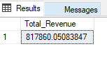

1. Average Order Value:

SELECT SUM(total_price) / COUNT(DISTINCT order_id) AS Average_Order_Value from pizza_sales

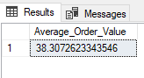

1. Total Pizza Sold:

SELECT SUM(quantity) AS Total_Pizza_Sold from pizza_sales

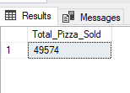

1. Total Order Placed:

SELECT COUNT(DISTINCT order_id) AS Total_Orders from pizza_sales

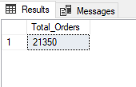

1. Average pizza per order:

SELECT CAST(CAST(SUM(quantity) AS DECIMAL(10,2)) / CAST(COUNT(DISTINCT order_id) AS DECIMAL(10,2)) AS DECIMAL(10,2)) AS Average_Pizza_PerOrder from pizza_sales

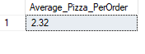

1. **Daily Trend for Orders:**

SELECT DATENAME(DW, order_date) AS order_day, COUNT(DISTINCT order_id) AS total_orders   
FROM pizza_sales  
GROUP BY DATENAME(DW, order_date)

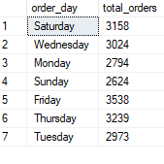

1. **Hourly Trends for Orders:**

SELECT DATEPART(HOUR, order_time) as order_hours, COUNT(DISTINCT order_id) as total_orders  
from pizza_sales  
group by DATEPART(HOUR, order_time)  
order by DATEPART(HOUR, order_time)

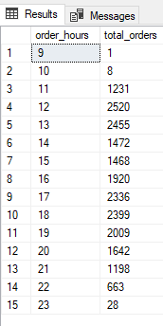

1. **% SALES BY PIZZA CATEGORY:**

SELECT pizza_category, CAST(SUM(total_price) AS DECIMAL(10,2)) AS total_revenue,

CAST(SUM(total_price) * 100 / (SELECT SUM(total_price) from pizza_sales) AS DECIMAL(10,2)) AS P_Sales_ByCategory

FROM pizza_sales

GROUP BY pizza_category  
ORDER BY P_Sales_ByCategory

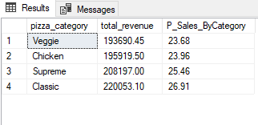

1. **% SALES BY PIZZA SIZE:**

SELECT pizza_size, CAST(SUM(total_price) AS DECIMAL(10,2)) AS total_revenue,

CAST(SUM(total_price) * 100 / (SELECT SUM(total_price) from pizza_sales) AS DECIMAL(10,2)) AS P_Sales_BySize

FROM pizza_sales

GROUP BY pizza_size

ORDER BY P_Sales_BySize DESC

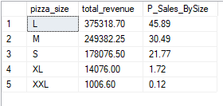

1. **Total Pizzas Sold by Pizza Category:**

SELECT pizza_category, SUM(quantity) AS Total_Pizza_Sold

from pizza_sales

GROUP BY pizza_category

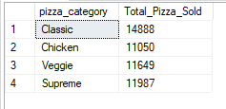

1. **Top5 Best Sellers:**

SELECT TOP 5 pizza_name, SUM(quantity) AS Total_Pizza_Sold

from pizza_sales

GROUP BY pizza_name

ORDER BY sum(quantity) DESC

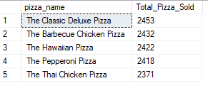

1. **Bottom5 Worst Sellers:**

SELECT TOP 5 pizza_name, SUM(quantity) AS Total_Pizza_Sold

from pizza_sales

GROUP BY pizza_name

ORDER BY sum(quantity) ASC

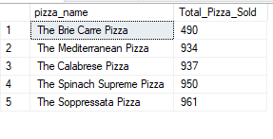

By

Ayush Laduna