Traffic Light Controller
8086 assembly in EMU8086
PRN: 2125UIDM1080, 2125UIDM1031, 2125UIDF1102, 2125UIDM1116
Aim
Simulate a traffic light by printing RED (STOP), YELLOW (READY) and GREEN (GO), pausing about 3 seconds after each, and repeating until a key is pressed.
Code
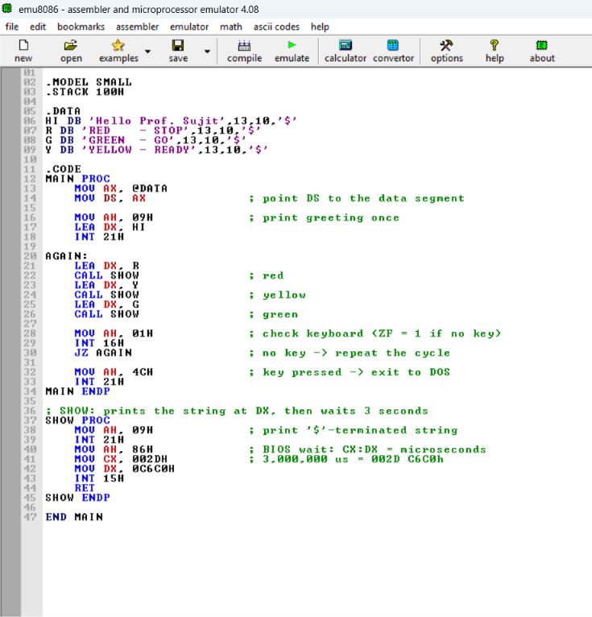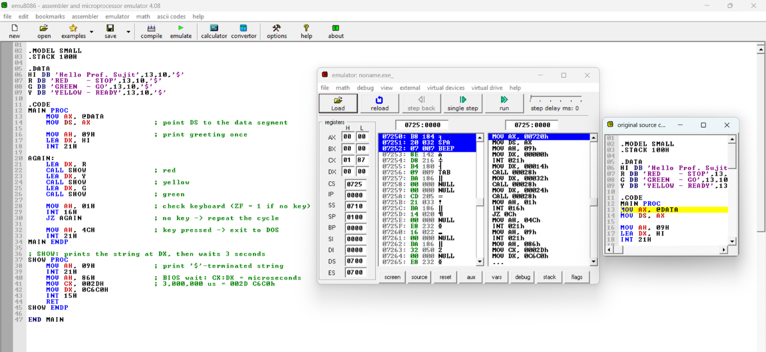
How it works
.MODEL SMALL / .STACK 100H | Sets the small memory model and reserves 256 bytes of stack.
.DATA (HI, R, Y, G) | Stores the greeting and the RED, YELLOW and GREEN messages. 13,10 moves to a new line and $ marks the end of each string.
MOV AX, @DATA / MOV DS, AX | Points DS to the data segment so the strings can be read.
INT 21H (AH = 09H) | Prints the string whose address is in DX.
AGAIN: | Start of the loop that repeats the light cycle.
LEA DX / CALL SHOW | Loads one message and calls SHOW to print it and wait. Done for red, yellow, then green.
INT 16H (AH = 01H) | Checks the keyboard without waiting. ZF = 1 means no key was pressed.
JZ AGAIN | No key pressed, so go back to AGAIN and repeat.
MOV AH, 4CH / INT 21H | A key was pressed, so exit to DOS.
SHOW PROC | A small routine that prints the message in DX, then waits.
INT 15H (AH = 86H) | Waits for CX:DX microseconds. 002D C6C0H is 3,000,000, so about 3 seconds.
END MAIN | Ends the program and marks MAIN as the entry point.
Output
The greeting prints once. Then the three messages repeat in order, with a 3 second pause after each. The screen is never cleared, so the lines keep stacking until a key is pressed.
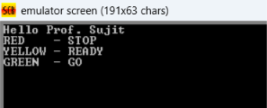
Result
The program prints RED, YELLOW and GREEN in order, waits about 3 seconds after each, and loops until a key is detected.

