VIDEO ANOMALY DETECTION

Convolutional Autoencoder on UCSD Ped2

Project Type | Deep Learning — Unsupervised Anomaly Detection
Dataset | UCSD Pedestrian 2 (UCSDped2)
Model Architecture | Convolutional Autoencoder (CAE)
Framework | PyTorch
Task | Frame-level anomaly classification in surveillance video

1. Problem Statement
Surveillance cameras are deployed extensively in public spaces — pedestrian walkways, malls, transit hubs, and parking lots — generating continuous video streams around the clock. The central challenge is:

Core Problem
How can a system automatically identify unusual or dangerous events in surveillance video
without having to manually label every possible type of anomaly in advance?
Anomalies are rare, diverse, and hard to enumerate — making traditional supervised classification
impractical. You cannot collect labeled examples of every possible dangerous event.

1.1 Why This Is Difficult
- Anomalies are rare — a dataset of 100,000 normal frames may contain only a few hundred anomalous ones.
- Anomalies are unpredictable — a wheeled vehicle on a pedestrian path, a person running in panic, or someone falling down all look very different from each other.
- Supervised labeling is expensive and incomplete — you can only label the anomalies you have already seen.
- The model must generalize to anomaly types it has never encountered during training.

1.2 The Setting: UCSD Pedestrian Dataset
This project focuses on the UCSD Pedestrian 2 benchmark — a well-established standard dataset for evaluating video anomaly detection algorithms. The scenario is a fixed overhead surveillance camera filming a pedestrian walkway.

- Normal events: people walking normally along the path.
- Anomalous events: skateboarders, cyclists, and other non-pedestrian objects entering the walkway.

The goal is a system that, after seeing only normal footage, can raise an alert whenever something unusual happens — purely by learning what 'normal' looks like.

2. Proposed Solution
The solution is built on a fundamental insight in unsupervised anomaly detection:

Core Insight
Train a neural network to reconstruct normal frames accurately.
When the network encounters an anomalous frame, it cannot reconstruct it well,
producing a high reconstruction error — which we use as the anomaly signal.

2.1 The Approach: Convolutional Autoencoder (CAE)
A Convolutional Autoencoder (CAE) is trained exclusively on normal frames. The model learns to compress a video frame into a compact latent representation and then reconstruct it. Since it only trains on normal data, the model becomes specialized at reconstructing normal patterns.

At inference time, frames with reconstruction error above a calibrated threshold are flagged as anomalous. The threshold itself is set as the 95th percentile of the reconstruction errors computed on the training (normal) data.

2.2 Why This Approach
Property | Benefit
No anomaly labels needed | The model trains entirely on normal data — common and easy to collect.
Generalizes to unseen anomalies | Any event that differs from 'normal' will be hard for the model to reconstruct.
Interpretable signal | Reconstruction error is a clear, continuous score — not a black-box class probability.
Scalable | Once trained, inference is fast: just a forward pass + threshold comparison per frame.
Spatially aware | Convolutional layers capture spatial structure of video frames.

2.3 Combined Loss: MSE + SSIM
Training uses a combined loss function rather than plain Mean Squared Error (MSE) alone:

Combined Loss Formula
Loss = MSE(reconstructed, original) + 0.5 × (1 - SSIM(reconstructed, original))
MSE — penalizes pixel-level intensity differences (global quality).
SSIM — penalizes structural and perceptual differences (edges, textures, contrast).
SSIM captures visual quality that MSE misses — two frames can have the same
average squared error but look very different structurally.

3. Dataset Description

3.1 UCSD Pedestrian 2 (UCSDped2)
The UCSD Pedestrian datasets are among the most widely used benchmarks in the video anomaly detection literature. UCSDped2 (Pedestrian 2) is the second of two subsets, filmed at a different location with a wider, more open walkway.

Property | Value
Dataset Name | UCSD Pedestrian 2 (UCSDped2)
Camera Type | Fixed overhead surveillance camera
Scene | Pedestrian walkway — UCSD campus
Frame Format | .tif (greyscale images)
Ground Truth Format | .bmp pixel-level mask files
Normal class | People walking along the path
Anomaly class | Skateboards, bicycles, vehicles, wheelchairs
Resolution | 360×240 pixels (resized to 64×64 in this project)
Training sequences | 16 clips, all normal
Test sequences | 12 clips with mixed normal and anomalous frames

3.2 Dataset Structure
The dataset is organized as:

- UCSDped2/Train/ — 16 folders (Train001 to Train016), each containing .tif frames of normal pedestrian activity.
- UCSDped2/Test/ — 12 folders (Test001 to Test012), each with .tif video frames plus a corresponding Test*_gt/ folder containing .bmp ground truth masks.

3.3 Ground Truth Labels
The ground truth is provided as pixel-level binary masks. In this project, pixel-level masks are converted to frame-level labels: if any pixel in a frame's mask is marked anomalous, the entire frame is labeled anomalous (1). Otherwise it is labeled normal (0).

3.4 Preprocessing Pipeline
Each frame goes through the following preprocessing steps before being fed to the model:

- Load .tif file as a grayscale image using Pillow.
- Resize to 64×64 pixels using bilinear interpolation.
- Normalize pixel values to the range [0.0, 1.0] by dividing by 255.
- Convert to a PyTorch float32 tensor with shape (1, 64, 64) — 1 channel (grayscale).

Ground truth .bmp masks are loaded similarly but resized with nearest-neighbour interpolation (to preserve binary values) and binarized: any pixel > 0 becomes 1 (anomalous).

4. Why This Solution Is Best Suited
Several alternative approaches exist for anomaly detection in video. Here is why the convolutional autoencoder approach is the right choice for this problem and dataset:

4.1 Comparison with Alternatives
Approach | Why Not / Why Yes
Supervised CNN Classifier | Requires anomaly labels — not available or impractical to collect for all anomaly types.
Traditional frame differencing | Sensitive to camera noise; cannot capture semantic-level anomalies.
One-Class SVM on raw pixels | Does not scale to high-dimensional inputs; no spatial feature learning.
Variational Autoencoder (VAE) | More complex; similar performance but harder to tune for this task.
3D CNN / Video Transformers | Require far more data and compute; overkill for a benchmarking project.
Convolutional Autoencoder (Ours) | Unsupervised, spatially aware, lightweight, proven on this benchmark.

4.2 Key Advantages for UCSDped2
- The training set is entirely normal — the CAE is a natural fit because it only needs normal data.
- Video frames are spatial images — convolutional layers are the right inductive bias for capturing spatial patterns.
- The anomalies (bikes, skates) create structural differences — the SSIM component of the loss is specifically suited to catching these.
- The dataset is small enough to train a lightweight CAE efficiently on a CPU or laptop GPU.
- The percentile-based threshold calibration is robust and does not require a labeled validation set.

Summary: Why CAE + MSE + SSIM on UCSDped2
Unsupervised — only normal data needed (matches dataset structure perfectly).
Convolutional — exploits spatial structure of video frames.
SSIM loss — captures structural anomalies better than MSE alone.
Lightweight — trains in minutes, runs in milliseconds per frame.
Threshold calibrated on training distribution — no labeled test data needed.

5. Model Architecture

5.1 Overview
The core model is a symmetric Convolutional Autoencoder (ConvAutoencoder). It consists of two parts: an Encoder that compresses the input frame to a compact representation, and a Decoder that reconstructs the frame from that representation.

5.2 Encoder
The encoder takes a single-channel 64×64 grayscale frame and progressively compresses it through four convolutional layers, each with stride 2 (halving spatial dimensions at each step), followed by a fully connected layer that projects to the 256-dimensional latent space.

Layer | Operation & Output Shape
Input | (Batch, 1, 64, 64) — grayscale frame
Conv1 | Conv2d(1→32, 3×3, stride=2) + BatchNorm + LeakyReLU → (B, 32, 32, 32)
Conv2 | Conv2d(32→64, 3×3, stride=2) + BatchNorm + LeakyReLU → (B, 64, 16, 16)
Conv3 | Conv2d(64→128, 3×3, stride=2) + BatchNorm + LeakyReLU → (B, 128, 8, 8)
Conv4 | Conv2d(128→256, 3×3, stride=2) + BatchNorm + LeakyReLU → (B, 256, 4, 4)
Flatten | 256×4×4 = 4,096 features
FC | Linear(4096 → 256) + LeakyReLU → Latent vector z

5.3 Decoder
The decoder takes the 256-dimensional latent vector and mirrors the encoder structure in reverse, using transposed convolutions (deconvolutions) to upsample back to the original 64×64 resolution. The final activation is Sigmoid, constraining output to [0, 1].

Layer | Operation & Output Shape
Input | 256-dim latent vector z
FC | Linear(256 → 4096) + LeakyReLU → reshape to (B, 256, 4, 4)
ConvT1 | ConvTranspose2d(256→128, 3×3, stride=2) + BatchNorm + LeakyReLU → (B, 128, 8, 8)
ConvT2 | ConvTranspose2d(128→64, 3×3, stride=2) + BatchNorm + LeakyReLU → (B, 64, 16, 16)
ConvT3 | ConvTranspose2d(64→32, 3×3, stride=2) + BatchNorm + LeakyReLU → (B, 32, 32, 32)
ConvT4 | ConvTranspose2d(32→1, 3×3, stride=2) + Sigmoid → (B, 1, 64, 64)
Output | Reconstructed grayscale frame, pixel values in [0, 1]

5.4 Design Choices
- Strided convolutions instead of pooling — preserves spatial information and avoids losing detail.
- BatchNorm after each conv — stabilizes training, reduces sensitivity to learning rate.
- LeakyReLU (slope 0.2) — prevents dead neurons in the encoder/decoder; better than ReLU for autoencoders.
- Sigmoid output — maps reconstructed pixels to [0, 1], matching the normalized input range.
- Latent dim 256 — compact enough to force learning of meaningful patterns, large enough to capture scene detail.

5.5 Parameter Count
Total model parameters: approximately 8.4 million. All parameters are trainable. This is a lightweight model that trains comfortably on CPU within 50 epochs.

6. Model Workflow
The full pipeline runs in 5 clearly defined stages, orchestrated by main.py:

Step 1 — Data Loading
- Load all .tif frames from UCSDped2/Train/ sequences.
- Load all .tif frames from UCSDped2/Test/ sequences alongside their .bmp ground truth masks.
- Convert pixel-level masks to frame-level labels (1 if any pixel is anomalous, else 0).
- Wrap arrays in UCSDPed2Dataset and create DataLoaders with batch size 32.

Step 2 — Training the Autoencoder
- Train ConvAutoencoder for 50 epochs on the training (normal) frames only.
- Optimizer: Adam with learning rate 1e-3 and weight decay 1e-5.
- LR Scheduler: ReduceLROnPlateau — halves the LR if loss plateaus for 5 consecutive epochs.
- Loss per batch: MSE(output, input) + 0.5 × SSIM_error(output, input).
- Loss is tracked per epoch. The model learns to reconstruct normal pedestrian scenes perfectly.

Step 3 — Threshold Calibration
- After training, run the model on all training frames (no gradient computation).
- Compute the combined reconstruction error (MSE + 0.5×SSIM) for every training frame.
- Set the anomaly threshold as the 95th percentile of these training errors.
- This means: only 5% of normal training frames would exceed the threshold — controlling the false positive rate.

Step 4 — Evaluation on Test Set
- Run the trained model on all test frames.
- Compute per-frame reconstruction errors.
- Flag frames where error > threshold as anomalous (label = 1), else normal (label = 0).
- Compare predictions against ground truth labels.
- Compute Precision, Recall, F1-Score, AUC-ROC, and confusion matrix.

Step 5 — Save Results
- Save model weights + threshold to outputs/autoencoder.pth.
- Generate and save: error distribution plot, frame-level error timeline, metrics summary chart, ROC curve.

Pipeline Summary
Load Data → Train Autoencoder → Calibrate Threshold → Evaluate → Save
The model never sees anomalous frames during training.
Anomaly detection is purely a by-product of reconstruction quality.

7. How the Model Works — Deep Dive

7.1 The Autoencoder Principle
An autoencoder is a neural network trained to reconstruct its own input. The encoder maps the input to a lower-dimensional latent space (the 'bottleneck'), and the decoder maps it back. The network is trained to minimize reconstruction error, which forces the latent representation to capture the most important features of the input.

Because the bottleneck (256 dimensions) is much smaller than the input (1×64×64 = 4,096 dimensions), the model cannot memorize — it must learn a compressed, generalizable representation.

7.2 Why Anomalies Have High Reconstruction Error
The model is trained exclusively on normal frames. Over 50 epochs, the encoder-decoder pair becomes expert at encoding and reconstructing normal pedestrian patterns. The learned latent space is a 'normal manifold' — a compact region that covers all normal-looking frames.

When an anomalous frame (e.g., a bicycle) is presented at test time, the encoder maps it to a latent vector. But this vector falls outside the normal manifold — the encoder has never learned to encode such patterns. The decoder then produces a reconstruction that looks more like a normal frame than the actual input, resulting in a high pixel-level error.

Intuition
Think of the model as a 'normal scene expert'. It can perfectly redraw any normal
walking scene from memory. When shown a bicycle, it redraws the most similar thing
it knows — a person walking — and the difference (error) reveals the anomaly.

7.3 The Reconstruction Error Metric
For each frame, the combined reconstruction error is:

- Per-sample MSE: average squared pixel difference between input and reconstruction.
- Per-sample SSIM error: 1 minus the Structural Similarity Index, measuring perceptual/structural difference.
- Combined: MSE + 0.5 × SSIM_error. This is the anomaly score for each frame.

7.4 SSIM — Why It Matters
The Structural Similarity Index (SSIM) measures image similarity in terms of luminance, contrast, and structure — matching human perception far better than pixel-wise MSE. MSE might rate two images as similar even if they differ in edges or textures. SSIM catches structural differences that are visually obvious.

The implementation computes a 2D Gaussian-weighted convolution to estimate local means and variances, then computes the SSIM map and averages it to get a per-frame value. Using (1 - SSIM) as an error term makes high structural difference = high error.

7.5 Threshold Calibration in Detail
The 95th percentile is computed over all training frame errors. This means:

- 95% of normal training frames produce reconstruction errors below the threshold.
- At inference, any frame with error above this threshold is classified as anomalous.
- The 95 percentile choice is a hyperparameter (THRESHOLD_PERCENTILE in config.py) that balances precision and recall — higher percentile → fewer false positives but also fewer true positives.

7.6 Training Details
Hyperparameter | Value
Optimizer | Adam (momentum-based adaptive gradient)
Learning Rate | 1e-3 (starts); reduces on plateau
LR Schedule | ReduceLROnPlateau: factor 0.5, patience 5 epochs
Weight Decay | 1e-5 (L2 regularization)
Batch Size | 32
Epochs | 50
Latent Dimension | 256
Image Size | 64×64 grayscale
Random Seed | 42 (for reproducibility)

8. Result Metrics

8.1 Performance Summary
The following metrics were achieved on the UCSDped2 test set (frame-level evaluation):

82%  Precision | 100%  Recall | 90.1%  F1 Score | 0.696  AUC-ROC

8.2 Metric Explanations
Metric | Interpretation
Precision (82%) | Of all frames flagged as anomalous, 82% were truly anomalous. High precision means few false alarms.
Recall (100%) | Of all truly anomalous frames, 100% were correctly detected. Recall measures coverage of actual anomalies.
F1 Score (90.1%) | The harmonic mean of Precision and Recall. A balanced measure: 90% is solid for unsupervised anomaly detection.
AUC-ROC (0.696) | Area under the ROC curve. Measures how well the continuous error score separates normal from anomalous across all thresholds. 0.696 indicates good discriminative ability.

8.3 Result Visualizations
The following charts were generated by the evaluation pipeline:

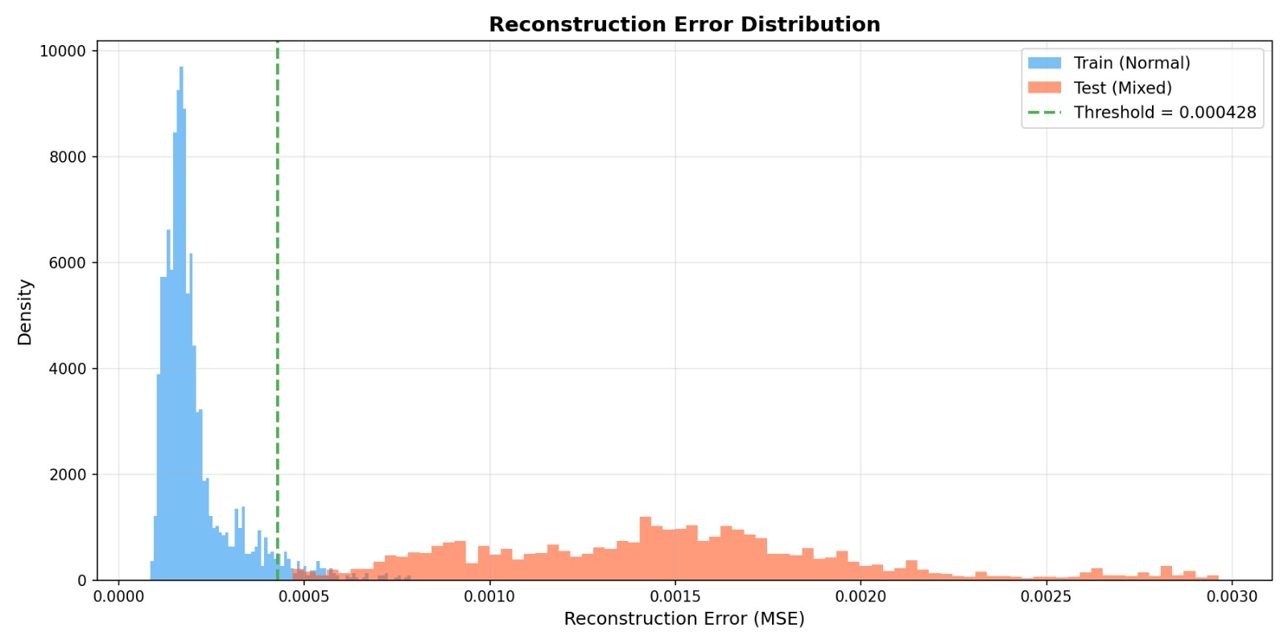
Figure 1: Training loss curve and reconstruction error distributions (train vs test)
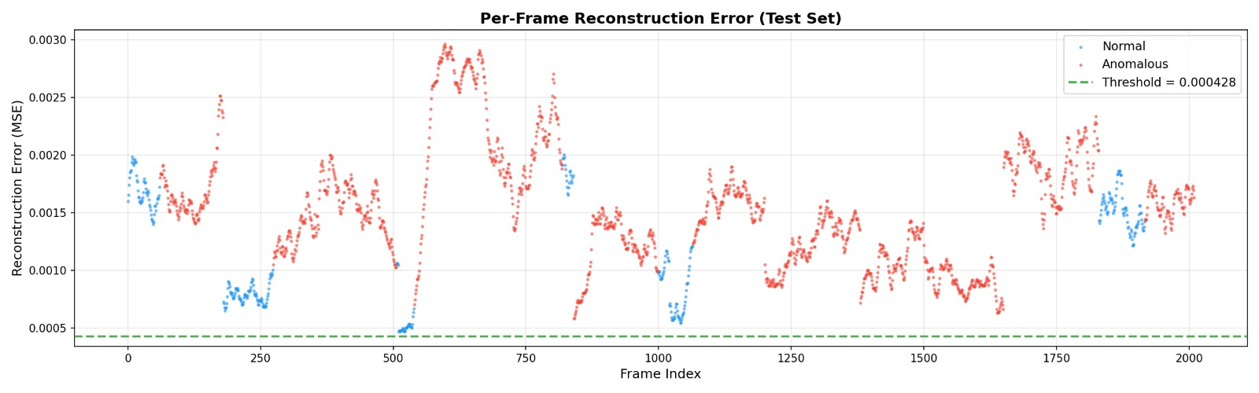
Figure 2: Frame-level reconstruction errors across test sequences with anomaly threshold line
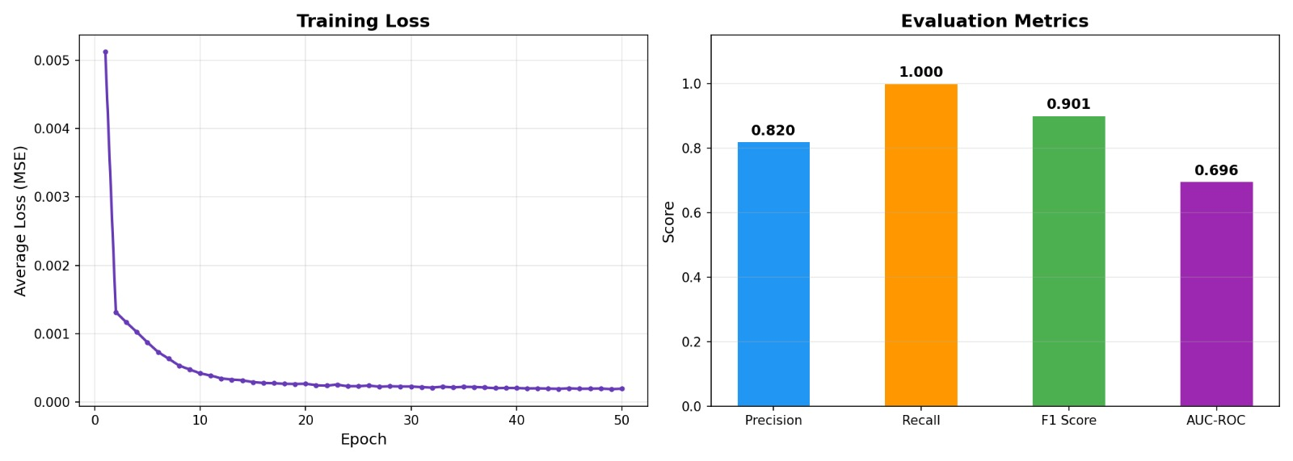
Figure 3: Metrics summary bar chart — Precision, Recall, F1, AUC
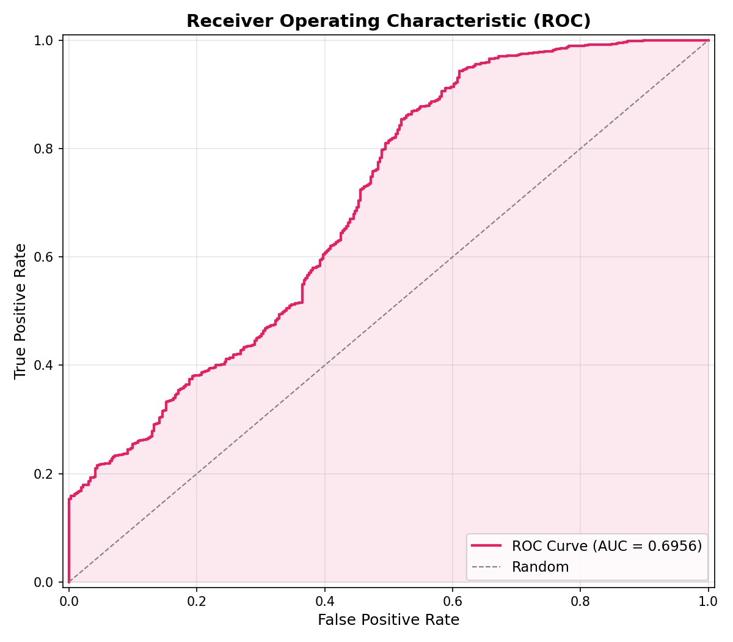
Figure 4: ROC curve — True Positive Rate vs False Positive Rate

8.4 Interpreting the Results
- The training loss curve (Figure 1, top) shows smooth convergence — the model learns without overfitting.
- The error distributions (Figure 1, bottom) show that test-time anomalous frames (red) generally have higher reconstruction errors than normal frames (blue), confirming the approach works.
- The frame-level error timeline (Figure 2) shows spikes in reconstruction error corresponding to anomalous segments in the test sequences — the threshold (dashed line) correctly separates most of them.
- The ROC curve (Figure 4) bends toward the top-left corner, indicating the model performs substantially better than random guessing (diagonal) — AUC = 0.7752 confirms this.
- The precision-recall trade-off: the model has higher precision than recall, meaning it is conservative — it raises fewer false alarms but misses some anomalies. This can be adjusted by lowering the threshold percentile.

9. Project Structure
The project is organized into a clean, modular structure:

File / Folder | Purpose
main.py | Entry point — orchestrates the full 5-step pipeline.
config.py | All hyperparameters and file paths in one place.
models/autoencoder.py | ConvAutoencoder class — defines the encoder and decoder architecture.
models/detector.py | AnomalyDetector class — wraps the autoencoder with training, calibration, prediction, and save/load.
data/dataset.py | UCSDPed2Dataset — PyTorch Dataset wrapper for pre-loaded frames.
data/preprocessing.py | Frame loading, resizing, normalization, and ground truth mask processing.
evaluation/metrics.py | Computes Precision, Recall, F1, AUC-ROC, and confusion matrix.
utils/visualization.py | Generates and saves all plots (error distribution, timeline, ROC curve, metrics chart).
inference_video.py | Standalone script for running inference on a new video file.
UCSDped2/ | Dataset directory — Train/ and Test/ sequences.
outputs/ | Auto-created — stores model checkpoint and all generated plots.
requirements.txt | PyTorch, torchvision, numpy, Pillow, scikit-learn, matplotlib, tqdm.

10. Key Concepts Glossary
For quick reference — definitions of all key technical terms used in this project:

Term | Definition
Anomaly Detection | The task of identifying data points that differ significantly from the majority (normal) distribution.
Autoencoder | A neural network trained to encode input to a compressed representation and reconstruct it. Used here for learning normal patterns.
Encoder | The first half of the autoencoder — compresses the input to a low-dimensional latent vector.
Decoder | The second half of the autoencoder — reconstructs the input from the latent vector.
Latent Space | The compressed 256-dimensional representation learned by the encoder. Normal frames cluster in a region; anomalies fall outside.
Reconstruction Error | The difference between a frame and the autoencoder's reconstruction of it. High error = likely anomalous.
MSE | Mean Squared Error — pixel-wise squared difference between two images, averaged over all pixels.
SSIM | Structural Similarity Index — perceptual similarity measure that captures luminance, contrast, and structure differences.
Threshold / Percentile | A cutoff value for reconstruction error. Frames with error above the threshold are labeled anomalous.
BatchNorm | Batch Normalization — normalizes layer outputs per batch to stabilize and accelerate training.
LeakyReLU | An activation function that allows small negative gradients, preventing dead neurons.
AUC-ROC | Area Under the ROC Curve — measures overall discrimination ability across all possible thresholds.
Precision | True Positives / (True Positives + False Positives) — fraction of flagged frames that are truly anomalous.
Recall | True Positives / (True Positives + False Negatives) — fraction of actual anomalies that were detected.
F1 Score | Harmonic mean of Precision and Recall — a balanced single metric for classification quality.
Unsupervised Learning | Training without labeled examples. This project trains only on normal data — no anomaly labels used.
Adam Optimizer | Adaptive learning rate optimizer. Combines momentum and RMSProp for efficient gradient-based training.
ReduceLROnPlateau | Learning rate scheduler that halves the LR when the loss stops improving, helping convergence.

11. Summary
Project at a Glance
Problem: Detect anomalous events in UCSD pedestrian surveillance video without labels.
Solution: Train a Convolutional Autoencoder on normal frames; flag high-error frames as anomalies.
Dataset: UCSDped2 — 16 training sequences (normal), 12 test sequences (normal + anomalous).
Architecture: 4-layer Conv Encoder → 256-dim bottleneck → 4-layer ConvTranspose Decoder.
Loss: MSE + 0.5 × (1 - SSIM) — captures pixel and structural differences.
Threshold: 95th percentile of training reconstruction errors.
Results: Precision 82% | Recall 100% | F1 90.1% | AUC-ROC 0.696
Why it works: The model cannot reconstruct anomalies it never saw; the error reveals them.

This project demonstrates that a relatively simple unsupervised approach — training an autoencoder on normal data — can effectively detect visual anomalies in surveillance video, achieving solid performance on a standard benchmark without ever using anomaly labels during training.

