ARTIFICIAL INTELLIGENCE
Case Study Report
Interactive 8-Puzzle Problem Solver using Depth Limited Search
A from-scratch JavaScript implementation with live search visualisation
Detail | Information
Student Name | Ayushmaan Nayak
Registration Number | 24BCE2612
Course | Artificial Intelligence
Course Code | BCSE306L
Slot | C1 + TC1
Semester | Fall Semester 2026-27
Faculty | Dr. Naga Raja G
Assignment | Digital Assignment (Case Study), 10 marks
Algorithm | 3. Depth Limited Search (DLS)
Technologies | HTML5, CSS3, ES6 JavaScript, Bootstrap 5
Repository | github.com/ayushmaannayak123/AI-8Puzzle-Visualizer
Live Site | ayushmaannayak123.github.io/AI-8Puzzle-Visualizer
Date | October 2026

1. Introduction and Objective
State-space search is the foundation of classical Artificial Intelligence: a problem is described as a set of states, a set of actions that move between them, a start and a goal, and a search algorithm decides which states to examine and in what order. The 8-Puzzle is the standard teaching example because it is small enough to run in a browser yet large enough (181,440 reachable states) for the differences between algorithms to matter.
The objective of this case study is to model the 8-Puzzle as a search problem, implement the algorithm assigned to registration number 24BCE2612 from scratch, and build an interactive web application that makes its behaviour visible: the order in which nodes are expanded, the frontier, the explored list, the moment the depth limit is hit, backtracking, and the final animated solution.
Scope. The guidelines list seven algorithms, but state that each student must implement only the one assigned to them. Algorithm number 3, Depth Limited Search (DLS), is assigned to this registration number, so this project implements DLS only. Informed-search material in the guidelines (heuristics, h(n), f(n)) therefore does not apply and is intentionally absent.

2. Problem Formulation
The 8-Puzzle is a 3 × 3 board with eight numbered tiles and one blank. A tile adjacent to the blank may slide into it, which is equivalent to moving the blank Up, Down, Left or Right. The problem is formalised in Table 1.
Element | Definition in this project
State | A length-9 array (row-major) holding 0–8, with 0 as the blank. Packed into a single base-9 integer for fast hashing.
Initial state | Chosen by the user (three rows, e.g. 283 / 164 / 7_5) or generated randomly.
Goal state | Chosen by the user (default 123 / 8_4 / 765).
Actions | Blank moves Up, Down, Left, Right, whenever it stays on the board (2 actions in a corner, 3 on an edge, 4 in the centre).
Transition model | Swap the blank with the neighbouring tile.
Step cost | 1 per move, so path cost g(n) equals the depth of the node.
Goal test | Current arrangement equals the goal arrangement.
State space | 9! = 362,880 arrangements; exactly half (181,440) are reachable from any given state.
Branching factor b | At most 4; about 2.67 on average; about 1.67 once the move that undoes the previous one is ignored.
Table 1: 8-Puzzle as a state-space search problem

2.1 Solvability
Half of all arrangements cannot be turned into a given goal. For an odd-width board such as 3 × 3, a goal is reachable if and only if the permutation that maps the initial tile order to the goal tile order (blank ignored) is even, i.e. has an even number of inversions. The application checks this before searching and refuses to run an impossible puzzle, explaining why. The check works for any goal, not only the one with the blank in the corner; it was verified against real move sequences for five different goals.

3. The Algorithm: Depth Limited Search

3.1 Description
Depth Limited Search is Depth-First Search with a predetermined depth limit l. It follows one branch as deep as allowed, treats every node at depth l as if it had no successors, then backtracks and tries the next branch. The limit cures DFS’s weakness of descending an endless (or very long) path, at the cost of a new one: if the shallowest goal lies deeper than l, DLS cannot find it.
Following Russell and Norvig [1], DLS ends in one of three ways:
- solution: a goal node was reached within the limit;
- cutoff: no goal found, but at least one branch was truncated at depth l, so a deeper solution may exist;
- failure: no goal found and nothing was truncated, so the reachable space is exhausted and no solution exists.

3.2 Pseudocode
function DEPTH-LIMITED-SEARCH(problem, l) returns solution | cutoff | failure
frontier <- stack containing NODE(problem.INITIAL)
cutoff_occurred <- false
while frontier is not empty do
node <- POP(frontier)
if problem.IS-GOAL(node.STATE) then return SOLUTION(node)
if DEPTH(node) >= l then
cutoff_occurred <- true // do not expand
else
for each action in problem.ACTIONS(node.STATE) do
child <- CHILD-NODE(problem, node, action)
if child is not a repeated state then PUSH(child, frontier)
return cutoff if cutoff_occurred else failure

3.3 Properties
Property | Value | Explanation
Time complexity | O(b^l) | In the worst case every node down to depth l is generated.
Space complexity | O(b·l) | Only the current path and the unexpanded siblings along it are stored, plus the closed table described in Section 5.2.
Completeness | No (only if l ≥ d) | If l < d the goal lies beyond the horizon and a cutoff is returned.
Optimality | No | The first goal met is returned, which may be much deeper than the shallowest one. Optimal only if l = d.
Table 2: Theoretical properties of DLS (b = branching factor, d = shallowest goal depth)

3.4 Worked example from the guidelines
The example in the guidelines is the initial state 283 / 164 / 7_5 and the goal 123 / 8_4 / 765. With l = 5 the application records the seven steps in Table 3. Nodes are popped from a stack; successors are pushed in reverse order so that Up is explored first.
Step | State popped | Depth | Reached by | Action taken | Stack size | Generated / expanded
1 | 283/164/7_5 | 0 | - | expanded | 3 | 4 / 1
2 | 283/1_4/765 | 1 | Up | expanded | 5 | 8 / 2
3 | 2_3/184/765 | 2 | Up | expanded | 6 | 11 / 3
4 | _23/184/765 | 3 | Left | expanded | 6 | 13 / 4
5 | 123/_84/765 | 4 | Down | expanded | 7 | 16 / 5
6 | 123/784/_65 | 5 | Down | cut off | 6 | 16 / 5
7 | 123/8_4/765 | 5 | Right | GOAL | 5 | 16 / 5
Table 3: Trace of DLS on the example from the guidelines with depth limit 5 (recorded by the application)
The path found is Up → Up → Left → Down → Right (blank moves), five moves long. At step 6 the node 123/784/_65 sits exactly at depth 5, so it is cut off rather than expanded; DLS then pops the next node from the stack, which is the goal.
Running the same puzzle with l = 4 returns a cutoff: 19 nodes are expanded, 14 are cut off at depth 4, and no goal is found, because the shortest solution needs five moves. This is the incompleteness of DLS in action (Figure 4).

4. System Design

4.1 Architecture
The application is a static single-page site (no build step, no server), so it runs by opening index.html and deploys directly to GitHub Pages. Navigation uses URL hashes (#home, #puzzle, #algorithm). The search engine is deliberately independent of the user interface: dls.js has no DOM access and can be tested in Node.
Module | Responsibility
js/config.js | Student name, registration number, course and title shown on the Home page and footer (the only file to edit for personal details).
js/puzzle.js | State encoding, parsing of the 283/164/7_5 input format, successor function, solvability test, random puzzle generator.
js/dls.js | The Depth Limited Search engine, node pool, repeated-state handling, statistics and the step-level Trace used for playback.
js/visualization.js | Animated board, search-trace and solution playback, statistics panel, successor cards, result banner, summary.
js/algoInfoData.js, js/main.js | Content of the Algorithm Information page; routing, input validation, run pipeline, controls, keyboard shortcuts.
css/style.css + Bootstrap 5.3 | Dark design system on top of the Bootstrap grid, navbar, tabs, forms and tables. Bootstrap and fonts are vendored locally, so the site works offline.
Table 4: Modules and responsibilities

4.2 Data structures
- Frontier: an explicit LIFO stack of node ids. Being explicit (not recursive) lets the search be paused, recorded and replayed, and avoids call-stack overflow.
- Node pool: parallel typed arrays (state, parent, depth, move). A solution path is rebuilt by following parent pointers.
- Closed table: a Map from state to the shallowest depth at which it was expanded.
- Trace: compact per-step records (node, kind, counters, stack size). A full step view is rebuilt on demand, so even a 300,000-step search can be scrubbed smoothly.

5. Implementation Details and Design Decisions

5.1 Key algorithm loop
while (stack.length > 0) {
const id = stack.pop();
const key = nState.a[id], depth = nDepth.a[id];
if (closed) { // stale: already expanded at <= this depth
const seen = closed.get(key);
if (seen !== undefined && seen <= depth) { pruned++; continue; }
}
visits++;
if (key === goalKey) { kind = GOAL; goalId = id; }
else if (depth >= limit) { // depth limit: leaf, do not expand
kind = CUTOFF; cutoffs++; cutoffOccurred = true; closed?.set(key, depth);
}
else { // expand
kind = EXPAND; expanded++; closed?.set(key, depth);
for (const s of Puzzle.successors(Puzzle.decode(key))) {
generated++; /* discard repeats, otherwise create the node */
}
/* push children in reverse so "Up" is popped first */
}
if (kind === GOAL) break;
}
status = goalId >= 0 ? "solution" : aborted ? "aborted"
: cutoffOccurred ? "cutoff" : "failure";

5.2 Handling loops in the state graph
The 8-puzzle graph is full of cycles (every move can be undone), so a naive tree-search DLS repeats the same states enormously. This implementation therefore keeps a depth-aware closed table:
- Depth-aware closed table. A node is skipped if its state has already been expanded at the same or a shallower depth, because everything reachable below it within the limit has already been explored. A state reached at a strictly shallower depth is re-expanded, so correctness within the limit is preserved. (A plain visited-set would be wrong for DLS: it could discard the shallow route to the goal after reaching the same state by a deep route first.)

5.3 Counting conventions
- Nodes generated: every successor created (including those immediately discarded as repeats) plus the root.
- Nodes expanded: nodes whose successors were generated. Nodes popped at depth l are reported separately as “cut off”, and the goal node is not counted as expanded.
- Execution time: measured around the search loop of a run that records nothing; the identical deterministic run is then repeated with recording for the animation. The time therefore excludes animation and trace overhead.
- Memory (approximate): (peak frontier size + path length) × 32 bytes + closed-table entries × 24 bytes, labelled Low (< 64 KB), Medium (< 1 MB) or High.

5.4 Safety and correctness measures
- A fixed budget of 300,000 node visits stops runaway searches. A run that reaches it is reported as “aborted”, never as a false “no solution”.
- Input is validated with specific messages (wrong length, invalid character, duplicate or missing tile); the blank may be typed as _ or 0.
- Successor order is fixed (Up, Down, Left, Right) so every run is reproducible and the stack behaviour can be explained step by step.
- Random puzzles are produced by scrambling the goal with legal moves (Easy 5–9, Medium 12–17, Hard 22–30 moves), so they are solvable by construction and never equal the goal.

6. User Interface Walkthrough
The interface follows the nine website requirements of the guidelines. Figures 1–6 show the finished application.

6.1 Home page
Shows the course name, assignment title, student name and registration number, the assigned algorithm, an introduction to the 8-Puzzle and a navigation menu.
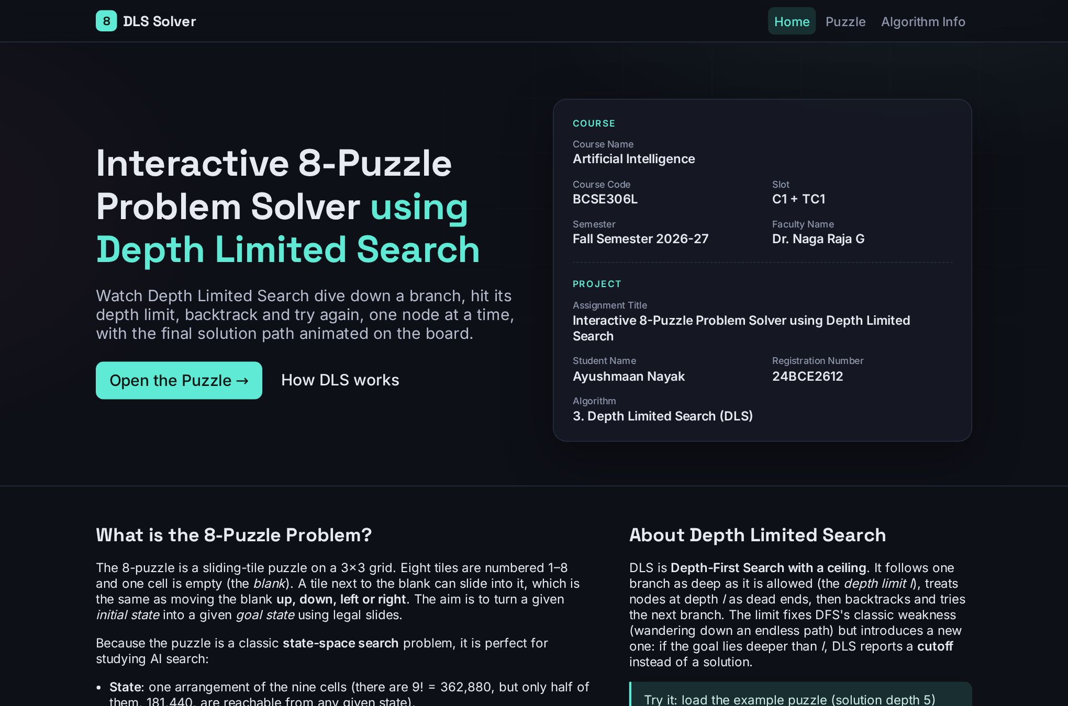
Figure 1: Home page

6.2 Puzzle input, controls and layout
Method 1 accepts the initial and goal state as three rows of three characters exactly as in the guidelines, with a live preview board. Method 2 generates a random solvable puzzle at three difficulty levels. The Controls panel holds the depth-limit slider and number box, the Run button, the compact buttons Pause, Resume, Reset, Prev, Next and End, a speed slider and the Search / Solution toggle, plus a scrubber and keyboard shortcuts (Space, Left, Right). The controls sit right next to the board, with the solution summary below the board and the search process below the controls, so the puzzle stays in view while a search is run and stepped through.
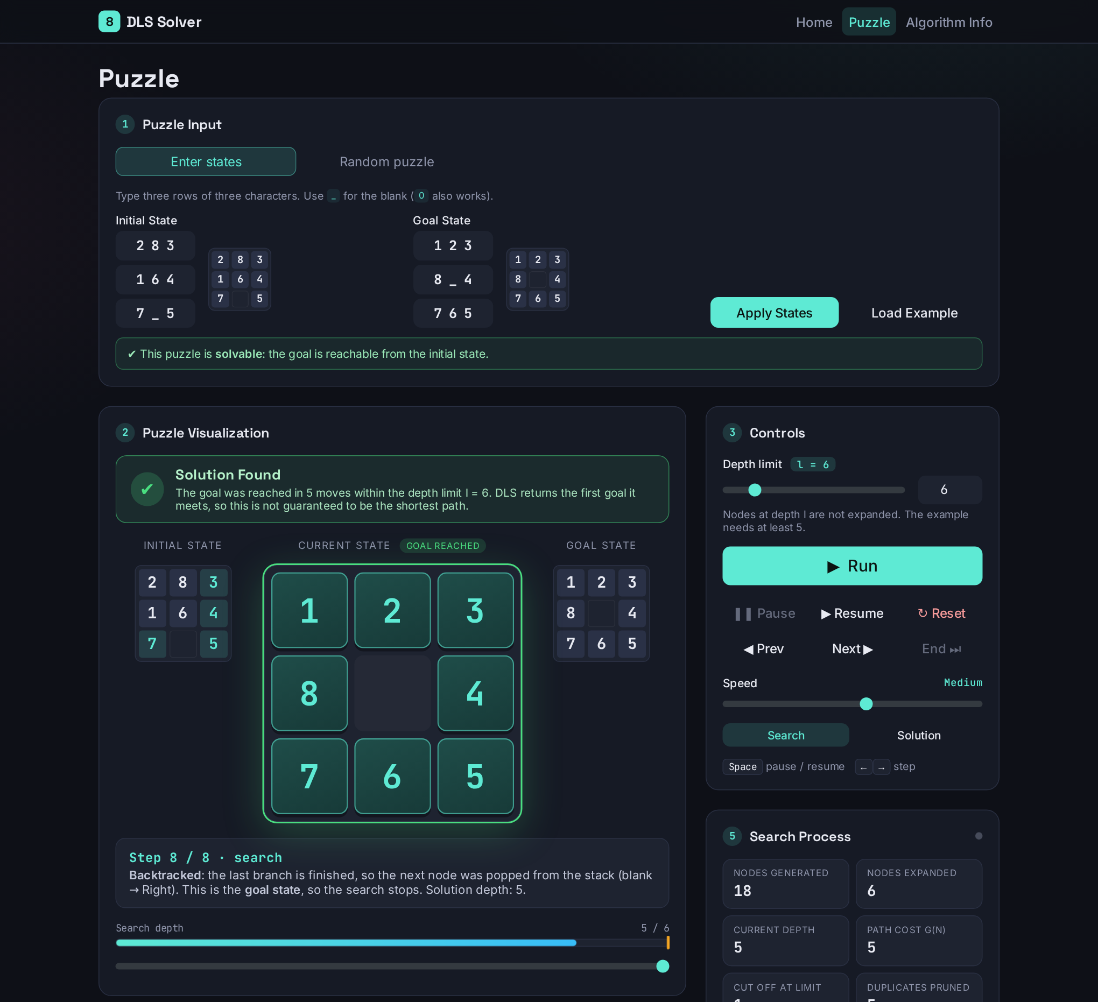
Figure 2: Puzzle page: input, animated board with result banner, and controls (search trace, step 6 of 8 at limit 6)

6.3 Visualisation and search process
The main board animates tile movement with CSS transforms: the blank visibly slides across the board when the search descends, and jumps with a “backtracked” explanation when it returns to a previous branch. The Search Process panel updates every step with the nodes generated and expanded, depth, path cost g(n), cut-off count, duplicates pruned, frontier size and explored size. It also shows the successors generated at that step (each marked pushed or discarded as a repeat).
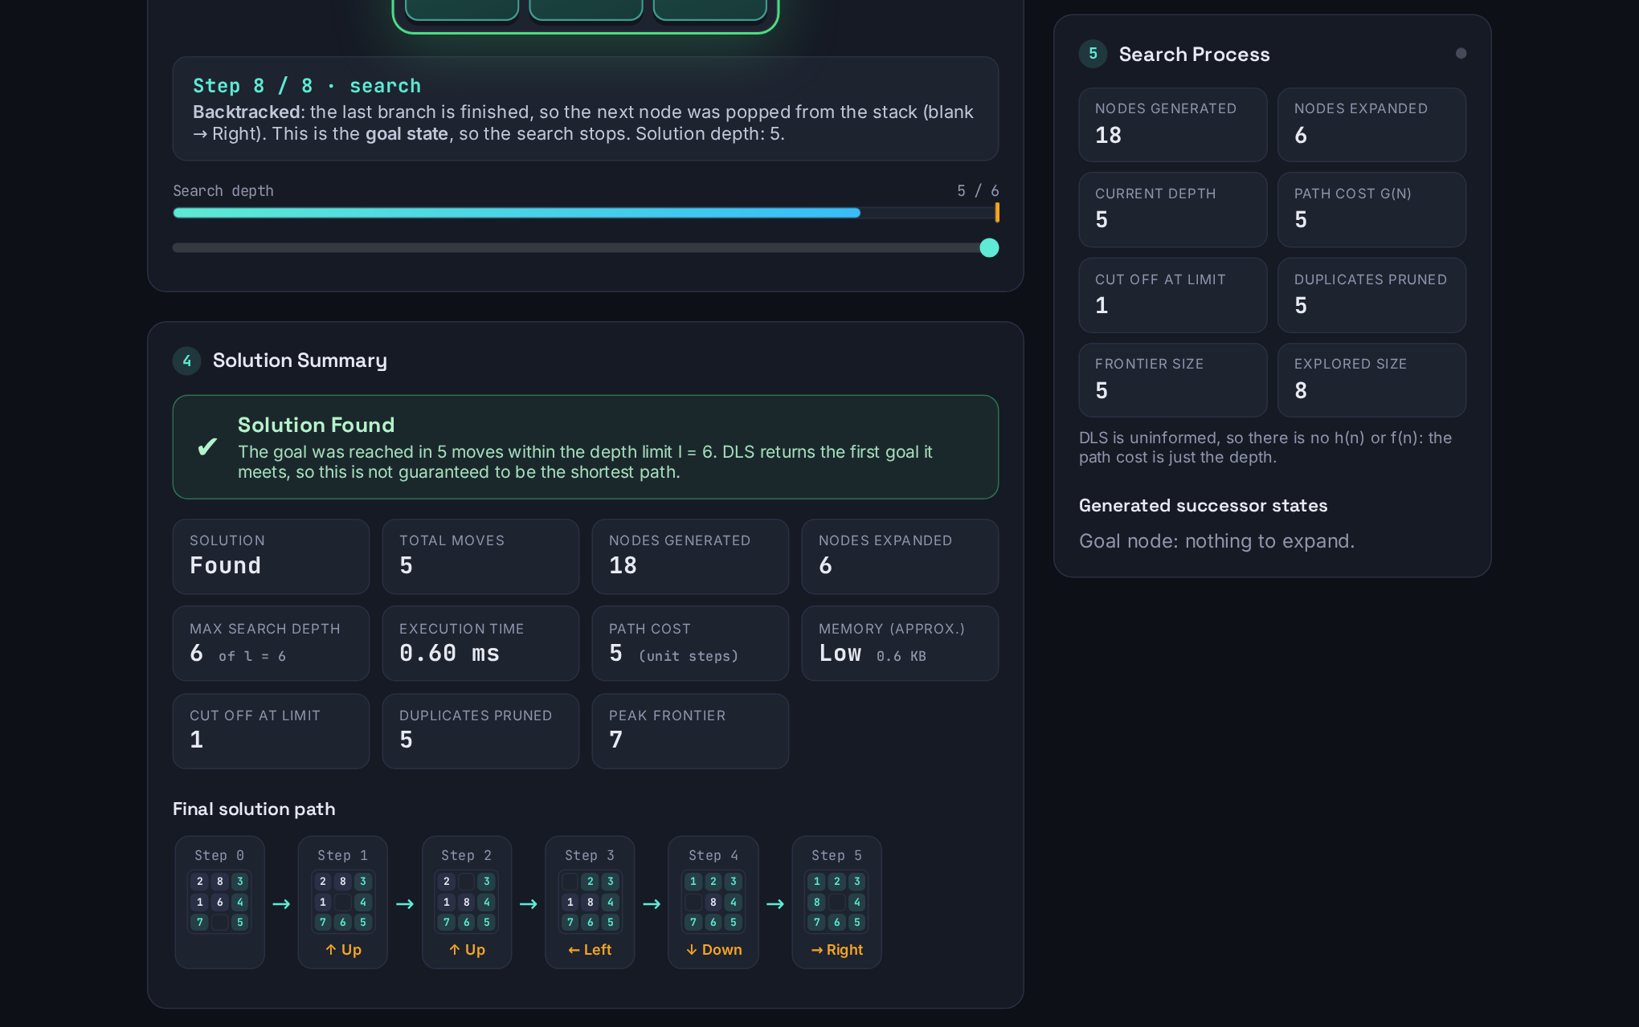
Figure 3: Solution summary and final path (left) and search process (right)

6.4 Result indicator, cutoff and playback
A result banner above the board always says where the search stands: “Searching…” while the search is replayed (with a Skip to result button), then a clear verdict with an explanation. A found goal gives a green banner. When the limit is too small the banner is amber, reads “Solution Not Found: cutoff”, explains that a deeper solution may exist and offers a one-click retry with a larger limit; failure and an exhausted node budget are shown in red. The board is outlined in the same colour. The Solution Summary below the board reports solution found / not found, total moves, nodes generated and expanded, maximum search depth, execution time, path cost and approximate memory. After a successful search the animation switches automatically to Solution Playback, stepping the blank along the final path.
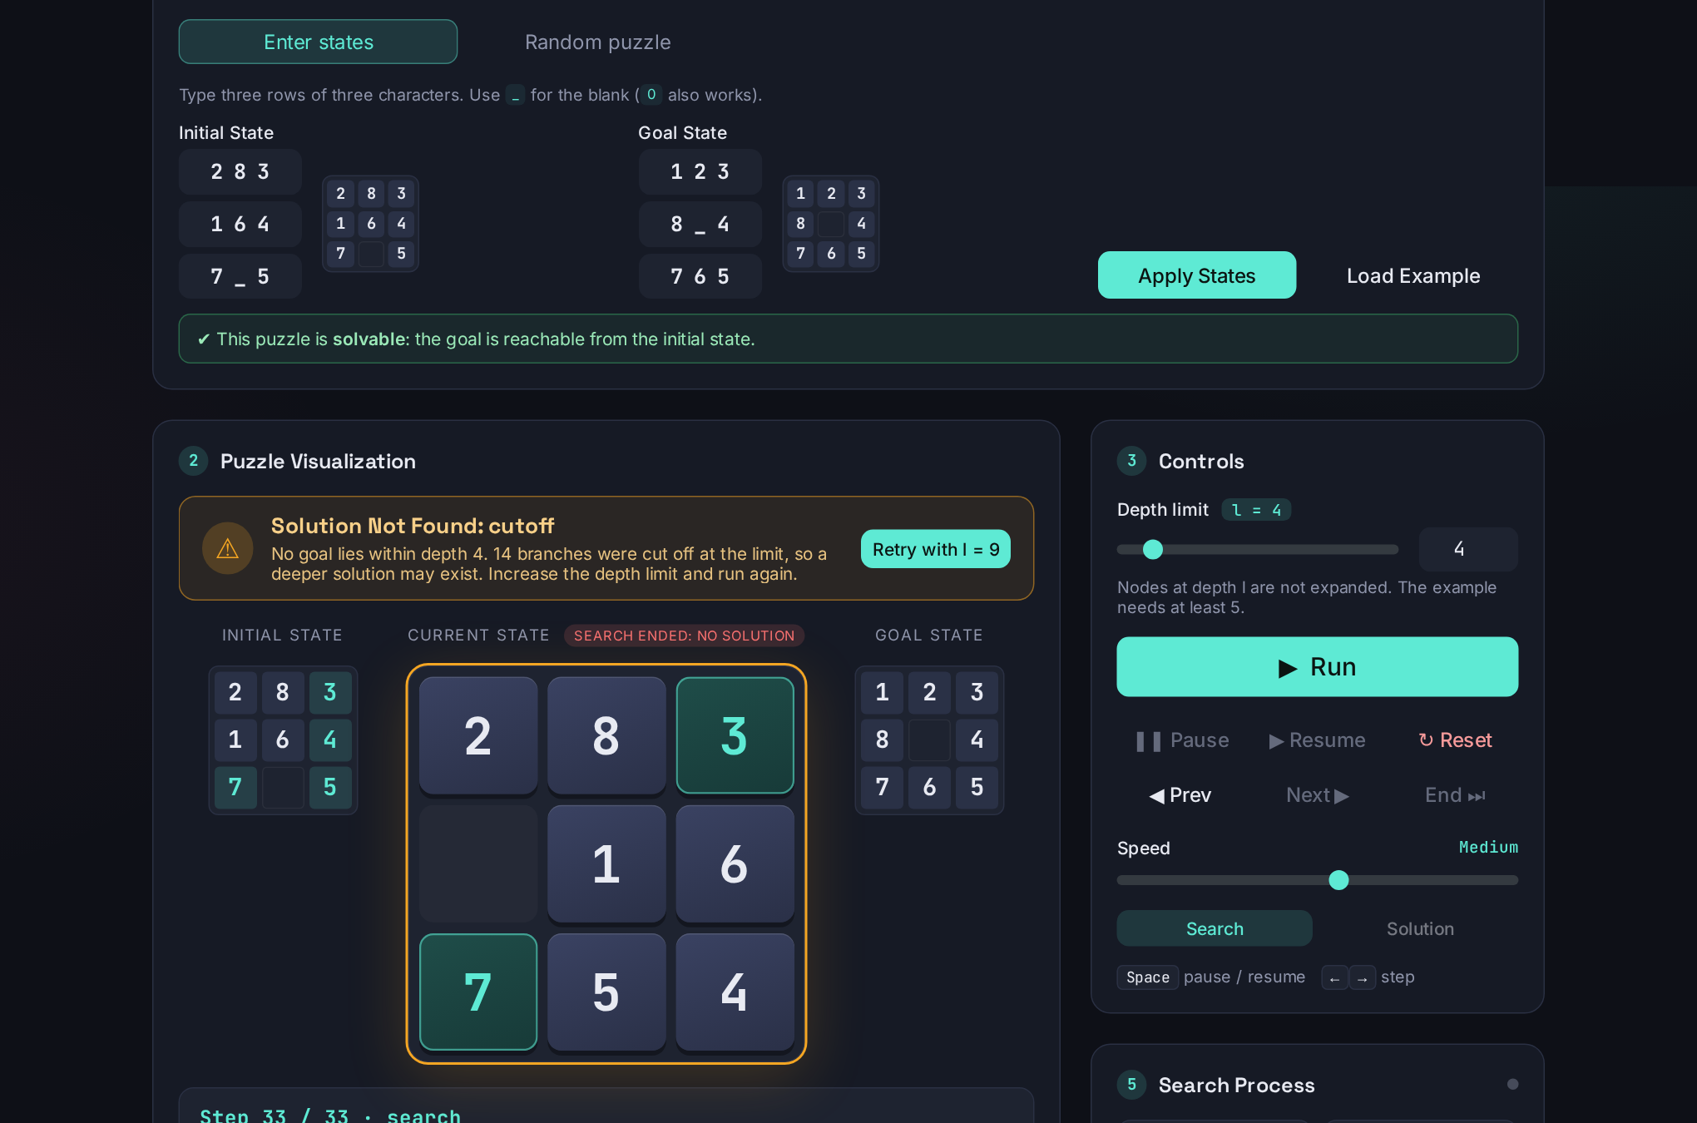
Figure 4: Depth limit 4 on the example from the guidelines: amber “cutoff” banner with retry button, board outlined in amber
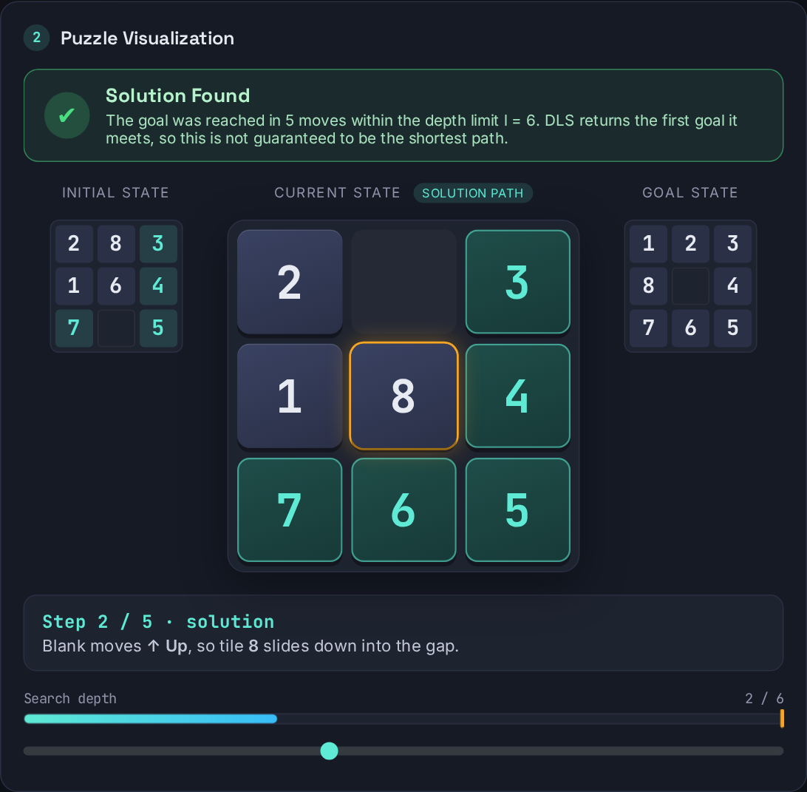
Figure 5: Solution playback: step-by-step blank movement along the final path

6.5 Algorithm information page
Provides the description, working principle, pseudocode, advantages, limitations, time and space complexity, completeness and optimality of DLS, an implementation section and IEEE-style references.
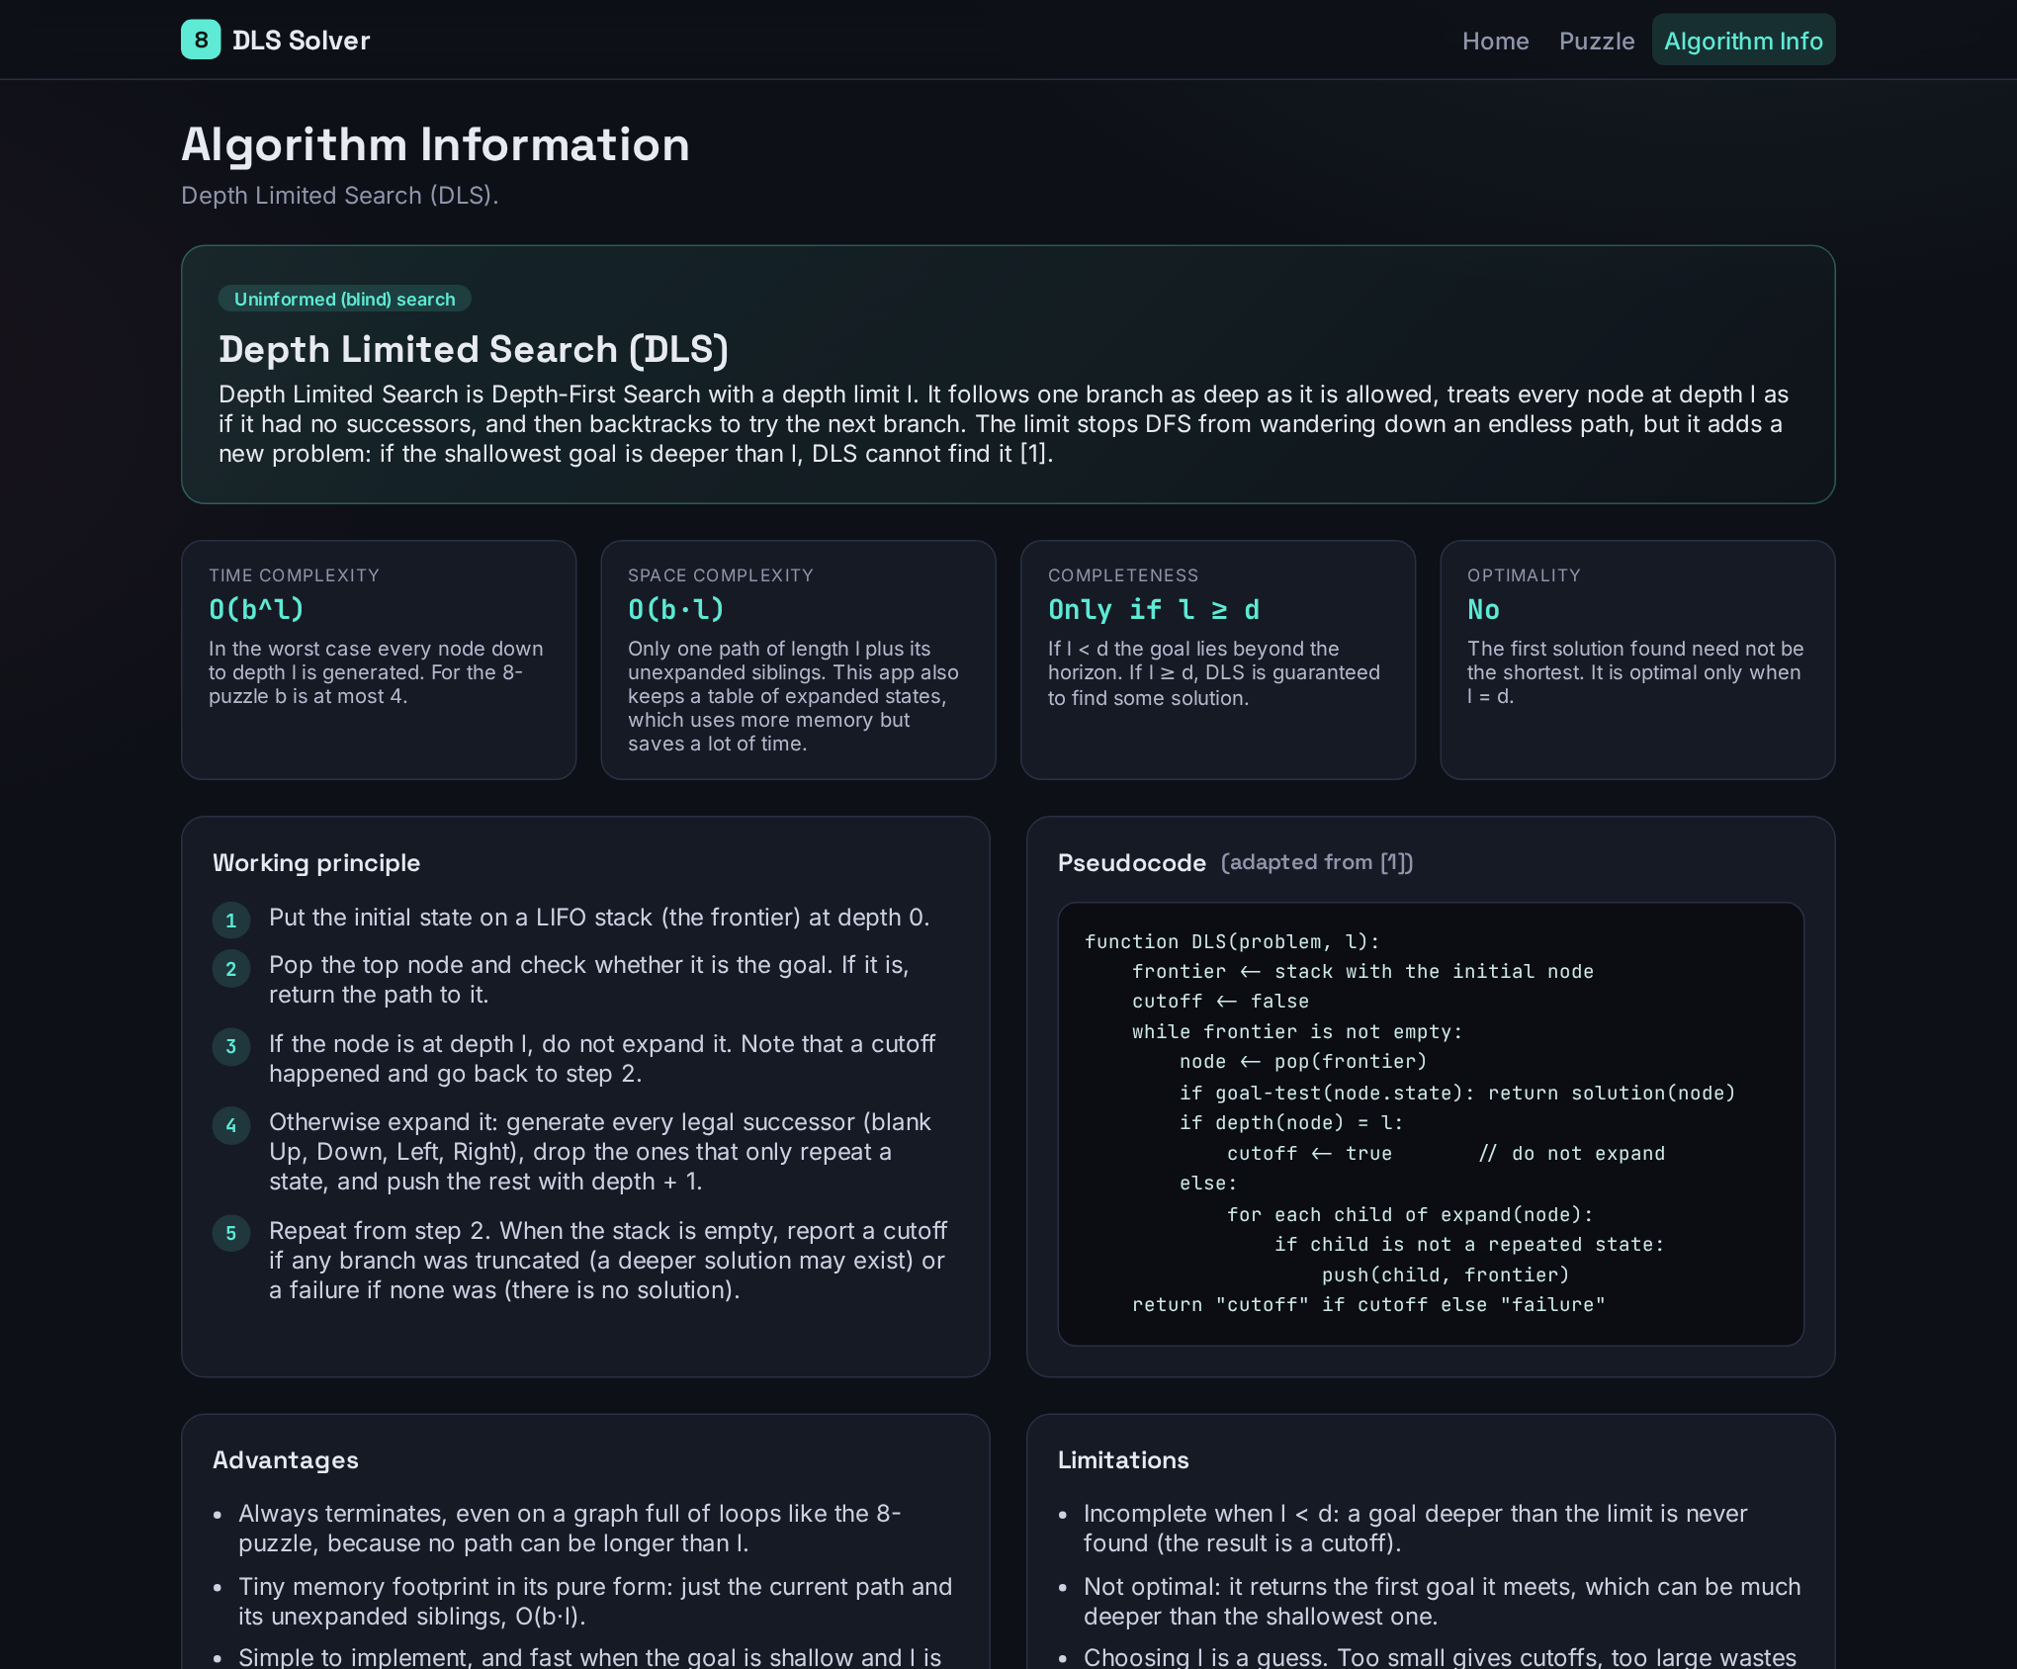
Figure 6: Algorithm information page

7. Testing and Verification

7.1 Automated tests
A dependency-free Node test suite (tests/dls.test.js, run with node tests/dls.test.js) contains 18 tests, all passing. Table 5 summarises what they cover.
Area | What is checked
Puzzle utilities (7 tests) | Encode/decode round-trip; the 283/164/7_5 format from the guidelines; rejection of invalid input; successor counts (corner 2, edge 3, centre 4); solvability for five different goals; random generator is solvable, never equals the goal and respects the difficulty range.
Correctness of DLS (4 tests) | Limit 5 finds the 5-move solution and limit 4 is a cutoff; limit 0 behaviour; the search never exceeds the limit; every returned path is a legal sequence of moves from start to goal, including at generous limits.
Bookkeeping and trace (5 tests) | visited = expanded + cut off + goal; recording does not change the search; the trace starts at the root and ends at the goal; the stack is LIFO (after an expansion the next node visited is its first pushed child); the first node explored is the Up move.
Robustness (2 tests) | The node budget aborts instead of hanging; two runs give identical statistics (determinism).
Table 5: Automated test coverage

7.2 Independent cross-check
To verify DLS against ground truth, an independent exhaustive search was used (outside the project, not shipped) to compute the true shortest distance d* from every one of the 181,440 reachable states to the goal. DLS was then run 1,200 times on 300 random puzzles at the limits d*−1, d*, d*+2 and 14. Result: zero mismatches. DLS found a solution exactly when the limit was at least d*, never returned a path shorter than d*, and returned “cutoff” (not failure) otherwise. Among the 840 successful runs, 221 returned a path longer than the optimum, which demonstrates in practice that DLS is not optimal.
The browser interface was also exercised in headless Chromium: all pages load without console errors; input validation, unsolvable detection, cutoff, playback, random puzzles, the result banner and its retry button, and a 390-pixel mobile layout (no horizontal overflow) behave as designed.

8. Experimental Results and Analysis

8.1 Effect of the depth limit
Table 6 runs DLS on the example from the guidelines (shortest solution: 5 moves) at twelve limits. Times are the best of seven runs after a warm-up, measured in Node on the same engine the browser uses; absolute values vary by machine.
Limit l | Outcome | Expanded | Generated | Cut off | Moves | Time (ms) | Memory
2 | Cutoff | 4 | 12 | 5 | – | 0.01 | Low (0.5 KB)
3 | Cutoff | 9 | 27 | 10 | – | 0.02 | Low (0.8 KB)
4 | Cutoff | 19 | 51 | 14 | – | 0.03 | Low (1.1 KB)
5 | Solution | 5 | 16 | 1 | 5 | 0.02 | Low (0.5 KB)
6 | Solution | 6 | 18 | 1 | 5 | 0.02 | Low (0.6 KB)
8 | Solution | 9 | 27 | 4 | 5 | 0.02 | Low (0.9 KB)
10 | Solution | 21 | 57 | 10 | 5 | 0.03 | Low (1.4 KB)
12 | Solution | 51 | 141 | 33 | 5 | 0.07 | Low (2.8 KB)
15 | Solution | 99 | 274 | 63 | 15 | 0.11 | Low (4.7 KB)
20 | Solution | 681 | 1,819 | 402 | 19 | 0.67 | Low (25.5 KB)
25 | Solution | 2,008 | 5,583 | 1,383 | 25 | 2.24 | Medium (72.5 KB)
31 | Solution | 10,119 | 28,146 | 6,600 | 31 | 6.32 | Medium (324.1 KB)
Table 6: DLS on 283/164/7_5 → 123/8_4/765 for different depth limits (closed-table mode)
Observations:
- Incomplete below d. Limits 2, 3 and 4 all return a cutoff; the goal first becomes reachable at l = 5.
- Not optimal above d. The shortest solution has 5 moves, and limits 5 to 12 find it, but l = 15 returns a 15-move path, l = 20 a 19-move path, l = 25 a 25-move path and l = 31 a 31-move path. With a larger limit DLS commits to a deep branch before the shallow one is tried.
- Cost grows sharply with l. Expanded nodes rise from 5 (l = 5) to 10,119 (l = 31), a factor of about 2,000, and the approximate memory moves from Low to Medium, even though the answer does not improve. A well-chosen limit is the whole point of DLS.
- Failure is not free. A cutoff still costs work: a harder puzzle (267/831/_54 variants) at l = 15 expands 5,570 nodes before DLS can only report “not within this limit”.

8.2 Relation to the other algorithms
Depth Limited Search sits between the extremes: with l = ∞ it becomes DFS (which can run away on deep or infinite spaces), and repeating it with l = 0, 1, 2, … gives Iterative Deepening [2], which is complete and optimal at the cost of re-doing shallow work. DLS itself is the right tool when a bound on the solution depth is known, as with the puzzles generated by an n-move scramble (a solution exists at depth ≤ n).

9. Requirement Traceability
Requirement in the guidelines | Where it is satisfied | Status
Implement the assigned algorithm from scratch in JavaScript | js/dls.js (no search libraries) | Done (DLS)
HTML5, CSS3, ES6 JavaScript, one UI framework | Bootstrap 5.3 (vendored) | Done
Home page with course, title, name, reg. no., intro, navigation | Home | Done
Puzzle input: typed states and random solvable puzzle | Puzzle → Puzzle Input | Done
Depth limit for DLS | Puzzle → Controls | Done
Initial, goal, current, successors, final path; animated blank | Puzzle → Visualization | Done
Real-time process information | Puzzle → Search Process | Done (generated, expanded, depth, path cost, frontier size, explored size, successors)
Solution summary (8 items) | Puzzle → Solution Summary | Done
Clear found / not found indicator | Result banner above the board | Done
Algorithm information page (8 items) | Algorithm Info | Done
Run, Pause, Resume, Next, Previous, Reset, Speed | Puzzle → Controls | Done
Repository structure and README sections | Repository, README.md | Done
GitHub Pages deployment; demonstration video | Repository settings; recorded separately | To be completed by the student
Table 7: Traceability of the assignment requirements

10. Limitations and Future Work
- Only DLS is implemented, by design. Adding Iterative Deepening would be a natural extension, since it reuses the same engine with a loop over l.
- The memory figure is an estimate based on fixed record sizes, not a measurement of the JavaScript heap.
- Very deep limits on hard puzzles hit the node budget and are reported as aborted rather than solved; a Web Worker would let the search run longer without freezing the page.
- Only the 3 × 3 board is supported; generalising to 4 × 4 would need a different state encoding and a different solvability rule.

11. Conclusion
The project models the 8-Puzzle as a state-space search problem and implements Depth Limited Search from scratch, with correct three-way outcomes (solution, cutoff, failure), a depth-aware closed table for repeated states and a safety budget. The engine was verified by 18 automated tests and against an exhaustive ground truth over 1,200 runs with no mismatch. The interface makes the algorithm observable: the stack, the depth limit being hit, backtracking, the animated solution, and the effect of the limit on completeness, optimality, time and memory. The experiments confirm the textbook properties of DLS: it is incomplete when l < d, not optimal, and its cost grows quickly with l.

12. References
[1] S. Russell and P. Norvig, Artificial Intelligence: A Modern Approach, 4th ed. Hoboken, NJ, USA: Pearson, 2020, sec. 3.4.
[2] R. E. Korf, “Depth-first iterative-deepening: An optimal admissible tree search,” Artif. Intell., vol. 27, no. 1, pp. 97–109, Sep. 1985.
[3] Bootstrap Team, “Bootstrap v5.3 documentation.” getbootstrap.com. Accessed: Oct. 23, 2026. [Online]. Available: https://getbootstrap.com
[4] Fontsource, “Space Grotesk, Inter and JetBrains Mono (SIL Open Font License).” fontsource.org. Accessed: Oct. 23, 2026. [Online]. Available: https://fontsource.org
[5] Mozilla, “MDN Web Docs: JavaScript and CSS references.” developer.mozilla.org. Accessed: Oct. 23, 2026. [Online]. Available: https://developer.mozilla.org

Appendix A: Running and Deploying

Run locally
git clone https://github.com/ayushmaannayak123/AI-8Puzzle-Visualizer.git
cd AI-8Puzzle-Visualizer
# open index.html in a browser (or: python -m http.server 8000)
node tests/dls.test.js # optional: run the 18 tests

Publish on GitHub Pages
- Create an empty public repository named AI-8Puzzle-Visualizer on GitHub.
- Push the project folder to the main branch (git init, add, commit, remote add, push).
- Repository Settings → Pages → Source: Deploy from a branch → Branch: main, folder / (root) → Save.
- After a minute the site is live at https://ayushmaannayak123.github.io/AI-8Puzzle-Visualizer/.
- Record the 3–5 minute demonstration video and submit the PDF containing the repository URL, live URL, README and video link.

