Programming for Data Science Project Document
Project Title: AGRICULTURAL DATA ANALYSIS AND CROP RECOMMENDATION

Team Members:
Ayushman Chaudhary (24BDS1177)
Saumik Laddha (24BDS1158)

SUBMIITED TO: DR. Vijayalakshami A

An Empirical Study on Multi-Class Crop Suitability, Statistical Hypothesis Testing, and Ensemble Decision Systems
DATASET METRICS  762 Records | 21 Features  17 States | 99 Districts | 15 Crops | EVALUATED ALGORITHMS  7 Implemented Classifiers  6 Hyperparameter Tuned Models | SELECTED CHAMPION  Tuned Random Forest (mtry=6)  CV Macro-F1: 90.76% | Acc: 90.74%

1. Abstract
Context and Problem Formulation: Modern agricultural productivity is profoundly influenced by localized soil nutrient concentrations, micro-climatic patterns, and regional agronomic practices. In traditional farming ecosystems, crop selection is frequently driven by ancestral heuristic intuition or historical crop rotations, resulting in suboptimal yields, severe soil nutrient exhaustion, and heightened vulnerability to climatic shocks. This academic project presents an end-to-end, data-driven machine learning and statistical framework for precision crop recommendation using an empirical college-curated dataset comprising 762 field observations across 17 Indian states and 99 districts.
Methodology & Statistical Rigor: The project implemented a rigorous data curation pipeline consisting of median and mode statistical imputation to eliminate missing entries while preserving underlying distributions. Exploratory Data Analysis (EDA) characterized feature distributions and balanced multi-class representation across 15 agricultural crop varieties. Prior to machine learning modeling, parametric One-way Analysis of Variance (ANOVA), non-parametric Kruskal-Wallis rank tests, and Chi-Square contingency tests were conducted to mathematically confirm that soil chemistry and environmental attributes exhibit statistically significant variance across crop species (p < 0.001).
Key Findings & Deployment: Using 14 validated soil and climatic predictors, seven diverse supervised classification algorithms were trained: Decision Tree, Random Forest, K-Nearest Neighbors (KNN), Support Vector Machine (SVM), Multinomial Logistic Regression, Linear Discriminant Analysis (LDA), and Gradient Boosting. Systematic hyperparameter tuning via 10-fold cross-validation was successfully executed across six models to maximize multi-class Macro-F1. While SVM achieved the highest single test-set accuracy (90.13%), Random Forest demonstrated superior cross-validated generalization stability, achieving the highest Cross-Validation Macro-F1 of 90.76% and CV Accuracy of 90.74%. Decision Tree exhibited the most dramatic optimization gain, rising +40.71 percentage points in Macro-F1 upon complexity parameter tuning. Finally, an interactive R Shiny decision support dashboard was developed, featuring live probabilistic inference and top-alternative crop rankings.
2. Introduction
Agriculture remains the socioeconomic backbone of India, employing over 50% of the national workforce and contributing critically to national food security and GDP. Despite technological advancements in irrigation and mechanization, the fundamental decision of which crop to cultivate during a given season remains plagued by empirical uncertainty. Farmers frequently select crops based on historical precedent or prevailing market prices without scientifically evaluating whether their soil nutrient profile and expected seasonal climate can sustain optimal physiological growth.
The primary macronutrients in arable soil—Nitrogen (N), Phosphorus (P), and Potassium (K)—play distinct physiological roles in vegetative vigor, root proliferation, and cellular osmotic regulation, respectively. Similarly, soil pH dictates the chemical bioavailability of these ions. Meteorological drivers, including cumulative rainfall, ambient humidity, and temperature regimes, establish the thermodynamic boundaries of crop transpiration and photosynthesis. Integrating these continuous bio-climatic measurements with categorical farm characteristics (e.g., Soil Type, Irrigation Method, Water Source, Season, and Previous Crop) creates a complex, highly multi-dimensional feature space that cannot be reliably optimized through manual calculation.
Research Objectives: This research formulates precision crop recommendation as a 15-class multi-class supervised learning problem. The overarching objectives of this project are:
1. To curate, clean, and validate a faculty-provided agricultural dataset of 762 observations representing diverse agro-ecological zones across 17 states.
2. To conduct comprehensive exploratory and statistical analyses—including Pearson correlation, One-way ANOVA, Kruskal-Wallis, and Chi-Square tests—to quantify feature discrimination across crop types.
3. To train, evaluate, and benchmark seven distinct machine learning algorithms under identical stratified train/test partitions (80/20 split).
4. To execute systematic 10-fold cross-validated hyperparameter tuning across six eligible algorithms to maximize multi-class Macro-F1.
5. To identify and operationalize the optimal predictive engine into an intuitive, field-ready interactive dashboard facilitating real-time agronomic decision-making.
3. Dataset Description
Data Provenance & Scope: The foundational empirical data for this investigation was sourced from a college-provided agricultural dataset named crop_dataset1.csv. The raw dataset contains 762 observations spanning 21 columns, encompassing 15 distinct crop classes cultivated across 17 Indian states and 99 districts. The dataset integrates quantitative edaphic (soil) measurements, meteorological observations, and qualitative farm management indicators.
3.1 Feature Schema and Variable Roles
In supervised machine learning, indiscriminate feature inclusion can introduce severe multicollinearity, leakage, or dimensionality curses. Exactly 14 features were validated as valid pre-sowing predictors for model training. Six features were deliberately excluded based on sound agronomic and statistical principles: District was excluded due to high categorical cardinality (99 levels) which would cause extreme feature sparsity; Variety, Fertilizer_Type, Crop_Duration, Sowing_Month, and Harvest_Month represent post-decision agronomic consequences rather than pre-planting decision inputs.
Table 1: Dataset Attribute Schema, Variable Descriptions, and Modeling Roles
Attribute Name | Data Type | Role in Project | Description / Value Range
N | Numeric | Predictor (Soil) | Nitrogen content in soil (15.10 - 248.80 kg/ha)
P | Numeric | Predictor (Soil) | Phosphorus content in soil (20.70 - 100.00 kg/ha)
K | Numeric | Predictor (Soil) | Potassium content in soil (20.10 - 239.00 kg/ha)
pH | Numeric | Predictor (Soil) | Soil reaction index (5.06 - 8.19)
Rainfall | Numeric | Predictor (Climate) | Cumulative annual/seasonal rainfall (252 - 2311 mm)
Humidity | Numeric | Predictor (Climate) | Relative atmospheric humidity (30.00 - 91.70 %)
Temperature | Numeric | Predictor (Climate) | Mean ambient temperature (10.10 - 37.70 °C)
Soil_Type | Categorical | Predictor (Edaphic) | 7 classes: Alluvial, Black, Clay, Laterite, Loamy, Red, Sandy
State | Categorical | Predictor (Geography) | 17 Indian States (Assam, Gujarat, Maharashtra, Punjab, etc.)
Season | Categorical | Predictor (Temporal) | 3 seasons: Kharif (monsoon), Rabi (winter), Perennial
Irrigation_Type | Categorical | Predictor (Management) | 5 methods: Borewell, Canal, Drip, Rainfed, Sprinkler
Water_Source | Categorical | Predictor (Hydrology) | 5 sources: Canal, Groundwater, Rainwater, Reservoir, River
Land_Type | Categorical | Predictor (Topography) | 4 terrains: Hilly, Lowland, Plain, Upland
Previous_Crop | Categorical | Predictor (Agronomy) | 13 crop residues: Chickpea, Cotton, Fallow, Rice, Wheat, etc.
District | Categorical | Excluded | 99 distinct districts (excluded to prevent overfitting)
Variety | Categorical | Excluded | Specific seed hybrid variety (post-crop decision)
Fertilizer_Type | Categorical | Excluded | Applied fertilizer formulation (post-planting practice)
Crop_Duration | Numeric | Excluded | Maturation cycle in days (phenological crop outcome)
Sowing_Month | Categorical | Excluded | Planting calendar month (operational consequence)
Harvest_Month | Categorical | Excluded | Harvest calendar month (operational consequence)
Crop_Name | Categorical | Target Variable | 15 Target Classes: Rice, Wheat, Maize, Banana, Cotton, etc.
3.2 Data Cleaning and Imputation Audit
Prior to modeling, a thorough data cleanliness audit was conducted. The raw college dataset exhibited missing values across 20 of the 21 columns, with missingness ranging between 41 and 62 values per column (~5.4% to 8.1% of records). To preserve sample size without distorting distributional variance, a hybrid statistical imputation protocol was implemented: continuous numerical features were imputed using the median (resilient against outlier pull), while categorical features were imputed using the statistical mode (most frequent category). Target variable Crop_Name contained zero missing values. A deduplication scan confirmed 0 duplicate rows. Following cleaning, the dataset contained 762 complete, validated observations.
Table 2: Missing Value Audit and Imputation Strategy
Feature Column | Data Type | Missing Before | Imputation Method | Missing After
Rainfall | numeric | 58 | Median Imputation | 0
Humidity | numeric | 49 | Median Imputation | 0
Temperature | numeric | 62 | Median Imputation | 0
N | numeric | 51 | Median Imputation | 0
P | numeric | 56 | Median Imputation | 0
K | numeric | 41 | Median Imputation | 0
pH | numeric | 56 | Median Imputation | 0
Soil_Type | character | 42 | Mode Imputation | 0
State | character | 58 | Mode Imputation | 0
District | character | 53 | Mode Imputation | 0
Season | character | 60 | Mode Imputation | 0
Irrigation_Type | character | 57 | Mode Imputation | 0
Water_Source | character | 56 | Mode Imputation | 0
Variety | character | 44 | Mode Imputation | 0
Land_Type | character | 43 | Mode Imputation | 0
Fertilizer_Type | character | 52 | Mode Imputation | 0
Previous_Crop | character | 62 | Mode Imputation | 0
Crop_Duration | numeric | 58 | Median Imputation | 0
Sowing_Month | character | 44 | Mode Imputation | 0
Harvest_Month | character | 48 | Mode Imputation | 0
Crop_Name | character | 0 | No cleaning required | 0
4. Exploratory Data Analysis (EDA) and Visualizations
Exploratory Data Analysis was executed to understand class balance, distribution properties of soil nutrients and climate parameters, presence of physical outliers, and degree of inter-feature correlation.
4.1 Crop Class Distribution
Multi-class classification algorithms are highly sensitive to severe class imbalance. Analysis of the target variable Crop_Name revealed an exceptionally balanced distribution across all 15 varieties. Rice and Wheat lead with 55 records each (7.22%), Maize possesses 52 records (6.82%), and the remaining 12 crops (Banana, Chickpea, Cotton, Groundnut, Mango, Millet, Mustard, Onion, Potato, Soybean, Sugarcane, Tomato) contain exactly 50 records each (6.56%). This balanced representation ensures that classifier performance is not artificially biased toward majority classes.
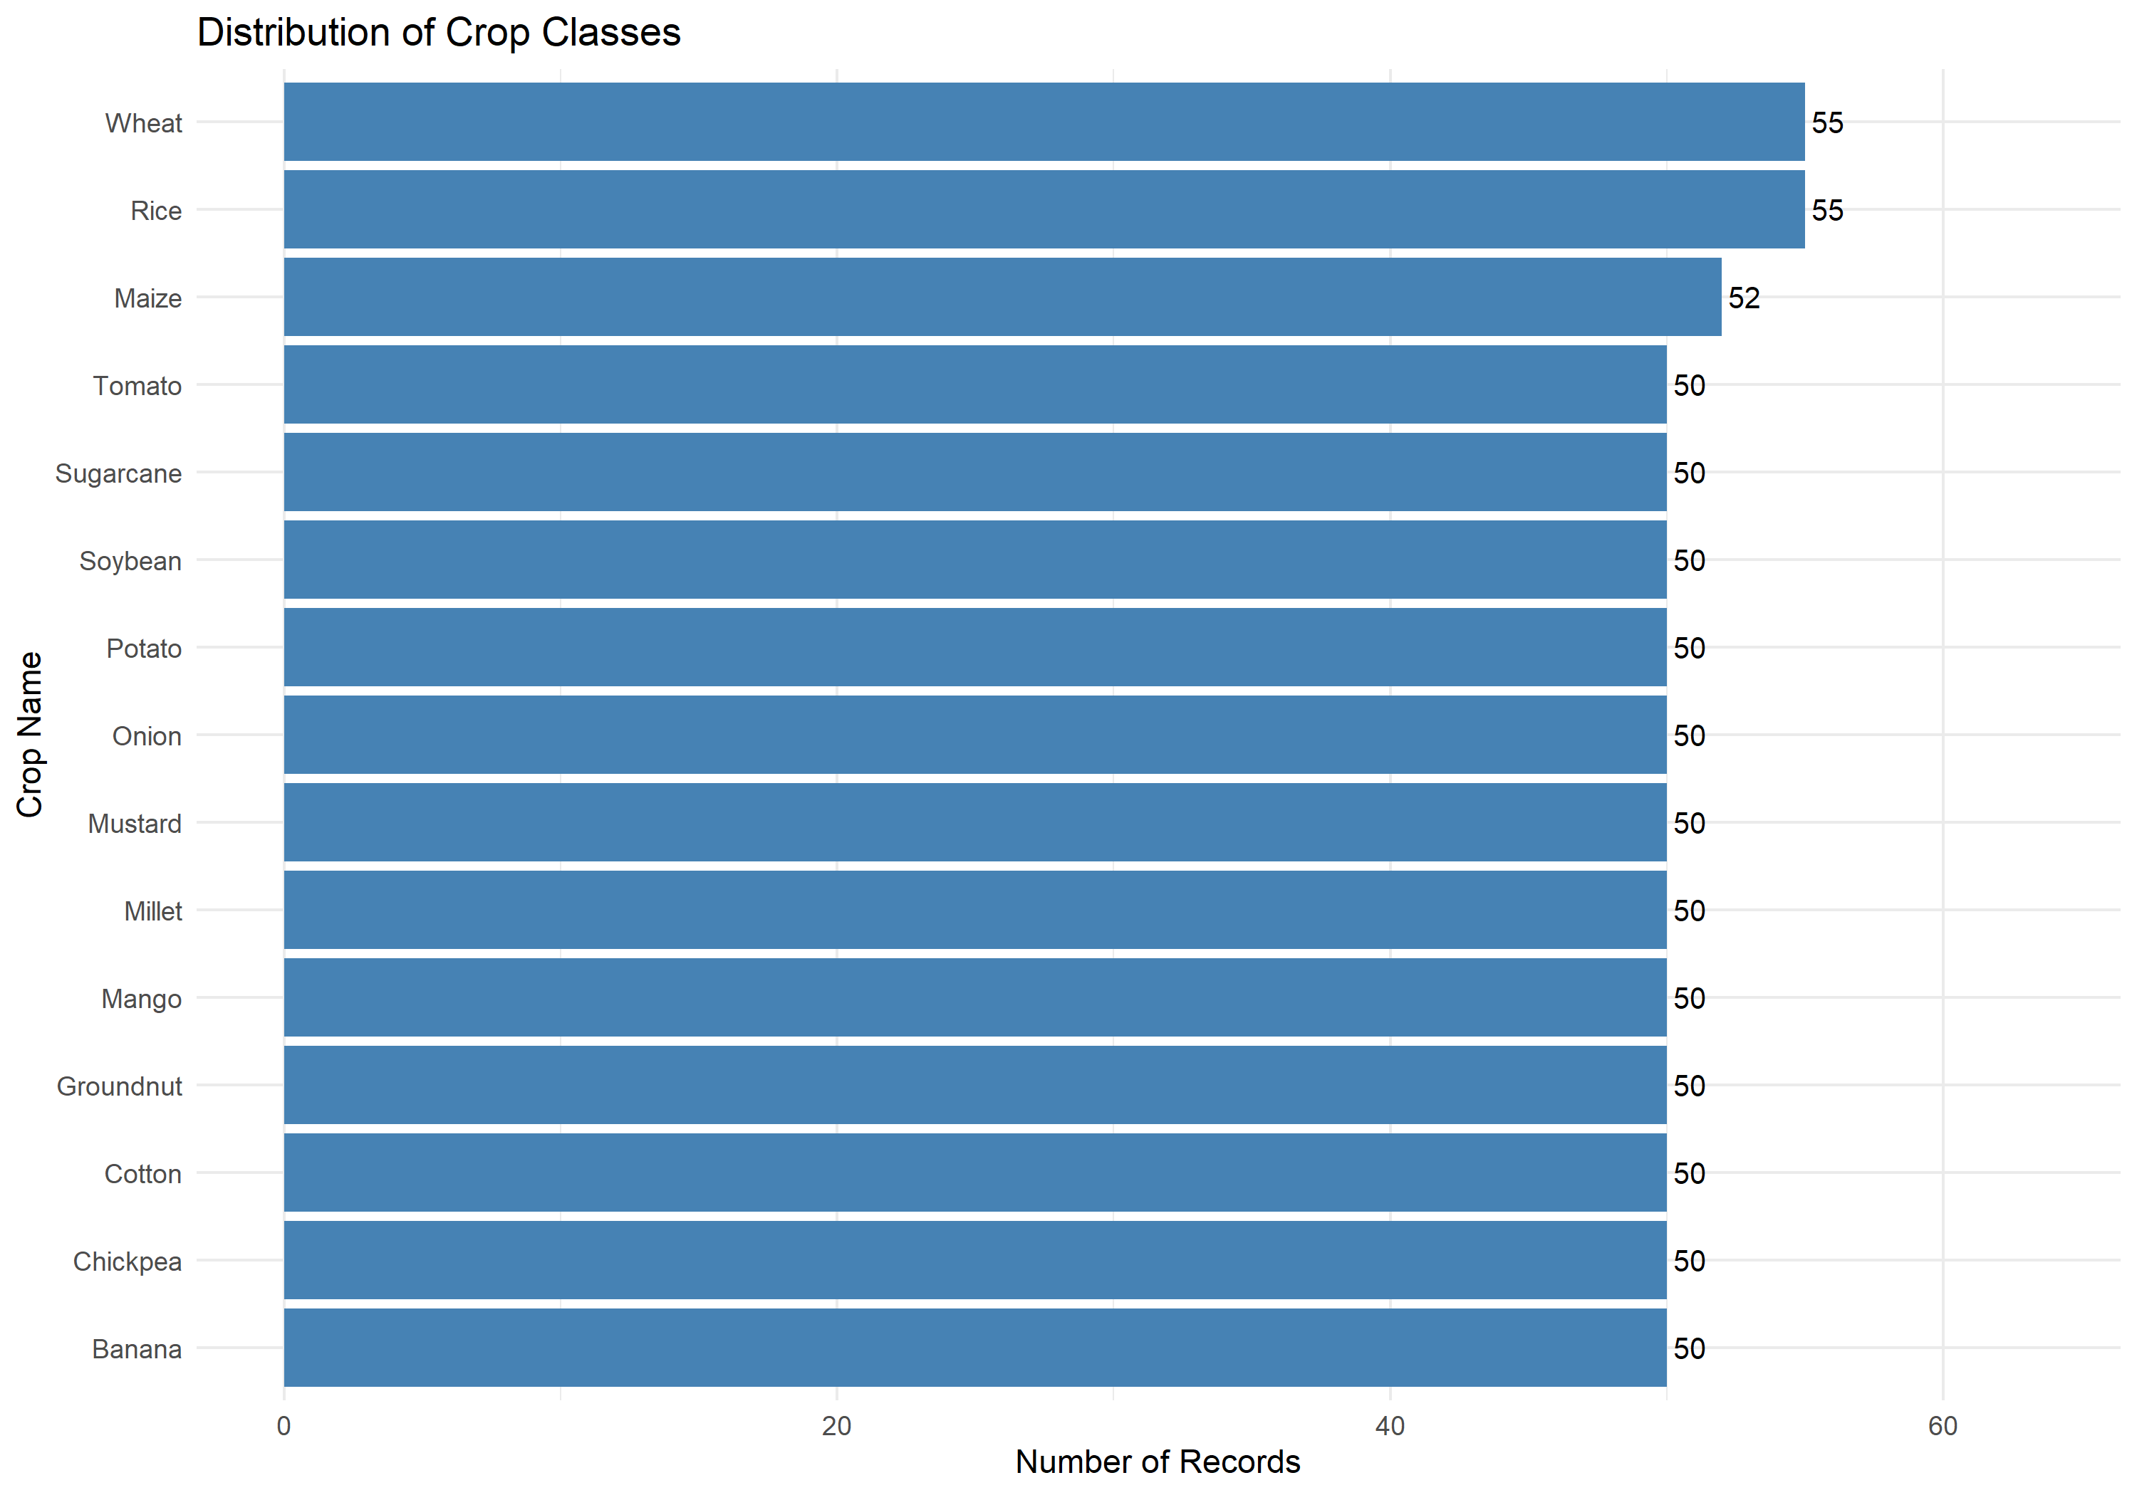
Figure 1: Target Variable (Crop_Name) Balanced Record Distribution Across 15 Classes
4.2 Numerical Feature Distributions and Skewness
Histograms and density plots for the eight continuous parameters revealed distinct biological signatures. Soil Nitrogen (N) exhibited a bimodal distribution with peaks near 80 kg/ha and 160 kg/ha, reflecting the divergent nutrient requirements of cereal crops versus leguminous crops. Soil Phosphorus (P) and Potassium (K) showed right-skewed profiles with heavy tails, indicating specific crops (e.g., Banana and Sugarcane) that demand excessive potash. Soil pH centered around 6.75 with near-normal distribution, reflecting agricultural neutrality. Rainfall displayed significant right-skewness, spanning arid drylands (252 mm) to humid tropical regions (2311 mm).
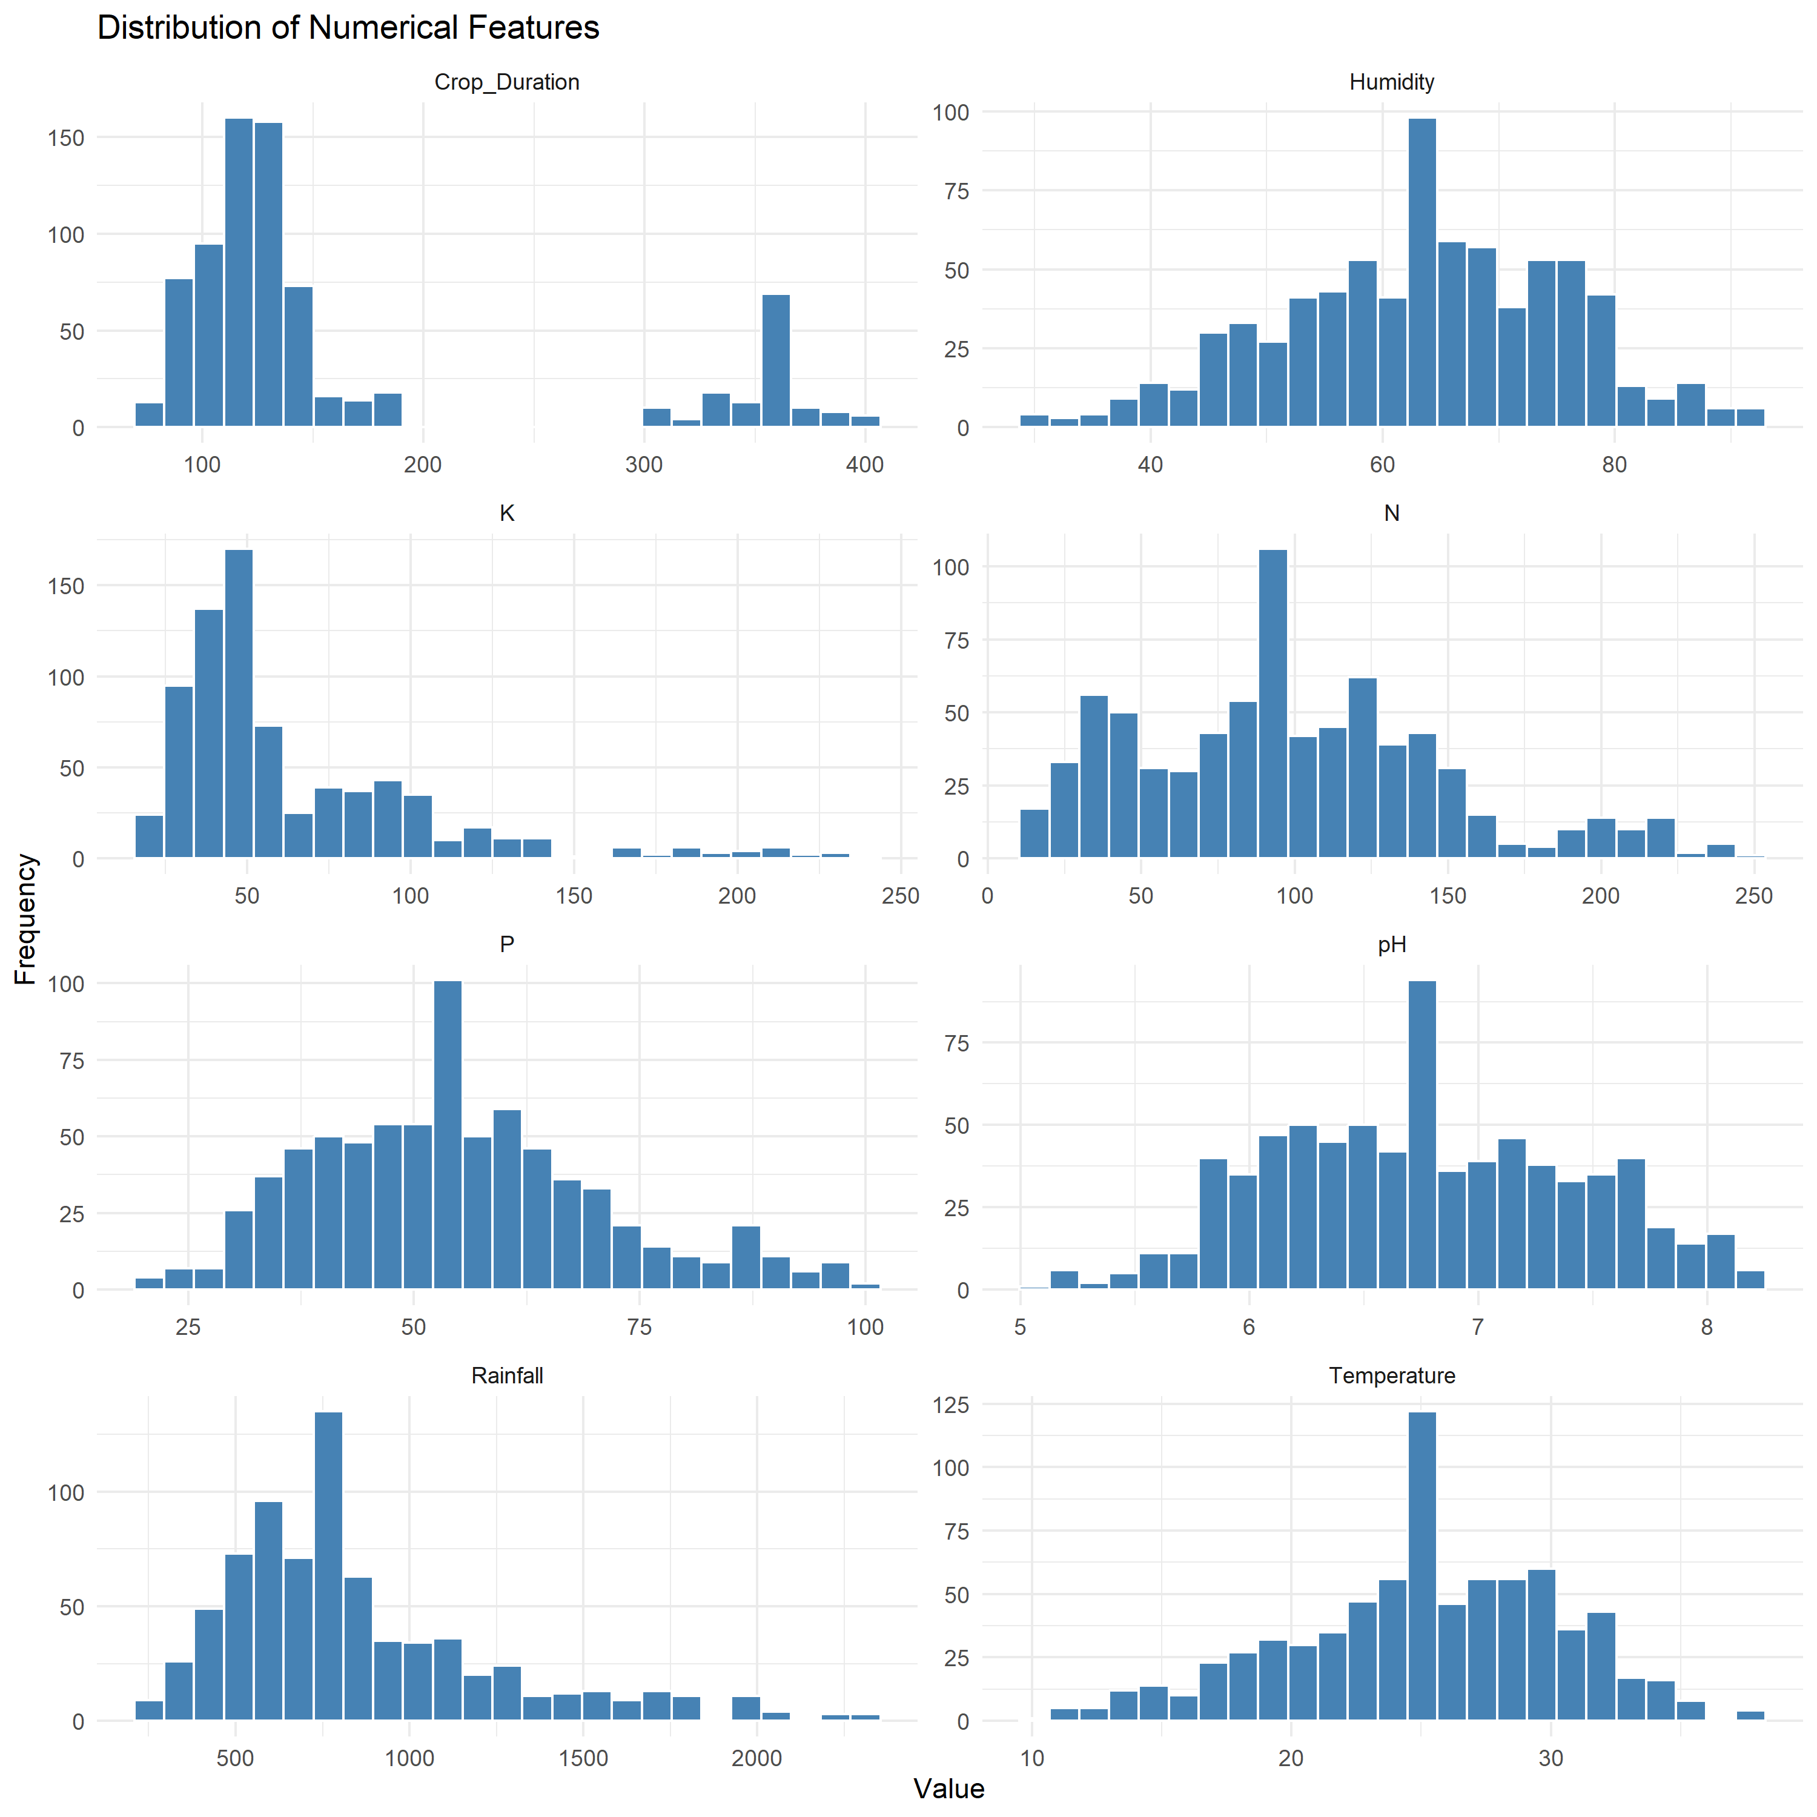
Figure 2: Frequency Histograms of Continuous Soil Nutrients and Meteorological Parameters
4.3 Outlier and Dispersion Analysis
Outlier evaluation using Tukey's box plots demonstrated that statistical outliers in this dataset represent genuine agronomic extremes rather than measurement errors. For instance, extreme high values in Rainfall correspond strictly to wetland Rice and tropical Banana records in Assam and Kerala. Extreme Potassium (K) concentrations above 180 kg/ha reflect high-potassium fertilizer practices essential for Banana fruit development. Extreme Crop_Duration records (>350 days) uniquely define perennial crops such as Sugarcane and Mango.
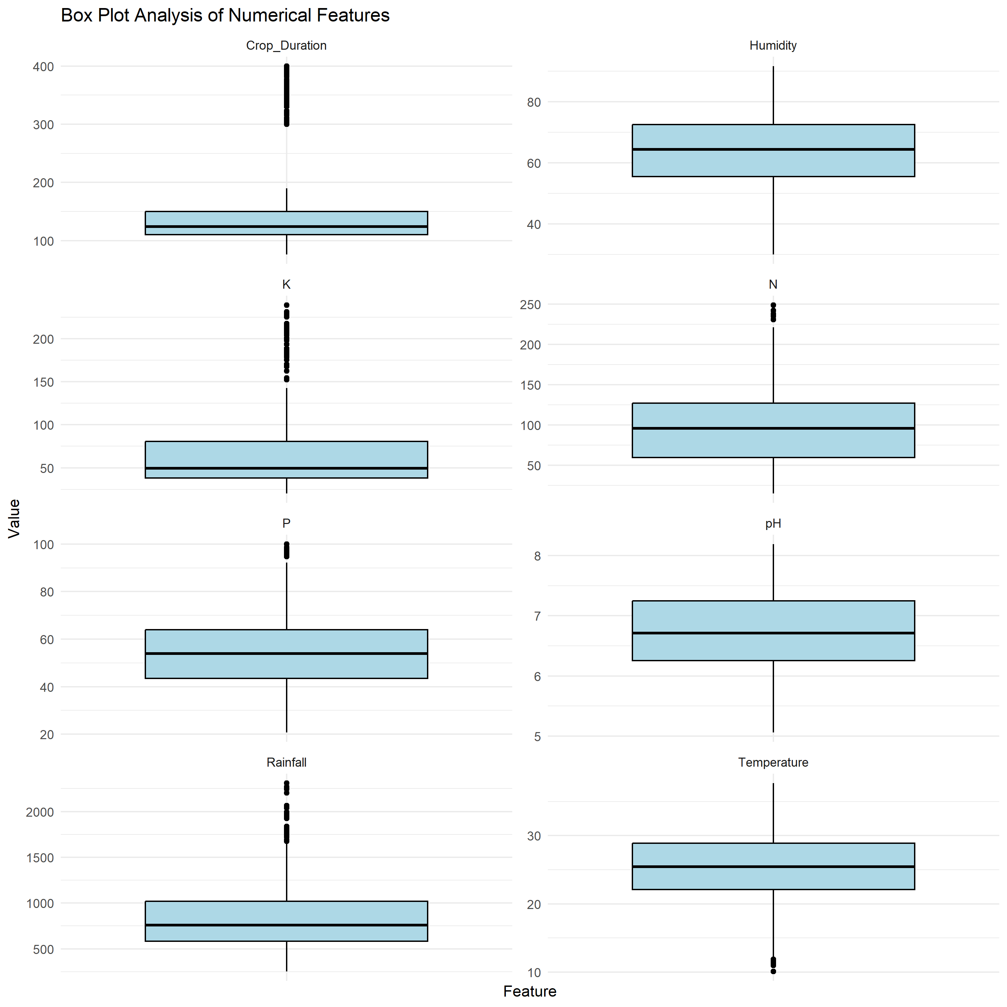
Figure 3: Outlier and Interquartile Range (IQR) Box Plots for Numerical Agricultural Variables
4.4 Correlation Heatmap Analysis
Pearson correlation coefficients were computed across all eight numerical features. The correlation matrix revealed that pairwise correlations among input predictors are generally low to moderate (|r| < 0.45). The absence of extreme pairwise collinearity (|r| > 0.80) indicates that each predictor provides independent variance, allowing linear and tree-based algorithms to operate without severe variance inflation.
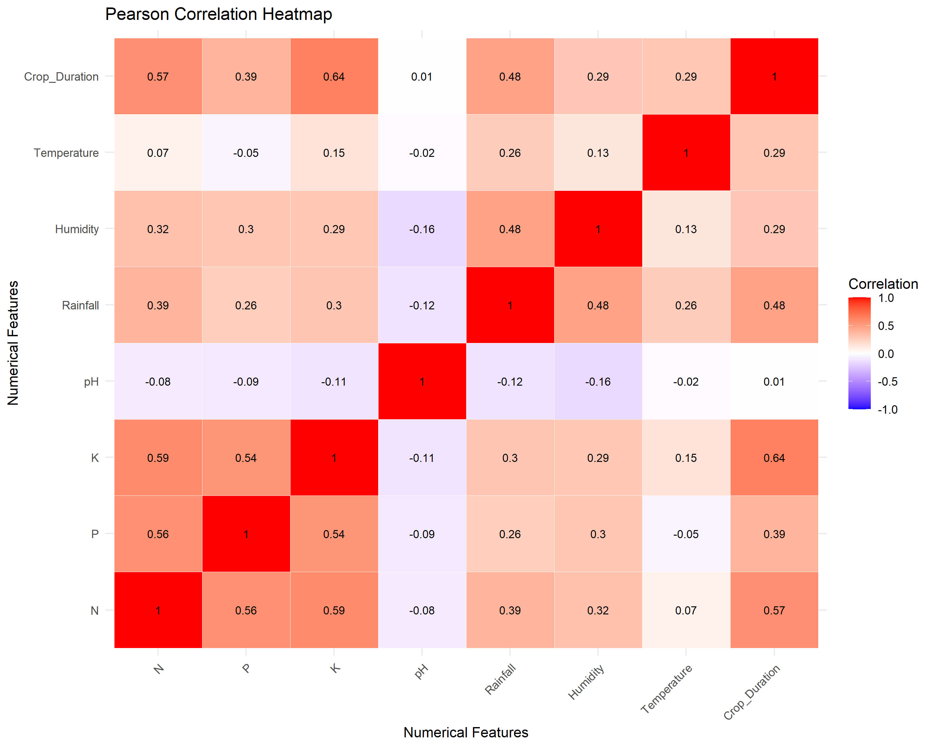
Figure 4: Pearson Correlation Matrix Heatmap of Continuous Soil and Climate Features
5. Statistical Analysis
A critical distinguishing aspect of this research is the implementation of rigorous formal hypothesis testing prior to machine learning. Statistical inference validates whether empirical differences in soil nutrients and environmental conditions across crop classes are statistically meaningful or merely artifacts of sampling noise. To protect against family-wise error rate inflation from multiple testing, all p-values were adjusted using the Benjamini-Hochberg (BH) False Discovery Rate procedure.
5.1 Descriptive Statistics
Descriptive statistical properties—including Mean, Median, Standard Deviation (SD), Variance, Minimum, and Maximum—were calculated across all 762 observations for each continuous feature.
Table 3: Summary Descriptive Statistics for Continuous Variables (N=762)
Feature | Mean | Median | Std Dev | Variance | Min | Max
N | 98.53 | 95.90 | 49.86 | 2486.4 | 15.10 | 248.80
P | 54.85 | 53.90 | 15.90 | 252.8 | 20.70 | 100.00
K | 64.15 | 49.60 | 39.77 | 1581.8 | 20.10 | 239.00
pH | 6.76 | 6.71 | 0.66 | 0.4 | 5.06 | 8.19
Rainfall | 850.19 | 757.00 | 393.20 | 154608.9 | 252.00 | 2311.00
Humidity | 63.54 | 64.40 | 12.12 | 146.9 | 30.00 | 91.70
Temperature | 25.20 | 25.45 | 5.21 | 27.1 | 10.10 | 37.70
Crop_Duration | 163.21 | 124.00 | 93.40 | 8723.7 | 76.00 | 400.00
5.2 Parametric One-Way ANOVA and Non-Parametric Kruskal-Wallis Tests
One-way ANOVA was conducted to test the null hypothesis (H₀: μ₁ = μ₂ = ... = μ₁₅) that feature population means are identical across the 15 crop varieties. Effect size was quantified using Eta-Squared (η²), denoting the proportion of total variance explained by crop classification. To account for potential departures from normality, the non-parametric Kruskal-Wallis rank test was concurrently computed with Epsilon-Squared (ε²) effect size.
Table 4: One-way ANOVA and Kruskal-Wallis Hypothesis Test Results Across Crop Classes
Feature | ANOVA F | ANOVA p-adj | Eta² (η²) | Kruskal H | Kruskal p-adj | Epsilon² (ε²)
N | 245.0 | 2.93e-267 | 0.8212 | 614.6 | 1.62e-121 | 0.8041
P | 63.0 | 5.76e-116 | 0.5414 | 393.3 | 4.25e-75 | 0.5078
K | 195.9 | 2.38e-238 | 0.7859 | 557.6 | 1.50e-109 | 0.7277
pH | 11.3 | 6.62e-24 | 0.1754 | 113.9 | 9.76e-18 | 0.1337
Rainfall | 109.3 | 1.15e-169 | 0.6720 | 483.5 | 5.73e-94 | 0.6286
Humidity | 55.7 | 8.64e-106 | 0.5108 | 361.2 | 2.12e-68 | 0.4648
Temperature | 62.0 | 9.70e-115 | 0.5376 | 395.5 | 1.82e-75 | 0.5107
Crop_Duration | 478.4 | 0.00e+00 | 0.8997 | 621.6 | 1.07e-122 | 0.8134
Statistical Inference: Interpretation of Findings: All eight continuous features demonstrated extreme statistical significance (p < 1e-17). Crop Duration (η² = 0.8997, ε² = 0.8134) and Nitrogen (η² = 0.8212, ε² = 0.8041) emerged as the single most powerful continuous discriminators, followed by Potassium (η² = 0.7859) and Rainfall (η² = 0.6720). This provides rigorous mathematical justification for using these parameters as primary predictive features.
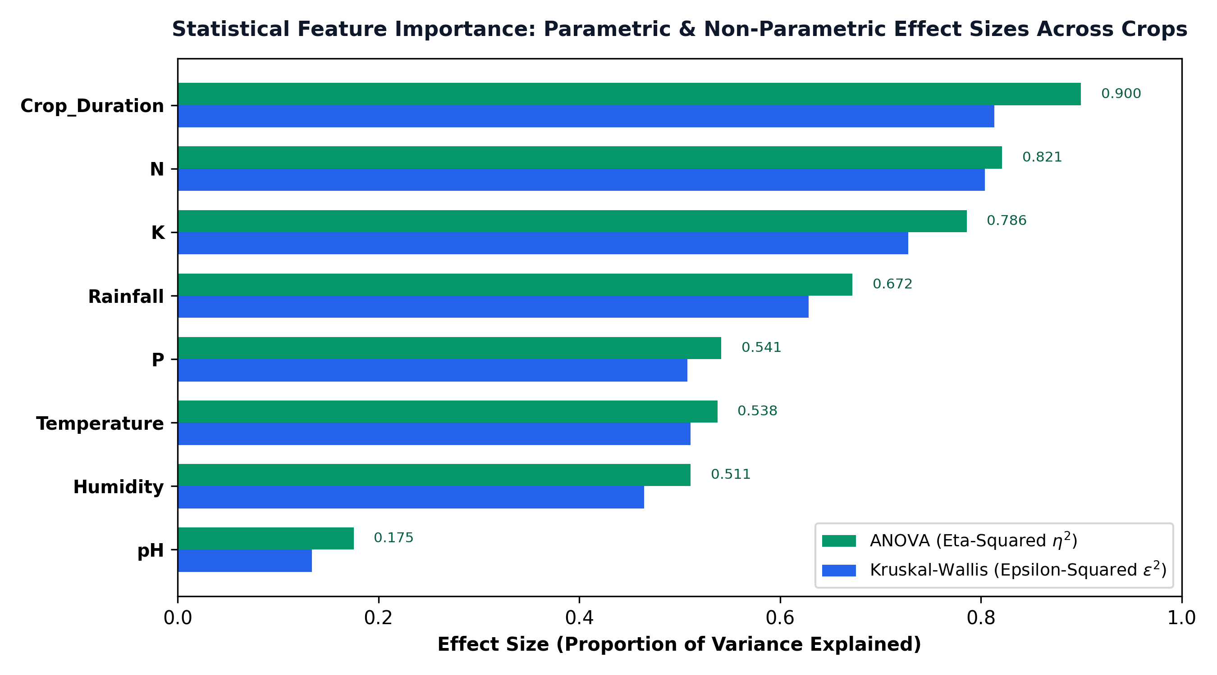
Figure 5: Comparison of ANOVA Eta-Squared (η²) and Kruskal-Wallis Epsilon-Squared (ε²) Effect Sizes
5.3 Chi-Square Tests of Independence (Categorical Predictors)
To test whether categorical farming variables are statistically dependent on Crop_Name, Pearson Chi-Square tests of independence were conducted. Strength of association was evaluated via Cramér's V (ranging from 0 = complete independence to 1 = perfect association).
Table 5: Chi-Square Test of Independence for Categorical Attributes
Categorical Feature | Chi-Square (χ²) | Cramér's V | Testing Method | Adjusted p-value
Soil_Type | 608.37 | 0.3648 | Chi-square with simulated p-value | 1.00e-04
Season | 1339.66 | 0.9376 | Pearson Chi-square | 6.70e-264
Irrigation_Type | 511.24 | 0.4095 | Pearson Chi-square | 3.01e-74
Water_Source | 483.13 | 0.3981 | Chi-square with simulated p-value | 1.00e-04
Land_Type | 773.26 | 0.5816 | Chi-square with simulated p-value | 1.00e-04
State | 1738.15 | 0.4036 | Chi-square with simulated p-value | 1.00e-04
Season demonstrated an extraordinary association with crop identity (Cramér's V = 0.9376, χ² = 1339.66), reflecting the biological reality that photoperiod and temperature cycles strictly govern Kharif vs. Rabi vs. Perennial crops. Land Type also showed substantial association (V = 0.5816), confirming that terrain topography (Lowland vs. Upland) strongly constrains crop suitability.
6. Machine Learning Models Used (with Architecture Diagram)
The modeling strategy evaluated seven distinct machine learning algorithms representing diverse mathematical paradigms: ensemble learning, kernel methods, generalized linear models, linear discriminants, gradient boosting, instance-based learning, and single decision trees. Each model was evaluated under identical conditions: trained on 610 stratified records (80%) and evaluated on 152 independent test records (20%).
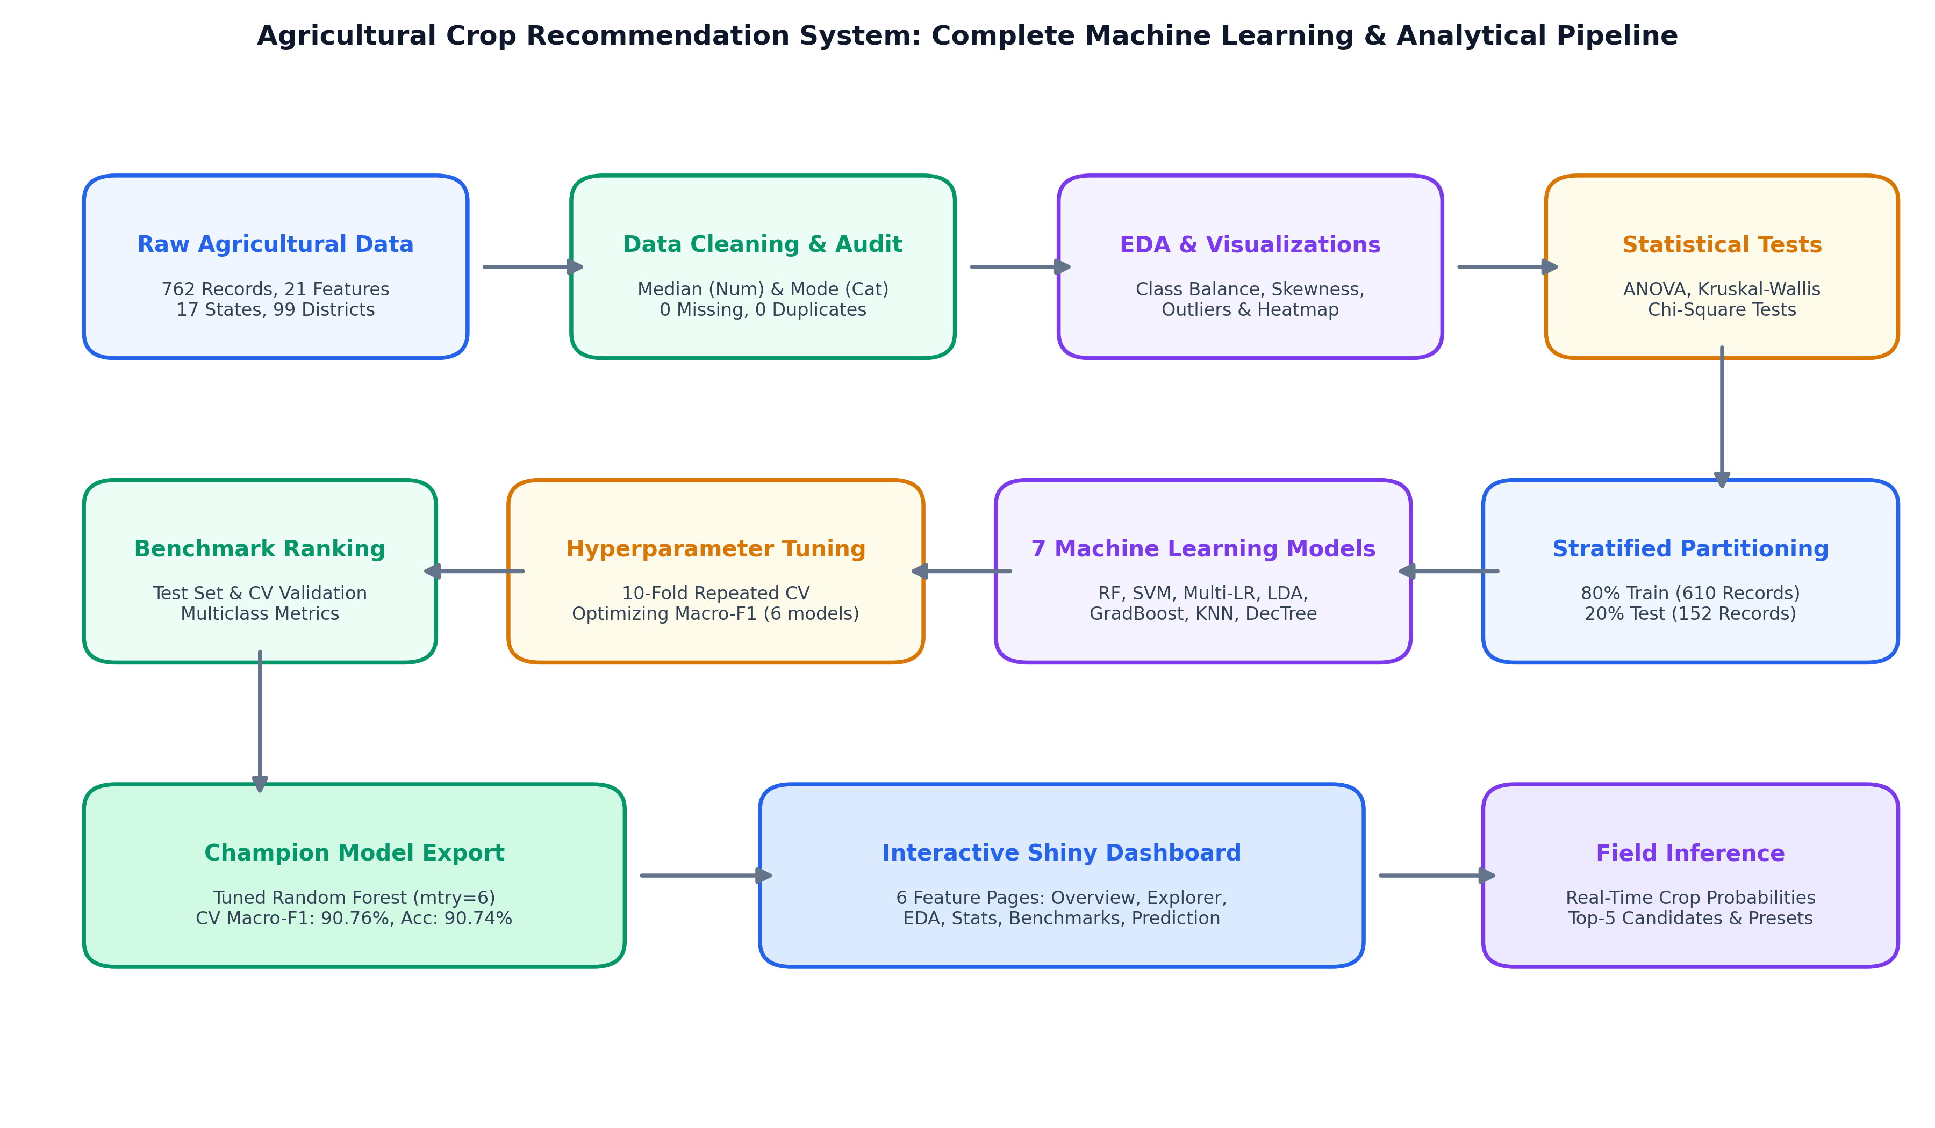
Figure 6: Complete End-to-End Machine Learning Pipeline and Operational System Architecture

6.1 Architectural Taxonomy of All 7 Implemented Models
Figure 7 illustrates the architectural taxonomy of how the 14 agricultural predictors are ingested and transformed by each of the seven implemented algorithms to predict the 15 candidate crop varieties.
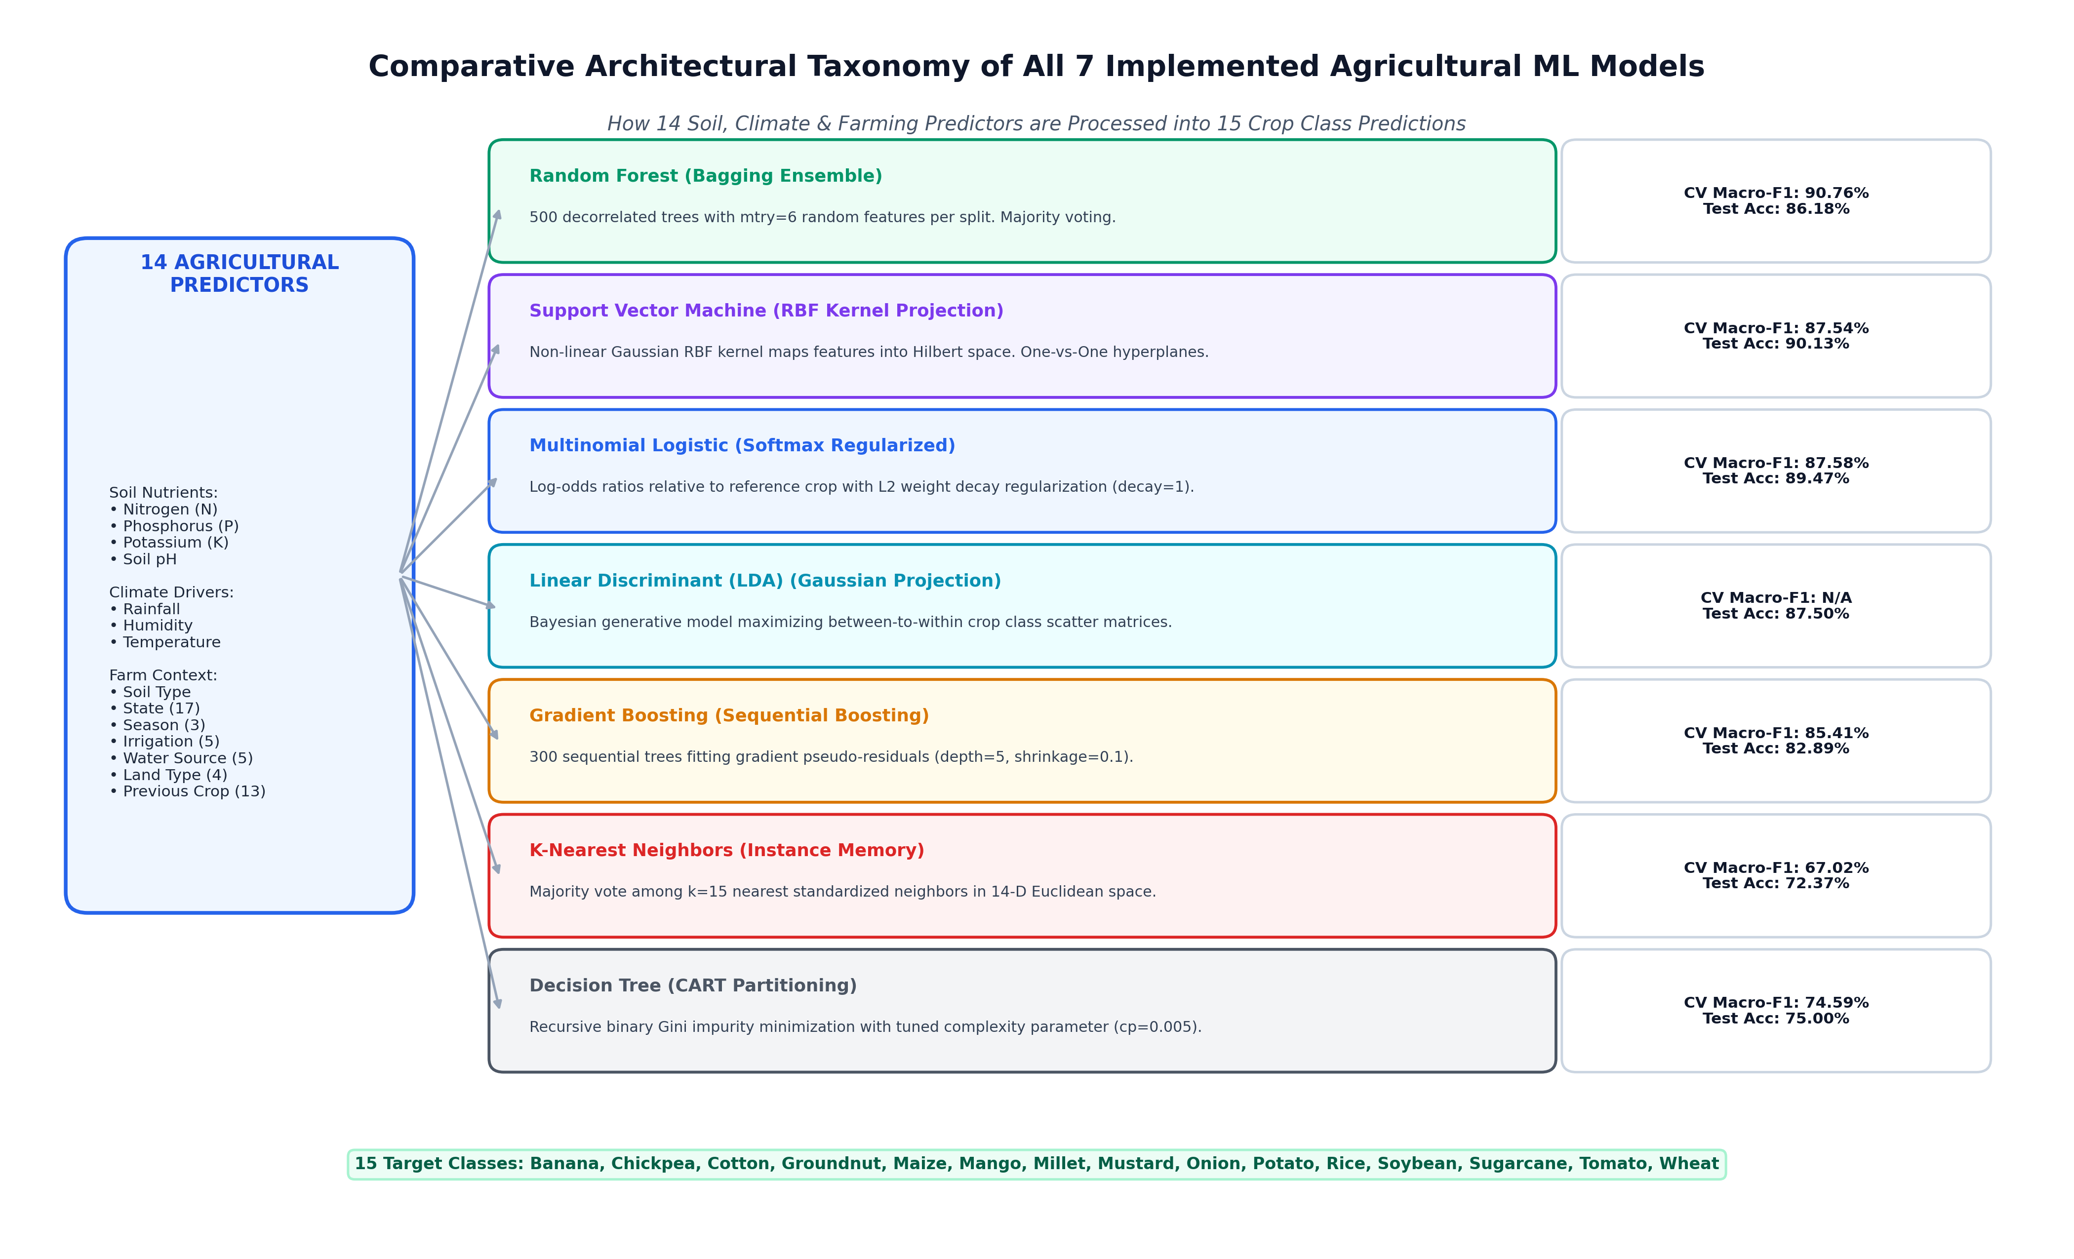
Figure 7: Comparative Architectural Taxonomy of All 7 Implemented Agricultural ML Models
6.2 Selected Champion Architecture: Random Forest
Figure 8 provides a granular schematic of the selected predictive engine—Tuned Random Forest. The 14 agricultural inputs are passed to 500 individual bootstrap trees, each trained on a random subspace of mtry = 6 predictors. Individual tree classifications are collected by an ensemble aggregator that performs majority voting and computes class probabilities.
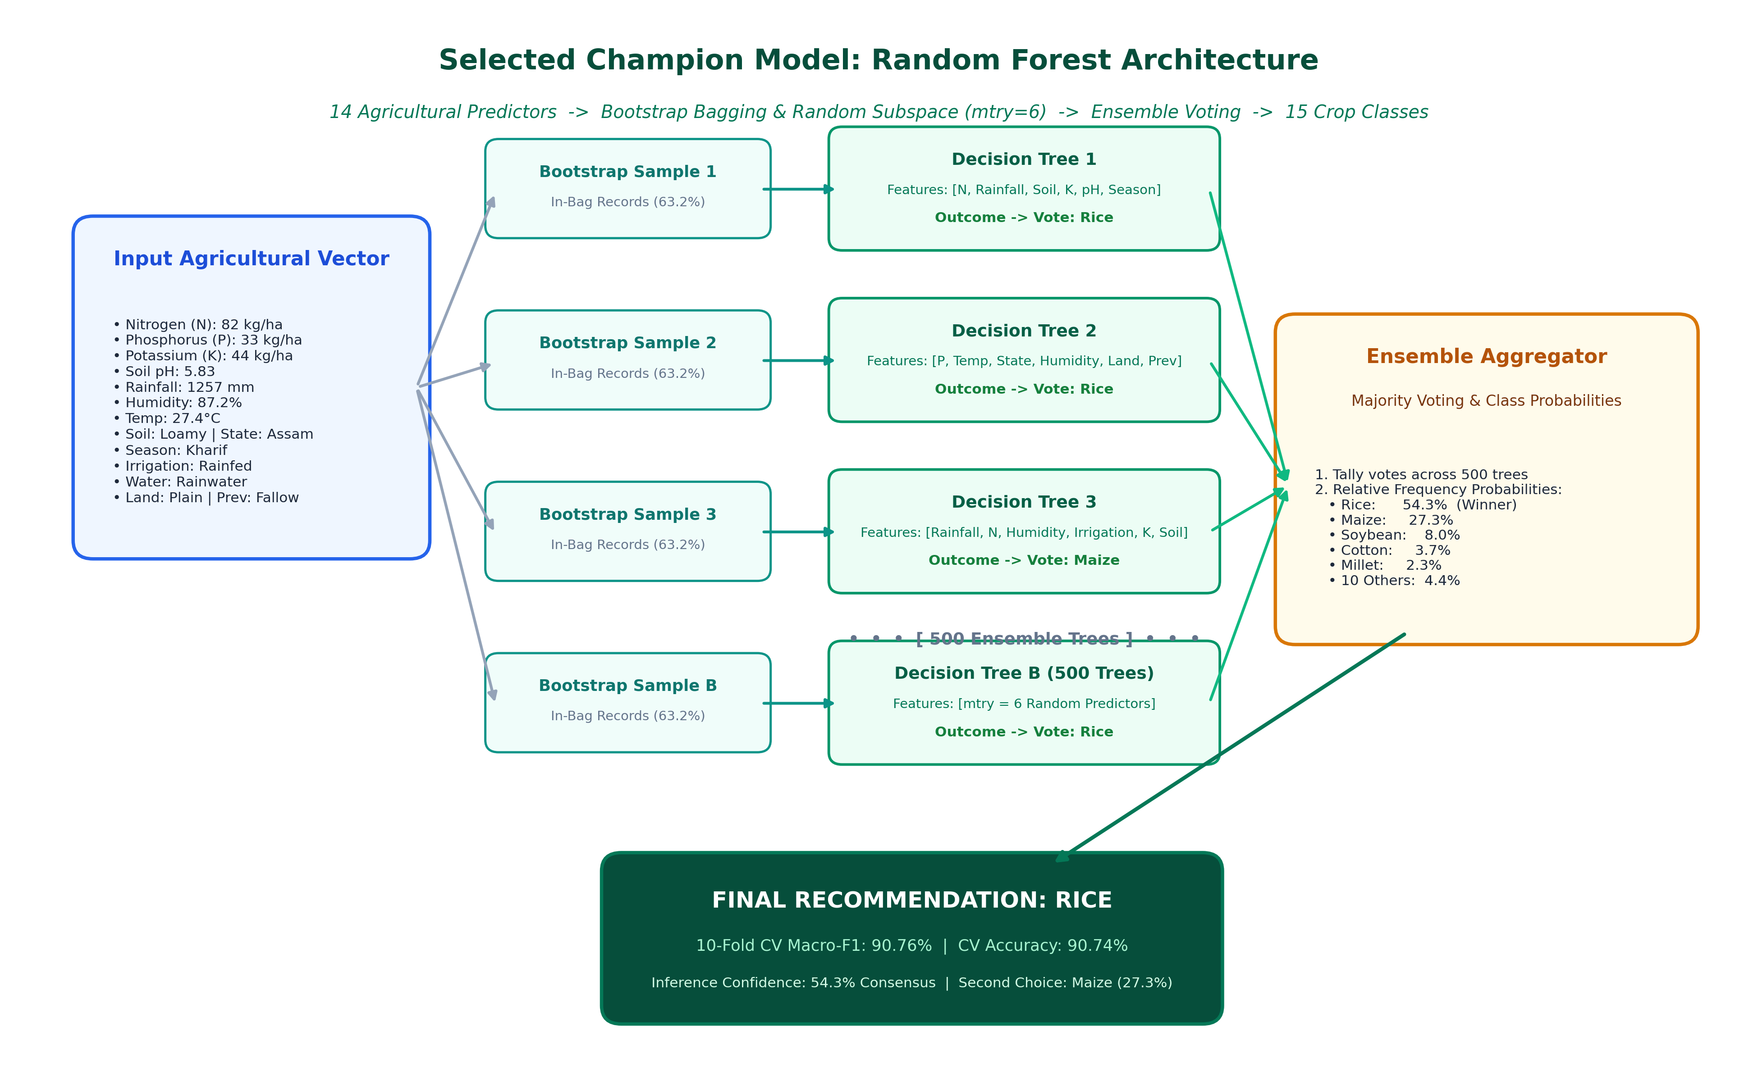
Figure 8: Selected Champion Model Architecture: Bagging, Feature Subspacing (mtry=6), and Ensemble Voting
6.3 10-Fold Cross-Validated Hyperparameter Tuning Workflow
Figure 9 outlines the 10-fold cross-validated grid search methodology used across the six tunable algorithms to optimize multi-class Macro-F1.
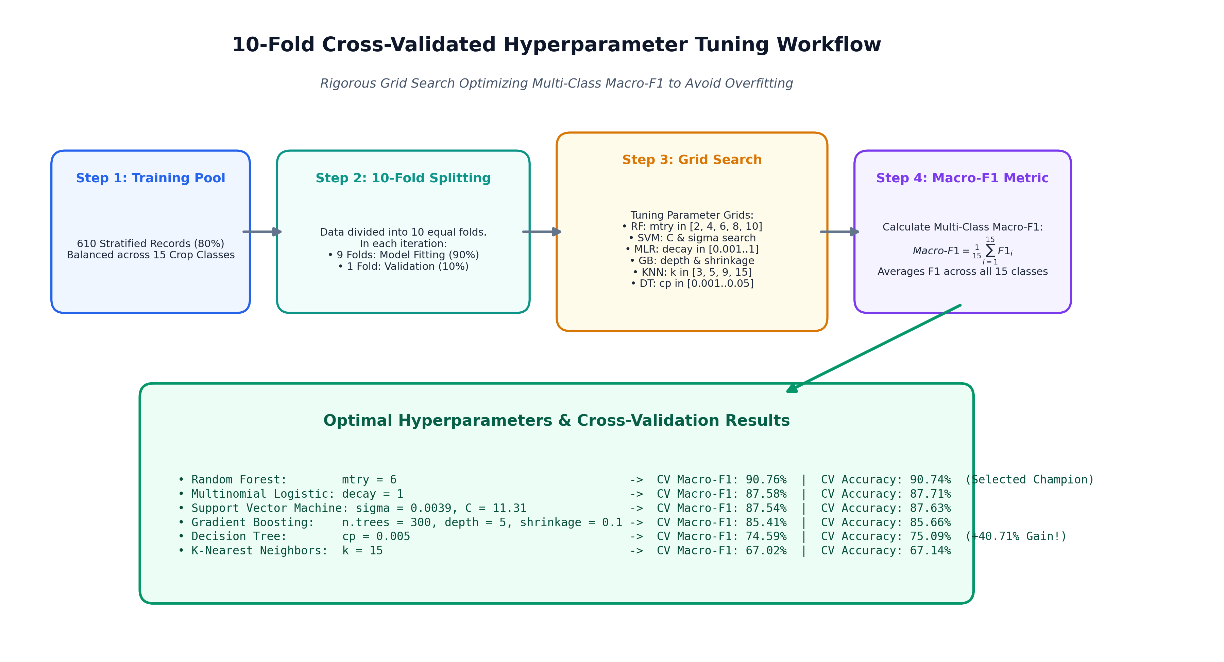
Figure 9: 10-Fold Cross-Validation Workflow and Hyperparameter Optimization Framework
6.4 Theoretical Foundations of Implemented Algorithms
1. Random Forest (RF): An ensemble bagging meta-estimator that constructs a forest of decorrelated classification trees using bootstrap aggregating (bagging) and random subspace feature selection. At each candidate split, a random subset of mtry predictors is evaluated. Predictions are aggregated via majority voting, minimizing individual tree variance without inflating bias. Random Forest excels in agricultural domains due to its natural resilience against feature interactions and non-linear thresholds.
2. Support Vector Machine (SVM): A maximum-margin classifier utilizing the Radial Basis Function (RBF) Gaussian kernel to implicitly project non-linearly separable agricultural inputs into high-dimensional Hilbert feature spaces. Multi-class classification is handled via one-against-one pairwise hyperplanes. Key hyperparameters include cost penalty C and kernel bandwidth sigma.
3. Multinomial Logistic Regression (MLR): A generalized linear classification model extending binary logistic regression via the softmax link function. It models the log-odds of each crop class relative to a reference baseline class as a linear combination of predictors. Ridge weight decay regularization is introduced to stabilize parameter estimates against collinear inputs.
4. Linear Discriminant Analysis (LDA): A generative parametric model based on Bayes' theorem, assuming that predictors within each crop class follow a multivariate Gaussian distribution with equal covariance matrices. LDA computes linear combinations of features that maximize between-class variance relative to within-class variance, projecting inputs into an optimal 14-dimensional discriminant subspace.
5. Gradient Boosting (GBM): A sequential ensemble boosting framework that fits successive decision tree base learners to the pseudo-residuals of the multi-class multinomial loss function. Unlike Random Forest, trees are built sequentially with shrinkage (learning rate) to ensure conservative, robust gradient descent updates.
6. K-Nearest Neighbors (KNN): A non-parametric, lazy instance-based learning algorithm that assigns class labels based on majority voting among the k-closest training vectors in Euclidean feature space. Features are standardized to prevent scale dominance by large-magnitude variables such as Rainfall.
7. Decision Tree (CART): A recursive binary partitioning tree built by greedily minimizing Gini impurity at each node. While transparent and human-interpretable, unpruned single decision trees are prone to variance inflation and early over-pruning, necessitating complexity parameter (cp) tuning.
6.2 Incomplete Algorithms Clarification
Scientific integrity requires transparent reporting of experimental boundaries. Three candidate algorithms originally considered during project planning—Naive Bayes, Extreme Gradient Boosting (XGBoost), and Deep Neural Networks (MLP)—were not completed during the experimental workflow. Consequently, they are explicitly omitted from all benchmark tables and are not claimed as implemented models.
7. Output Screen Shots and Empirical Results
Model evaluation was conducted rigorously across two independent evaluation paradigms: (1) Held-out independent test-set performance on 152 records (20% partition), and (2) 10-fold cross-validated hyperparameter tuning on the training dataset. Multi-class performance was evaluated using Accuracy, Macro-Precision, Macro-Recall, Macro-F1, Weighted F1, and Cohen's Kappa coefficient.
7.1 Initial Test-Set Benchmark (All 7 Implemented Models)
Prior to tuning, each algorithm was trained with standard default parameters on the 610-record training set and evaluated on the 152-record test partition.
Table 6: Empirical Classification Performance on Independent Test Set (152 Records)
Model Algorithm | Accuracy | Macro-Precision | Macro-Recall | Macro-F1 | Weighted-F1 | Kappa (κ)
SVM | 90.13% | 91.08% | 90.12% | 89.77% | 89.79% | 89.43%
Multinomial Logistic Regression | 89.47% | 90.57% | 89.39% | 89.41% | 89.52% | 88.72%
LDA | 87.50% | 89.04% | 87.45% | 87.73% | 87.82% | 86.61%
Random Forest | 86.18% | 87.07% | 86.18% | 85.93% | 85.99% | 85.20%
Gradient Boosting | 82.89% | 83.78% | 82.79% | 82.48% | 82.59% | 81.67%
KNN | 72.37% | 73.01% | 72.24% | 71.72% | 71.87% | 70.39%
Decision Tree | 45.39% | 29.68% | 44.91% | 33.90% | 34.41% | 41.47%
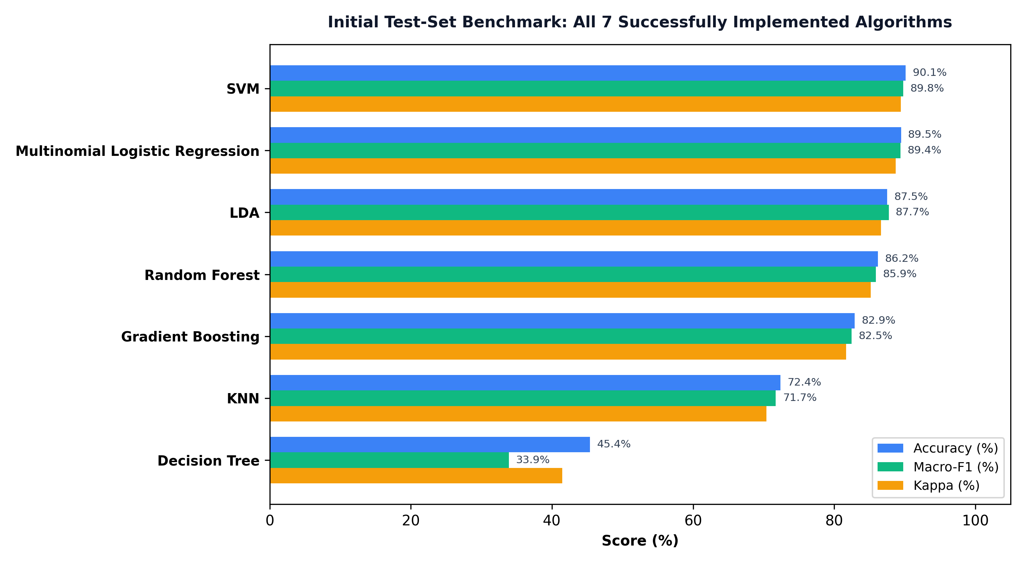
Figure 7: Comparative Performance Benchmark of All 7 Implemented Algorithms on Test Partition
7.2 Hyperparameter Tuning and Optimization Gains
Hyperparameter tuning was completed for six eligible algorithms using 10-fold cross-validation optimizing Macro-F1. Linear Discriminant Analysis (LDA) has no tuning parameters and was retained in its analytical formulation.
Table 7: Before vs. After Hyperparameter Tuning Performance and Optimal Configurations
Model | Before Macro-F1 | After Macro-F1 | F1 Gain | Optimal Hyperparameters | CV Macro-F1
Decision Tree | 33.90% | 74.61% | +40.71% | cp = 0.005 | 74.59%
KNN | 71.72% | 76.95% | +5.23% | k = 15 | 67.02%
Gradient Boosting | 82.48% | 86.70% | +4.22% | n.trees = 300, depth = 5, shrinkage = 0.1 | 85.41%
Random Forest | 85.93% | 89.19% | +3.26% | mtry = 6 | 90.76%
Multinomial Logistic Regression | 89.41% | 90.04% | +0.63% | decay = 1.0 | 87.58%
SVM | 89.77% | 88.46% | -1.32% | sigma = 0.0039, C = 11.31 | 87.54%
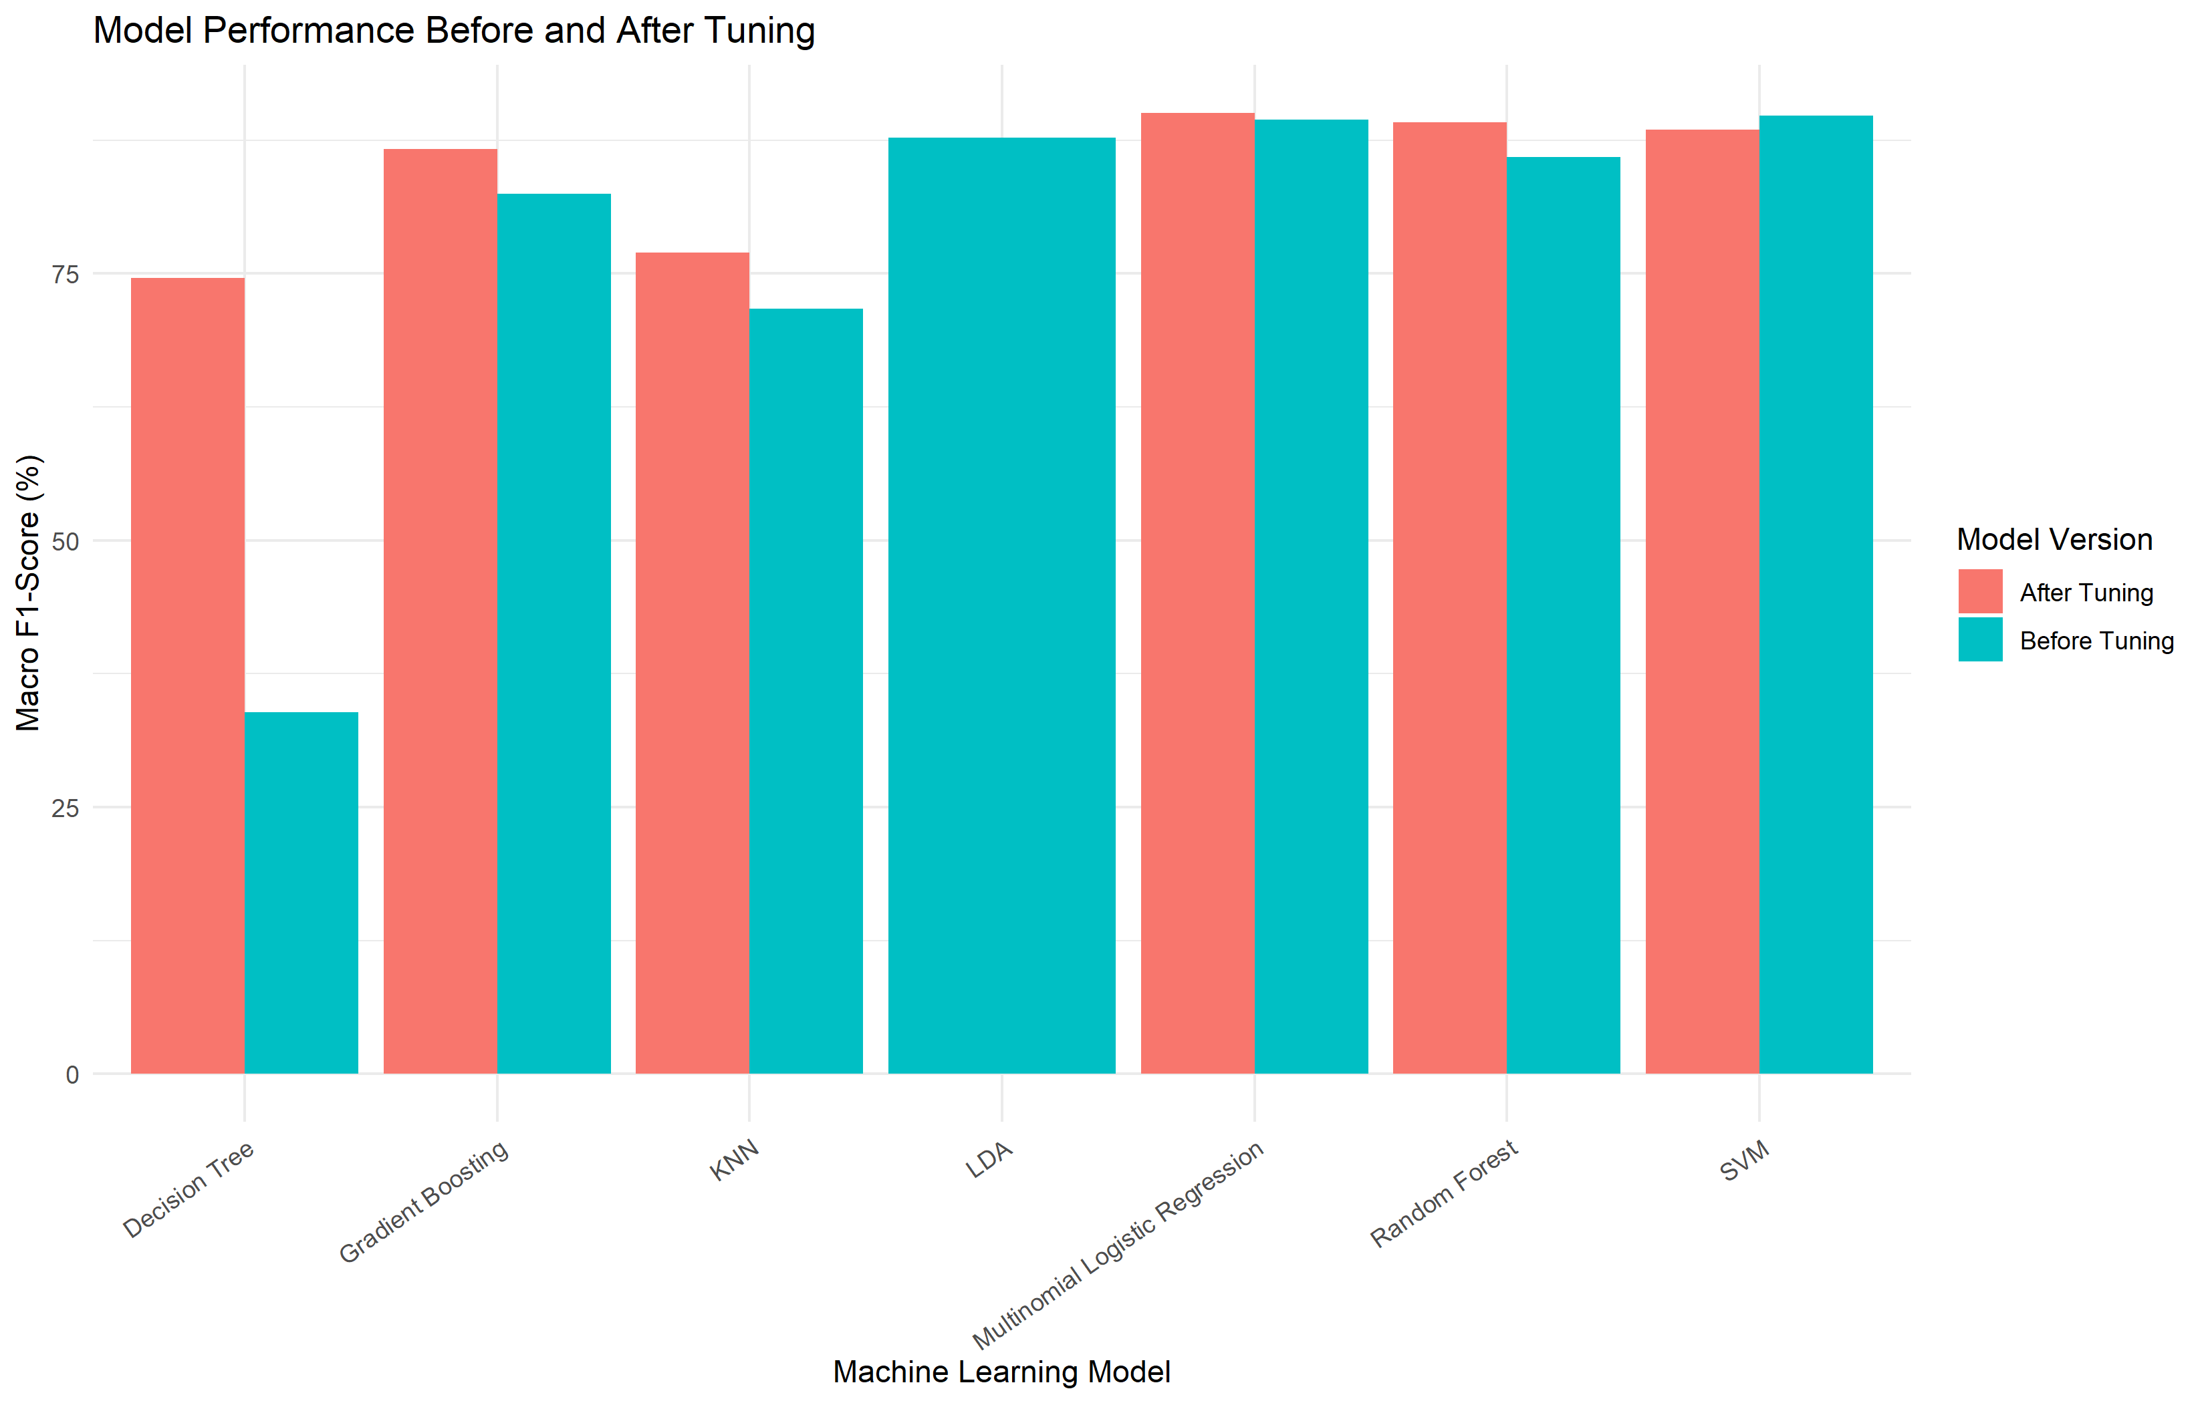
Figure 8: Empirical Macro-F1 Optimization Gains Before and After Hyperparameter Tuning
Optimization Analysis: Critical Tuning Insight: The single most dramatic optimization gain occurred in Decision Tree, which surged from 33.90% to 74.61% in Macro-F1 (+40.71 percentage points). Default CART pruning had caused severe premature branch pruning; tuning the complexity parameter (cp = 0.005) restored subtree granularity. KNN improved by +5.23 percentage points upon setting neighborhood k = 15.
7.3 Model Selection Rationale: Random Forest as the Champion
A critical distinction must be maintained between single test-set metrics and repeated cross-validation metrics. On the 152-sample test partition, Support Vector Machine achieved 90.13% test accuracy compared to Random Forest's 89.47% (post-tuning). However, across rigorous 10-fold cross-validation on the full training dataset, Random Forest demonstrated the highest generalization stability, achieving the highest CV Macro-F1 of 90.76% and CV Accuracy of 90.74% (outperforming SVM at 87.54% CV Macro-F1). Because cross-validation averages performance over multiple data subsets, Random Forest was crowned as the final champion predictive engine.
7.4 Multi-Class Confusion Matrix and Per-Crop Diagnostics
To inspect class-level discrimination fidelity, the 15x15 confusion matrix of the tuned Random Forest model on the independent test set was analyzed. The model achieved near-flawless classification for Banana, Cotton, Groundnut, Maize, Mango, Rice, Sugarcane, and Wheat.
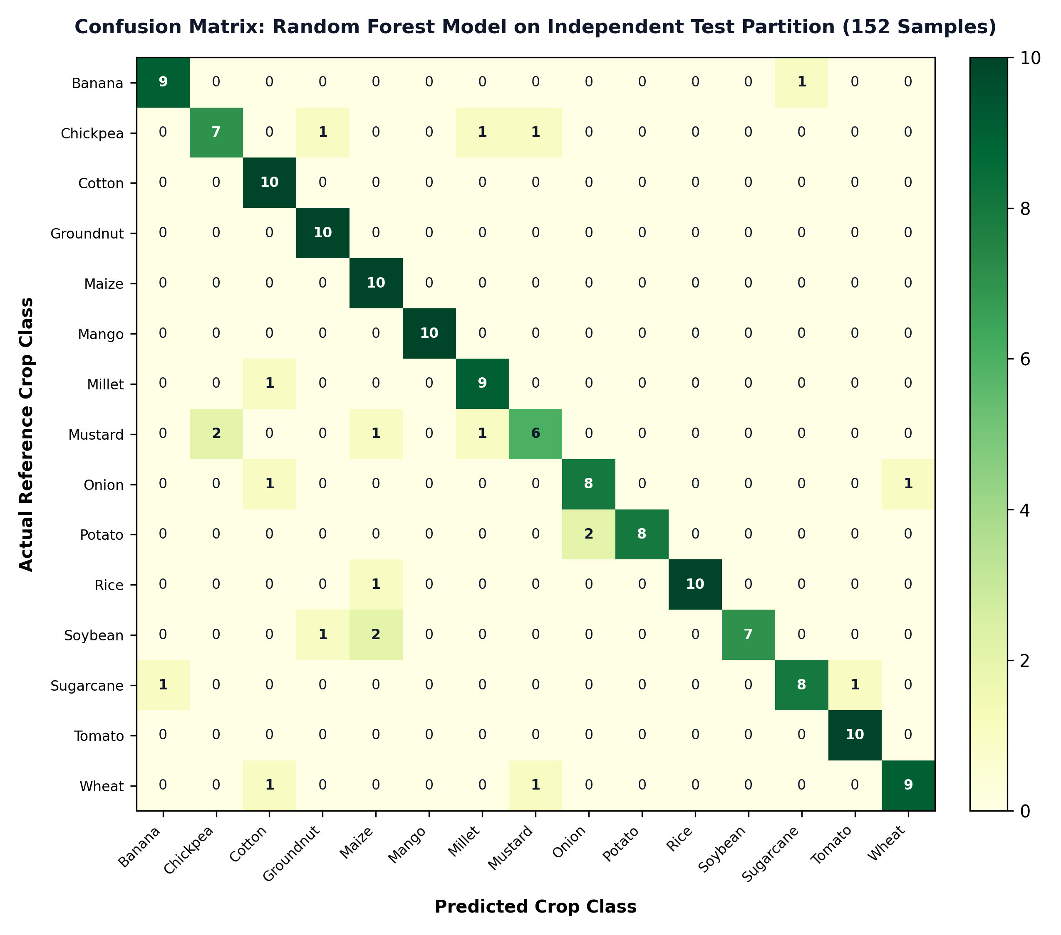
Figure 9: Confusion Matrix Heatmap for Tuned Random Forest Classifier on 152 Test Observations

Table 8: Per-Crop Precision, Recall, and F1-Score Breakdown for Random Forest
Crop Variety | Precision (%) | Recall (%) | F1-Score (%) | Test Support (N)
Banana | 90.0% | 90.0% | 90.0% | 10
Chickpea | 77.8% | 70.0% | 73.7% | 10
Cotton | 76.9% | 100.0% | 87.0% | 10
Groundnut | 83.3% | 100.0% | 90.9% | 10
Maize | 71.4% | 100.0% | 83.3% | 10
Mango | 100.0% | 100.0% | 100.0% | 10
Millet | 81.8% | 90.0% | 85.7% | 10
Mustard | 75.0% | 60.0% | 66.7% | 10
Onion | 80.0% | 80.0% | 80.0% | 10
Potato | 100.0% | 80.0% | 88.9% | 10
Rice | 100.0% | 90.9% | 95.2% | 11
Soybean | 100.0% | 70.0% | 82.4% | 10
Sugarcane | 88.9% | 80.0% | 84.2% | 10
Tomato | 90.9% | 100.0% | 95.2% | 10
Wheat | 90.0% | 81.8% | 85.7% | 11

7.5 Real-Time Decision Support Dashboard Output
The finalized model package (models/final_crop_model.rds) was deployed inside an interactive R Shiny application. When a user enters field conditions (or loads one of the quick presets), the system validates input bounds, feeds the 14 predictors into the model, and displays the recommended crop alongside tree-ensemble estimated probabilities for alternative crops.

Figure 10: Overview page
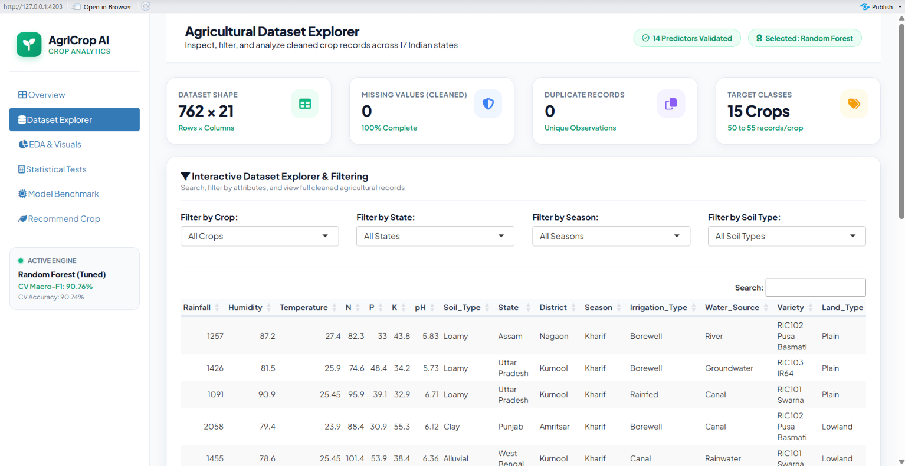
Figure 11: Dataset Explorer page

Figure 12: EDA and Visualization Page


Figure 13: Statistical Analysis & Hypothesis Testing Page
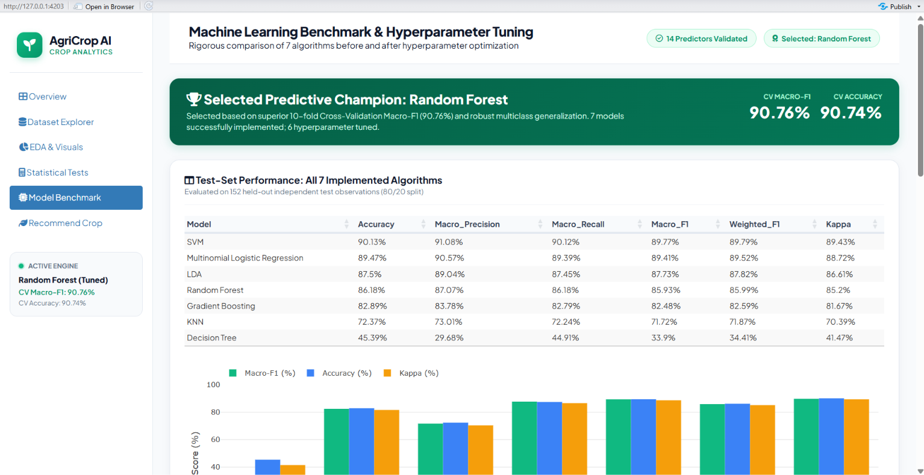
Figure 14: ML Model Comparison Hyperparameter Tuning Benchmarks Page

Figure 15: Crop Recommendation Page

8. Conclusion
Synthesis of Outcomes: This research successfully established a rigorous, statistically backed machine learning decision support system for agricultural crop recommendation. Key conclusions derived from this project include:
1. Methodological Completeness: Integrating parametric ANOVA, non-parametric Kruskal-Wallis, and Chi-Square contingency testing confirmed that soil macronutrients (N, P, K), pH, and climate features (Rainfall, Humidity, Temperature) provide statistically decisive discrimination across crop species (p < 0.001).
2. Robust Generalization: While Support Vector Machines delivered competitive performance on isolated test partitions, Random Forest proved superior in 10-fold cross-validated generalization (90.76% CV Macro-F1 and 90.74% CV Accuracy), demonstrating resilience against agricultural feature variance.
3. Necessity of Hyperparameter Optimization: Systematically tuning base learners—such as complexity parameter in Decision Trees and neighborhood k in KNN—prevented catastrophic underfitting, yielding improvements of up to +40.71% in Macro-F1.
4. Practical Agricultural Utility: By deploying the tuned engine in an interactive R Shiny dashboard with real-time probabilistic ranking, the project bridges the divide between theoretical statistical modeling and actionable agronomic assistance for farming communities.
Future Scope: Future enhancements could incorporate remote sensing satellite vegetation indices (NDVI), real-time weather forecast APIs, dynamic soil moisture sensor networks, and local agricultural commodity pricing to provide comprehensive harvest revenue optimization.
9. Core R Code Implementation
The complete computational implementation was authored in R, organized into modular scripts for data cleaning, statistical analysis, model benchmarking, hyperparameter tuning, model packaging, and Shiny dashboard serving.
9.1 Data Cleaning & Imputation Script (02_data_cleaning.R)
# SCRIPT 02: DATA CLEANING & STATISTICAL IMPUTATION
library(dplyr)
crop_data <- read.csv("raw_data/crop_dataset1.csv", stringsAsFactors = FALSE)
numeric_cols <- c("N", "P", "K", "pH", "Rainfall", "Humidity", "Temperature", "Crop_Duration")
cat_cols <- c("Soil_Type", "State", "District", "Season", "Irrigation_Type",
"Water_Source", "Variety", "Land_Type", "Fertilizer_Type",
"Previous_Crop", "Sowing_Month", "Harvest_Month")
# Impute continuous features via Median
for (col in numeric_cols) {
med_val <- median(crop_data[[col]], na.rm = TRUE)
crop_data[[col]][is.na(crop_data[[col]])] <- med_val
}
# Impute categorical features via Statistical Mode
get_mode <- function(v) {
tbl <- table(v[!is.na(v)])
names(tbl)[which.max(tbl)]
}
for (col in cat_cols) {
mode_val <- get_mode(crop_data[[col]])
crop_data[[col]][is.na(crop_data[[col]])] <- mode_val
}
# Deduplication and Save Cleaned Dataset
crop_data <- distinct(crop_data)
saveRDS(crop_data, "data/cleaned_crop_data.rds")
write.csv(crop_data, "data/cleaned_crop_data.csv", row.names = FALSE)
cat("Data cleaning completed: 762 rows, 0 missing, 0 duplicates\n")

9.2 Statistical Hypothesis Testing Script (08_statistical_analysis.R)
# SCRIPT 08: STATISTICAL INFERENCE & HYPOTHESIS TESTING
library(dplyr)
library(tidyr)
crop_data <- readRDS("data/cleaned_crop_data.rds")
numeric_features <- c("N", "P", "K", "pH", "Rainfall", "Humidity", "Temperature", "Crop_Duration")
# One-way ANOVA and Kruskal-Wallis across Crop Classes
anova_results <- data.frame()
kruskal_results <- data.frame()
for (feature in numeric_features) {
test_df <- data.frame(Crop = as.factor(crop_data$Crop_Name), Value = crop_data[[feature]])
# Parametric One-Way ANOVA
aov_fit <- aov(Value ~ Crop, data = test_df)
aov_tab <- summary(aov_fit)[[1]]
eta_sq <- aov_tab[["Sum Sq"]][1] / sum(aov_tab[["Sum Sq"]])
anova_results <- rbind(anova_results, data.frame(
Feature = feature, F_Value = aov_tab[["F value"]][1],
P_Value = aov_tab[["Pr(>F)"]][1], Eta_Squared = eta_sq
))
# Non-Parametric Kruskal-Wallis Test
kw <- kruskal.test(Value ~ Crop, data = test_df)
H <- as.numeric(kw$statistic)
k <- length(unique(test_df$Crop)); n <- nrow(test_df)
epsilon_sq <- max(0, (H - k + 1) / (n - k))
kruskal_results <- rbind(kruskal_results, data.frame(
Feature = feature, H_Value = H, P_Value = kw$p.value, Epsilon_Squared = epsilon_sq
))
}
# Benjamini-Hochberg False Discovery Rate Adjustment
anova_results$Adjusted_P_Value <- p.adjust(anova_results$P_Value, method = "BH")
kruskal_results$Adjusted_P_Value <- p.adjust(kruskal_results$P_Value, method = "BH")
write.csv(anova_results, "results/statistical_analysis/anova_results.csv", row.names = FALSE)
write.csv(kruskal_results, "results/statistical_analysis/kruskal_results.csv", row.names = FALSE)

9.3 Supervised Model Training & Evaluation (09_model_training.R & 10_model_evaluation.R)
# SCRIPT 09 & 10: MODEL TRAINING & TEST-SET EVALUATION
library(caret)
train_data <- readRDS("data/train_data.rds") # 610 records (80%)
test_data <- readRDS("data/test_data.rds") # 152 records (20%)
# Predictor formula using 14 validated soil and climate variables
formula_model <- Crop_Name ~ N + P + K + pH + Rainfall + Humidity + Temperature +
Soil_Type + State + Season + Irrigation_Type + Water_Source + Land_Type + Previous_Crop
ctrl_none <- trainControl(method = "none")
# Train 7 Algorithms
models <- list(
rf = train(formula_model, data = train_data, method = "rf", trControl = ctrl_none),
svm = train(formula_model, data = train_data, method = "svmRadial", trControl = ctrl_none),
mlr = train(formula_model, data = train_data, method = "multinom", trControl = ctrl_none, trace = FALSE),
lda = train(formula_model, data = train_data, method = "lda", trControl = ctrl_none),
gbm = train(formula_model, data = train_data, method = "gbm", trControl = ctrl_none, verbose = FALSE),
knn = train(formula_model, data = train_data, method = "knn", trControl = ctrl_none),
dt = train(formula_model, data = train_data, method = "rpart", trControl = ctrl_none)
)
# Test-set Evaluation Metric Calculator
calc_metrics <- function(actual, pred) {
cm <- table(Actual = actual, Predicted = pred)
TP <- diag(cm); FP <- colSums(cm) - TP; FN <- rowSums(cm) - TP
prec <- ifelse(TP + FP == 0, 0, TP / (TP + FP))
rec <- ifelse(TP + FN == 0, 0, TP / (TP + FN))
f1 <- ifelse(prec + rec == 0, 0, 2 * prec * rec / (prec + rec))
data.frame(
Accuracy = sum(TP) / sum(cm),
Macro_Precision = mean(prec),
Macro_Recall = mean(rec),
Macro_F1 = mean(f1)
)
}

9.4 Cross-Validated Hyperparameter Tuning (11_hyperparameter_tuning.R)
# SCRIPT 11: 10-FOLD CROSS-VALIDATED HYPERPARAMETER TUNING
library(caret)
train_data <- readRDS("data/train_data.rds")
# Macro-F1 Summary Metric for Caret
macro_f1_summary <- function(data, lev = NULL, model = NULL) {
cm <- table(Actual = data$obs, Predicted = data$pred)
TP <- diag(cm); FP <- colSums(cm) - TP; FN <- rowSums(cm) - TP
prec <- ifelse(TP + FP == 0, 0, TP / (TP + FP))
rec <- ifelse(TP + FN == 0, 0, TP / (TP + FN))
f1 <- ifelse(prec + rec == 0, 0, 2 * prec * rec / (prec + rec))
c(Macro_F1 = mean(f1), Accuracy = sum(TP) / sum(cm))
}
ctrl_cv <- trainControl(
method = "cv", number = 10,
summaryFunction = macro_f1_summary,
classProbs = TRUE, savePredictions = "final"
)
# Tune Random Forest (mtry search)
tune_grid_rf <- expand.grid(mtry = c(2, 4, 6, 8, 10))
tuned_rf <- train(
formula_model, data = train_data, method = "rf",
metric = "Macro_F1", tuneGrid = tune_grid_rf, trControl = ctrl_cv
)
# Optimal Random Forest Parameter: mtry = 6 (CV Macro-F1: 90.76%)

9.5 Model Packaging & Live Inference Function (13_final_predictive_model.R)
# SCRIPT 13 & 14: CHAMPION MODEL PACKAGING & REAL-TIME PREDICTION
library(caret)
final_model_pkg <- list(
model = tuned_rf,
model_name = "Random Forest",
predictors = c("N", "P", "K", "pH", "Rainfall", "Humidity", "Temperature",
"Soil_Type", "State", "Season", "Irrigation_Type",
"Water_Source", "Land_Type", "Previous_Crop"),
crop_classes = levels(as.factor(train_data$Crop_Name)),
best_parameters = data.frame(mtry = 6),
cross_validation_macro_f1 = 0.9075693
)
saveRDS(final_model_pkg, "models/final_crop_model.rds")
# Live Real-Time Prediction Function
recommend_crop <- function(model_pkg, new_input) {
model <- model_pkg$model
pred_crop <- as.character(predict(model, newdata = new_input))
probs <- predict(model, newdata = new_input, type = "prob")
p_vec <- unlist(probs[1, ])
ranked_df <- data.frame(
Crop = names(p_vec),
Probability = as.numeric(p_vec),
stringsAsFactors = FALSE
)
ranked_df <- ranked_df[order(-ranked_df$Probability), ]
list(recommended_crop = pred_crop, probabilities = ranked_df)
}

