WEEK 5 INTERNSHIP REPORT
Performance Analysis and Optimization Strategy
Internal Communication Platform
Junior Systems Analyst Online Internship
24 September 2026
Academic simulation: performance values are illustrative, not production measurements.

Executive Summary
This report provides a comprehensive performance analysis and optimization strategy for a hypothetical Internal Communication Platform used by a mid-sized company. The system is assumed to support authentication, messaging, notifications, user profiles, search, and real-time communication. The purpose is to identify performance issues under increasing user load and propose practical improvements supported by measurable performance metrics.
Because the assignment does not provide production monitoring data, the analysis uses clearly labelled simulated measurements. The workload increases from 50 to 800 concurrent users. At the highest simulated load, P95 response time reaches 7.60 seconds, throughput reaches 705 requests/second, CPU utilization reaches 96%, database latency reaches 350 ms, and error rate reaches 5.10%. These trends indicate that the system is approaching resource and data-access limits. The proposed strategy focuses on database optimization, caching, connection management, application profiling, asynchronous processing, horizontal scaling, and observability.

1. Objective
Conduct a comprehensive performance analysis of the system and propose an optimization strategy. The objective is to measure how the hypothetical Internal Communication Platform behaves as workload increases, identify performance degradation, and translate the evidence into an actionable optimization plan. The analysis considers response time, throughput, resource utilization, database behavior, reliability, and scalability.

2. Analytical Skills and Informed Recommendations
This task is designed to demonstrate the analytical skills required to measure system performance and make informed recommendations. A systems analyst should not select an optimization only because it is technically popular. The recommendation should be connected to measurable evidence, business requirements, system constraints, implementation effort, cost, risk, and validation results. The report therefore uses a baseline, defined metrics, a controlled workload, bottleneck analysis, and target values.

3. Scenario: Current System Experiencing Performance Bottlenecks
The scenario assumes that the existing internal communication system is experiencing performance bottlenecks as more employees use it simultaneously. The assumed architecture contains web/mobile clients, a load balancer or API gateway, application services, Redis caching, and a PostgreSQL database. REST APIs support normal operations and WebSockets support real-time communication. Potential pressure points include database queries, CPU, memory, connection pools, cache effectiveness, and large request/response payloads.

4. Simulated Data Analysis and Assessment
The system is assessed using simulated workload data rather than real production telemetry. Six concurrency levels are considered: 50, 100, 200, 400, 600, and 800 users. At each level, P95 response time, throughput, CPU utilization, memory utilization, database latency, and error rate are recorded. The simulated baseline shows that response time increases sharply above 400 users, CPU approaches saturation, database latency grows significantly, and error rate increases. Throughput also begins to flatten at high concurrency.

5. Proposed Optimization Strategy
The optimization strategy addresses the system at multiple layers. First, database queries and indexes should be reviewed using execution plans and slow-query logs. Second, Redis should cache frequently requested, relatively stable data. Third, application and database connection pools should be tuned using measured wait time and utilization. Fourth, unbounded queries and large payloads should be controlled with pagination and field selection. Fifth, non-critical processing should move to background workers. Finally, application services can be scaled horizontally behind a load balancer when measurements show that a single instance is insufficient.

6. Critical Performance Metrics
The critical metrics are P95 response time, throughput, CPU utilization, memory utilization, database latency, and error rate. P95 is preferred over average latency because it exposes the slower experiences that averages can hide. Throughput represents useful processing capacity. CPU and memory reveal resource pressure. Database latency identifies persistence-layer constraints. Error rate shows whether overload is affecting reliability. Secondary metrics should include cache hit ratio, database connection-pool utilization, queue depth, slow-query frequency, WebSocket connections, and application instance count.

7. Methodology for Simulating Performance Analysis
The recommended simulation begins with a warm-up period and then measures a fixed workload window at each concurrency level. The same workload mix and test data should be used across runs. Representative operations include login, dashboard loading, conversation retrieval, message sending, notification retrieval, user search, and persistent WebSocket connections. Each test should be repeated to reduce random variation. System, application, database, and network metrics should be collected during the same period so that relationships between symptoms and possible causes can be examined.

8. Load Testing, Benchmarking and Controlled Comparison
The methodology includes load testing, benchmarking, and controlled comparison. A baseline is captured before changes. The optimized version is then tested under the same workload, test data, environment, and duration. Results should be compared using P50, P95 and P99 response times, throughput, resource utilization, database latency, and errors. Where practical, one optimization should be introduced at a time so its effect can be understood. Warm-up state, cache state, database size, connection limits, test duration, and software version should be documented for repeatability.

9. Theoretical Modeling and User Load Simulation
The theoretical model treats system capacity as a function of concurrent users and constrained resources. As demand increases, throughput normally rises until a limiting resource becomes saturated; after that point, additional users can increase latency without producing proportional throughput gains. The baseline data illustrates this behavior: throughput rises from 120 requests/second at 50 users to 690 at 400 users, but reaches only 705 at 800 users. This flattening, combined with high CPU and database latency, indicates a capacity boundary that should be investigated. The optimization target represents the expected behavior after removing some of these constraints.

10. Potential Bottlenecks and Targeted Solutions
Potential bottlenecks include database queries and indexing, insufficient caching, CPU saturation, connection contention, large payloads, unbounded queries, and limited observability. Database problems can be addressed through execution-plan review, appropriate indexes, query optimization, removal of N+1 access patterns, and pagination. Caching can reduce repeated database reads. CPU pressure can be reduced through profiling and by moving non-critical work to background workers. Connection pools should be tuned rather than simply enlarged. Payloads should be bounded. Centralized metrics, logs, traces, and alerts should be introduced to support diagnosis.

11. Trade-offs: Cost, Complexity and Potential Risks
Each optimization introduces trade-offs. Redis adds infrastructure and creates cache-invalidation and stale-data risks. Additional database indexes can speed up reads but consume storage and may increase write cost. Horizontal scaling increases capacity but adds infrastructure and operational complexity. Asynchronous processing improves request latency but introduces queues, retries, eventual consistency, and idempotency requirements. Connection-pool tuning can improve efficiency, but an incorrectly sized pool can create contention or starvation. Therefore, every optimization should have monitoring, validation criteria, and rollback conditions.

12. Deliverable: Comprehensive Report and Recommendations
The primary deliverable is this Word report, supported by tables, charts, a performance architecture diagram, simulated CSV datasets, and a Python analysis script. The report documents the analysis, methodology, proposed optimization strategy, bottlenecks, trade-offs, and detailed recommendations. The accompanying GitHub project provides an organized structure so that an evaluator can inspect the supporting evidence and reproduce the basic calculations.

13. Diagrams and Tables Supporting the Report
The report is supported by visual evidence where appropriate. The included charts show P95 response time, throughput, CPU and memory utilization, and database latency across the simulated workload. The architecture diagram identifies the main application paths and highlights database, cache, and resource-pressure areas. Tables summarize the baseline values, target values, performance metrics, bottlenecks, optimization actions, and trade-offs. These visuals connect the analytical findings to the recommendations.

14. Evaluation Criteria Alignment
The report is designed to address the stated evaluation areas: depth of analysis, clarity of the optimization strategy, and logical presentation. Depth is demonstrated through multiple metrics, multiple load levels, bottleneck reasoning, benchmarking, modeling, and trade-off analysis. Clarity is supported by mapping each bottleneck to a targeted solution and measurable validation metric. Logical presentation follows the sequence of objective, scenario, data, metrics, methodology, bottlenecks, optimization, trade-offs, deliverable, visuals, and final understanding.

15. Demonstrated Understanding of Performance Metrics and Optimization Challenges
The project demonstrates that performance optimization is an evidence-driven systems-analysis activity. A systems analyst must define performance objectives, select meaningful metrics, establish controlled test conditions, analyze trends, identify probable bottlenecks, compare solution options, document risks, and verify that changes improve the required outcomes without damaging reliability or security. The work also recognizes that optimization is not a one-time activity: monitoring, regression testing, capacity planning, and periodic reassessment are required as user numbers and system behavior change.

Baseline Performance Data
Users | P95 (s) | Throughput | CPU % | Memory % | DB ms | Errors %
50 | 0.85 | 120 | 32 | 48 | 40 | 0.20
100 | 1.10 | 235 | 43 | 52 | 55 | 0.30
200 | 1.60 | 430 | 58 | 61 | 78 | 0.50
400 | 2.80 | 690 | 76 | 73 | 130 | 1.20
600 | 4.90 | 720 | 91 | 86 | 220 | 2.80
800 | 7.60 | 705 | 96 | 93 | 350 | 5.10
Interpretation: the most significant simulated degradation appears from 400 users upward. At 800 users, CPU is 96%, database latency is 350 ms, P95 response time is 7.60 seconds, and error rate is 5.10%. These are simulation findings, not production claims.
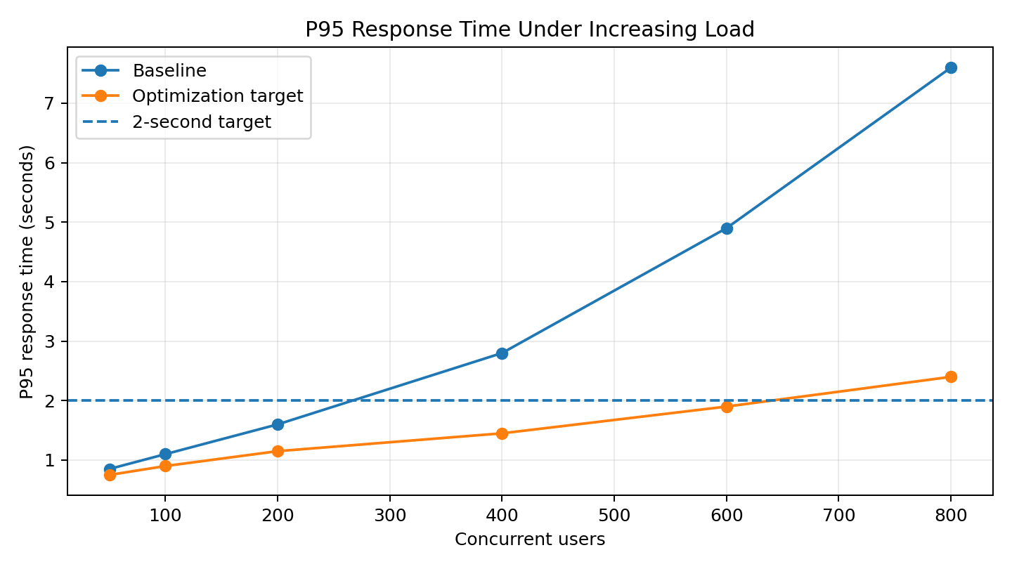
Figure 1. P95 response time under increasing load.
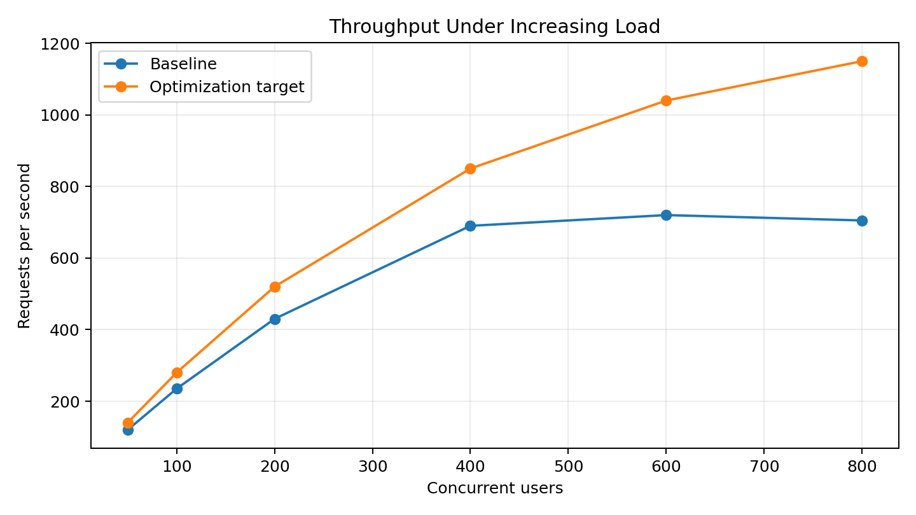
Figure 2. Throughput under increasing load.
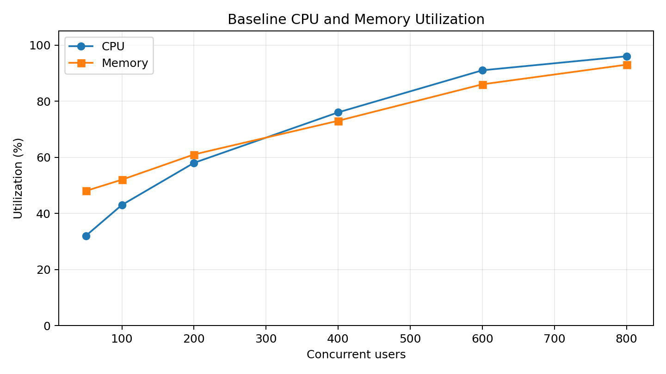
Figure 3. Baseline CPU and memory utilization.
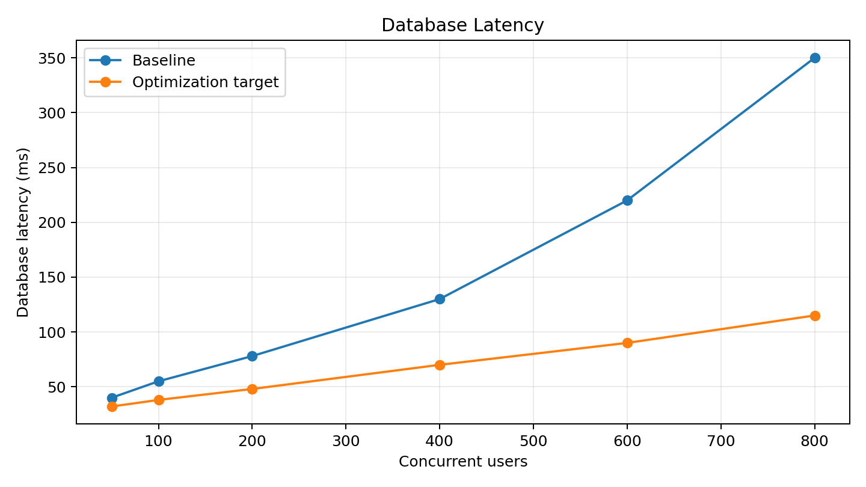
Figure 4. Database latency before and after the optimization target.

Optimization Target at 800 Concurrent Users
The following values are illustrative targets for the academic optimization scenario. They are not guaranteed production results.
Metric | Baseline | Target | Expected change
P95 response time | 7.60 s | 2.40 s | 68.4% lower
Throughput | 705 req/s | 1150 req/s | 63.1% higher
CPU utilization | 96% | 76% | 20 percentage points lower
Database latency | 350 ms | 115 ms | 67.1% lower
Error rate | 5.10% | 0.80% | 84.3% lower

Implementation and Validation Plan
- Phase 1 – Instrumentation: establish dashboards, logs, traces and a repeatable baseline.
- Phase 2 – Database optimization: inspect slow queries, execution plans, indexes and connection behavior.
- Phase 3 – Caching and payload optimization: introduce Redis where appropriate and add pagination/bounded responses.
- Phase 4 – Application scaling: profile CPU-intensive paths, introduce asynchronous work, and scale application instances where evidence supports it.
- Phase 5 – Regression and monitoring: repeat the load tests, compare against targets, verify reliability/security, and document rollback criteria.

Conclusion
The simulated performance analysis shows a clear method for investigating a system that degrades under increasing user load. The important finding is not a single number but the relationship among latency, throughput, CPU, memory, database behavior, and errors. The proposed optimization strategy therefore combines database optimization, caching, connection management, application improvements, scaling, and observability. In a real project, the simulated values would be replaced with measurements from a controlled staging environment, and each optimization would be accepted only after repeatable before-and-after testing.

Appendix – GitHub Project Contents
- README.md – project overview and reproduction instructions
- docs/REPORT_DESCRIPTION.md – 200+ word internship submission description
- data/baseline_performance.csv – simulated baseline measurements
- data/simulated_optimization_target.csv – simulated target values
- analysis/analyze_performance.py – basic analysis script
- diagrams/response_time.png – response-time chart
- diagrams/throughput.png – throughput chart
- diagrams/resource_utilization.png – resource-utilization chart
- diagrams/database_latency.png – database-latency chart
- diagrams/performance_architecture.png – architecture/bottleneck diagram
- report/Week5_Performance_Analysis_Optimization_Report.docx – final report

