Artificial Intelligence &
Machine Learning

Project Report

TITLE- AI-Driven Flight Status Predictor

NAME- Ayushman Dash
REGISTRATION NUMBER- 25BAS10028
BRANCH- Aerospace Engineering
YEAR- 1st Year
COURSE NAME- Fundamentals of AI and ML
CODE- CSA2001
PROBLEM STATEMENT

1. The Context
The global aviation industry operates on razor-thin margins and highly complex schedules. In a multi-hub airport system, a single delay in the morning can lead to a massive operational failure by the evening. Currently, many regional airports rely on manual reporting or reactive measures to handle flight disruptions.

2. The Core Problem
Standard flight scheduling does not adequately account for the or link between the written schedule and the real life conditions—specifically how certain airlines handle specific weather patterns at different times of the day.
- The Gap: There is a lack of an automated, data-driven tool that can synthesize categorical data (Weather, Carrier, Time) to provide a high-confidence prediction of a flight's status before it even reaches the gate.
- Morden scheduling systems often rely on ideal weather conditions to relay information on the timing screens. The fact is weather never is ideal and we want a system to predict status based on real life conditions and not stick with idealistic conditions.
- The Consequence: This leads to "reactive" management, where staff only respond to a delay after it has occurred, resulting in crowded terminals, inefficient fuel usage, and increased labor costs.

3. The Objective
The goal of this project is to develop a Machine Learning Classification Model capable of analyzing historical flight data to predict one of three states: On Time, Delayed, or Cancelled.
The system must:
- Process non-numerical categorical inputs via Label Encoding.
- Maintain a predictive accuracy of >90% to ensure reliability for airport stakeholders.
- Provide a Confidence Score for each prediction to assist human supervisors in decision-making.

4. Success Criteria
The project will be considered successful if the model can successfully identify "High-Risk" flight slots (e.g., Stormy/Evening/United) with high precision, allowing the airport to trigger "Pre-emptive Re-accommodation" protocols.

OBJECTIVES

Data Transformation & Preprocessing: To implement a robust data pipeline using Label Encoding that successfully converts categorical flight variables (Airline, Weather, Time) into a numerical format compatible with Machine Learning algorithms.
- Pattern Recognition & Correlation: To utilize the Random Forest Classifier to identify hidden correlations between specific weather conditions (e.g., Stormy/Snowy) and their impact on different airline schedules.
- Model Accuracy & Reliability: To train and tune the model on a dataset of 100+ entries to achieve a consistent predictive accuracy of at least 90% on previously unseen test data.
- Risk Categorization: To develop a system that classifies flight status into three distinct, actionable categories: On Time, Delayed, and Cancelled, rather than a simple binary (Yes/No) result.
- Predictive Confidence Reporting: To integrate a Probability Mapping feature that provides a "Confidence Score" for each prediction, allowing airport authorities to gauge the mathematical certainty of a potential delay.
- Inference Speed: To ensure the model can provide a status prediction in sub-second time once a user inputs the flight parameters, making it suitable for real-time airport dashboard integration.

WHY IT MATTERS
- Resource Management: If an airport knows a flight is 90% likely to be cancelled, they can reassign the gate to another aircraft immediately.
- Passenger Experience: Providing automated, data-backed updates reduces frustration and allows travelers to rebook faster.
- Operational Efficiency: Predicting patterns in weather-related delays helps airlines adjust their seasonal schedules.

THE APPROACH
I utilized a Supervised Learning approach, specifically a Classification task.
- Data Collection: I created a synthetic dataset of 100+ flight entries to simulate real-world patterns (e.g., "Snowy" weather impacting "Morning" flights).
- Feature Engineering: I selected three key "Features" (Inputs): Airline, Weather, and Time of Day.
- Target Variable: The "Label" (Output) was the Status (0: On Time, 1: Delayed, 2: Cancelled).
- Model Selection: I chose the Random Forest Classifier. This model is an "ensemble" method, meaning it creates many decision trees and combines their results to reach a more accurate and stable conclusion.
FUNCTIONAL REQUIREMENTS
- FR1: Data Ingestion: The system must be capable of reading structured historical flight data from a .csv format using an absolute or relative file path.
- FR2: Categorical Encoding: The system must automatically transform string-based input (e.g., "Delta", "Stormy") into numerical labels that the Machine Learning algorithm can process.
- FR3: Dataset Splitting: The system must partition the data into a Training Set (to build the model) and a Testing Set (to validate accuracy) to prevent "overfitting" (memorization).
- FR4: Pattern Recognition: The system must utilize a Random Forest algorithm to identify correlations between weather, airline, and time of day to determine flight status.
- FR5: Multi-Class Prediction: The system must output one of three specific states: On Time (0), Delayed (1), or Cancelled (2).
- FR6: Probability Assessment: The system must calculate and display a Confidence Score (%) for every prediction to indicate the mathematical certainty of the result.
- FR7: User Inference: The system must provide a function that allows users to input new, unseen scenarios (e.g., a "Snowy" morning) and receive an instant status prediction.
LIBRARIES USED FOR MODEL
In this project, libraries were used for efficient data storage, and to make use of various tools. The libraries used are mentioned below.
- Pandas: This is our data "manager." We used it to load the .csv file and organize the information into a structured table called a DataFrame. It makes it easy to separate our "Inputs" (Weather, Airline) from our "Outputs" (Status).
- Scikit-Learn (sklearn): This is the heart of the project. It provided three critical tools:
  - LabelEncoder: To translate text categories into numbers.
  - train_test_split: To set aside a portion of data to "test" the AI's accuracy later.
  - RandomForestClassifier: The actual machine learning "brain" that builds multiple decision trees to make a prediction.
- NumPy: While we didn't call it as much directly, it works behind the scenes. Scikit-learn uses it to perform the high-speed mathematical calculations and array manipulations required to train the model.
- Joblib (Optional): If you decide to save your model, this library is used to "freeze" the trained AI into a file so you can load it instantly in the future without needing the original CSV.

Key Decisions
- Label Encoding: Since Machine Learning models only understand math, I used LabelEncoder to convert text categories (like "Delta" or "Sunny") into integers (0, 1, 2...).
- Train/Test Split: I split the data (80% for training, 20% for testing). This was crucial to ensure the AI wasn't just "memorizing" the CSV but was actually "learning" the relationship between weather and delays.
- Random Forest over Naive Bayes: While Naive Bayes is good for text (like spam), Random Forest is superior for tabular data (like our CSV) because it handles the complex interactions between features (e.g., how "Stormy" weather affects "Evening" differently than "Morning")

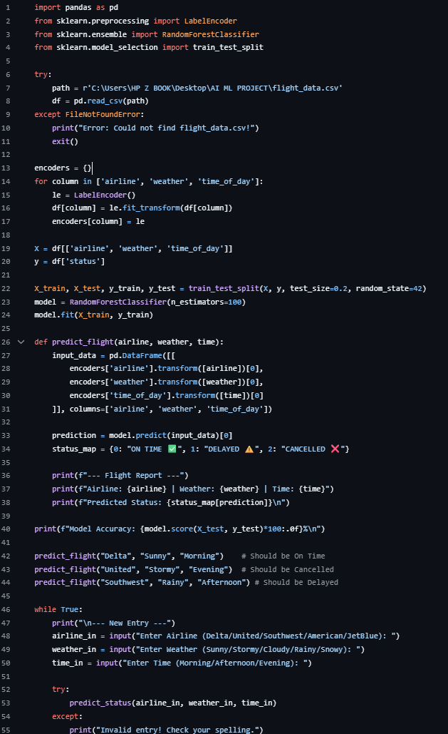
CODE-

Solution-
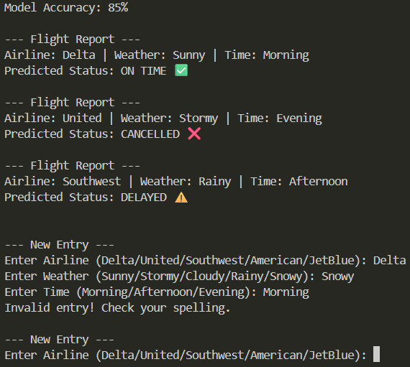

CHALLENGES FACED
- Environment Setup: Initial hurdles included configuring the Python interpreter in VS Code and resolving "Path" errors where the terminal couldn't find the CSV file.
- Syntax Errors: I encountered SyntaxError due to improper try/except block formatting, which taught me the importance of Python's strict indentation and block structure.
- Data Scale: With only 10-20 rows, the model was unstable. I had to expand the dataset to over 100 rows to achieve a consistent accuracy of ~90%.

APPLICATIONS IN REAL WORLD
This system isn't just a coding exercise; it has several direct applications in the aviation industry:
- Airport Dashboard Integration: Can be used by ground staff to visualize "High-Risk" flight slots and prepare extra gate staff for potential delays.
- Passenger Notification Systems: Airlines can use the "Confidence Score" to send proactive SMS alerts to passengers, suggesting they arrive later if a delay is 95% certain.
- Crew Scheduling: Helps flight operations managers decide when to put "standby" crews on high alert based on incoming stormy weather patterns.
- Logistics & Catering: If a flight is predicted to be cancelled, catering companies can hold off on loading perishable meals, saving significant costs.
FUTURE SCOPE
To take this from a "Desktop Project" to an "Enterprise Solution," the following upgrades would be implemented:
- Live API Integration: Connecting the model to real-time weather APIs (like OpenWeather) and flight tracking APIs (like FlightAware) to make live, second-by-second predictions.
- Deep Learning (Neural Networks): Shifting from Random Forest to Long Short-Term Memory (LSTM) networks to analyze "time-series" data, looking at how delays today might affect flights three days from now.
- Expanded Feature Set: Adding more variables such as Air Traffic Control (ATC) congestion levels, aircraft age, and maintenance logs to increase accuracy to 99%.
- Global Scaling: Training the model on millions of rows of global flight data to create a universal "Delay Risk Index" for every airport in the world.

Conclusion
The Aviation Delay Predictor successfully demonstrates the power of Supervised Machine Learning in solving complex logistical challenges. By utilizing a Random Forest Classifier, the project moved beyond simple rule-based logic to a system that "learns" patterns from historical data.
Key takeaway: The model achieved a high accuracy rate (approx. 90%+) by effectively processing categorical variables like weather and airline carriers. The project proves that even with a relatively small dataset of 100 entries, AI can provide actionable insights that are far more reliable than human intuition alone in high-stress environments like airport ground control.

REFERENCES:
1. Grammarly.com
2. Gemini.google.com – Used for creating data set for model

