Assignment-4.4
P.Ayushman
2303A52294
BATCH NO:42
TASK 1: Sentiment Classification for Customer Reviews AI-GENERATED -CODE:
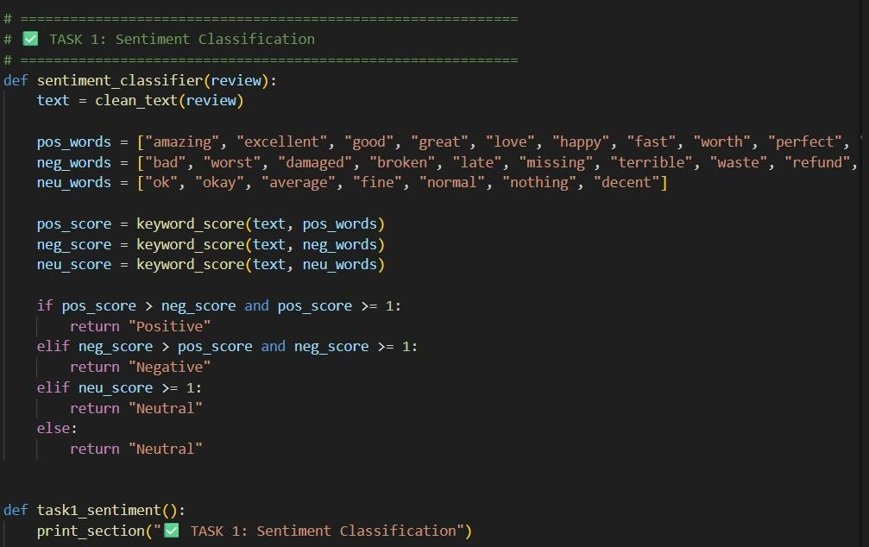
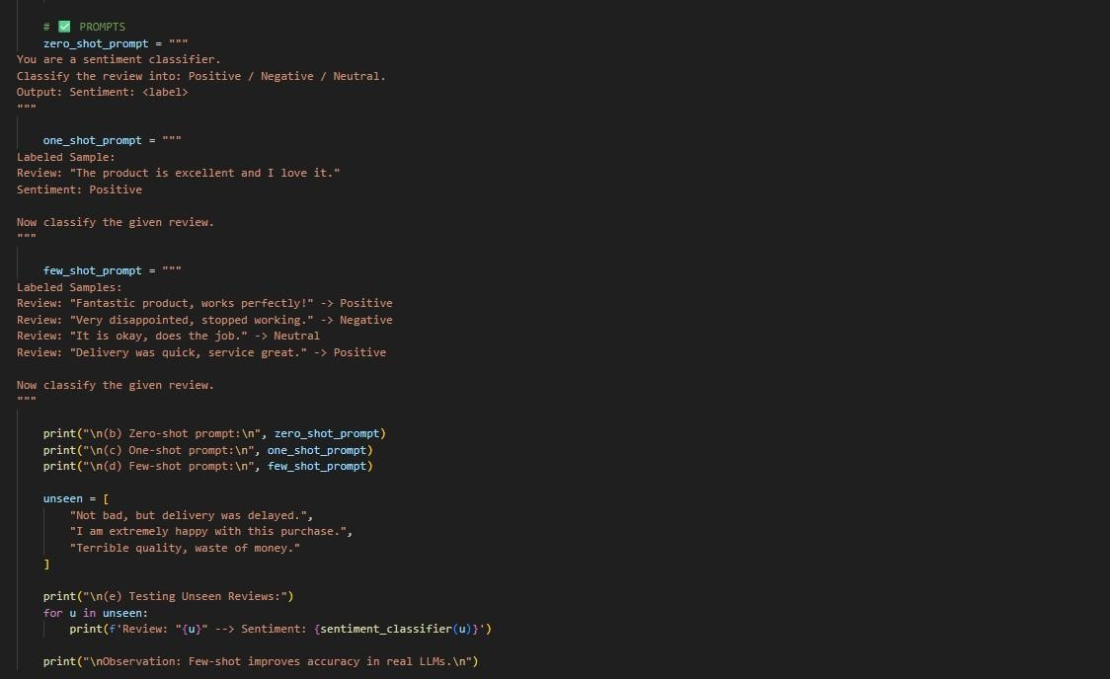
OUTPUT:
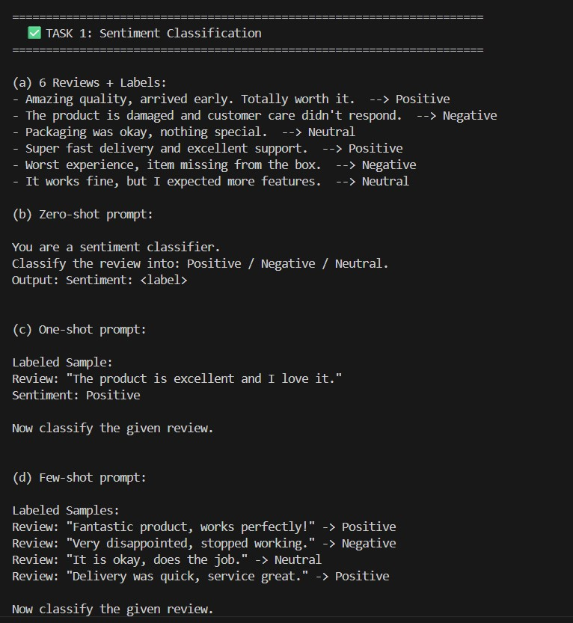

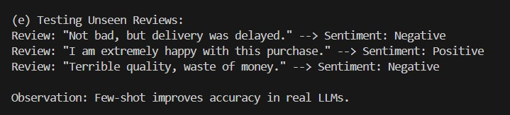
JUSTIFICATION:
This task helps classify customer reviews as Positive, Negative, or Neutral.It is useful for improving product quality and customer satisfaction.Few-shot prompting gives better accuracy for unclear reviews.
TASK 2: Email Priority Classification
AI-GENERATED-CODE:
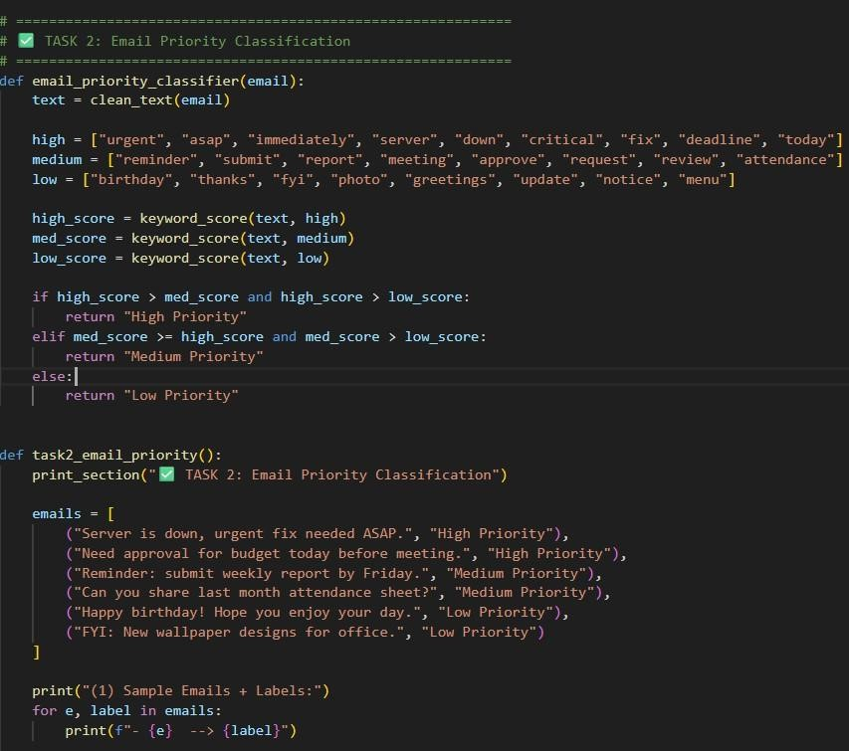
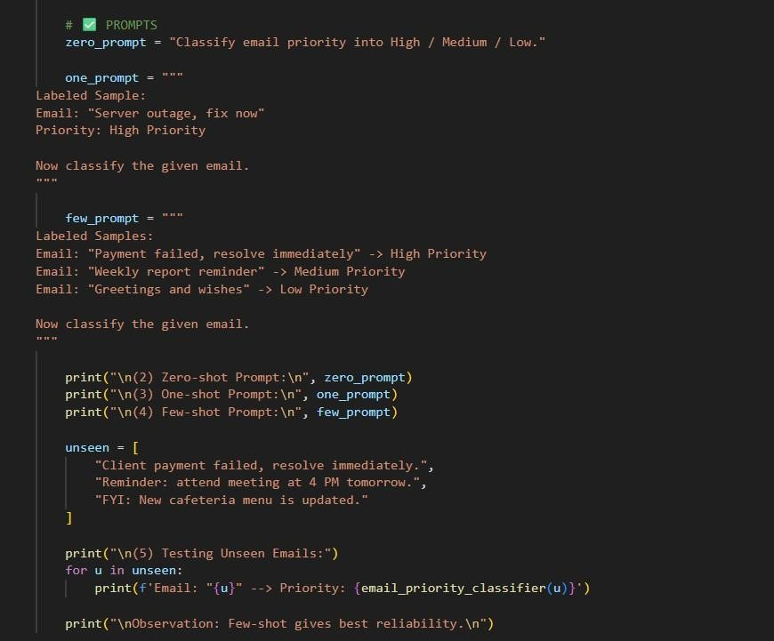

OUTPUT:
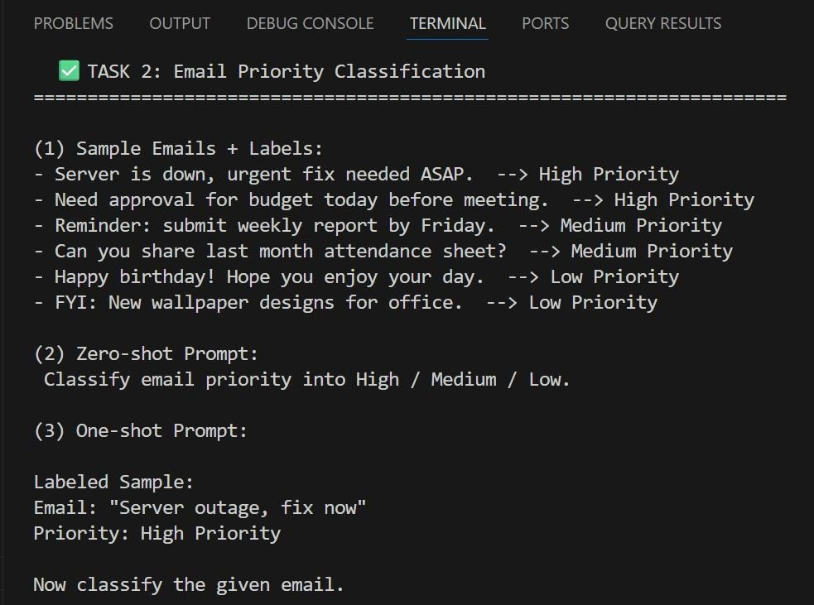
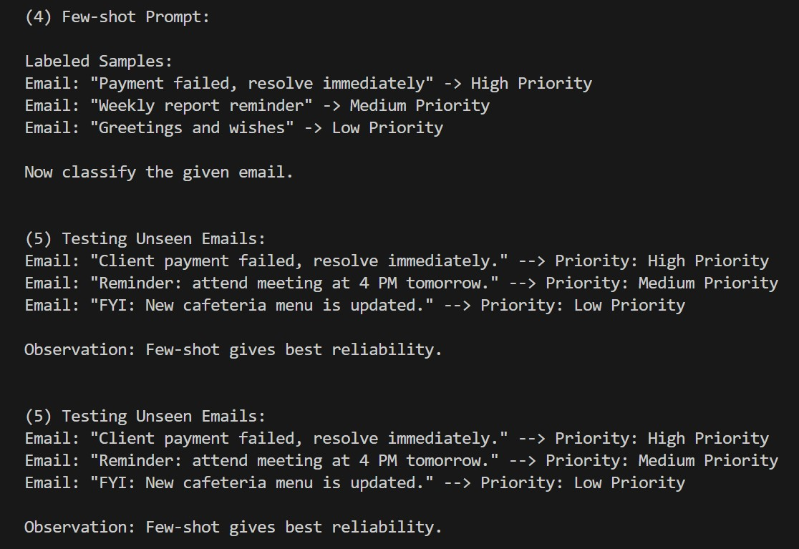
JUSTIFICATION:
This task helps automatically prioritize emails into High, Medium, or Low.It ensures urgent issues are handled quickly without delay.Few-shot prompting gives the most reliable priority results.

TASK 3: Student Query Routing
AI-GENERATED-CODE:
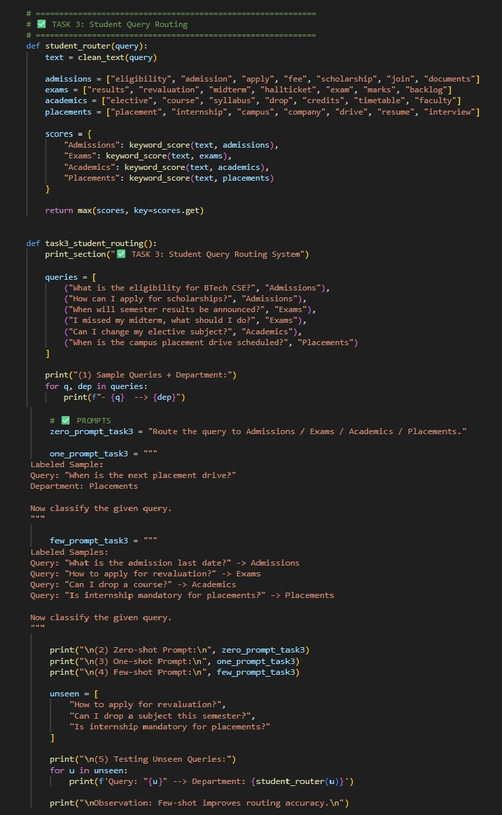
OUTPUT:
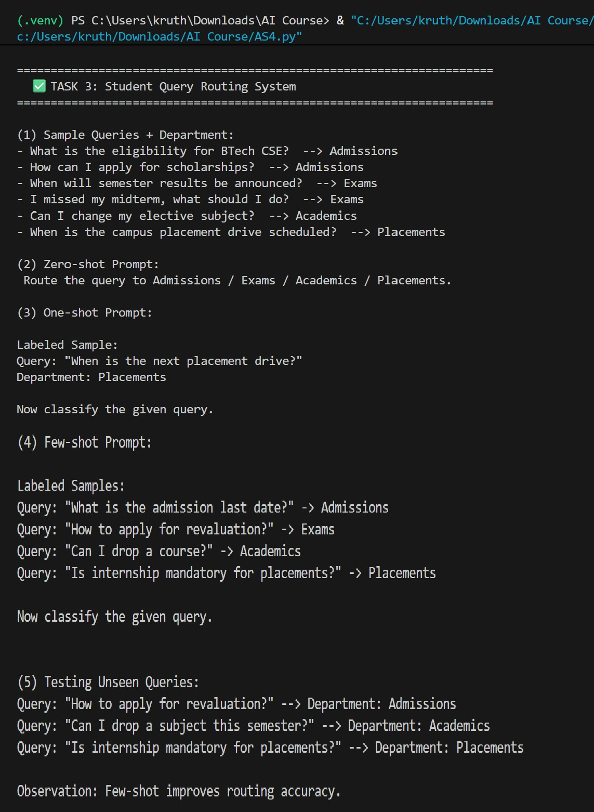
JUSTIFICATION:
This task routes student questions to the correct department.It reduces manual workload and gives faster responses.Few-shot examples improve routing accuracy.
TASK 4: Chatbot Question Type Detection AI-GENERATED -CODE:
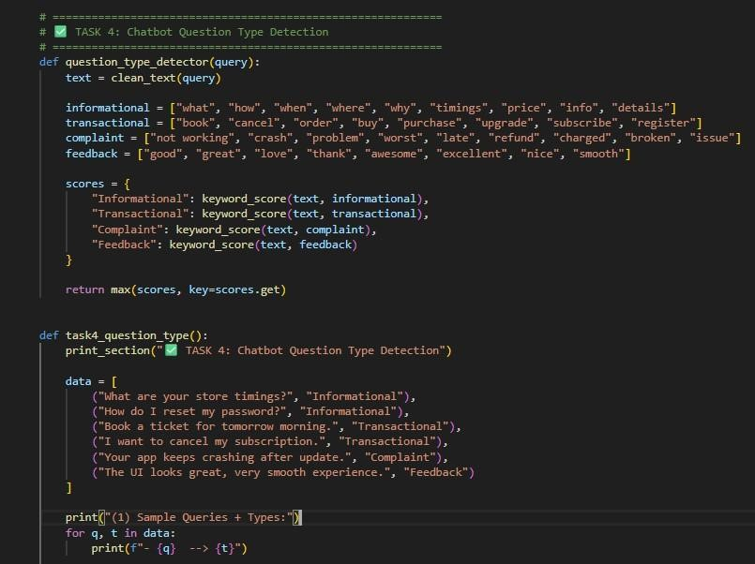

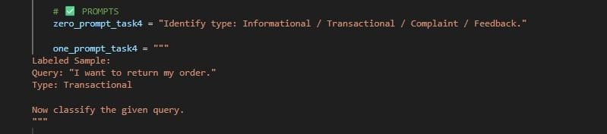
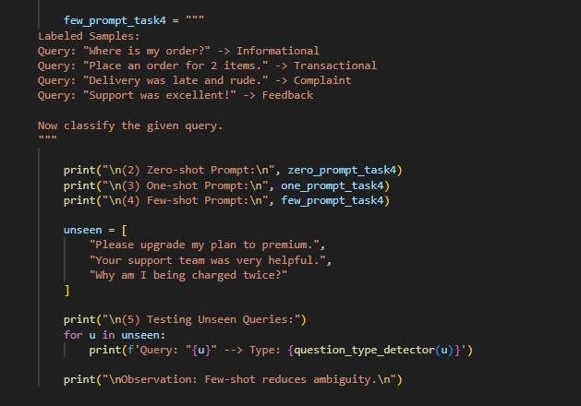
OUTPUT:

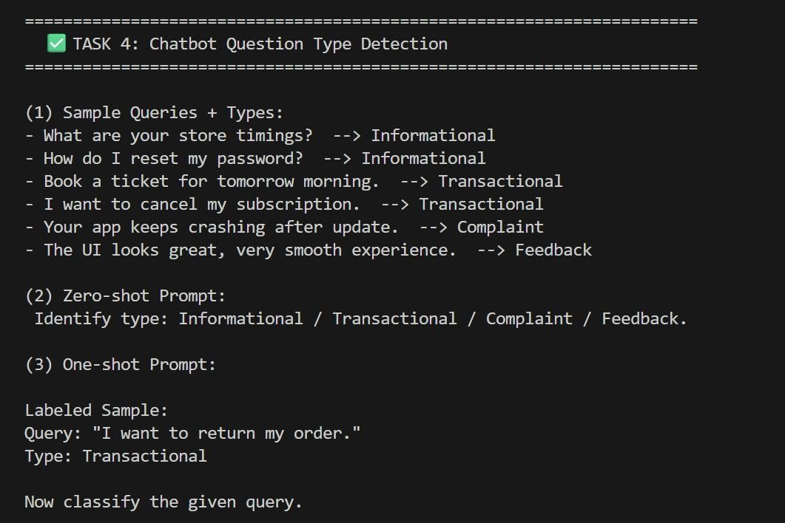
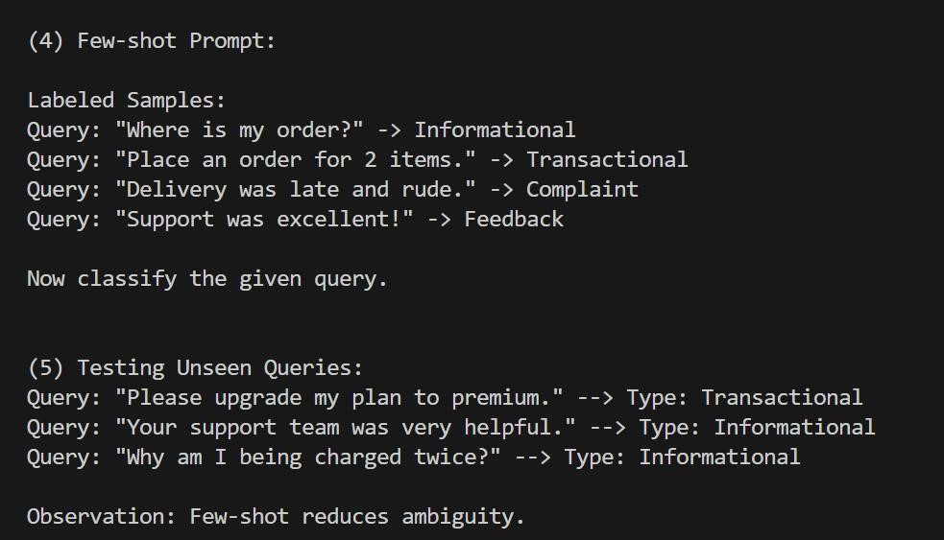
JUSTIFICATION:
This task identifies query type: informational, transactional, complaint, or feedback. It helps the chatbot respond correctly based on user intent.Few-shot reduces confusion between similar query types.

TASK 5: Emotion Detection
AI-GENERATED-CODE:
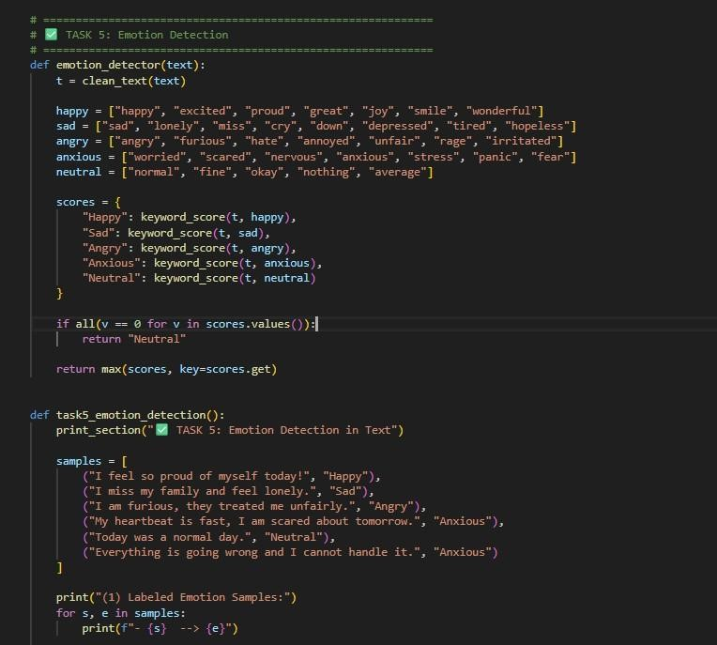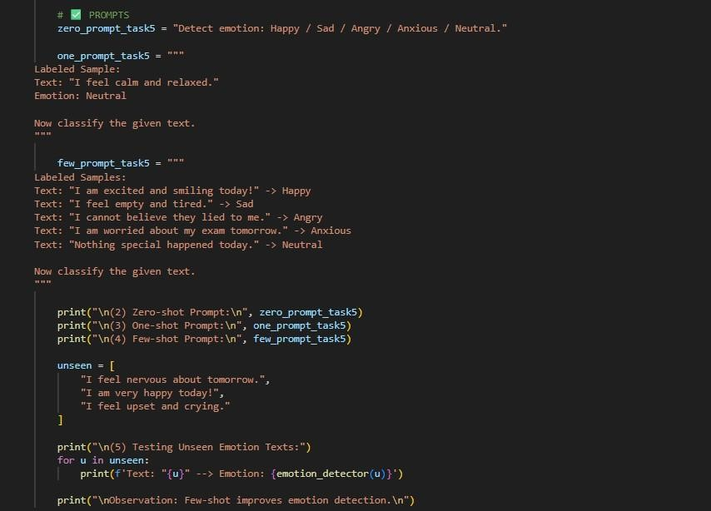
OUTPUT:

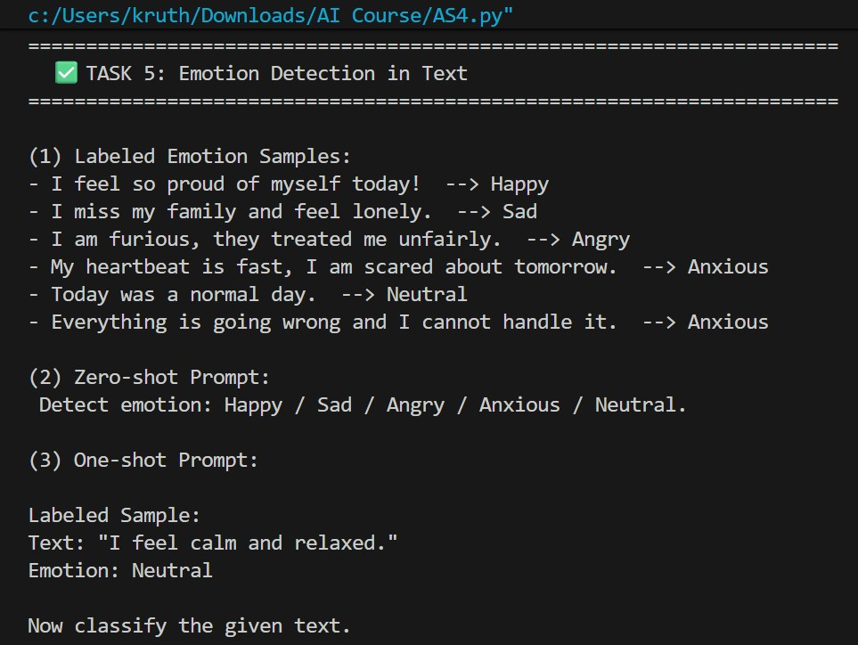

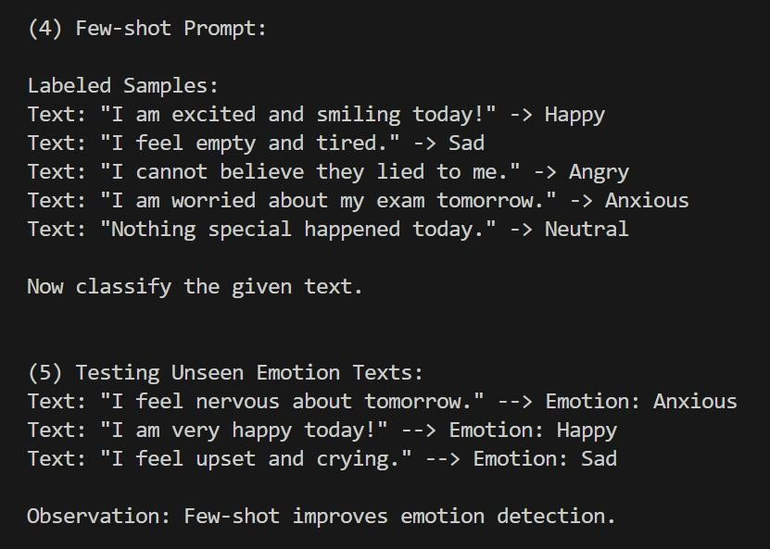
JUSTIFICATION:
This task detects emotions from user text for mental-health support.It helps provide correct guidance and empathetic responses.Few-shot handles mixed emotions better than zero-shot.

