ASSIGNMENT-6.4
Name :P.Ayushman
Hall Ticket No :2303a52294
Batch-42
Task 1: Student Performance Evaluation System
Scenario
You are building a simple academic management module for a university system where student performance needs to be evaluated automatically.
Task Description
Create the skeleton of a Python class named Student with the attributes:
- name
- roll_number
- marks
Write only the class definition and attribute initialization.
Then, using GitHub Copilot, prompt the tool to complete:
- A method to display student details
- A method that checks whether the student’s marks are above the class average and returns an appropriate message
Use comments or partial method names to guide Copilot for code
Completion.

Prompt:
Generate a Python program with student name ,roll no,and marks add two methods Two prints the student details and Performance through the overall class students to return A message above or at or below performance through the loops.

CODE:
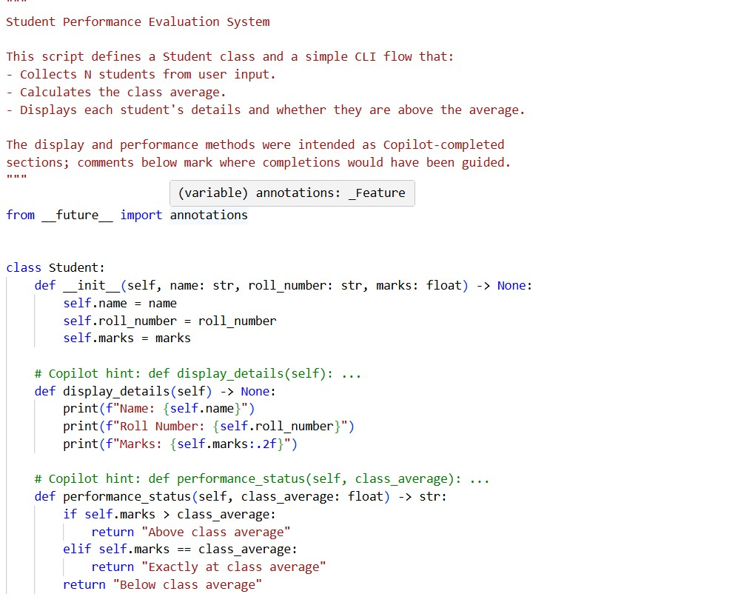
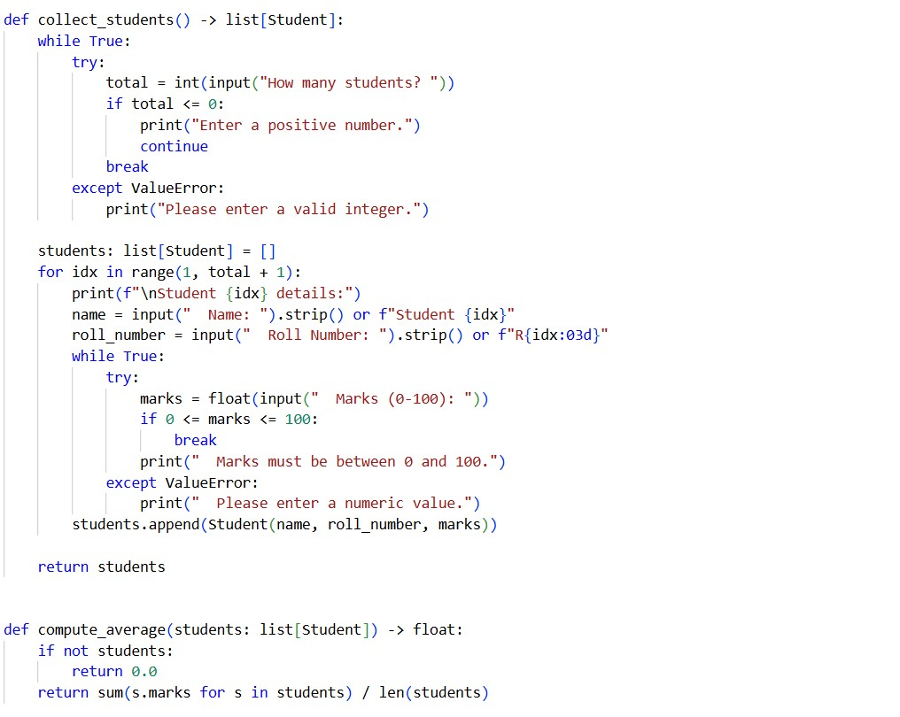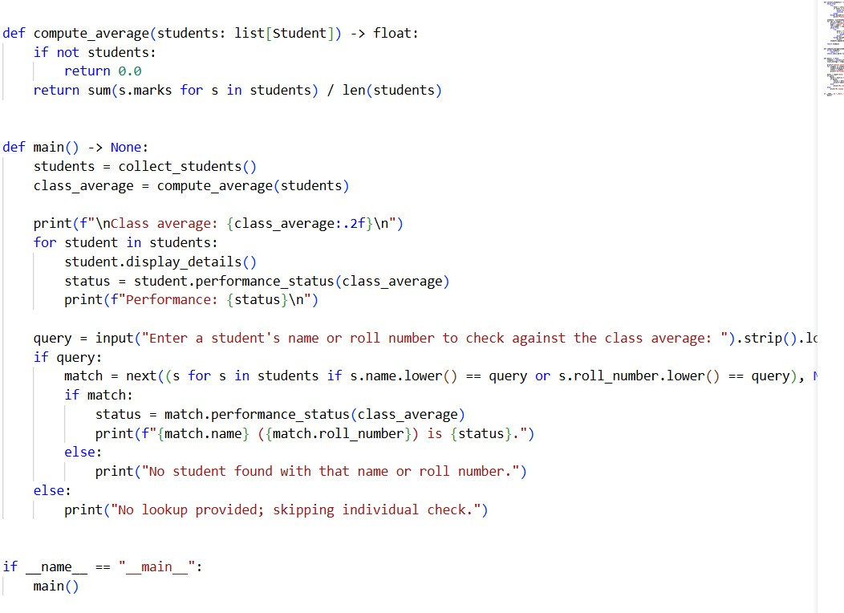
OUTPUT:
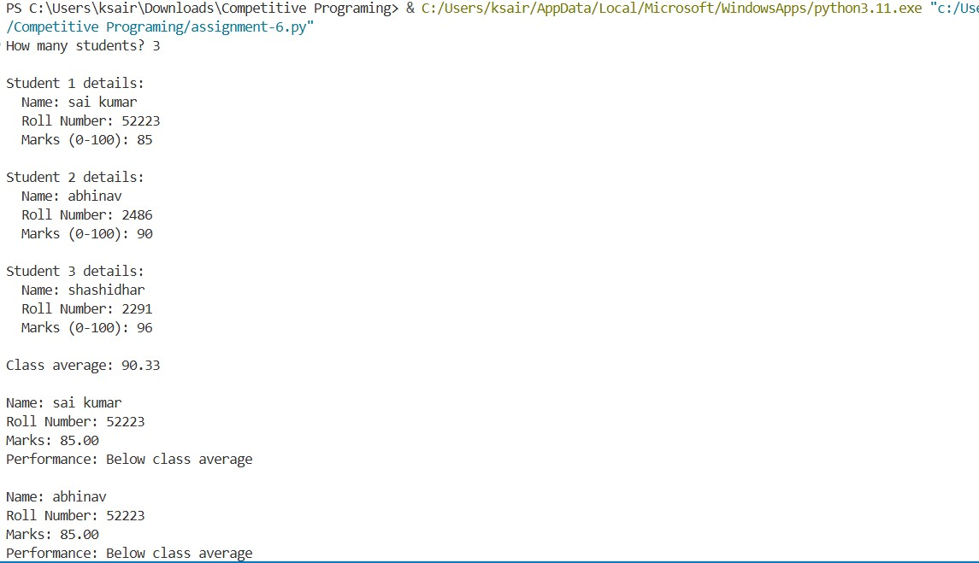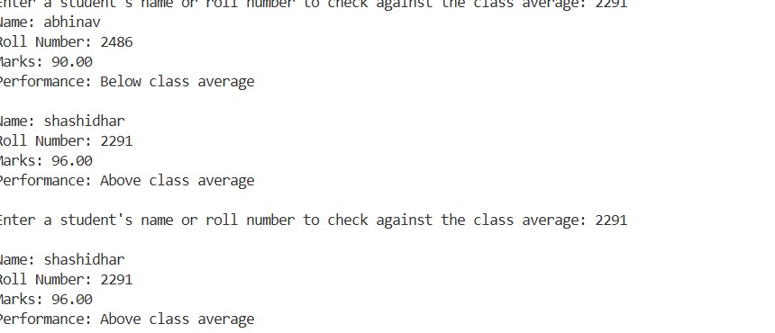
JUSTIFICATION:
The code meets the task by defining student with display and average-check methods using if/elif/else, gathering N students with validation, computing the class average once, printing each student’s details and status, and allowing a final lookup by name or roll number. Task 2: Data Processing in a Monitoring System
Scenario
You are working on a basic data monitoring script where sensor readings are collected as numbers. Only even readings need further processing.
Task Description
Write the initial part of a for loop to iterate over a list of integers representing sensor readings.
Add a comment prompt instructing GitHub Copilot to:
- Identify even numbers
- Calculate their square
- Print the result in a readable format
Allow Copilot to complete the remaining loop logic.
Prompt:
Check if it's even using the modulus operator. If it is even, go ahead and calculate the square of that number. Then print it out nicely so I can see the original reading and its squared value. Oh, and if it's odd, just print a message saying we skipped it. Make sure everything looks clean and readable.
Code:
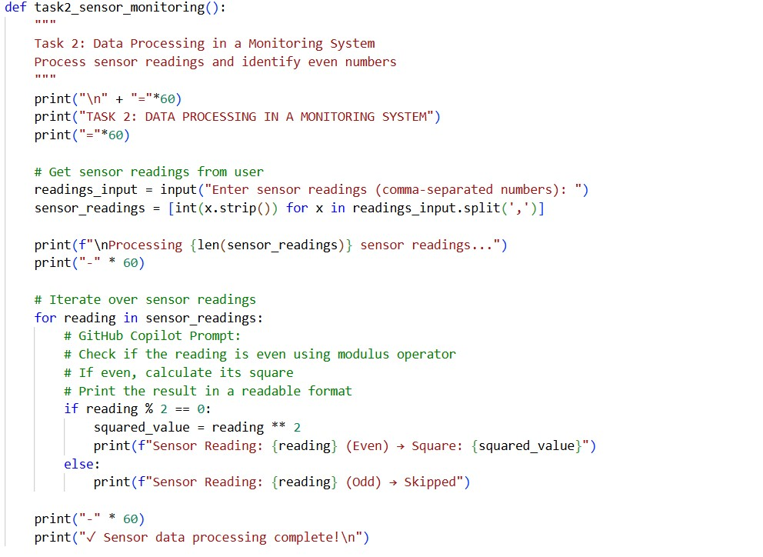
Output:
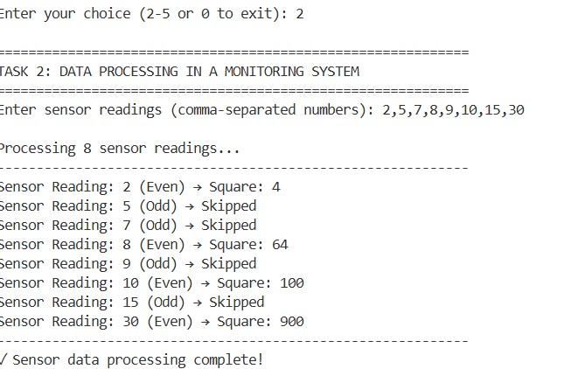

Justification:
Loop through each sensor reading in the list. For every reading, check if it's an even number by using the modulus operator (reading % 2 == 0). If the reading is even, calculate its square using the exponentiation operator (reading ** 2) and print both the original reading and its squared value in a clean, readable format. If the reading is odd, print a message indicating that it was skipped and won't be processed further. Make sure all output includes clear labels so users can easily understand which readings were processed and which were ignored.
Task 3: Banking Transaction Simulation
Scenario
You are developing a basic banking module that handles deposits and withdrawals for customers.
Task Description
Create the structure of a Python class named Bank Account with attributes:
- Account holder
- balance
Use GitHub Copilot to complete methods for:
- Depositing money
- Withdrawing money
- Preventing withdrawals when the balance is insufficient

Prompt:
I'm building a Bank Account class here. It needs account holder and balance attributes. Can you help me create a deposit method that takes an amount, checks if it's positive, adds it to the balance using self, and prints a nice success message with the new balance.Also need a withdraw method that checks if there's enough money in the account before taking it out. If the balance is too low, show an error message saying insufficient funds. Use if-else for the balance check and work with self balance throughout.
Code:
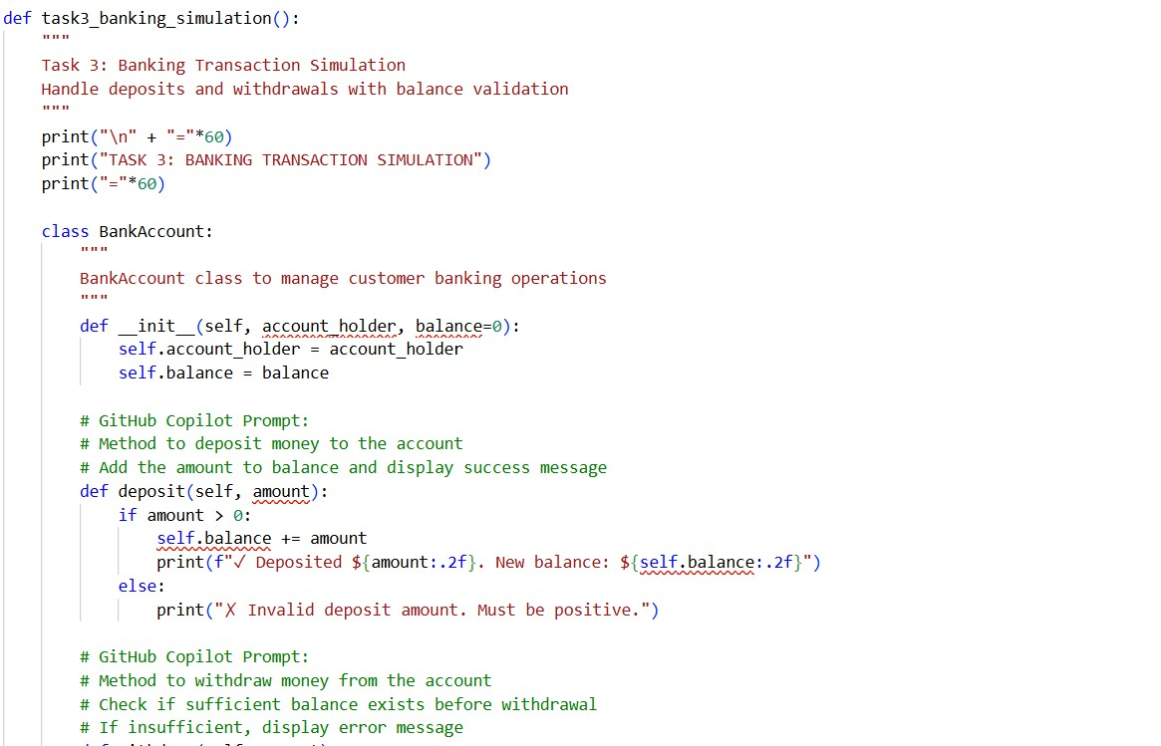

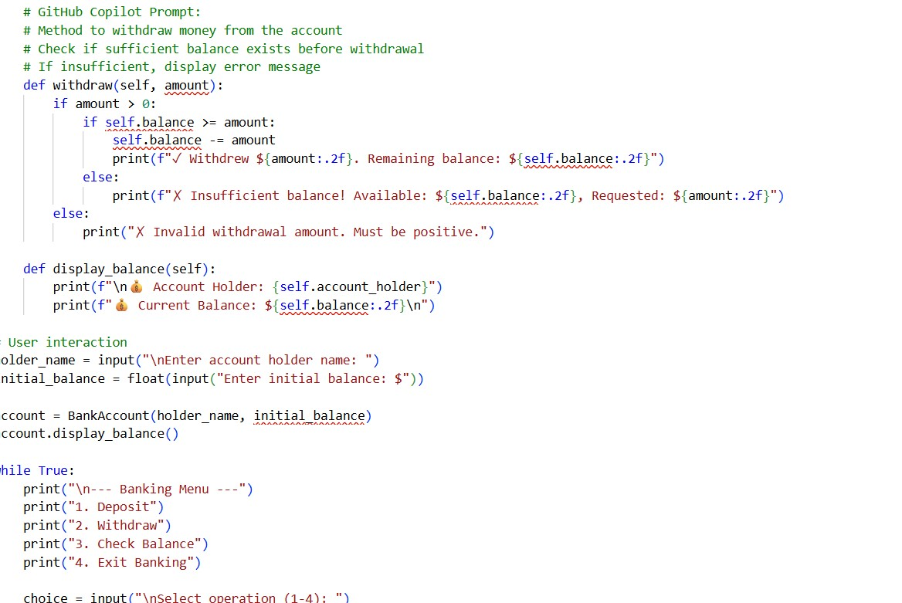
Output:
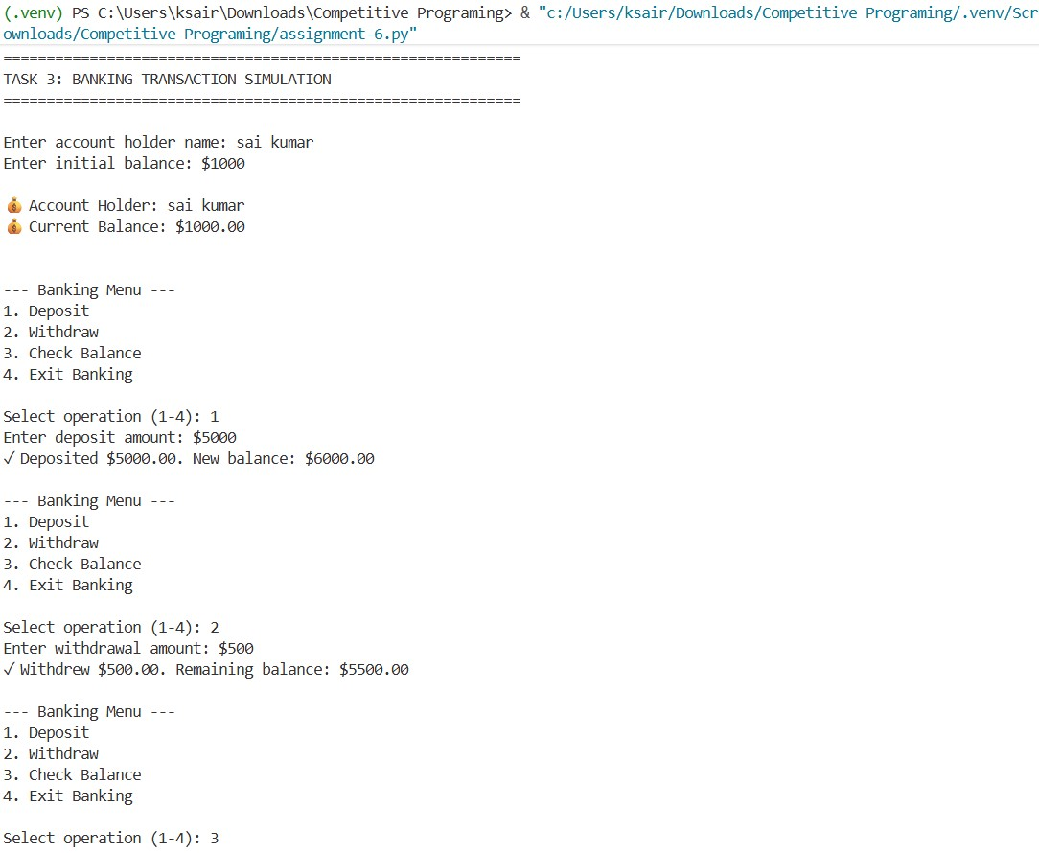

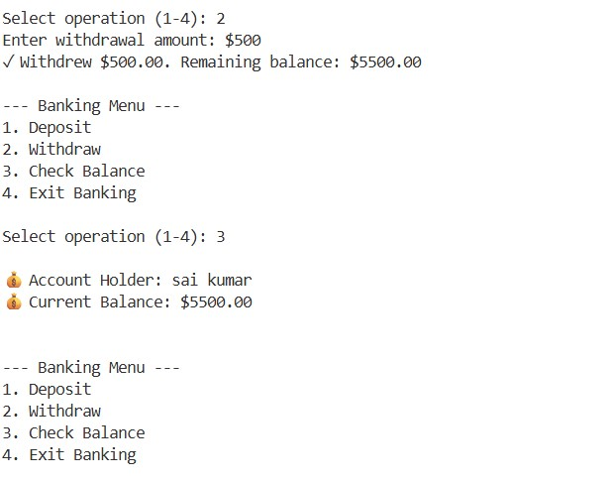
Justification:
Create a method named deposit that accepts an amount parameter. First validate that the amount is positive. If valid, add the amount to self.balance using the += operator and print a success message showing the deposited amount and the new balance formatted to 2 decimal places. If the amount is not positive, display an error message asking for a positive value.Create a method named withdraw that accepts an amount parameter. First check if the amount is positive. Then use an if-else statement to verify whether self.balance is greater than or equal to the requested amount. If sufficient balance exists, subtract the amount from self.balance and print a success message with the withdrawn amount .
Task 4: Student Scholarship Eligibility Check
Scenario: A university wants to identify students eligible for a merit-based scholarship based on their scores.
Task Description
Define a list of dictionaries where each dictionary represents a student with:
- name
- score
Write the initialization and list structure yourself.
Then, prompt GitHub Copilot to generate a while loop that:
- Iterates through the list
- Prints the names of students who scored more than 75
Prompt:
I need a while loop to go through this students list. Start with index at 0, then in each loop get the current student using students[index]. Check if their score is more than 75. If yes, print their name and say they're eligible for the scholarship. If not, print they're not eligible. Remember to increment the index each time and keep looping while index is less than the length of students. Also keep track of how many students are eligible so I can show a total count at the end.
Code:
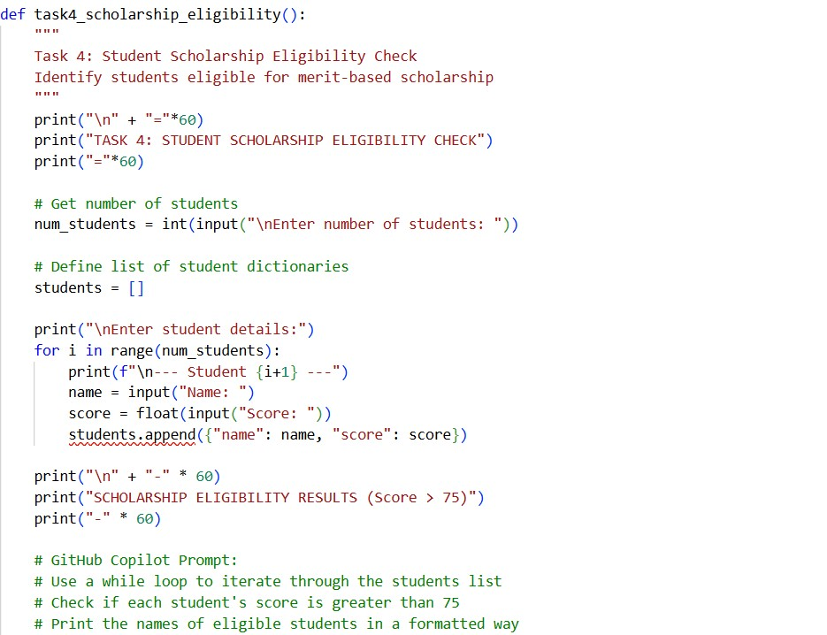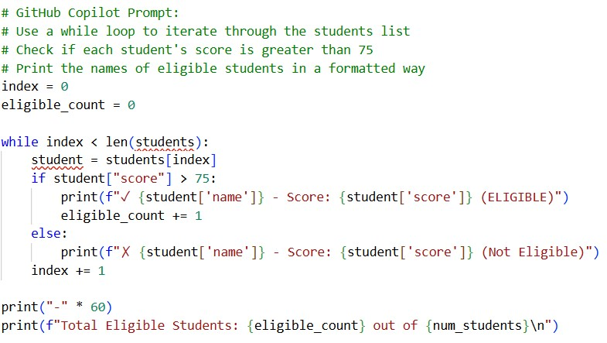
Output:
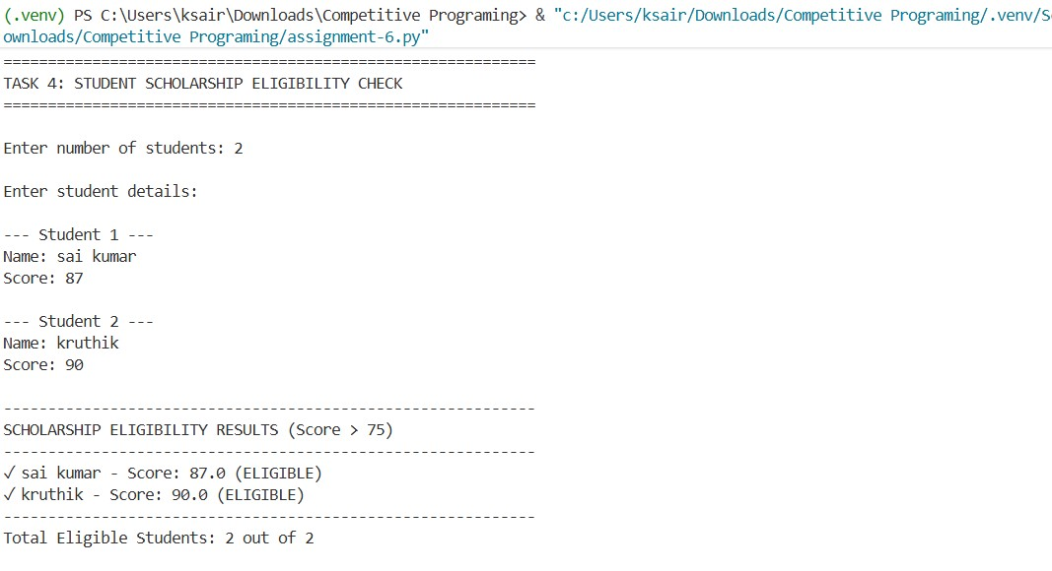
Justification:
This approach uses a while loop with an index to manually control iteration over the students list, ensuring clear access to each student record using students[index]. The if condition cleanly separates eligible and non-eligible students based on the score threshold of 75, making the decision logic easy to understand. Maintaining the eligible_count variable allows accurate tracking of qualified students during iteration, and displaying the final count after the loop provides a clear summary of results. Incrementing the index in each iteration prevents infinite loops and ensures all applicants are processed systematically.
Task 5: Online Shopping Cart Module
Scenario
You are designing a simplified shopping cart system for an e-commerce website that supports item management and discount calculation.
Task Description
Begin writing a Python class named Shopping cart with:
- An empty list to store items (each item may include name, price, quantity)
Use GitHub Copilot to generate methods that:
- Add items to the cart
- Remove items from the cart
- Calculate the total bill using a loop
- Apply conditional discounts (e.g., discount if total exceeds a certain amount)

Prompt:
Create a Shopping cart class with an empty items list. Add three methods: add item(name, price, quantity) to store an item dict and confirm addition; remove item(name) to find and remove an item case-insensitively with success/error messages, calculate total() to print a receipt showing each item, compute subtotal, apply a 10% discount if subtotal > 100, and display subtotal, discount (if any), and final total formatted to 2 decimals.
Code:
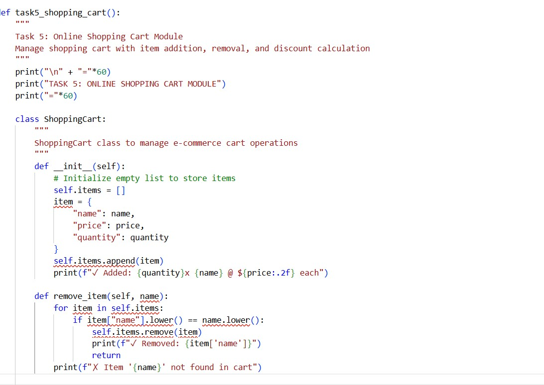
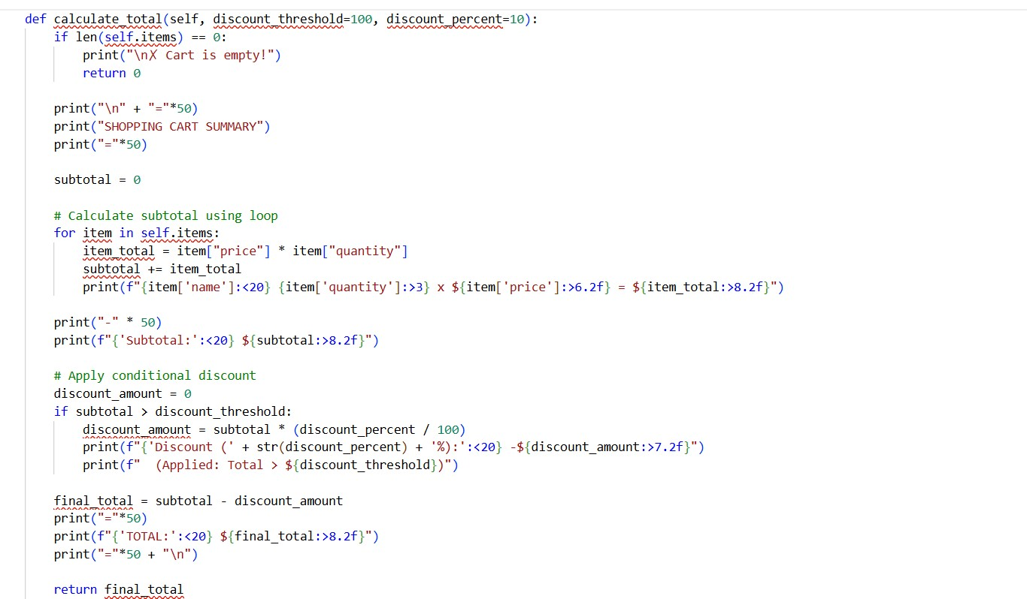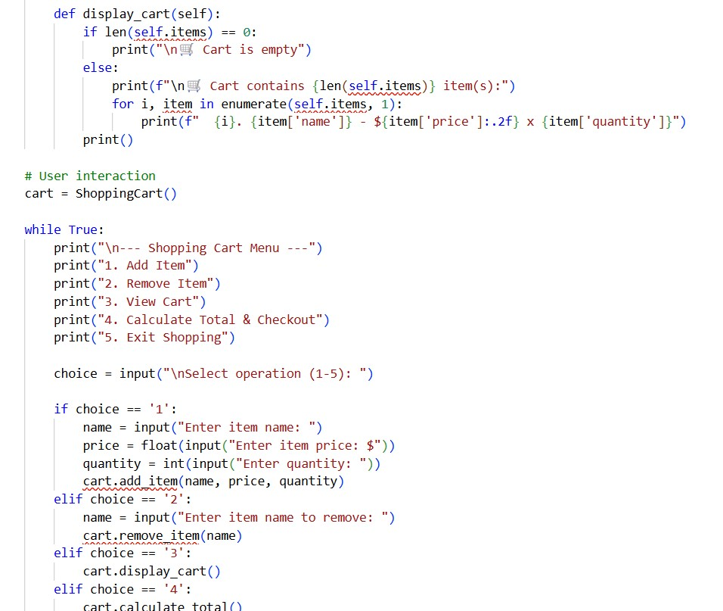
Output:
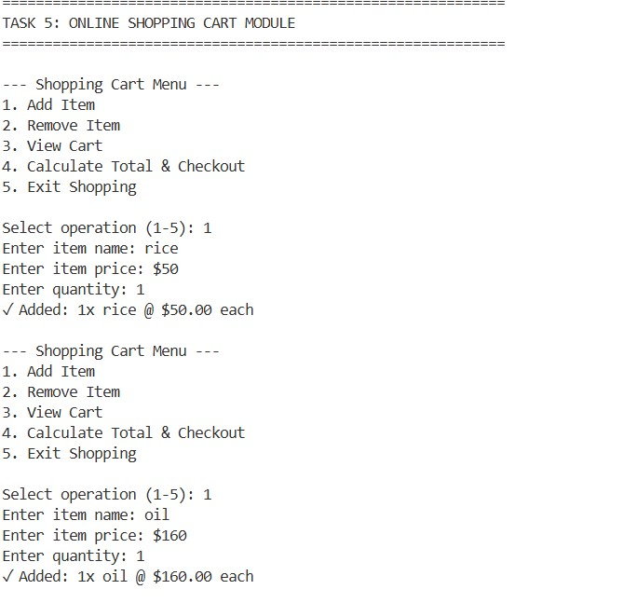
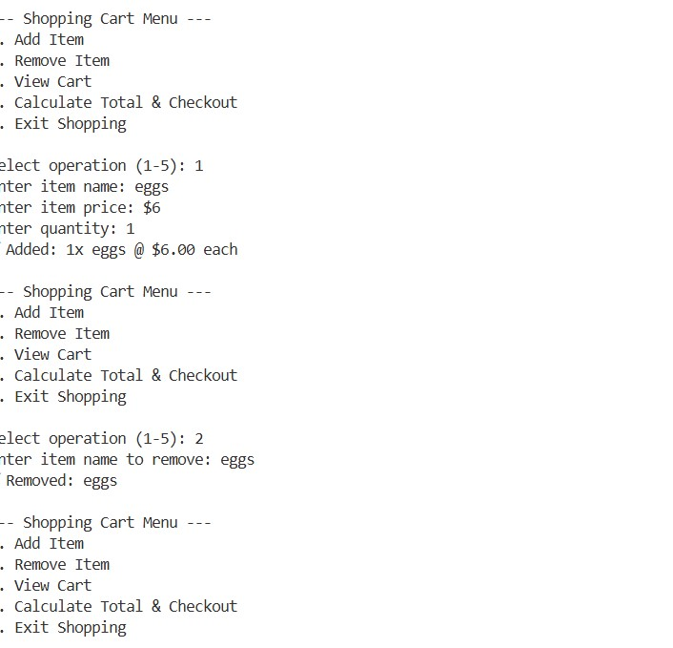
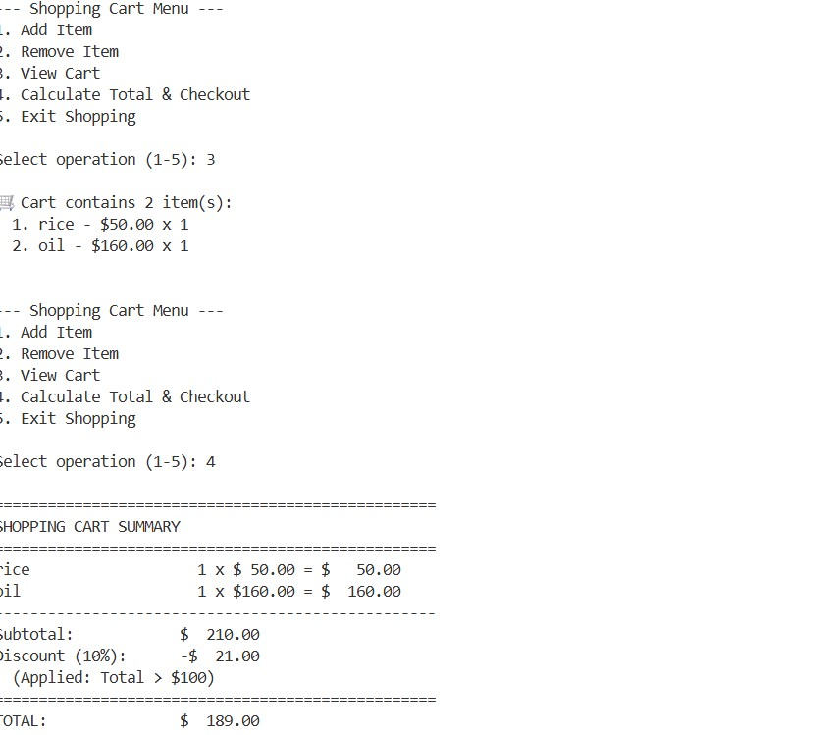
Justification:
The Shopping cart class uses a list to manage items easily. Adding and removing items lets users update their cart. A loop ensures accurate total calculation based on price and quantity. Conditional discounts mimic real e-commerce offers and encourage higher spending.

