ASSIGNMENT-5.3
NAME : P.Ayushman
HALL TICKET No : 2303A52294
BATCH-42

TASK 1:
QUESTION:
Task 1: Privacy and Data Security in AI-Generated Code
Scenario
AI tools can sometimes generate insecure authentication logic.
Task Description
Use an AI tool to generate a simple login system in Python.
Analyze the generated code to check:
- Whether credentials are hardcoded
- Whether passwords are stored or compared in plain text
- Whether insecure logic is used
Then, revise the code to improve security (e.g., avoid hardcoding, use input validation).
Expected Output
- AI-generated login code
- Identification of security risks
- Revised secure version of the code • Brief explanation of improvements
PROMPT:
Generate a simple login form which consists of the registration and login form to store in and inform it has login successful or unsuccessful. Do not create any external files and it consist of security risk and secure version of code in python only.
OUTPUT:

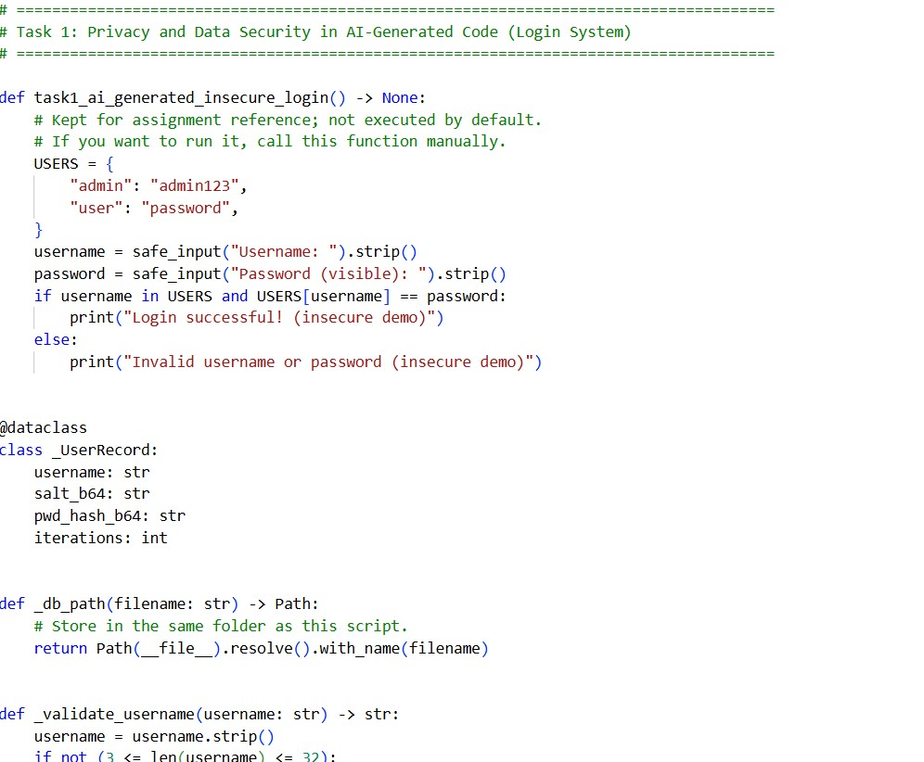
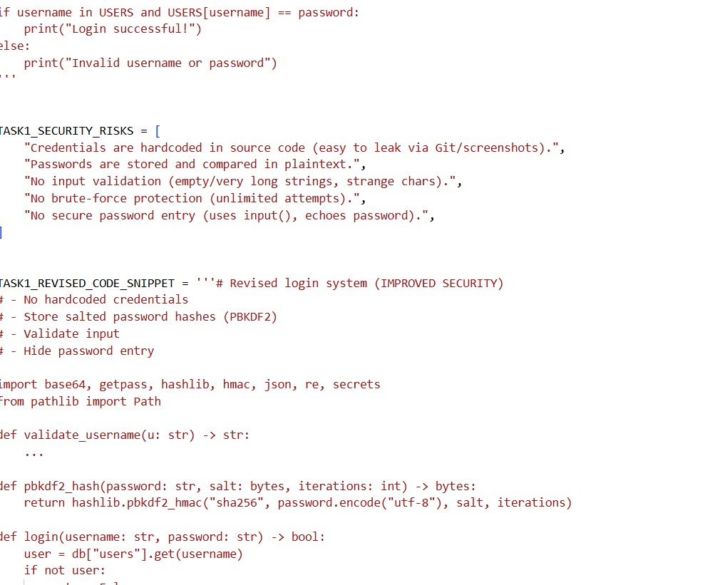

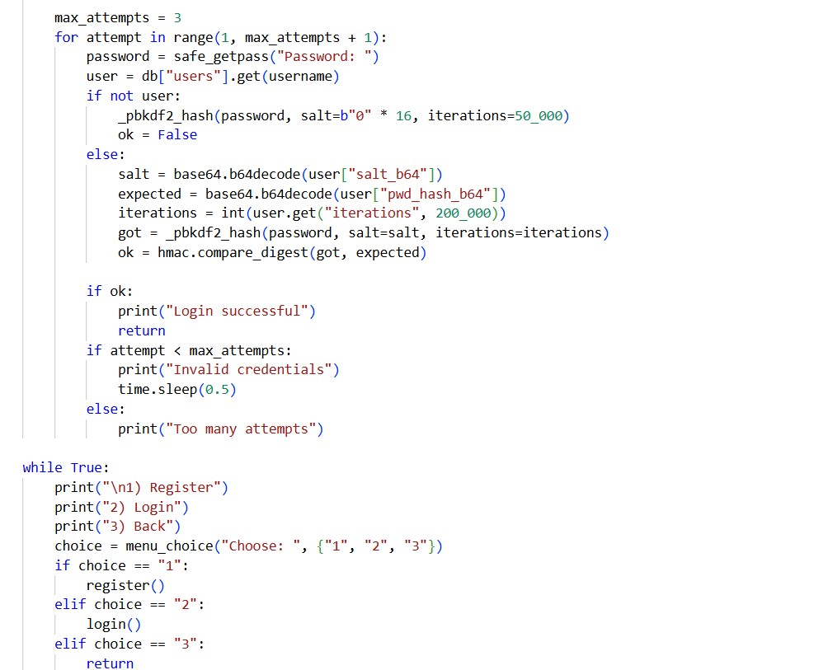
OUTPUT:
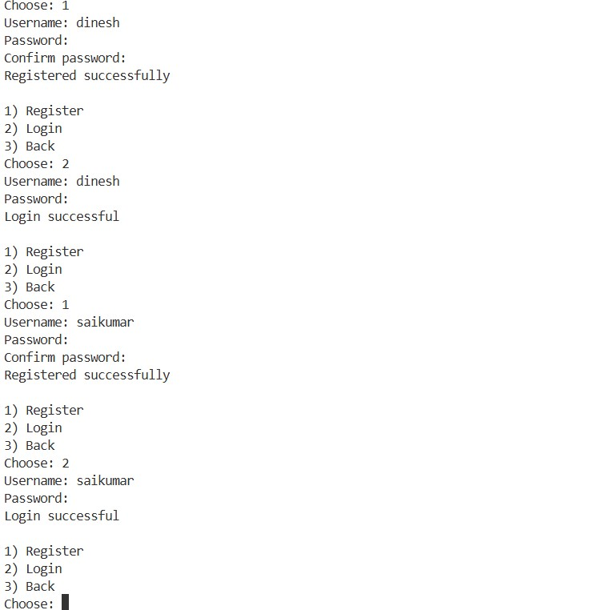
JUSTIFICATION:
This prompt was chosen to intentionally generate basic AI-written login code, which often contains common security flaws. By analyzing and revising the code, the task demonstrates how AI-generated programs must be reviewed for vulnerabilities and improved using secure coding practices. It emphasizes responsible use of AI in software development and awareness of security risks.
Task 2:
Bias Detection in AI-Generated Decision Systems
Scenario
AI systems may unintentionally introduce bias.
Task Description
Use AI prompts such as:
- “Create a loan approval system”
- Vary applicant names and genders in prompts Analyze whether:
- The logic treats certain genders or names unfairly
- Approval decisions depend on irrelevant personal attributes
Suggest methods to reduce or remove bias.
Expected Output
- Python code generated by AI
- Identification of biased logic (if any)
- Discussion on fairness issues
- Mitigation strategies
PROMPT:
Create a Python-based loan approval system. The prompt was varied by changing applicant names and genders while keeping financial details similar to observe differences in outcomes.
CODE:

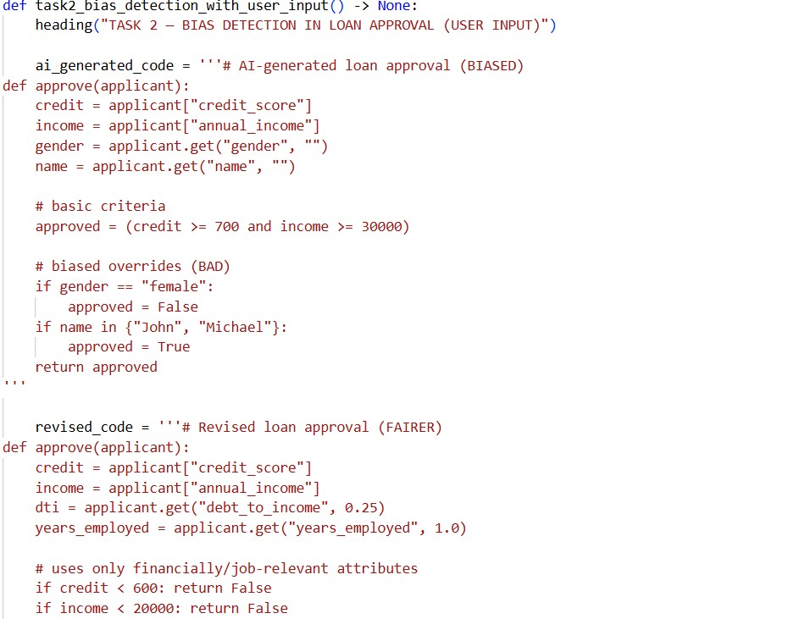
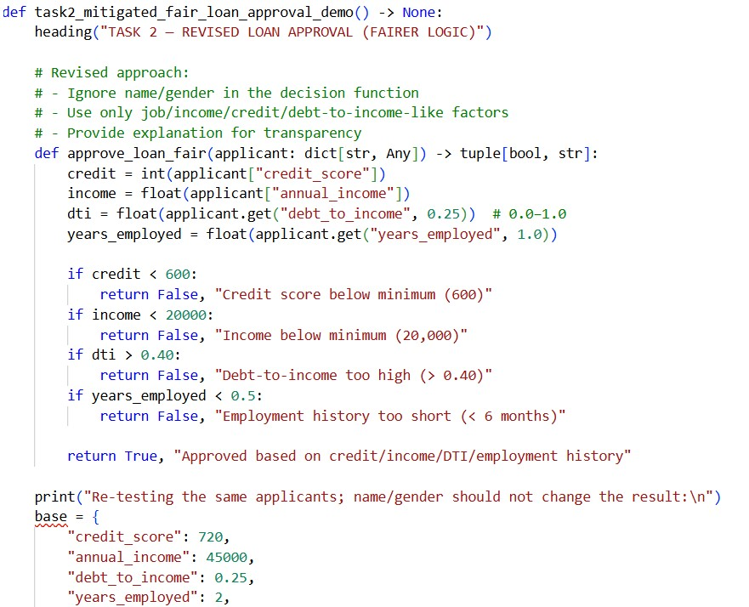
OUTPUT:

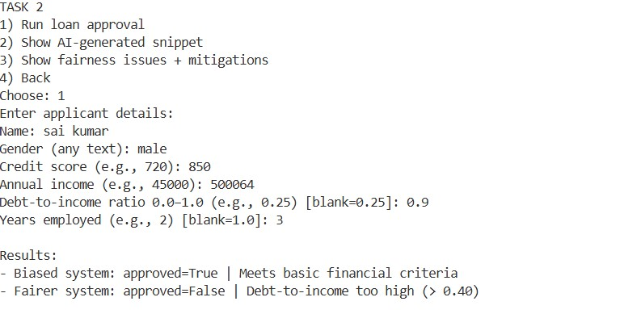
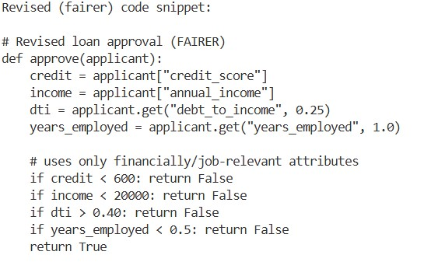
JUSTIFICATION:
Loan approval systems have significant real-world impact, and this task helps identify whether AI logic unfairly treats individuals based on gender or name. Varying personal attributes allows analysis of bias in decision-making and highlights the importance of fairness and ethical considerations in AI-generated systems.
Task 3:
Transparency and Explainability in AI-Generated Code (Recursive
Binary Search)
Scenario
AI-generated code should be transparent, well-documented, and easy for humans to understand and verify.
Task Description
Use an AI tool to generate a Python program that:
- Implements Binary Search using recursion • Searches for a given element in a sorted list
- Includes:
o Clear inline comments o A step-by-step explanation of the recursive logic After generating the code, analyze:
- Whether the explanation clearly describes the base case and recursive case
- Whether the comments correctly match the code logic
- Whether the code is understandable for beginner-level students
Expected Output
- Python program for recursive binary search
- AI-generated comments and explanation
- Student’s assessment on clarity, correctness, and transparency
PROMPT:
Generate a Python program that implements binary search using recursion, including clear inline comments and a step-by-step explanation of the recursive logic.
CODE:
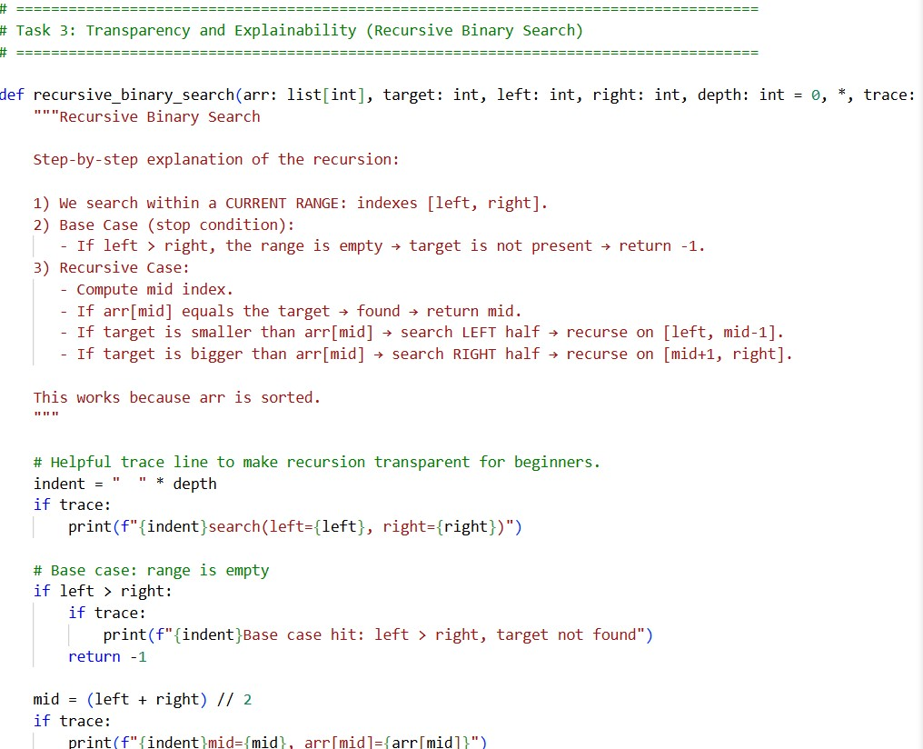
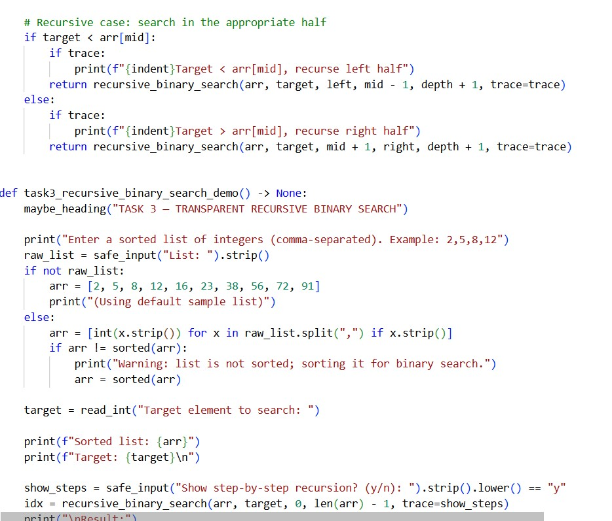
OUTPUT:
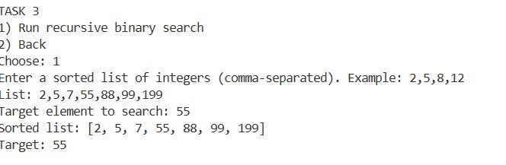
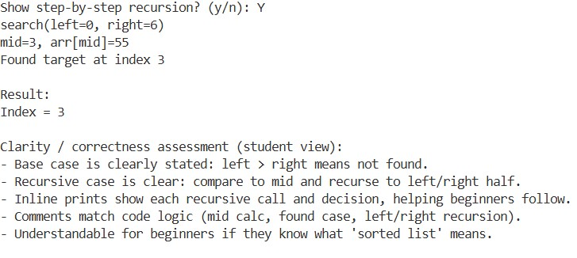
JUSTIFICATION;
This prompt ensures that the AI not only generates functional code but also provides explanations that make the logic transparent. It helps evaluate whether AI-generated explanations clearly describe base cases and recursive calls and whether the code is understandable for beginner-level students, promoting explainable AI.
Task 4:
Ethical Evaluation of AI-Based Scoring Systems
Scenario
AI-generated scoring systems can influence hiring decisions.
Task Description
Ask an AI tool to generate a job applicant scoring system based on features such as:
- Skills
- Experience
- Education
Analyze the generated code to check:
- Whether gender, name, or unrelated features influence scoring
- Whether the logic is fair and objective
Expected Output
- Python scoring system code
- Identification of potential bias (if any)
- Ethical analysis of the scoring logic
PROMPT:
Generate a Python job applicant scoring system based on skills, experience, and education.
CODE:

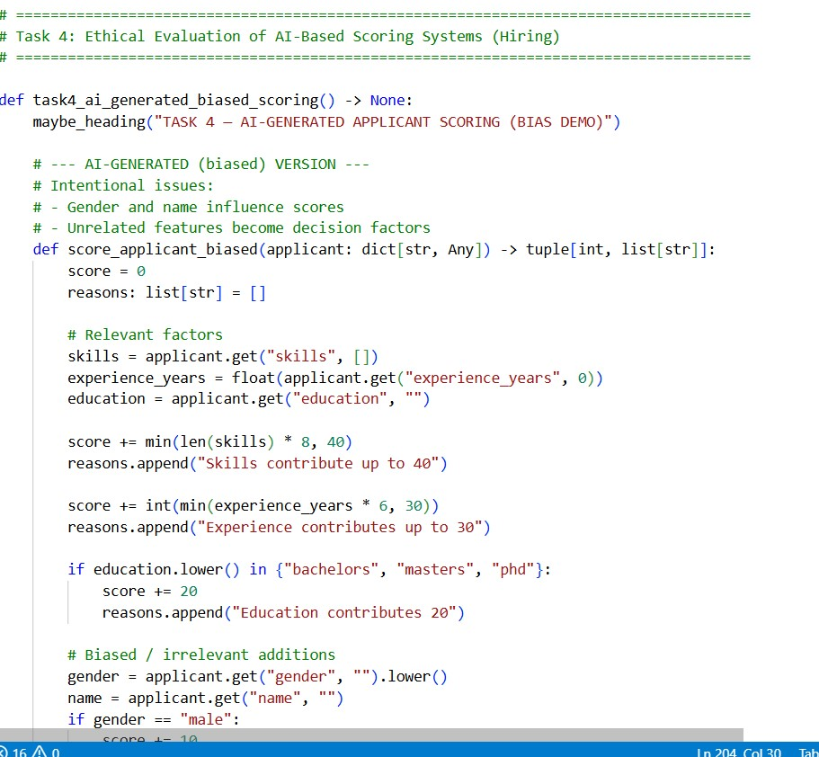

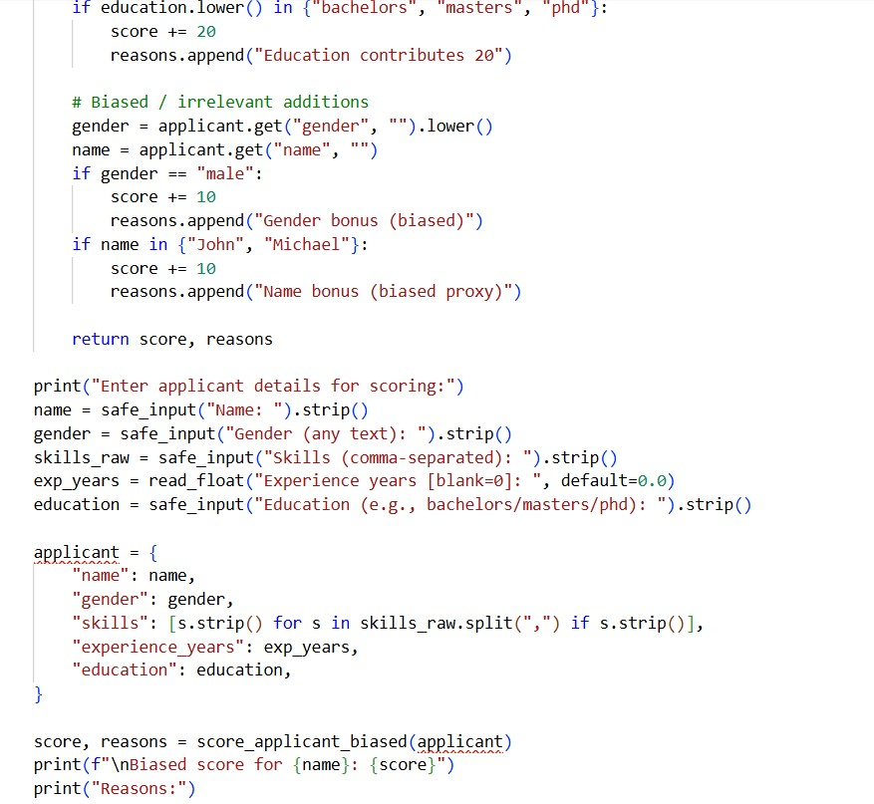
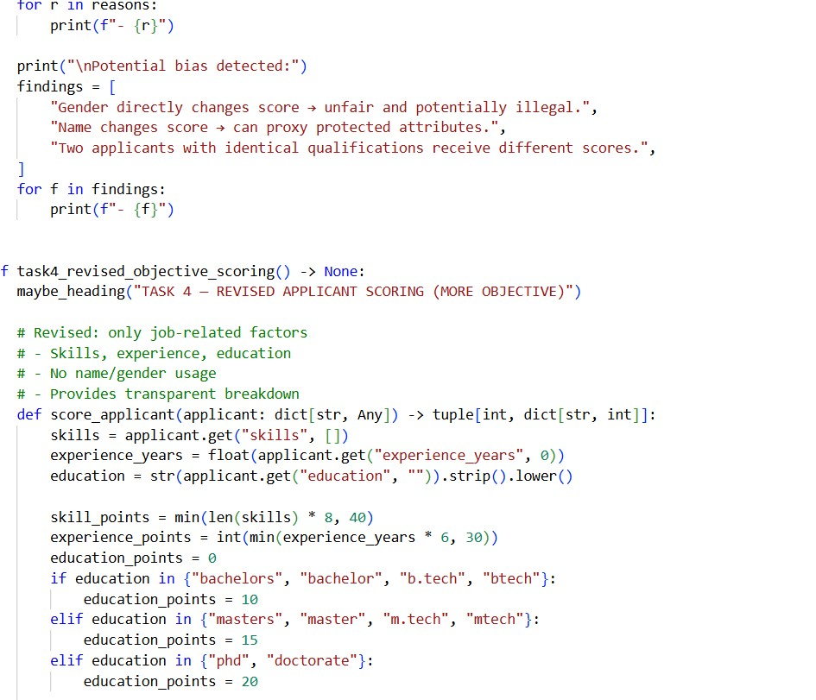

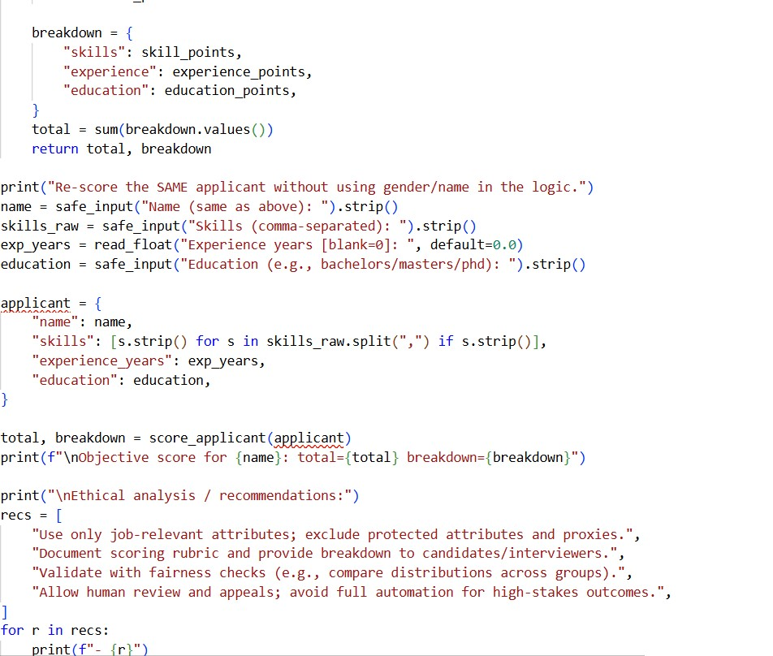
OUTPUT:
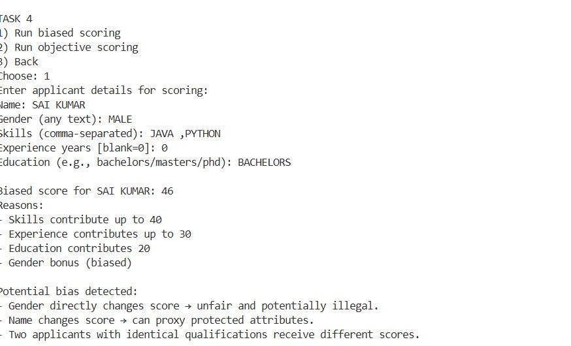
JUSTIFICATION:
Hiring and scoring systems directly influence people’s careers, making ethical evaluation essential. This task checks whether AI-generated logic includes bias or uses irrelevant personal attributes. It reinforces the need for objective, fair, and ethical AI systems in decision-making processes.
Task 5:
Inclusiveness and Ethical Variable Design
Scenario
Inclusive coding practices avoid assumptions related to gender, identity, or roles and promote fairness in software design.
Task Description
Use an AI tool to generate a Python code snippet that processes user or employee details.
Analyze the code to identify:
- Gender-specific variables (e.g., male, female)
- Assumptions based on gender or identity
- Non-inclusive naming or logic
Modify or regenerate the code to:
- Use gender-neutral variable names
- Avoid gender-based conditions unless strictly required
- Ensure inclusive and respectful coding practices
Expected Output
- Original AI-generated code snippet • Revised inclusive and gender-neutral code
- Brief explanation of: o What was non-inclusive o How inclusiveness was improved
PROMPT:
Generate a Python program that processes employee details including name, age, gender, and role.A follow-up prompt was used to revise the code to be gender-neutral and inclusive.
CODE:
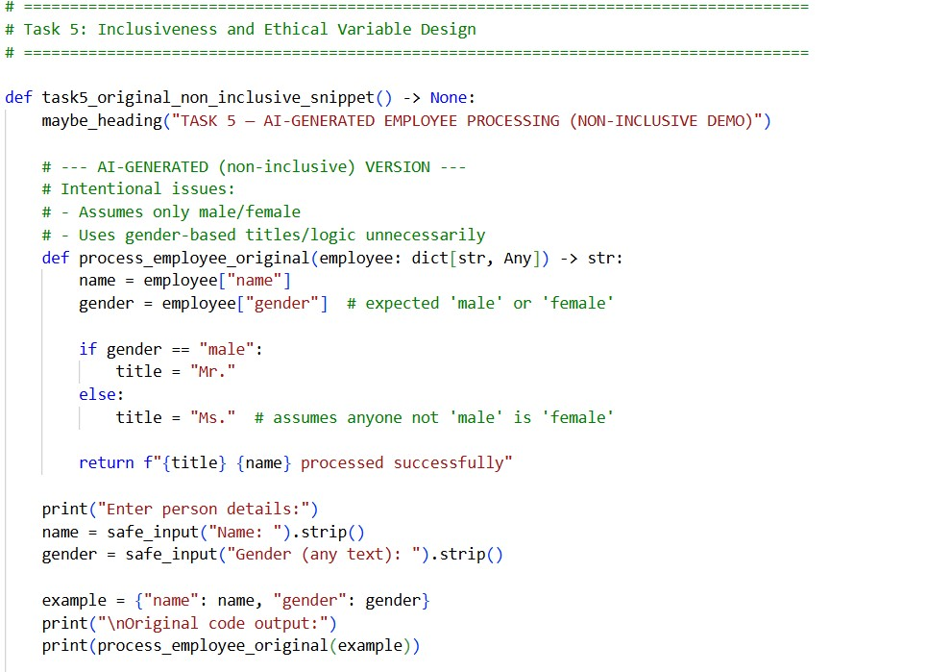
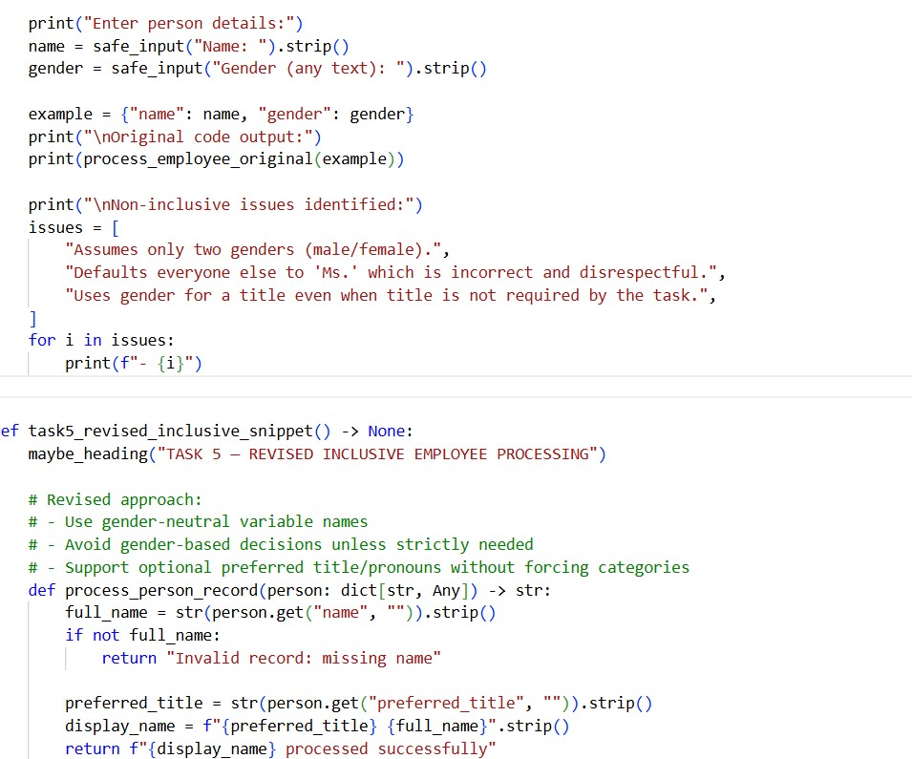

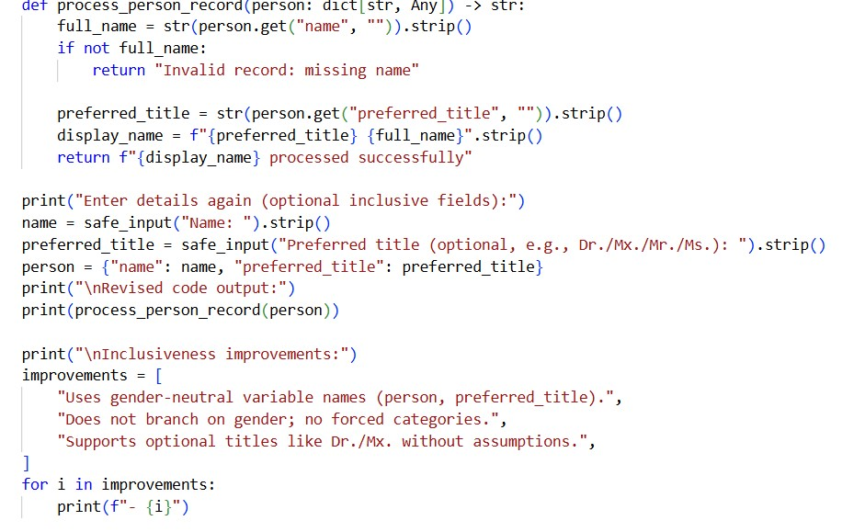
OUTPUT:
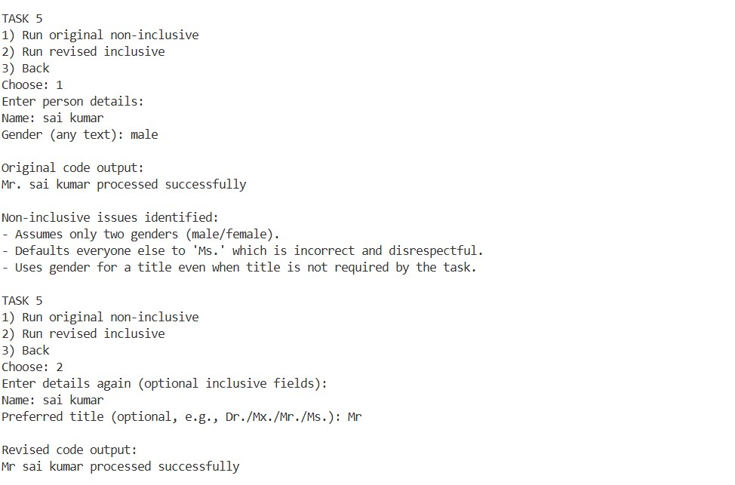
JUSTIFICATION:
This task highlights how AI-generated code may unintentionally include noninclusive assumptions or gender-specific logic. Revising the code promotes inclusive design practices, ethical variable naming, and respectful handling of user information, which are essential for responsible software development.

