Top 10 Economies by GDP (PPP) Rank, 1980–2022:
A Redesign Critique of HowMuch’s “Largest Economies in the World Over the Last 40 Years”
Ayush Mishra
Information Visualization 04:547:321:01
Professor Marissa Anema
March 13, 2026

Selected chart: HowMuch’s “Largest Economies in the World Over the Last 40 Years”
GitHub repository: https://github.com/ayushmish605/largest-economies-information-visualization/tree/main. The repository contains the README writeup, cleaned data, process notes, source metadata, and Tableau redesign materials for this project. I strongly encourage you to review the repository as well, since it clarifies how I sourced and constructed the derived dataset, makes the data-preparation process more transparent, and documents the research I did to verify how the underlying values were obtained. It also includes the Pandas script I wrote to transform the raw source material into a clean, Tableau-compatible format, which required substantial time and care to develop.
Tableau Public link: https://public.tableau.com/app/profile/ayush.mishra6684/viz/Top10EconomiesbyGDPPPPRank19802022ATableauRedesign/Story. I also encourage you to view the Tableau Public version directly, since the graphs are interactive and some of their most important features are easier to understand in that format. Both charts include a Source Dataset switch for comparing the HowMuch-derived values with the IMF WEO values, and the rank matrix also includes sorting controls that reorder countries by selected benchmark years. The interactive version therefore shows the redesign more completely than static screenshots alone.

Redesign Critique: “Largest Economies in the World Over the Last 40 Years”
I chose to use HowMuch’s “Largest Economies in the World Over the Last 40 Years,” an infographic that shows changes in rank over time by displaying changes in values using GDP (PPP). The original infographic is eye-catching, but it does require the viewer to process multiple components at once. Therefore, this infographic makes three key changes: (1) removing clutter from trajectories and designs, (2) correcting issues with dealing with irregular time intervals, and (3) adding a secondary view to help with understanding the main trends.
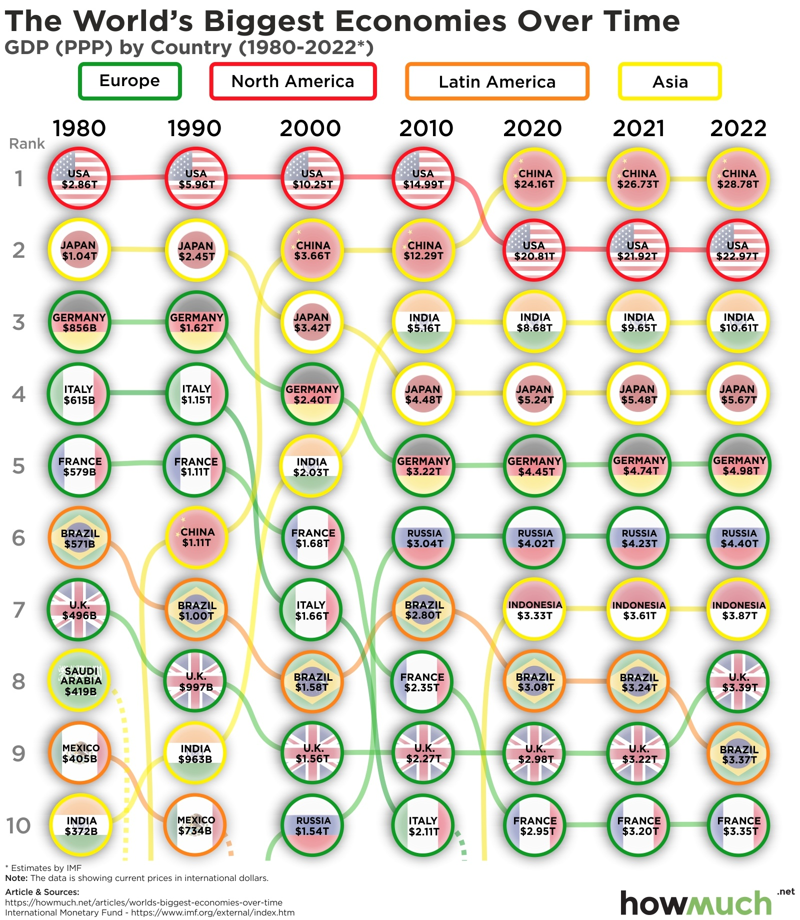
Figure 1. Original HowMuch infographic used as the basis for critique.

Issue 1: Tangled Trajectories and Decorative Overload Complicate Comparison
The main drawback in the original chart is the way it conveys the ranking narrative, where multiple simultaneous encodings obscure the ranking. Schwabish argues that “readers understand visualizations more accurately when values are put on a common baseline and when the form of the visualization is well-aligned with the task at hand” (Schwabish, 2021, p. 370). The task at hand in the case of the ranking chart is to identify relative positions, rising values, and declining values. The visual encodings, however, overcomplicate the task at hand. According to Dunford, “too many variables and poor color choice are two of the most common mistakes in data visualization” (Dunford, n.d., p. 21). The original chart is an exemplary case of how color, form, and icon, in addition to the ranking positions, overcomplicate the task.
The redesigned chart attempts to rectify the situation by removing all unnecessary visual encodings that are not directly related to comparison. The final connected dot chart only includes the essential visual encodings that are relevant to comparison. The rank position is still the main visual cue, and each country is represented by a single path of connected dots. The labels are only included in the form of short identifiers on the initial position of each path. Another option that was attempted in the redesign process was the small multiples option, where multiple charts are combined in one chart to avoid crossing lines. However, Schwabish argues that “small multiples are often used in favor of relative comparison between groups, and in the process, compromise absolute comparison” (Schwabish, 2021, p. 372).
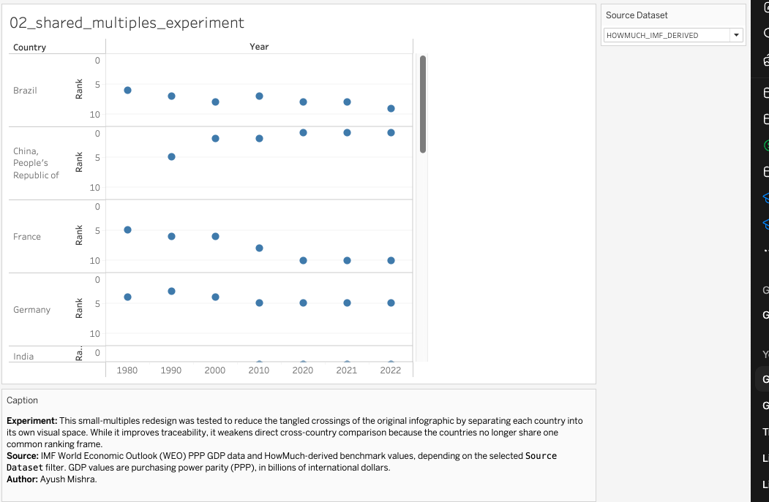
Figure 2. Small-multiples experiment: easier local tracing, but weaker shared comparison.

The compromise in the case of the small multiples option was that the paths were easier to understand, but the ranking narrative was weakened. The final comparison chart, therefore, includes all countries in one frame, without flags, badges, and other regional decorations. The reason for removing the decorations is Tufte’s analytic design argument, in which “method and evidence should be more prominent than decoration” (Tufte, 2006, p. 123).
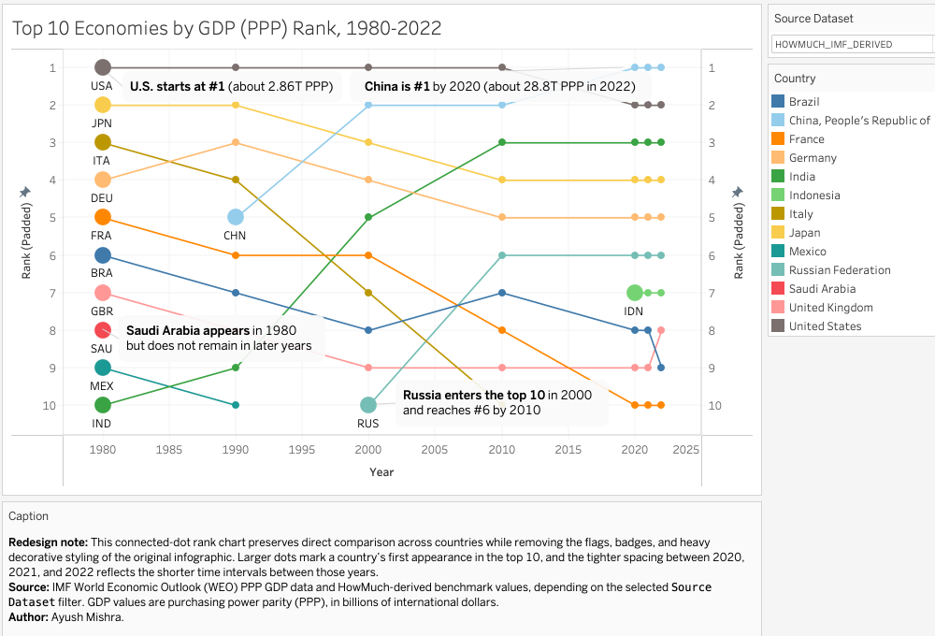
Figure 3. Shared connected-dot redesign used to preserve comparison while reducing clutter.

Issue 2: Equal spacing for unequal time intervals distorts temporal interpretation
The second prominent issue centers on temporal spacing. In the original infographic, equal spacing is provided for unequal time intervals, such as 1980–1990, 1990–2000, and 2021–2022. This implies that equal amounts of time have elapsed in each of these intervals, even though the first two intervals have ten years separating them, and the last one has one year separating it from the previous point. Dunford points out that, in the use of visual images of time, there is a risk of misleading the audience, especially when dates and information on time are presented in a way that alters the narrative (Dunford, n.d., p. 10). Moreover, Tufte points out that, when working with visual images, there is always a compromise when showing complex information on a flat surface, such as in the use of time scaling (Tufte, 1990, p. 15). In the original infographic, equal spacing for unequal intervals exaggerates the flow of recent years compared to earlier decades.
In Tableau, this issue was resolved by changing the benchmark years to a continuous scale in the shared comparison view. As such, the decade intervals have larger gaps, whereas 2020, 2021, and 2022 are in close proximity. This is an important issue in that it improves the visual grammar by making it more accurate. According to Schwabish, an accurate graph structure should help in the accurate perception of values instead of leaving the audience to try and interpret the logic from the labels (Schwabish, 2021, p. 370). In the new infographic, the recent years are not represented as decade shifts. This is acknowledged in the infographic as a way of letting the audience know that the closer spacing in the recent years is intentional.

Issue 3: The original chart requires an analytical companion view
The third issue relates to the original infographic, where multiple tasks are performed in one chart: ranking, tracing trends, identifying, grouping, and storytelling. Although this makes the chart more memorable, it makes it less analytically convenient. The discussion on the redesigned infographic by Schwabish emphasizes that there is no single “correct” way to remake the infographic and that the goal of the redesign should be to “create an alternative that is cleaner, clearer, and more effective” (Schwabish, 2021, p. 13). After considering all the options, it was realized that none of the single charts could solve all the problems. The connected dot chart maintains the idea of competition and comparison but forces the viewer to track multiple paths. The small multiples solution, on the other hand, eliminates path tangles but makes cross-country comparison more difficult. The table of ranks, on the other hand, is too static.
Therefore, the best solution was to develop an alternative pair of charts. The main chart is the shared connected dot chart, and the companion chart is the rank matrix, where countries are rows, years are columns, and each cell contains the rank and color code.
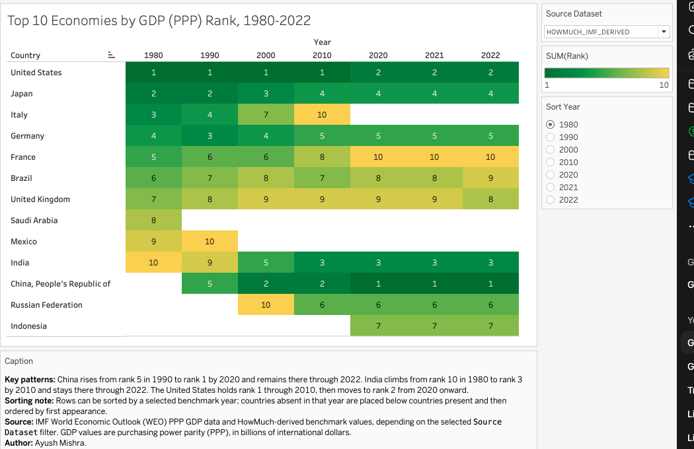
Figure 4. Rank matrix / highlight table used as the interpretive companion view.

The rank matrix eliminates tangles and focuses on the main trends, where China moves up from rank 5 in 1990 to rank 1 in 2020, where India moves up from rank 10 in 1980 to rank 3 in 2010, and where the United States holds rank 1 until 2010 and then drops to rank 2. According to Dunford, “the main advantage of data visualization is that it enables communication to a wider audience” (Dunford, n.d., p. 1). The rank matrix does just that, acting as an interpretive companion, not a replacement chart. It also meets the criterion of matching the form of the chart to the task, where one chart is used for comparison and the other for storytelling and verification (Schwabish, 2021, pp. 370, 372).

Conclusion
In the final Tableau redesign, two views are utilized: a shared y-axis rank chart for cross-country comparison and a rank matrix for easy analysis. All three concerns are addressed with these two views, yet they are still tied to the theories of Schwabish, Tufte, and Dunford.

References
Dunford. (n.d.). When data visualization really isn't useful (and when it is). Tempo.io. https://www.tempo.io/blog/good-and-bad-data-visualization
Irena. (2025, September 23). Visualizing the largest economies in the world over the last 40 years (Update: February 2021). HowMuch.net. https://howmuch.net/articles/worlds-biggest-economies-over-time
Schwabish, J. (2021). Better data visualizations: A guide for scholars, researchers, and wonks. Columbia University Press.
Tufte, E. R. (1990). Envisioning information. Graphics Press.
Tufte, E. R. (2006). Beautiful evidence. Graphics Press.

