Table Agent:

Input image:

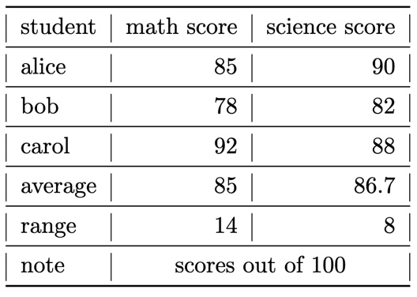

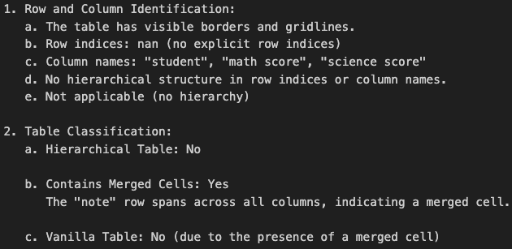Summarize overall information:

Analyze and convert the table into markdown format:

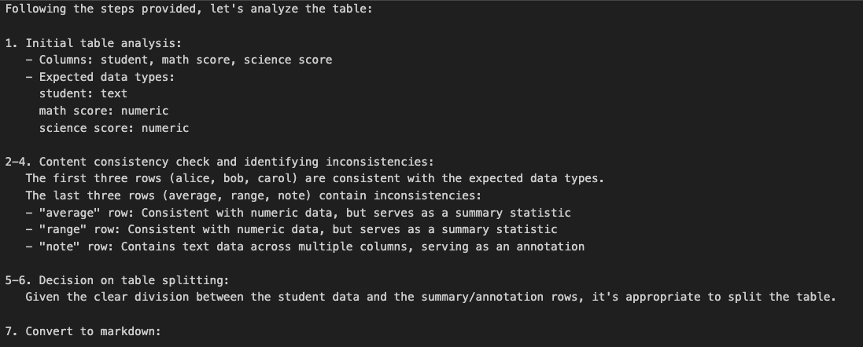

Input image:

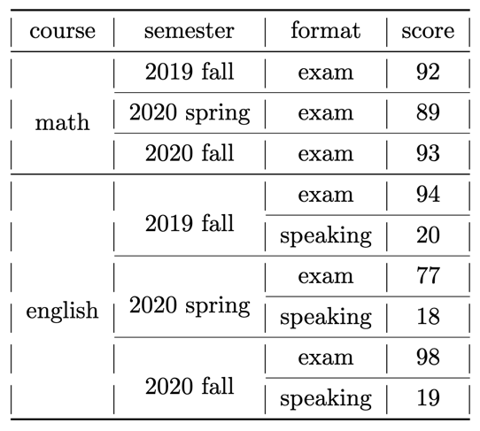

Summarize overall information:

Prompt with advanced instructions

Output:

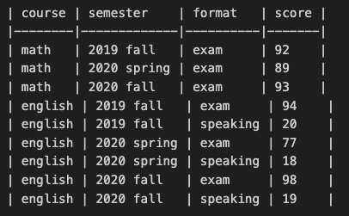

Plain Promp:

Please convert the table into markdown format

Output:

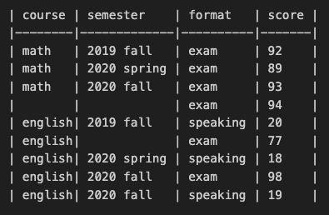

Input images:

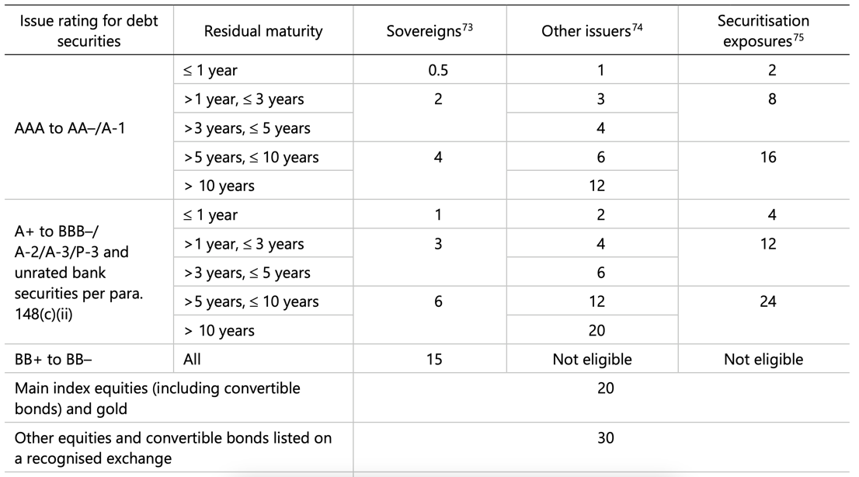

Summarize overall information:

Prompt (inconsistent rows + merged cells)

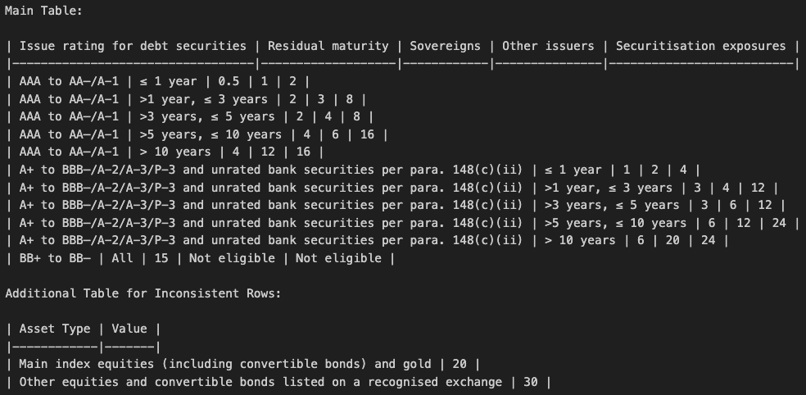

Input image:

Summarize overall information:

Output:

