RV UNIVERSITY, BENGALURU-59

SCHOOL OF COMPUTER SCIENCE AND ENGINEERING


A Project Synopsis On
Real-Time Suspicious Movement Detection System for Exam Malpractice Monitoring Using Dual ESP32-CAM Modules
For the Course Internet of Things(CS2404)
In
School of Computer Science and Engineering
Submitted By
Name1: Ayush Gowda MJ USN1: 1RUA25CSE0097
Name2: Dishanth Vasupal KR USN2: 1RUA25CSE0163
Name3: Dullipala Shreevathsa USN3: 1RUA25CSE00__
Name4: Diganth R USN4: 1RUA25CSE00__

Under the Guidance of
Dr./Prof. Guide Name
Designation
School of CSE
RV University, Bengaluru-560059
2025-2026

ABSTRACT

This project presents a low-cost IoT-based exam monitoring aid using two fixed ESP32-CAM modules to monitor exam halls. The system uses OpenCV frame differencing, background subtraction and motion-contour analysis instead of trained machine learning models. When suspicious movement is detected, it captures a snapshot, marks the suspected area with a red square, stores the evidence and alerts the invigilator through a web dashboard.

1. Introduction
During examinations and placement tests, invigilators are often responsible for monitoring many students at once, making it difficult to continuously observe every candidate for suspicious behaviour such as leaning, turning repeatedly, or attempting to copy from nearby students. This project proposes an IoT-based assistive surveillance system built around two ESP32-CAM modules fixed at the front and back of the classroom. The camera feeds are processed on a backend server using non-ML OpenCV techniques such as frame differencing, background subtraction and motion-contour analysis. Each camera view is divided into calibrated seat zones, so movement can be mapped to a particular seat without face recognition. When suspicious movement crosses the threshold, the system captures a snapshot, marks the suspected person/zone with a red square, stores the evidence and displays the alert on the web dashboard for invigilator verification.

2. Objectives:
1. To design and deploy a dual ESP32-CAM hardware setup that captures full classroom coverage over Wi-Fi.
2. To detect suspicious movement in calibrated camera zones using OpenCV frame differencing, background subtraction and contour analysis, without training or using machine learning models.
3. To develop a web-based dashboard that displays live camera feeds, real-time alerts and saved snapshots with a red square around the suspected area.
4. To log all flagged incidents with timestamp, camera position and marked snapshot image for post-exam review and reporting.

3. Block diagram:

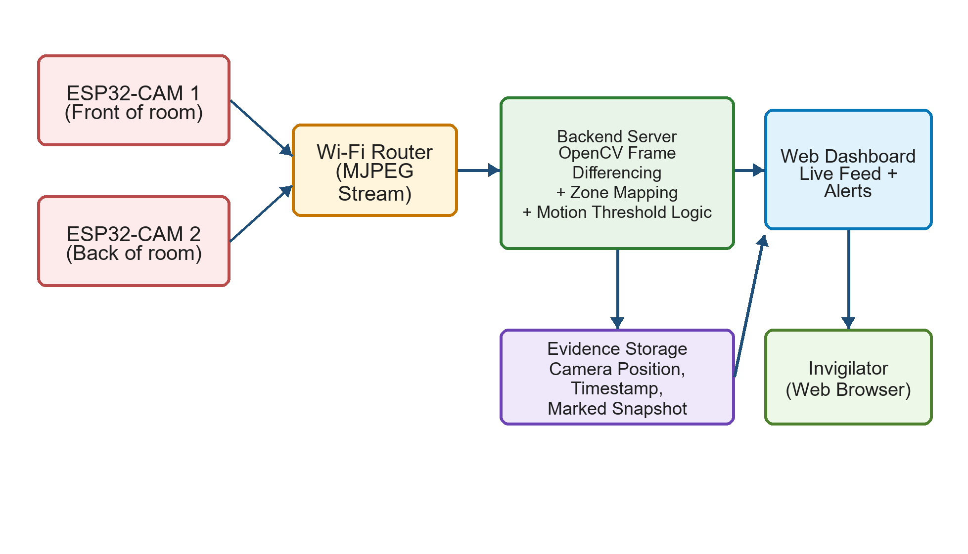
Technical explanation: Two ESP32-CAM (AI-Thinker, OV2640) modules are fixed at the front and back of the classroom and stream MJPEG video over Wi-Fi to a backend server running Python. The system does not use trained machine learning models for human detection. During setup, each camera view is calibrated into fixed monitoring zones based on the classroom layout. The backend uses OpenCV frame differencing or background subtraction to detect moving regions between consecutive frames. Contours are filtered by size, duration and position to ignore small noise, blinking and lighting changes. If movement stays above the threshold for a few consecutive frames, the server saves the current frame, draws a red square around the suspected area, logs the camera position, timestamp and image path in SQLite, and sends the alert to the Flask/FastAPI web dashboard for invigilator verification.

4. Component required in the format given below:( given as an example)

Sl.  No. | Part | Specification | Quantity | Price/  Unit  ( Rs.) | GST  (Rs.) | Total Cost/  Unit | Total (Rs.) | Link
1 | ESP32-CAM #1 | ESP32-CAM (AI-Thinker, OV2640) | 2 | 600 | 18% | 708 | 1416 | robu.in
2 | Camera Lens | Wide-angle lens attachment for OV2640 | 2 | 150 | 18% | 177 | 354 | robu.in
3 | Power Adapter | 5V 2A USB power adapter | 2 | 180 | 18% | 212 | 424 | amazon.in
4 | USB-TTL Programmer | FTDI/USB-TTL programmer (for flashing) | 1 | 200 | 18% | 236 | 236 | robu.in
5 | Camera Mount | ESP32 camera Module mounting stand/clamp | 2 | 120 | 18% | 142 | 284 | amazon.in
6 | Jumper Wires | Jumper wires (M-M/M-F set) | 1 | 100 | 18% | 118 | 118 | amazon.in
7 | Wi-Fi Router | Dedicated Wi-Fi router/access point | 1 | 1500 | 18% | 1770 | 1770 | amazon.in
8 | MicroSD Card | MicroSD card, 8GB (optional local storage) | 2 | 200 | 18% | 236 | 472 | amazon.in
 |  |  |  |  |  |  | 4,700 (approx.)

5. Expected outcome

A working prototype in which two ESP32-CAM units continuously monitor a classroom during an exam and automatically flag suspicious movement using OpenCV-based frame differencing, background subtraction and calibrated monitoring zones. For every valid alert, the system captures a snapshot, draws a red square around the suspected area, saves the image evidence with timestamp and camera position, and displays it on a live web dashboard. The system is expected to reduce the manual monitoring load on invigilators and provide objective visual records for post-exam review without relying on trained machine learning models or face recognition.

