RV UNIVERSITY, BENGALURU-59

SCHOOL OF COMPUTER SCIENCE AND ENGINEERING


A Project Synopsis On
Real-Time Suspicious Movement Detection System for Exam Malpractice Monitoring Using Dual ESP32-CAM Modules
For the Course Internet of Things(CS2404)
In
School of Computer Science and Engineering
Submitted By
Name1: Ayush Gowda MJ USN1: 1RUA25CSE0097
Name2: Dishanth Vasupal KR USN2: 1RUA25CSE0163
Name3: Dullipala Shreevathsa USN3: 1RUA25CSE0159
Name4: Diganth R USN4: 1RUA25CSE0160

Under the Guidance of
Dr. Vidya M J
Designation
School of CSE
RV University, Bengaluru-560059
2025-2026

ABSTRACT

This project proposes a low-cost IoT-based exam monitoring system using two fixed ESP32-CAM modules placed at the front and back of a classroom. The system assists invigilators by continuously monitoring students during examinations and identifying suspicious movements such as repeated turning, leaning or abnormal body movement. A pre-trained YOLO object detection model is used to detect students/persons in the camera feed, while OpenCV-based motion analysis checks whether the detected person shows suspicious movement. When an alert condition is met, the system captures the frame, draws a red bounding box around the suspected person, stores the marked snapshot with timestamp and camera position, and displays the alert on a web dashboard for review.

1. Introduction
During examinations and placement tests, invigilators are often responsible for monitoring many students at once, making it difficult to continuously observe every candidate for suspicious behaviour such as leaning, repeated turning, or attempting to copy from nearby students. This project proposes an IoT-based assistive surveillance system built around two ESP32-CAM modules fixed at the front and back of the classroom. The camera feeds are streamed to a backend server, where a pre-trained YOLO model detects each visible student/person and OpenCV-based motion analysis checks movement across consecutive frames. If suspicious movement overlaps a detected person and remains above a configured threshold, the system captures the frame, draws a red square around that person, saves the evidence and displays the alert on the web dashboard for invigilator verification.

2. Objectives:
1. To design and deploy a dual ESP32-CAM hardware setup that captures full classroom coverage over Wi-Fi.
2. To detect students/persons using a pre-trained YOLO object detection model and analyze their movement using OpenCV-based frame differencing and threshold logic.
3. To develop a web-based dashboard that displays live camera feeds, real-time alerts and saved snapshots with a red square around the suspected person.
4. To log all flagged incidents with timestamp, camera position and marked snapshot image for post-exam review and reporting.

3. Block diagram:

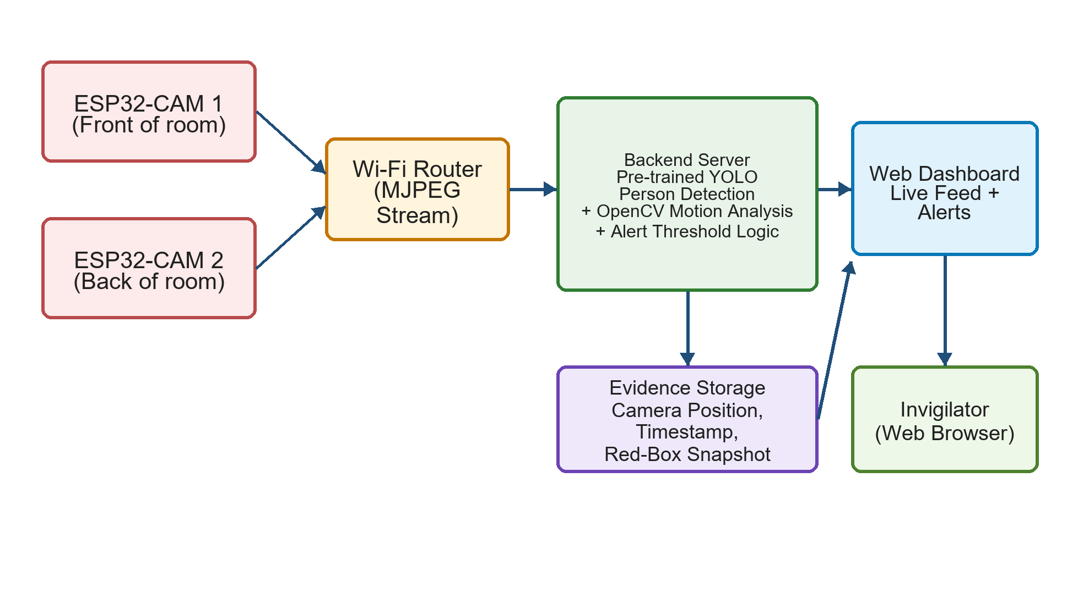
Technical explanation: Two ESP32-CAM (AI-Thinker, OV2640) modules are fixed at the front and back of the classroom and stream MJPEG video over Wi-Fi to a backend server running Python. The backend uses a pre-trained YOLO object detection model to detect students/persons in each frame. OpenCV is then used for frame differencing and motion analysis between consecutive frames. When a motion region overlaps with a YOLO person bounding box and remains above the configured threshold for a few frames, the event is treated as suspicious. The server immediately saves the current frame, draws a red square around the detected person, logs the camera position, timestamp and image path in SQLite, and sends the alert to the Flask/FastAPI web dashboard for invigilator verification. This approach is more accurate than only using basic motion detection because the red box is attached to the detected person rather than just a random moving region.

4. Component required in the format given below:( given as an example)

Sl.  No. | Part | Specification | Quantity | Price/  Unit  ( Rs.) | GST  (Rs.) | Total Cost/  Unit | Total (Rs.) | Link
1 | ESP32-CAM #1 | ESP32-CAM (AI-Thinker, OV2640) | 2 | 600 | 18% | 708 | 1416 | robu.in
2 | Camera Lens | Wide-angle lens attachment for OV2640 | 2 | 150 | 18% | 177 | 354 | robu.in
3 | Power Adapter | 5V 2A USB power adapter | 2 | 180 | 18% | 212 | 424 | amazon.in
4 | USB-TTL Programmer | FTDI/USB-TTL programmer (for flashing) | 1 | 200 | 18% | 236 | 236 | robu.in
5 | Camera Mount | ESP32 camera Module mounting stand/clamp | 2 | 120 | 18% | 142 | 284 | amazon.in
6 | Jumper Wires | Jumper wires (M-M/M-F set) | 1 | 100 | 18% | 118 | 118 | amazon.in
7 | Wi-Fi Router | Dedicated Wi-Fi router/access point | 1 | 1500 | 18% | 1770 | 1770 | amazon.in
8 | MicroSD Card | MicroSD card, 8GB (optional local storage) | 2 | 200 | 18% | 236 | 472 | amazon.in
 |  |  |  |  |  |  | 4,700 (approx.)

5. Expected outcome

A working prototype in which two ESP32-CAM units continuously monitor a classroom during an exam and automatically flag suspicious student movement using a pre-trained YOLO person detection model combined with OpenCV motion analysis. For every valid alert, the system captures a snapshot, draws a red square around the suspected person, saves the image evidence with timestamp and camera position, and displays it on a live web dashboard. The system is expected to reduce manual monitoring load, improve alert accuracy compared to simple motion detection, and provide objective visual records for post-exam review.

