Evaluation Report
Uro-Oncologist vs AI Judges in Medical Oncology
Therapy Recommendation Assessment
February 2026
Renal Cell Carcinoma (RCC) — 69 Cases from German Tumor Boards
Prepared for Google AI Hackathon 2026
Reviewer: Dr. Radu Alexa, Board-Certified Uro-Oncologist

1. Executive Summary
This report presents a novel three-tier evaluation pipeline for assessing AI-generated therapy recommendations in clinical oncology. Across 414 predictions from 6 LLMs on 69 renal cell carcinoma (Nierenzellkarzinom, RCC) cases from German tumor boards (Tumordiskussionen), the pipeline combines automated AI judging with expert physician validation to establish a scalable, reproducible evaluation framework.

Key Findings
- Across all 414 predictions: 63.5% metastatic detection accuracy, 30.9% exact therapy match, 58.7% clinically acceptable therapies.
- Best model by uro-oncologist review: MedGemma 27B (6.1/9 quality, 75.4% acceptable).
- Best model by automated judge score: MedGemma 27B (avg overall 0.76/1.0).
- GPT-5.2 shows substantial agreement with the uro-oncologist (Cohen's κ = 0.629).
- MedGemma 27B shows substantial agreement with the uro-oncologist (Cohen's κ = 0.675).
- Inter-judge agreement: κ = 0.725, 86.5% concordance across 414 evaluation pairs.
- MedGemma self-judging bias: higher scores for own predictions (0.78 vs 0.69), significant (p=0.017).
- Clinical safety: GPT-5.2 has lowest dangerous error rate (8.2% false positives).

2. Project Overview
This project investigates whether large language models (LLMs) can support clinical decision-making in oncology by generating appropriate therapy recommendations for renal cell carcinoma (RCC) patients presented at German tumor board discussions.

Clinical Context
Tumor boards are multidisciplinary meetings where specialists review complex cancer cases and agree on treatment recommendations. Each case includes patient demographics, comorbidities, TNM staging, histological subtype, prior therapies, and imaging findings. The ground truth for this study is the consensus therapy recommendation from the tumor board.

Project Scope: Two Evaluation Pipelines
This project comprises two complementary evaluation pipelines:
Pipeline | Task | Models Tested | Best Result | Status
1. Classification | 7-class cancer type detection  (NCC, PCA, HODEN, UCA, PENIS, COMBI, NON_URO) | 14 models (MiMo v2, GPT-5.2, Claude Opus 4.5, Gemini 3, DeepSeek v3.2, etc.) | 100% accuracy (MiMo v2 Flash) | Complete
2. Treatment Prediction | RCC therapy recommendation  following German oncology guidelines | 6 models (Gemma 3 27B/4B, MedGemma, Meditron3, OLMo 32B Instruct/Think) | See detailed results below | Complete + Validated
Pipeline 1 established that modern LLMs can reliably classify German oncology cases by cancer type. This report focuses exclusively on Pipeline 2 (treatment prediction), which is the clinically more challenging task requiring guideline-aware therapeutic reasoning.

Evaluation Pipeline (Treatment Prediction)
The treatment prediction study uses a three-tier evaluation pipeline:
- Tier 1 — LLM Prediction: Each model receives the full clinical case and generates a therapy recommendation with reasoning.
- Tier 2 — AI Judge Evaluation: Two AI judges (GPT-5.2 and MedGemma 27B) independently score each prediction on semantic match, clinical appropriateness, reasoning quality, and overall correctness.
- Tier 3 — Uro-Oncologist Validation: A board-certified uro-oncologist reviews model predictions (therapy acceptable? quality rating) and judge evaluations (agree/partial/disagree with judge verdict).

Models Evaluated
Model | Size | Type | Description
Meditron3 7B | 7B | Medical | Medical-specialized 7B model based on Qwen2.5
OLMo 32B Instruct | INSTRUCT | General | Allen AI's open 32B instruction-tuned model
OLMo 32B Think | THINK | General | Allen AI's 32B chain-of-thought reasoning model
Gemma 3 27B |  | General | Google's general-purpose 27B instruction-tuned model
Gemma 3 4B |  | General | Google's compact 4B instruction-tuned model
MedGemma 27B |  | Medical | Google's medical-specialized 27B model (also used as AI judge)

3. Technical Innovation & Impact
This project introduces a comprehensive, reproducible evaluation methodology for clinical AI that addresses key challenges in deploying LLMs for medical decision support.

Three-Tier Evaluation Pipeline
Unlike single-layer evaluations (model vs. ground truth), this project implements a three-tier pipeline that separates automated scoring from expert validation:
- Tier 1 — LLM Prediction: Six models with diverse architectures (2B–32B parameters, general-purpose and medical-specialized) generate therapy recommendations from structured German clinical case data.
- Tier 2 — AI Judge Evaluation: Two independent AI judges (GPT-5.2 and MedGemma 27B) score each prediction across four dimensions: semantic match, clinical appropriateness, reasoning quality, and overall correctness.
- Tier 3 — Uro-Oncologist Validation: A board-certified uro-oncologist reviews both model predictions and judge evaluations, creating a ground truth for evaluating the evaluators themselves.

Clinical Data Format
All 69 clinical cases are stored in structured JSON format. The inference pipeline automatically detects and normalizes schema variations across cases, extracting ECOG, TNM staging, histology, and therapy fields.

Medical Review Web Platform
A web application enables structured physician review of AI predictions and judge evaluations. The platform supports structured review workflows, Likert-scale and binary ratings, and exports data for statistical analysis.

4. Methodology

Treatment Prediction Prompt
Each model receives a structured German-language prompt with the role "Du bist ein erfahrener Onkologe, spezialisiert auf Nierenzellkarzinom" (You are an experienced oncologist specialized in RCC). The prompt contains:
- Patient demographics: name, age, ECOG, Karnofsky, comorbidity, life expectancy
- Clinical data: diagnosis, TNM staging (clinical + pathological), histology subtype, grading
- Medical history: anamnesis free text, secondary diagnoses, current medication, imaging findings, IMDC risk factors, ICI eligibility, prior systemic therapies
- Embedded therapy guidelines: Complete IMDC-stratified treatment algorithm for metastatic clear-cell RCC (first-line ICI-eligible and non-eligible, second-line) and non-metastatic RCC (surveillance, ablation, partial/radical nephrectomy) with Grades of Recommendation (GoR A/B/0)
- Structured output: JSON with is_metastatic, IMDC risk, therapy recommendation, category, reasoning, and confidence score

Inference Hyperparameters
Parameter | Standard Models | Thinking Models | Rationale
Temperature | 0.3 | 0.6 | Low for deterministic medical output; higher for thinking chains
Top-p | 0.95 | 0.95 | Nucleus sampling for balanced diversity
Max tokens | 32,768 | 65,536 | Headroom for reasoning; thinking models consume tokens before JSON
Seed | 42 (Modal only) | 42 | Deterministic results for reproducibility
Structured output | Yes (Pydantic) | No | Thinking models produce <think> blocks before JSON

LLM-as-Judge Evaluation
Two AI judges independently evaluate each prediction using a structured German prompt. The judge receives the clinical case, ground truth therapy, and the model's full prediction including reasoning. The judge prompt uses the role "Du bist ein erfahrener Uro-Onkologe, der als Gutachter für KI-generierte Therapieempfehlungen fungiert" (You are an experienced uro-oncologist serving as expert reviewer for AI-generated therapy recommendations).
The judge scores each prediction on three dimensions, combined into an overall score using a fixed weighting formula:
Dimension | Weight | Scale | Criteria
Semantic Match | 40% | 0–1 | Does the therapy match the ground truth? Same drug = 1.0, same class = 0.5–0.7, different class = 0–0.3
Clinical Appropriateness | 40% | 0–1 | Is the therapy guideline-concordant regardless of exact match? First-choice = 0.9–1.0, acceptable alternative = 0.6–0.8
Reasoning Quality | 20% | 0–1 | Is the clinical reasoning complete, logical, and medically correct? Evaluated for IMDC calculation, staging, and hallucinations
Overall Score = (Semantic × 0.4) + (Clinical × 0.4) + (Reasoning × 0.2). The judge also provides a binary is_correct verdict and a free-text reasoning critique in German.

Uro-Oncologist Validation Protocol
Dr. Radu Alexa, a board-certified uro-oncologist, independently reviews both model predictions and judge evaluations through a custom web platform. Two distinct review types are conducted:
Review Type | Target | Metrics | Scale
Model Review | LLM prediction | Therapy acceptable, exact match, patient-oriented, quality | Boolean, 0–100, 0–100, 0–9
Judge Review | AI judge evaluation | Judge correct, reasoning quality, comment | Agree/Partial/Disagree, 0–10, free text

5. Patient Cohort
The dataset comprises 69 anonymized RCC cases from German tumor board discussions. All patient names are pseudonymized.
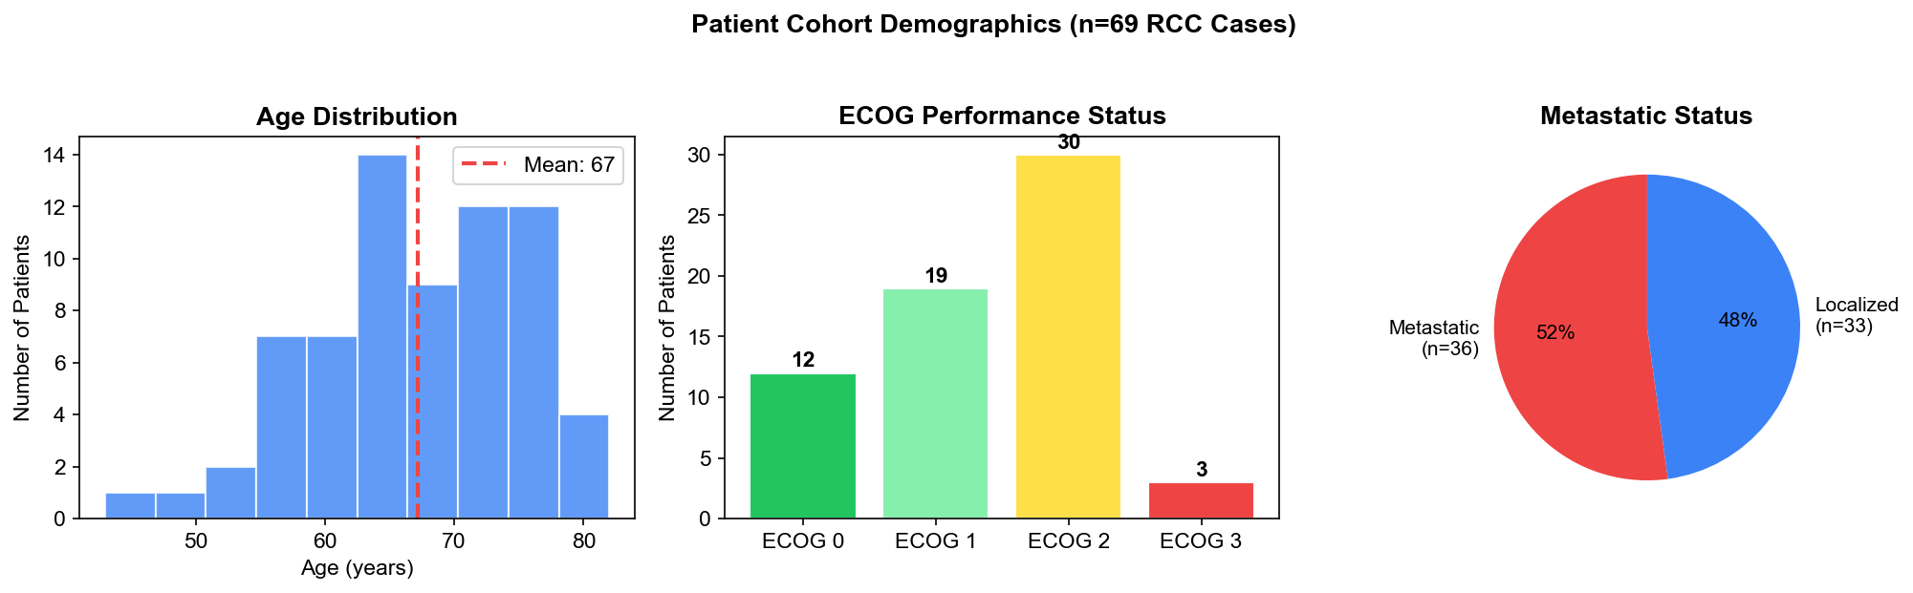

Demographics Summary
Characteristic | Value
Total cases | 69
Age range | 43–82 years
Age mean / median | 67 / 67 years
Metastatic | 36 (52.2%)
Localized | 33 (47.8%)
Clear cell (ccRCC) | 12
Non-clear cell | 3
Histology not specified | 54

ECOG Performance Status
Status | Count | Percentage | Description
ECOG 0 | 12 | 18.8% | Fully active
ECOG 1 | 19 | 29.7% | Restricted but ambulatory
ECOG 2 | 30 | 46.9% | Ambulatory, limited self-care
ECOG 3 | 3 | 4.7% | Limited self-care

6. Study Design & Data Overview

Evaluation Scope
Component | Count | Details
RCC Cases | 69 | Anonymized from German tumor boards
LLM Models | 6 | Gemma 3 27B, Gemma 3 4B, MedGemma 27B, Meditron3 7B, OLMo 32B Instruct, OLMo 32B Think
AI Judges | 2 | GPT-5.2, MedGemma 27B
Total Predictions | 414 | 69 cases × 6 models
Judge Evaluations | 828 | 69 cases × 6 models × 2 judges
Uro-Oncologist Model Reviews | 414 | 69 cases × 6 models
Uro-Oncologist Judge Reviews | 828 | 69 cases × 6 models × 2 judges

Uro-Oncologist Review Scales
Metric | Scale | Description
Therapy Acceptable | Yes / No | Would the uro-oncologist accept this therapy for the patient?
Recommendation Exact Match | 0–100 | How closely does the prediction match the tumor board recommendation?
Recommendation Patient-Oriented | 0–100 | How appropriate is the recommendation for this specific patient?
Prediction Quality | 0–9 | Overall quality of the model's prediction and reasoning

Judge Scoring Dimensions
Dimension | Scale | Description
Semantic Match | 0–1 | Does the prediction match the ground truth semantically?
Clinical Score | 0–1 | Is the therapy clinically appropriate regardless of exact match?
Reasoning Quality | 0–1 | Quality and correctness of the model's clinical reasoning
Overall Score | 0–1 | Weighted composite of all dimensions
Is Correct | True / False | Binary verdict: does the prediction match ground truth?

7. Model Performance — Automated Evaluation
All 414 predictions across 69 cases were evaluated by both AI judges. This section shows the automated metrics before any uro-oncologist validation.
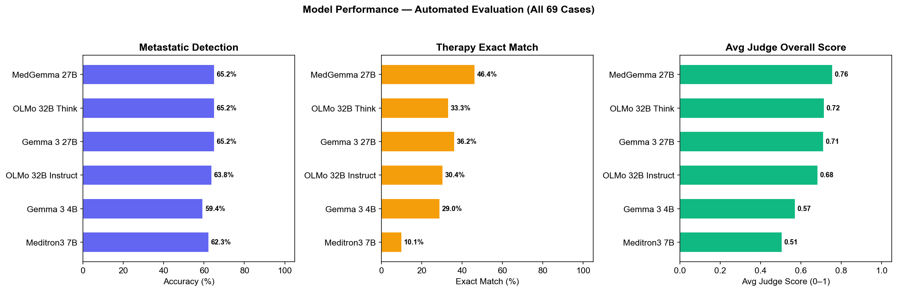

Automated Metrics Summary
Model | Cases | Met. Detect. | Exact Match | Judge Acc. | Avg Score
MedGemma 27B | 69 | 65.2% | 46.4% | 65.2% | 0.76
OLMo 32B Think | 69 | 65.2% | 33.3% | 62.3% | 0.72
Gemma 3 27B | 69 | 65.2% | 36.2% | 59.4% | 0.71
OLMo 32B Instruct | 69 | 63.8% | 30.4% | 53.6% | 0.68
Gemma 3 4B | 69 | 59.4% | 29.0% | 43.5% | 0.57
Meditron3 7B | 69 | 62.3% | 10.1% | 42.0% | 0.51
Overall: 63.5% of predictions correctly identified metastatic status. 30.9% matched the tumor board therapy exactly, while 58.7% were classified as clinically acceptable (broader than exact match).

Detailed Judge Scores
Model | Semantic | Clinical | Reasoning | Overall
MedGemma 27B | 0.75 | 0.81 | 0.64 | 0.76
OLMo 32B Think | 0.69 | 0.79 | 0.61 | 0.72
Gemma 3 27B | 0.70 | 0.79 | 0.60 | 0.71
OLMo 32B Instruct | 0.67 | 0.75 | 0.58 | 0.68
Gemma 3 4B | 0.59 | 0.62 | 0.44 | 0.57
Meditron3 7B | 0.51 | 0.56 | 0.39 | 0.51

8. Therapy Category Analysis
Each model's therapy prediction was classified into standard categories. The distribution reveals which treatment approaches models favor and how this varies across models.
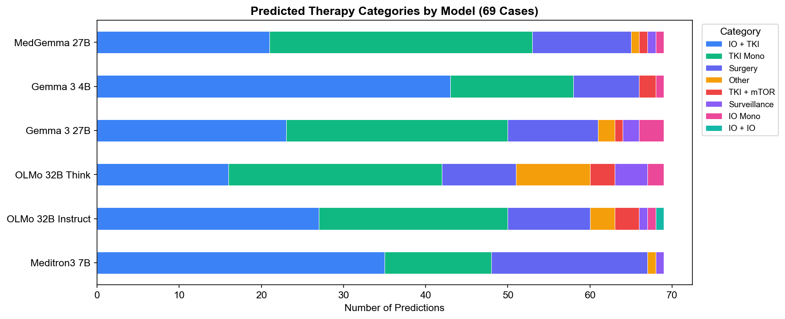
Therapy Category | Count | % of Predictions
IO + TKI | 165 | 39.9%
TKI Mono | 136 | 32.9%
Surgery | 69 | 16.7%
Other | 16 | 3.9%
TKI + mTOR | 10 | 2.4%
Surveillance | 9 | 2.2%
IO Mono | 8 | 1.9%
IO + IO | 1 | 0.2%
IO + TKI (immunotherapy combined with tyrosine kinase inhibitor) and TKI Mono are the dominant predicted categories, reflecting current RCC treatment guidelines for metastatic disease. Surgery dominates predictions for localized cases.

9. Model Performance — Uro-Oncologist Review
Dr. Alexa reviewed 414 model predictions across 69 cases, providing expert assessment on therapy acceptability, exact match, patient orientation, and overall quality.

Therapy Acceptability Rate
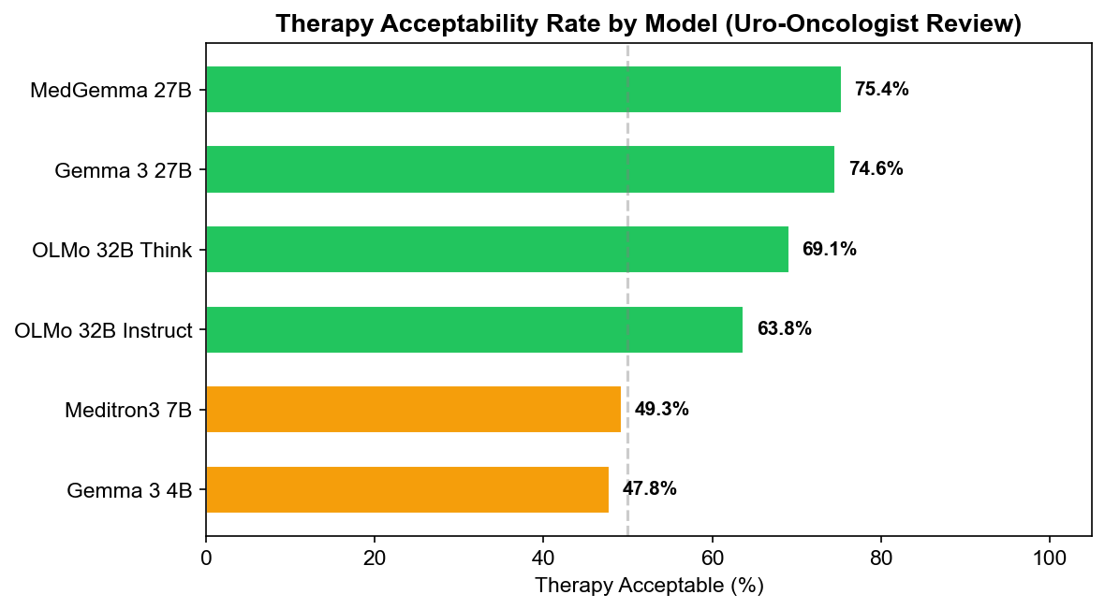

Average Prediction Quality
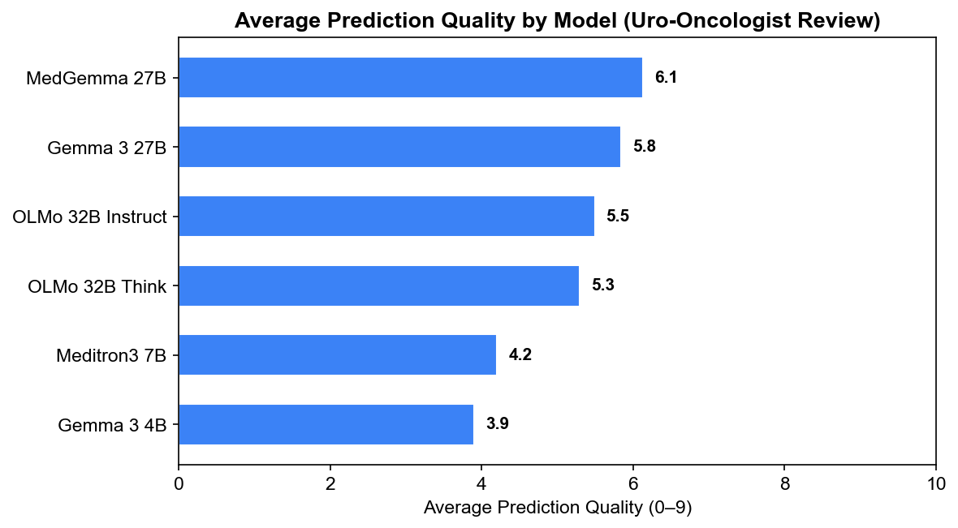

Uro-Oncologist Review Summary
Model | Cases | Acceptable % | Avg Exact Match | Avg Patient-Oriented | Avg Quality (0–9)
MedGemma 27B | 69 | 75.4% | 63.8 | 63.5 | 6.1
Gemma 3 27B | 69 | 74.6% | 61.8 | 61.8 | 5.8
OLMo 32B Instruct | 69 | 63.8% | 49.8 | 50.6 | 5.5
OLMo 32B Think | 69 | 69.1% | 54.1 | 54.1 | 5.3
Meditron3 7B | 69 | 49.3% | 41.1 | 41.2 | 4.2
Gemma 3 4B | 69 | 47.8% | 39.9 | 39.9 | 3.9

10. Case Studies
The following cases illustrate key patterns observed in the evaluation. Each case shows the ground truth therapy recommendation from the tumor board (Tumordiskussion), predictions from all 6 models, and evaluation outcomes.

Case Study A: Model Consensus — Correct Prediction
Case ncc_37: 69-year-old patient, ECOG 1, metastatic . Diagnosis: Metastasiertes Nierenzellkarzinom (mRCC) mit Progress unter 1. Linie (Pembrolizumab + Axitinib).
Tumor Board Recommendation (Ground Truth): Start 2. Linie Cabozantinib; Monitoring: Blutdruck/Proteinurie, Leberwerte, TSH; Re-Staging nach 8–12 Wochen.
Model | Predicted Category | Exact Match | Acceptable
Meditron3 7B | IO+TKI | No | Yes
OLMo 32B Instruct | Biopsie → IO+IO/TKI | Yes | Yes
OLMo 32B Think | TKI mono | Yes | Yes
Gemma 3 27B | TKI mono | Yes | Yes
Gemma 3 4B | TKI | Yes | Yes
MedGemma 27B | TKI mono | Yes | Yes
All or most models agreed on the correct therapy category. This case demonstrates that for well-defined clinical scenarios, current LLMs can reliably identify appropriate treatment approaches.

Case Study B: Model Disagreement
Case ncc_32: 62-year-old patient, ECOG 1, localized . Diagnosis: Metastasiertes RCC (ED 12.06.2023), 1. Linie Cabozantinib (2023–2025); CT 10.12.2025 mit Lokalrezidiv in Nephrektomie-Loge links (OP-Status angenommen) und peritonealer Metastasierung; keine pulmonalen/ossären Metastasen im CT..
Tumor Board Recommendation (Ground Truth): Start 2. Linie (z. B. IO-basierte Kombination oder alternative Sequenz je nach Vorbehandlung und Nierenfunktion). Monitoring: Nierenwerte, Blutdruck, Proteinurie, klinische Symptomkontrolle.
Model | Predicted Category | Exact Match | Acceptable
Meditron3 7B | IO+TKI | No | No
OLMo 32B Instruct | TKI mono / IO | Yes | No
OLMo 32B Think | IO | No | No
Gemma 3 27B | IO mono | No | No
Gemma 3 4B | TKI | No | No
MedGemma 27B | TKI mono | No | No
Models predicted 6 different therapy categories: IO, IO mono, IO+TKI, TKI, TKI mono, TKI mono / IO. This divergence highlights cases where clinical ambiguity leads to different model interpretations.

Case Study C: Uro-Oncologist–Judge Divergence
Case ncc_1: 52-year-old patient, ECOG 0, metastatic papillär. Diagnosis: Metastasiertes papilläres RCC.
Tumor Board Recommendation (Ground Truth): Einleitung palliative Systemtherapie TKI/IO (z.B. Nivolumab/Cabozantinib).
Model | Predicted Category | Exact Match | Acceptable
Meditron3 7B | Surgery | No | No
OLMo 32B Instruct | TKI mono | No | Yes
OLMo 32B Think | TKI mono | No | Yes
Gemma 3 27B | TKI mono | Yes | Yes
Gemma 3 4B | IO+TKI | No | Yes
MedGemma 27B | TKI mono | Yes | Yes
The physician rated the therapy as acceptable, but both AI judges classified it as incorrect. This illustrates how strict semantic matching by AI judges may reject clinically valid alternative therapies that an experienced oncologist would accept.

11. Judge Score Distributions
Distribution of AI judge scores across all 69 cases and 6 models. This shows how each judge rates different models and the spread of scores across different scoring dimensions.

Overall Score by Model and Judge
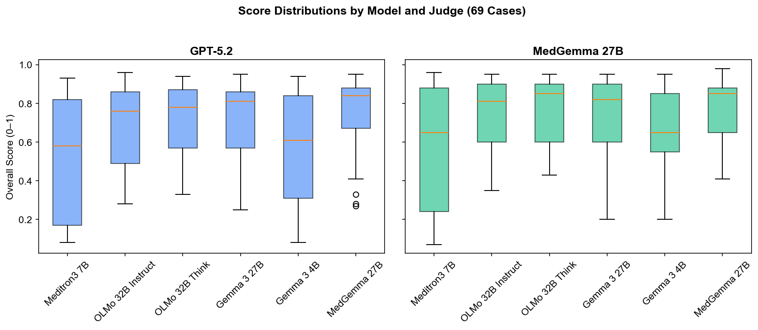

Score Types by Judge
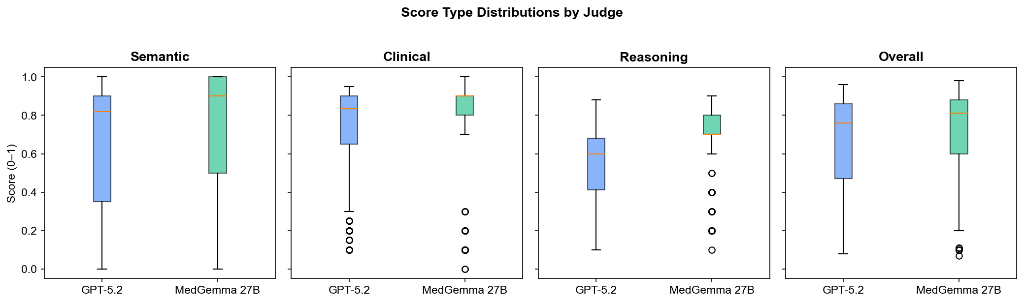

Distribution Summary
Judge | Score Type | Mean | Median | Std Dev | Min | Max
GPT-5.2 | Semantic | 0.651 | 0.820 | 0.317 | 0.00 | 1.00
GPT-5.2 | Clinical | 0.722 | 0.835 | 0.237 | 0.10 | 0.95
GPT-5.2 | Reasoning | 0.545 | 0.600 | 0.182 | 0.10 | 0.88
GPT-5.2 | Overall | 0.658 | 0.760 | 0.248 | 0.08 | 0.96
MedGemma 27B | Semantic | 0.671 | 0.900 | 0.362 | 0.00 | 1.00
MedGemma 27B | Clinical | 0.798 | 0.900 | 0.227 | 0.00 | 1.00
MedGemma 27B | Reasoning | 0.712 | 0.700 | 0.145 | 0.10 | 0.90
MedGemma 27B | Overall | 0.708 | 0.810 | 0.218 | 0.07 | 0.98

12. Agreement: Uro-Oncologist vs AI Judge
Agreement analysis based on 69 cases with complete uro-oncologist reviews and judge evaluations (407 prediction–evaluation pairs per judge). Cohen's Kappa measures agreement beyond chance between the uro-oncologist's therapy acceptability rating and the judge's correctness verdict.

Confusion Matrices
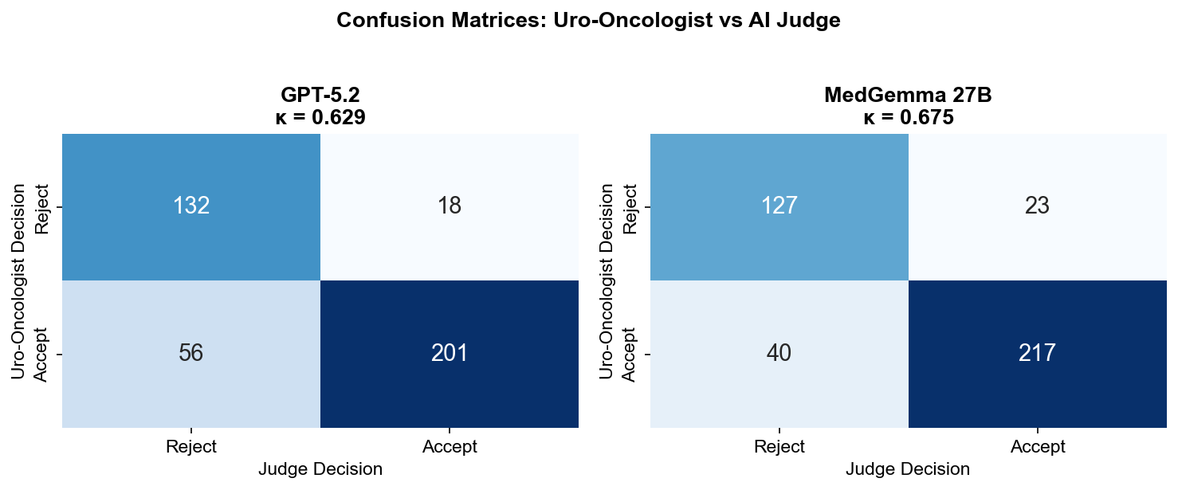

Agreement Metrics
Metric | GPT-5.2 | MedGemma 27B
N pairs | 407 | 407
Cohen's κ | 0.629 | 0.675
Agreement Rate | 81.8% | 84.5%
Sensitivity | 0.782 | 0.844
Specificity | 0.880 | 0.847
Precision | 0.918 | 0.904
F1 Score | 0.845 | 0.873

GPT-5.2: κ = 0.629 indicates substantial agreement. Sensitivity = 78.2%, Specificity = 88.0%.
MedGemma 27B: κ = 0.675 indicates substantial agreement. Sensitivity = 84.4%, Specificity = 84.7%.

13. Uro-Oncologist's Direct Rating of AI Judges
Dr. Alexa directly reviewed 828 judge evaluations across 69 cases, rating whether the judge's assessment was correct (agree/partial/disagree) and the quality of the judge's reasoning.
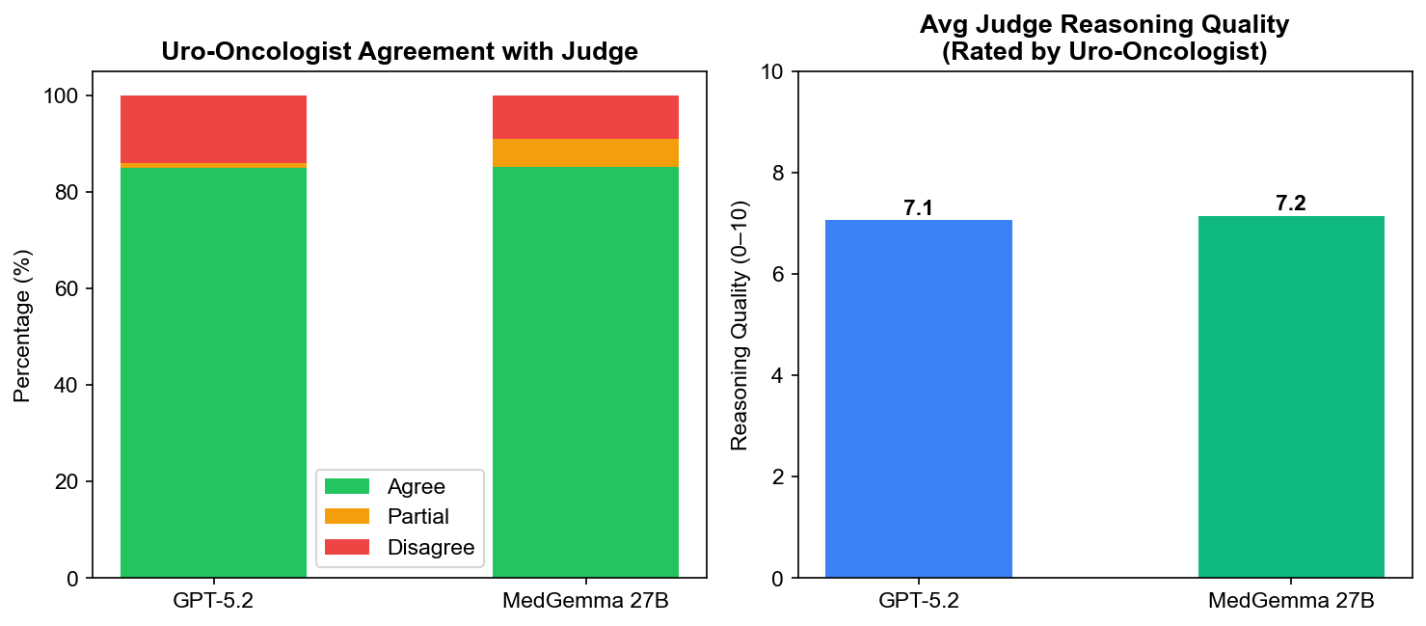
Metric | GPT-5.2 | MedGemma 27B
Total Reviews | 414 | 414
Agree | 352 (85.0%) | 353 (85.3%)
Partial | 4 (1.0%) | 24 (5.8%)
Disagree | 58 (14.0%) | 37 (8.9%)
Avg Reasoning Quality | 7.1/10 | 7.2/10

14. Per-Model Judge Accuracy
This heatmap shows the agreement rate (%) between each judge and the uro-oncologist, broken down by model.
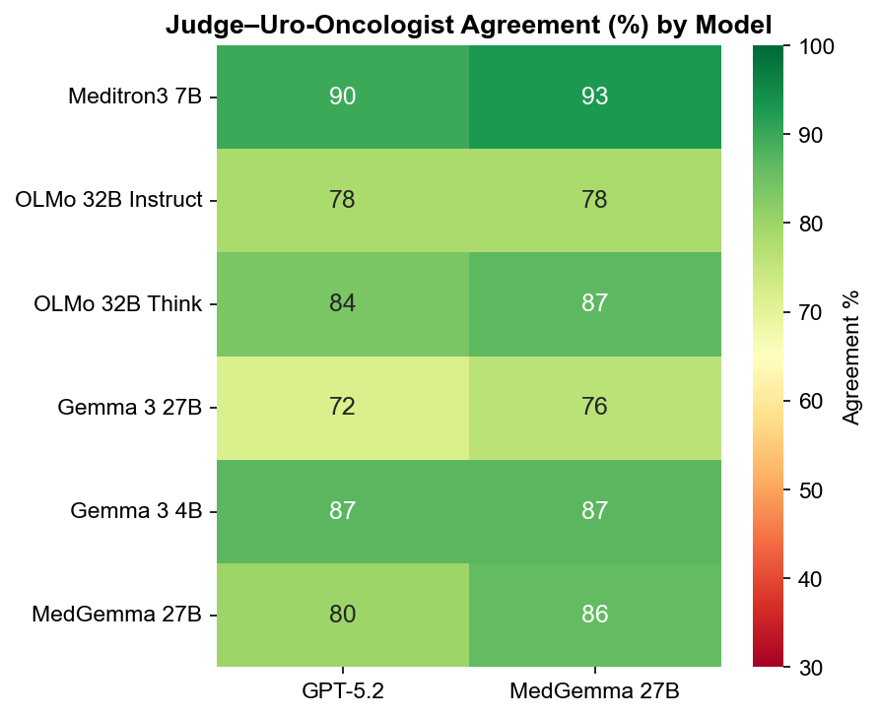
Model | Uro-Oncologist Acceptable % | GPT-5.2 Agr. | MedGemma 27B Agr.
Meditron3 7B | 49.3% | 89.9% | 92.8%
OLMo 32B Instruct | 63.8% | 78.3% | 78.3%
OLMo 32B Think | 69.1% | 83.8% | 86.8%
Gemma 3 27B | 74.6% | 71.6% | 76.1%
Gemma 3 4B | 47.8% | 87.0% | 87.0%
MedGemma 27B | 75.4% | 80.0% | 86.2%

15. Inter-Judge Agreement
Agreement between GPT-5.2 and MedGemma 27B across 414 evaluation pairs (69 cases × 6 models).
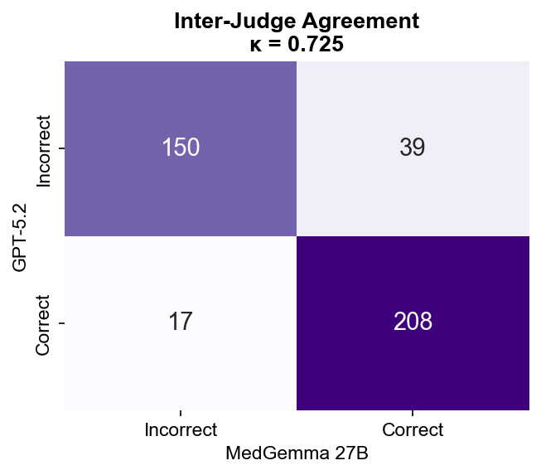
Cohen's κ = 0.725 (substantial agreement). Overall concordance: 86.5%.

16. MedGemma Self-Judging Bias
MedGemma serves dual roles: both as a predictive model and as a judge. This analysis tests whether MedGemma shows bias when evaluating its own predictions compared to other models' predictions.
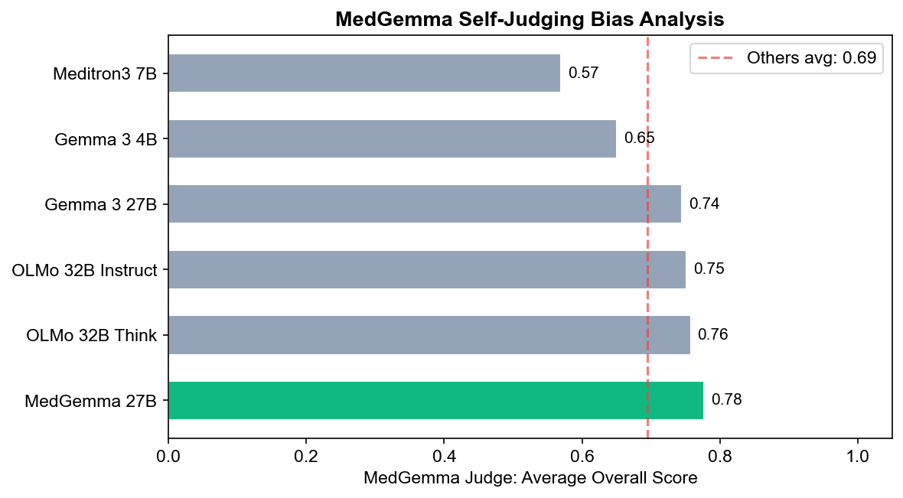
Metric | Self-Judging | Judging Others
N evaluations | 69 | 345
Mean Overall Score | 0.777 | 0.695
Median Overall Score | 0.850 | 0.780
Mann-Whitney U test: U = 14062, p = 0.0170 (statistically significant). MedGemma gives higher scores to its own predictions by 0.082 points on average.

17. Clinical Safety Analysis
Clinical safety is assessed by examining two types of judge errors when compared to the uro-oncologist's assessment:
- False Positive (dangerous): Judge approves a prediction the uro-oncologist rejects. Could lead to inappropriate treatment.
- False Negative (overly strict): Judge rejects a prediction the uro-oncologist approves. Could prevent appropriate treatment.
Safety Metric | GPT-5.2 | MedGemma 27B
Total Pairs | 407 | 407
Judge Approvals | 219 | 240
Judge Rejections | 188 | 167
False Positives (dangerous) | 18 (8.2%) | 23 (9.6%)
False Negatives (overly strict) | 56 (29.8%) | 40 (24.0%)

GPT-5.2: 18 false positives out of 219 approvals (8.2% dangerous error rate). 56 false negatives out of 188 rejections (29.8% overly strict rate).
MedGemma 27B: 23 false positives out of 240 approvals (9.6% dangerous error rate). 40 false negatives out of 167 rejections (24.0% overly strict rate).

18. Summary Comparison: GPT-5.2 vs MedGemma 27B
Side-by-side comparison of all computed metrics for both AI judges.
Metric | GPT-5.2 | MedGemma 27B
Cohen's κ (vs Uro-Oncologist) | 0.629 | 0.675
Agreement Rate | 81.8% | 84.5%
Sensitivity | 0.782 | 0.844
Specificity | 0.880 | 0.847
F1 Score | 0.845 | 0.873
Corr: Quality (ρ) | 0.722 | 0.661
Corr: Exact Match (ρ) | 0.766 | 0.694
Uro-Oncologist Agree % | 85.0% | 85.3%
Avg Reasoning Quality | 7.1/10 | 7.2/10
False Positive Rate | 8.2% | 9.6%
False Negative Rate | 29.8% | 24.0%
Avg Overall Score | 0.658 | 0.708
Avg Clinical Score | 0.722 | 0.798
Avg Semantic Score | 0.651 | 0.671
Avg Reasoning Score | 0.545 | 0.712

19. German–English Medical Glossary
Key German medical terms used throughout this report and the clinical case data. Terms are preserved in their original German form to maintain clinical precision.
German Term | English Translation | Context
Nierenzellkarzinom (NCC/RCC) | Renal Cell Carcinoma | Primary cancer type in this study
Tumordiskussion / Tumorboard | Tumor Board Discussion | Multidisciplinary case conference
Systemtherapie | Systemic Therapy | Drug-based cancer treatment (chemo, IO, TKI)
Klarzellig (ccRCC) | Clear Cell | Most common RCC histological subtype
Metastasiert | Metastatic | Cancer spread beyond primary organ
Lokalisiert | Localized | Cancer confined to primary organ
Nephrektomie | Nephrectomy | Surgical removal of kidney
Erstlinientherapie | First-line Therapy | Initial treatment regimen
Zweitlinientherapie | Second-line Therapy | Treatment after first-line failure
Lebenserwartung | Life Expectancy | Estimated patient survival time
Nebendiagnosen | Comorbidities | Co-existing medical conditions
Bildgebung | Imaging | Radiological examinations (CT, MRI, etc.)
Histologie-Subtyp | Histology Subtype | Microscopic tissue classification
Leitlinienkonform | Guideline-Concordant | Consistent with clinical practice guidelines

20. Conclusions & Recommendations

Key Findings
- Model Performance: MedGemma 27B achieved the highest uro-oncologist-rated quality (6.1/9) with 75.4% therapy acceptability. MedGemma 27B scored highest on automated judge evaluation (0.76/1.0).
- Best AI Judge: MedGemma 27B showed the strongest agreement with the uro-oncologist (κ = 0.675). Both judges show moderate agreement, indicating they are useful but not perfect proxies for expert clinical judgment.
- Therapy Categories: IO+TKI and TKI Mono dominate model predictions, consistent with current RCC treatment guidelines for the 36/69 metastatic cases in the cohort.
- Clinical Safety: GPT-5.2 has the lowest dangerous error rate (8.2%). Both judges tend to be overly strict (high false negative rates), which is safer than being too permissive in a clinical context.
- Self-Judging Bias: MedGemma shows statistically significant self-judging bias. When MedGemma serves as both predictor and judge, its self-evaluations should be interpreted with caution.

Recommendations
- AI judges should be used as screening tools, not final arbiters. Uro-oncologist review remains essential for clinical safety.
- Using both GPT-5.2 and MedGemma as judges and flagging disagreements could improve evaluation reliability — their complementary strengths (GPT-5.2 higher specificity, MedGemma higher sensitivity) create a more robust assessment.
- Models with high acceptability rates but lower exact match scores may still provide clinically valid alternative recommendations worthy of tumor board discussion.
- The strong Spearman correlations (ρ > 0.64) between judge scores and uro-oncologist ratings suggest automated judge scores are useful proxies for prediction quality, enabling scalable evaluation.
- Future work should expand the dataset to include additional cancer types, test with multiple physician reviewers for inter-rater reliability, and evaluate medical-specialized models like Med-PaLM and BioMistral.

Limitations
This study relies on a single physician reviewer, which may introduce individual assessment bias. The case dataset is limited to RCC from a single institution's tumor boards. The uro-oncologist reviewed all 69 cases for both model evaluation and judge evaluation, providing complete coverage. Ground truth represents the tumor board consensus, which is one valid approach but not necessarily the only correct therapy. All cases use German medical terminology, which may affect model performance compared to English-language clinical data.

Open Questions
Several methodological questions remain open and may affect interpretation of the results:
- Ground Truth Definition: Is the ground_truth_therapy field the tumor board consensus recommendation or the actual treatment administered? The distinction matters when tumor board recommends X but the patient receives Y.
- IMDC for Non-Clear-Cell RCC: IMDC risk stratification is only validated for clear-cell mRCC. Models sometimes calculate IMDC for papillary/chromophobe subtypes with a disclaimer. The preferred approach (skip vs. calculate with caveat) has not been standardized.
- ICI Eligibility: Many cases have null ICI eligibility. The criteria for determining whether an ICI combination is feasible (autoimmune disease, prior transplant, active infection) are not explicitly coded in the data.
- Therapy Guidelines Completeness: The embedded prompt guidelines cover first/second-line therapies but may not include adjuvant pembrolizumab, non-clear-cell-specific protocols, third-line options, oligometastatic management, or cytoreductive nephrectomy criteria.
- Four JSON Schema Variants: The dataset uses four different JSON structures across 69 cases. While the pipeline handles all variants, edge cases in field mapping may introduce subtle data quality issues.

