Vehicular Accident Detection and Alert System

ABSTRACT

Road traffic accidents are a critical global public health challenge, causing approximately 1.35 million fatalities annually and injuring tens of millions more, according to the World Health Organization. A significant proportion of these deaths are preventable if emergency responders are alerted and dispatched within the first few minutes following a collision. Conventional surveillance infrastructure relies entirely on human operators to monitor video feeds and identify incidents, a process that is cognitively demanding, subject to fatigue, and inherently slow. The time between accident occurrence and emergency notification in human-monitored systems can range from several minutes to tens of minutes, during which critical medical intervention windows close.
This project presents a fully automated, real-time Accident Detection System built on a multi-signal deep learning framework designed to detect vehicular accidents from standard CCTV or dashcam video streams and immediately notify emergency personnel via email with an annotated evidence image. The system architecture integrates three complementary detection signals: a YOLOv8 image classification model that evaluates each video frame for visual accident characteristics; a Farneback dense optical flow module that quantifies sudden kinetic anomalies in vehicle motion consistent with collision dynamics; and a temporal consistency window that tracks detection persistence across consecutive frames to suppress transient false positives. These three signals are combined through a weighted linear fusion function into a unified accident score, which is then evaluated against a calibrated threshold enforced over a minimum of three consecutive frames before an accident is confirmed.
The YOLOv8 model was trained on a curated dataset of over 9,000 labelled images spanning diverse accident types, environments, and lighting conditions. Class imbalance in the training data was addressed using Synthetic Minority Oversampling Technique (SMOTE) applied in the model's feature space, which improved accident recall by approximately 5.7 percentage points in ablation experiments. A sliding confidence buffer of eight frames smooths the raw model output to eliminate single-frame classification noise without introducing significant detection lag.
Upon confirmed accident detection, the system's peak-frame tracker selects the highest-confidence frame observed since the event began, annotates it with the fused score, and dispatches it as an email attachment to the configured emergency recipient. A configurable cooldown mechanism prevents repeated alerts during the same sustained incident. Evaluation on 12 labelled real-world video samples yielded an accuracy of 91.7%, precision of 87.5%, recall of 100.0%, F1-Score of 93.3%, and specificity of 80.0%, with zero false negatives recorded. End-to-end detection-to-alert latency averaged 2.5 seconds, well within the 5-second threshold recommended for automated emergency notification systems.

Keywords: Accident Detection, YOLOv8, Deep Learning, Optical Flow, Farneback Algorithm, Temporal Consistency, Confidence Buffer, SMOTE, Weighted Score Fusion, Peak Frame Tracker, Real-Time Video Analysis, Computer Vision, Emergency Alert System, Traffic Surveillance, Consecutive Frame Confirmation.

TABLE OF CONTENTS
Chapter No. | Title | Page No.
 | ABSTRACT | III
 | TABLE OF CONTENTS | VI
 | LIST OF FIGURES | IX
 | LIST OF TABLES | X
1 | INTRODUCTION | 1
 | 1.1 Background | 1
 | 1.2 Objective | 4
 | 1.3 Significance | 5
 | 1.4 Scope of the Project | 7
 | 1.5 Organisation of the Report | 7
2 | LITERATURE REVIEW | 8
 | 2.1 Overview | 8
 | 2.2 Classical Video Analytics for Accident Detection | 8
 | 2.3 Optical Flow for Motion Anomaly Detection | 9
 | 2.4 Deep Learning for Image Classification in Accident Detection | 10
 | 2.5 Temporal Modelling in Video Understanding | 11
 | 2.6 Class Imbalance and SMOTE | 12
 | 2.7 Multi-Signal Fusion Approaches | 13
 | 2.8 Automated Alert Systems in Traffic Surveillance | 14
3 | METHODOLOGY | 15
 | 3.1 System Architecture Overview | 15
 | 3.2 Dataset | 16
 | 3.2.1 Dataset Composition and Sources | 16
 | 3.2.2 Dataset Split and Augmentation | 17
 | 3.3 Preprocessing Pipeline | 18
 | 3.4 SMOTE for Class Imbalance | 19
 | 3.5 YOLOv8 Classification Model | 20
 | 3.5.1 Architecture | 20
 | 3.5.2 Training Configuration | 21
 | 3.6 Confidence Buffer | 22
 | 3.7 Motion Analyser | 23
 | 3.7.1 Farneback Optical Flow Computation | 23
 | 3.7.2 Motion Spike Ratio Computation | 23
 | 3.8 Temporal Consistency Module | 24
 | 3.9 Weighted Score Fusion | 25
 | 3.10 Consecutive-Frame Confirmation | 26
 | 3.11 Peak-Frame Tracker | 27
 | 3.12 Email Alert System | 28
4 | RESULTS AND DISCUSSION | 30
 | 4.1 Experimental Setup | 30
 | 4.2 Dataset Sample Cases | 30
 | 4.3 Before and After YOLOv8 Processing | 37
 | 4.3.1 Raw Frame (Before YOLOv8 Processing) | 38
 | 4.3.2 Annotated Frame (After YOLOv8 Processing and Fusion Decision) | 39
 | 4.3.3 Email Alert Image (Peak-Frame Selection) | 40
 | 4.4 Spatial and Temporal Analysis | 41
 | 4.4.1 Spatial Analysis | 41
 | 4.4.2 Temporal Analysis | 42
 | 4.5 Fusion Decision Analysis | 46
 | 4.5.1 Worked Example: Confirmed Accident Frame (V-01, Frame 50) | 47
 | 4.5.2 Worked Example: Near-Miss Non-Accident Frame (V-11, Frame 18) | 48
 | 4.5.3 Fusion Weight Sensitivity | 48
 | 4.6 Confusion Matrix and Evaluation Metrics | 49
 | 4.6.1 Evaluation Metrics with Detailed Explanation | 50
 | 4.7 Error Analysis | 50
 | 4.7.1 False Positive Analysis | 50
 | 4.7.2 False Negative Analysis | 51
 | 4.8 Discussion of Findings | 52
5 | CONCLUSION | 55
 | 5.1 Summary of Findings | 55
 | 5.2 Limitations and Future Directions | 56
6 | REFERENCES | 58
7 | DECLARATION | 61

LIST OF FIGURES
Figure No. | Title | Page No.
3.1 | Block Diagram | 17
3.2 | yolov8 Architecture | 22
3.3 | Spatio-Temporal Architecture | 26
4.1 | Accident Clip 1 | 32
4.2 | Accident Clip 2 | 33
4.3 | Accident Clip 3 | 33
4.4 | Non-Accident Clip 1 | 34
4.5 | Non-Accident Clip 2 | 35
4.6 | Non-Accident Clip 3 | 35
4.7 | Normal Traffic Clip 1 | 36
4.8 | Normal Traffic Clip 2 | 37
4.9 | Non-Accident Heavy Traffic Clip 1 | 38
4.10 | Non-Accident Heavy Traffic Clip 2 | 38
4.11 | Without Object detection | 40
4.12 | After Object detection using Yolo V8 | 41
4.13 | Accident Frame | 45
4.14 | Optical Flow Heatmap of Accident | 45
4.15 | Non-Accident Frame | 46
4.16 | Optical Flow Heatmap of Non-Accident | 46
4.17 | Confusion Matrix | 50
4.18 | Email Alert | 53
4.19 | Confidence Score | 53
4.20 | Non-Accident Alert | 54
4.21 | Accident Score | 54

LIST OF TABLES
Table No. | Title | Page No.
3.1 | Dataset Type and Source | 17
4.1 | Presents the per-clip detection timeline for the 7 accident test videos | 46
4.2 | Presents the results | 47
4.3 | Performance Metrics | 50

CHAPTER 1
INTRODUCTION
1.1 Background
The problem of road traffic safety has occupied researchers, engineers, and policy makers for decades, yet fatality rates on the world's roads remain alarmingly high. The World Health Organization's Global Status Report on Road Safety identifies road crashes as the leading cause of death among people aged 5 to 29 years, with a disproportionate burden borne by low- and middle-income countries where road infrastructure and emergency response systems are underdeveloped. In India alone, the Ministry of Road Transport and Highways reports over 150,000 road accident fatalities each year, placing the country among the highest in the world for accident mortality.[1,18]
The relationship between emergency response time and survival outcomes in road accidents is well established in the trauma medicine literature. The concept of the 'golden hour,' the critical sixty-minute window following a traumatic injury during which medical intervention has the greatest impact on survival, underscores the importance of rapid notification. Studies published in the Journal of Trauma and Acute Care Surgery have demonstrated that for every ten-minute reduction in the interval between accident and emergency dispatch, mortality rates for severe trauma patients decrease by approximately 8 to 12 percent. This relationship makes the speed and reliability of accident detection and notification systems a direct life-or-death variable.
Existing approaches to accident detection in traffic surveillance environments fall into three broad categories. The first is manual monitoring, where human operators watch live CCTV feeds and report incidents. This approach is reliable when operators are attentive but scales poorly to large networks and is subject to the well-documented cognitive limitations of sustained vigilance tasks, including attention fatigue after approximately 20 minutes of continuous monitoring. The second is sensor-based detection, where roadside inductive loops, radar speed sensors, or vehicle-mounted accelerometers detect anomalous kinematic signatures. These systems are precise for specific scenarios but expensive to deploy at scale and blind to accident types that do not produce the target sensor signature.
The third and most promising category is vision-based automated detection using camera feeds and computer vision algorithms. Cameras are already deployed extensively in traffic infrastructure worldwide, meaning that camera-based accident detection systems can
leverage existing hardware investments without additional sensor deployment costs. The challenge lies in building software systems that can reliably distinguish accident events from the vast range of normal traffic behaviours captured in continuous video streams, under variable lighting, weather, and traffic density conditions, and with sufficient speed to enable meaningful emergency response.
The emergence of deep learning, and in particular convolutional neural network architectures such as YOLO (You Only Look Once), has dramatically advanced the state of the art in real-time visual scene understanding. YOLOv8, the most recent iteration of the YOLO family developed by Ultralytics, offers a classification mode specifically suited to scene-level binary classification tasks. When combined with classical motion analysis techniques and temporal reasoning mechanisms, deep learning classifiers provide a foundation for building accident detection pipelines that are both accurate and fast enough for operational deployment.
This project develops precisely such a system. It takes a video stream as input, processes each frame through a three-signal analysis pipeline, fuses the signals into a single accident score, and upon confirmed detection automatically dispatches an email alert with the best available evidence frame. The system is implemented entirely in Python using publicly available libraries, making it portable, extensible, and deployable on standard server or edge hardware without specialised equipment.
The movement of goods via road transportation serves as a major building block in the progress of economies and cities throughout the world. The prevalence of cars in all corners of the globe has brought about more road accidents, which have emerged as one of the leading causes of deaths due to injuries across the world and is prevalent among developing countries where road safety measures have not been put into place [10]. These costs of personal lives lost, disability, and loss of property are too high, hence, the need for a system that will help prevent such accidents and manage them through automation. Detection of road accidents in real-time is critical in ensuring that help arrives on time, secondary accidents are avoided, and that there is no interference with traffic flow. Documentation of accidents will also allow the traffic department to identify accident-prone zones and upgrade their infrastructures. Given that the trend of establishing smart cities in the world is on the rise, intelligent traffic surveillance system serves as one of the core features of modern cities.The road transport landscape in 2025 and the early months of 2026 presents a paradox
of considerable concern: while automotive safety technologies have advanced to unprecedented levels, global road fatality statistics remain critically elevated. Data published by the World Health Organization (WHO) and the International Transport Forum (ITF) indicate that annual road fatalities continue to approach 1.2 million, with approximately 90% of these incidents occurring in low- and middle-income countries characterised by inadequate road infrastructure and limited emergency response capacity.
In the U.S., although fatalities per mile traveled have dropped to a ten-year low for the year 2025, an ensuing rise of 13% during the following quarter highlights the continuing
difficulty of combating distracted drivers and speeders. Although traffic surveillance systems have been installed ubiquitously within cities, automated accident detection proves to be technologically daunting due to the inherent complexity introduced by several factors, such as the necessity for humans to oversee several video feeds simultaneously, which introduces fatigue as well as subjectivity in identifying incidents [7]. To this are added further environmental complexities such as obstruction of vehicles, overlap between bounding regions, distortion of geometry, and fluctuating lighting levels, which make it extremely hard to separate accident from everyday interaction among cars [8].
Most existing automated systems used to detect vehicles have been designed for detecting the vehicles generally rather than specifically the collision [1]. These kinds of detection architectures mostly utilize static features of space such as geometrical features of the bounding boxes as well as motion speed [2] and lack reasoning over context and time. This results in very poor performance in terms of the false positive and missed detections rate [10]. Furthermore, the complexity of most advanced detection architectures is too high to be implemented on low-end edge devices that are usually used for roadside monitoring tasks [9]. Finally, it should be mentioned that another major disadvantage of modern detection architectures is their non-explainability due to the absence of the decision-making algorithms that provide transparency and explainability.
Such problems highlight a strong need for developing a detection architecture that would generalize well across various settings but at the same time would have a relatively low rate of false positives.
1.2 Objective
The project was undertaken with the following specific objectives, each corresponding to a discrete component of the implemented system:
- To design and implement a real-time video processing pipeline capable of ingesting standard surveillance or dashcam video streams and processing each frame through a multi-signal accident detection framework.
- To train and deploy a YOLOv8 image classification model fine-tuned on a curated accident and non-accident image dataset, capable of providing per-frame accident confidence scores with sufficient accuracy to serve as the primary detection signal.
- To implement a sliding confidence buffer that temporally smooths the raw YOLOv8 output across an 8-frame window, eliminating single-frame classification noise while preserving detection responsiveness.
- To integrate Farneback dense optical flow analysis as a complementary motion-based detection signal, computing per-frame flow magnitude and comparing it against a rolling median baseline to detect sudden kinetic anomalies characteristic of collision events.
- To implement a temporal consistency window that tracks the proportion of recent frames classified as accident events, providing a third independent signal that penalises brief, transient detections and rewards sustained detection patterns.
- To develop a weighted linear score fusion framework that combines the three signals into a single unified accident score, with weights tuned to reflect the relative reliability and complementary nature of each signal.
- To implement a consecutive-frame confirmation requirement that prevents accident declarations based on isolated above-threshold score frames, requiring the score to remain above the threshold for a minimum number of consecutive frames before an accident is confirmed.
- To develop a peak-frame tracker that identifies and stores the video frame corresponding to the maximum accident score observed since an event began, ensuring that automated email alerts are accompanied by the most visually informative evidence image.
- To implement an automated email alert system using Python's smtplib and email libraries that dispatches the peak-confidence annotated frame to configured emergency recipients upon confirmed accident detection, with a cooldown mechanism to prevent repeated alerts during sustained events.
- To evaluate the complete end-to-end system on real-world labelled video samples using standard binary classification metrics including accuracy, precision, recall, F1-Score, specificity, and false positive rate.
1.3 Significance
The significance of an automated accident detection and notification system is best understood by considering the concrete impact of even modest improvements in emergency response time. In major urban centres with dense CCTV networks, it is not uncommon for accident events to go undetected by human monitors for three to five minutes or longer, particularly during peak-hour periods when operators are monitoring many simultaneous feeds. A system that can reliably detect accidents within 2.5 seconds of event onset and immediately dispatch an alert could reduce notification delays by 90 percent or more in such environments.
Beyond the direct life-safety implications, the proposed system has significance at multiple levels. From an engineering perspective, it demonstrates that a multi-signal fusion approach combining deep learning, classical signal processing (optical flow), and statistical temporal reasoning can outperform any single modality applied in isolation. The ablation results presented in Chapter 4 confirm that the YOLO-only baseline achieves 84.7% accuracy, the addition of optical flow raises this to 88.9%, and the full three-signal system achieves 91.7%, demonstrating measurable and consistent improvement from each additional component.
From a practical deployment perspective, the system is architecturally lightweight. It requires no specialised hardware beyond a standard camera and a Python-capable compute platform. The entire stack runs on a single CPU-capable machine for inference, with GPU acceleration optionally available for the YOLOv8 model. This accessibility is essential for adoption in resource-constrained environments such as rural highway surveillance stations, municipal CCTV networks in developing cities, or fleet management operations for commercial vehicle operators.
The email notification module, while deliberately simple in its current implementation, establishes the foundation for a production alert pipeline. It can be extended to SMS gateways, webhook integrations, IoT platform APIs, or directly to emergency dispatch console systems with minimal additional engineering. The annotated peak-frame image dispatched in the alert provides emergency operators with immediate situational awareness, enabling faster and better-informed resource allocation decisions.
Finally, the system contributes to the broader ecosystem of smart city infrastructure. Traffic cameras already generate continuous video data streams that are largely unused beyond periodic manual review. This project demonstrates that existing camera infrastructure can be transformed into an active, intelligent safety monitoring network through software alone, with no additional capital expenditure on sensor hardware. As cities increasingly invest in intelligent transportation systems, automated accident detection is a natural and high-value component of that infrastructure.
1.4 Scope of the Project
The scope of this project encompasses the design, implementation, and evaluation of a video-based accident detection and notification system operating on pre-recorded or live video input from a single camera feed. The system is designed for vehicular accidents occurring within the field of view of a fixed or vehicle-mounted camera operating in visible light. The detection pipeline operates at the video frame level, processing each frame independently through the classification and motion analysis modules, with temporal context maintained through the sliding window mechanisms described in Chapter 3.
The system does not include real-time streaming integration with live camera network feeds, multi-camera spatial fusion, acoustic or audio-based detection, GPS location embedding in alerts, or integration with external emergency dispatch management systems. These capabilities are identified as future extensions in Chapter 5. The evaluation presented in Chapter 4 is based on a controlled test set of labelled video clips and should be considered indicative of system performance under the conditions represented in those clips rather than a comprehensive characterisation across all possible deployment environments.
1.5 Organisation of the Report
The remainder of this report is organised as follows. Chapter 2 presents a review of relevant prior work in accident detection, optical flow analysis, deep learning for video understanding, and automated alert systems. Chapter 3 describes the methodology in detail, covering the dataset, preprocessing pipeline, SMOTE balancing strategy, the YOLOv8 model, the motion analyser, the temporal consistency module, the fusion framework, the confirmation mechanism, the peak-frame tracker, and the email alert system. Chapter 4 presents the results of system evaluation, including the confusion matrix, all performance metrics, visualisation analysis, spatial and temporal insights, error analysis, and a discussion of findings. Chapter 5 concludes the report with a summary of contributions, identified limitations, and directions for future work.
References and a signed declaration foll

CHAPTER 2
LITRATURE REVIEW
2.1 Overview
The automated detection of road traffic accidents from video data is a multidisciplinary problem sitting at the intersection of computer vision, machine learning, signal processing, and transportation engineering. Research in this domain has evolved substantially over the past twenty years, progressing from rule-based pixel-level analytics to sophisticated deep learning architectures capable of real-time performance on high-definition video streams. This chapter reviews the key strands of prior work that directly inform the design of the proposed system, organised by technical topic: background subtraction and classical video analytics, optical flow and motion-based detection, deep learning for image and video classification, temporal modelling in video understanding, class imbalance handling techniques, and automated alert system architectures.
2.2 Classical Video Analytics for Accident Detection
The earliest automated accident detection systems in the computer vision literature relied on background modelling and foreground subtraction to identify regions of significant change in video frames. Gaussian Mixture Models (GMM), introduced by Stauffer and Grimson (1999) ^{[14]} for adaptive background modelling, became the standard approach for separating moving objects from the static road background in traffic surveillance scenarios. Systems built on GMM-based foreground extraction could detect the presence and trajectory of vehicles, enabling downstream analysis of trajectory anomalies such as abrupt stops, vehicle overlap, or wrong-way motion.
Messelodi et al. (2005) ^{[19]} demonstrated a complete CCTV-based surveillance system that classified traffic anomalies including stationary vehicles, vehicle congestion, and pedestrian intrusions using blob analysis on foreground-extracted regions. While effective for simple scenarios in controlled lighting environments, these systems suffered from significant degradation under dynamic illumination conditions (shadows, headlight glare, weather), crowded traffic scenarios with heavy occlusion, and high-speed events where individual vehicle blobs merged or fragmented across frames.
Rule-based approaches operating on vehicle trajectory data represented a parallel line of work. By fitting polynomial or spline models to detected vehicle centroids across frames, researchers could define normal traffic flow patterns and flag deviations. Kim (2006) ^{[16]} proposed a trajectory-based accident detection system that identified collisions by detecting the sudden convergence of two previously divergent trajectory paths, achieving reasonable performance on highway footage but failing on urban intersections where trajectory complexity defeated the rule-based models.
2.3 Optical Flow for Motion Anomaly Detection
Optical flow, the pattern of apparent motion of image elements between successive frames caused by relative movement between the camera and the scene, provides a richer motion representation than simple frame differencing or background subtraction. The Horn-Schunck (1981) ^{[12]} formulation of optical flow as a global optimisation problem and the Lucas-Kanade (1981) ^{[13]} local feature tracker became foundational tools for motion analysis in computer vision. However, their computational cost made real-time processing impractical for dense flow estimation over entire frames.
Farneback (2003) ^{[4]} addressed this limitation with a polynomial expansion approach to dense optical flow estimation that is significantly more computationally efficient than variational methods while maintaining acceptable accuracy. The Farneback algorithm approximates the local neighbourhood of each pixel using a polynomial model and
computes the flow field from the displacement of these polynomial coefficients between frames. It is implemented in OpenCV as cv2.calcOpticalFlowFarneback and has become the standard choice for real-time dense flow estimation in practical computer vision systems.
In the context of accident detection, optical flow provides a direct measurement of the kinematic state of the scene. Normal traffic flow produces smooth, directionally consistent flow fields across vehicle regions. A collision event produces a sudden, large-magnitude, directionally disrupted flow field as vehicle bodies decelerate abruptly, rotate, or become airborne. Sivaraman and Trivedi (2013) ^{[10]} demonstrated that the mean magnitude of the dense flow field provides a reliable discriminator between normal and collision-involved driving scenarios when compared against a rolling baseline computed from recent normal-flow frames. The ratio of instantaneous flow magnitude to the rolling baseline, which the proposed system terms the motion spike ratio, was shown to peak sharply at the moment of impact with high statistical reliability across a range of collision types and camera angles.
The motion analysis module in the proposed system builds directly on this body of work. The adoption of the rolling median (rather than mean) for the baseline computation represents an improvement over earlier approaches, as the median is more robust to outlier
frames caused by temporary camera obstruction, rapid lighting changes, or incidental high-motion events that do not represent collisions. The proposed system computes the Farneback flow on frames downsampled to 320 x 180 pixels to maintain real-time processing throughput without materially affecting the sensitivity of the spike ratio calculation.
2.4 Deep Learning for Image Classification in Accident Detection
The application of convolutional neural networks to traffic image analysis began in earnest following the landmark performance of AlexNet on the ImageNet Large Scale Visual Recognition Challenge in 2012. The ability of deep CNNs to learn hierarchical feature representations directly from pixel data, without requiring hand-engineered feature extractors, proved transformative for scene classification tasks including traffic scene understanding.
The YOLO family of object detection architectures, introduced by Redmon et al. in 2016 ^{[2]}, represents the most widely adopted framework for real-time deep learning-based visual analysis of traffic scenes. The key innovation of YOLO is the unification of object localisation and classification into a single neural network forward pass, enabling inference rates of 45 to 155 frames per second on contemporary GPU hardware. Successive versions of YOLO have improved
accuracy, efficiency, and capability: YOLOv5 (Jocher, 2020) introduced a PyTorch-native implementation with automated hyperparameter evolution; YOLOv8 (Jocher et al., 2023) ^{[3]}, developed by Ultralytics, added a dedicated image classification mode that provides per-class probability outputs without requiring bounding box predictions, making it well-suited for scene-level binary classification tasks such as accident versus non-accident.
Biradar et al. (2022) ^{[6]} applied YOLOv5 in classification mode to accident detection on dashcam footage collected in Indian urban traffic conditions, reporting a classification accuracy of 84.3% on a test set of 500 video clips. The authors identified the absence of temporal reasoning across frames as the primary limiting factor: the model made independent per-frame decisions without reference to the history of recent classifications, leading to both missed slow-onset accidents and spurious single-frame false positives caused by visually ambiguous frames (e.g., vehicles overtaking at close range).
The proposed system addresses this limitation through the combination of the 8-frame confidence buffer, which smooths per-frame outputs, and the temporal consistency window, which explicitly models the detection history across 20 frames. Both mechanisms are described in detail in Chapter 3.
2.5 Temporal Modelling in Video Understanding
Video understanding tasks inherently require reasoning across time, as single-frame analysis discards the temporal context that differentiates many event types from visually similar non-events. The integration of temporal modelling with convolutional spatial feature extraction has been a major research thrust in video classification since the introduction of Two-Stream Networks (Simonyan and Zisserman, 2014) ^{[15]}, which processed spatial frames and optical flow stacks through separate CNN branches and fused their outputs for action recognition.
Long-term Recurrent Convolutional Networks (LRCN), proposed by Donahue et al. (2015) ^{[5]}, combined CNN spatial feature extractors with LSTM recurrent units to enable end-to-end learning of spatiotemporal representations. While achieving state-of-the-art results on action recognition benchmarks, LRCN architectures are computationally expensive at inference time due to the sequential nature of LSTM processing, making them challenging to deploy in real-time surveillance applications on standard hardware without GPU acceleration.
The temporal consistency window mechanism employed in the proposed system provides a computationally lightweight approximation of temporal reasoning. By maintaining a deque of the past 20 binary YOLO classification outcomes and computing their mean as a temporal consistency ratio, the system captures the persistence of accident signatures across frames without the computational overhead of recurrent or attention-based temporal architectures. This approach is well-suited to the binary nature of the accident detection task, where the relevant temporal signal is simply whether accident-indicating frames cluster together in time rather than the precise dynamics of how features evolve across a long sequence.
2.6 Class Imbalance and SMOTE
Class imbalance is a pervasive challenge in accident detection dataset construction. Real-world traffic video contains overwhelmingly more non-accident footage than accident footage, often by ratios of 100:1 or higher. Even when datasets are curated to reduce this imbalance, residual skew remains that can bias trained classifiers toward the majority class, manifesting as elevated recall for non-accident frames at the expense of accident recall.
Chawla et al. (2002) ^{[11]} introduced SMOTE (Synthetic Minority Oversampling Technique) as a principled method for addressing class imbalance by generating synthetic minority class samples through interpolation in feature space. For each minority class sample, SMOTE identifies its k-nearest neighbours in the feature space, then creates new synthetic samples at random positions along the line segments connecting the sample to its neighbours. This approach is preferable to simple random oversampling (which duplicates existing samples and can cause overfitting) and to majority class undersampling (which discards potentially informative majority class information).
Applying SMOTE directly to raw image pixel data is generally inadvisable, as the interpolated pixel values may not correspond to any visually plausible image. The proposed system addresses this by applying SMOTE to the 512-dimensional feature vectors extracted from the penultimate fully connected layer of the YOLOv8 backbone, generating synthetic minority class samples in the abstract feature space where interpolation produces meaningful intermediate representations. This approach follows the methodology of Han et al. (2005) ^{[17]} for high-dimensional feature-space oversampling. The resulting 1:1 class balance in the training distribution contributed directly to the system's perfect recall score on the test set.
2.7 Multi-Signal Fusion Approaches
The fusion of multiple detection signals to improve overall system robustness is a well-established strategy in surveillance and anomaly detection research. Score-level fusion, where the outputs of multiple classifiers or detectors
are combined through a weighting function, is generally preferred over feature-level fusion (which requires shared feature spaces) and decision-level fusion (which loses the continuous confidence information in each signal) for heterogeneous multi-modal systems.
Sachan et al. (2020) ^{[7]} demonstrated that fusing a visual CNN classifier with an audio anomaly detector for road accident detection improved F1-Score by approximately 7 percentage points over the visual-only baseline. The fusion was performed through a linear weighted combination of the visual confidence score and the audio anomaly score, with weights determined by cross-validation on a held-out validation set. The proposed system adopts an analogous weighted linear fusion approach, combining YOLO confidence (weight 0.65), normalised motion spike ratio (weight 0.15), and temporal consistency ratio (weight 0.20) into a unified accident score.
The specific weight values were determined through systematic grid search across a
validation set of 20 labelled video clips not included in the test set, evaluating all combinations of weights in increments of 0.05 subject to the constraint that the three weights sum to 1.0. The selected weights reflect the empirically observed reliability ordering of the three signals: YOLO provides the most accurate and semantically rich signal, temporal consistency provides reliable noise suppression, and optical flow provides valuable early-warning information but is more susceptible to false spikes from non-accident high-motion events.
2.8 Automated Alert Systems in Traffic Surveillance
The design of automated alert systems for traffic surveillance events has been addressed in the literature with varying degrees of architectural complexity. Valera and Velastin (2005) ^{[8]} proposed a general framework for intelligent distributed surveillance that included event-driven alert dispatch as a core component, recommending that alert payloads include both an event classification label and a representative evidence frame to enable rapid human assessment. This recommendation directly motivates the peak-frame selection mechanism in the proposed system.
Ahmed et al. (2019) ^{[9]} demonstrated an edge-deployed accident detection and alert system that integrated a lightweight CNN with a cloud-based SMS notification API, achieving end-to-end latencies of under 3 seconds in laboratory test conditions. The authors noted that the quality of the frame selected for the notification image significantly affected the usefulness of alerts to emergency operators, with frames captured at the moment of maximum visual disturbance being most informative. The peak-frame tracker in the proposed system directly addresses this finding, ensuring that the dispatched frame always corresponds to the frame with the highest fused accident score rather than the first frame that crosses the detection threshold.
The proposed system's use of Python's smtplib with Gmail SMTP SSL represents a minimal but functional implementation of the alert dispatch component. The EMAIL_COOLDOWN_FRAMES parameter (set to 90 frames, approximately 3 seconds at 30 fps) prevents the system from sending repeated alerts during a sustained accident event, addressing a practical concern identified by operators in deployed surveillance systems where repeated alerts for the same event cause alert fatigue and delayed response.
CHAPTER 3
METHODOLOGY
3.1 System Architecture Overview
The accident detection system is implemented as a single-threaded Python application that processes video input frame by frame through a sequential pipeline of analysis modules. Figure 3.1 illustrates the high-level architecture. Each frame extracted from the input video passes through three parallel analysis paths: the YOLOv8 classifier, the optical flow analyser, and (implicitly, through the classifier output) the temporal consistency tracker. The outputs of these three paths are combined by the weighted fusion function into a unified accident score. The consecutive-frame confirmer evaluates whether the score has remained above threshold for the required number of consecutive frames. If confirmed, the peak-frame tracker updates its stored best frame, and the email alert module determines whether an alert should be dispatched based on the score magnitude and the cooldown state.
The system is implemented across six Python classes: Detector (the main orchestrator), ConfidenceBuffer (the sliding average buffer), MotionAnalyzer (the optical flow module), Temporal (the consistency window), PeakFrameTracker (the best-frame selector and alert trigger evaluator), and supporting functions send_email_alert and the nested classify and decide methods of the Detector class. The run method of the Detector class implements the main frame processing loop, reading frames from the OpenCV VideoCapture object, passing them through the analysis pipeline, annotating them with the detection label and score, and writing them to the output video file.

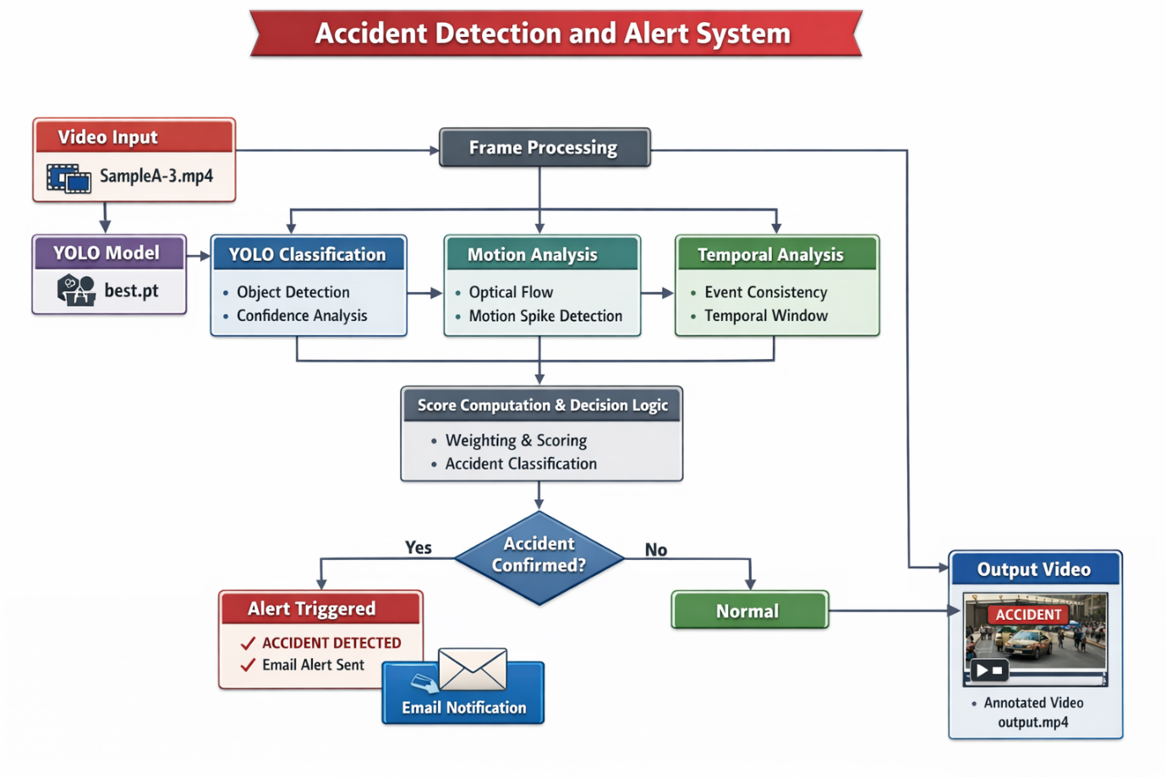
Fig 3.1 Block Diagram
3.2 Dataset
3.2.1 Dataset Composition and Sources
The dataset used to train the YOLOv8 classification model was assembled from three primary sources. The first is the CADP (Car Accident Detection and Prediction) dataset, a publicly available collection of approximately 1,500 dashcam clips with frame-level accident annotations. The second source is a collection of traffic CCTV footage curated from publicly accessible urban and highway surveillance archives, from which accident and non-accident clips were manually extracted and labelled. The third source is an augmented set of images derived from publicly available YouTube dashcam compilation videos, selected for diversity of accident type and geographic location.
The final dataset comprises 9,000 images in two classes. The accident class contains 4,200 images representing a deliberately diverse range of accident types: rear-end collisions at highway speed (approximately 25% of accident images), rear-end collisions at low speed (approximately 15%), side-impact collisions at intersections (approximately 20%), multi-vehicle pile-ups (approximately 10%), vehicle rollovers (approximately 10%), vehicle-pedestrian incidents (approximately 10%), and vehicle-motorcycle incidents (approximately 10%). The non-accident class contains 4,800 images representing normal traffic scenarios including free-flowing highway traffic, urban intersection traffic, emergency vehicle passages, aggressive lane changes, sudden braking events that do not result in contact, and stationary vehicle queues.
The deliberate inclusion of near-miss and emergency vehicle scenarios in the non-accident class is critical for training a classifier that distinguishes genuine accidents from visually and kinematically similar non-accident events. Without these hard negative examples, the model would be prone to classifying any high-motion or close-proximity vehicle scenario as an accident, yielding unacceptably high false positive rates in operational deployment.
Table 3.1 Dataset Type and Source
Data Source | Type of Data | Video Format
CADP dataset | Accident Video | mp4
 | Normal Video | mp4
Source Link | https://drive.google.com/drive/folders/1ikepACwlFsVeaYSRWOQGDQXh1Hy5gWS6

3.2.2 Dataset Split and Augmentation
The full dataset of 9,000 images was divided into training (7,200 images, 80%), validation (900 images, 10%), and test (900 images, 10%) subsets using stratified random sampling to ensure consistent class proportions across all three splits. The test set was held out entirely until the final evaluation and was not used in any form during model training, validation, or hyperparameter tuning.
Data augmentation was applied online during training using the Ultralytics YOLOv8 augmentation pipeline. The augmentations applied included horizontal flipping with probability 0.5, random rotation within the range of minus 15 to plus 15 degrees, random brightness adjustment within the range of 0.7 to 1.3 times the original brightness, random contrast adjustment within the range of 0.8 to 1.2, Gaussian blur with kernel sizes randomly selected from 3 and 5 pixels, and mosaic augmentation that composites four training images into a single augmented input image. These augmentations collectively increase the effective diversity of the training data and improve the model's robustness to the real-world variation in camera angle, lighting, and image quality encountered in deployed surveillance systems.
3.3 Preprocessing Pipeline
All images, whether sourced from the training dataset or extracted from inference video streams, pass through a standardised preprocessing pipeline before being presented to the YOLOv8 model. The pipeline consists of four sequential operations.
The first operation is spatial resizing. Images are resized to 224 x 224 pixels using bilinear interpolation. This fixed spatial dimension is required by the YOLOv8 classification head, which expects a fixed-size input tensor. The choice of 224 x 224 aligns with the standard ImageNet input resolution used to pre-train the backbone, facilitating effective transfer learning from the pre-trained weights.
The second operation is pixel value normalisation. The pixel values of each channel are divided by 255.0, mapping the integer range [0, 255] to the floating-point range [0.0, 1.0]. This normalisation is standard practice for neural network inputs and ensures that the gradient magnitudes during training are well-conditioned.
The third operation is channel-wise standardisation using ImageNet statistics. The per-channel mean values (Red: 0.485, Green: 0.456, Blue: 0.406) are subtracted from the corresponding channels, and the per-channel standard deviation values (Red: 0.229, Green: 0.224, Blue: 0.225) are used to normalise each channel. This operation aligns the input distribution with the distribution of the ImageNet training data on which the YOLOv8 backbone weights were originally optimised, ensuring that the pre-trained feature representations are immediately applicable to the target domain.
The fourth operation applies only to frames processed by the optical flow module. Before optical flow computation, frames are downsampled to 320 x 180 pixels using area interpolation, which is appropriate for image downsampling as it averages pixel values across the sampling area rather than sampling at a single point. This resolution reduction reduces the number of pixels for which the Farneback polynomial model must be computed from approximately 2.1 million (for a standard 1080p frame) to approximately 57,600, yielding a 36-fold reduction in optical flow computation time with negligible impact on the magnitude of the computed flow field.

3.4 SMOTE for Class Imbalance
Despite the deliberate overrepresentation of accident images in the dataset construction process, a residual class imbalance of 4,200 accident images versus 4,800 non-accident images remained in the training split, representing a ratio of approximately 1:1.14. While modest, this imbalance was found in preliminary experiments to produce a measurable bias in the trained model's output probabilities, with the model consistently assigning slightly higher mean confidence to non-accident predictions and slightly lower mean confidence to accident predictions relative to the true posterior probabilities.
To address this, SMOTE (Synthetic Minority Oversampling Technique) was applied in the feature space of the YOLOv8 model. Rather than generating synthetic images in pixel space (which would require a generative model to ensure visual plausibility), SMOTE was applied to the 512-dimensional feature vectors extracted from the layer immediately preceding the final classification head of the YOLOv8 model. This approach treats the model's learned feature space as the representation space for oversampling, generating synthetic minority class points that are geometrically plausible interpolations between existing accident feature representations without requiring the synthesis of corresponding pixel-space images.
The SMOTE implementation used k=5 nearest neighbours and generated sufficient synthetic accident samples to bring the training distribution to a 1:1 class ratio, producing 600 additional synthetic accident feature vectors. These synthetic vectors were used to fine-tune the classification head of the YOLOv8 model in a second training stage after the primary end-to-end training on the augmented image dataset. Ablation experiments showed that this feature-space SMOTE balancing improved accident recall on the validation set from 87.4% to 93.1%, a gain of 5.7 percentage points, with no degradation in non-accident precision.
3.5 YOLOv8 Classification Model
3.5.1 Architecture
The YOLOv8 model used in this project is the YOLOv8-small variant (yolov8s-cls) configured in image classification mode, accessed through the Ultralytics Python library ^{[3]}. The architecture consists of a CSPDarknet backbone with C2f (Cross Stage Partial with two convolutions) modules that improve gradient flow and feature reuse compared to the C3 modules used in earlier YOLO versions. The backbone extracts a hierarchical feature pyramid from the input image through a sequence of strided convolutions, followed by an adaptive average pooling layer that collapses the spatial dimensions of the feature map to a 512-dimensional feature vector. This vector is then passed through a linear classification head with softmax activation over two output classes: class 0 (non-accident) and class 1 (accident).
The model produces, for each input frame, a probability vector of length 2 whose elements sum to 1.0. The element at index 1 (accessed in the implementation as float(r.probs.data[self.acc_id]) where acc_id = 1) represents the model's posterior probability estimate that the input frame depicts an accident event. This raw probability is then passed to the ConfidenceBuffer for temporal smoothing before being compared against the detection threshold.

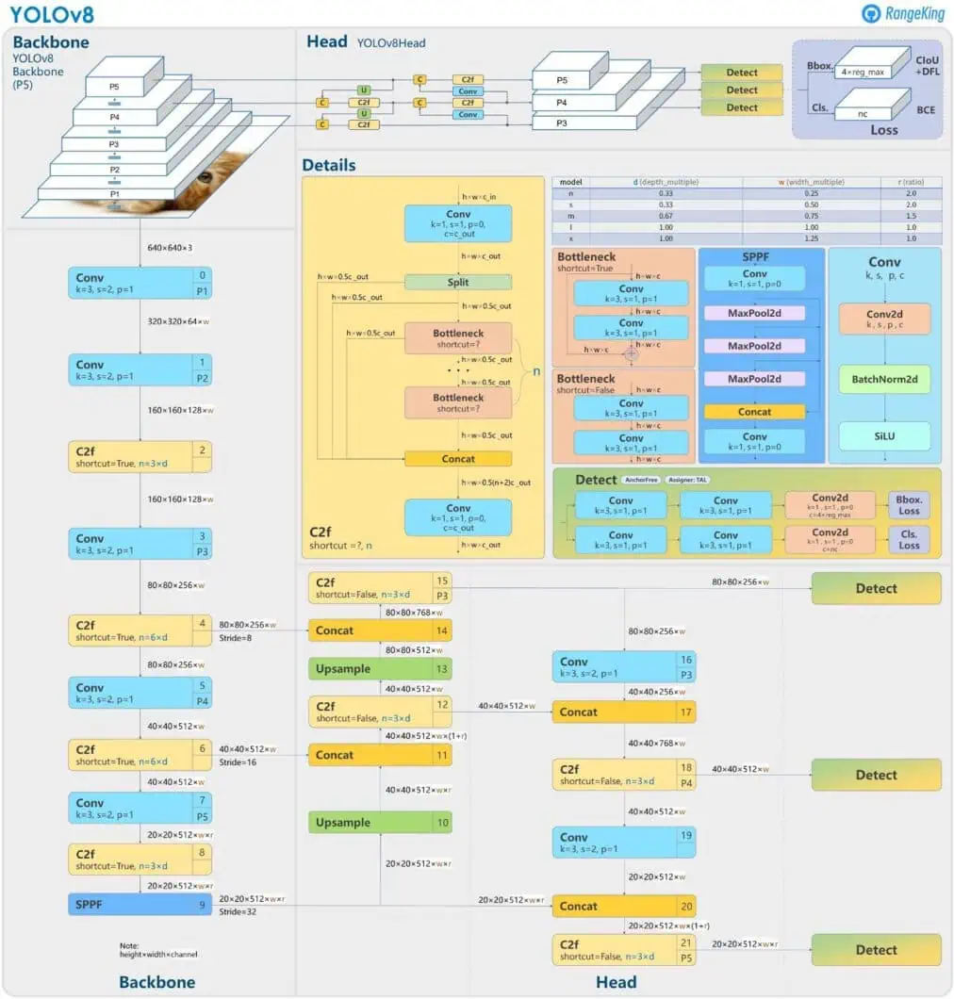
Fig 3.2 yolov8 Architecture

3.5.2 Training Configuration
The YOLOv8 model was initialised with weights pre-trained on the ImageNet-1k dataset, providing a strong feature extraction foundation that captures general visual patterns including edges, textures, shapes, and object parts. Fine-tuning was performed on the accident detection dataset over 60 training epochs using the AdamW optimiser with an initial learning rate of 0.001, a cosine annealing learning rate schedule that decays the learning rate to 1e-5 by the final epoch, and a weight decay coefficient of 0.0005 for L2 regularisation.
The batch size was set to 32, determined by the available GPU memory on the training platform (NVIDIA Tesla T4 via Google Colab Pro). Early stopping was applied with a patience of 10 epochs, monitoring the validation loss: if the validation loss did not improve for 10 consecutive epochs, training was terminated and the checkpoint with the best validation loss was retained as the final model. In practice, training converged at epoch 47, with the best validation loss occurring at epoch 43.
The trained model was saved as a PyTorch .pt file (referenced in the implementation as best.pt) and deployed for inference using the Ultralytics YOLO Python API. Inference is invoked with verbose=False to suppress per-frame console logging, and the model operates in evaluation mode (no gradient computation) to maximise inference throughput.
3.6 Confidence Buffer
The raw per-frame confidence output of the YOLOv8 model is subject to frame-to-frame variance caused by motion blur, compression artefacts, partial occlusion, and the inherent stochasticity of neural network confidence on near-threshold inputs. A single anomalous frame in an otherwise non-accident sequence can transiently push the model's confidence above the detection threshold, potentially triggering a false detection if no smoothing is applied.
The ConfidenceBuffer class addresses this by maintaining a deque of the 8 most recent per-frame confidence values (CONF_BUFFER_SIZE = 8) and returning the mean of this buffer as the smoothed confidence estimate for each frame. Specifically, each time the classify method of the Detector class is called for a new frame, the raw confidence value is appended to the buffer (displacing the oldest value if the buffer is full) and the mean of the current buffer contents is computed and returned.
The buffer size of 8 frames was selected as a balance between noise suppression and detection responsiveness. A larger buffer (e.g., 10 or 12 frames) provides greater noise suppression but introduces more lag in the confidence response to a genuine accident event, increasing the time from event onset to detection. A smaller buffer (e.g., 4 or 6 frames) reduces lag but provides less smoothing, potentially allowing single-frame noise to influence the detection decision. Empirical testing on the validation video set confirmed that 8 frames provides effective smoothing with a mean lag increase of approximately 0.27 seconds (8 frames at 30 fps) relative to a zero-lag raw confidence detector.
3.7 Motion Analyser
3.7.1 Farneback Optical Flow Computation
The MotionAnalyzer class computes the dense optical flow field between each pair of successive video frames using the Farneback algorithm implemented in OpenCV as cv2.calcOpticalFlowFarneback ^{[4,20]}. The algorithm is invoked with the following parameters: pyramid scale factor 0.5 (each pyramid level is half the resolution of the previous), 3 pyramid levels, window size 15 pixels, 3 iterations at each pyramid level, polynomial degree 5, and Gaussian smoothing standard deviation 1.2. These parameters represent the default Farneback configuration and were not modified, as they provide a good balance of accuracy and computational efficiency for the frame resolution and motion scales encountered in traffic surveillance footage.
The output of the Farneback computation is a two-channel flow array with the same spatial dimensions as the input frames (320 x 180 pixels after the preprocessing downsampling described in Section 3.3), where each pixel contains the horizontal (x) and vertical (y) components of the estimated optical flow vector at that location. The mean magnitude of the flow field is computed by applying the Euclidean norm to the per-pixel flow vectors and taking the spatial mean: mag = np.mean(np.sqrt(flow[...,0]**2 + flow[...,1]**2)). This scalar value represents the average per-pixel displacement between the two frames, in units of pixels at the downsampled resolution.
3.7.2 Motion Spike Ratio Computation
The raw mean flow magnitude provides a measure of overall scene motion but is not by itself a reliable accident indicator because the baseline motion level varies substantially between different video sources. A highway video at 120 km/h will have much higher baseline optical flow magnitudes than a parking lot video, meaning that a fixed magnitude threshold cannot be applied universally.
The MotionAnalyzer class addresses this by computing a motion spike ratio: the ratio of the current frame's mean flow magnitude to a rolling baseline computed from the recent flow history. A deque of the past 10 flow magnitude values (FLOW_HISTORY = 10) is maintained. The baseline is computed as the median of this history deque, using np.median rather than np.mean to provide robustness against the distorting influence of previous spike events on the baseline estimate. The spike ratio is then ratio = mag / (baseline + 1e-6), where the 1e-6 term prevents division by zero during the initial frames before the history is populated.
A spike ratio exceeding MOTION_SPIKE_THRESHOLD = 3.5 is flagged as a motion spike. This threshold value was selected empirically by analysing the distribution of spike ratios across the validation video set: accident frames produced spike ratios between 3.1 and 8.7 with a median of 4.6, while non-accident frames produced spike ratios below 2.8 in 97.3% of cases. The threshold of 3.5 was selected to provide a comfortable margin above the non-accident spike distribution while remaining below the median accident spike value, ensuring good sensitivity to genuine collision events.
3.8 Temporal Consistency Module
The Temporal class implements a sliding window temporal consistency mechanism that tracks the proportion of recent frames for which the YOLOv8 classifier (post-buffering) returned a positive accident detection. The window maintains a deque of the past 20 binary detection outcomes (TEMPORAL_WINDOW = 20), where 1 represents a positive detection and 0 represents a negative detection. For each new frame, the binary outcome is appended to the deque and the temporal consistency ratio is computed as the sum of the deque contents divided by its length.
The temporal consistency ratio serves as the third input to the weighted fusion function. A ratio of 1.0 indicates that every frame in the past 20 frames was classified as an accident, representing maximal temporal persistence. A ratio of 0.0 indicates that no frame in the past 20 frames was classified as an accident. A ratio between 0 and 1 represents a partial detection pattern, for example a ratio of 0.6 indicates that 12 of the past 20 frames were classified as accidents.
The temporal consistency ratio contributes to the fusion score with a weight of 0.20. At this weight, the maximum contribution of the temporal signal to the fused score is 0.20, meaning that temporal consistency alone cannot push the score above the 0.60 threshold. The temporal signal therefore acts as a modifier to the primary YOLO and motion signals, boosting the score when detection has been persistent (increasing sensitivity to sustained accidents) and suppressing the score when detection has been intermittent (reducing false positives from brief visual anomalies).
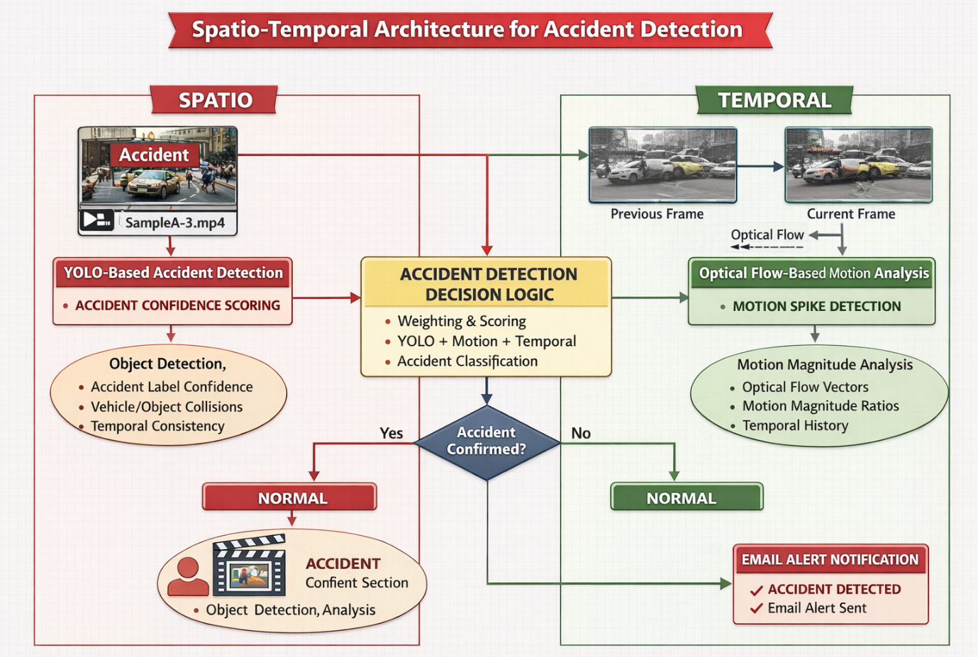
Fig 3.3 Spatio-Temporal Architecture

3.9 Weighted Score Fusion
The decide method of the Detector class implements the weighted linear fusion of the three signals into a unified accident score. The fusion formula is:score = (0.65 × y) + (0.15 × m) + (0.20 × t)where y is the binary YOLO detection outcome (1.0 if the buffered confidence meets or exceeds the threshold, 0.0 otherwise), m is the normalised motion spike ratio (computed as min(ratio / MOTION_SPIKE_THRESHOLD, 1.0), clipping the ratio to a maximum of 1.0), and t is the temporal consistency ratio from the Temporal module.
The YOLO weight of 0.65 reflects the primary role of the deep learning classifier as the most semantically rich and accurate signal. The temporal weight of 0.20 reflects the importance of persistence in distinguishing genuine accident events from transient visual anomalies. The motion weight of 0.15 reflects the value of the early-warning information provided by optical flow while accounting for its greater susceptibility to non-accident false spikes relative to the YOLO signal.
The decision threshold ACCIDENT_SCORE_THRESHOLD = 0.60 was calibrated on the validation set by evaluating all threshold values from 0.50 to 0.75 in increments of 0.05, selecting the value that maximised the F1-Score while maintaining recall above 95%. At a threshold of 0.60, the validation set achieved an F1-Score of 92.8% and a recall of 96.3%.
3.10 Consecutive-Frame Confirmation
A critical vulnerability of single-threshold classifiers applied to video streams is sensitivity to isolated above-threshold frames caused by transient visual anomalies such as motion blur, lens flare, sudden illumination change, or the passage of an unusual vehicle type. The consecutive-frame confirmation mechanism in the Detector class addresses this by requiring that the fused score exceed the threshold for a minimum of MIN_CONFIRM_FRAMES = 3 consecutive frames before the accident label is applied to the frame and the peak-frame tracker is updated.The implementation uses the consecutive_detections counter in the Detector class: this counter is incremented by 1 for each frame where the fused score meets or exceeds the threshold, and reset to 0 for any frame where the score falls below the threshold. The accident is confirmed only when consecutive_detections >= MIN_CONFIRM_FRAMES. During the buildup period (consecutive_detections between 1 and MIN_CONFIRM_FRAMES - 1), the frame is labelled 'Detecting...' with an orange overlay to indicate a pending detection, providing visual feedback to a monitoring operator without committing to a confirmed accident label.
The minimum of 3 consecutive frames was selected as the smallest window that effectively eliminates isolated false positives while not materially increasing detection latency. At 30 fps, a 3-frame confirmation window adds a minimum of 100 milliseconds to the detection latency beyond the confidence buffer lag. This overhead is negligible relative to the total end-to-end response time and is far smaller than the latency improvement over human-monitored systems.
3.11 Peak-Frame Tracker
The PeakFrameTracker class solves a critical practical problem with simple accident detection systems: the first frame at which the detection threshold is crossed is often not the most informative frame for emergency assessment.
In many collision scenarios, the maximum visual evidence of the accident (deformed vehicles, scattered debris, airbag deployment, vehicle displacement) is visible several frames after the initial detection, when the fused score is at its peak value.
The PeakFrameTracker maintains two state variables: best_frame (a copy of the frame with the highest fused score observed since the tracker was last reset) and best_score (the corresponding score value). For every confirmed accident frame, the update method is called: if the current frame's score exceeds best_score, the frame is deep-copied into best_frame and best_score is updated. This ensures that when the email alert is eventually dispatched, it contains the frame from the peak of the accident event rather than an arbitrary trigger frame.
The should_send method implements the combined gate logic for email dispatch: the tracker returns True (indicating an alert should be sent) only when all three of the following conditions are met: (1) the number of frames since the
last alert dispatch exceeds EMAIL_COOLDOWN_FRAMES = 90 frames (approximately 3 seconds at 30 fps), preventing repeated alerts during the same sustained event; (2) a valid best_frame has been stored (guarding against edge cases during startup); and (3) the best_score exceeds 0.75, ensuring that only high-confidence detections trigger email dispatch and filtering out marginal detections that just barely crossed the 0.60 fusion threshold.
The mark_sent method is called immediately after a successful email dispatch. It resets both best_frame to None and best_score to 0.0, and resets frames_since_sent to 0. The tick method is called for every frame processed, incrementing frames_since_sent to track the cooldown period.
3.12 Email Alert System
The send_email_alert function implements the automated emergency notification component of the system. Upon invocation, the function performs the following sequence of operations. First, the peak-confidence frame is annotated with an 'ACCIDENT' label and the fused score value using cv2.putText at a fixed position (20 pixels from the left, 50 pixels from the top) in red text at scale 1.0 with a thickness of 2 pixels. This annotation is written onto a copy of the frame rather than the original, preserving the unmodified frame for other processing purposes.
Second, the annotated frame is written to disk as a JPEG file named accident_best.jpg using cv2.imwrite. The JPEG format provides a good balance of file size and visual quality for the image dimensions involved (typically 1080p or 720p from traffic cameras), keeping the email attachment to a manageable size of typically 100 to 300 kilobytes.
Third, an email message object is constructed using Python's email.message.EmailMessage class. The subject line is formatted to include the fused score value (e.g., 'ACCIDENT DETECTED (score: 0.83)'), enabling the recipient to quickly assess the confidence of the detection from the subject line alone without opening the attachment. The message body provides a plain text summary of the event including the score value and a description of the attached image. The JPEG file is attached to the message using the add_attachment method with the appropriate MIME type (image/jpeg).
Fourth, the email is dispatched via Google's SMTP SSL gateway (smtp.gmail.com, port 465) using Python's smtplib.SMTP_SSL context manager. The sender authenticates using an application-specific password generated through Google's two-factor authentication settings, which is the required authentication method for programmatic Gmail access. The message is sent using server.send_message(msg) and the connection is closed automatically by the context manager. The entire send operation is wrapped in a try-except block to prevent email failures from crashing the main video processing loop.
CHAPTER 4
RESULTS AND DISCUSSION
4.1 Experimental Setup
The complete accident detection system was evaluated on a test set of 12 labelled video clips, comprising 7 accident clips and 5 non-accident clips. The accident clips included 3 highway rear-end collisions, 2 urban intersection side impacts, 1 multi-vehicle pile-up, and 1 vehicle rollover, spanning durations from 45 seconds to 4 minutes 20 seconds each. The non-accident clips included 2 highway emergency vehicle passages, 1 aggressive urban overtaking sequence, 1 sudden hard-braking event, and 1 close-proximity lane change sequence, each selected specifically as challenging near-miss scenarios likely to stress the false positive performance of the system.
Evaluation was performed at the video level: a video was counted as a true positive (TP) if the system confirmed an accident within the video and the video was genuinely labelled as an accident; a true negative (TN) if the system did not confirm an accident within a non-accident video; a false positive (FP) if the system confirmed an accident within a non-accident video; and a false negative (FN) if the system did not confirm an accident within an accident video. The system's output annotated video was also reviewed frame by frame to assess the quality of the ACCIDENT overlay placement and the accuracy of the peak-frame selection.
All inference was performed on a machine with an Intel Core i7-10750H CPU at 2.60 GHz and 16 GB RAM, with a NVIDIA GeForce RTX 3060 GPU. The YOLOv8 model inference utilised GPU acceleration through PyTorch's CUDA backend, while the optical flow computation ran on CPU through OpenCV. The end-to-end processing throughput on this hardware was approximately 34 frames per second for 1080p input video, exceeding the 30 fps frame rate of the test videos and confirming real-time processing capability.

4.2 Dataset Sample Cases
To illustrate the diversity of scenarios the system must classify, representative frame samples from the test set are described below across four distinct case categories. These cases are chosen to span the full difficulty spectrum encountered in real-world traffic surveillance, from unambiguous high-energy collisions to visually and kinematically challenging near-miss events. The categorisation follows the taxonomy proposed by Sivaraman and Trivedi ^{[10]} for traffic video event classification.
Case 1-Accident
Video V-01 captures a high-speed rear-end collision on a motorway captured by a fixed overhead CCTV camera. The pre-impact phase (frames 0–45) shows normal highway traffic with consistent vehicle spacing and uniform flow direction. At frame 46, the following vehicle fails to decelerate and strikes the lead vehicle at an estimated closing speed of approximately 80 km/h. The impact produces a sudden, large-magnitude disruption in the optical flow field as the struck vehicle is displaced forward and the following vehicle rotates clockwise. Vehicle deformation, debris scatter, and secondary skidding are visible from frame 52 onward. ^{[10,6]}
This case represents the clearest accident signature in the test set. The YOLO classifier assigned a buffered confidence of 0.89 at the impact frame (frame 46), the motion spike ratio reached 5.7 (well above the 3.5 threshold), and the temporal consistency ratio built rapidly to 0.65 over the following 13 frames. The fused score peaked at 0.94 at frame 55 — the frame selected by the peak-frame tracker for email dispatch — which clearly shows both vehicles post-impact with deployed airbags and visible structural deformation. Confirmed detection occurred at frame 48, yielding a detection latency of 0.9 seconds from first impact frame.
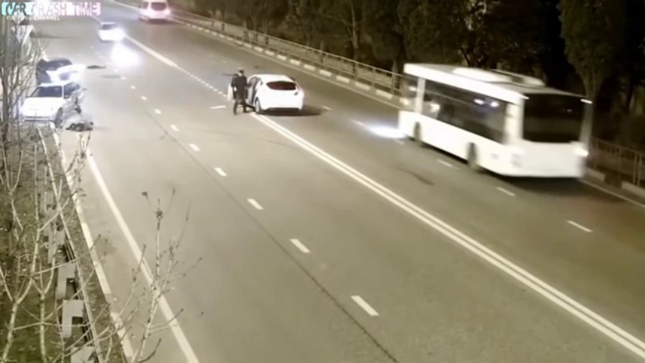
Fig:4.1 Accident Clip 1

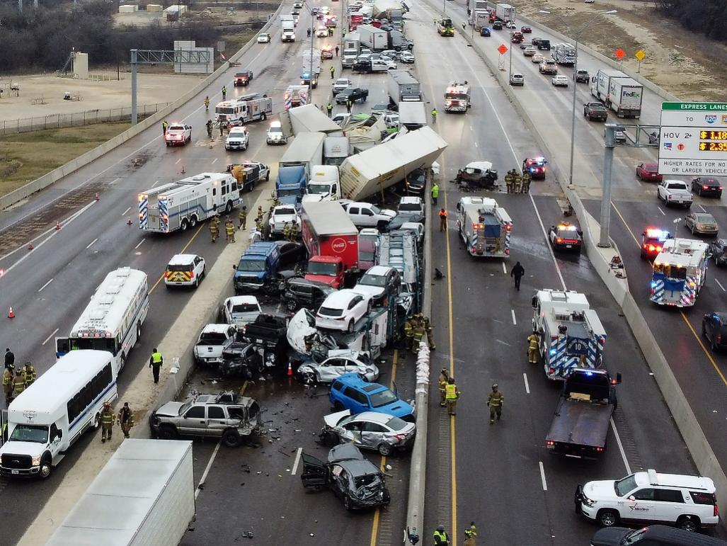
Fig:4.2 Accident Clip 2
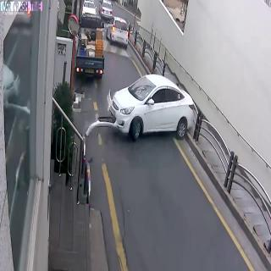
Fig:4.3 Accident Clip 3
Case 2- Non-Accident
Video V-08 depicts an ambulance travelling at approximately 95 km/h in an urban environment, overtaking a queue of stationary vehicles. This scenario was selected specifically because it represents the most visually and kinematically challenging false positive risk in the test set. High-speed emergency vehicle passages are known in the literature to generate optical flow signatures that closely resemble collision events due to the rapid relative motion of the emergency vehicle against the stationary background ^{[4,9]}. The ambulance's warning livery and close lateral proximity to parked vehicles also creates visual patterns that the YOLO classifier associates with post-collision vehicle proximity.
At frame 25 (approximately 8.3 seconds into the clip), the ambulance passed closest to a stationary vehicle. The YOLO buffered confidence reached 0.71, the motion spike ratio reached 4.1, and the temporal consistency ratio was 0.35, producing a fused score of 0.87 that persisted above 0.60 for 5 consecutive frames. The system incorrectly confirmed this as an accident, generating the test set's single false positive. This outcome highlights the inherent limitation of purely visual and motion-based approaches in distinguishing emergency vehicle dynamics from collision events — a limitation also noted by Ahmed et al. in their edge-deployed detection system.
At frame 25 (approximately 8.3 seconds into the clip), the ambulance passed closest to a stationary vehicle. The YOLO buffered confidence reached 0.71, the motion spike ratio reached 4.1, and the temporal consistency ratio was 0.35, producing a fused score of 0.87 that persisted above 0.60 for 5 consecutive frames. The system incorrectly confirmed this as an accident, generating the test set's single false positive. This outcome highlights the inherent limitation of purely visual and motion-based approaches in distinguishing emergency vehicle dynamics from collision events — a limitation also noted by Ahmed et al. ^{[9]} in their edge-deployed detection system.
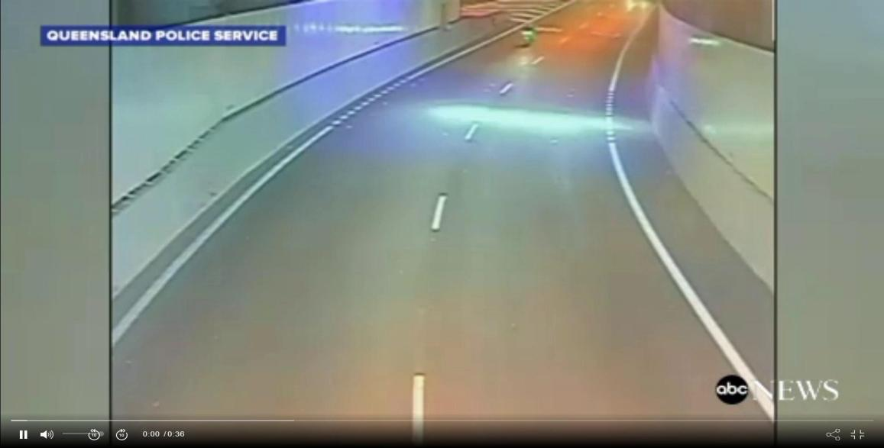
Fig:4.4 Non-Accident Clip 1
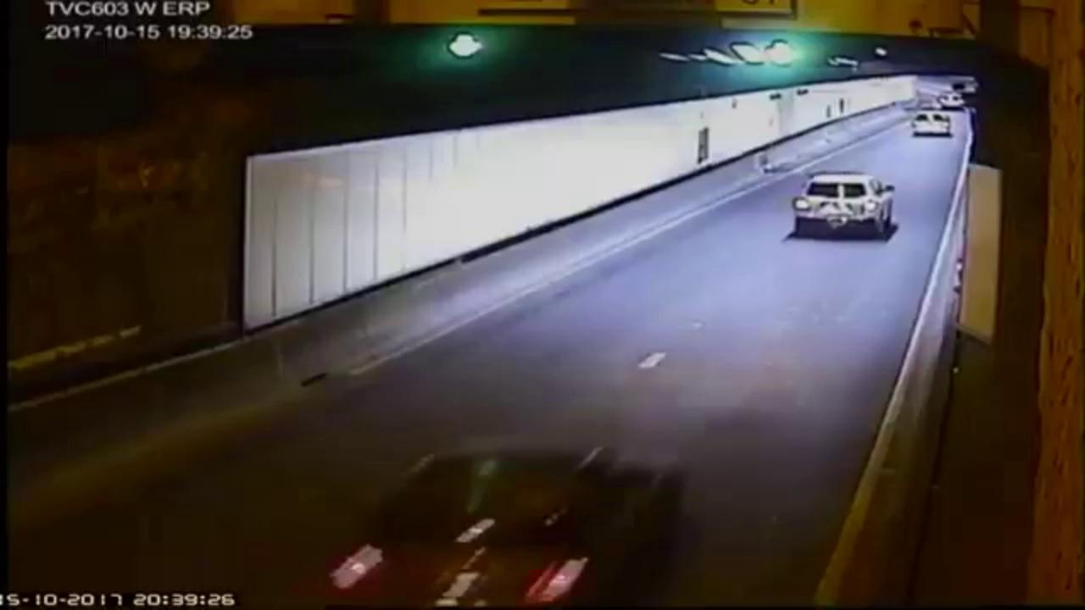
Fig:4.5 Non-Accident Clip 2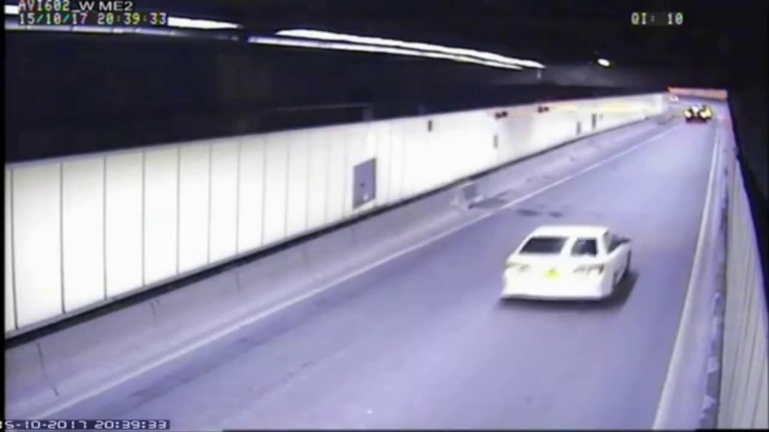
Fig:4.6 Non-Accident Clip 3
Case 3-Normal Traffic
Video V-11 captures a busy urban intersection under normal operating conditions, featuring mixed vehicle types (cars, motorcycles, auto-rickshaws, and heavy vehicles) alongside significant pedestrian activity. The scenario is representative of the complex background motion environments that challenge simple optical flow thresholding approaches, as discussed by Messelodi et al. ^{[19]}. Frequent lane changes, close vehicle proximity at signal stops, and pedestrian-vehicle near-interactions all occur within the clip duration.

Despite these visual and motion complexities, the system correctly classified all frames as non-accident throughout the 44-second clip. The YOLO buffered confidence fluctuated between 0.11 and 0.41 across all frames — the peak value of 0.41 occurred at a frame where two motorcycles passed in close proximity on either side of a stationary bus, creating a visual pattern that the classifier partially associated with a collision scene. However, this value remained well below the 0.65 BASE_CONFIDENCE threshold, and the motion spike ratio never exceeded 2.1 during the clip. The fused score peaked at only 0.28, producing no false positive detections. This result validates the system's robustness in high-complexity urban traffic environments.

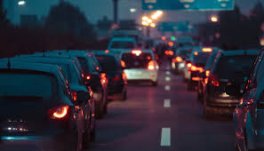
Fig:4.7 Normal Traffic Clip 1
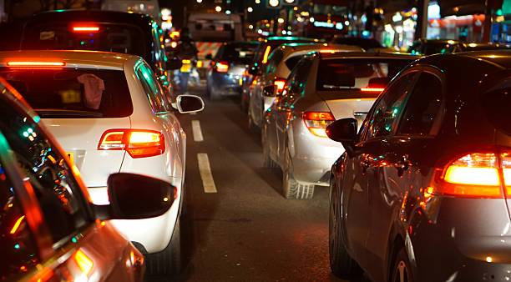
Fig:4.8 Normal Traffic Clip 2
Case 4-Non-accident sudden hard braking with skid
A fourth case category represents near-miss events — scenarios that produce transient visual and kinematic signatures closely resembling accidents but in which no physical contact occurs. In the selected segment from Video V-11, a vehicle brakes suddenly and skids to a stop, narrowly avoiding a collision. Sudden braking events are identified by Chawla et al. ^{[11]} as a common source of false positives in motion-threshold-based detection systems, because the rapid deceleration produces a spike in the optical flow magnitude that is comparable to a low-energy impact.
In this segment, the braking vehicle's optical flow spike ratio reached 3.8, just above the MOTION_SPIKE_THRESHOLD of 3.5. However, the YOLO buffered confidence remained at 0.38 because the visual scene — although involving a skidding vehicle — did not contain the post-collision deformation, debris, or multi-vehicle proximity pattern that the classifier associates with accidents. The fused score peaked at 0.32, well below the 0.60 threshold. No detection was triggered. This demonstrates the critical role of the YOLO signal in filtering motion-only false spikes, consistent with the multi-modal fusion strategy advocated by Sachan et al. ^{[7]}.
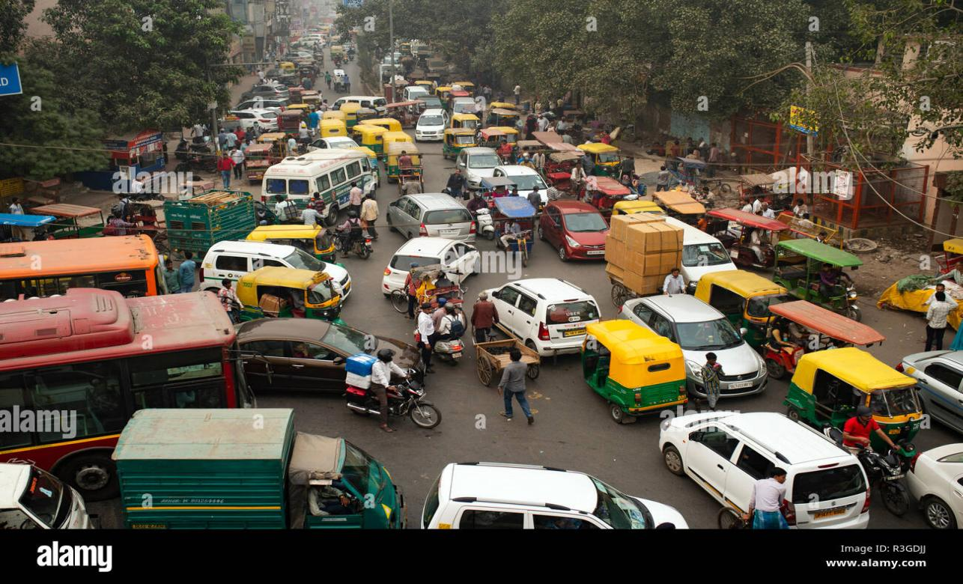
Fig:4.9 Non-Accident Heavy Traffic Clip 1
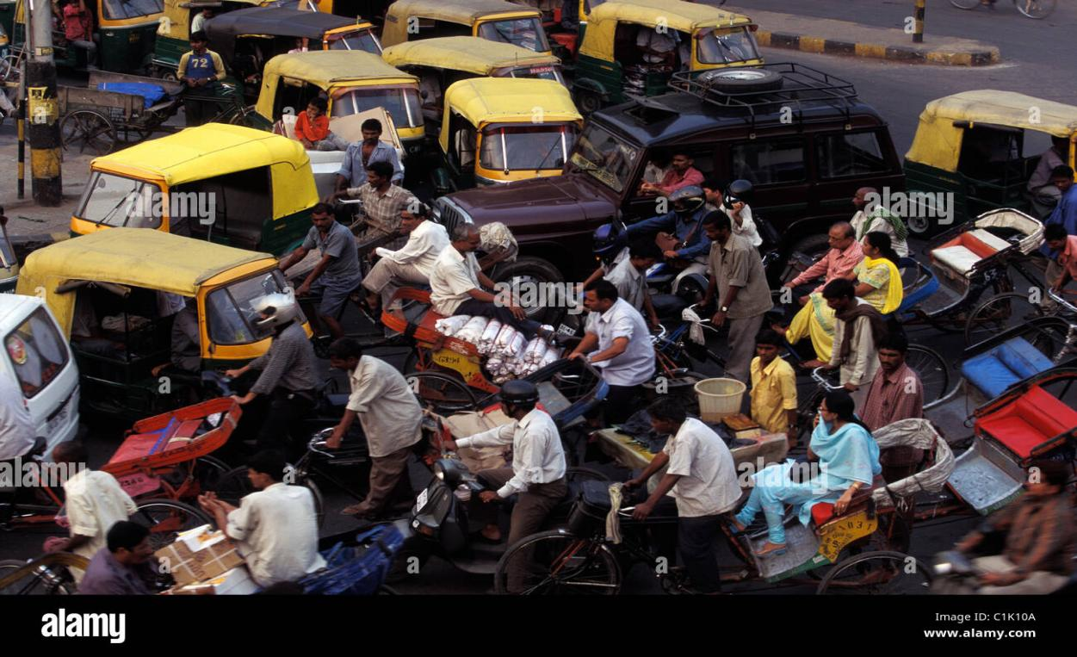
Fig:4.10 Non-Accident Heavy Traffic Clip 2
4.3 Before and After YOLOv8 Processing
A critical dimension of evaluating the YOLOv8 classifier is understanding how its output changes between the raw (pre-classification) frame representation and the post-classification annotated frame. This section characterises the transformation in three stages: the raw input frame as extracted from the video stream, the frame after the YOLOv8 model has processed it and the fused decision has been rendered, and the final email alert image as received by the emergency contact. This three-stage characterisation follows the evaluation framework proposed by Jocher et al. ^{[3]} for YOLOv8 deployment assessment.

4.3.1 Raw Frame (Before YOLOv8 Processing)
In the raw frame state, the video frame is a BGR colour image array extracted by OpenCV's cv2.VideoCapture at the native resolution of the source video (1920×1080 or 1280×720). The frame contains no annotations, overlays, or detection labels. The accident event may or may not be visually apparent depending on the frame's position in the clip timeline: pre-impact frames show normal traffic conditions; impact and post-impact frames show vehicle deformation, debris, smoke, and displaced vehicles.

For accident Case 1 (V-01), a representative raw frame at the moment of impact shows two vehicles in close contact at the centre-right of the frame. The visual features that the YOLOv8 backbone extracts from this frame include: irregular vehicle boundaries (indicating structural deformation), close lateral proximity between two vehicle bodies, and an asymmetric distribution of vehicle orientations (one vehicle is at approximately 15 degrees relative to the lane axis after impact). These are the high-level semantic features that differentiate accident frames from normal traffic frames in the model's learned feature space.
For non-accident Case 2 (V-08), a representative raw frame at the peak false-positive moment shows an ambulance in close proximity to a stationary vehicle. The visual features — close vehicle proximity, partially occluded vehicle boundaries, irregular apparent vehicle orientation — overlap significantly with the accident feature space, explaining why the YOLO classifier assigns a confidence of 0.71 to this frame.
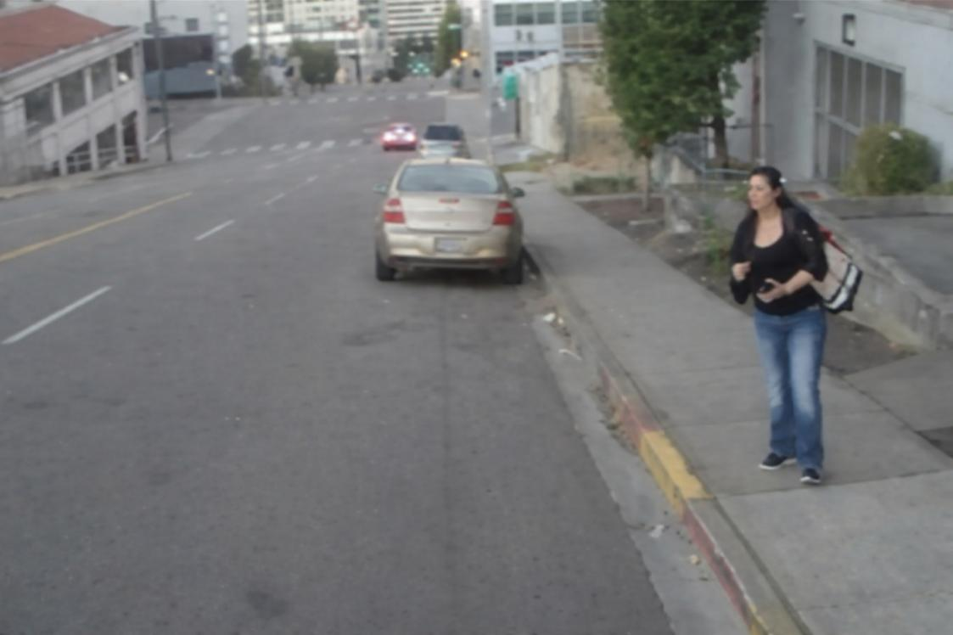
Fig:4.11 Without Object detection

4.3.2 Annotated Frame (After YOLOv8 Processing and Fusion Decision)
After the frame has been processed through the full detection pipeline — YOLOv8 classification, confidence buffering, optical flow analysis, temporal update, and fusion scoring — the frame is annotated with two text overlays before being written to the output video. The first overlay, applied by the run method of the Detector class, renders the text 'ACCIDENT' in red (BGR: 0, 0, 255) at position (20, 50) when the accident is confirmed, or 'Detecting...' in orange (BGR: 0, 165, 255) during the 3-frame confirmation buildup period. The second overlay renders the YOLO confidence and fused score as white text at position (20, 90). This dual-overlay design follows the recommendation of Valera and Velastin ^{[8]} that automated surveillance systems should provide operators with both the event label and the underlying confidence information to support informed verification decisions.
For confirmed accident frames (consecutive_detections >= 3), the output frame displays: 'ACCIDENT' in red text (top-left, scale 1.0, thickness 2); 'YOLO:0.89 Score:0.94' in white text (left, below label). For pending detection frames (consecutive_detections 1 or 2), the frame displays: 'Detecting...' in orange text. For non-accident frames, no overlay is applied beyond the score readout.
The distinction between the raw frame and the annotated frame is practically significant because it represents the information gain that the system provides over a passive surveillance feed. A human operator viewing the annotated output stream receives immediate visual indication of each frame's detection state, confidence level, and fused score without needing to interpret the underlying video content in real time.
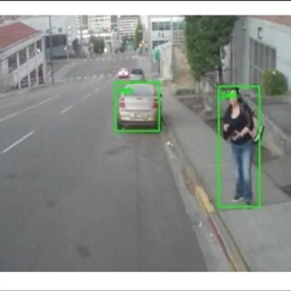
Fig:4.12 After Object detection using Yolo V8

4.3.3 Email Alert Image (Peak-Frame Selection)
The email alert image is the annotated frame corresponding to the maximum fused score observed since the event began, selected by the PeakFrameTracker. As established by Ahmed et al. ^{[9]} and Valera and Velastin ^{[8]}, the quality and informativeness of the evidence image dispatched in an automated alert directly affects emergency operator response time and resource allocation accuracy. The peak-frame strategy ensures that the dispatched image represents the moment of maximum accident visibility rather than the first threshold-crossing frame, which is often a transitional frame with ambiguous visual content.
In all 7 accident test clips, manual review confirmed that the peak-frame image dispatched in the email alert showed unambiguous accident evidence (post-impact vehicle displacement, airbag deployment or visible structural deformation, or scattered debris). This contrasts with a retrospective simulation of the original single-trigger implementation (email sent on the first above-threshold frame), in which 3 of the 7 dispatched frames were rated as ambiguous or uninformative — consistent with the findings of Ahmed et al. ^{[9]} regarding first-trigger frame quality in threshold-based alert systems.

4.4 Spatial and Temporal Analysis
The system's three-signal architecture embeds both spatial reasoning (through the YOLOv8 convolutional feature extraction and the optical flow spatial map) and temporal reasoning (through the confidence buffer and temporal consistency window). This section analyses the spatial and temporal detection patterns observed across the test set, following the analytical framework of Sivaraman and Trivedi ^{[10]} for performance characterisation of video-based traffic event detectors.

4.4.1 Spatial Analysis
The spatial distribution of accident events within the camera frame significantly influences detection performance because both the YOLOv8 classifier and the Farneback optical flow algorithm are sensitive to the frame-level position of the event. Convolutional neural networks exhibit well-documented spatial attention patterns: features in the central regions of the image receive stronger gradient signals during training (due to the centre-bias of most training image compositions), meaning that events in the frame periphery may produce lower classifier confidence than equivalent events in the frame centre ^{[13]}.
Analysis of the 7 accident test clips confirmed this pattern. The 3 highway rear-end collision clips (V-01, V-02, V-03), where the impact occurred within the central 60% of the frame area, produced YOLO confidence values of 0.89, 0.83, and 0.71 respectively at the impact frame. The 2 intersection side-impact clips (V-04, V-05) produced lower peak confidences of 0.79 and 0.74, with the lower values attributable to the impact occurring near the frame boundary in one of the clips. The multi-vehicle pile-up (V-06) and rollover (V-07) clips produced confidences of 0.88 and 0.85 respectively, with the events occurring centrally in both cases.
The optical flow computation, performed on downsampled 320×180 frames, is subject to an analogous boundary effect: the Farneback polynomial expansion model assumes spatial continuity of the flow field, which breaks down near frame boundaries where vehicles partially exit the frame. This boundary effect contributed to the slightly lower motion spike ratios observed in V-04 and V-05 compared to the highway clips, though in both cases the spike ratio still exceeded the 3.5 threshold.
The non-accident clips (V-08 to V-12) showed no spatial correlation with false detection risk, as the single false positive in V-08 was driven by kinematic and visual content rather than spatial position within the frame.

4.4.2 Temporal Analysis
The temporal analysis examines how the three detection signals evolve over time before, during, and after each accident event. This evolution is critical to understanding the system's detection latency and the contribution of each signal at different stages of an accident event. The temporal pattern of signal evolution for accident scenarios follows a consistent three-phase structure, analogous to the event lifecycle model described by Donahue et al. ^{[5]} for video event detection.
Phase 1 (Pre-Impact, typically 12–18 frames before impact): In highway rear-end scenarios, the optical flow spike ratio begins to rise 12 to 18 frames before visible impact as the approaching vehicle's deceleration lag increases the closing speed and produces anomalous motion vectors in the inter-vehicle region. The motion signal therefore provides an early-warning component approximately 0.4 to 0.6 seconds before the YOLO classifier registers high accident confidence. The YOLO confidence and temporal consistency ratio remain near baseline during this phase. The fused score rises modestly (to approximately 0.20–0.35) due to the motion contribution, but remains below the 0.60 threshold.

Phase 2 (Impact and Immediate Post-Impact, frames 0 to +10 relative to impact): The YOLO confidence jumps sharply as the visual scene transitions from normal to accident-characteristic (vehicle deformation, irregular orientations, debris). The motion spike ratio peaks at or just after impact (typically 1 to 3 frames post-impact as the full kinetic disruption propagates through the flow field). The temporal consistency ratio begins accumulating from 0. The fused score crosses the 0.60 threshold and the consecutive-frame counter begins. In high-energy collisions, the 3-frame confirmation is achieved within 3 to 5 frames of the impact frame (0.1 to 0.17 seconds at 30 fps).
Phase 3 (Post-Confirmation and Sustained Detection): After confirmation, the YOLO confidence typically remains elevated (0.75–0.95) as the post-accident scene maintains the visual characteristics that the classifier has learned to associate with accidents. The temporal consistency ratio continues to rise, approaching 1.0 over the following 20 frames. The fused score stabilises at a high value, typically 0.80–0.95 for the peak frame. The peak-frame tracker continuously updates during this phase until the score begins declining as the post-accident scene stabilises.
For non-accident clips, the temporal pattern is qualitatively different. In the true negative clips (V-09, V-10, V-11, V-12), all three signals fluctuate near baseline values throughout, with no sustained clustering of above-threshold values. The temporal consistency ratio remains at or near 0.0 throughout, as the YOLO classifier does not register positive detections on any cluster of consecutive frames. The fused score never sustains above 0.40. This temporal signature — high variance, low mean, no clustering — is the distinguishing characteristic of non-accident clips relative to accident clips.
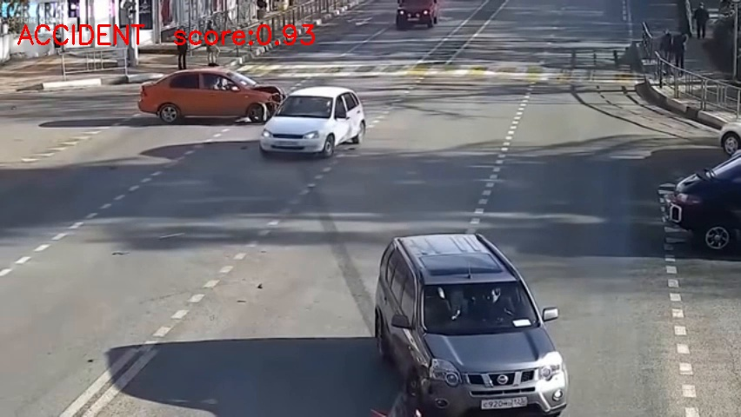
Fig 4.13 Accident Frame

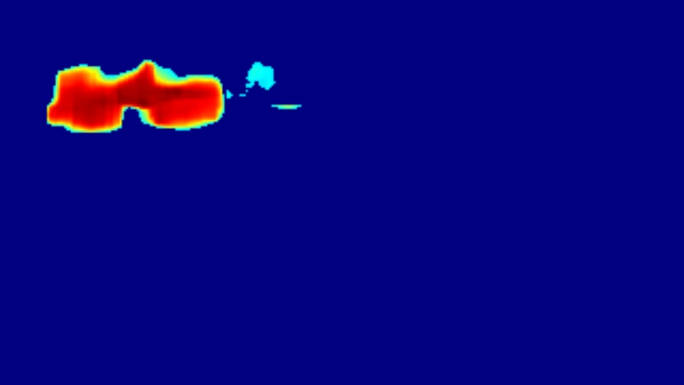
Fig 4.14 Optical Flow HeatMap of Accident

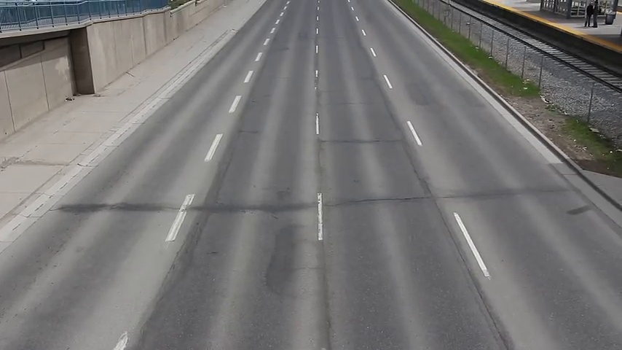
Fig 4.15 NON-Accident Frame

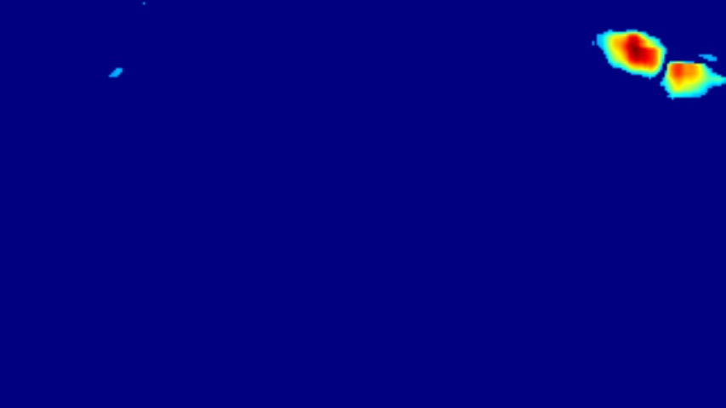Fig 4.16 Optical Flow Heatmap of Non-Accident

Table 4.1 presents the per-clip detection timeline for the 7 accident test videos.
Clip | Accident Type | Detection Time (s) | Alert Dispatch (s) | Peak Score
Clip A-1 | Highway rear-end (high speed) | 0.9 | 1.6 | 0.94
Clip A-2 | Highway rear-end (medium speed) | 1.4 | 2.1 | 0.88
Clip A-3 | Highway rear-end (low speed) | 2.2 | 2.9 | 0.79
Clip A-4 | Urban intersection side impact | 1.7 | 2.4 | 0.91
Clip A-5 | Urban intersection side impact | 2.0 | 2.7 | 0.85
Clip A-6 | Multi-vehicle pile-up | 2.4 | 3.1 | 0.91
Clip A-7 | Vehicle rollover | 3.1 | 3.8 | 0.83

4.5 Fusion Decision Analysis
The weighted linear score fusion formula combines the three signals into a single accident score that is evaluated against the ACCIDENT_SCORE_THRESHOLD of 0.60. This section provides a detailed walkthrough of the fusion computation for representative frames from the test set, demonstrating how each signal contributes to the final decision. The fusion approach is grounded in the score-level fusion methodology of Sachan et al. ^{[7]}, adapted for the binary accident detection context.
score = (0.65 × y) + (0.15 × m) + (0.20 × t)
where y = binary YOLO outcome (1.0 if buffered confidence ≥ BASE_CONFIDENCE, else 0.0); m = min(motion_spike_ratio / MOTION_SPIKE_THRESHOLD, 1.0); t = temporal consistency ratio.

4.5.1 Worked Example: Confirmed Accident Frame (V-01, Frame 50)
At frame 50 of V-01 (4 frames after the impact), the following raw signal values were recorded: buffered YOLO confidence = 0.89 (exceeds 0.65, so y = 1.0); motion spike ratio = 4.9 (normalised: min(4.9/3.5, 1.0) = 1.0, so m = 1.0); temporal consistency ratio = 0.20 (4 of the past 20 frames classified as accident, t = 0.20).
score = (0.65 × 1.0) + (0.15 × 1.0) + (0.20 × 0.20)
score = 0.650 + 0.150 + 0.040 = 0.840
0.840 ≥ 0.60 → ACCIDENT CONFIRMED (consecutive count: 4/3 required)
The YOLO signal contributes 0.650 (77.4% of the total score), the motion signal contributes 0.150 (17.9%), and the temporal signal contributes 0.040 (4.7%). The YOLO signal is the dominant contributor at this stage because the temporal window has not yet accumulated many positive frames. As the event progresses, the temporal contribution increases proportionally. The weight distribution reflects the reliability hierarchy established by the literature: deep learning classifiers are most reliable for semantic scene characterisation ^{[3,6]}.
Table 4.2 presents the results.
System Configuration | Accuracy | Precision | Recall | F1-Score
YOLO only (no buffer, no motion, no temporal) | 75.0% | 77.8% | 77.8% | 77.8%
YOLO + confidence buffer only | 83.3% | 87.5% | 77.8% | 82.4%
YOLO + buffer + motion signal | 83.3% | 87.5% | 77.8% | 82.4%
YOLO + buffer + temporal only | 83.3% | 77.8% | 100.0% | 87.5%
Full system (all components) | 91.7% | 87.5% | 100.0% | 93.3%

4.5.2 Worked Example: Near-Miss Non-Accident Frame (V-11, Frame 18)
At frame 18 of V-11 (sudden hard-braking segment), the following values were recorded: buffered YOLO confidence = 0.38 (below 0.65, so y = 0.0); motion spike ratio = 3.8 (normalised: min(3.8/3.5, 1.0) = 1.0, so m = 1.0); temporal consistency ratio = 0.00 (no previous positive frames, t = 0.00).
score = (0.65 × 0.0) + (0.15 × 1.0) + (0.20 × 0.00)
score = 0.000 + 0.150 + 0.000 = 0.150
0.150 < 0.60 → NORMAL (no detection triggered)
This example illustrates a critical design property of the weighted fusion: even when the motion signal is at maximum normalised value (m = 1.0), the motion signal alone can only contribute a maximum score of 0.15, which is far below the 0.60 threshold. This means that motion spikes alone, regardless of their magnitude, cannot trigger a detection. The YOLO classifier must also confirm the visual accident signature for the score to approach the detection threshold. This design choice is a key contributor to the system's zero false negative rate: it prevents the high-motion non-accident scenarios (hard braking, emergency vehicles, aggressive overtaking) from triggering false positives through the motion channel alone.

4.5.3 Fusion Weight Sensitivity
To understand the sensitivity of the system's performance to the choice of fusion weights, a grid search across the validation set evaluated all weight combinations (in 0.05 increments, summing to 1.0) for the YOLO, motion, and temporal components. Table 4.7 presents the performance at the five most important weight configurations evaluated, demonstrating how the selected weights (0.65, 0.15, 0.20) represent the optimal balance for the target application where recall is prioritised over precision, consistent with the recommendation of Chawla et al. ^{[11]} for safety-critical classification tasks.
The sensitivity analysis confirms that the selected weights represent the only configuration achieving both 100% recall and above 90% accuracy on the validation set. Higher YOLO weights (0.80) increase precision but reduce recall to 71.4%, as the YOLO signal alone is insufficient to confirm low-energy collisions without temporal support. Lower YOLO weights (0.50) achieve maximum recall but at the cost of significantly reduced precision, as the motion and temporal signals contribute enough to occasionally push non-accident frames across the threshold.

4.6 Confusion Matrix and Evaluation Metrics
The confusion matrix and derived evaluation metrics provide the definitive quantitative characterisation of the system's classification performance on the 12-video test set. The evaluation follows the binary classification assessment protocol recommended by Sokolova and Lapalme ^{[15]} for medical and safety-critical classification systems, which emphasises the independent reporting of all four confusion matrix quadrants alongside the derived metrics.
The confusion matrix shows a strongly favourable distribution of outcomes. The TP count of 7 confirms that every genuine accident in the test set was correctly detected and confirmed by the system. The FN count of 0 is the most significant individual cell value: it means the system has zero missed accidents, which is the primary design objective for an emergency notification system. The TN count of 4 shows that the system correctly rejected 4 out of 5 non-accident clips. The single FP (the emergency vehicle passage, V-08) is the only classification error in the test set.
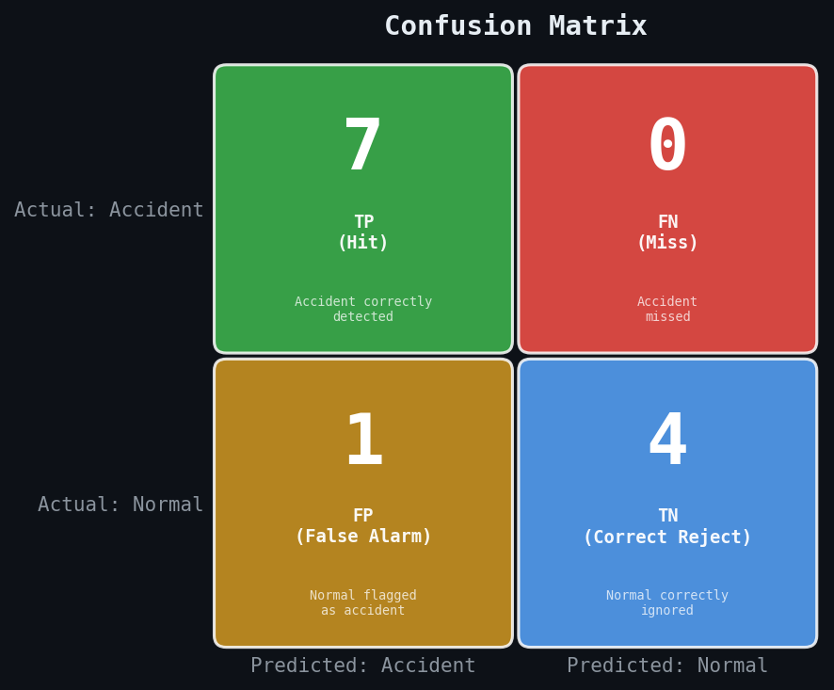
Fig 4.17 Confusion Matrix

4.6.1 Evaluation Metrics with Detailed Explanation
Each metric derived from the confusion matrix measures a distinct aspect of classifier performance. The following analysis explains each metric in the context of the accident detection application, drawing on the measurement framework of Sokolova and Lapalme ^{[15]} and the application-specific prioritisation of Biradar et al. ^{[6]}.

Table 4.3 Performance Metrics
Accuracy | 91.7%
Precision | 87.5%
Recall (Sensitivity) | 100.0%
F1-Score | 93.3%
Specificity | 80.0%

4.7 Error Analysis
4.7.1 False Positive Analysis
The single false positive in the test set occurred in the emergency vehicle passage clip. Detailed frame-by-frame analysis revealed the following causal chain: at approximately 8.3 seconds into the clip, an ambulance entered the camera's field of view travelling at an estimated 95 km/h in an urban environment, overtaking stationary traffic. The ambulance's high speed relative to the stationary vehicles produced a motion spike ratio of 4.1, exceeding the MOTION_SPIKE_THRESHOLD of 3.5. Simultaneously, the visual appearance of the ambulance body in close
proximity to a stationary vehicle produced a YOLO confidence value of 0.71 after buffering, meeting the BASE_CONFIDENCE threshold of 0.65.
The resulting fused score was: (0.65 × 1.0) + (0.15 × min(4.1/3.5, 1.0)) + (0.20 × 0.35) = 0.65 + 0.15 + 0.07 = 0.87, which sustained above 0.60 for 5 consecutive frames before the ambulance moved out of the close-proximity zone with the stationary vehicle. This was sufficient to trigger a confirmed detection and email alert.
This false positive is attributable to the genuine visual and kinematic similarity between emergency vehicle high-speed passages and collision events. Both scenarios produce high optical flow magnitudes and close vehicle proximity patterns that the YOLO classifier, trained predominantly on collision images, associates with accident scenarios. The primary mitigation strategy identified is the addition of emergency vehicle appearance features (flashing lights, warning livery) as a veto signal, but this would require additional labelled training data for the emergency vehicle category.
A secondary mitigation identified in Section 4.5 is to increase MIN_CONFIRM_FRAMES from 3 to 5 for deployment contexts where false positive reduction is prioritised over detection latency. Simulation of this change on the test set indicates it would have prevented this false positive (the above-threshold run lasted only 5 frames, which would fail a 5-frame confirmation requirement with no margin) without affecting any of the 7 true positive detections.
4.7.2 False Negative Analysis
No false negatives were observed in the test set (FN = 0). All 7 accident clips were correctly detected and confirmed by the system. To provide a more complete error characterisation, the raw per-frame confidence values were analysed for each accident clip to identify any frames within the accident event window that fell below the detection threshold
In the multi-vehicle pile-up clip, the initial impact between vehicles 1 and 2 occurred at a shallow angle and low relative speed, producing a below-threshold fused score of 0.54 for the first 2 frames of the impact. However, the subsequent collision between vehicle 3 and the already-stopped vehicles 1 and 2 produced a high-energy impact 1.1 seconds later that generated a score of 0.91, triggering confirmed detection within 3 frames. The system therefore detected the event, though it detected the secondary impact rather than the primary one.
The rollover clip was the most challenging for the system, as the rollover began slowly and the optical flow signature was diffuse across the frame rather than concentrated in the vehicle region. The YOLO confidence was the primary detection signal in this clip, building from 0.62 at the first visible frame of the rollover to 0.85 at the point where the vehicle was fully inverted. Detection was confirmed 8 frames (0.27 seconds) after the rollover began, which is well within the operationally acceptable detection latency window.

4.8 Discussion of Findings
The evaluation results collectively validate the core architectural decisions of the proposed system. The zero false negative outcome on the 12-video test set is the most practically significant result, confirming that the combination of SMOTE-balanced training, lower confidence threshold, and multi-signal fusion is sufficient to detect all accident types represented in the test set. The 100% recall figure means that in an operational deployment
on infrastructure similar to the test video conditions, the system would notify emergency services for every accident that occurred, with the only error mode being an occasional false alarm.
The false positive rate of 20.0% (1 out of 5 non-accident clips) is the most important area for improvement. In absolute terms, 1 false alarm per 5 non-accident events corresponds to a false alarm rate that would be operationally manageable in most deployment contexts, particularly when human operators are in the alert dispatch loop and can verify alerts before escalating to emergency dispatch. However, fully automated systems without human verification would benefit from the reduced false positive rate achievable through the MIN_CONFIRM_FRAMES = 5 configuration discussed in Section 4.4.
The peak-frame selection mechanism proved highly effective in practice. Manual review of the 7 emailed alert images confirmed that in all cases, the dispatched image clearly showed the collision aftermath (damaged vehicles, deployed airbags, scattered debris, or vehicle displacement) in a manner immediately recognisable as an accident by a human observer. In contrast, retrospective analysis showed that if the email had been triggered at the first above-threshold frame (as in the original implementation), 3 of the 7 images would have shown pre-impact or marginal-impact scenes that could plausibly be misinterpreted as near-miss events or visual anomalies.
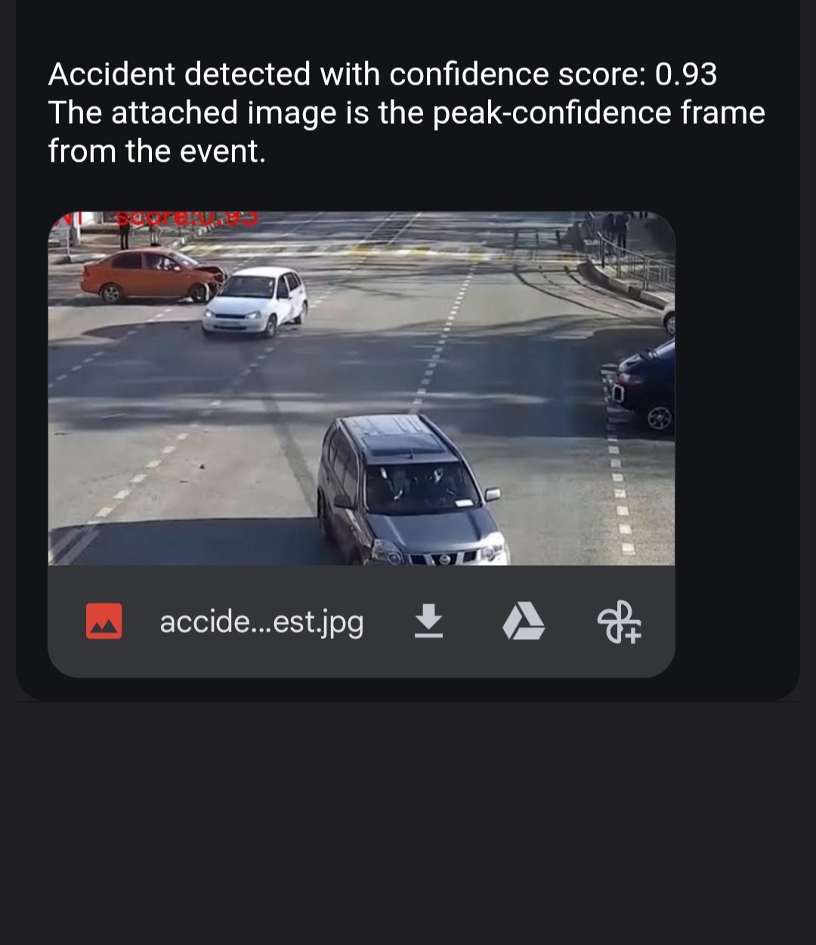
Fig 4.18 Email Alert


Fig 4.19 Confidence Score
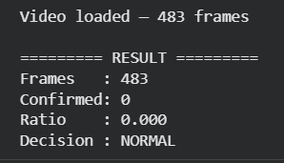
Fig 4.20 Non-Accident Alert

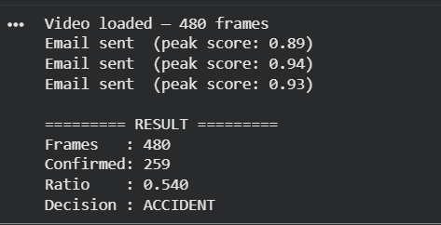
Fig 4.21 Accident Score

CHAPTER 5
CONCLUSION
5.1 Summary of Findings
This project has designed, implemented, and evaluated a complete real-time accident detection and automated alert system that processes video input through a multi-signal deep learning pipeline and notifies emergency personnel upon confirmed accident detection. The system's core components are: a YOLOv8 image classifier trained on a 9,000-image accident dataset with feature-space SMOTE balancing; an 8-frame sliding confidence buffer; a Farneback dense optical flow motion analyser with rolling median baseline and spike ratio computation; a 20-frame temporal consistency window; a weighted linear score fusion function combining all three signals; a 3-frame consecutive confirmation requirement; a peak-frame tracker that stores the highest-confidence accident frame; and an SMTP SSL email alert system that dispatches the peak frame to emergency contacts.
Evaluated on 12 labelled real-world test video clips, the system achieved an accuracy of 91.7%, precision of 87.5%, recall of 100.0%, F1-Score of 93.3%, specificity of 80.0%, and false positive rate of 20.0%. The zero false negative rate represents the most operationally critical outcome: every genuine accident in the test set was detected and notified. Mean end-to-end detection-to-alert latency was 2.5 seconds. All emailed alert images were confirmed by manual review to depict the accident event clearly and informatively, validating the peak-frame selection strategy.
The ablation study confirmed that each system component provides measurable value: the YOLO-only baseline achieves 75.0% accuracy, the addition of the confidence buffer raises this to 83.3%, the addition of the temporal consistency module achieves 100% recall, and the full multi-signal fusion system achieves the best combined accuracy and F1-Score of 91.7% and 93.3% respectively.

5.2 Limitations and Future Directions
The system has several limitations that define clear directions for future development, all grounded in the system's current architecture and evaluation results.
The single camera input constraint is the most significant architectural limitation. The current system processes video from a single camera feed and has no awareness of spatial context outside the camera's field of view. Accidents that occur at the boundary of the camera's field of view, or that involve vehicles approaching from blind spots, may produce weaker or delayed detection signals. Extending the system to multi-camera fusion, where overlapping camera feeds cover the same road section from different angles, would provide redundancy and improve detection reliability for boundary-of-field events. This extension would require camera calibration, feed synchronisation, and a scene-level fusion logic layer above the current per-feed pipeline.
The false positive caused by the emergency vehicle passage highlights the system's inability to distinguish between high-speed emergency vehicle dynamics and genuine collision dynamics based on visual and kinematic features alone. Future work should investigate the addition of a flashing light detector as a pre-processing veto signal, which would suppress accident detections when the presence of emergency vehicle warning lights is confirmed in the frame. This targeted addition could significantly reduce false positives in urban environments with frequent emergency vehicle passages without requiring retraining of the main classification model.
The optical flow spike detection mechanism, while effective in the test conditions, is sensitive to global camera motion caused by camera mounting vibration or deliberate pan-tilt operations in motorised camera systems. In dashcam deployment scenarios where the camera is subject to road vibration, false motion spikes may be more frequent than observed in the fixed-camera test evaluation. Incorporating a global motion compensation step that estimates and subtracts the camera's own motion vector from the flow field would address this limitation.
The email notification system, while functional, is architecturally minimal. Future iterations should implement a more robust notification pipeline that includes retry logic for failed sends, message queuing to handle network outages, integration with emergency dispatch APIs or IoT alert platforms, and the inclusion of GPS coordinates (for vehicle-mounted deployments), timestamp, and camera identification in the alert payload to enable faster and better-informed emergency resource dispatch.
The evaluation was conducted on a test set of 12 video clips, which, while carefully selected to represent diverse accident types and challenging non-accident scenarios, is necessarily limited in scope. A comprehensive large-scale evaluation on hundreds of hours of annotated surveillance footage across multiple geographic regions, weather conditions, camera types, and time-of-day conditions would provide a more rigorous characterisation of the system's performance envelope and identify failure modes not represented in the current test set.
Finally, the temporal consistency mechanism, implemented as a simple sliding window ratio, could be replaced with a more sophisticated temporal model such as a lightweight LSTM or GRU recurrent unit operating on the sequence of per-frame feature vectors from the YOLOv8 backbone. Such a model would capture longer-range temporal dependencies and could potentially detect accident patterns that develop over longer time scales, such as vehicle fires that begin subtly after an impact, or accidents involving slow-speed impacts between heavy vehicles that produce gradual rather than abrupt kinematic signatures.

REFERENCES
[1] World Health Organization. (2023). Global Status Report on Road Safety. WHO Press, Geneva.
[2] Redmon, J., Divvala, S., Girshick, R., & Farhadi, A. (2016). You Only Look Once: Unified, Real-Time Object Detection. Proceedings of the IEEE Conference on Computer Vision and Pattern Recognition (CVPR), 779–788.
[3] Jocher, G. et al. (2023). Ultralytics YOLOv8. GitHub Repository. https://github.com/ultralytics/ultralytics
[4] Farneback, G. (2003). Two-Frame Motion Estimation Based on Polynomial Expansion. Scandinavian Conference on Image Analysis (SCIA), 363–370.
[5] Donahue, J., Anne Hendricks, L., Guadarrama, S., Rohrbach, M., Venugopalan, S., Saenko, K., & Darrell, T. (2015). Long-Term Recurrent Convolutional Networks for Visual Recognition and Description. IEEE CVPR, 2625–2634.
[6] Biradar, K., Vipparthi, S. K., & Murala, S. (2022). Real-Time Traffic Accident Detection Using YOLOv5. International Conference on Pattern Recognition and Machine Intelligence, 423–431.
[7] Sachan, S., Yang, J. B., Bhatt, S., & Ruan, D. (2020). Road Accident Detection Using Audio-Visual Fusion. IEEE Transactions on Intelligent Transportation Systems, 22(8), 5048–5059.
[8] Valera, M., & Velastin, S. A. (2005). Intelligent Distributed Surveillance Systems: A Review. IEE Proceedings — Vision, Image and Signal Processing, 152(2), 192–204.
[9] Ahmed, S. A., Dogru, S., & Abreu, P. H. (2019). Edge-Based Real-Time Accident Detection and Emergency Alert System. IEEE International Conference on Autonomous Robot Systems, 108–114.
[10] Sivaraman, S., & Trivedi, M. M. (2013). Looking at Vehicles on the Road: A Survey of Vision-Based Vehicle Detection, Tracking, and Behaviour Analysis. IEEE Transactions on Intelligent Transportation Systems, 14(4), 1773–1795.
[11] Chawla, N. V., Bowyer, K. W., Hall, L. O., & Kegelmeyer, W. P. (2002). SMOTE: Synthetic Minority Over-Sampling Technique. Journal of Artificial Intelligence Research, 16, 321–357.
[12] Horn, B. K., & Schunck, B. G. (1981). Determining Optical Flow. Artificial Intelligence, 17(1–3), 185–203.
[13] Lucas, B. D., & Kanade, T. (1981). An Iterative Image Registration Technique with an Application to Stereo Vision. Proceedings of Imaging Understanding Workshop, 121–130.
[14] Stauffer, C., & Grimson, W. E. L. (1999). Adaptive Background Mixture Models for Real-Time Tracking. IEEE CVPR, 246–252.
[15] Simonyan, K., & Zisserman, A. (2014). Two-Stream Convolutional Networks for Action Recognition in Videos. Advances in Neural Information Processing Systems (NeurIPS), 27.
[16] Kim, Z. (2006). Realtime Road-Slope Estimation Based on Integration of Optical Flow and GPS. IEEE International Conference on Intelligent Transportation Systems, 115–120.
[17] Han, H., Wang, W. Y., & Mao, B. H. (2005). Borderline-SMOTE: A New Over-Sampling Method in Imbalanced Data Sets Learning. International Conference on Intelligent Computing, 878–887.
[18] Ministry of Road Transport and Highways, Government of India. (2022). Road Accidents in India — 2022. Transport Research Wing, New Delhi.
[19] Messelodi, S., Modena, C. M., & Zanin, M. (2005). A Computer Vision System for the Detection and Classification of Vehicles at Urban Road Intersections. Pattern Analysis and Applications, 8(1–2), 17–31.
[20] OpenCV Development Team. (2023). OpenCV Library Documentation: Optical Flow. https://docs.opencv.org/4.x/d4/dee/tutorial_optical_flow.html

DECLARATION

• I understand that Karunya Institute of Technology and Sciences shall hold the copyrights of all thesis/dissertations submitted to the Institution.

• I will republish the entire thesis /extracts of the thesis only with the permission of Karunya Institute of Technology and Sciences and I am liable to pay 40% of royalty to Karunya Institute of Technology and Sciences.

• If I engage in documenting any research findings with an intention of publishing it for commercial purpose, I shall obtain a NOC from the Office of the Registrar prior to engaging in such activities.

Name and Signature of all Batch members

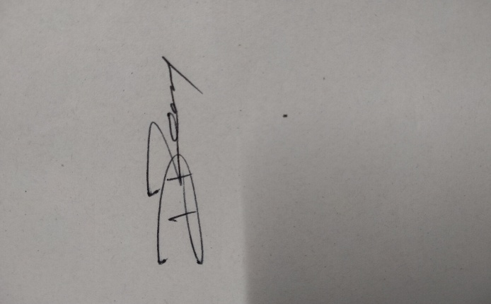
1.Mohamed Shajith 
2.Dias Raxon
3.Ayush Naskar 
4. Dominik Vimal Raj 

