IMSAxes Project Report

Chapter 1 Overview of the Company

1.1 About the Company
Meditab Software (I) Pvt. Ltd. is a leading provider of software in the healthcare sector, creating innovative products such as Intelligent Medical Software (IMS). Founded in 1998, Meditab has built a legacy of bringing together comprehensive software implementations for hospitals, dispensaries, pharmacies, and specialty clinics. The organizational culture nurtures research and development, aiming to optimize the healthcare technology landscape. Operations are distributed internationally, focusing on quality assurance, HIPAA compliance, and agile software development life cycles.
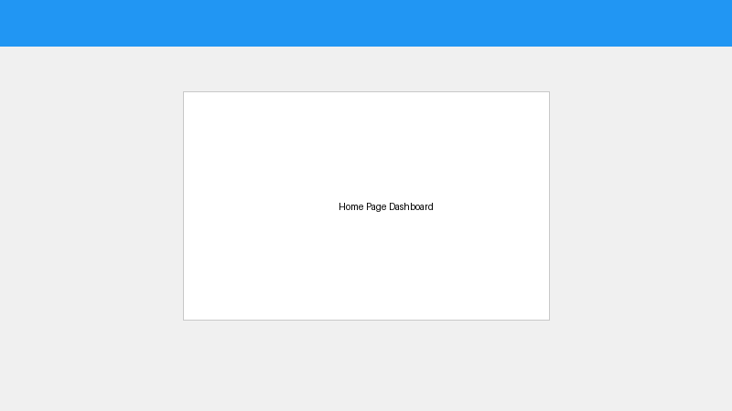

1.2 Key Offerings
The company offers an extensive suite of products beyond just EHR (Electronic Health Record). Their flagship product, IMS, provides deep integrations into practice management and medical billing. Additionally, they provide intelligent scheduling algorithms, automated prescription fulfillment software, and a robust telemedicine connectivity suite designed to empower patients. Over the years, Meditab has transitioned to cloud-based solutions heavily reliant on large-scale databases and microservice-driven backends.

1.3 Company Growth & Recognition
Meditab has experienced continuous growth by adapting to modern technologies and meeting regulatory compliances in the US healthcare market, such as Meaningful Use certifications. The company invests heavily in automating internal QA processes to handle the large testing matrices effectively, minimizing regression cycles and time-to-market. Quality assurance is treated as a first-class citizen.

1.4 Scope of Work
The intern's scope of work involves developing internal tools for Quality Assurance, specifically streamlining automation testing through a centralized dashboard known as AXES. By automating the execution triggers across remote server nodes, the intern minimizes the manual effort typically required to perform complex build pipelines. The scope entails full-stack development covering a Node.js framework and React.js interfaces.

Chapter 2 Overview of Internship

2.1 Internship Summary & Project Details
The internship focused on the development of IMSAxes, a robust automation execution platform integrating front-end and back-end environments to facilitate seamless automation test triggering, tracking, and reporting. The internship exposed the intern to real-world software engineering dynamics, sprint planning, and the rigorous discipline of maintaining enterprise-grade architectural standards. It covered the deployment of Node instances, securing APIs via stateless tokens, and building responsive SPAs (Single Page Applications) utilizing the React ecosystem.

2.2 Project Overview
IMSAxes is a comprehensive system comprising a Node.js backend (AXES) and a React frontend (Axes_redux). It handles execution setups, schedules test runs via Maven strings, collects live logs via Socket.io bidirectional connections, and provides real-time tracking of executing suites without refreshing the browser.

2.3 Purpose of Project
The purpose is to minimize manual intervention during automation execution. Historically, QA engineers had to manually log in using Remote Desktop to virtual machines, update the Git repository, configure the execution XML files, and run Maven commands. This project fully automates this pipeline. It provides the QA team with an isolated environment to execute automated scripts uniformly and track issues transparently.

2.4 Objective
To build a scalable and interactive platform for automated sanity and regression testing. The key objectives include: 1) Reducing manual testing configuration effort by 80%. 2) Increasing test coverage visibility. 3) Providing a fault-tolerant HTTP API capable of handling concurrent testing sessions.

2.5 Technology & Tools
The project leveraged a modern web stack:
- Frontend: React.js (Component-based UI), Redux (Global State Management).
- Backend: Node.js, Express framework for routing.
- Database: MySQL managed via Sequelize ORM.
- Execution Environment: Windows Server, PowerShell scripts for OS-level control.
- Automation tools: Maven, Socket.IO for web sockets, Websockify for VNC proxying.

Chapter 3 Project Structure and Management

3.1 Project Planning
The project was planned with distinct milestones adhering to an Agile methodology. Initial scoping involved gathering requirements from QA leads. The back-end restructuring phase decoupled the orchestration engine from the data access layer. Subsequent phases implemented the Websocket servers, followed by dynamic state mapping in the React frontend.

3.2 Function Points and Complexity
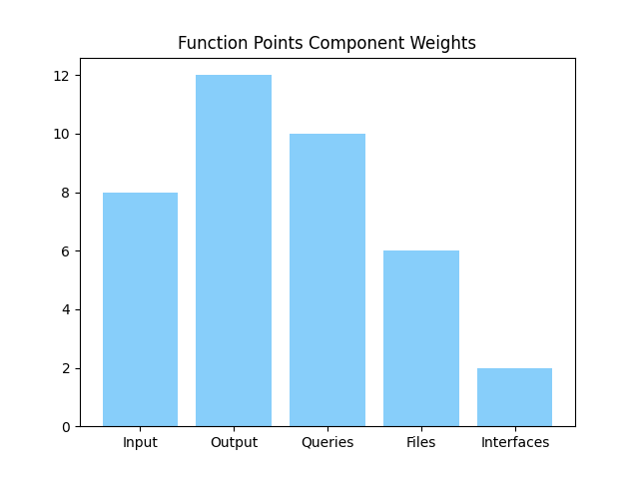

3.3 Lines of Code (LOC) Estimates
The system was divided into various modules to calculate effort and lines of code (LOC). The complexity was distributed primarily between the UI rendering and the backend task orchestration mechanisms.
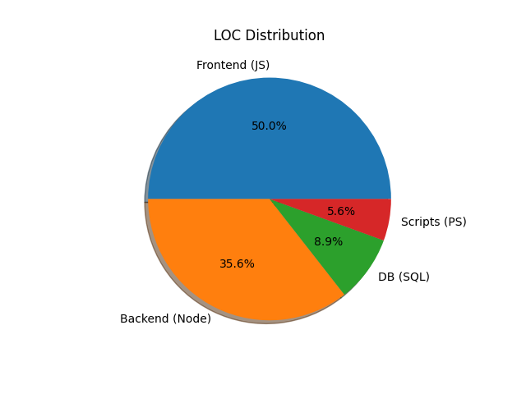

3.4 Project Scheduling and Representation
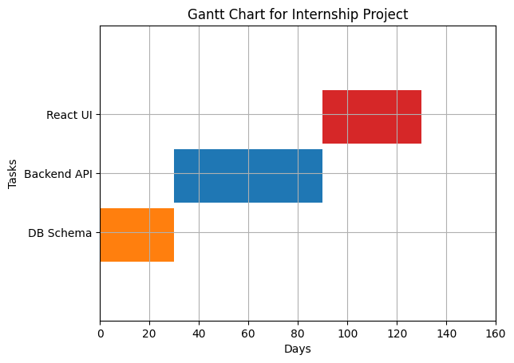

Chapter 4 Project And System Requirement Study

4.1 User Characteristics
The application serves QA Engineers, Developers, and System Administrators. Users are expected to have fundamental knowledge of testing terminologies like Regression, Sanity, Test Suites, and pass/fail diagnostics.

4.2 Hardware And Software Requirements
Hardware Specifications:
- Server Node: Intel Xeon E5 or equivalent, 16GB RAM, 100GB SSD Storage.
- Client Node: Intel Core i5, 8GB RAM, Modern internet connection.
Software Specifications:
- Node.js v14+, NPM/Yarn.
- MySQL 8.0 instance running locally or on a dedicated DB cluster.
- Target IIS or Express Server hosting.

4.3 Assumptions and Dependencies
It is assumed that the remote IMS target servers (e.g., `imsautomate02`) are continuously active and connected to the corporate intranet. Correct execution credentials must be preemptively registered in the database. Network firewalls must allow inbound/outbound traffic on the configured Socket.IO port.

Chapter 5 System/Resource Analysis

5.1 Activity Diagram
The following diagram illustrates the workflow of taking an execution request and deploying it asynchronously on the remote node.
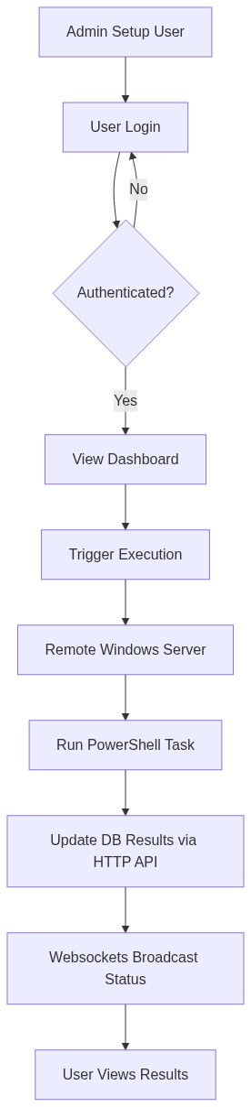

5.2 Use Case Diagram
Interactions between the primary actors (Admins, QA) and the core modules of the AXES platform.
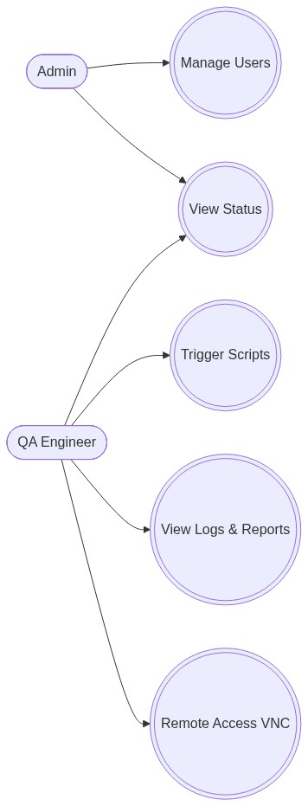

5.3 Framework Diagram
This framework maps the data flow from the React frontend, through the Express REST controllers and WebSockets, down to the shell executions.
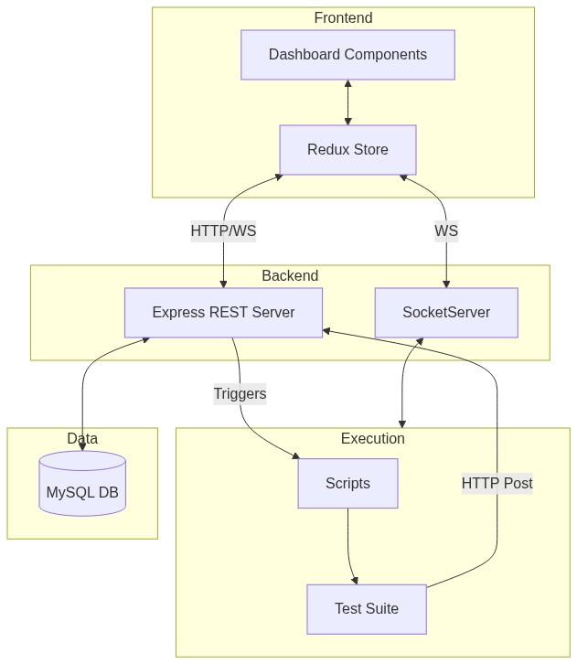

5.4 Sequence Diagram
The sequence tracks the lifecycle of an HTTP execution request being translated into an asynchronous Maven trigger.
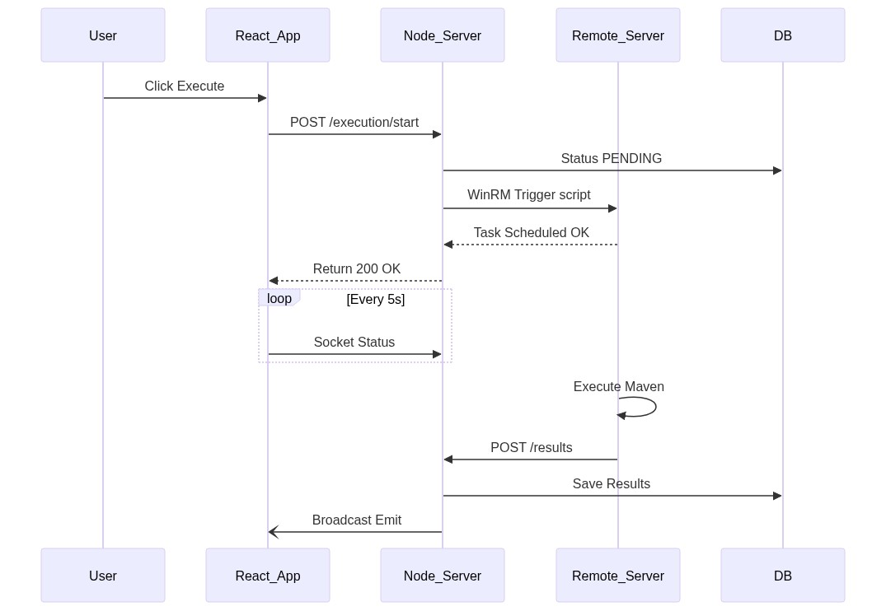

Chapter 6 Axes Design

6.1 Login Page And Interface Design
The design system guarantees responsive scaling for various monitor sizes. Secure JWT mechanisms were mapped to the login interfaces.
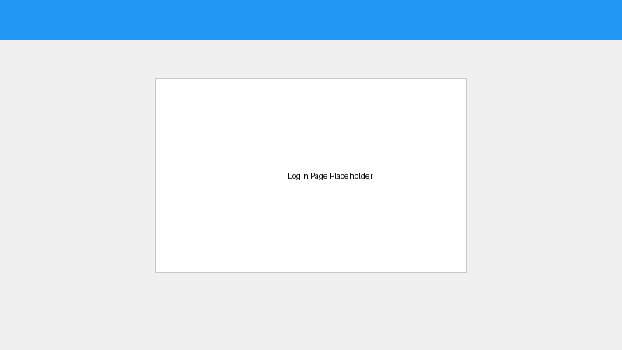
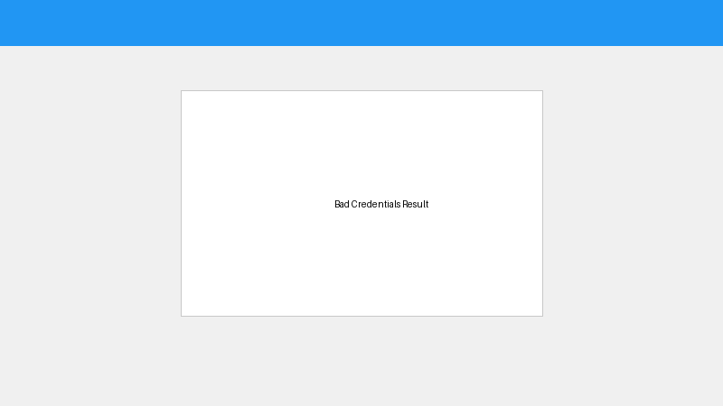

Chapter 7 Implementation Planning

7.1 Implementation Environment
Development primarily occurred using IDEs like VS Code with standard Node environments. Dep testing utilized isolated staging databases to avoid data pollution on production testing trackers. The React DevTools extension and Redux Logger were actively utilized to trace functional bugs in data states.

7.2 Code Level Documentation
Asynchronous flow handling was performed utilizing modern JS Promises and `async/await` syntaxes to sidestep callback hell. Code modularity inside the Express backend isolated the `/api/execute` route logic from the Database driver models. Sequelize models defined strict structural validations enforcing correct foreign key mappings between `Users`, `Projects`, `Executions`, and `Reports`.

Chapter 8 Testing

8.1 Testing Strategy
Integration testing validated the payload consistency between React and Node. Security testing ensured protected routes reject invalid JWT tokens. Boundary constraints were applied by mocking over-capacity queue loads on the Execution Queue.
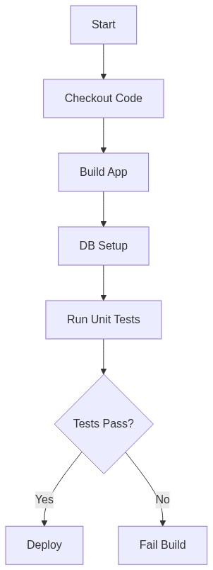

8.2 Unit Testing
Unit test cases ensured that the regex-based Test Discovery (identifying `@Test` methods) accurately parsed the Java files independent of their complexity or inline comments.

Chapter 9 Conclusion
The successful implementation of IMSAxes consolidated discrete front-end UI commands and complex remote OS-level executions into a seamless workflow. The platform drastically improved visibility of test executions and provided granular logging data. Dealing with asynchronous delays out of IIS Task Schedulers challenged initial designs, leading to the creation of robust web-hook callbacks from the testing suite itself.

Chapter 10 Limitations and Future Enhancements
Currently dependent on Windows-specific PowerShell execution paths, restricting the orchestrator targets to Windows Server machines. Future versions aim to implement a Python or Go-based background agent executable on any OS (Linux/macOS). Furthermore, machine-learning-driven analysis pipelines could be integrated to automatically classify test stack-trace errors into known categories (e.g., UI changed, timeout, bad data).

Chapter 11 Bibliography/ References
1. React.js Technical Documentation: https://reactjs.org/
2. Node.js & HTTP Parsing: https://nodejs.org/
3. Express Routing Guides
4. Internal Project Documentation: IMS_Workflow_Documentation.md and class_diagram.md

