Practical : 3

Name : Patel Jindal Bharatbhai

Enrollment No. : 230280107098

* Logical Operation in Single Circuit

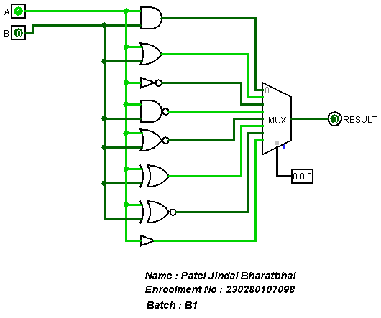

|  |  |  |  |  |
| --- | --- | --- | --- | --- |
| S2 | S1 | S0 | output | operation |
| 0 | 0 | 0 | A /\ B | AND |
| 0 | 0 | 1 | A \/ B | OR |
| 0 | 1 | 0 | A’ | NOT |
| 0 | 1 | 1 | (A /\ B)’ | NOR |
| 1 | 0 | 0 | (A \/ B)’ | NAND |
| 1 | 0 | 1 | AB’ + A’B | EX-OR |
| 1 | 1 | 0 | AB + A’B’ | EX-NOR |
| 1 | 1 | 1 | A | BUFFER |

* EX-OR

