MACHINE LEARNING

TEAM: SMOOTH OPERATORS

**RESULT IMAGES**

1. Image - 1: Results of Euclidean k-means (no. of clusters = 2)

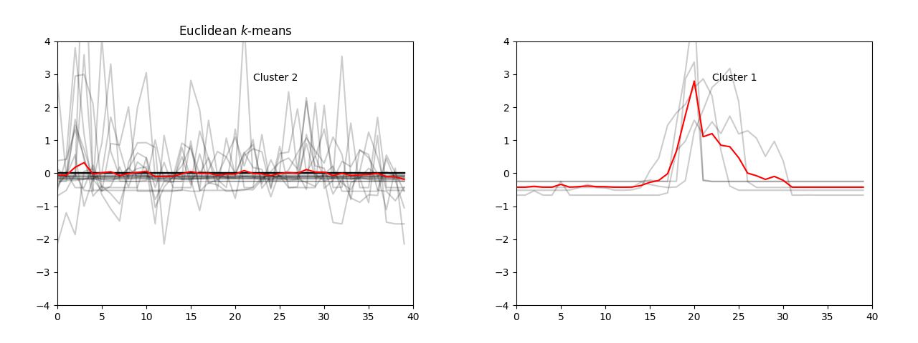

1. Image - 2: Results of soft-DTW k-means (no. of clusters = 2)

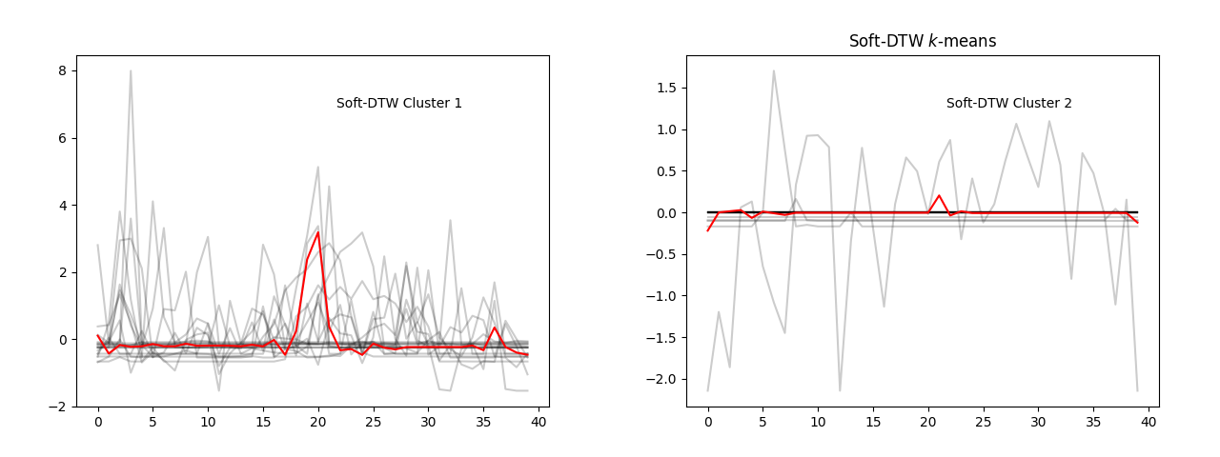

1. Image - 3: Results of DBA k-means (no. of clusters = 2)

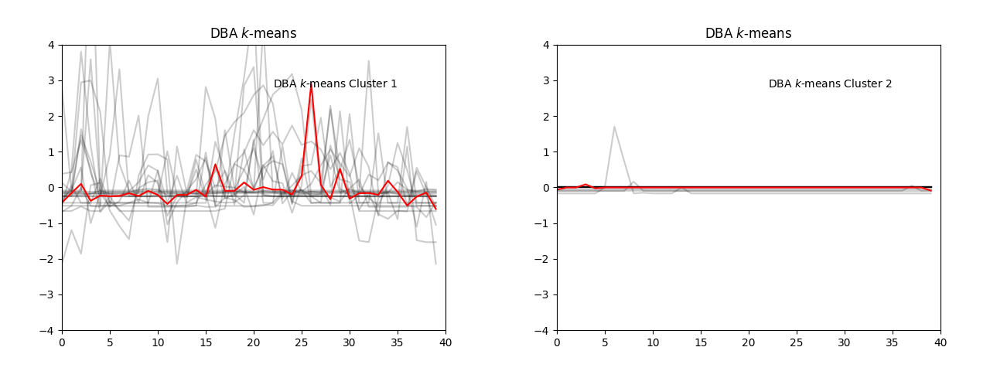

1. Comparison of silhouette scores:

