Classify building usage type from street acquired images using genetic algorithm and compare with other optimizers (Adam, GD, SGD)

Ayush Pandey and 20071

*Abstract*—The usage of Convolution Neural Networks in the field of Image classification has achieved remarkable success in recent years. Automating the design of CNN’s is required to help some users having limited domain knowledge to fine tune the architecture for achieving desired performance and accuracy. Usage of different evolutionary methods such as Genetic Algorithms helps in simplifying, automating the architecture of CNN’s and also to improve their performance. In this project, we used GA to optimize the parameters of CNN. Then compared it with different optimizers like SGD, ADAM and GD.

Keywords— Genetic Algorithms, Classification, optimization, ADAM, SGD, GD

# Introduction and Background

In this project we classify building usage type from satellite acquired images. Micro-level information on buildings and physical infrastructure is increasing in relevance to social, economic and environmental statistical programs. Building type is an important piece of information that has crucial applications in social and economic analysis and urban planning. Having an up-to-date database of such data on a large scale is important at both the local and national levels. For example, the development of a housing strategy requires up-to-date information on existing and new building types. Information on building types and their development, in each jurisdiction, would help the various levels of government to set up policies to improve quality of life and access to services in each neighbourhood, monitor housing supply, and increase housing affordability.

Street-view imagery provides a close view of building façades, and hence can be used to extract a building type. There has been some effort in the literature to extract data from street-view images. This includes various applications such as estimating urban land use and the demographic makeup of neighbourhoods. Moreover, street-view imagery has been used for building instance classification. Results from the work above show that street-view images can indeed provide a rich source of information in multiple applications.

We also used transfer learning and used VGG model. The rapid developments in Computer Vision, and by extension – image classification has been further accelerated by the advent of Transfer Learning. To put it simply, Transfer learning allows us to use a pre-existing model, trained on a huge dataset, for our own tasks. Consequently reducing the cost of training new deep learning models and since the datasets have been vetted, we can be assured of the quality.

We used genetic algorithm to optimize weights. Genetic Algorithms (GAs) are adaptive heuristic search algorithms that belong to the larger part of evolutionary algorithms. Genetic algorithms are based on the ideas of natural selection and genetics. These are intelligent exploitation of random search provided with historical data to direct the search into the region of better performance in solution space. **They are commonly used to generate high-quality solutions for optimization problems and search problems.**

**Genetic algorithms simulate the process of natural selection** which means those species who can adapt to changes in their environment are able to survive and reproduce and go to next generation. In simple words, they simulate “survival of the fittest” among individual of consecutive generation for solving a problem. **Each generation consist of a population of individuals** and each individual represents a point in search space and possible solution. Each individual is represented as a string of character/integer/float/bits. This string is analogous to the Chromosome.

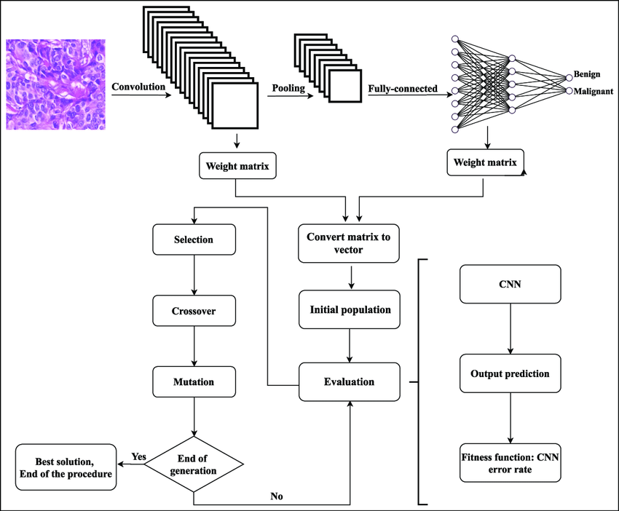

Dataset- [(Link)](https://drive.google.com/drive/folders/1PLr-N5sIy1RBkc_Y5H3MZ9ixJU5-Z0ID?usp=share_link)

We have test and train dataset containing approximately 1000 images. Each has 4 categories namely commercial, industrial, residential and others.

# Methodology

## Step1

First, we unzipped the train and test data from google drive. Then applied data loader from pytorch to convert test and train images to tensor.

## Step 2

Then I used the VGG model for encoding the tensor. Freezed all the layers of VGG except the last two. Also, added a last layer to it containing 4 neurons as in our project we need to classify different building in 4 categories.

## Step 3

Then, trained the VGG model to out dataset and printed the classification report.

## Step 4

Now applied the genetic algorithm. First, generated 6 random arrays of size 16384 containing 0 and 1 values only, and then converted it to a tensor of size (4,4096). The values in these tensors will be weights of last layer.

## Step 5

Now inserted the random generated tensor above to the last layer of VGG and trained it to our model. Then printed the classification report. Repeated this step for all the 6 random generated tensors.

## Step 6

Took the best two tensor according to weighed average score. Now these two will act as parent and mutated them to find 4 offspring. After that mutated them until the difference between the offspring and parent became minimized. Printed the best results. These will be the final weights of last layer

# Results and Discussion

## The parameters of vgg sequential layer used is given below-

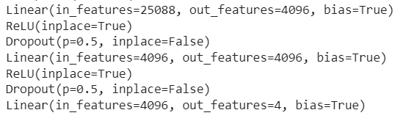

Fig 1. Parameters in sequential VGG

## Figures and Tables

|  |  |
| --- | --- |
| Binary Tensor | Weighted Average |
| 1 | 0.16 |
| 2 | 0.23 |
| 3 | 0.27 |
| 4 | 0.40 |
| 5 | 0.23 |
| 6 | 0.34 |

## In this section all the classification reports(SGD, GD, Adam and Genetic Algorithm are present)

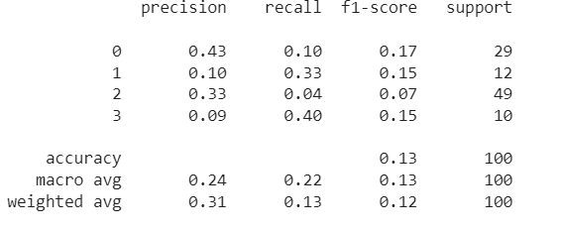

Fig 2. Classification Report for GD

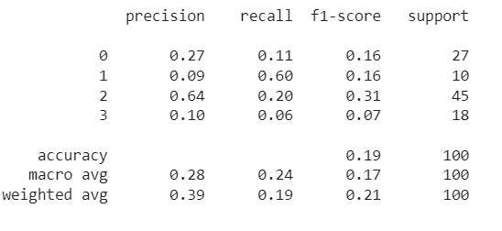

Fig 3. Classification Report of SGD

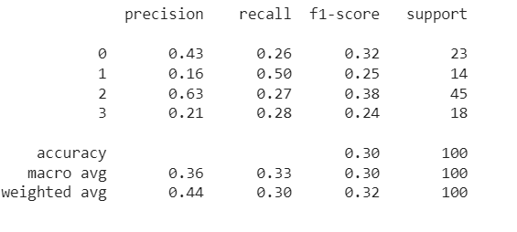

Fig 4. Classification Report of Adam

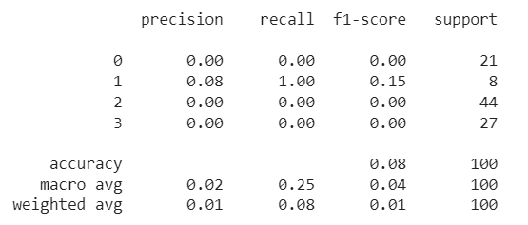

Fig 5. Classification Report of Genetic Algorithm

## Conclusion-

We compared SGD, Adam, GD and genetic algorithms from

Classification report. Genetic Algorithm perform poorly on our

Dataset while Adam is best performing optimizer in our dataset.

Thus, we conclude that genetic algorithm is not a good choice for

Classification.

##### References

[1] Khatereh Davoudi and Parimala Thulasiraman ,

Evolving convolutional neural network parameters through the genetic algorithm for the breast cancer classification problem

[2] Sai Nivedh Vallala , Optimization of CNN Architecture using Genetic Algorithm for Image Classification, Medium Blog

[3] Geeks for geeks, Genetic Algorithm

[4] Ahmed Gad, Artificial Neural Networks Optimization

[5] Pulkit Sharma, Deep Learning for Everyone: Master the Powerful

Art of Transfer Learning using PyTorch, analyticsvidya blog.

[6] Wangda Zuo , Guifang Shao and Tiejun Li, Genetic Algorithm for

Building Optimization: State-of-the-Art Survey