**Mini Project**  
(2019-2020)

**Automated Student Attendance Management System Using Face Recognition**

**Synopsis**



Institute of Engineering & Technology

Team Members:  
Amit Kumar Rai(171500041)  
Ayush Pandey(171500077)  
Aditya Srivastava(171500020)  
Kartikeya Mishra(171500157)

Supervised By:  
Mr. Vivek Kumar  
(Assistant Professor)

Department of Computer Engineering & Applications

## About the Project

Attendance management system is a necessary tool for taking attendance in any environment where attendance is critical. However, most of the existing approach are time consuming, intrusive and it require manual work from the users. This project is aimed at developing a less intrusive, cost effective and more efficient automated student attendance management system using face recognition. Program take attendance by using IP camera mounted in front of a classroom, to acquire images of the entire class. It detect the faces in the image and compares it with the enrolled faces in the database. On identification of a registered face on the acquired image collections, the attendance register is marked as present otherwise absent. The system is developed on Open Source image processing library hence, it is not vendor hardware nor software dependent.

## Motivation

Colleges/universities are almost same. In able to reduce the workload of every lecturer in key-in the student’s attendance records to the system at every end of semester since this system will record all student’s attendance accurately and automatically in every classes attended by students throughout the whole semester. Besides that, students have paid the colleges/universities in order to gain knowledge that helps them in building up their future career. Therefore, every colleges/universities must provide the responsibilities in ensuring their students will really attend all the classes for the subjects they had registered.

**Keywords**: Student Attendance, Face Recognition, Face Detection, marking Attendance

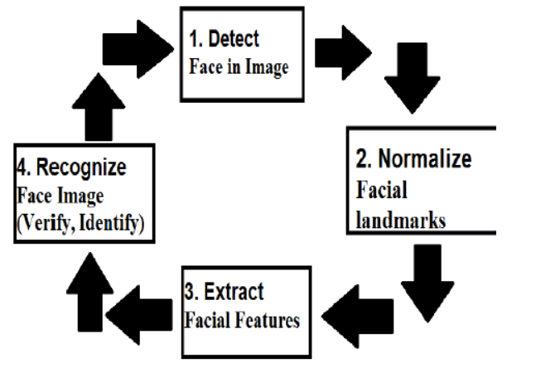

Requirements

**Software**: Open CV, Image AI, Eigen Face Algorithm, MySQL (For database connectivity)

**Hardware**: Laptop (with processor i3 and above), 8GB RAM, Webcam/CCTV

## System Algorithm

This section describes the software algorithm for the system. The algorithm consists of the following steps:

* Image acquisition
* Gray Scale
* Histogram Normalization
* Noise removal
* Face recognition
* Attendance

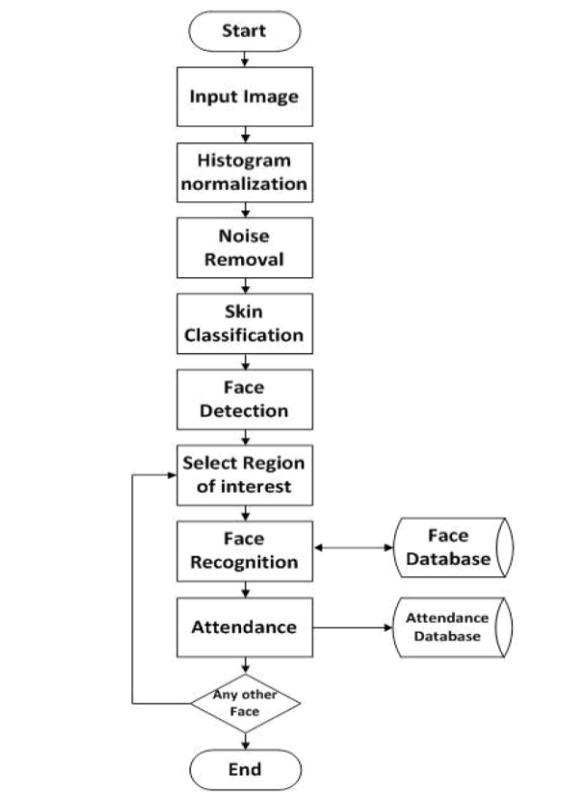In the first step image is captured from the camera. There are illumination effects in the captured image because of different lighting conditions and some noise which is to be removed before going the next steps. Histogram normalization is used for contrast enhancement in the spatial domain. Median filter is used for removal of noise in the image. There are other techniques like low pass filter for noise removal and smoothing of the images but median filter gives good results.

## Future scope

The current recognition system has been designed for frontal views of face images. A neural network architecture (may be together with a feature based approach) can be implemented in which the orientation of the face is first determined, and then the most suitable recognition method is selected, Also the current recognition system acquires face images only from face files located on magnetic mediums. Camera and scanner support should be implemented for greater flexibilty.

## Applications

This system is used for various application such as security purpose, industry, Education, Face recognition etc.