"""______________________________________________________________________________

This Project is created by

39 AYUSH PATEL

0103CS181041

Poject Name : Colour Finder and Colour Picker

______________________________________________________________________________

This project will take an image from the command line itself

and then you can select whichever colour you want to ranging from 16 million

colour options, just you have to double click on the colour and it will

automatically copy the colour name with its hex values to the clipboard.

"""

import cv2

import numpy as np

import pandas as pd

import argparse

import pyperclip as pp

ap = argparse.ArgumentParser()

ap.add_argument('-i', '--image', required=True, help="Image Path")

args = vars(ap.parse_args())

img_path = args['image']

img = cv2.imread(img_path)

clicked = False

r = g = b = xpos = ypos = 0

#Reading csv

index=["color","color_name","hex","R","G","B"]

csv = pd.read_csv('colors.csv', names=index, header=None)

#To calculate the most matching color

def getColorName(R,G,B):

minimum = 10000

for i in range(len(csv)):

d = abs(R- int(csv.loc[i,"R"])) + abs(G- int(csv.loc[i,"G"]))+ abs(B- int(csv.loc[i,"B"]))

if(d<=minimum):

minimum = d

cname = csv.loc[i,"color_name"]

return cname

#function to get x,y coordinates of mouse click

def draw_function(event, x,y,flags,param):

if event == cv2.EVENT_LBUTTONDBLCLK:

global b,g,r,xpos,ypos, clicked

clicked = True

xpos = x

ypos = y

b,g,r = img[y,x]

b = int(b)

g = int(g)

r = int(r)

cv2.namedWindow('image')

cv2.setMouseCallback('image',draw_function)

while(1):

cv2.imshow("image",img)

if (clicked):

cv2.rectangle(img,(20,20), (750,60), (b,g,r), -1)

text = getColorName(r,g,b) + ' R='+ str(r) + ' G='+ str(g) + ' B='+ str(b)

cv2.putText(img, text,(50,50),2,0.8,(255,255,255),2,cv2.LINE_AA)

if(r+g+b>=600):

cv2.putText(img, text,(50,50),2,0.8,(0,0,0),2,cv2.LINE_AA)

clicked=False

#for copying it to clipboard

pp.copy(text)

pp.paste()

if cv2.waitKey(20) & 0xFF ==27:

break

cv2.destroyAllWindows()

OUTPUT SCREENS:

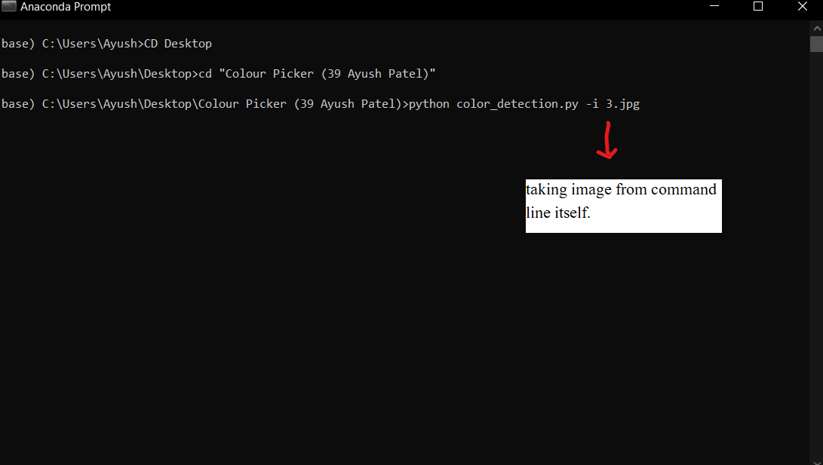

Image is loaded… and showing on the screen

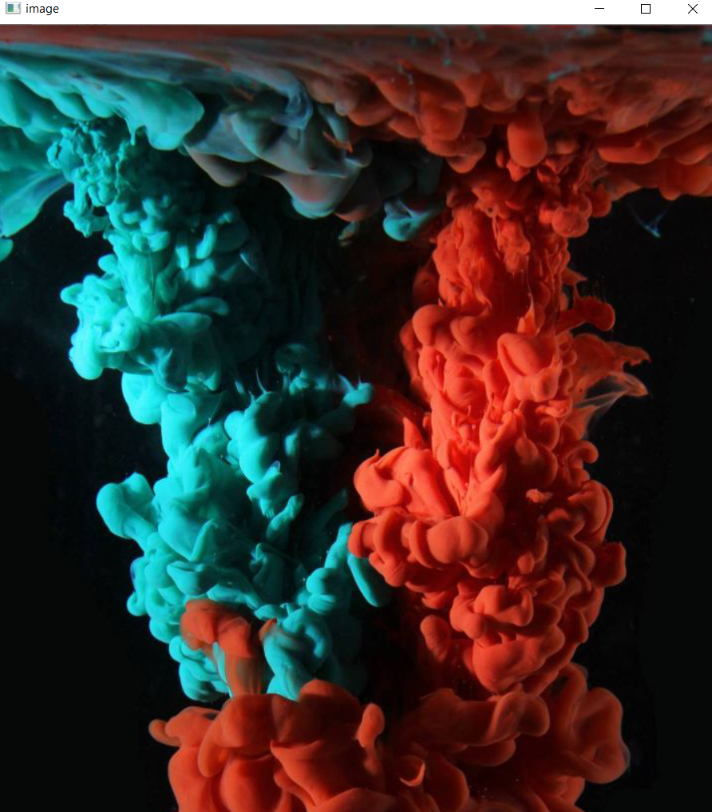

Picking a colour

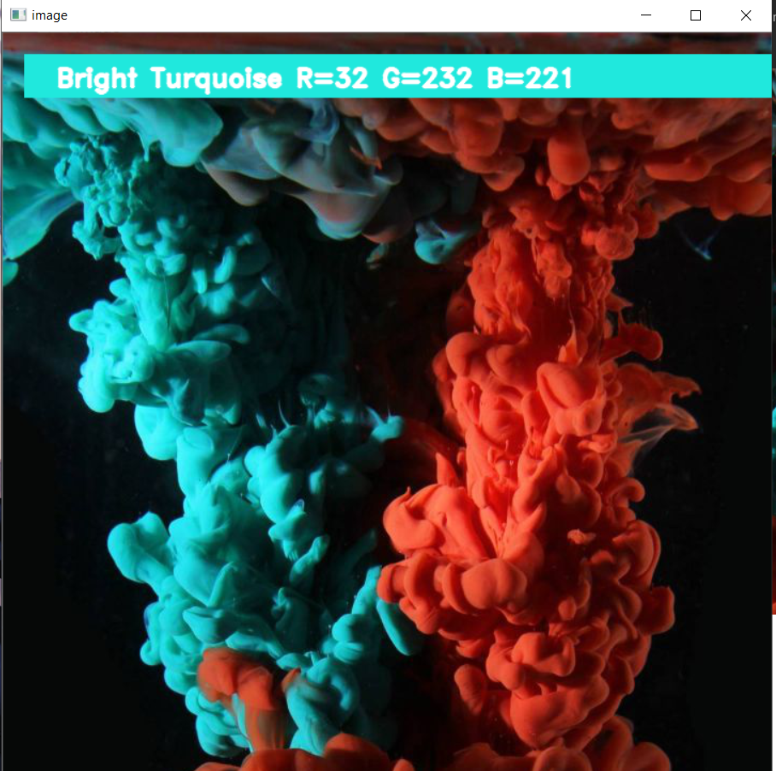

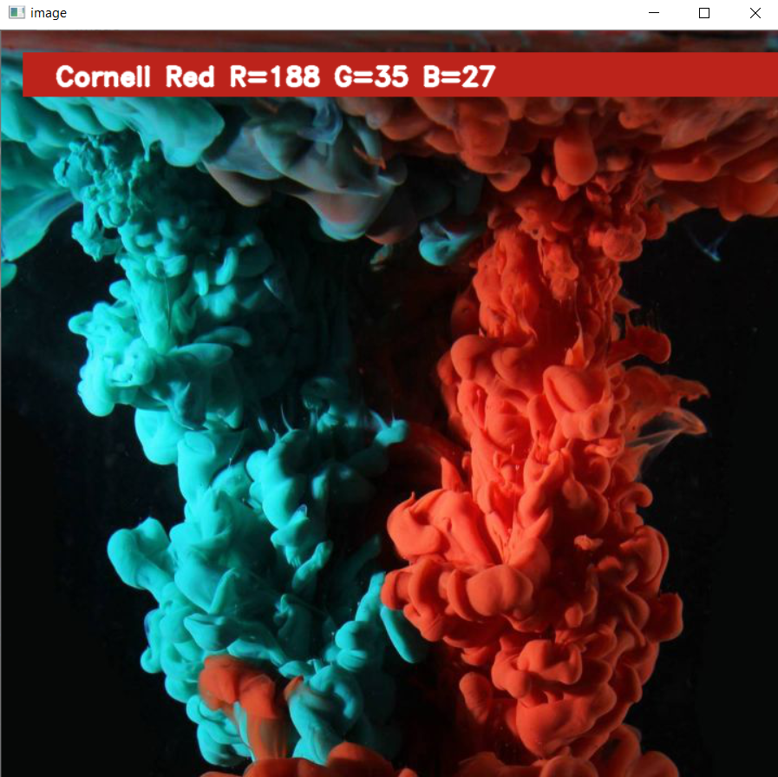

______________________________________________________________________________

This Project is created by

39 AYUSH PATEL

0103CS181041

Poject Name : Colour Finder and Colour Picker

______________________________________________________________________________