Deploy Static Website on AWS

In this project, you will deploy a static website to AWS using S3, CloudFront, and IAM.

The files included are:

index.html - The Index document for the website.

/img - The background image file for the website.

/vendor - Bootssrap CSS framework, Font, and JavaScript libraries needed for the website to function.

/css - CSS files for the website.

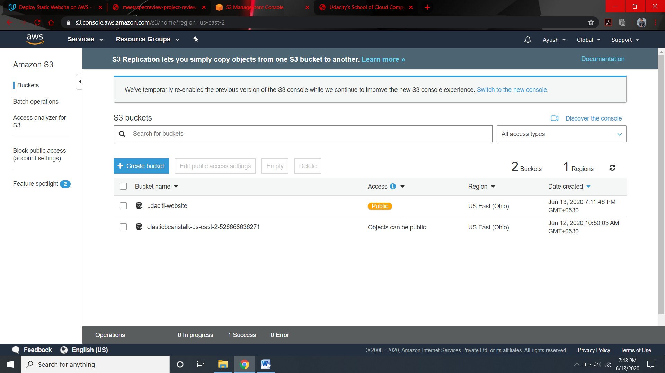

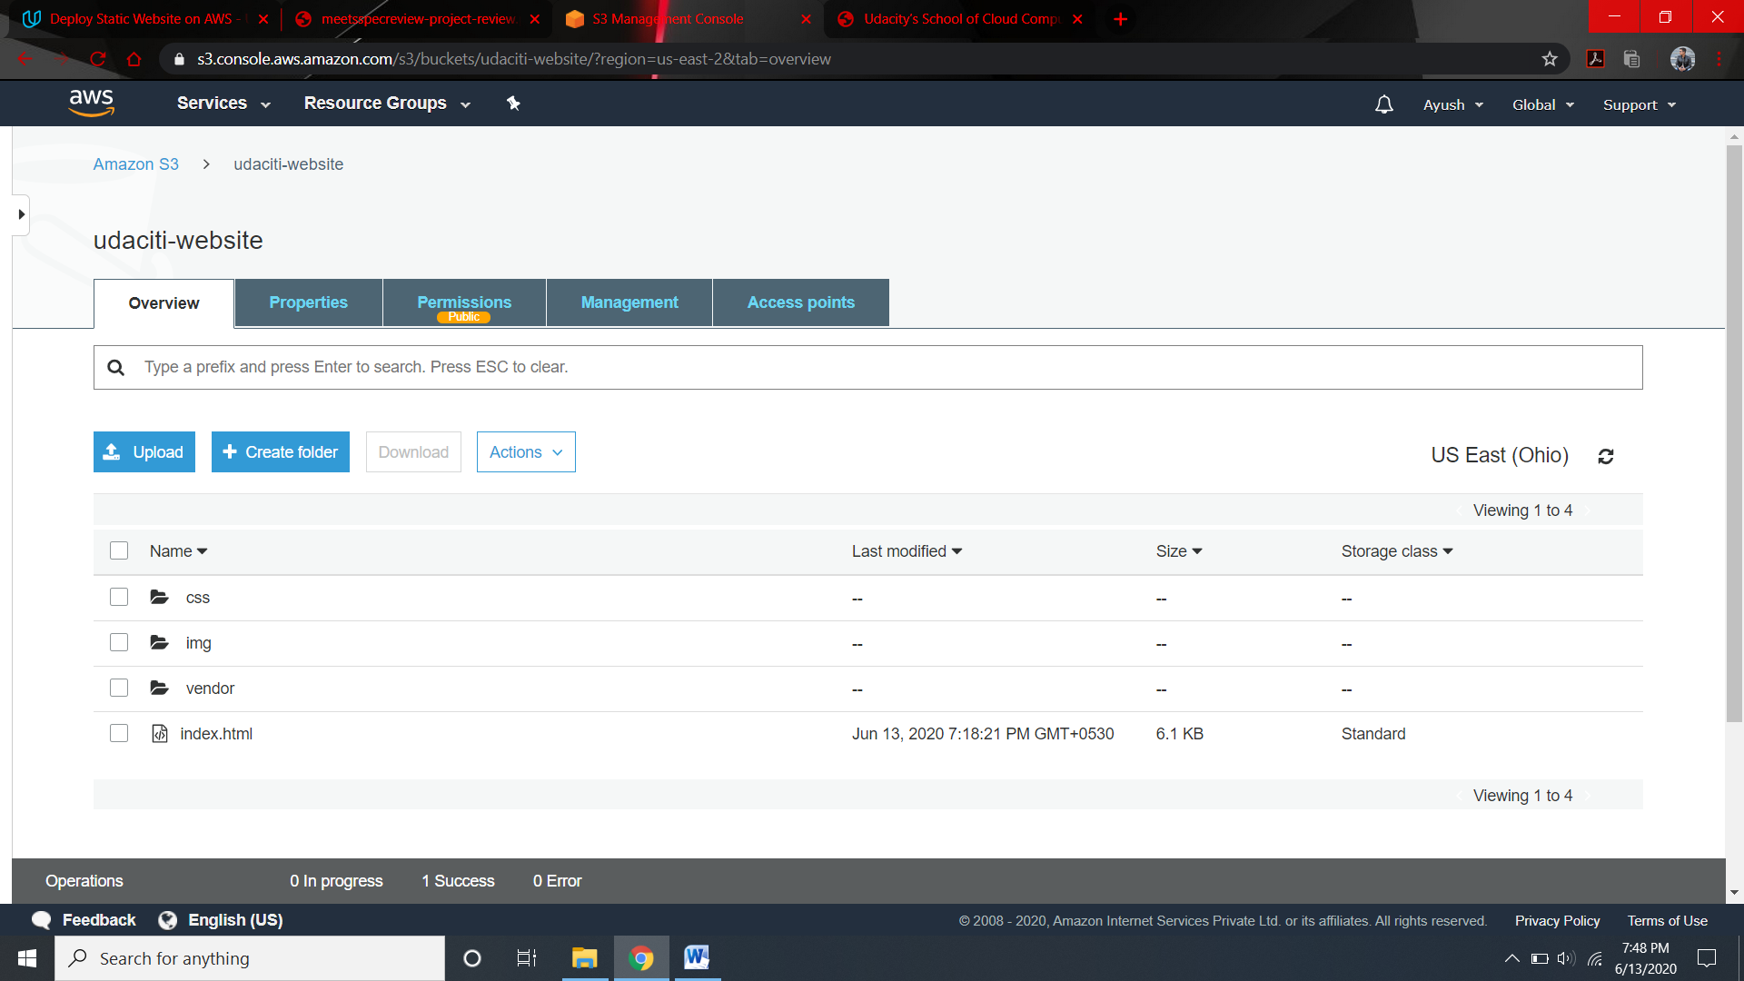

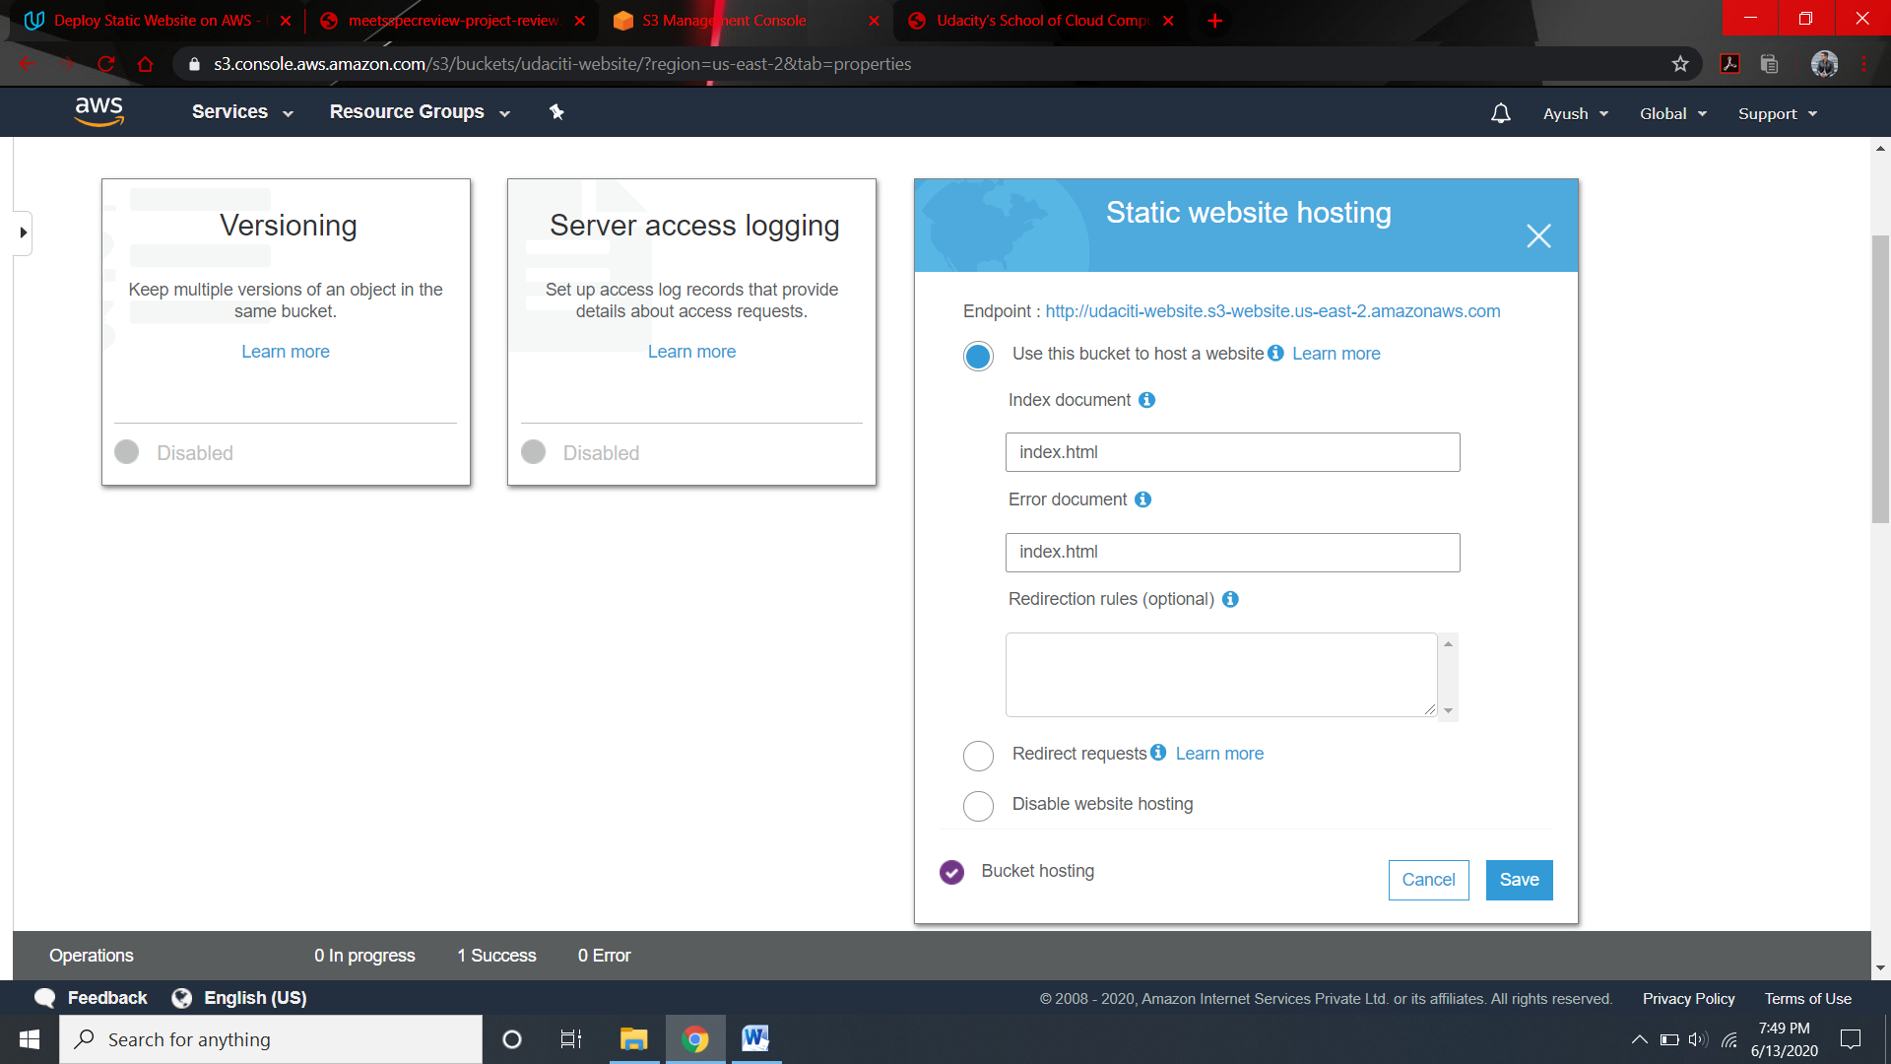

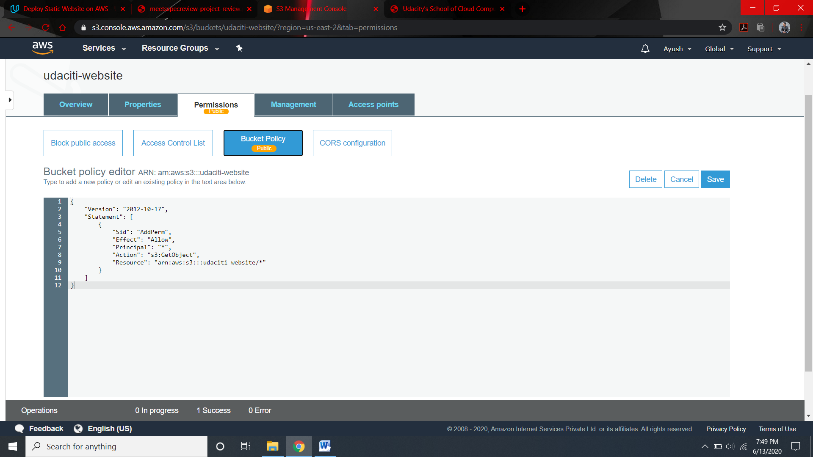

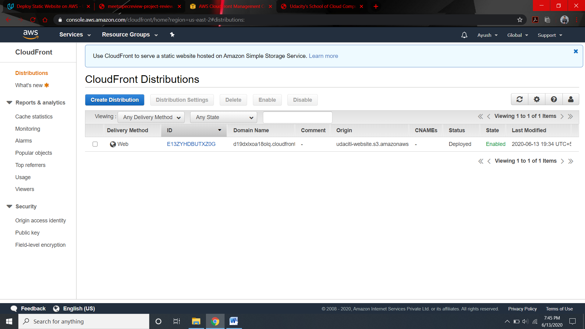

The website is publically accessible

<URL:-> <http://udaciti-website.s3.us-east-2.amazonaws.com/index.html>

