

**HOUSING-PRICE PREDICTION**

**Submitted by:**

**AYUSH PATHAK**

**ACKNOWLEDGMENT**

I would like to express my gratitude towards Flip-Robo for giving me this opportunity to show case my talent and also for their constant support and guidance. Also, I would like to thank data-trained for providing me internship. I express my deepest thanks to **Sajid Choudhary**, for taking part in useful decision & giving necessary advices and guidance and arranged all facilities to make my project easier. I choose this moment to acknowledge his contribution gratefully. I perceive as this opportunity as a big milestone in my career development. I will strive to use gained skills and knowledge in the best possible way, and I will continue to work on their improvement, in order to attain desired career objectives. Hope to continue cooperation with all of you in the future.

Some of the reference sources are as follows:

* Internet
* Coding Ninjas
* Medium.com
* Analytics Vidhya
* StackOverflow

Thanks

Ayush Pathak

# INTRODUCTION

## BUSINESS PROBLEM FRAMING

This is a real estate problem where a US based housing company named Surprise Housing has decided to invest in Australian Market. Their agenda is to buy houses in Australia at prices below their actual value in the market and sell them at high prices to gain profit. To do this this company uses data analytics to decide in which property they must invest.

Company has collected the data of previously sold houses in Australia and with the help of this data they want to know to the value of prospective properties to decide whether it will suitable to invest in the properties or not.

To know the value of properties company has provided data to us to do data analysis and to extract the information of attributes which are important to predict the price of the houses. They want a machine learning model which can predict the price of houses and also the significance of each important attribute in house prediction i.e, how and to what intensity each variable impacts the price of the house.

## CONCEPTUAL BACKGROUND OF THE DOMAIN PROBLEM

In real estate the value of property usually increases with time as seen in many countries. One of the causes for this is due to rising population.

The value of property also depends on the proximity of the property, its size its neighbourhood and audience for which the property is subjected to be sold. For example if audience is mainly concerned of commercial purpose. Then the property which is located in densely populated area will be sold very fast and at high prices compared to the one located at remote place. Similarly if audience is concerned only on living place then property with less dense area having large area with all services will be sold at higher prices.The company is looking at prospective properties to buy houses to enter the market. We are required to build a model using Machine Learning in order to predict the actual value of the prospective properties and decide whether to invest in them or not.

## REVIEW OF LITERATURE

Houses are one of the necessary needs of each and every person around the globe and therefore housing and real estate market is one of the markets which is one of the major contributors in the world’s economy.

A US-based housing company named Surprise Housing has decided to enter the Australian market. The company uses data analytics to purchase houses at a price below their actual values and flip them at a higher price.We are required to build a model using Machine Learning in order to predict the actual value of the prospective properties and decide whether to invest in them or not.With its great weather, cosmopolitan cities, diverse natural landscapes and relaxed lifestyle, it’s no wonder that Australia remains a top pick for expats.

Living cost in Australia for one person: $2,835 per month. Average living expenses for a couple: $4,118 per month. Average monthly living expenses for a family of 4: $5,378. Australia currently has the 16th highest cost of living in the world, with the USA and UK well behind at 21st and 33rd place respectively. Sydney and Melbourne are popular choices for expats moving to Australia.

House pricing in some of the top Australian cities:-

Sydney - median house price A$1,142,212

Adelaide- median house price A$542,947

Hobbart (smaller city)- median house price A$530,570.

## MOTIVATION FOR THE PROBLEM UNDERTAKEN

To understand real world problems where Machine Learning and Data Analysis can be applied to help organizations in various domains to make better decisions with the help of which they can gain profit or can be escaped from any loss which otherwise could be possible without the study of data .One of such domain is Real Estate.

Houses are one of the necessary need of each and every person around the globe and therefore housing and real estate market is one of the markets which is one of the major contributors in the world’s economy. It is a very large market and there are various companies working in the domain. Data science comes as a very important tool to solve problems in the domain to help the companies increase their overall revenue, profits, improving their marketing strategies and focusing on changing trends in house sales and purchases. Predictive modelling, Market mix modelling, recommendation systems are some of the machine learning techniques used for achieving the business goals for housing companies. Our problem is related to one such housing company.

# ANALYTICAL PROBLEM FRAMING

## MATHEMATICAL/ ANALYTICAL MODELING OF THE PROBLEM

In this project we have performed various mathematical and statistical analysis such as we checked description or statistical summary of the data using describe, checked correlation using corr and also visualized it using heatmap. Then we have used Z-Score to plot outliers and remove skewness too.

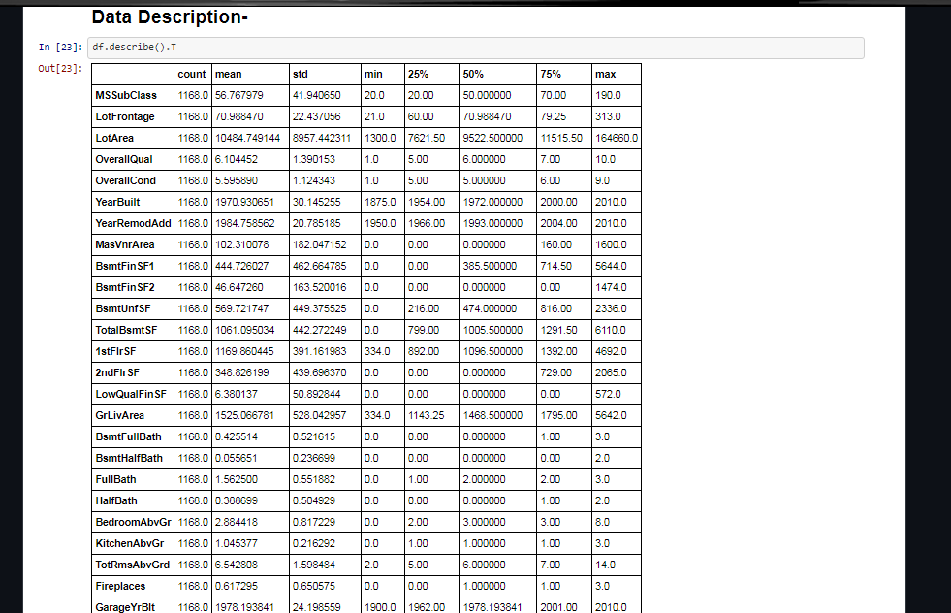

From this statistical analysis we make some of the interpretations that,

* Maximum standard deviation of 8957.44 is observed in LotArea column.
* Maximum SalePrice of a house observed is 755000 and minimum is 34900.

## DATA SOURCES AND THEIR FORMATS

The variable features of this problem statement are as :

MSSubClass: Identifies the type of dwelling involved in the sale

MSZoning: Identifies the general zoning classification of the sale

LotFrontage: Linear feet of street connected to property

LotArea: Lot size in square feet

Street: Type of road access to property

Alley: Type of alley access to property

LotShape: General shape of property

LandContour: Flatness of the property

Utilities: Type of utilities available

LotConfig: Lot configuration

LandSlope: Slope of property

Neighborhood: Physical locations within Ames city limits

Condition1: Proximity to various conditions

Condition2: Proximity to various conditions (if more than one is present)

BldgType: Type of dwelling

HouseStyle: Style of dwelling

OverallQual: Rates the overall material and finish of the house

OverallCond: Rates the overall condition of the house

YearBuilt: Original construction date

YearRemodAdd: Remodel date (same as construction date if no remodeling or additions)

RoofStyle: Type of roof

RoofMatl: Roof material

Exterior1st: Exterior covering on house

Exterior2nd: Exterior covering on house (if more than one material)

MasVnrType: Masonry veneer type

MasVnrArea: Masonry veneer area in square feet

ExterQual: Evaluates the quality of the material on the exterior

ExterCond: Evaluates the present condition of the material on the exterior

Foundation: Type of foundation

BsmtQual: Evaluates the height of the basement

BsmtCond: Evaluates the general condition of the basement

BsmtExposure: Refers to walkout or garden level walls

BsmtFinType1: Rating of basement finished area

BsmtFinSF1: Type 1 finished square feet

BsmtFinType2: Rating of basement finished area (if multiple types)

BsmtFinSF2: Type 2 finished square feet

BsmtUnfSF: Unfinished square feet of basement area

TotalBsmtSF: Total square feet of basement area

Heating: Type of heating

HeatingQC: Heating quality and condition

CentralAir: Central air conditioning

Electrical: Electrical system

1stFlrSF: First Floor square feet

2ndFlrSF: Second floor square feet

LowQualFinSF: Low quality finished square feet (all floors)

GrLivArea: Above grade (ground) living area square feet

BsmtFullBath: Basement full bathrooms

BsmtHalfBath: Basement half bathrooms

FullBath: Full bathrooms above grade

HalfBath: Half baths above grade

Bedroom: Bedrooms above grade (does NOT include basement bedrooms)

Kitchen: Kitchens above grade

KitchenQual: Kitchen quality

TotRmsAbvGrd: Total rooms above grade (does not include bathrooms)

Functional: Home functionality (Assume typical unless deductions are warranted)

Fireplaces: Number of fireplaces

FireplaceQu: Fireplace quality

GarageType: Garage location

GarageYrBlt: Year garage was built

GarageFinish: Interior finish of the garage

GarageCars: Size of garage in car capacity

GarageArea: Size of garage in square feet

GarageQual: Garage quality

GarageCond: Garage condition

PavedDrive: Paved driveway

WoodDeckSF: Wood deck area in square feet

OpenPorchSF: Open porch area in square feet

EnclosedPorch: Enclosed porch area in square feet

3SsnPorch: Three season porch area in square feet

ScreenPorch: Screen porch area in square feet

PoolArea: Pool area in square feet

PoolQC: Pool quality

Fence: Fence quality

MiscFeature: Miscellaneous feature not covered in other categories

MiscVal: $Value of miscellaneous feature

MoSold: Month Sold (MM)

YrSold: Year Sold (YYYY)

SaleType: Type of sale

SaleCondition: Condition of sale

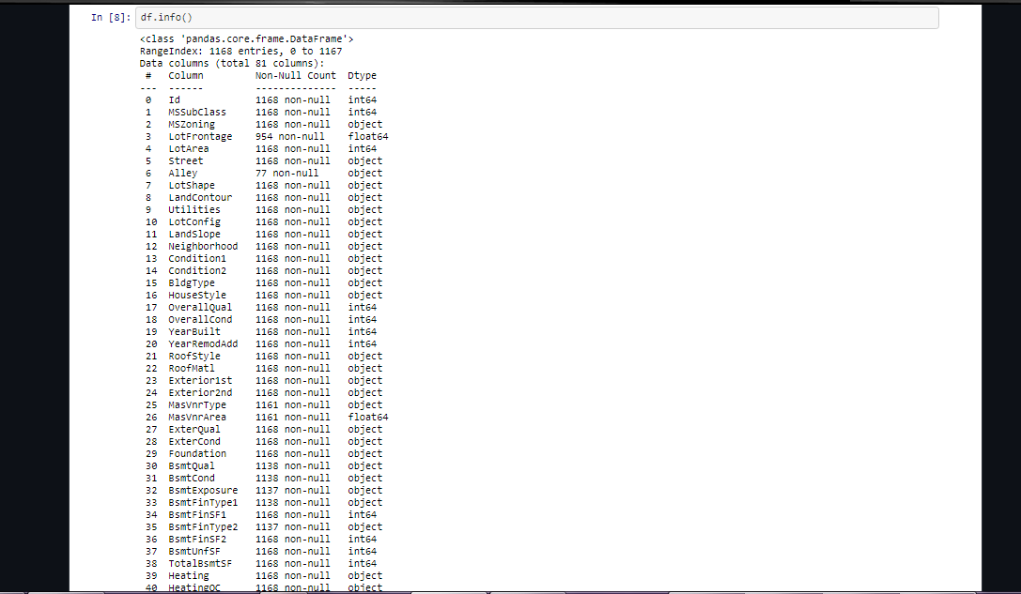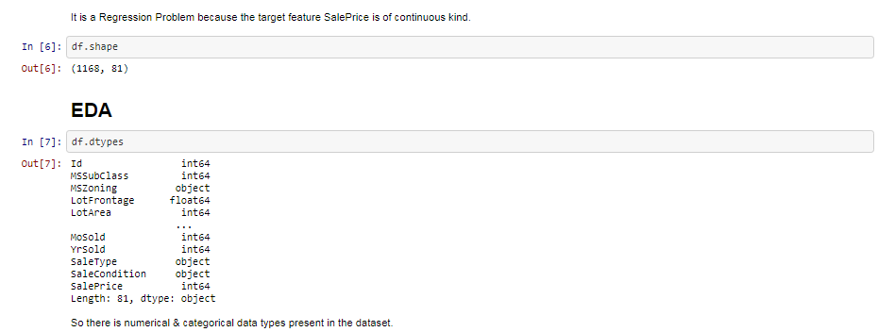

## DATA PREPROCESSING DONE

After loading all the required libraries we loaded the data into our jupyter notebook.

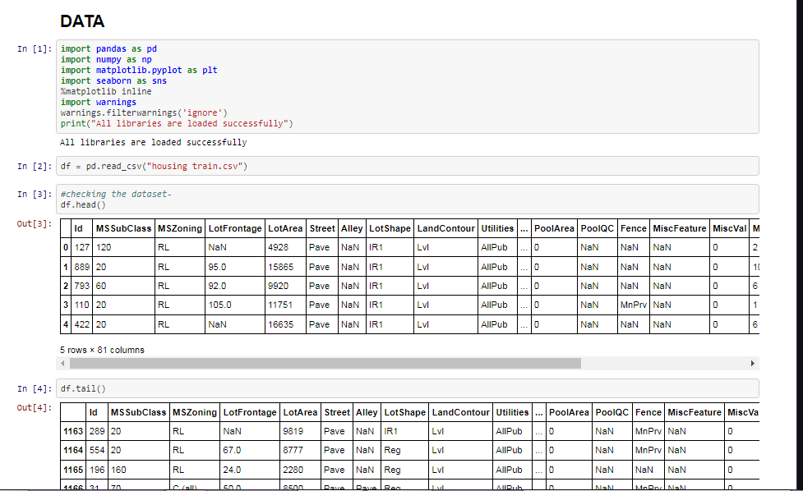

Cleaning the data was done through Feature Engineering.Some columns that were not used in the forecast have been eliminated, while others have been split. We started by cleansing the data. We looked at the fraction of missing values in columns first, then imputed missing values.

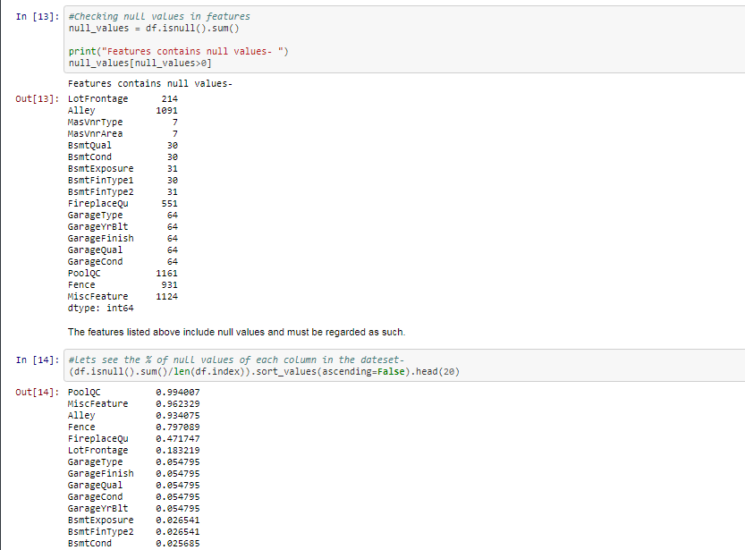

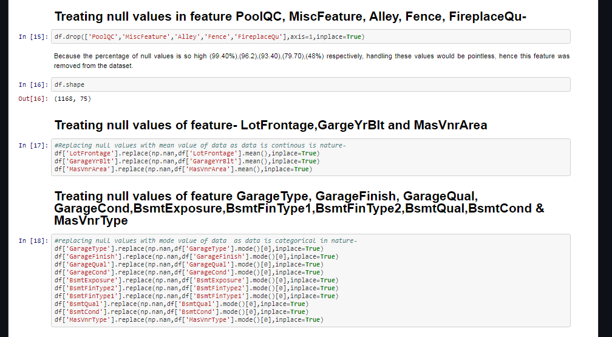

checking the correlation with target variable 'SalePrice'

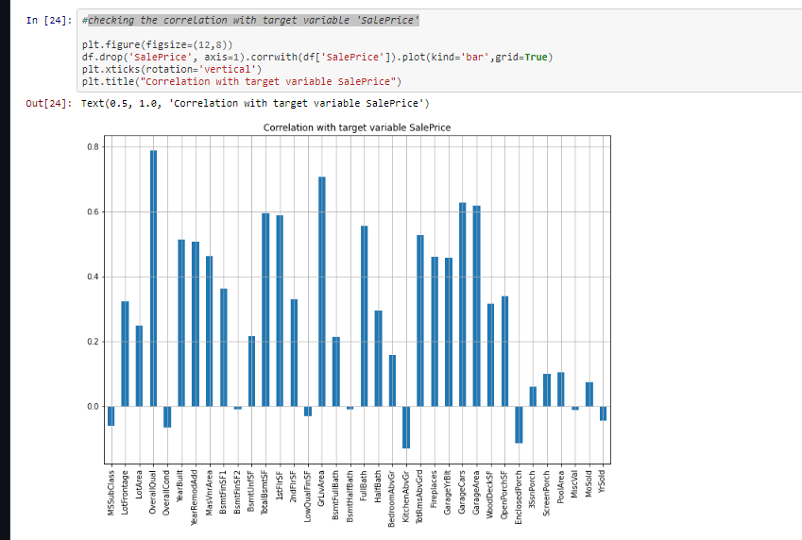

observations-

OverallQual has the strongest positive correlation with SalePrice.

KitchenAbvGrd has the strongest negatively correlation with SalePrice.

## HARDWARE AND SOFTWARE REQUIREMENTS AND TOOLS USED

**HARDWARE:**

Window Edition- Windows 7 Professional

Processor – i5 5th gen

System type – 32bit

RAM – 4GB

**SOFTWARE:**

Jupyter Notebook (Anaconda ) – Python 3.9.0

Microsoft Excel 2010

**LIBRARIES:**

The tools, libraries and packages we used for accomplishing this project are pandas, numpy, matplotlib, seaborn, scipy stats, sklearn.decompositionpca, sklearnstandardscaler, GridSearchCV, joblib.

***From sklearn.preprocessing import StandardScaler***

As these columns are different in scale, they are standardized to have common scale while building machine learning model. This is useful when you want to compare data that correspond to different units.

***fromsklearn.preprocessing import Label Encoder***

Label Encoder  and One Hot Encoder. These two encoders are parts of the SciKit Learn library in Python, and they are used to convert categorical data, or text data, into numbers, which our predictive models can better understand.

***fromsklearn.model_selection import train_test_split,cross_val_score***

Train_test_split is a function in Sklearn model selection for splitting data arrays into two subsets: for training data and for testing data. With this function, you don't need to divide the dataset manually. By default, Sklearntrain_test_split will make random partitions for the two subsets.Through pandas library we loaded our csv file ‘Data file’ into dataframe and performed data manipulation and analysis. With the help of numpy we worked with arrays.With the help of matplotlib and seaborn we did plot various graphs and figures and done data visualization.With scipy stats we treated outliers through winsorization technique.With sklearn.decomposition’spca package we reduced the number of feature variables from 256 to 100 by plotting scrre plot with their Eigenvalues and chose the number of columns on the basis of their nodes.With sklearn’sstandardscaler package we scaled all the feature variables onto single scale.

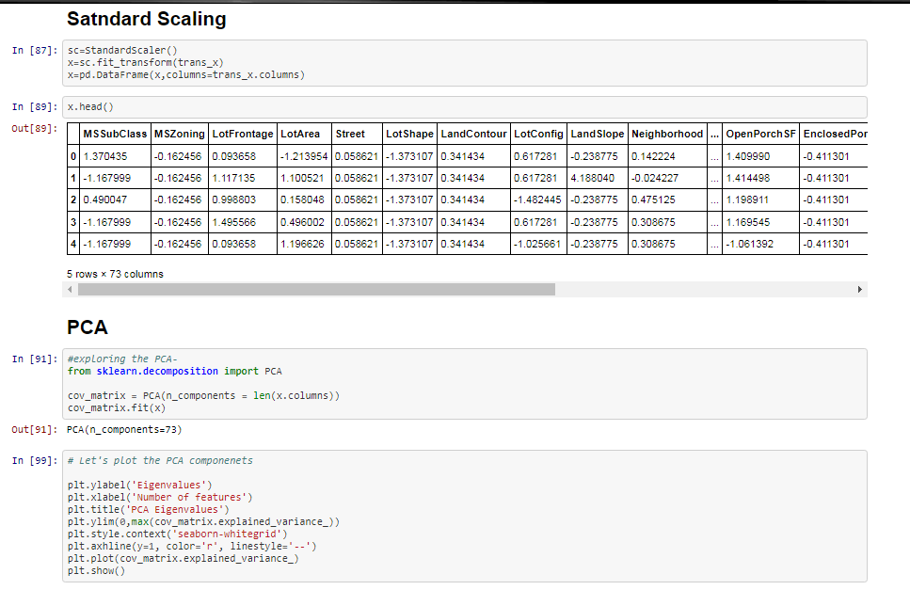

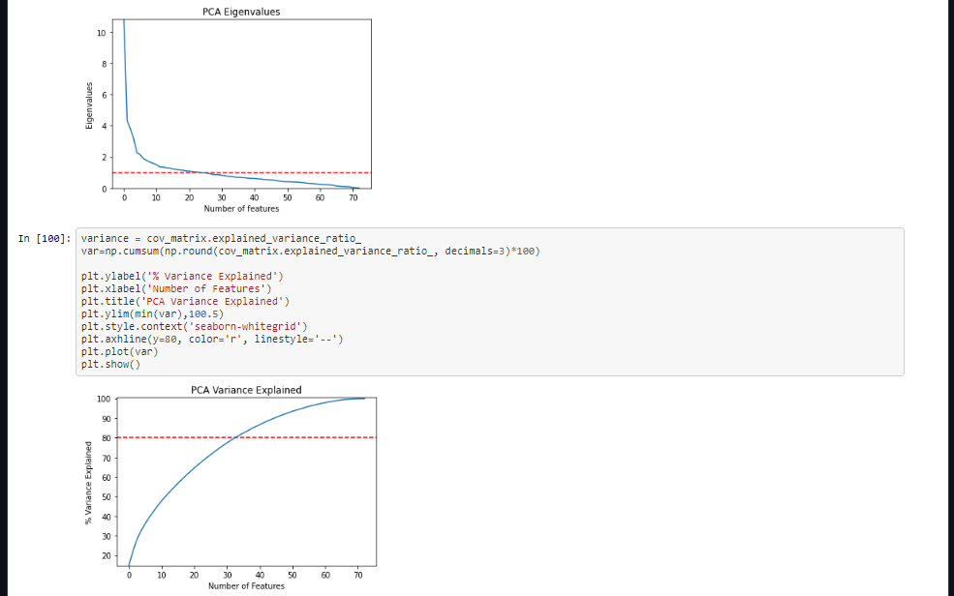

# MODEL/S DEVELOPMENT AND EVALUATION

## IDENTIFICATION OF POSSIBLE PROBLEM-SOLVING APPROACHES (METHODS)

We first converted all our categorical variables to numeric variables with the help of dummy variables to checkout and dropped the columns which we felt were unnecessary.

We observed skewness in data so we tried to remove the skewness through treating outliers with winsorization technique.

The data was improper scaled so we scaled the feature variables on a single scale using sklearn’sStandardScaler package.

There were too many (256) feature variables in the data so we reduced it to 73 with the help of Principal Component Analysis(PCA) by plotting Eigenvalues and taking the number of nodes as our number of feature variables.

## TESTING OF IDENTIFIED APPROACHES (ALGORITHMS)

The algorithms we used for the training and testing are as follows:-

* Linear Regression
* Lasso
* Ridge
* Elastic Net
* SVR
* KNeighborsRegressor
* Random Forest Regressor
* Ada Boost Regressor
* Gradient Boosting Regressor

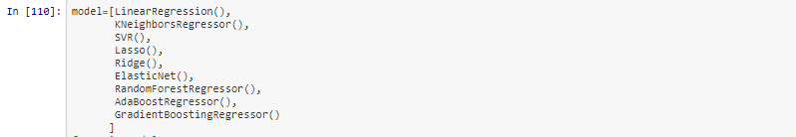

## EVALUATING SELECTED MODELS

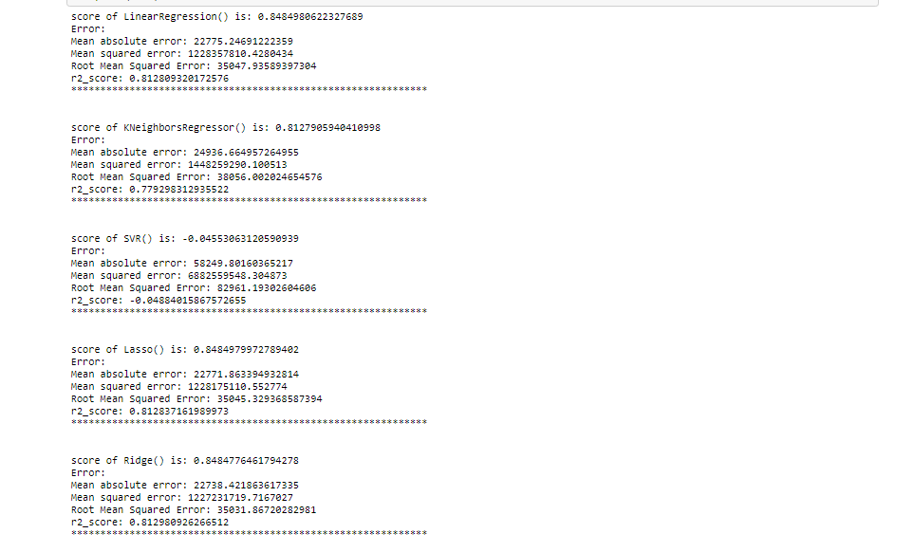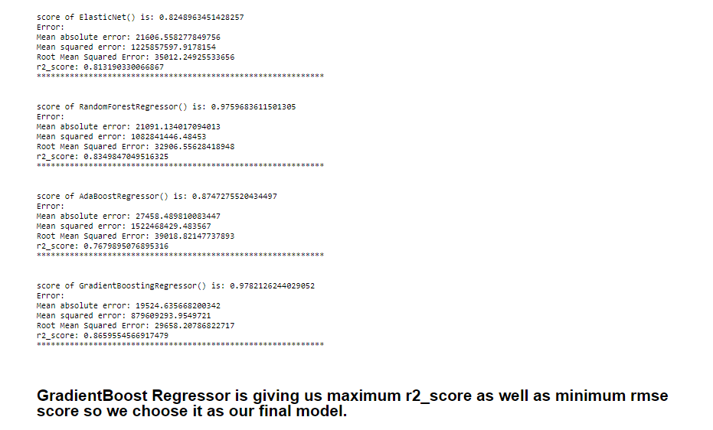

## KEY METRICS FOR SUCCESS IN SOLVING PROBLEM UNDER CONSIDERATION

We used the metric Root Mean Squared Error by selecting the Gradient Boost Regressormodel which was giving us best(minimum) RMSE score as well as best r2 score.

## VISUALIZATIONS

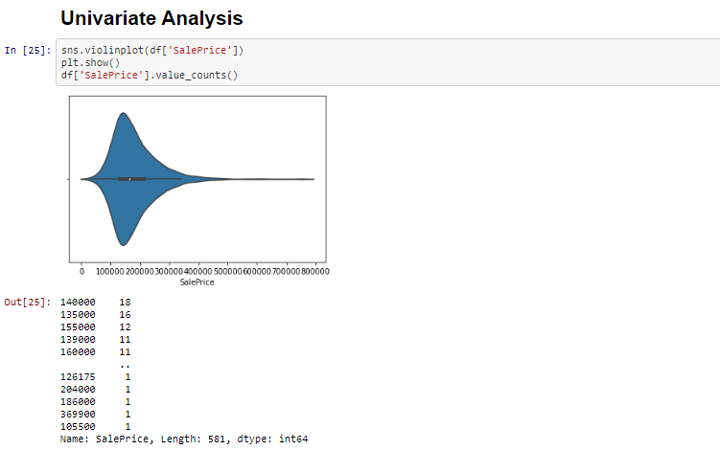

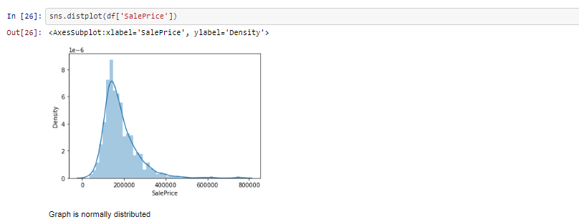

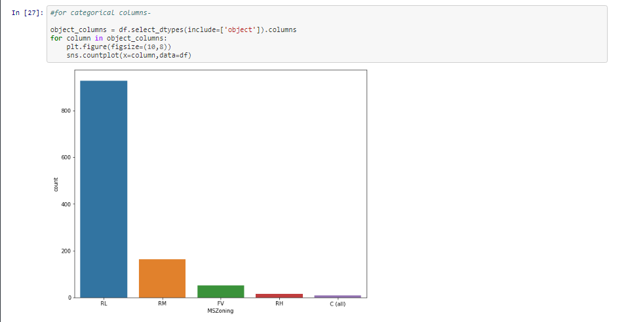

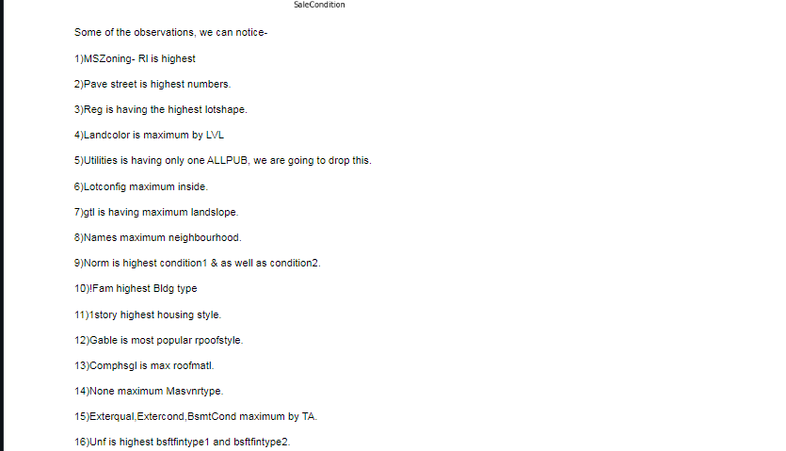

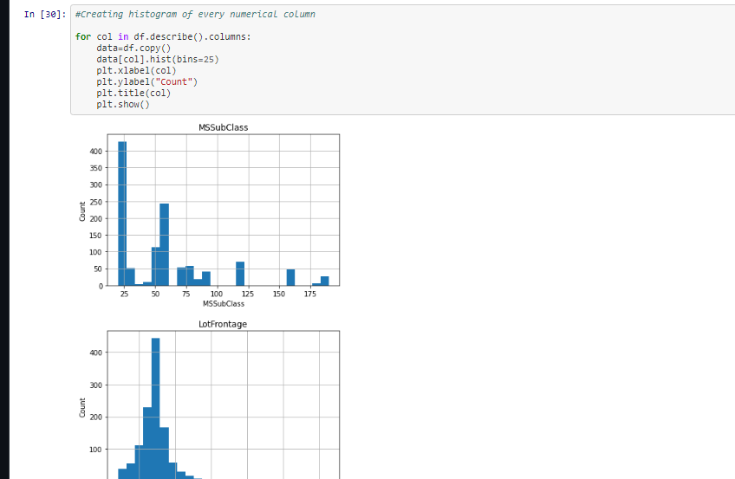

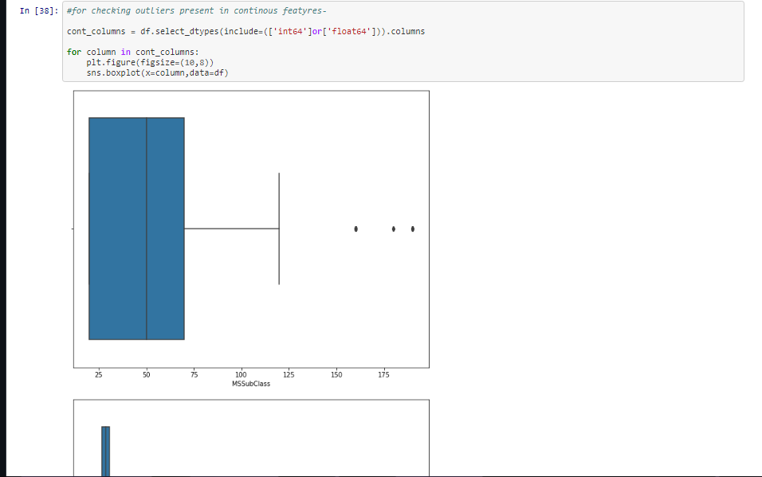

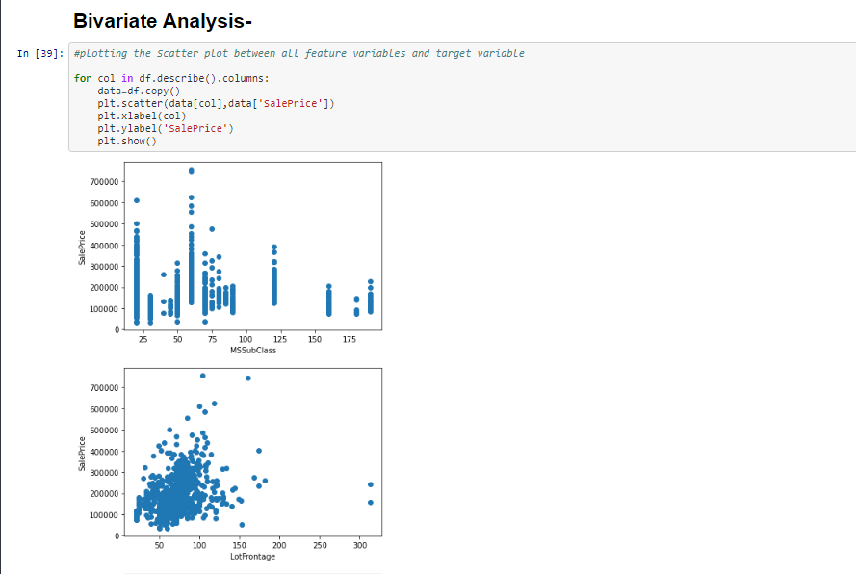

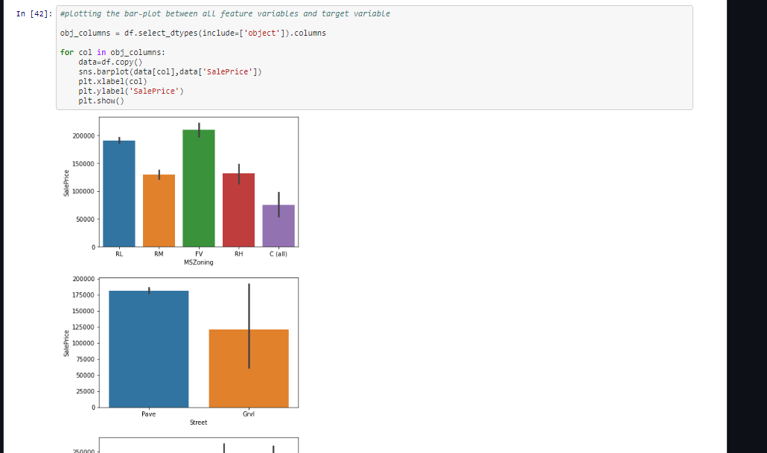

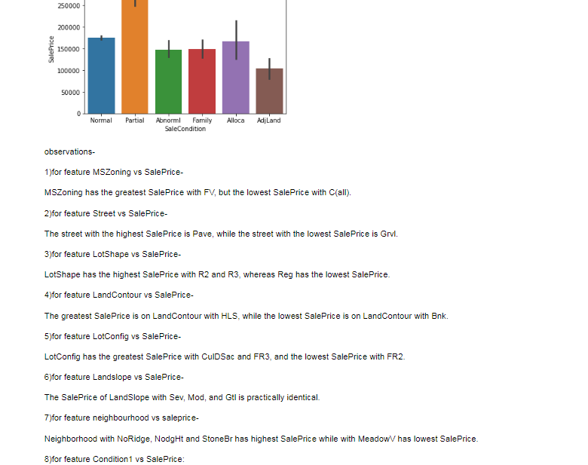

**CORRELATION BETWEEN FEATURES**

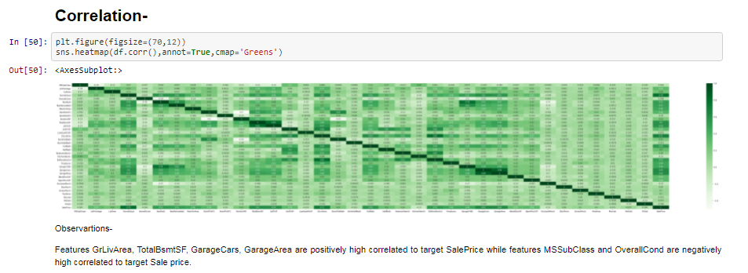

## INTERPRETATION OF THE RESULTS

From the visualization we interpreted that the target variable SalePrice was highly positively correlated with the columns GrLivArea, YearBuilt, OverallQual, GarageCars, GarageArea.From the preprocessing we interpreted that data was improper scaled.

**HYPERTUNING THE MODEL**

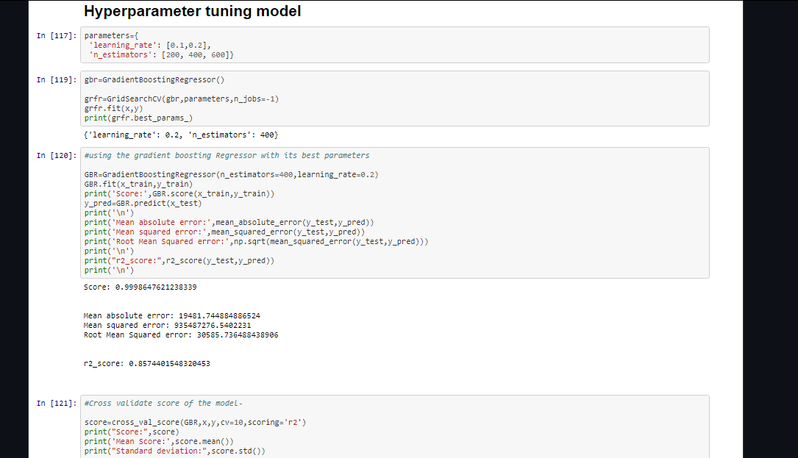

From this we observe, we can see very good cross validation score of 85% with minimal deviation.

**NOTE - Libraries that I used for training & testing the dataset is enlisted below-**

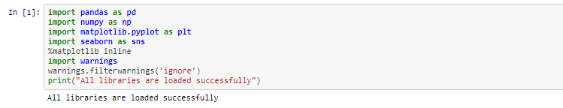

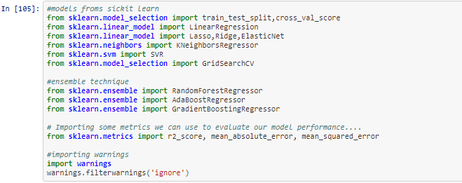

# CONCLUSION

## KEY FINDINGS AND CONCLUSIONS OF THE STUDY

In this research, we attempted to demonstrate how housing prices fluctuate and the elements that influence their fluctuation.The best(minimum) RMSE score was obtained by GridSearchCV utilising the optimal settings of the Gradient Regressor, however the Ridge Regressor model also performed well.

## LEARNING OUTCOMES OF THE STUDY IN RESPECT OF DATA SCIENCE

This experiment has highlighted the importance of effective sampling, modelling, and data prediction.We were able to analyse and comprehend several hidden insights about the data using various advanced visualisation tools.Through data cleaning we were able to remove unnecessary columns and outliers from our dataset due to which our model would have suffered from overfitting or underfitting.

The few challenges while working on this project where:-

* + Improper scaling
  + Too many features
  + Missing values
  + Skewed data due to outliers

The data was improper scaled so we scaled it to a single scale using sklearns’s package StandardScaler.There were too many features present in the data so we applied Principal Component Analysis(PCA) and found out the Eigenvalues and on the basis of number of nodes we were able able to reduce our features upto 73 columns.There were lot of missing values present in different columns which we imputed on the basis of our understanding.The columns were skewed due to presence of outliers which we handled through winsorization technique.

## 

## LIMITATIONS OF THIS WORK AND SCOPE FOR FUTURE WORK

While we were unable to achieve our aim of a minimum RMSE in house price prediction without allowing the model to overfit, we did create a system that can go very near to that goal given enough time and data.There is always space for improvement in any endeavour.The very nature of this project allows for multiple algorithms to be integrated together as modules and their results can be combined to increase the accuracy of the final result. This model can further be improved with the addition of more algorithms into it. However, the output of these algorithms needs to be in the same format as the others. Once that condition is satisfied, the modules are easy to add as done in the code. This provides a great degree of modularity and versatility to the project.

For more information, please visit:-

https://github.com/ayushpathak0912/flip-robo-HOUSE-PREDICTION/blob/main/Housing%20Project.ipynb