**Survey Results:**

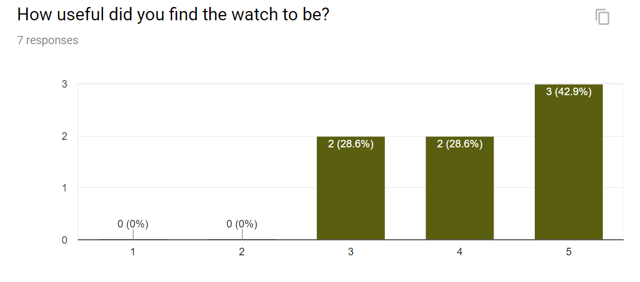

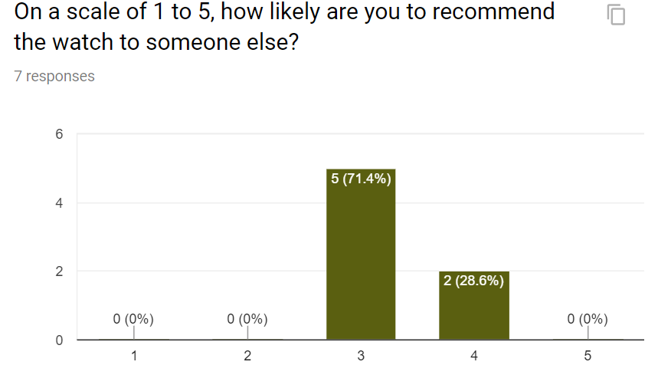

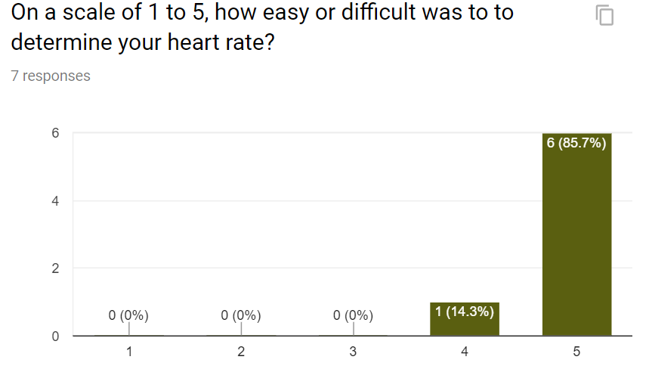

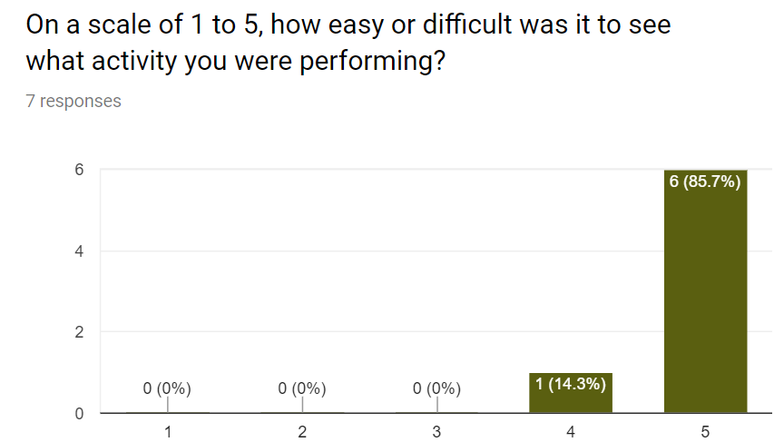

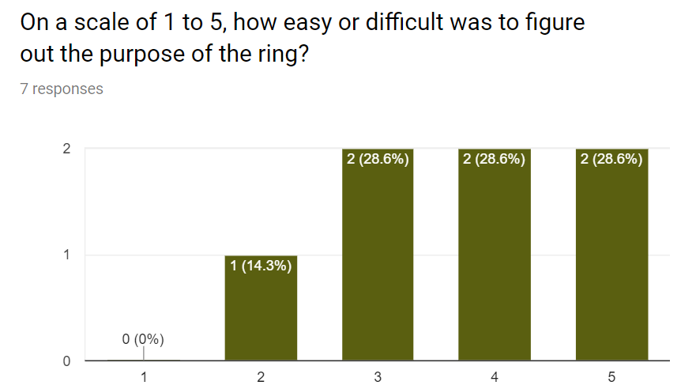

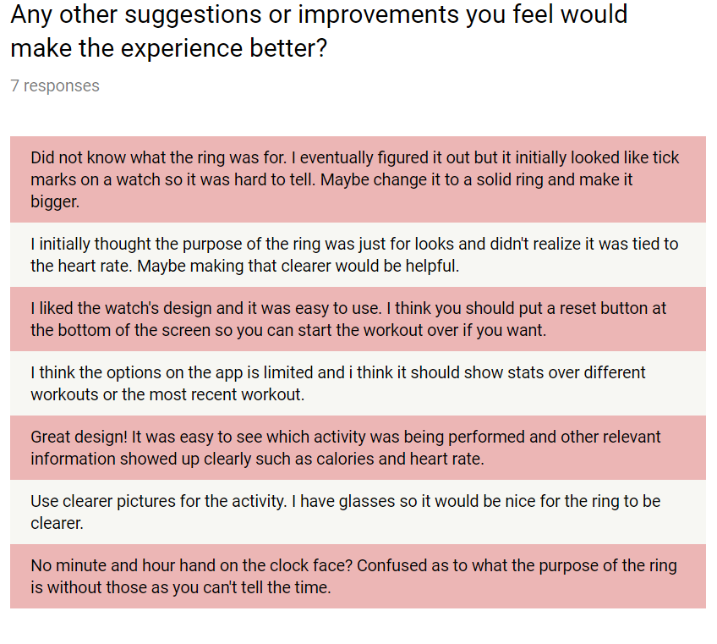

**Analysis:**

With the seven participants, we were able to get great feedback on how we could improve the design and functionality of the wearable system. While gathering feedback, we attempted to cover a wide range of participants from the population. Doing this would ensure our results would be more inclusive as we are already working with a small sample size to begin with.

In our survey, we attempted to gather information people’s fitness habits associated with the Samsung Gear S2 watch that we were testing on. We asked participants 5 questions: how useful was the watch; would you recommend the watch to someone else; how difficult was it to determine the heart rate; how difficult was it to see which activity was being performed; and how easy or difficult it was for participants to figure out the purpose of the ring. For all of the survey questions, we gave the participants a scale from 1-5 to determine how easy or difficult the action was.

Our results from the survey indicated that most of the participants found the watch to be at least somewhat useful with five out of the seven participants finding the watch to be more useful. We can most likely attribute these findings to our where we selected our population sample from which was Ramsey Student Center at UGA. Since most of the participants cared about their fitness, it would only be appropriate for them to feel that a watch that tracks fitness metrics would be useful for them. A majority of the participants also were somewhat likely to recommend the watch to someone else. This was probably due to our product being an initial prototype and there are other polished UI’s on the market already that we were being compared to. A majority of the participants determined heart rate and activity recognition without any problems. For the last question about determining the purpose of the ring, results were scattered ranging from 2 to 5. Upon reading the feedback section of the survey, it was clear that the participants had trouble with the ring. One participant said “Did not know what the ring was for. I eventually figured it out but it initially looked like tick marks on a watch”. Another participant said “I think you should put a reset button at the bottom of the screen”. Another participant said “thought the purpose of the ring was just for looks and didn't realize it was tied to the heart rate”.   
  
 We also had two testers who performed the 10 usability heuristics to provide comments and feedback. The participants identified all ten of the heuristic criteria but we determined five of them to be most applicable for our purposes. For the visibility of system status, the participants were able to identify five components of the UI. The only component that both participants had trouble with was the heart rate ring. “The size of the ring is too small and the color change is a gradient so it causes confusion as to what the current color the ring is.” Another criteria that we found important was the match between system and the real world. Both participants were able to easily recognize activity icons, time, and abbreviations used to interact with the information provided. The criteria of user control and freedom was identified as a problem area. Giving the ability for users’ to change what information they want to see would be an easy fix along with allowing more customization. Consistency and standards throughout the watch face app had low variance with color coded texts and numbers to match. The final criteria we found useful for a watch face app was aesthetics and minimalist design. Because screen space is limited on wearable devices, it is important to take advantage of minimalistic designs. The participants noted there was a good balance between empty space and used space showing information on the device.

**Mock-Ups Before/After Feedback:**

