**"Classification Report for YOLOv5s Model on Iris and Pupil Dataset"**

**Overview**

1. Capture

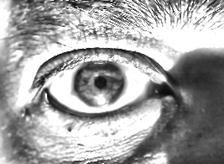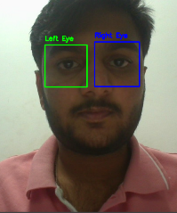

3. Image enhancement

2. Extract eye

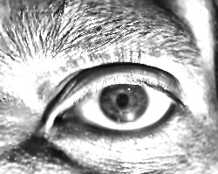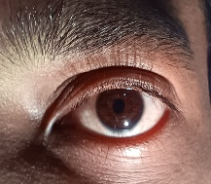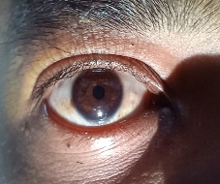

Left eye

Right eye

CLAHE, specular reflection removal and image sharpening

Haar-cascade classifier

Resolution:50mp

5. Ratios:-

4. Processed image

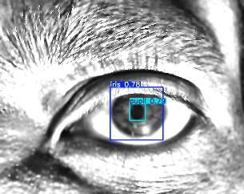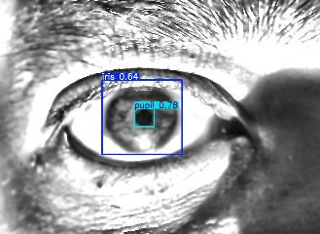

Left Eye: 3.76

Right Eye: 3.84

Fine tuned **YOLOV5s**

**Approach**

1. Capture

* Detect the face and eyes using bounding boxes.
* Use a model (e.g., YOLO) for face and eye detection.
* Mark regions of interest (eyes) within the face.

2. Extract Eye

* Isolate the left and right eyes from the captured image.
* Crop out the eye regions for further processing.

3. Image Enhancement

* Apply image enhancement techniques to improve clarity.
* Convert the eye images to grayscale for better feature extraction.

4. Processed Image

* Process the enhanced images for further analysis.
* Overlay bounding boxes on specific eye features (like iris/pupil).
* Display calculated ratios (e.g., pupil-to-iris ratio) for left and right eyes:
  + Left Eye Ratio: 3.76
  + Right Eye Ratio: 3.84

**Dataset Description**

The Dataset comprises:

* 310 training images.
* 90 validation images.
* 45 testing images.
* Classes: Iris and Pupil.
* Sample Images:

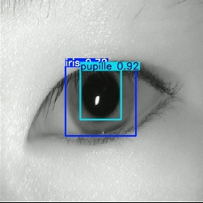 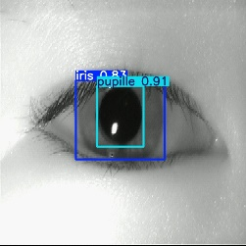

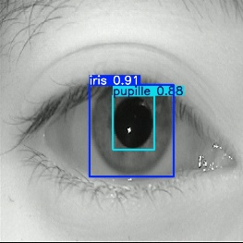 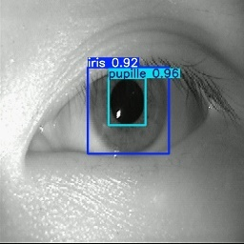

**Model Training Insights**

* **Batch Size**: 4
* **Image Resolution**: 640 x 640
* **Epochs**: 100
* **Weights Used**: yolov5s.pt (pre-trained)
* **Data Config**: "Directory \\data.yaml"

**Evaluation Metrics**

1. **Precision:** Precision measures object detection accuracy, calculated as:  
    **Precision = True Positives / (True Positives + False Positives)**.

**Precision=** **0.98877**

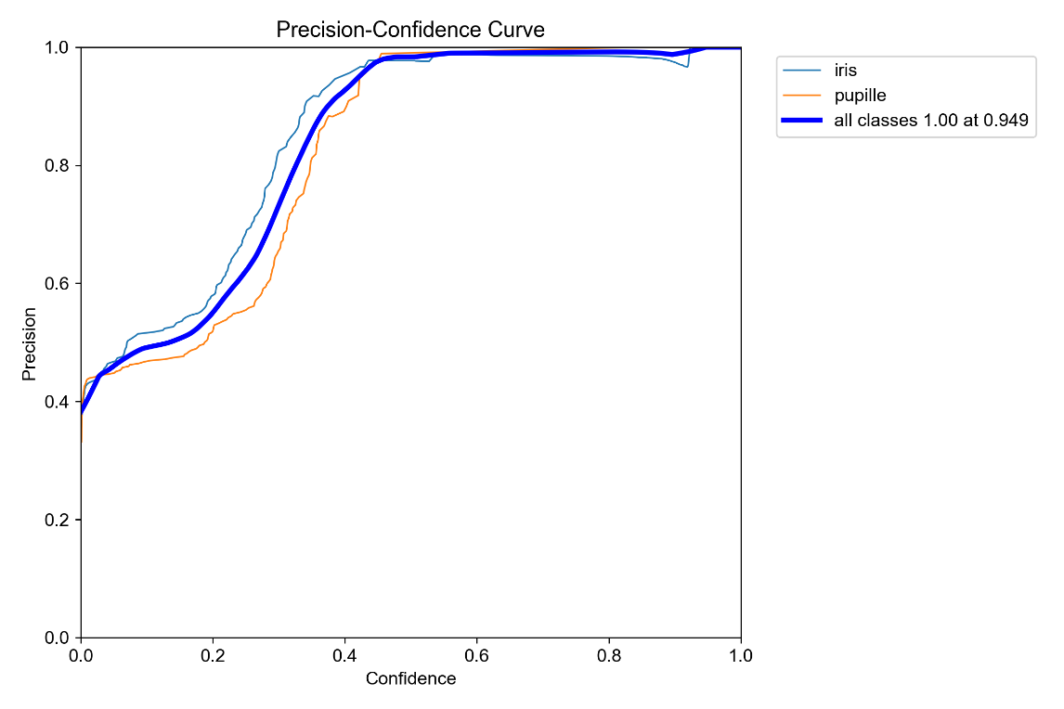

1. **Recall:** Recall measures how well the system detects ground truth objects, calculatedas: **Recall = True Positives / (True Positives + False Negatives).**

**Recall=** **0.94936**

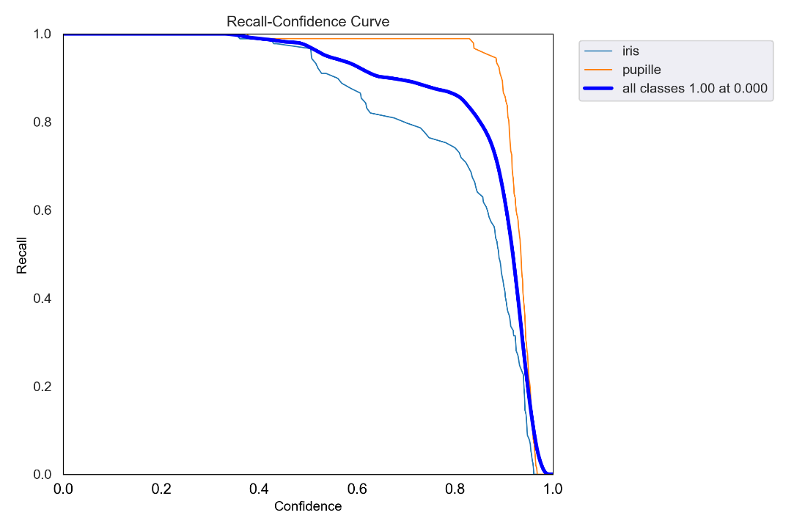

1. **F1-Score:** The F1-score is the weighted harmonic mean of precision and recall, ranging from 0 to 1. A higher F1-score indicates better model performance. It is calculated as: **F1-score = 2 × (Precision × Recall) / (Precision + Recall).**

**F1-score=0.96866.**

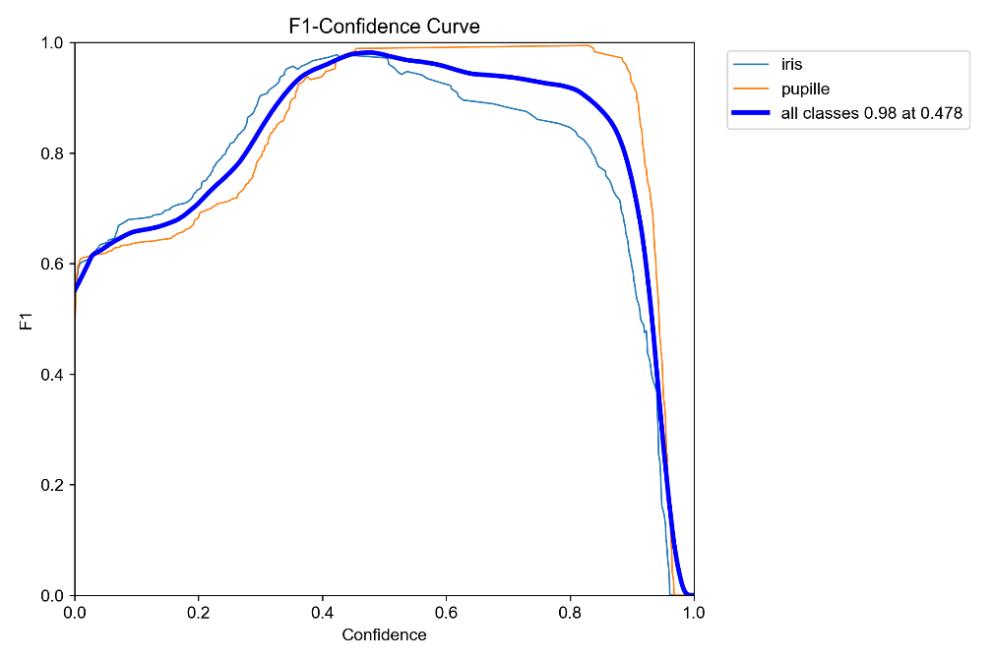

1. **Confusion Matrix**: This metric evaluates detection model performance for both binary and multi-class classification.

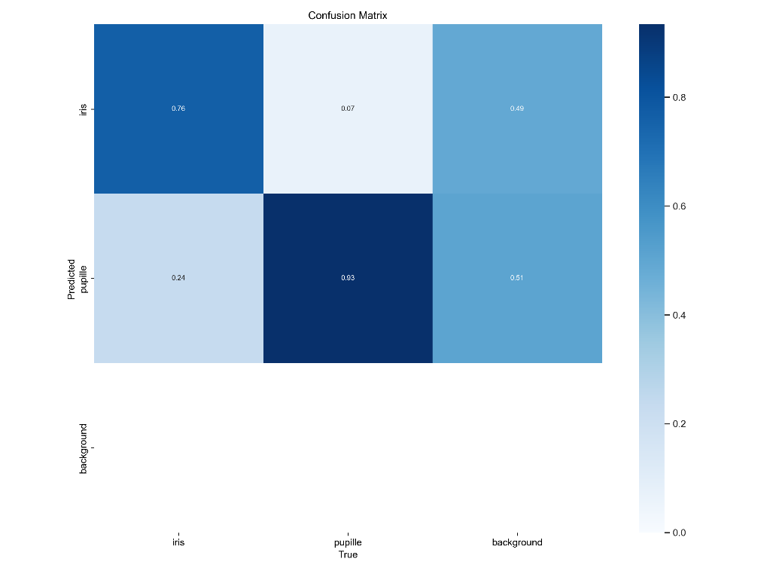

1. **mAP (Mean Average Precision):** mAP evaluates object detection models, with values ranging from 0 to 100. A higher mAP indicates better performance.

**mAP@0.5 uses IoU 0.5; mAP@0.5:0.95 averages IoU from 0.5 to 0.95.**

**mAP_0.5=** **0.98664.**

**mAP_0.5:0.95=0.90323.**

|  |  |  |  |  |  |  |
| --- | --- | --- | --- | --- | --- | --- |
| **Class** | **Images** | **Instances** | **P** | **R** | **mAP50** | **mAP50-95** |
| **Iris** | **90** | **89** | **0.977** | **0.972** | **0.985** | **0.924** |
| **Pupil** | **90** | **91** | **0.989** | **0.989** | **0.994** | **0.897** |
| **All** | **90** | **180** | **0.983** | **0.98** | **0.99** | **0.911** |

**Train Results**

**Test Results**

|  |  |  |  |  |  |  |
| --- | --- | --- | --- | --- | --- | --- |
| **Class** | **Images** | **Instances** | **Precision** | **Recall** | **mAP50** | **mAP50-95** |
| **Iris** | **45** | **90** | **0.99** | **0.99** | **0.995** | **0.901** |
| **Pupil** | **45** | **45** | **1.00** | **0.981** | **0.995** | **0.929** |
| **All** | **90** | **45** | **0.979** | **1.00** | **0.995** | **0.873** |

**Overall Graphical Results**

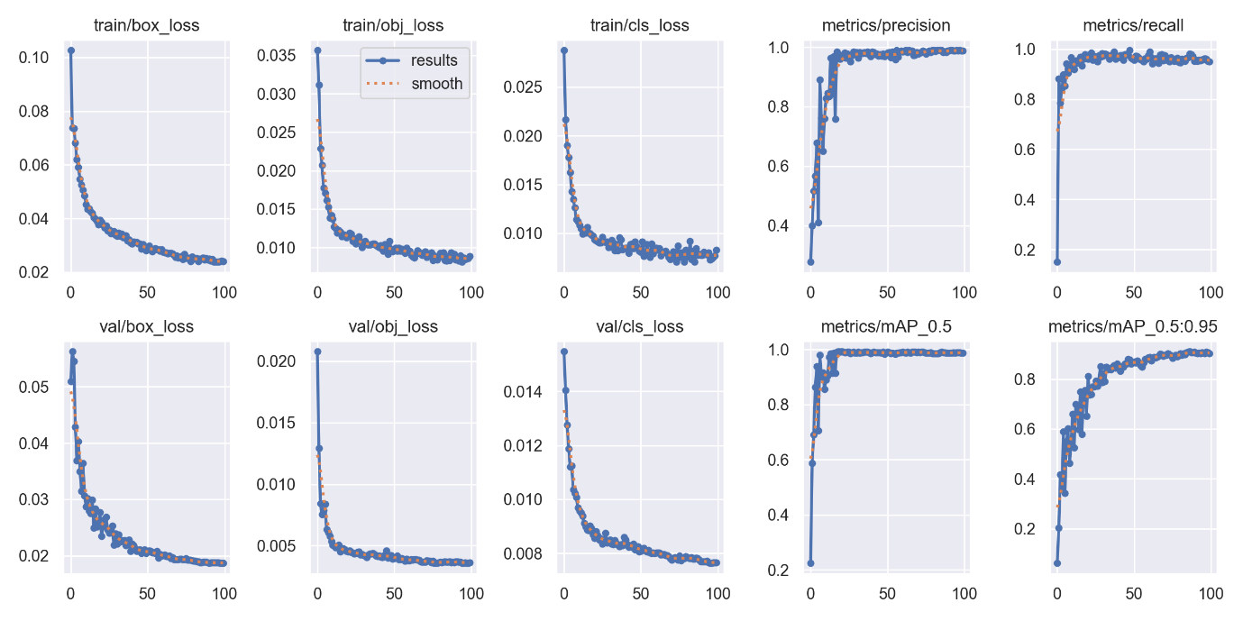

Click here for detailed Stats.

[results.xlsx](https://1drv.ms/x/c/22a5112dd062cf2a/ESASo1k8PiNCgXkR6CnQ7nMBGcll16zwXYYZtgOKsktphQ?e=Ndw8ee)

**Conclusion**

For the model demonstration, we used a dataset similar to the one used for training the new model but containing only 100 images. While this smaller dataset allowed us to test the model's performance quickly, it limited the generalizability of the results. The new dataset, which is similar in structure but much larger, contains 450 images. This significant increase in the number of images contributed to improved precision and overall performance of the model by providing better feature learning during training.

**Test Images:**

