Don’t Do Drugs!

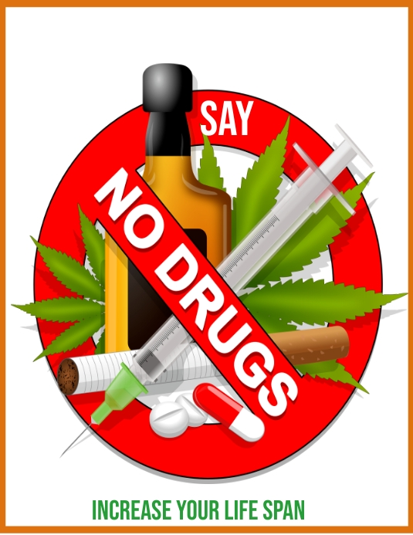Drugs are substances other than food that change the structure or function of the body or mind. Drugs are effective in treating illnesses when prescribed by a physician and used accordingly.

However, in our day and age, a lot of people misuse drugs. Misuse is defined as using a drug in a way that is not intended, such as taking too much of a prescription. This can lead to abuse and overdose! One fact about drugs that is shocking is that almost 80,000 people die to drug overdose every year in the U.S., according to the CDC.

Using drugs has many consequences. Many drugs have effects such as insomnia, disorientation, a loss of appetite, and tremors! Overdose, which is when you have a strong and possibly fatal reaction to too much of a drug, can result in shallow respiration, coma, clammy skin and possibly death!

So, drugs are not safe to have in any occasion. But how exactly do you avoid them? Well, you should follow these tips.

* Surround yourself with friends that do not do drugs. This will minimize peer pressure and allow you to not take drugs. But what if your friends begin to take drugs?
* Then, you should be prepared with refusal skills. Practice these beforehand and be ready to employ them whenever you feel peer pressure is coming.
* You also could try to help your community get rid of drug abuse and misuse. If your community has less drug abuse, you will be safer and less drugs will be in circulation. This means you will be less likely to take drugs.

More than 160 billion dollars is lost by the United States to drugs each year. People miss out on life when something else controls them. It is important that we stay drug-free and help our community out in doing so.