AI Strategy for Retail and E-commerce

Project Report

Submitted by

Ayush Rai
Enrollment No. 20261010
PGDM in Big Data Analytics

Course: Introduction to Artificial Intelligence
Course Faculty: Chintan Patel

Date: 18th October 2026

AI in Retail and E-Commerce
A strategy to fix inventory, keep customers and cut delivery cost in a mid-size retail company

1. Executive Summary
A mid-size retailer is in a difficult middle position. It is too large to run on gut feeling and spreadsheets, yet too small to match the technology budgets of the big national marketplaces. Three problems usually appear together. Stock sits in the wrong place, customers buy once and then drift away, and deliveries cost too much or arrive late. This report explains how artificial intelligence (AI) can help with all three, and how one shared data base can serve them.
The recommendation is one connected programme with three pillars: personalised shopping, smarter stock levels and leaner logistics. Personalisation lifts sales and repeat purchases. Better forecasting keeps popular items on the shelf and reduces dead stock. Better routing and delay warnings lower delivery cost and build customer trust. The plan runs in four phases over 18 months. It starts with data clean-up and small pilots, and it releases more money only when a pilot beats its baseline. Under the illustrative assumptions in Appendix D, the programme pays back in about 17 months. These figures are planning assumptions, and the company must replace them with its own data.

2. Business Context and Problem Diagnosis
For this report the company is assumed to be an omnichannel retailer with an online store, 30 to 50 physical stores, two or three warehouses, a few hundred thousand customers and tens of thousands of products. Its data sits in separate systems: the billing counters, the website, the ERP, the warehouse system and the courier portals. Most decisions on reordering, offers and delivery routes are made by experienced staff using spreadsheets. That works up to a point, but it does not keep up with changing demand.
Table 1. The three problems, their causes and their effect on the business
Problem | Common cause | Effect on the business
Poor inventory management | Forecasts based on last year’s sales and gut feel; one stock rule for every store; slow reaction to trends | Stockouts on fast sellers; cash locked in slow sellers; heavy markdowns
Low customer retention | Same offer sent to everyone; recommendations ignore real behaviour; complaints not analysed | High cost of winning new customers; low repeat purchase; falling customer value
Inefficient supply chain | Fixed routes and carriers; delays found only after they happen; damage found at the customer’s door | High cost per order; late deliveries; returns and poor reviews
The three problems feed each other. A customer who finds a product out of stock, or gets a parcel late, is less likely to come back. Marketing money spent on items that are not available is wasted. This is why the report treats them as one programme and not as three separate projects.

3. The AI Strategy at a Glance
In this report, AI mostly means well-tested machine learning and optimisation methods, not futuristic robots. These methods learn patterns from past data, make a prediction, and help staff choose an action. Four principles guide the strategy. First, start from the business problem and not from the tool. Second, build one shared data layer and reuse it. Third, keep people in charge of final decisions. Fourth, prove value in a pilot against a baseline before scaling up. Figure A6 in the appendix shows how data, models, decisions and feedback connect.

4. Pillar 1: Personalised Shopping Experience
Personalisation means showing each customer what is useful to them at the right time, instead of sending the same offer to everybody. Five tools do most of the work.
Product recommendations. A recommendation system ranks products using what a customer viewed and bought, and what similar customers chose (Ricci et al., 2022). A mid-size retailer should start with simple “customers who bought this also bought” logic and move to richer models as its data grows. Recommendations must be linked to livestock, so that customers are never pushed towards items that are unavailable.
Customer segments. K-Means clustering groups customers by how often they buy and how much they spend (Figure A3). Each group gets a different plan. Frequent, high-spend customers get early access and loyalty rewards. Occasional, high-spend customers get reminders and bundle offers. Frequent, lower-spend customers are shown higher-value items. Occasional, lower-spend customers get only low-cost win-back messages.
Churn warning. A classification model estimates which customers are likely to stop buying. The risk score is updated as new signals arrive, for example two ignored emails or a complaint, which follows the same idea as Bayes’ theorem. The team can then step in with a call, a service fix or a small offer before the customer is lost (Figure A4).
Reading reviews and messages. Natural language processing sorts reviews and support messages by topic and mood, so that repeated problems such as wrong sizing or late delivery are found and fixed early. A chat assistant can answer simple order-status questions at any hour and pass difficult cases to staff.
Right offer, right size. Models can also choose the message, the timing and the discount level. A control group should be kept checking that the offer really changed behaviour, because discounts given to people who would have bought anyway only reduce profit.
How this helps. Relevant recommendations raise conversion and basket size. Better retention lowers the need for costly new-customer advertising. Targeted discounts protect margin, and a good chat assistant reduces support workload. The company must collect consent, follow India’s Digital Personal Data Protection Act, 2023, and avoid messaging so often that customers feel watched or annoyed.

5. Pillar 2: Optimising Stock Levels
Stock decisions improve when they are based on a forecast for each product and each location, instead of one rule for the whole chain.
Demand forecasting. Time-series methods learn trend, seasonality, festival peaks, promotions and price changes from past sales (Hyndman & Athanasopoulos, 2021). A forecast should always be compared with a simple benchmark such as last year’s sales. A complex model is worth using only if it clearly beats the benchmark (Figure A1).
Stockout warning and safety stock. A supervised model flags items that are likely to run out before the next delivery, taking supplier delays into account. Safety stock is then set item by item, so a fast seller with an unreliable supplier gets a bigger buffer than a steady, low-risk item.
Replenishment. An optimisation step combines the forecast, supplier lead time, budget and shelf space to suggest order quantities. Buyers review and approve the suggestions, and their corrections help the system improve.
Moving stock between locations. When one store or warehouse is short and another has too much, the system suggests transfers or ship-from-store fulfilment. This sells existing stock before new stock is ordered.
Slow movers. Models can spot products drifting towards dead stock early, so a small, timely discount can be used instead of a deep clearance sale later. Reinforcement learning (Sutton & Barto, 2018) can be tested for ordering policies in a later phase, but only in a simulator first.
How this helps. Higher availability means fewer lost sales. Lower excess stock frees working capital and cuts storage, interest and markdown costs (Figure A2).

6. Pillar 3: Streamlining Logistics
Delay prediction. Models that use order details, supplier history, warehouse load, courier performance and weather or traffic information flag orders that are likely to be late. The team can then switch courier or warn the customer before a complaint arrives.
Route and delivery planning. The A* search algorithm finds a low-cost path across a road network (Hart et al., 1968). Real delivery planning must also respect vehicle capacity, delivery time windows and driver hours, so optimisation methods are added on top. The result is fewer kilometres, less fuel and more drops per trip.
Choosing where to ship from. For each order the system can pick the warehouse or store that meets the promised date at the lowest cost. Inside the warehouse, fast-moving items can be placed closer to the packing area to shorten picking time.
Honest delivery dates. Regression models estimate delivery time for each pin code and courier, so the promised date is realistic. This reduces “where is my order” calls.
Damage checks. A convolutional neural network, a type of deep-learning model (LeCun et al., 2015), can check photos taken at packing and flag visible damage before the parcel leaves. It needs enough labelled photos and must be tuned so that it does not raise too many false alarms.
How this helps. The company gets a lower cost per order, a higher on-time rate, and fewer returns and complaints. Reliable delivery also supports repeat purchases, which links this pillar back to retention (Figure A5).

7. How the Pillars Create Sales Growth and Cost Reduction
Table A2 lists the main value levers. The pillars are stronger together than apart. The demand forecast uses customer segment and campaign data, so promotions do not surprise the stock team. The recommendation engine reads live stock, so offers match what can be shipped. The logistics plan uses the forecast to place stock closer to demand before the festival rush. In short, sales growth comes from relevance, availability and reliable delivery, and cost reduction comes from less waste in stock, marketing and transport.

8. Implementation Roadmap
The programme runs in four phases over 18 months (Figure A8 and Table A5). Phase 0 (months 1 to 3) is the foundation: audit and clean the data, link the main systems, agree baselines and name an owner for every KPI. Phase 1 (months 4 to 8) holds the quick wins: a demand forecasting pilot in the top categories, churn scoring and segmentation, and delay alerts on one courier route. Phase 2 (months 9 to 14) scales what worked, with replenishment suggestions, recommendations on the site, app and email, and route and fulfilment optimisation. Phase 3 (months 15 to 18) adds damage checks, markdown planning and a chat assistant, and tests reinforcement learning in simulation. Each phase ends with a gate. The next phase starts only if the earlier one met its agreed targets.
A mid-size company should mostly buy or rent proven tools, such as cloud platforms and open-source libraries like scikit-learn (scikit-learn developers, n.d.), and build custom models only where its own data gives it an edge. A small core team is enough: a business owner, a data engineer, one or two analysts or data scientists, and people from buying, marketing and logistics. Staff training matters as much as the models, because buyers and store managers must trust the suggestions before they use them.

9. Measuring Success and Value
Success is judged at two levels. Model measures, such as forecast error and churn-prediction accuracy, show whether the model is good. Business KPIs, such as stockout rate, repeat purchase rate and cost per order, show whether the business is better off (Table A3). Baselines are recorded before launch, and results are compared with a control group or with matched periods. For classification and image models, both false alarms and misses are reported.
Appendix D gives an illustrative return calculation (Table A4 and Figure A7). It assumes an investment of Rs. 3.0 crore in year one, a running cost of Rs. 1.2 crore a year, and annual benefits of about Rs. 7.0 crore by year two. On those assumptions the programme breaks even in about 17 months. The calculation shows how to build the business case. It should be redone with real company numbers after the first pilots.

10. Risks and Good Practice
Table A6 lists the main risks and how to handle them. Four deserve special attention. Poor data quality is the most common reason AI projects disappoint, so Phase 0 must not be skipped. Customer privacy must be protected through consent, limited access and clear retention rules. Models drift as customer taste and supply conditions change, so accuracy should be tracked every month and models retrained when needed. Finally, people must stay in the loop. Buyers, marketers and logistics planners should be able to override a suggestion, and every override should be recorded and reviewed.

11. Conclusion and Recommendations
A mid-size retailer does not need to copy the biggest players. It needs to pick a few problems that cost real money, fix its data, and prove value in small steps. AI can help it keep the right stock, serve each customer better and deliver at lower cost, and these three efforts support each other. The recommended next steps are:
- Start with data. Clean and link product, customer, order and delivery data before buying any model.
- Begin with demand forecasting and churn scoring, because they are quick to test and easy to measure.
- Connect personalisation to live stock, so that offers always match what can be delivered.
- Run every pilot against a baseline or control group, and scale only what shows measured gains.
- Keep humans in charge, protect customer data and review model performance every month.

References
Government of India. (2023). The Digital Personal Data Protection Act, 2023 (Act No. 22 of 2023).
Hart, P. E., Nilsson, N. J., & Raphael, B. (1968). A formal basis for the heuristic determination of minimum cost paths. IEEE Transactions on Systems Science and Cybernetics, 4(2), 100–107.
Hyndman, R. J., & Athanasopoulos, G. (2021). Forecasting: Principles and practice (3rd ed.). OTexts. https://otexts.com/fpp3/
LeCun, Y., Bengio, Y., & Hinton, G. (2015). Deep learning. Nature, 521, 436–444.
Ricci, F., Rokach, L., & Shapira, B. (2022). Recommender systems: Techniques, applications, and challenges. In Recommender Systems Handbook (3rd ed., pp. 1–35). Springer.
scikit-learn developers. (n.d.). User guide. https://scikit-learn.org/stable/user_guide.html
Sutton, R. S., & Barto, A. G. (2018). Reinforcement learning: An introduction (2nd ed.). MIT Press.
These are method references. They do not prove that any retailer achieved the illustrative results in the appendices.

Appendices
Appendix A. Technique Map and Value Levers
Table A1. AI techniques, practical use and main data needed
Area | AI technique | Practical use | Main data needed
Stock | Time-series forecasting | Forecast demand by product and location | Daily sales, promotions, prices, festival dates
Stock | Supervised learning | Flag items likely to stock out | Sales, stock, supplier lead times
Stock | Optimisation | Suggest order quantities and transfers | Forecasts, budget, shelf and warehouse space
Stock | Reinforcement learning (later) | Test adaptive ordering rules in a simulator | Simulated stock and demand
Customers | K-Means clustering | Group customers by frequency and spend | Orders, order value, recency
Customers | Classification | Estimate churn risk | Purchase history, complaints, email activity
Customers | Recommendation system | Rank products for each customer | Views, purchases, product details
Customers | Natural language processing | Sort reviews and messages by topic and mood | Reviews, chat and support text
Customers | Bayes’ theorem | Update churn risk as new signals arrive | Churn signals and past outcomes
Logistics | Regression | Estimate delivery time and cost | Past deliveries, distance, courier data
Logistics | Predictive analytics | Warn about likely delays | Order, supplier, warehouse, courier data
Logistics | A* search and optimisation | Plan routes, loads and shipping point | Road network, vehicles, time windows
Logistics | CNN image analysis | Flag damaged packages at packing | Labelled package photos

Table A2. Value levers: where sales growth and cost reduction come from
Value lever | Effect | Pillars | Main KPI
Relevant recommendations raise conversion and basket size | Sales up | 1 and 2 | Conversion rate, average order value
More repeat purchases from better service and offers | Sales up | 1 and 3 | Repeat purchase rate, churn rate
Fewer lost sales from stockouts | Sales up | 2 | Stockout rate
Less excess stock and fewer markdowns | Cost down | 2 | Excess stock cost, inventory turns
Lower delivery cost per order | Cost down | 3 | Logistics cost per order
Targeted marketing instead of mass offers | Cost down | 1 | Cost per retained customer
Fewer support calls and returns | Cost down | 1 and 3 | Contacts per 100 orders

Appendix B. Illustrative Charts
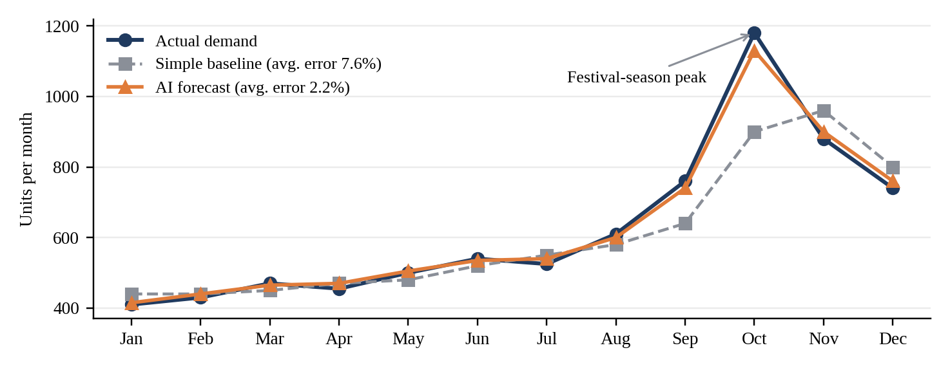
Figure A1. Monthly demand: actual, simple baseline and AI forecast (illustrative values; error is the average percentage gap to actual demand).
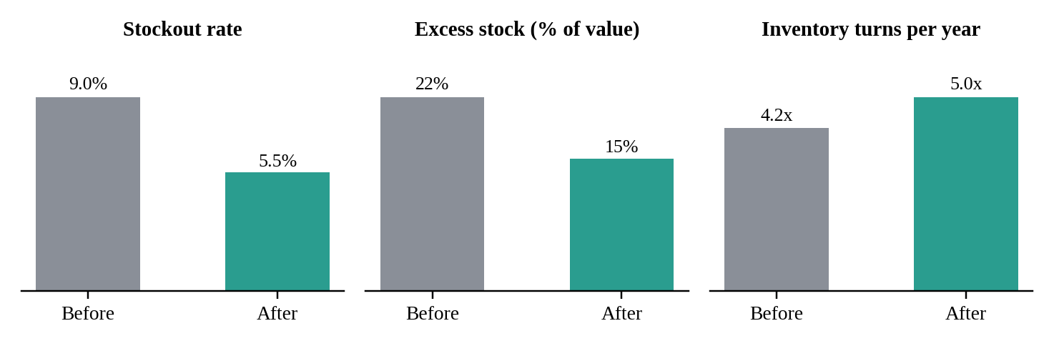
Figure A2. Illustrative inventory KPIs before and after the programme (planning targets, not measured results).
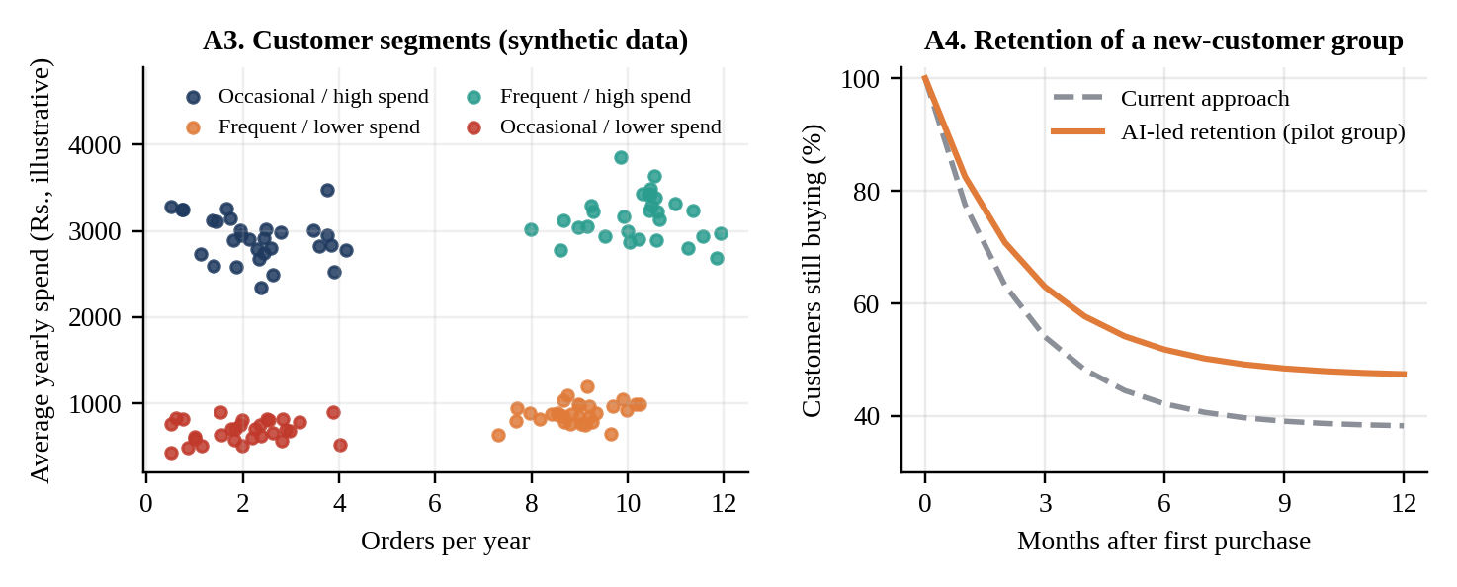
Figures A3 and A4. Left: K-Means segments on synthetic customer data. Right: illustrative retention curve. Neither uses real customer records.

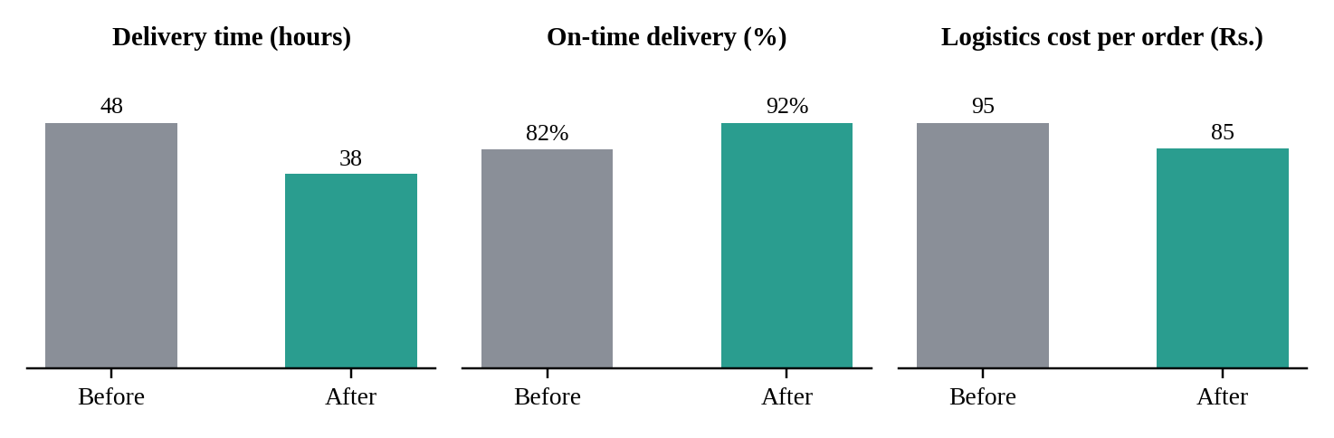
Figure A5. Illustrative logistics KPIs before and after the programme (planning targets, not measured results).
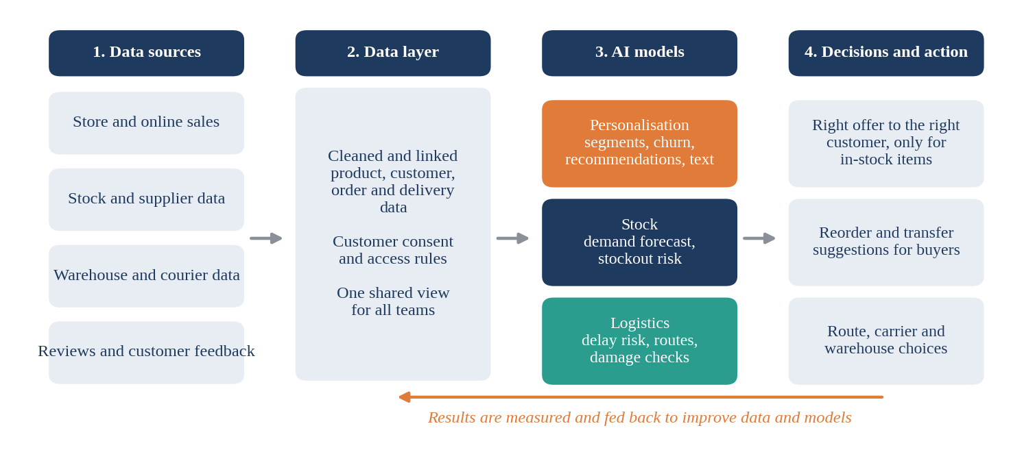
Figure A6. How data, AI models, decisions and feedback connect across the three pillars.
Appendix C. KPI Table
Table A3. KPI definitions and desired direction
Area | KPI | What it measures | Direction
Stock | Stockout rate | Share of product-days with no stock | Lower
Stock | Forecast error | Gap between forecast and actual (MAPE) | Lower
Stock | Excess stock; turns | Stock above need; yearly stock turnover | Lower; higher
Customers | Repeat purchase rate | Share of customers who buy again | Higher
Customers | Churn rate | Share of customers who go inactive | Lower
Customers | Conversion; order value | Visits ending in a sale; basket value | Higher
Logistics | Delivery time | Hours from order to delivery | Lower
Logistics | On-time delivery | Share of deliveries within promised date | Higher
Logistics | Cost per order | Transport and fulfilment cost per order | Lower
Inspection | Damage detection | Precision and recall of image check | Higher

Appendix D. Illustrative Return on Investment
Table A4. Assumptions and illustrative results (Rs. crore)
Item | Value
Assumed company: yearly revenue; gross margin | 300; 30%
Assumed average stock value; logistics cost (8% of revenue) | 60; 24
Year-1 investment: data platform 1.2, models and tools 1.0, system links 0.5, training 0.3 | 3.0
Running cost per year | 1.2
Yearly benefit at year 2: extra gross profit from 4% higher sales | 3.6
Yearly benefit at year 2: lower stock carrying cost and markdowns | 2.0
Yearly benefit at year 2: 6% lower logistics cost | 1.4
Total yearly benefit: year 1 (ramp-up) / year 2 / year 3 | 2.1 / 7.0 / 8.0
Net result: year 1 / year 2 / year 3 | -2.1 / 5.8 / 6.8
Cumulative net benefit after 3 years; break-even point | 10.5; about month 17
Cash released by 7 points less excess stock (not counted as a benefit) | about 4.2
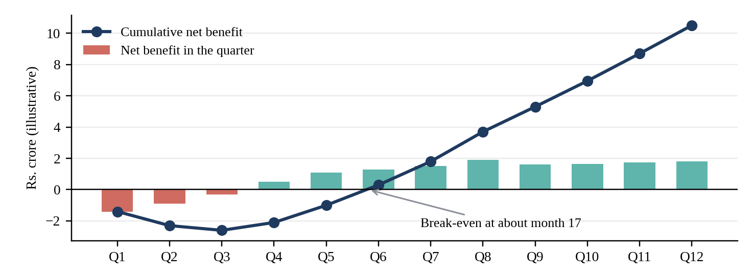
Figure A7. Illustrative quarterly and cumulative net benefit over three years. All values come from the assumptions in Table A4.

Appendix E. Roadmap and Phase Gates
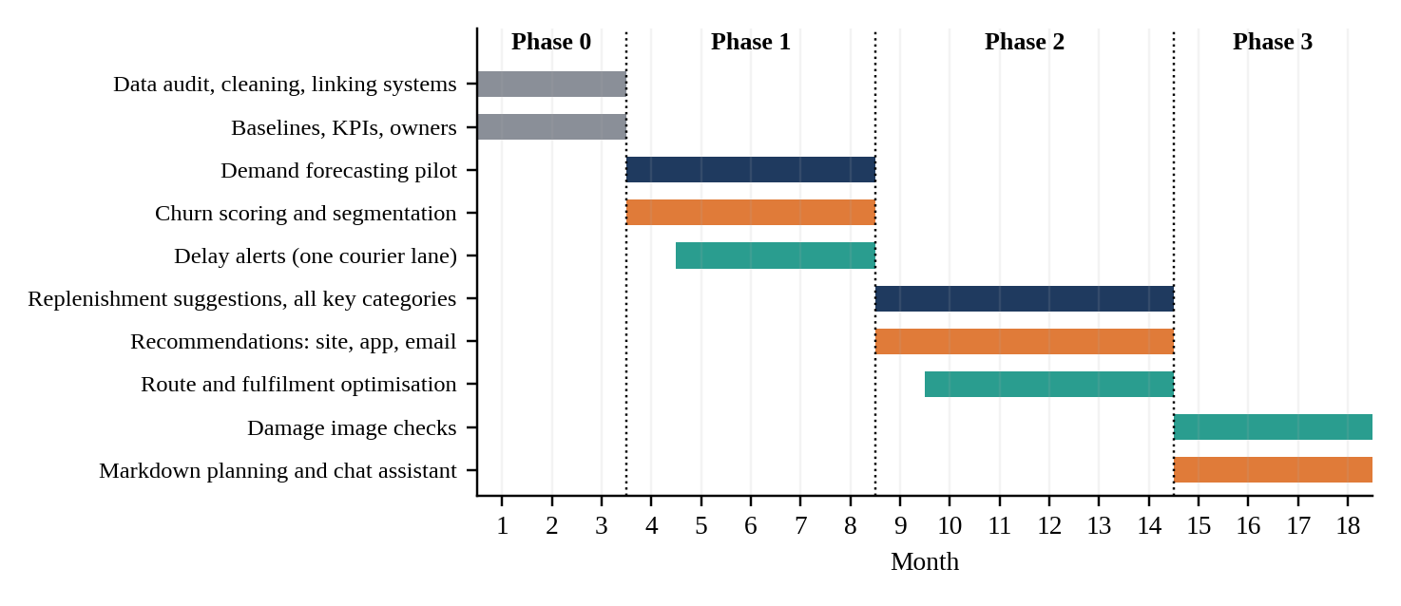
Figure A8. 18-month roadmap. Orange: personalisation. Navy: stock. Teal: logistics. Grey: foundation.
Table A5. Phase gates
Phase | Months | Main work | Gate to move on
0. Foundation | 1 to 3 | Clean and link data; set baselines and owners | Data quality checks passed; baselines agreed
1. Quick wins | 4 to 8 | Forecasting, churn scoring, delay alerts (pilots) | Pilots beat baseline on agreed KPIs
2. Scale | 9 to 14 | Replenishment, recommendations, route optimisation | Measured gains; cost within budget
3. Advance | 15 to 18 | Damage checks, markdown planning, chat assistant | Stable operation; team ready to run it
Appendix F. Risks and Good Practice
Table A6. Main risks and how to handle them
Risk | What can go wrong | How to handle it
Poor data | Missing or wrong records give weak forecasts | Clean and link data in Phase 0; add quality checks
Privacy | Customer data used without consent | Collect consent; limit access; set retention rules
Over-targeting | Too many messages annoy customers | Cap contact frequency; track complaints and opt-outs
Model drift | Accuracy falls as demand and supply change | Track accuracy monthly; retrain when needed
Low staff trust | Buyers and planners ignore suggestions | Involve them early; allow overrides; train staff
Cost overrun | Tools and vendors cost more than planned | Release money by phase gates; prefer proven tools

